James M. Gold, Baltimore, MD, USA
Editor-in-Chief
Schizophrenia Bulletin

Subject: Submission of Manuscript Entitled " Social Prediction Error Signals During the Trust Game in Patients With Schizophrenia: An fMRI Study "

Dear Dr. Gold;

In the name of all authors, I want to submit our manuscript, " Social Prediction Error Signals During the Trust Game in Patients With Schizophrenia: An fMRI Study," for consideration as a research article for Schizophrenia Bulletin. We investigated social prediction errors (PEs) in patients with schizophrenia (SZ) during the Trust Game within a reinforcement-learning framework.
Social cognitive deficits are hallmark of SZ, and social cognitive deficits significantly contribute to psychopathology. We show that—even trust behavior appears superficially intact—patients exhibit larger PE magnitudes and lower learning rates than healthy controls (HC). PE-related activation engages bilateral TPJ in HC is attenuated in SZ, with a shift toward lower-level visual cortices and cerebellum. PE magnitude is further modulated by sex (largest in male patients) and increases with longer duration of illness. These results align with hierarchical predictive-coding accounts positing underweighted higher-level belief updating in SZ and compensatory reliance on sensory/cerebellar systems—implicating TPJ-centric and cerebello-cortical circuits as targets for intervention.

All authors have approved the final version of this manuscript. Neither the manuscript as a whole nor any part of it has been published previously, nor is it under consideration for publication elsewhere. Furthermore, all authors agree to comply with the submission policies of Schizophrenia Bulletin.

Thank you very much for considering our work. We look forward to your feedback and hope that our study meets the standards for publication in Schizophrenia Bulletin.

Sincerely,

Ali Saffet Gonul, MD (on behalf of all co-authors)
Professor of Psychiatry
Ege University School of Medicine
Department of psychiatry
SoCAT Lab
Bornova Izmir Turkey

Title: Social Prediction Error Signals During the Trust Game in Patients with Schizophrenia: An fMRI Study

Authors’ Information:
Elif Ozge Aktas¹, Kaan Keskin¹, Cemre Kandemir^{1,2}, Aslıhan Uyar^{1,3}, İbrahim Sungur¹, Kaya Oguz^{1,4,5}, Yigit Erdogan¹, Omer Kitis^{1,6}, Ali Saffet Gonul¹

1 SoCAT Lab, Department of Psychiatry, Ege University, Izmir, Turkey
2 International Computer Institute, Ege University, Izmir, Turkey
3 Department of Psychiatry, Mugla Sitki Kocman University Training and Research Hospital, Mugla, Turkey
4 School of Engineering, Applied Science and Technology, Canadian University, Dubai
5 Department of Computer Engineering, Izmir University of Economics, Izmir, Turkey
6 Department of Radiology, School of Medicine, Ege University, Izmir, Turkey

Elif Ozge Aktas’ e-mail address: elifozgeaktas@gmail.com
Kaan Keskin’s Academic e-mail address: kaan.keskin@ege.edu.tr
Cemre Kandemir’s Academic e-mail address: cemre.candemir@ege.edu.tr
Aslıhan Uyar’s e-mail address: aslihanuyar48@gmail.com
İbrahim Sungur’s e-mail address: sunguribrahim97@gmail.com
Kaya Oğuz’s e-mail address: kaya.oguz@cud.ac.ae
Yiğit Erdogan’s e-mail address: yigiterdogan@gmail.com
Omer Kitis’ e-mail address: omer.kitis@ege.edu.tr
Ali Saffet Gonul’s e-mail address: ali.saffet.gonul@ege.edu.tr

Corresponding author:

Ali Saffet Gonul, MD

Address:
Ege University School of Medicine Department of Psychiatry
SoCAT Lab
Bornova
Izmir Turkey

Phone: +90 542 412 4684, E-mail: ali.saffet.gonul@ege.edu.tr

CRediT authorship contribution statement:

Elif Ozge Aktas: Writing – review & editing, Writing – original draft, Visualization, Validation, Methodology, Investigation, Formal analysis, Conceptualization. Kaan Keskin: Writing – review & editing, Methodology, Investigation, Formal analysis, Software. Cemre Kandemir: Software, Formal Analysis. Aslıhan Uyar: Investigation. İbrahim Sungur: Investigation. Kaya Oguz: Software. Yigit Erdogan: Project administration. Omer Kitis: Formal Analysis, Data Curation. Ali Saffet Gonul: Writing – review & editing, Writing – original draft, Supervision, Methodology, Conceptualization, Project administration, Funding acquisition, Resources.

Abstract

Background: Social cognitive deficits are a hallmark of schizophrenia (SZ). The temporoparietal junction (TPJ) is a core region for social cognition, supporting belief updating and prediction error (PE) processing in social contexts. This study investigated PE formation in patients with SZ during alternating reciprocal interactions with others. Methods: schizophrenia patients and healthy controls (HC) performed a model-based fMRI Trust Game. Trial-wise PEs from a reinforcement-learning model were used as parametric modulators of BOLD responses at outcome; behavior, sex, and duration of illness (DoI) were examined. Results: Investment behavior was broadly similar across groups, with both SZ and HC reducing investments when reciprocity decreased. Despite comparable choices, computational indices showed altered learning in SZ: larger PE magnitudes and lower learning rates than HC. A significant group x sex interaction emerged—male patients exhibited the greatest PEs—while PE magnitude increased with longer DoI. Neuroimaging revealed robust PE-related activation in bilateral temporoparietal junction (TPJ) and occipital cortex in HC. In SZ, TPJ engagement was attenuated, with PE-related activity shifted toward lower-level visual cortices and cerebellum. Conclusions: Schizophrenia features disrupted PE computations and reduced TPJ involvement during social feedback, despite superficially intact trust behavior under structured conditions. Findings support hierarchical predictive-coding accounts in which higher-level belief updating is underweighted in SZ, prompting compensatory reliance on sensory and cerebellar systems. Targeting TPJ-centric and cerebello-cortical circuits may improve social learning and functioning.
Keywords: Social Cognition, Schizophrenia, Trust Game, Prediction Error, Temporoparietal Junction, Cerebellum

1.Introduction
Schizophrenia is a complex and multifaceted mental disorder characterized by a range of cognitive deficits. Cognitive impairments, including deficits in memory, attention, and executive function, precede the clinical diagnosis of schizophrenia, highlighting their role as core features of the disorder^{1,2}. Social cognitive dysfunction, a subset of cognitive impairment, refers to difficulties in understanding and processing social information, which can manifest as challenges in recognizing emotions, understanding social cues, experience difficulties in managing reciprocity within social relationships, and engaging in effective communication^{3,4}. Social cognition is of great importance in adapting to an environment with numerous stimuli and changes. Difficulties in social functioning lead to social isolation, and interpersonal problems exacerbate feelings of loneliness and depression. These further compound the overall impact of the disorder on quality of life, causing relapses, significantly impairing quality of life, and negatively affecting rehabilitation processes^{5–7}.

Measurement and Treatment Research to Improve Cognition in Schizophrenia (MATRICS), conducted by NIMH, suggested that social cognition be examined in five main areas. These areas are: emotion processing, social perception, social knowledge, attribution bias, and theory of mind^{8,9}. Due to the complexity of social cognition, it is difficult to assess it with clinical interviews or scales. To address this problem, researchers employ neuroeconomic games grounded in game theory. These games allow interpersonal interactions to be simulated in controlled laboratory settings, enabling experimental investigation of social decision-making and elucidation of the underlying neural mechanisms¹⁰.

The trust game is one of the most studied neuroeconomics games for assessing social cognition¹¹. This game typically involves two players: an investor and a trustee. The investor decides to invest, give an endowment to the trustee, or keep it himself. If the investor invests the money, the amount sent is usually increased. The trustee then decides to share the money with an investor or keep it all to himself. In a study of patients with schizophrenia, patients with schizophrenia invested less than controls during play with a cooperative partner but did not differ when playing with a deceptive partner¹². These findings suggest that they are impaired in adapting to changing environmental conditions, have reduced behavioral flexibility after negative feedback, and develop poor strategies.

In the trust game, a safe environment refers to a context in which the participant expects cooperative behavior from their partner, such as when interacting with a close friend or a consistently fair trustee. During the anticipation phase of the trust game in a safe environment, healthy individuals showed increased coupling between the right parietal cortex, the fusiform gyrus (FG), and the inferior/middle temporal gyrus. During cooperative responses in trust games, patients with schizophrenia showed lower BOLD signals in the right temporoparietal junction (TPJ). The TPJ plays a crucial role in processes such as empathy, theory of mind, understanding others’ intentions, and social decision-making tasks^{13–16}. Those abilities also important to foresee the current behavior’s consequences on others which might affect the reciprocal behavior of others. These abilities are also essential for anticipating how one’s current behavior will affect others, which in turn may influence their reciprocal responses. Thus, the diminished activation observed in patients may reflect core cognitive deficits of the disorder, including impaired theory of mind and difficulties in processing social cues¹⁷.

Sustaining ongoing social interaction and functioning requires multiple cognitive processes, including social perception, understanding others’ actions, observational social learning, and social decision-making. In a rapidly changing world, many of these functions rely on advance predictions to generate adequate responses. Therefore, predictive mechanisms are central to social communication and interpersonal interactions, ultimately shaping daily functioning. Motor control, perceptual inference, and reward-based learning occur through constant updating of predictions based on error^{18–20} called prediction error (PE). Prediction error refers to a mismatch between the prior prediction and the actual results. If the outcome is better than expected, it's called positive PE, and if the outcome is worse than expected, it is called negative PE. Effective learning occurs by monitoring prediction errors²¹. Being able to predict the consequences of our actions is essential for effective decision-making. The temporoparietal junction (TPJ), a central anatomical region for social cognition, is also involved in the formation of social prediction errors and has been shown to play a critical role in this process²². Studies indicate that patients with schizophrenia exhibit deficits in learning from social feedback, which may be linked to abnormal activation in the TPJ and other related brain regions²³. Such neural disruptions can give rise to maladaptive social behaviors, including misinterpretation of others’ intentions, heightened interpersonal sensitivity, and social withdrawal

Abnormal neural activation during prediction error (PE) formation has been reported in schizophrenia. Compared to healthy controls, patients show reduced activation in the right superior frontal lobe and the inferior frontal lobes. In contrast, increased activation has been observed in the posterior cingulate cortex (PCC), a core region of the default mode network (DMN), suggesting impairments in self-referential prediction processes related to self-worth in the schizophrenia group²⁴. In negative prediction error, differences in mPFC and right middle frontal cortex activations have been observed^{24,25}. In positive prediction error, impairments are manifested by deactivation in PFC, which may explain the avolition among negative findings²⁶. It has also been suggested that impaired PE calculations in schizophrenia might be associated with the delusions formation ^{27,28}. This assumption is supported by the findings suggesting the role of dopamine in PE. The change in dopamine levels is directly associated with PE formation. This assumption is supported by evidence implicating dopamine in PE signaling, as changes in dopamine levels are directly linked to PE formation. According to the incentive salience hypothesis, increased firing of chaotic or stress-related dopaminergic afferents in the striatum of patients with schizophrenia may lead to the attribution of salience—aberrant PE—to irrelevant stimuli^{29–31}. Such over-attribution of meaning to neutral cues can distort thought content and mood, thereby fostering perceptual abnormalities and delusional beliefs ²⁴. Furthermore, this mechanism has been proposed to disrupt cognitive processes by inducing paradoxical learning, characterized by over-learning of irrelevant and neutral information and under-learning of rewarding events. In this context, the temporoparietal junction (TPJ), which closely interacts with dopaminergic systems^{32–34}, may influence social reward processing—a function critical for the establishment of trust and cooperation in social interactions³⁵.

The interplay between neural mechanisms, social cognition, and dopamine dysregulation highlights schizophrenia's multifaceted nature. The TPJ emerges as a critical region for understanding the social deficits associated with the disorder, particularly in the context of trust and cooperation. The neural underpinnings of social cognition in schizophrenia with PE contribute to a deeper understanding of the disorder.

Based on the accumulated literature, we hypothesized that TPJ activation would be reduced in patients with schizophrenia and that this reduction would be associated with abnormal prediction error (PE) processing. To test this hypothesis, we compared TPJ activation between schizophrenia patients and healthy controls during a trust game, combined with a quasi-reinforcement model designed to first induce positive PEs and then negative PEs which were extracted from behavioral data and correlated with BOLD signals measured using fMRI.

2.Methods

2.1.Participants
Twenty-nine clinically stable, right-handed schizophrenia patients (mean age ± SD) were recruited from the Ege University Department of Psychiatry Outpatient Unit. All patients had remained on a stable treatment regimen for at least six months before participation, without further alteration in medical treatment The study was conducted under the Declaration of Helsinki, and written informed consent was obtained from all participants.

Patients with current depressive episodes, substance use disorders, or significant medical conditions affecting cerebral blood flow such as diabetes, hypertension and morbid obesity were excluded. Healthy controls were recruited through community advertisements and had no history of psychiatric disorders and no family history of schizophrenia. Demographic characteristics of all participants are presented in Table 1.

2.2 Psychometric Assessment
Schizophrenia diagnoses were confirmed by using the Structured Clinical Interview for DSM-5 (SCID-5). The Positive and Negative Syndrome Symptom Scale (PANSS), a semi-structured assessment, was administered to evaluate symptom severty and patient functionality. Cognitive and social functioning were evaluated with the Schizophrenia Cognition Rating Scale (ScoRS) and the Functional Remission of General Schizophrenia (FROGS).

[ Insert Table 1]

Table 1. Demographics and clinical characteristics of the subjects

2.3.Task Paradigm
The experimental paradigm is based on the "Trust Game," a widely used game-theoretical model in the literature that captures interpersonal trust³⁶. Participants met the trustee in person before the fMRI sessions to enhance their belief that they were interacting with a real partner during the task, although the trustee’s responses were preprogrammed. The greeting of trustee to participants procedure was standardized to prevent any influence on baseline trust levels.

In each trial, the participant starts with an initial endowment of 40 Turkish Lira (TL) and must decide whether to keep the money or invest it by transferring it to the trustee. If the participant keeps the money, it is evenly split between them and the trustee. If the participant chooses to invest, the amount is tripled to 120 TL, and the trustee then decides whether to share this amount equally with the participant or keep all of it. The task consisted of three blocks, each comprising 20 trials, with varying levels of reciprocity toward the investor, for a total of 60 trials. Each trial follows a standardized sequence presented across six screens (See Figure 1). Each trial of the Trust Game followed a structured sequence of six consecutive screens, designed to capture the participant's decision-making and trust behavior under controlled experimental conditions (Figure 2).
In the first decision screen, participants saw a photo of the trustee alongside their initial endowment of 40 Turkish Lira (TL). They were instructed to decide whether to keep the money or invest it by transferring it to the trustee. No action or response was needed during this phase, and the screen remained visible for 6 seconds. On the second-choice screen, participants were asked to confirm their earlier decision (“invest” or “keep”) by pressing the appropriate button within a 3-second window. Before starting the task, they were informed that failing to respond would result in zero earnings for that trial (0 TL) and that missing responses on five trials—whether in a row or not—would lead to the termination of the entire task and exclusion of the subject. A 3-second waiting screen followed, during which participants anticipated the trustee's response. The fourth outcome screen showed the trustee’s decision—whether to share the tripled amount or keep it entirely—along with the outcome of the trial, including the participant’s earnings. In the fifth jitter screen inter-trial interval followed, lasting randomly between 3 and 6 seconds. During this time, a blank screen was displayed to introduce temporal variability between trials. In the last sixth fixation screen, to maintain a total inter-trial interval of 9 seconds, a fixation cross (“+”) was shown for the remaining time—ranging from 3 to 6 seconds—depending on the length of the preceding jittered interval.

Additionally, after every 10 trials, participants were prompted to rate their level of trust in the trustee using a scale from 1 (not at all) to 7 (completely). This rating screen remained visible for 9 seconds. Each trial lasted 24 seconds, leading to a total task duration of approximately 24 minutes and 54 seconds.

[Insert Figure 1]

Figure 1. Single-trial timeline of the Trust Game. At the start of each trial, the participant receives an endowment of 40 Turkish Lira (TL) and chooses to Keep or Invest (transfer to a trustee). If they Keep, the 40 TL is split evenly (20 TL each). If they Invest, the transfer is tripled to 120 TL; the trustee then either shares it equally (60 TL each) or keeps the entire 120 TL. The six panels illustrate the standardized sequence of screens presented on every trial—from endowment and choice to trustee decision and outcome feedback. The task comprised three blocks of 20 trials (60 trials total), with the core decision on each trial being whether to trust the trustee.

[ Insert Figure 2]

Figure 2. Trial screens and timing in the Trust Game. fMRI task model for each trial. Each participant plays the game as sets of 20 trials, i.e., 60 trials in total. (1) Decision/anticipation (6 s): trustee photo + 40 TL endowment shown; no response required. (2) Choice confirmation (≤3 s): participants confirm Keep vs Invest via button press; no response yields 0 TL for that trial; five missed responses (consecutive or not) terminate the task. (3) Anticipation (3 s): waiting for trustee’s decision. (4) Outcome (3 s): trustee’s choice display share the tripled investment (120 TL, 60 TL each) or keep all—along with participant earnings. (E) Jittered ITI (blank) 3–6 s. (F) Fixation 3–6 s, adjusted to yield a fixed 9 s total inter-trial interval. Durations in seconds unless noted.

2.4. Computational Learning Model Based on Rescorla-Wagner
We implemented a quasi-reinforcement learning (RL) model based on the Rescorla-Wagner rule to estimate participants’ trial-by-trial reward predictions and learning dynamics during a sequential investment task. The model was applied separately to three experimental blocks (phases, each with 20 trials) featuring varying gain probabilities (80%, 50%, and 80%).
On each trial $t$, the predicted reward value $v_{t}$ was updated according to the standard delta rule:
$$v_{t}=v_{t-1}+α_{t-1}∙(r_{t}-v_{t-1})$$
Here, $r_{t}$ is the actual reward and $α_{t}$ is the trial-specific learning rate. Unlike classical fixed-𝛼 Rescorla-Wagner models, we introduced an adaptive learning rate mechanism that updated 𝛼 based on the social partner’s behavior with a fixed step size ($ε=0.025)$:
If the participant invested and the trustee shared: $α=α_{t-1}+ ε$
If the participant invested and trustee keeps: $α=α_{t-1}- ε$
If the participant did not invest: $α=α_{t-1}$

2.4.1 Prediction Error Acquisition
Prediction error (PE) was defined as the discrepancy between the obtained reward and the model’s predicted reward on each trial. Formally, at trial t the signed prediction error is
$$δ_{t}=r_{t}-v_{t-1}$$
The value estimated is updated via delta rule:
$$v_{t}=v_{t-1}+a_{t-1 }∙δ_{t}$$
Here, $δ_{t}$ includes direction, positive values indicate outcomes better than expected (positive PE) and negative values indicate worse-than expected values (negative PE). Block-wise initialization followed the task structure with the first block $v_{0}=0$ and $α_{0}=0.5$. At the start of the second and third blocks, the learning rate was reset to 0.5 while the prior predicted value carried over from the last trial of the preceding block. The resulting trial-by-trial sequence of $δ_{t}$formed a prediction error time series, which was entered as a parametric regressor in the BOLD analysis to examine how neural activity tracked both the magnitude and direction (valence) of deviations from expectation.

2.5.fMRI Analysis
2.5.1. fMRI Preprocessing
All preprocessing was carried out in SPM running under MATLAB R2024a. Each subject’s functional runs were realigned to the first volume using the “Estimate & Reslice” routine to correct for head motion. The realigned time-series were then slice-timing corrected (interpolated to the middle slice) to compensate for interleaved acquisition delays.

Next, the mean functional image was rigid-body coregistered to the participant’s T1-weighted structural scan. The structural image was segmented into gray matter, white matter and cerebrospinal fluid via SPM’s unified segmentation (using the tissue-probability maps). The resulting deformation fields were applied to warp the functional volumes into MNI space (2×2×2 mm isotropic voxels). Finally, the normalized functional images were smoothed with an 8 mm FWHM Gaussian kernel to enhance signal-to-noise ratio and accommodate inter-subject anatomical variability.

2.5.2. First Level
For each participant, the design matrix included task regressors and trial-by-trial prediction error (PE) estimates derived from a computational model. Specifically, three separate parametric regressors were included: $PE_{1}$, $PE_{2}$ and $PE_{3}$ each corresponding to trial-by-trial learning signals within one of three blocks with varying reward contingencies. These regressors were modeled as parametric modulators without orthogonalization and were convolved with the canonical hemodynamic response function (HRF). Motion parameters were not included as additional regressors in the final model, and a high-pass filter with a 128 s cutoff was applied to remove low-frequency drifts.

The GLM was estimated for each subject, and contrast images were generated for each condition of interest. Contrasts included each individual PE regressor (e.g. $PE_{1}$, $PE_{2}$, $PE_{3}$) as well as their combination as a time series. PE is regressed on the responses of the trustees, where participants encounter the predicted outcome of share reciprocity. Contrast images were then carried forward to the second-level analysis for group-level inference.

2.5.3.Second Level
Second-level statistical analyses were conducted using SPM to assess within-group and between-group effects of prediction error (PE)–related activation. First-level contrast images representing trial-by-trial PE modulation were entered into second-level models for group-level inference.

For the within-group one-sample t-tests were conducted separately for the HC and SZ groups to identify brain regions showing significant PE-related activation within each population. For the HC group, sex was included as a covariate. For the SZ group, both sex and duration of illness (DoI) were included as covariates to account for individual differences that may influence PE-related brain responses. Covariates were mean-centered before inclusion. All second-level models were estimated using classical (maximum likelihood) estimation, and results were corrected for multiple comparisons at the cluster level (FWE-corrected p < 0.05) using a cluster-forming threshold of p < 0.001 uncorrected.

Additionally, a two-sample t-test was used to compare individuals with schizophrenia (SZ) to healthy controls (HC). To control for confounding variables, sex was included as a covariate of no interest. Contrast images for each subject were grouped accordingly, and individuals with missing or incomplete data were excluded from the analysis. Group comparisons (e.g., SZ > HC and HC > SZ) were tested while accounting for sex-related variance. Anatomical locations were identified using the Neuromorphometrics atlas provided in SPM.

2.6 Hypothesis Testing
For investment decisions, prediction errors, and the learning parameter, we used an appropriate general linear model based on our assumptions. Model diagnostics are detailed in the Supplementary Material. Statistical models implemented in R 4.3.2³⁷ with lme4 package³⁸.

2.5.1. Binomial Generalized Linear Mixed-Effects Model (GLMM) for Investment Decisions

We analyzed binary investment responses using a generalized linear mixed-effects model (GLMM) with a binomial distribution and a logit link function. The aim was to investigate the effects of the experimental group and task phase on the likelihood of making an investment decision, while accounting for repeated measures within participants. The model included fixed effects for group and task phase (three levels: phase 1, phase 2, and phase 3). Participant-level variability was modeled with a random intercept for subject.
$$logit\left(p_{ij}\right)= β_{0}+β_{1}∙Group_{i}+ \sum_{k=2}^{3}{}β_{k}∙1\left(Task_{ij}=k\right)+ β_{4 }∙Sex_{i}+β_{5}∙DoI_{i} {+ b}_{i}+ ε_{ij }$$
$$Y_{ij}=Bernoulli\left(p_{ij}\right)$$

Here, the term $p_{ij}$ is the probability that the participant $i$on trial $j$makes a positive response (e.g invests). $Y_{ij}$​ follows the assumption that the response variable is Bernoulli distributed, with success probability $p_{ij}$ defined by the fixed and random effects through a logistic link. $β_{o}$ is the fixed intercept, where $β_{1}$ is fixed effect for Group (patient vs control) and $β_{k}$ indicates effect of Task phase relative to first phase as reference. Sex and Duration of Illness (DOI) are included in the model, with sex being a categorical factor and DOI a continuous variable. $b_{i}$ denoting random intercept for the subject $i$ with $ε_{ij}$ denoting residual error. Model diagnostics demonstrated model assumptions are adequately met (See Supplementary Figure 1)

2.5.2.Lognormal Linear Mixed-Effects Model for Prediction Errors

Because prediction error (PE) values included zero or negative values, we applied a constant shift to ensure all observations were strictly positive. This transformation preserved the relative structure of the data while enabling the use of log-transformation. The log-transformed PE values were then modeled using a linear mixed-effects model, assuming a lognormal distribution. This approach is appropriate for positively skewed data with heteroscedasticity and allows for multiplicative interpretation of fixed effects. Residual diagnostics indicated no issues with dispersion or heteroscedasticity; however, tests for residual uniformity and outliers revealed minor deviations, suggesting the model may be sensitive to extreme values (see Supplementary Figure 2).

Based on the data characteristics and model diagnostics, the final model was defined as:
$$μ_{ij}=β_{o}+β_{1} ∙Group_{i}* β_{4 }∙Sex_{i}+\sum_{k=2}^{3}{}β_{k}∙1\left(Task_{ij}=k\right)+β_{5}∙DoI_{i}+b_{i}+ ε_{ij}$$
$$Task_{ij}∈\left\{1,2,3\right\}$$
$$y_{ij}^{*} \sim LogNormal\left(μ_{ij}, σ^{2}\right)$$
$$y_{ij}^{*}=y_{ij}+cb_{i} \sim N\left(0, σ_{b}^{2}\right)$$

Here $y_{ij}$ is the PE for the subject $i$in the trial $j$. $y_{ij}^{*}$ is the shifted PE value, where $c$ the constant is added to make values strictly positive. $y_{ij}^{*}$ follows the assumption that PE is lognormal distributed. $β_{o}$ is the fixed intercept, where $β_{1}$ is fixed effect for Group (patient vs control) and $β_{k}$ indicates the effect of the Task phase relative to the first phase as reference. As with the binomial model, Sex and Duration of Illness (DOI) are included in the model, with sex being a categorical factor and DOI is a continuous variable. $b_{i}$ denotes random intercept for subject $i$ with $ε_{ij}$ denoting residual error.

2.5.3. Gaussian Mixed-Effects Model for Trial-by-Trial Learning Rates

To examine changes in trial-by-trial learning rate (α) across task phases and clinical groups, we fitted a generalized linear mixed-effects model assuming a Gaussian distribution with a logit link function. This approach is appropriate for continuous outcomes constrained to the (0, 1) interval—such as learning rates derived from the Rescorla-Wagner model—while enabling linear modeling on the logit-transformed scale. All α values were strictly within the (0,1) range, avoiding the boundary values (0 or 1) that are undefined under the logit transformation.

The model included fixed effects for Group, Task phase, and Sex, as well as their interaction (Group × Sex), and Duration of Illness (DoI) as a continuous covariate similar to the PE model above. A random intercept for Subject was included to account for repeated measurements within individuals. This structure allowed us to estimate how α varied across phases and between groups, while accounting for between-subject variability and clinical covariates. The final statistical model was defined as (See Supplementary Figure 3 for model diagnostics):
$$logit(μ_{ij})=β_{o}+β_{1} ∙Group_{i}* β_{4 }∙Sex_{i}+\sum_{k=2}^{3}{β_{k}∙1\left(Task_{ij}=k\right)}+β_{5}∙DoI_{i}+b_{i}+ ε_{ij} \\ y_{ij}^{} \sim N\left(μ_{ij}, σ^{2}\right)$$

3.Results

3.1. Behavioral Results
A binomial generalized linear mixed-effects model (GLMM) with a logit link was used to examine the effects of group, sex, task phase, and duration of illness (DoI) on investment decisions, while accounting for repeated measures with a random intercept for participants. Results are reported as odds ratios (OR) with 95% confidence intervals (see Methods – Hypothesis Testing).

The schizophrenia (SZ) group showed no significant difference in investment behavior compared to healthy controls (HC) (OR = 0.85, p = .590) in any of the phases, However, investment odds were significantly lower in phase 2 compared to phase 1 (OR ≈ 0.76, 95% CI ≈ [0.65, 0.89], p < .001) for both groups, suggesting a reduction in cooperative behavior during this phase. No significant difference was observed between phase 3 and phase 1 (OR ≈ 1.03, p = .750). Duration of illness (DoI) was not significantly associated with investment likelihood (OR ≈ 0.99, p = .503) with sex was also not a significant predictor (OR = 1.05, p = .820).

These findings indicate that while group and sex did not significantly influence investment decisions, phase 2 consistently decreased the odds of investing across participants. There is no evidence that group or sex moderated this phase effect in the current model specification (See Supplementary Figure 4).

3.2. Prediction Error
The schizophrenia group exhibited a multiplicative effect of 0.96 (95% CI ≈ [0.904, 1.026], p = .22) compared to healthy controls, indicating a non-significant 4% reduction in PE. Male participants had significantly higher PE than females, with a multiplicative effect of 1.08 (95% CI ≈ [1.028, 1.124], p = .001), reflecting an 8% increase. A significant interaction between group and sex was observed (multiplicative effect = 1.12, 95% CI ≈ [1.044, 1.207], p = .001), indicating that males with schizophrenia had 12% higher PE than expected from the additive effects of group and sex alone.

Compared to phase 1, other task phases had no significant effect on PE. Duration of illness was positively associated with PE, with a multiplicative effect of 1.003 (95% CI ≈ [1.000, 1.006], p<.05), reflecting a 0.3% increase in PE per unit increase in illness duration.
These findings suggest that prediction error is explicitly increased in male patients with schizophrenia, rather than uniformly across all individuals with the disorder, and is not significantly modulated by task phase (See Supplementary Figure 5).

3.3. Learning Rate
To make these findings clearer, the model’s results were converted to show how much the raw learning rate (𝛼), calculated from a Rescorla-Wagner model, changed. A multiplicative effect above 1.0 means the learning rate increased compared to the reference group, while a value below 1.0 reflects a decrease.

Relative to healthy control (HC) females in Task 1, schizophrenia (SZ) females showed a 1.10-fold increase in learning rate (multiplicative effect = 1.10, 95% CI ≈ [1.07, 1.14],
p < .001). In contrast, HC males exhibited a 0.91-fold learning rate (95% CI ≈ [0.88, 0.94],
p < .001), indicating reduced learning relative to HC females. A significant negative interaction between group and sex revealed that SZ males had the lowest learning rate overall, with a 0.90-fold effect relative to the expected additive effects of SZ and male sex (95% CI ≈ [0.86, 0.95], p < .001).

Task phase did not significantly affect learning rate: Phase 2 yielded a 1.01-fold change (95% CI ≈ [0.98, 1.03], p = .62), and Phase 3 a 1.01-fold change (95% CI ≈ [0.98, 1.04],
p = .79), both statistically equivalent to Phase 1. Duration of illness (DoI) was also not significantly associated with α (multiplicative effect = 0.99, 95% CI ≈ [0.98, 1.00], p = .111), though the effect was slightly negative.

These results indicate that alterations in learning rate are sex-specific in schizophrenia, with increased $α$ in SZ females and decreased $α$ in SZ males, independent of task phase or illness duration (See Supplementary Figure 6).

3.4. PE-related Activations
In the HC group, significant activation associated with PE was observed in left superior parietal lobule and angular gyrus (peak MNI: [-30, -64, 26], T = 7.46, p < .05 FWE-corrected, k = 58 voxels) with right middle and superior occipital gyrus (peak MNI: [30, -76, 11], T = 7.52, p < .05 FWE-corrected, k = 28 voxels) and in response to PE controlling for sex.

However, in the SZ group, significant activation was observed in right occipital fusiform and inferior occipital gyrus in association to PE, controlling for sex and DoI (peak MNI: [27, -85, -7], T = 4.98, p < .001 uncorrected, k = 48 voxels).

In the between-group analysis, the SZ group exhibited greater PE-related activation than the HC group in the left cerebellum exterior and occipital fusiform gyrus (peak MNI: [−18, −85, −25], T = 4.22, p < .001 uncorrected, k = 26 voxels). No significant clusters were observed for the reverse contrast (HC > SZ).

In summary, the results indicate that the temporal-parietal junction (TPJ) shows increased PE-related activation in healthy controls, whereas this effect is absent in individuals with schizophrenia. In contrast, the schizophrenia group exhibited PE-related activation predominantly in lower-level sensory regions, including the occipital cortex and cerebellum. These findings may reflect a deficit in mentalizing processes in schizophrenia, whereby prediction errors are processed primarily in unimodal sensory regions rather than in higher order transmodal areas such as the TPJ.

[Insert Figure 3]

Figure 3. Prediction‐error‐related activations identified in SPM. A) For visualization purposes, uncorrected global p-values (p < .001) indicated activation in both right and left TPJ regions among healthy controls, controlling for sex (peak MNI: [30, −76, 11], T = 7.52, p < .001 uncorrected, k = 433 voxels; peak MNI: [-30, −64, 26], T = 7.46, p < .001 uncorrected, k = 359 voxels). Following FWE correction, significant clusters were identified in the left superior parietal lobule/angular gyrus (peak MNI = [–30, –64, 26], T = 7.46, p < .05 FWE-corrected, k = 58), as well as in the right middle and superior occipital gyrus (peak MNI = [30, –76, 11], T = 7.52, p < .05 FWE-corrected, k = 28). B) In the schizophrenia group (controlling for sex and duration of illness), a significant cluster emerged in the right occipital fusiform and inferior occipital gyrus (peak MNI = [27, –85, –7], T = 4.98, p < .001 uncorrected, k = 48). C) In the between‐group contrast (SZ > HC), greater prediction‐error‐related activation was found in the left cerebellum exterior and occipital fusiform gyrus (peak MNI = [–18, –85, –25], T = 4.22, p < .001 uncorrected, k = 26)

4.Discussion

This study examined behavioral and neural correlates of social prediction error (PE) processing during a trust game in individuals with schizophrenia (SZ) compared to healthy controls (HC). While behavioral investment patterns were broadly comparable across groups, pronounced group differences emerged in PE processing and associated regional neural activations.

4.1.Behavioral Adaptation and Trust Decisions
Statistical results yielded no significant differences in the total amount of investments across the task phases, contrary to several previous reports of diminished trust behavior in schizophrenia^{12,35}. Building on our behavioral results, it is striking that both patients and controls invested similar amounts in our computer-driven trust game. This result partially aligns with previous work in first-episode psychosis (FEP) and clinical high-risk populations, where trust adaptation remains preserved^{23,39}. Both SZ and HC participants reduced investment during Phase 2, suggesting a sensitivity to dynamic changes in social uncertainty. However, as shown with both increased prediction errors and decreased learning rate ($α)$ in schizophrenia, we replicated the impaired decision making and learning from feedback in schizophrenia^{40,41}. King-Casas and Chiu’s research revealed that individuals with schizophrenia display reluctance to trust others, even when their partners act cooperatively¹⁰. Supporting this, Fett et al. found that individuals in the early stages of psychosis exhibit a generalized distrust that is not influenced by partner behavior. Yet, meta-analytic reviews remind us that when social ambiguity is minimized, as in algorithmic trust paradigms, group differences in trust behavior often diminish or disappear⁴².

By using a pre-programmed trustee with a fixed 80% reciprocation probability, we effectively reduced social uncertainty, which may explain why patients showed similar willingness to invest as healthy controls, despite having different learning processes. Our results indicate that under certain structured and repetitive task conditions, individuals with schizophrenia may exhibit behaviors similar to healthy controls in response to social feedback. Although investment patterns appear equal, this equality may be achieved through different neural pathways. However, the relatively high remission rates, and preserved functionality measured by FROGS (70.80 (8.07)) and low PANSS scores (43.58 (10.26)) in our cohort, compared to the general schizophrenia population, may have attenuated behavioral manifestations.

4.2.Prediction Error Processing and Sex-Specific Modulation
Despite behavioral parity, group differences emerged in the neural encoding of prediction errors. A key finding was a significant group and sex interaction, wherein male patients exhibited increased PE relative to female patients and controls. This effect was not attributable to the main effects of sex or group alone. It may reflect increased volatility or aberrant salience attribution in male patients—a group disproportionately affected by early-onset SZ and severe symptom burden^{43–45}. That PE was positively associated with duration of illness further suggests that prolonged exposure to illness processes may alter PE computations, potentially reinforcing maladaptive belief updating.

Mismatch negativity (MMN) is a well‑established event‑related potential (ERP) component that is consistently found to be attenuated in individuals with schizophrenia^{46,47}. This MMN attenuation—thought to index aberrant PE signaling in auditory cortex and proxy for PE—is not only observed in patients but also in their first‑degree relatives, and it has been shown to predict the transition to psychosis in individuals at clinical high risk. These findings support the hypothesis that MMN reduction reflects disruptions in underlying predictive coding mechanisms. Importantly, MMN impairment has been associated with poor prognosis: remitted patients tend to show less MMN attenuation^{48,49} , suggesting a link between MMN deficits and learning abnormalities such as higher prediction errors and reduced learning rates. However, Erickson et al. reported that MMN deficits are not associated with illness duration and do not appear to worsen over the lifespan⁵⁰. In contrast, our findings indicate that poorer prognostic factors—such as male gender and longer illness duration—are associated with higher PE and impaired learning. This supports the notion that disrupted prediction error signaling may represent a core and persistent feature of schizophrenia.

4.3.Neural Correlates of Prediction Errors
Our results align with hierarchical predictive-coding accounts of schizophrenia: healthy controls (HC) showed robust prediction-error (PE) signaling in the temporo-parietal junction (TPJ), a trans-modal hub implicated in mentalizing and belief updating⁵¹. HC group demonstrated activations in both low-level (occipital) and higher-order (TPJ) for belief updating in social context. Whereas individuals with schizophrenia failed to engage this higher-order region and instead displayed PE-related activity confined to lower-level visual cortices and the cerebellum.

This downward shift suggests that, when higher-level predictions are imprecise or under-weighted in schizophrenia^{52–55}, unimodal sensory circuits assume a disproportionate role in registering discrepancies between expected and incoming information. The concomitant SZ > HC activation in cerebellar–occipital circuitry may represent a compensatory attempt to refine sensory timing and error calibration in the face of deficient TPJ involvement. Together, these findings reinforce the view that disrupted hierarchical weighting—and not merely reduced dopaminergic signaling—underlie impaired social-cognitive inference in schizophrenia.

Beyond the hierarchical reweighting evident in our task, recent meta‐analytic evidence suggests that altered cerebellar involvement is a hallmark of prediction‐error dysfunction in schizophrenia. Xun Yang and colleagues (2024) synthesized 14 fMRI studies and reported a broad pattern of mesolimbic hypoactivity—including the striatum, thalamus, amygdala, hippocampus, anterior cingulate, insula, superior temporal gyrus, and notably the cerebellum—when patients processed prediction error⁵¹. In contrast, our finding of increased cerebellar activation in SZ > HC likely reflects a task‐specific compensatory recruitment of cerebello–thalamo–cortical loops, whereby patients lean on timing and error‐calibration functions of the cerebellum to support deficient transmodal signaling.

Moreover, theories of cerebellar sequencing propose that the cerebellum “predicts the future” by encoding temporal patterns and refining error signals⁵⁶, a function that could be up-regulated to compensate for under-weighted top-down predictions in schizophrenia. Recent rTMS studies targeting the TPJ in schizophrenia have shown significant reductions in auditory hallucinations and improvements in cognitive functions such as verbal and visual learning^{57–59}. However, no research has examined the effects of TPJ- or cerebellum-focused interventions on social cognition. This study may inform future approaches targeting TPJ and cerebro-cerebellar circuits through neuromodulation or psychosocial interventions for the assessment of social cognition

.

5.Conclusion

These results show that, despite similar trust‑based investment behavior in schizophrenia and healthy controls, computational modeling revealed sex‑specific alterations: such as male patients exhibited elevated prediction errors and reduced learning rates, whereas female patients showed the opposite pattern. Prediction error magnitude also increased with longer illness duration, underscoring a persistent disruption in learning from social feedback.

Neuroimaging demonstrated that healthy controls recruit both sensory cortices and the transmodal TPJ for prediction‑error processing, while individuals with schizophrenia fail to engage the TPJ and instead rely on lower‑level occipital and cerebellar regions. These findings point to a core deficit in hierarchical predictive coding in schizophrenia.

Funding
This research was supported by Ege University Scientific Research Projects to A.S.G. (grant number 196-23567)

6.References
1. Guo JY, Ragland JD, Carter CS. Memory and cognition in schizophrenia. Mol Psychiatry. 2019;24(5):633-642. doi:10.1038/s41380-018-0231-1
2. Kochunov P, Coyle TR, Rowland LM, et al. Association of White Matter With Core Cognitive Deficits in Patients With Schizophrenia. JAMA Psychiatry. 2017;74(9):958. doi:10.1001/jamapsychiatry.2017.2228
3. Caqueo-Urízar A, Boyer L, Baumstarck K, Gilman SE. Subjective perceptions of cognitive deficits and their influences on quality of life among patients with schizophrenia. Qual Life Res. 2015;24(11):2753-2760. doi:10.1007/s11136-015-1019-2
4. Lesh TA, Niendam TA, Minzenberg MJ, Carter CS. Cognitive Control Deficits in Schizophrenia: Mechanisms and Meaning. Neuropsychopharmacol. 2011;36(1):316-338. doi:10.1038/npp.2010.156
5. Tripathi A, Kar SK, Shukla R. Cognitive Deficits in Schizophrenia: Understanding the Biological Correlates and Remediation Strategies. Clin Psychopharmacol Neurosci. 2018;16(1):7-17. doi:10.9758/cpn.2018.16.1.7
6. Prouteau A, Verdoux H, Briand C, et al. Cognitive predictors of psychosocial functioning outcome in schizophrenia: A follow-up study of subjects participating in a rehabilitation program. Schizophrenia Research. 2005;77(2-3):343-353. doi:10.1016/j.schres.2005.03.001
7. Pascal De Raykeer R, Hoertel N, Blanco C, et al. Effects of depression and cognitive impairment on quality of life in older adults with schizophrenia spectrum disorder: Results from a multicenter study. Journal of Affective Disorders. 2019;256:164-175. doi:10.1016/j.jad.2019.05.063
8. Green MF, Leitman DI. Social Cognition in Schizophrenia. Schizophrenia Bulletin. 2007;34(4):670-672. doi:10.1093/schbul/sbn045
9. Robson SE, Repetto L, Gountouna VE, Nicodemus KK. A review of neuroeconomic gameplay in psychiatric disorders. Mol Psychiatry. 2020;25(1):67-81. doi:10.1038/s41380-019-0405-5
10. King-Casas B, Chiu PH. Understanding Interpersonal Function in Psychiatric Illness Through Multiplayer Economic Games. Biological Psychiatry. 2012;72(2):119-125. doi:10.1016/j.biopsych.2012.03.033
11. Berg J, Dickhaut J, McCabe K. Trust, Reciprocity, and Social History. Games and Economic Behavior. 1995;10(1):122-142. doi:10.1006/game.1995.1027
12. Gromann PM, Heslenfeld DJ, Fett AK, Joyce DW, Shergill SS, Krabbendam L. Trust versus paranoia: abnormal response to social reward in psychotic illness. Brain. 2013;136(6):1968-1975. doi:10.1093/brain/awt076
13. Fett AKJ, Shergill SS, Joyce DW, et al. To trust or not to trust: the dynamics of social interaction in psychosis. Brain. 2012;135(3):976-984. doi:10.1093/brain/awr359
14. Schurz M, Radua J, Aichhorn M, Richlan F, Perner J. Fractionating theory of mind: A meta-analysis of functional brain imaging studies. Neuroscience & Biobehavioral Reviews. 2014;42:9-34. doi:10.1016/j.neubiorev.2014.01.009
15. Van Overwalle F. Social cognition and the brain: A meta‐analysis. Human Brain Mapping. 2009;30(3):829-858. doi:10.1002/hbm.20547
16. Carter RM, Bowling DL, Reeck C, Huettel SA. A Distinct Role of the Temporal-Parietal Junction in Predicting Socially Guided Decisions. Science. 2012;337(6090):109-111. doi:10.1126/science.1219681
17. Jáni M, Kašpárek T. Emotion recognition and theory of mind in schizophrenia: A meta-analysis of neuroimaging studies. The World Journal of Biological Psychiatry. 2018;19(sup3):S86-S96. doi:10.1080/15622975.2017.1324176
18. Miall RC, Wolpert DM. Forward Models for Physiological Motor Control. Neural Networks. 1996;9(8):1265-1279. doi:10.1016/s0893-6080(96)00035-4
19. Schultz W, Dickinson A. Neuronal Coding of Prediction Errors. Annu Rev Neurosci. 2000;23(1):473-500. doi:10.1146/annurev.neuro.23.1.473
20. Friston K, Kiebel S. Predictive coding under the free-energy principle. Philosophical Transactions of the Royal Society B: Biological Sciences. 2009;364(1521):1211-1221. doi:10.1098/rstb.2008.0300
21. Schultz W. Dopamine reward prediction error coding. Dialogues in Clinical Neuroscience. 2016;18(1):23-32. doi:10.31887/DCNS.2016.18.1/wschultz
22. Park B, Fareri D, Delgado M, Young L. The role of right temporoparietal junction in processing social prediction error across relationship contexts. Social Cognitive and Affective Neuroscience. 2021;16(8):772-781. doi:10.1093/scan/nsaa072
23. Lemmers-Jansen ILJ, Fett AKJ, Hanssen E, Veltman DJ, Krabbendam L. Learning to trust: social feedback normalizes trust behavior in first-episode psychosis and clinical high risk. Psychol Med. 2019;49(5):780-790. doi:10.1017/S003329171800140X
24. Yaple ZA, Tolomeo S, Yu R. Abnormal prediction error processing in schizophrenia and depression. Hum Brain Mapp. 2021;42(11):3547-3560. doi:10.1002/hbm.25453
25. Chung YS, Barch DM. Frontal-striatum dysfunction during reward processing: Relationships to amotivation in schizophrenia. Journal of Abnormal Psychology. 2016;125(3):453-469. doi:10.1037/abn0000137
26. Millard SJ, Bearden CE, Karlsgodt KH, Sharpe MJ. The prediction-error hypothesis of schizophrenia: new data point to circuit-specific changes in dopamine activity. Neuropsychopharmacol. 2022;47(3):628-640. doi:10.1038/s41386-021-01188-y
27. Corlett PR, Murray GK, Honey GD, et al. Disrupted prediction-error signal in psychosis: evidence for an associative account of delusions. Brain. 2007;130(9):2387-2400. doi:10.1093/brain/awm173
28. Griffiths O, Langdon R, Le Pelley ME, Coltheart M. Delusions and prediction error: re-examining the behavioural evidence for disrupted error signalling in delusion formation. Cognitive Neuropsychiatry. 2014;19(5):439-467. doi:10.1080/13546805.2014.897601
29. Howes OD, Nour MM. Dopamine and the aberrant salience hypothesis of schizophrenia. World Psychiatry. 2016;15(1):3-4. doi:10.1002/wps.20276
30. Heinz A, Schlagenhauf F. Dopaminergic Dysfunction in Schizophrenia: Salience Attribution Revisited. Schizophrenia Bulletin. 2010;36(3):472-485. doi:10.1093/schbul/sbq031
31. Kapur S. Psychosis as a State of Aberrant Salience: A Framework Linking Biology, Phenomenology, and Pharmacology in Schizophrenia. AJP. 2003;160(1):13-23. doi:10.1176/appi.ajp.160.1.13
32. Kitayama S, Yu Q, King AP, Yoon C, Liberzon I. The gray matter volume of the temporoparietal junction varies across cultures: a moderating role of the dopamine D4 receptor gene ( DRD4 ). Social Cognitive and Affective Neuroscience. 2020;15(2):193-202. doi:10.1093/scan/nsaa032
33. Soutschek A, Moisa M, Ruff CC, Tobler PN. The right temporoparietal junction enables delay of gratification by allowing decision makers to focus on future events. Rushworth MFS, ed. PLoS Biol. 2020;18(8):e3000800. doi:10.1371/journal.pbio.3000800
34. McNamara P, Durso R. The dopamine system, Parkinson’s disease and language function. Current Opinion in Behavioral Sciences. 2018;21:1-5. doi:10.1016/j.cobeha.2017.10.010
35. Fett AKJ, Shergill SS, Joyce DW, et al. To trust or not to trust: the dynamics of social interaction in psychosis. Brain. 2012;135(3):976-984. doi:10.1093/brain/awr359
36. Alós-Ferrer C, Farolfi F. Trust Games and Beyond. Front Neurosci. 2019;13:887. doi:10.3389/fnins.2019.00887
37. R Core Team. R: A Language and Environment for Statistical Computing. Published online 2023. https://www.R-project.org/
38. Bates D, Mächler M, Bolker B, Walker S. Fitting Linear Mixed-Effects Models Usinglme4. J Stat Soft. 2015;67(1). doi:10.18637/jss.v067.i01
39. Wisman‐van der Teen A, Lemmers‐Jansen ILJ, Oorschot M, Krabbendam L. Exploring the association between social behaviour, trust, and its neural correlates in first episode psychosis patients and in individuals at clinical high risk for psychosis. British J Clinic Psychol. 2022;61(3):629-646. doi:10.1111/bjc.12327
40. Saperia S, Da Silva S, Siddiqui I, et al. Reward-driven decision-making impairments in schizophrenia. Schizophrenia Research. 2019;206:277-283. doi:10.1016/j.schres.2018.11.004
41. Betz LT, Brambilla P, Ilankovic A, et al. Deciphering reward-based decision-making in schizophrenia: A meta-analysis and behavioral modeling of the Iowa Gambling Task. Schizophrenia Research. 2019;204:7-15. doi:10.1016/j.schres.2018.09.009
42. Tzieropoulos H. The Trust Game in neuroscience: A short review. Social Neuroscience. 2013;8(5):407-416. doi:10.1080/17470919.2013.832375
43. Waltz JA, Xu Z, Brown EC, Ruiz RR, Frank MJ, Gold JM. Motivational Deficits in Schizophrenia Are Associated With Reduced Differentiation Between Gain and Loss-Avoidance Feedback in the Striatum. Biological Psychiatry: Cognitive Neuroscience and Neuroimaging. 2018;3(3):239-247. doi:10.1016/j.bpsc.2017.07.008
44. Grossman LS, Harrow M, Rosen C, Faull R, Strauss GP. Sex differences in schizophrenia and other psychotic disorders: a 20-year longitudinal study of psychosis and recovery. Comprehensive Psychiatry. 2008;49(6):523-529. doi:10.1016/j.comppsych.2008.03.004
45. Grossman LS, Harrow M, Rosen C, Faull R. Sex Differences in Outcome and Recovery for Schizophrenia and Other Psychotic and Nonpsychotic Disorders. PS. 2006;57(6):844-850. doi:10.1176/ps.2006.57.6.844
46. Näätänen R, Todd J, Schall U. Mismatch negativity (MMN) as biomarker predicting psychosis in clinically at-risk individuals. Biological Psychology. 2016;116:36-40. doi:10.1016/j.biopsycho.2015.10.010
47. Kirihara K, Tada M, Koshiyama D, et al. A Predictive Coding Perspective on Mismatch Negativity Impairment in Schizophrenia. Front Psychiatry. 2020;11. doi:10.3389/fpsyt.2020.00660
48. Kim JS, Kwon YJ, Lee HY, Lee HS, Kim S, Shim S hoon. Mismatch Negativity Indices as a Prognostic Factor for Remission in Schizophrenia. Clin Psychopharmacol Neurosci. 2020;18(1):127-135. doi:10.9758/cpn.2020.18.1.127
49. Kim M, Lee TH, Yoon YB, Lee TY, Kwon JS. Predicting Remission in Subjects at Clinical High Risk for Psychosis Using Mismatch Negativity. Schizophrenia Bulletin. 2018;44(3):575-583. doi:10.1093/schbul/sbx102
50. Erickson MA, Ruffle A, Gold JM. A Meta-Analysis of Mismatch Negativity in Schizophrenia: From Clinical Risk to Disease Specificity and Progression. Biological Psychiatry. 2016;79(12):980-987. doi:10.1016/j.biopsych.2015.08.025
51. Yang X, Song Y, Zou Y, Li Y, Zeng J. Neural correlates of prediction error in patients with schizophrenia: evidence from an fMRI meta-analysis. Cerebral Cortex. 2024;34(1). doi:10.1093/cercor/bhad471
52. Stuke H, Weilnhammer VA, Sterzer P, Schmack K. Delusion Proneness is Linked to a Reduced Usage of Prior Beliefs in Perceptual Decisions. Schizophrenia Bulletin. Published online January 20, 2018. doi:10.1093/schbul/sbx189
53. Haarsma J, Knolle F, Griffin JD, et al. Influence of prior beliefs on perception in early psychosis: Effects of illness stage and hierarchical level of belief. Journal of Abnormal Psychology. 2020;129(6):581-598. doi:10.1037/abn0000494
54. Fletcher PC, Frith CD. Perceiving is believing: a Bayesian approach to explaining the positive symptoms of schizophrenia. Nat Rev Neurosci. 2009;10(1):48-58. doi:10.1038/nrn2536
55. Sterzer P, Adams RA, Fletcher P, et al. The Predictive Coding Account of Psychosis. Biological Psychiatry. 2018;84(9):634-643. doi:10.1016/j.biopsych.2018.05.015
56. Leggio M, Molinari M. Cerebellar Sequencing: a Trick for Predicting the Future. Cerebellum. 2015;14(1):35-38. doi:10.1007/s12311-014-0616-x
57. Brunelin J, Galvao F, Mondino M. Twice daily low frequency rTMS for treatment-resistant auditory hallucinations. International Journal of Clinical and Health Psychology. 2023;23(1):100344. doi:10.1016/j.ijchp.2022.100344
58. Xie Y, Guan M, Wang Z, et al. rTMS Induces Brain Functional and Structural Alternations in Schizophrenia Patient With Auditory Verbal Hallucination. Front Neurosci. 2021;15:722894. doi:10.3389/fnins.2021.722894
59. Hua Q, Wang L, He K, et al. Repetitive Transcranial Magnetic Stimulation for Auditory Verbal Hallucinations in Schizophrenia: A Randomized Clinical Trial. JAMA Netw Open. 2024;7(11):e2444215. doi:10.1001/jamanetworkopen.2024.44215
60. Hartig F. DHARMa: Residual Diagnostics for Hierarchical (Multi-Level / Mixed) Regression Models. Published online August 26, 2016. doi:10.32614/cran.package.dharma

Figures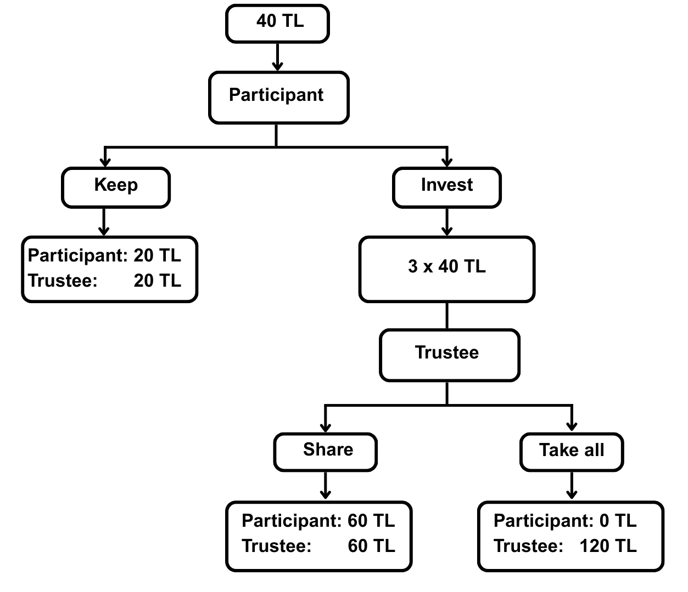
Figure 1

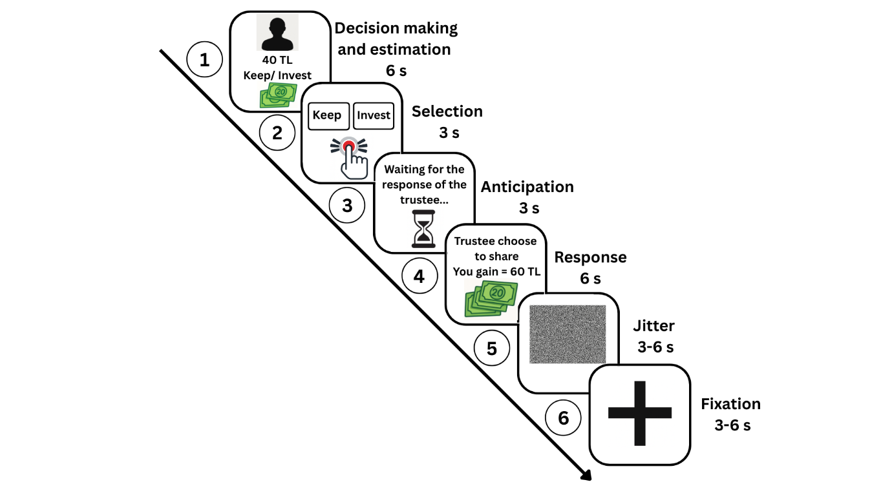

Figure 2

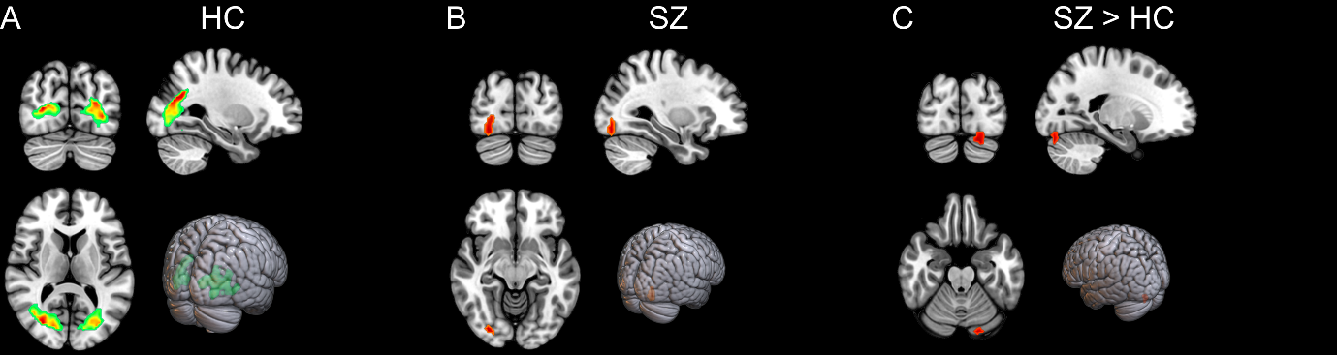
Figure 3

Supplementary Material
Model Diagnostics
Binary Model

Model diagnostics were performed using the DHARMa package⁶⁰. Simulated residuals showed no significant deviation from uniformity (KS test: p = 0.77), no overdispersion (p = 0.96), and no evidence of outlier inflation (p = 0.19). Residuals were homogeneously distributed across the range of predicted values, indicating that model assumptions were adequately met (see Supplementary Figure 1). Multicollinearity among fixed effects was assessed using generalized variance inflation factors (GVIF). All adjusted GVIF values were well below 2 (range: 1.00–1.46), indicating no evidence of multicollinearity among predictors.
The intraclass correlation coefficient (ICC) was calculated to assess the proportion of variance in investment decisions attributable to between-subject differences. The ICC was approximately 0.167, indicating that 16.7% of the variance was due to differences between participants, thereby justifying the inclusion of a random intercept in the model.

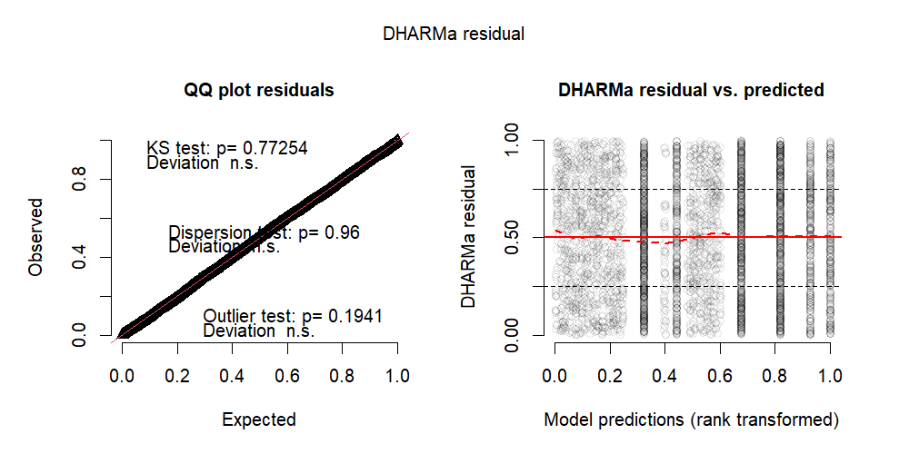
Supplementary Figure 1. Simulated residuals showed no significant deviation from uniformity (KS test: p = 0.77), no overdispersion (p = 0.96), and no evidence of outlier inflation (p = 0.19). Residuals were homogeneously distributed across the range of predicted values, indicating that model assumptions were adequately met

Prediction Error Model

To account for repeated measures and individual differences in the task, a random intercept for subject was included in the linear mixed-effects model. As with the Binomial model, all adjusted GVIF values were well below 2 (range: 1.00–1.46), indicating no evidence of multicollinearity among predictors. The intraclass correlation coefficient (ICC = 0.053) indicated that approximately 5.3% of the variance in log-transformed prediction error was attributable to between-subject variability, supporting the inclusion of a random effect for Subject.
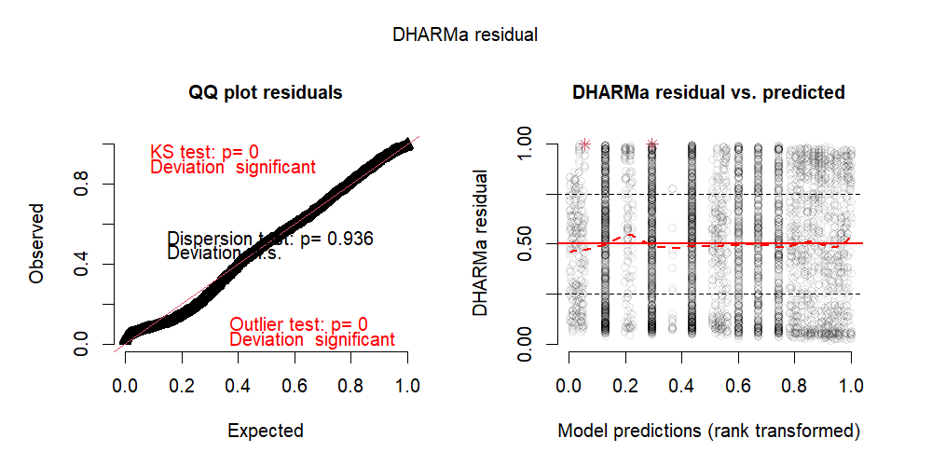

Supplementary Figure 2. Left: Quantile–quantile plot of scaled (uniform) residuals versus the expected uniform distribution. The panel reports DHARMa tests: Kolmogorov–Smirnov p = 0, dispersion p = 0.936, and outlier p = 0. Right: Scaled DHARMa residuals plotted against rank-transformed model predictions; points represent individual observations, the red line is a smoothed trend, horizontal dashed lines mark residual levels (0, 0.5, 1), and red asterisks denote flagged extreme residuals.

Learning Parameter (Alfa) Model

Residual diagnostics indicated that the model adequately captured the variance structure in the data. The dispersion test was non-significant (p = .92), suggesting no evidence of over- or underdispersion. However, the Kolmogorov-Smirnov (KS) test indicated a significant deviation from uniformity (p < .001), and the outlier test revealed a mild excess of extreme residuals (p = .022), suggesting the presence of a small number of influential observations (Supplementary Figure). Despite these minor deviations, the overall residual pattern remained acceptable for inferential purposes.

The intraclass correlation coefficient (ICC = 0.16) indicated that approximately 16% of the variance in learning rate (α) was attributable to between-subject differences, supporting the inclusion of a random intercept for Subject. To assess multicollinearity, generalized variance inflation factors (GVIFs) were computed using a linear model including only fixed effects. All adjusted GVIF were well below 2.0, with values ranging from 1.00 to 1.45, indicating no problematic collinearity among predictors.

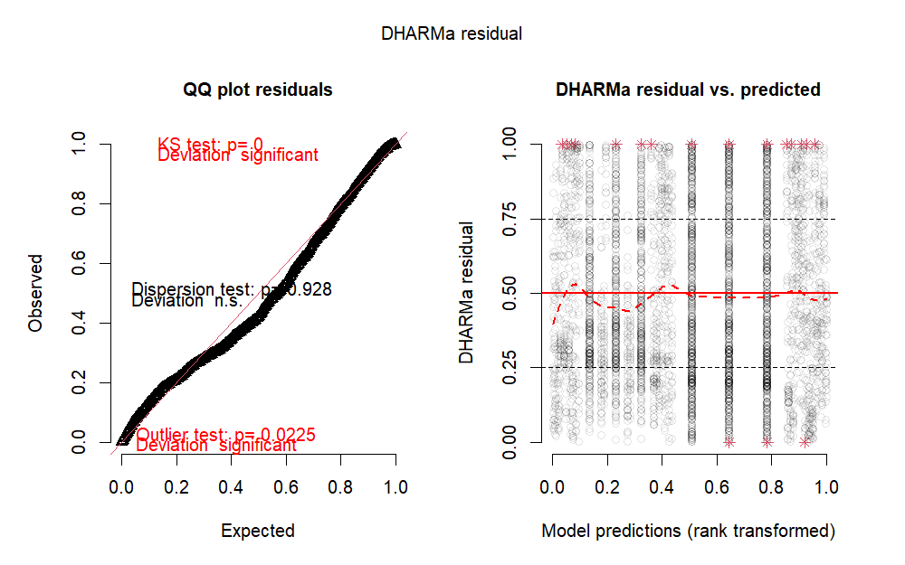
Supplementary Figure 3. Residual diagnostics indicated that the model adequately captured the variance structure in the data. The dispersion test was non-significant (p = .92), suggesting no evidence of over- or underdispersion. However, the Kolmogorov-Smirnov (KS) test indicated a significant deviation from uniformity (p < .001), and the outlier test revealed a mild excess of extreme residuals (p = .022), suggesting the presence of a small number of influential observations (Supplementary Figure). Despite these minor deviations, the overall residual pattern remained acceptable for inferential purposes.

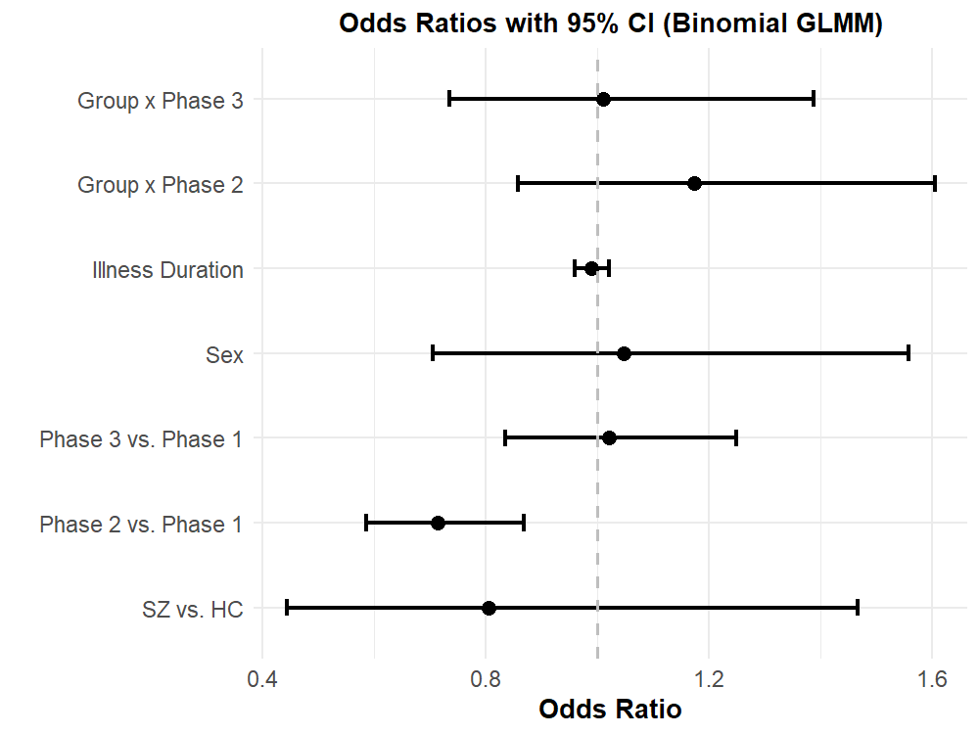
Supplementary Figure 4. Odds ratios for investment decisions from a binomial GLMM. Dots represent estimated odds ratios and horizontal lines indicate 95% confidence intervals. The model included fixed effects for diagnostic group (schizophrenia vs. healthy control), sex, task phase (Phase 2 and Phase 3 each compared to Phase 1), and duration of illness (in years), plus a random intercept for participants. The odds ratio for groups (SZ vs. HC) was 0.85 (p = .590), indicating no reliable difference in investment odds. Sex (male vs. female) had an OR of 1.05 (p = .820), showing no significant effect. Investments were significantly lower in Phase 2 compared to Phase 1 (OR = 0.76, 95% CI [0.65, 0.89], p < .001), while Phase 3 did not differ from Phase 1 (OR = 1.03, p = .750). Duration of illness was not associated with investment likelihood (OR = 0.99 per year, p = .503). Only the shift from Phase 1 to Phase 2 significantly altered investment odds.

Statistical Results

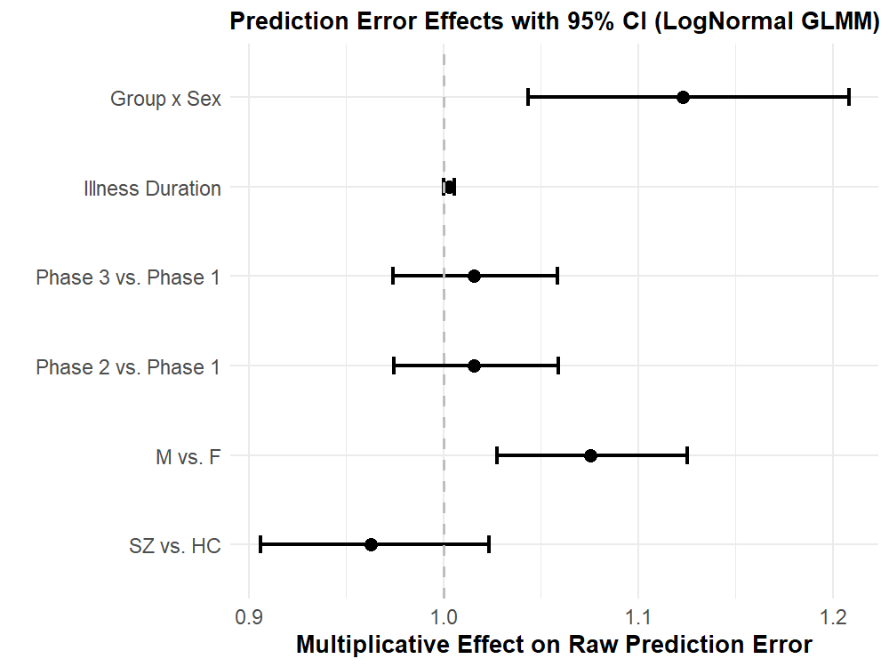
Supplementary Figure 5. Multiplicative effects for prediction error (PE) from a linear mixed‐effects model on PE. Dots represent estimated multiplicative effects and horizontal lines indicate 95% confidence intervals. The model included fixed effects for diagnostic group (schizophrenia vs. healthy control), sex (male vs. female), task phase (Phase 2 and Phase 3 each compared to Phase 1), the group × sex interaction, and duration of illness (DoI, in years), plus a random intercept for participants. The schizophrenia group showed a non-significant 4% reduction in PE compared to controls (multiplicative effect = 0.96, 95% CI [0.904, 1.026], p = .22). Male participants exhibited an 8% higher PE than females (multiplicative effect = 1.08, 95% CI [1.028, 1.124], p = .001). A significant group × sex interaction indicated that males with schizophrenia had 12% higher PE than expected additively (multiplicative effect = 1.12, 95% CI [1.044, 1.207], p = .001). Neither Phase 2 nor Phase 3 differed significantly from Phase 1, and each additional year of illness was associated with a 0.3% increase in PE (multiplicative effect = 1.003, 95% CI [1.000, 1.006], p < .05). These results suggest that elevated prediction errors are driven specifically by male patients with schizophrenia and are not modulated by task phase.

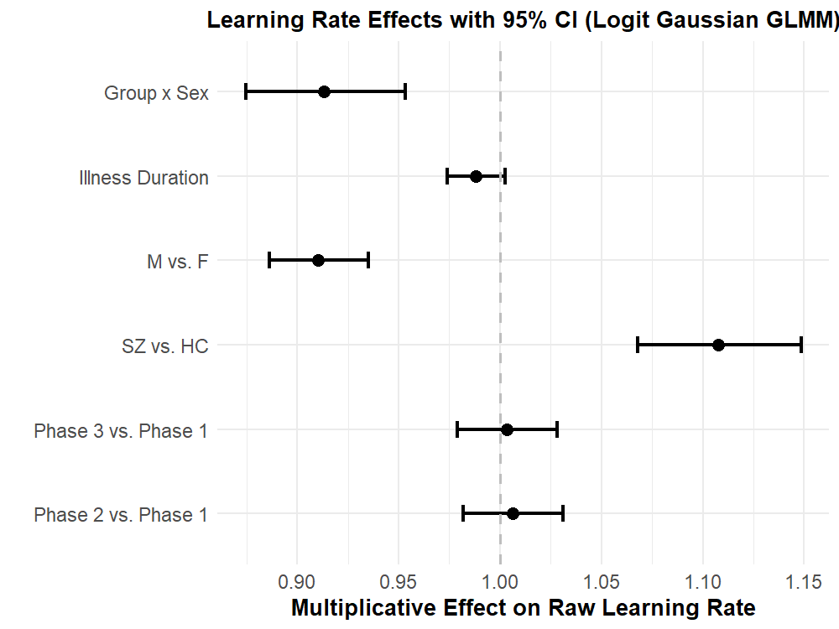
Supplementary Figure 6. Linear mixed-effects model predicting raw learning rate (). Relative to healthy control females in Phase 1, schizophrenia females showed a 1.10-fold increase in learning rate (95% CI [1.07, 1.14], p < .001), whereas healthy control males showed a 0.91-fold rate (95% CI [0.88, 0.94], p < .001). The group × sex interaction revealed that male patients with schizophrenia exhibited the lowest learning rates, with a 0.90-fold effect relative to additive expectations (95% CI [0.86, 0.95], p < .001). Task Phase 2 (1.01-fold, 95% CI [0.98, 1.03], p = .62) and Phase 3 (1.01-fold, 95% CI [0.98, 1.04], p = .79) did not differ significantly from Phase 1, and each additional year of illness was associated with a 0.99-fold change (95% CI [0.98, 1.00], p = .111). These findings demonstrate that learning-rate alterations in schizophrenia are sex-specific and independent of task phase or illness duration.

