Supplementary Material
Model Diagnostics
Binary Model

Model diagnostics were performed using the DHARMa package¹. Simulated residuals showed no significant deviation from uniformity (KS test: p = 0.77), no overdispersion (p = 0.96), and no evidence of outlier inflation (p = 0.19). Residuals were homogeneously distributed across the range of predicted values, indicating that model assumptions were adequately met (see Supplementary Figure 1). Multicollinearity among fixed effects was assessed using generalized variance inflation factors (GVIF). All adjusted GVIF values were well below 2 (range: 1.00–1.46), indicating no evidence of multicollinearity among predictors.
The intraclass correlation coefficient (ICC) was calculated to assess the proportion of variance in investment decisions attributable to between-subject differences. The ICC was approximately 0.167, indicating that 16.7% of the variance was due to differences between participants, thereby justifying the inclusion of a random intercept in the model.

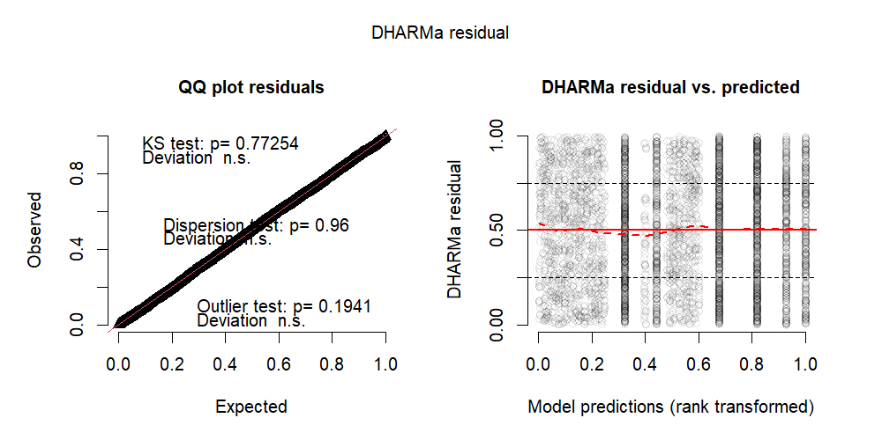
Supplementary Figure 1. Simulated residuals showed no significant deviation from uniformity (KS test: p = 0.77), no overdispersion (p = 0.96), and no evidence of outlier inflation (p = 0.19). Residuals were homogeneously distributed across the range of predicted values, indicating that model assumptions were adequately met

Prediction Error Model

To account for repeated measures and individual differences in the task, a random intercept for subject was included in the linear mixed-effects model. As with the Binomial model, all adjusted GVIF values were well below 2 (range: 1.00–1.46), indicating no evidence of multicollinearity among predictors. The intraclass correlation coefficient (ICC = 0.053) indicated that approximately 5.3% of the variance in log-transformed prediction error was attributable to between-subject variability, supporting the inclusion of a random effect for Subject.
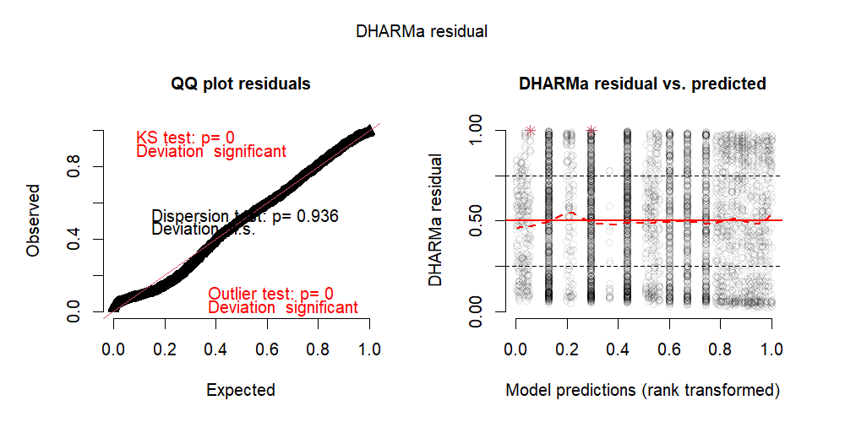

Supplementary Figure 2. Left: Quantile–quantile plot of scaled (uniform) residuals versus the expected uniform distribution. The panel reports DHARMa tests: Kolmogorov–Smirnov p = 0, dispersion p = 0.936, and outlier p = 0. Right: Scaled DHARMa residuals plotted against rank-transformed model predictions; points represent individual observations, the red line is a smoothed trend, horizontal dashed lines mark residual levels (0, 0.5, 1), and red asterisks denote flagged extreme residuals.

Learning Parameter (Alpha) Model

Residual diagnostics indicated that the model adequately captured the variance structure in the data. The dispersion test was non-significant (p = .92), suggesting no evidence of over- or underdispersion. However, the Kolmogorov-Smirnov (KS) test indicated a significant deviation from uniformity (p < .001), and the outlier test revealed a mild excess of extreme residuals (p = .022), suggesting the presence of a small number of influential observations (Supplementary Figure). Despite these minor deviations, the overall residual pattern remained acceptable for inferential purposes.

The intraclass correlation coefficient (ICC = 0.16) indicated that approximately 16% of the variance in learning rate (α) was attributable to between-subject differences, supporting the inclusion of a random intercept for Subject. To assess multicollinearity, generalized variance inflation factors (GVIFs) were computed using a linear model including only fixed effects. All adjusted GVIF were well below 2.0, with values ranging from 1.00 to 1.45, indicating no problematic collinearity among predictors.

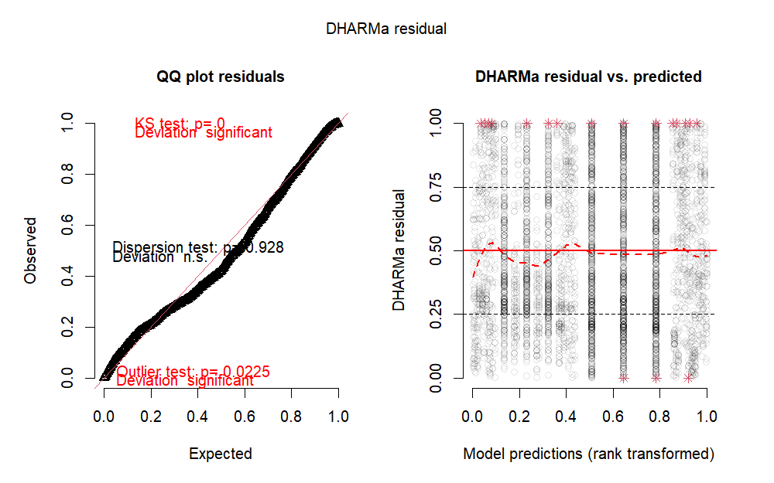
Supplementary Figure 3. Residual diagnostics indicated that the model adequately captured the variance structure in the data. The dispersion test was non-significant (p = .92), suggesting no evidence of over- or underdispersion. However, the Kolmogorov-Smirnov (KS) test indicated a significant deviation from uniformity (p < .001), and the outlier test revealed a mild excess of extreme residuals (p = .022), suggesting the presence of a small number of influential observations (Supplementary Figure). Despite these minor deviations, the overall residual pattern remained acceptable for inferential purposes.

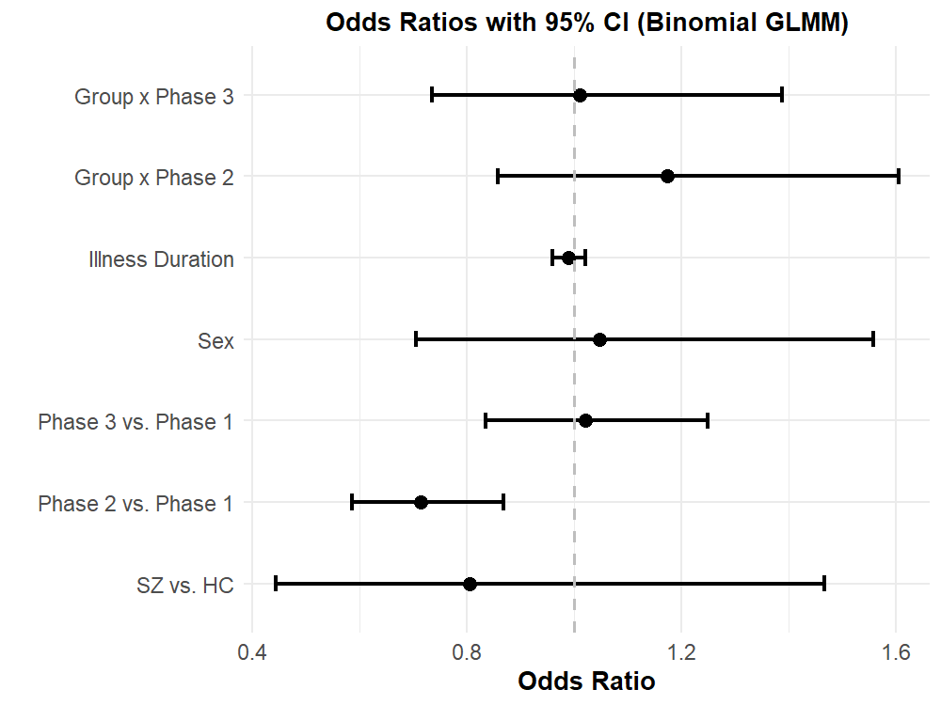
Supplementary Figure 4. Odds ratios for investment decisions from a binomial GLMM. Dots represent estimated odds ratios and horizontal lines indicate 95% confidence intervals. The model included fixed effects for diagnostic group (schizophrenia vs. healthy control), sex, task phase (Phase 2 and Phase 3 each compared to Phase 1), and duration of illness (in years), plus a random intercept for participants. The odds ratio for groups (SZ vs. HC) was 0.85 (p = .590), indicating no reliable difference in investment odds. Sex (male vs. female) had an OR of 1.05 (p = .820), showing no significant effect. Investments were significantly lower in Phase 2 compared to Phase 1 (OR = 0.76, 95% CI [0.65, 0.89], p < .001), while Phase 3 did not differ from Phase 1 (OR = 1.03, p = .750). Duration of illness was not associated with investment likelihood (OR = 0.99 per year, p = .503). Only the shift from Phase 1 to Phase 2 significantly altered investment odds.

Statistical Results

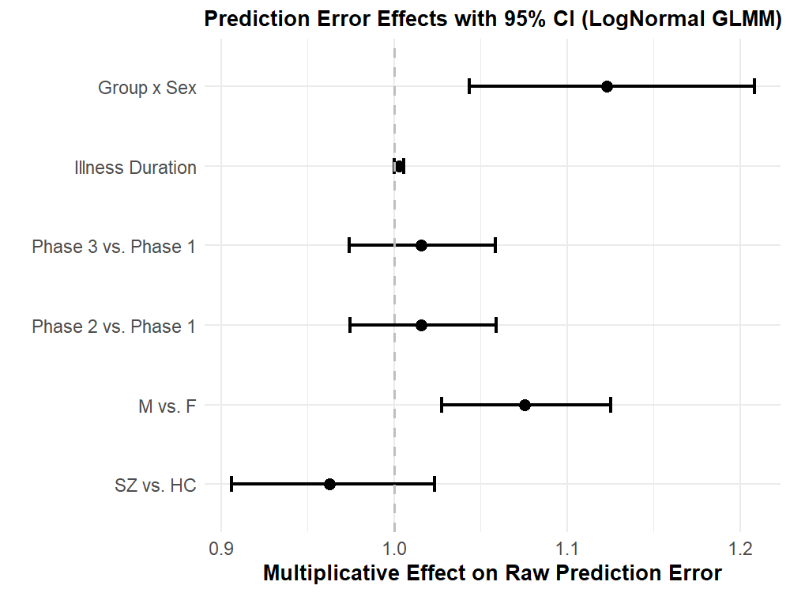
Supplementary Figure 5. Multiplicative effects for prediction error (PE) from a linear mixed‐effects model on PE. Dots represent estimated multiplicative effects and horizontal lines indicate 95% confidence intervals. The model included fixed effects for diagnostic group (schizophrenia vs. healthy control), sex (male vs. female), task phase (Phase 2 and Phase 3 each compared to Phase 1), the group × sex interaction, and duration of illness (DoI, in years), plus a random intercept for participants. The schizophrenia group showed a non-significant 4% reduction in PE compared to controls (multiplicative effect = 0.96, 95% CI [0.904, 1.026], p = .22). Male participants exhibited an 8% higher PE than females (multiplicative effect = 1.08, 95% CI [1.028, 1.124], p = .001). A significant group × sex interaction indicated that males with schizophrenia had 12% higher PE than expected additively (multiplicative effect = 1.12, 95% CI [1.044, 1.207], p = .001). Neither Phase 2 nor Phase 3 differed significantly from Phase 1, and each additional year of illness was associated with a 0.3% increase in PE (multiplicative effect = 1.003, 95% CI [1.000, 1.006], p < .05). These results suggest that elevated prediction errors are driven specifically by male patients with schizophrenia and are not modulated by task phase.

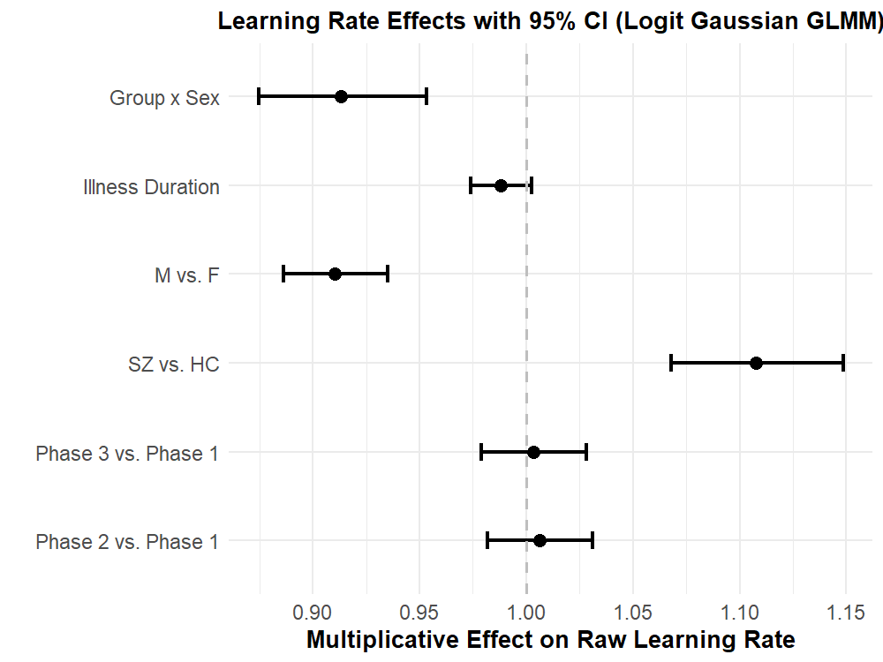
Supplementary Figure 6. Linear mixed-effects model predicting raw learning rate (). Relative to healthy control females in Phase 1, schizophrenia females showed a 1.10-fold increase in learning rate (95% CI [1.07, 1.14], p < .001), whereas healthy control males showed a 0.91-fold rate (95% CI [0.88, 0.94], p < .001). The group × sex interaction revealed that male patients with schizophrenia exhibited the lowest learning rates, with a 0.90-fold effect relative to additive expectations (95% CI [0.86, 0.95], p < .001). Task Phase 2 (1.01-fold, 95% CI [0.98, 1.03], p = .62) and Phase 3 (1.01-fold, 95% CI [0.98, 1.04], p = .79) did not differ significantly from Phase 1, and each additional year of illness was associated with a 0.99-fold change (95% CI [0.98, 1.00], p = .111). These findings demonstrate that learning-rate alterations in schizophrenia are sex-specific and independent of task phase or illness duration.

Supplementary References
1. Hartig F. DHARMa: Residual Diagnostics for Hierarchical (Multi-Level / Mixed) Regression Models. Published online August 26, 2016. doi:10.32614/cran.package.dharma

