Title: Social Prediction Error Signals During the Trust Game in Patients with Schizophrenia: An fMRI Study

Authors’ Information:
Elif Ozge Aktas¹, Kaan Keskin¹, Cemre Candemir^{1,2}, Aslıhan Uyar^{1,3}, İbrahim Sungur¹, Kaya Oguz^{1,4,5}, Yigit Erdogan¹, Omer Kitis^{1,6}, Ali Saffet Gonul¹

1 SoCAT Lab, Department of Psychiatry, Ege University, Izmir, Turkey
2 International Computer Institute, Ege University, Izmir, Turkey
3 Department of Psychiatry, Mugla Sitki Kocman University Training and Research Hospital, Mugla, Turkey
4 School of Engineering, Applied Science and Technology, Canadian University, Dubai
5 Department of Computer Engineering, Izmir University of Economics, Izmir, Turkey
6 Department of Radiology, School of Medicine, Ege University, Izmir, Turkey

Elif Ozge Aktas’ e-mail address: elifozgeaktas@gmail.com
Kaan Keskin’s Academic e-mail address: kaanka5312@gmail.com
Cemre Candemir’s Academic e-mail address: cemre.candemir@ege.edu.tr
Aslıhan Uyar’s e-mail address: aslihanuyar48@gmail.com
İbrahim Sungur’s e-mail address: sunguribrahim97@gmail.com
Kaya Oğuz’s e-mail address: kaya.oguz@cud.ac.ae
Yiğit Erdogan’s e-mail address: yigiterdogan@gmail.com
Omer Kitis’ e-mail address: omer.kitis@ege.edu.tr
Ali Saffet Gonul’s e-mail address: ali.saffet.gonul@ege.edu.tr

Corresponding author:

Ali Saffet Gonul, MD

Address:
Ege University School of Medicine Department of Psychiatry
SoCAT Lab
Bornova
Izmir Turkey

Phone: +90 542 412 4684, E-mail: ali.saffet.gonul@ege.edu.tr

CRediT authorship contribution statement:

Elif Ozge Aktas: Writing – review & editing, Writing – original draft, Visualization, Validation, Methodology, Investigation, Formal analysis, Conceptualization. Kaan Keskin: Writing – review & editing, Methodology, Investigation, Formal analysis, Software. Cemre Kandemir: Software, Formal Analysis. Aslıhan Uyar: Investigation. İbrahim Sungur: Investigation. Kaya Oguz: Software. Yigit Erdogan: Project administration. Omer Kitis: Formal Analysis, Data Curation. Ali Saffet Gonul: Writing – review & editing, Writing – original draft, Supervision, Methodology, Conceptualization, Project administration, Funding acquisition, Resources.

Abstract
Schizophrenia (SZ) is characterized by marked deficits in social cognition, yet the computational and neural mechanisms underlying social reinforcement learning remain poorly understood. We investigated dynamic social learning in patients with SZ (N = 29) and healthy controls (N = 45) during an iterative Trust Game performed under functional magnetic resonance imaging (fMRI).
Participant behavior was modeled using a Rescorla–Wagner framework to estimate learning rate $\left(α\right.$) and decision precision (inverse temperature, $β$), alongside trial-by-trial prediction errors (PEs) for neural analyses. Behaviorally, patients exhibited a marked impairment in utilizing positive social feedback, reflected in reduced win–stay behavior, significantly lower learning rates, and diminished model fit. Critically, patient behavior was best explained by a null model, indicating a failure to consistently integrate feedback into decision-making. At the computational level, reduced decision precision (lower β) was significantly associated with positive symptom severity, suggesting a link between stochastic choice behavior and psychosis. Neuronally, while healthy controls showed robust PE-related activation in canonical reward and visual processing regions, patients exhibited significantly attenuated PE signaling, particularly within the left lateral occipital cortex and fusiform gyrus.
These findings indicate a fundamental disruption in precision-weighted social belief updating in schizophrenia, characterized by stochastic decision-making and degraded neural encoding of prediction errors. This supports predictive coding accounts of psychosis, in which impaired precision assignment to sensory feedback undermines adaptive learning and contributes to positive symptoms.
Keywords: Schizophrenia, Social Dysfunction, Trust Game, Reinforcement Learning

- Introduction
Social cognitive dysfunction, particularly impairments in emotion recognition and interpersonal reciprocity, is a core feature of schizophrenia (SZ) that critically contributes to social isolation, relapse risk, and poor functional outcomes (1–6). These deficits reflect a fundamental disturbance in how individuals learn from and adapt to dynamic social environments, where successful interaction depends on continuously updating expectations about others based on feedback (7,8).
To navigate such environments, the brain must compute prediction errors (PEs), the discrepancy between expected and observed outcomes, which serve as the core signals for updating internal models (9–11). Within social contexts, these signals allow individuals to refine expectations about others’ intentions and adjust behavior accordingly. Although PE signaling has been classically linked to dopaminergic activity and ventral striatum, converging evidence demonstrates that it is implemented across distributed neural systems, including striatal, frontal, cingulate, and sensory processing regions (12–14).
Computational psychiatry provides a mechanistic framework to formalize these processes by decomposing behavior into latent parameters derived from reinforcement learning models (15,16). In this framework, the learning rate ($α$) determines how rapidly expectations are updated in response to PEs, while the inverse temperature ($β$) reflects the precision, or stochasticity, of the decision-making process (17,18). This approach enables dissociation between impairments in belief updating and deficits in the implementation of learned values into behavior, offering a powerful tool to characterize abnormalities in psychiatric disorders.
Within this framework, schizophrenia is associated with profound disruptions in PE processing and reinforcement learning (19,20). Behaviorally, individuals with SZ fail to effectively implement adaptive strategies such as “win–stay/loss–shift,” showing reduced sensitivity to positive social feedback despite relatively preserved responses to negative outcomes (21). At the neural level, functional imaging studies have revealed aberrant PE-related activity across frontal and cingulate regions, alongside dysregulated dopaminergic signaling that contributes to abnormal salience attribution (22–25). These disturbances have been directly linked to the emergence of positive symptoms, including delusions, which may arise from inappropriate updating of beliefs based on unreliable prediction signals (26,27).
Importantly, these abnormalities extend beyond canonical reward circuitry. Disruptions in fronto-striatal systems are accompanied by altered connectivity with temporal and extrastriate visual regions, including the fusiform gyrus (28,29); suggesting that impairments in social learning may also reflect degraded processing of socially relevant sensory information (19,30). From a predictive coding perspective, such deficits may arise from impaired precision-weighting of incoming sensory signals, leading to unreliable integration of external feedback and increased reliance on internally generated beliefs (31).
To address remaining gaps in understanding social reinforcement learning within interactive contexts, we employed an iterative Trust Game with fMRI and computational modeling. We hypothesized that SZ patients would exhibit impaired utilization of positive social feedback, reflected in reduced learning rates and/or increased desicion stochasticity, alongside blunted neural PE encoding in fronto-striatal and occipito-temporal networks. Furthermore, we predicted these abnormalities would correlate with positive symptom severity, linking aberrant learning to the phenomenology of psychosis.
- Methods
2.1 Participants
Thirty-three clinically stable, right-handed individuals with schizophrenia were recruited from the Ege University Department of Psychiatry outpatient clinic. All SZ participants had been on a stable pharmacological regimen for at least six months prior to enrollment, with no changes in treatment during this period. A total of 49 right-handed healthy controls (HC) were recruited via advertisements and social media platforms. The HC group was matched to the SZ group at he group level. The equivalence between groups in terms of age, sex and years of education was confirmed using independent samples t-tests for continuous variables and Pearson’s chi-square test for categorical variables, ensuring no significant differences (all p>0.05). The study was conducted in accordance with the Declaration of Helsinki, and all participants provided written informed consent.

Patients with current depressive episodes, substance use disorders, or significant medical comorbid conditions affecting cerebral blood flow such as diabetes, hypertension and morbid obesity were excluded. Healthy controls were recruited through community advertisements and had no history of psychiatric disorders and no family history of schizophrenia. Demographic characteristics of all participants are presented in Table 1. Four SZ and 3 HC subjects were excluded due to excessive head motion (>0.3 mm) in more than 20% of all TR, continued analysis with total of 29 SZ (SZ, mean age ± SD: 39.86 ± 11.03 years) and 46 HC participants. The mean duration of illness for the SZ group was 13.72 ± 10.23 years (see Table 1). The clinical sample consisted of individuals with a chronic course of the illness, and no first-episode patients were included.
2.2 Psychometric Assessment
Schizophrenia diagnoses were confirmed by using the Structured Clinical Interview for DSM-5 (SCID-5). The Positive and Negative Syndrome Symptom Scale (PANSS), a semi-structured assessment, was administered to evaluate symptom severity and patient functionality. Cognitive and social functioning were evaluated with the Schizophrenia Cognition Rating Scale (SCoRS). Healthy controls (HC) were similarly evaluated using the SCID-5 to rule out any current or lifetime psychiatric diagnose
2.3 Task Paradigm
Participants completed 60 trials of an iterative Trust Game during fMRI (32). To enhance ecological validity, participants briefly met the "trustee" prior to scanning, though the trustee’s reciprocal or deceptive responses were preprogrammed.

On each trial, participants received 40 Turkish Lira (TL) (~2 USD at the time of study) and chose to either "keep" or "invest." Keeping the money resulted in an even split (20 TL each). Investing tripled the endowment (120 TL), allowing the trustee to either share the money equally or keep the entire amount (see Figure 1).

Each 24-second trial comprised a standardized sequence (Figure 1): a 6-second decision-making phase featuring the trustee's photograph, a 3-second response window, a 3-second anticipation phase, and an outcome phase displaying the trustee’s choice. Trials were separated by a variable, jittered inter-trial interval (3-6s) to optimize event-related BOLD signal estimation. Total task duration of approximately 24 minutes and 54 seconds (See Figure 2). This design allows trial-by-trial estimation of prediction errors and value updating during social decision-making.

The simulated trustee’s responses were predetermined to manipulate participants' beliefs about trustworthiness across three blocks of 20 trials each (totaling 60 trials). Specifically, the trustee shared the tripled amount in 80% of the trials in the first block (Block 1), 50% in the second block (Block 2), and again 80% in the third block (Block 3). While the proportion of trustee responses was fixed per block, the order of outcomes was randomized for each participant.

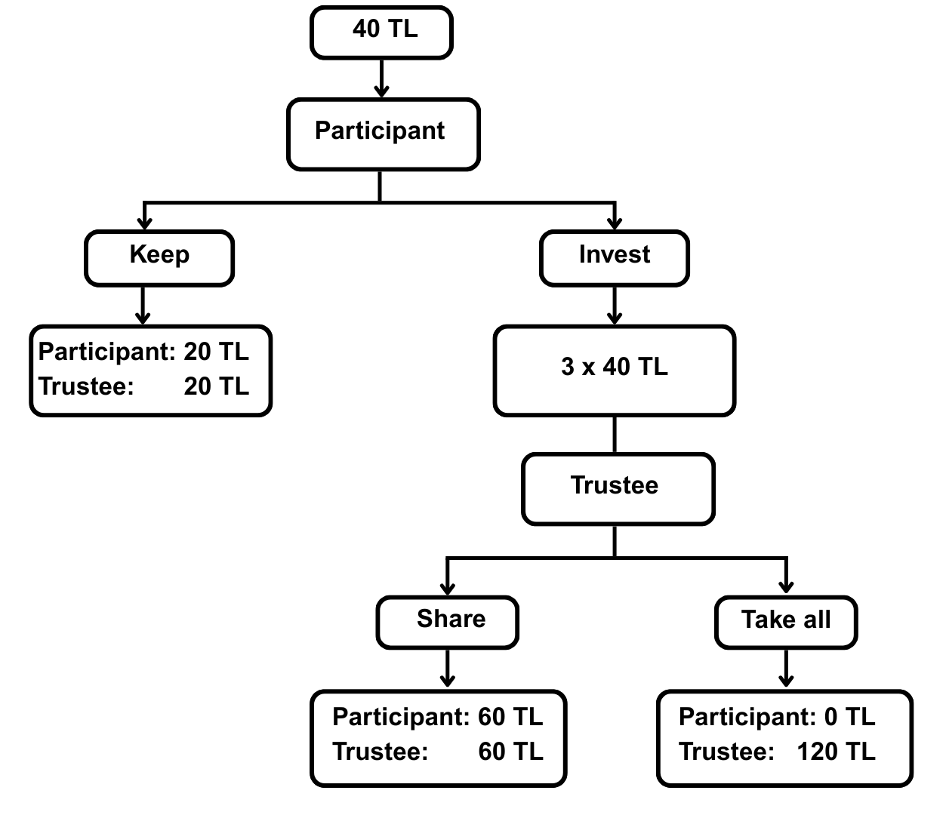
Figure 1. Single-trial timeline of the Trust Game. At the start of each trial, the participant receives an endowment of 40 Turkish Lira (TL) and chooses to Keep or Invest (transfer to a trustee). If they Keep, the 40 TL is split evenly (20 TL each). If they Invest, the transfer is tripled to 120 TL; the trustee then either shares it equally (60 TL each) or keeps the entire 120 TL. The six panels illustrate the standardized sequence of screens presented on every trial—from endowment and choice to trustee decision and outcome feedback. The task comprised three blocks of 20 trials (60 trials total), with the core decision on each trial being whether to trust the trustee.

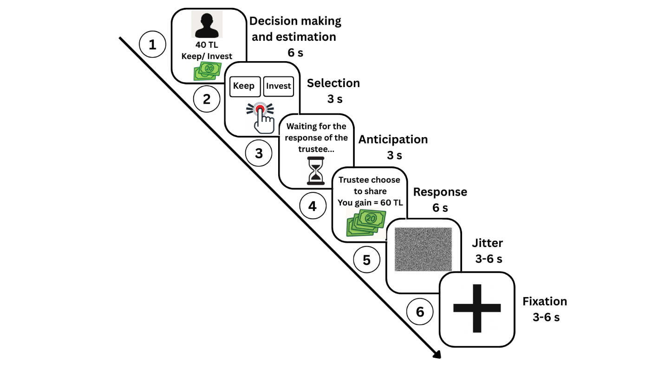
Figure 2. Trial screens and timing in the Trust Game. fMRI task model for each trial. Each participant plays the game as sets of 20 trials, i.e., 60 trials in total. (1) Decision/anticipation (6 s): trustee photo + 40 TL endowment shown; no response required. (2) Choice confirmation (≤3 s): participants confirm Keep vs Invest via button press; no response yields 0 TL for that trial; five missed responses (consecutive or not) terminate the task. (3) Anticipation (3 s): waiting for trustee’s decision. (4) Outcome (3 s): trustee’s choice display share the tripled investment (120 TL, 60 TL each) or keep all—along with participant earnings. (E) Jittered ITI (blank) 3–6 s. (F) Fixation 3–6 s, adjusted to yield a fixed 9 s total inter-trial interval. Durations in seconds unless noted.

2.4. Computational Learning Model Based on Rescorla-Wagner
Choice behavior was fit to a standard Rescorla-Wagner (RW) reinforcement learning model utilizing a SoftMax decision rule to estimate learning rate ($α$) and inverse temperature ($β$). Subject-level parameters were estimated using Maximum A Posteriori (MAP) estimation to ensure robust fits. Optimization routines and prior distributions are detailed in the Supplementary Material. We performed control analysis for model selection, comparing simple RW model to alternative models such as adaptive learning, dual alpha and null model. Full mathematical model formulations are provided in the Supplementary Material.
Model-free behavior was quantified using Win-Stay/Loss-Shift (WSLS) probabilities. A 'Win' was defined as a trial where the trustee reciprocated (shared the investment), and a 'Loss' as a trial where the trustee kept the investment. 'Win-Stay' was calculated as the probability of investing in trial $t\text{+}1$ given a win in trial $t.$
2.4.1 Model validation and Parameter Recovery
To ensure the mathematical reliability of our computational framework, we conducted extensive parameter recovery simulations and predictive checks. These analyses confirmed confident parameter identifiability for both learning rate and inverse temperature and demonstrated that the simple RW model reliably captured empirical choice trajectories (significantly outperforming chance). Full simulation methodologies and recovery statistics are detailed in the Supplementary Material.
2.4.2 Statistical Analysis of Computational Parameters

Group differences in the computational parameters ($α$, $β$, Pseudo-R²) were evaluated using non-parametric permutation tests (10,000 iterations). To robustly account for the non-normal distribution of the estimates, the difference in group medians was computed through the methodological resampling of group labels. Following the assessment of main group effects, we investigated the relationship between these computational parameters and clinical symptomatology using Ordinary Least Squares (OLS) regression. Prior to these regression analyses, a log transformation was applied specifically to the inverse temperature parameter ($τ$). Because $τ$ is theoretically unbounded at the upper end, its raw values exhibited a strong positive skew that violated the OLS assumption of normally distributed residuals. Log-transforming this parameter corrected the skew and stabilized the variance, ensuring robust model fits, whereas the naturally bounded learning rate ($α$) required no such transformation.
2.4.3 Analysis of Trial-by-Trial Prediction Errors
To investigate dynamic changes in surprise magnitude across the Trust Game, we analyzed the absolute value of trial-by-trial prediction errors ($\left|PE\right|$) extracted from the winning computational model. We employed a Linear Mixed-Effects Model (LMM) to account for the nested, repeated-measures structure of the data (i.e., multiple trials nested within individual subjects).

$${\left|PE\right|}_{ij}\text{=}β_{0}\text{+}β_{1}\left(Group_{i}\right)\text{+}β_{2}\left(Block_{ij}\right)\text{+}β_{3}\left(Group_{i}×Block_{ij}\right)\text{+}β_{4}\left(Sex_{i}\right)\text{+}β_{5}\left(Age_{i}\right)\text{+}u_{0i}\text{+}ϵ_{ij}$$

The dependent variable was the trial-specific $\left(j\right)$ absolute prediction errors ($\left|PE\right|$) for the subject $i$. The model included categorical fixed main effects for diagnostic $Group$ (HC vs SZ), Task Block ($Block$, Trials 1-20, 21-40 and 41-60), and their interaction ($Group×Block$). To control for potential demographic confounding, participants $Sex$ and standardized $Age$ (z-scored) were included as fixed-effect covariates. To appropriately model within-subject correlation and baseline individual differences in surprise, a random intercept for Subject ($\left.u_{0i}\right)$ was specified. Prior to analysis, $\left|PE\right|$ values were standardized (z-scored) within the sample to ensure optimizer convergence and stabilize variance estimates.
2.5 fMRI Data Acquisition and Preprocessing
Functional imaging (fMRI) was performed using a 3.0-Tesla scanner(Siemens Magnetom Verio, Erlangen, Germany) equipped with a 12-channel head coil. A 24-minute and 54-second task- based fMRI scan (utilizing the Trust Game paradigm) was acquired with the following core parameters: repetition time (TR) = 3000 ms, echo time (TE) = 30 ms, flip angle (FA) = 90°, voxel size 3x3x3 mm, matrix = 64x64, and the field of view (FOV) = 192x192 mm. Full acquisition parameters are detailed in the Supplementary Material. Standard preprocessing was conducted using SPM Standard preprocessing was conducted using the recent 2025 release of SPM, including spatial realignment, normalization to MNI space, spatial smoothing and offline motion parameter regression (see Supplementary Material).
2.6 fMRI Statistical Analysis
First-level General Linear Models (GLM) captured task-related BOLD responses. Crucially, trial-by-trial Prediction Errors (PE) were entered as an orthogonalized parametric modulator on the feedback onset to isolate computational learning signals. Second-level analyses evaluated group differences (Healthy Controls (HC) vs Schizophrenia (SZ)) via two sample t-tests. Whole-brain statistical maps were thresholded at an uncorrected $p<0.001$, followed by cluster-level FEW correction ($p_{FWE}<0.05$). Complete GLM construction and design matrix details are provided in the Supplementary Material.

3. Results
Statistical results are reported as Mean ($M$) and Standard Deviation ($SD;±$).
3.1 Model Free Behavioral Strategies
Permutation-based analyses (10,000 resamples) revealed a significant group difference in Win–Stay behavior. Individuals with SZ exhibited a significantly lower probability of repeating investment ($M_{SZ}=0.53±0.39$) following a cooperative outcome compared to HC ($M_{HC}=0.74±0.20,p\text{=}.0004$), indicating impaired utilization of positive social feedback. In contrast, Loss–Shift behavior did not differ significantly between groups, suggesting relatively preserved responses to negative outcomes. ($M_{SZ}=0.47±0.32,M_{HC}=0.42±0.25,p\text{=}.407$).

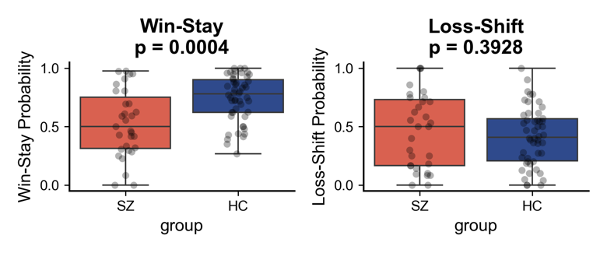
Figure 3. Group differences in Win-Stay and Loss-Shift behavior. Probability of utilizing Win-Stay and Loss-Shift heuristics for Healthy Controls (HC) and Schizophrenia (SZ) patients. SZ patients demonstrated a significantly lower probability of applying the Win-Stay strategy compared to HC, whereas Loss-Shift behavior remained intact across both groups. Colored markers represent individual participants, overlaid on box plots displaying the data distribution and median (permutation test).

3.2 Computational Modeling Results
Model comparison demonstrated that the standard Rescorla–Wagner (RW) model provided the best overall fit at the group level, yielding the lowest Bayesian Information Criterion (BIC) relative to alternative models, including dual-learning-rate and null models (Supplementary Table S1). Accordingly, the RW model was used to estimate individual learning parameters. Despite this group-level fit, a critical observation emerged at the individual level: for a substantial proportion of SZ participants, choice behavior was better explained by a null model than by reinforcement learning models, indicating a failure to systematically incorporate feedback into decision-making.

Permutation tests (10,000 resamples) revealed that SZ participants exhibited significantly reduced learning rates (α) compared to HC (Median = 0.051) compared to HC (Median = 0.197; respectively, p = .010, surviving Bonferroni correction), indicating impaired updating of expected value based on feedback. There was a trend-level difference in inverse temperature ($β$) between groups ($Median_{HC}=3.577,Median_{SZ}=3.499;p=.069$). Furthermore, overall model fit (Pseudo-R²) was significantly lower in patients ($Median=0.047$) than controls ($Median=0.178;p=0.0070$, surviving Bonferroni correction at $α_{corrected}=0.0166$) ($Median=0.051$) compared to HC ($Median=0.197,p=.010$, surviving Bonferroni correction.

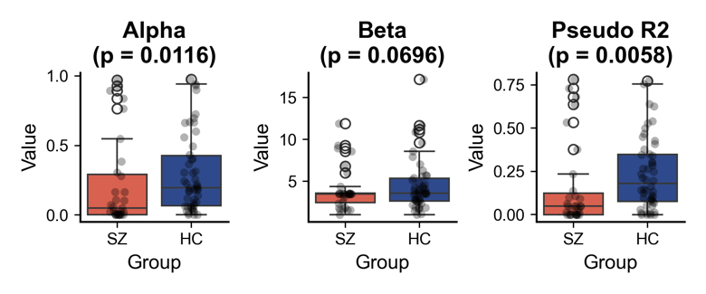

Figure 4. Group differences in computational learning parameters. Distributions of learning rate ($α$), inverse temperature $\left(β\right.$), and pseudo-R² for Healthy Controls (HC) and Schizophrenia (SZ) patients. SZ patients demonstrated significantly reduced learning rates and poorer overall model fits compared to HC, while differences in inverse temperature ($β$) were non-significant. Individual parameter estimates are overlaid on violin plots showing the data distribution and interquartile range (black bar) (permutation tests, Bonferroni-corrected).

3.4 Clinical Correlates of Computational Parameters
Within the SZ group (N = 27), multiple linear regression analyses were conducted to assess associations between computational parameters and clinical variables. The model predicting learning rate (α) was not statistically significant ($F(2,24)=1.82,p=.184$). However, the model predicting log-transformed inverse temperature (β) was significant ($F(2,24)=4.02,p=.031,R^{2}=0.25$).

Specifically, greater positive symptom severity (PANSS positive z-score) was associated with lower β, indicating increased decision stochasticity in patients with more severe positive symptoms $\left(t\text{=-}2.51,p\text{=}.019\right)$. In contrast, duration of illness, negative symptom severity and SCoRS scores were not significantly associated with either $α$ or $β$.
3.5 Trial-by-Trial Prediction Error Magnitudes
To characterize the temporal dynamics of learning, we examined the magnitude of absolute prediction errors (|PE|) across task blocks using a linear mixed-effects model, controlling for age and sex. Neither age ($p=.868$) nor sex ($p=.852$predicted |PE|.

At the group level, there was no significant main effect of diagnosis at baseline. However, a significant main effect of task block was observed: HC participants exhibited increased |PE| during the second (volatile) block relative to the initial block, consistent with adaptive sensitivity to environmental uncertainty ($Coefficient=0.032,z=2.74,p=.006$).

Critically, a significant group × block interaction emerged during this volatile phase ($Coefficient=-0.039,z=-2.07,p=.038$). While HC participants showed the expected increase in |PE|, SZ participants exhibited a blunted response, failing to scale prediction error magnitude in response to increased environmental unpredictability. No significant group differences were observed in the final block, indicating stabilization of learning signals ($p=.878$).
3.6 Neural Correlates of Prediction Error
To identify the neural substrates of computational learning, we first examined BOLD signals parametrically modulated by normalized trial-by-trial prediction errors (PE) at the onset of trustee feedback. Within the HC group, whole-brain analysis (height threshold $p<0.001$ uncorrected; cluster extent FWE-corrected $p<0.05$) revealed robust activation tracking PE. The most prominent cluster ($k=1833$voxels) peaked in the left visual/occipital cortex (MNI: [-42, -67, -7], $Z=5.82$, peak $p_{FWE}=0.005$). A second significant cluster ($k=223$ voxels) was identified in the caudate/nucleus accumbens regions (MNI: [12, 20, -1], $Z=4.73$, peak $p_{FWE}=0.016$). Lastly, a smaller cluster (k=27) was significant at right ventral striatum (Peak MNI: [15, -7, -13], $Z=4.54$, peak $p_{FWE}=0.036$). These findings confirm that healthy participants exhibited reliable neural encoding prediction errors across both reward-related and sensory-processing regions.

3.7 Group Differences in Prediction Error Signaling
Direct comparison between groups (HC > SZ) revealed a significant reduction in PE-related neural activation in the SZ cohort. Specifically, SZ participants exhibited attenuated BOLD responses within a large cluster encompassing the left lateral occipital cortex and middle occipital gyrus, extending into the fusiform gyrus. (MNI: [-27, -70, -1], cluster size $k=177$ voxels, peak $Z=4.83$, peak $p_{FWE}$ = 0.001). No regions showed significantly greater PE-related activation in the SZ group compared to HC.

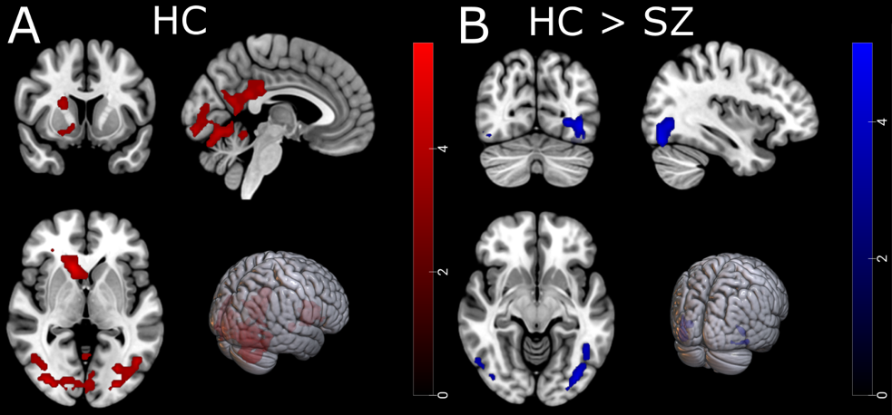
Figure 5. Neural correlates of social prediction error and group differences. Whole-brain parametric modulation analysis of BOLD signals tracking trial-by-trial prediction errors (PE) at the time of trustee feedback. (A) Within the Healthy Control (HC) group, positive PEs significantly engaged a network including the bilateral visual/occipital cortex, right caudate/nucleus accumbens, and right ventral striatum. (B) A two-sample t-test (HC > SZ) revealed that patients with schizophrenia exhibited significantly blunted PE-related activation compared to controls, specifically within the left lateral occipital cortex and middle occipital gyrus extending into the fusiform gyrus. Statistical maps are thresholded at $p<0.001$ (uncorrected) at the voxel level and FWE-corrected at $p<0.05$ at the cluster level. Color bars represent Z-statistics.

- Discussion
This study demonstrates a multi-level deficit in how individuals with schizophrenia (SZ) process social feedback. Behaviorally, patients struggled to learn from positive outcomes (reduced Win-Stay). Computationally, this impairment was driven by lower learning rates, while severe positive symptoms correlated with more random decision-making. Furthermore, unlike controls, SZ patients failed to adjust their prediction errors during unpredictable social interactions. At the neural level, this inability to update social expectations was mirrored by blunted prediction error signals in occipitotemporal regions, notably the fusiform gyrus. Together, these findings highlight a multidimensional failure in the behavioral, computational, and neural integration of social feedback in schizophrenia.
4.1 Group Differences in Model-Free Heuristics: Win-Stay/Loss-Shift Patterns
Before employing computational modelling, our model-free analysis revealed a fundamental impairment in how patients utilized social feedback. While healthy controls typically rely on an adaptive "Win-Stay/Loss-Shift" (WSLS) heuristic, the SZ cohort exhibited a significant reduction in “Win-Stay” behavior, frequently failing to re-invest even following mutually profitable interactions. This failure to capitalize on positive social reinforcement aligns with profound reward processing deficits characterizing schizophrenia (19,33,34). Rather than building a stable model of interpersonal trust, patients' trial-by-trial responses appeared disconnected from immediate feedback history.
While these deficits indicate impaired adaptive social functioning, simple heuristics cannot distinguish whether this failure stems from an inability to learn the trustee's value (learning rate) or to translate that value into consistent actions (decision noise). To isolate the precise mechanistic locus of this impairment, we turned to computational reinforcement learning models.
4.2 Behavioral Imprecision and Inconsistent Preferences

Behaviorally, standard reinforcement learning models poorly described patient choices, evidenced by severely reduced Pseudo-R² and blunted learning rates ($α$). Strikingly, a zero-parameter null model best fit most patients, indicating a profound failure to integrate trial-by-trial social feedback. Rather than dynamically updating expected values, patient decisions were highly stochastic. This aligns with findings that schizophrenia patients exhibit fundamentally inconsistent preference judgments (35), and that systemic "imprecision" might be a core pathophysiological mechanism (36).
Importantly, our findings align closely with the recently developed concept of spatiotemporal psychopathology advanced by the group around Northoff (36–38). Their framework conceptualizes schizophrenia fundamentally as a disorder of temporal imprecision, a deficit evident across both neural and behavioral accounts. In our Trust Game, the severe reduction in inverse temperature ($β$), indexing choice precision, suggests this imprecision disrupts higher-order social valuation, rendering patients incapable of utilizing positive feedback to guide consistent behavior.

While reduced $β$ is multifaceted and might capture cognitive noise or amotivation, lower $β$ in our cohort correlated specifically with positive symptom severity rather than negative symptoms or cognitive deficits. This clinical dissociation suggests that the observed computational deficits stem from primary psychopathology rather than secondary social withdrawal. Since choice imprecision was independent of negative symptoms, blunted prediction errors do not merely reflect social isolation. Instead, their specific link to positive symptoms supports a primary dopaminergic disruption. Aberrant precision-weighting degrades social feedback reliability, causing a symptom-associated lack of trust rather than a loss of social practice.
4.3 Failure to Adapt to Social Volatility: Blunted Prediction Errors
To elucidate the temporal dynamics of this learning failure, we analyzed absolute prediction error (PE) magnitudes across task phases. Normatively, PEs should scale with environmental uncertainty to rapidly update internal models when social contingencies change (28). Our Linear Mixed-Effects Model confirmed this in HC, who exhibited significantly increased PE magnitudes specifically during the volatile, 50% reward-rate phase, generating the appropriate computational surprise signals to drive behavioral adaptation.
In contrast, the SZ cohort demonstrated a significantly blunted PE response during this same volatile phase. This Group × Block interaction highlights a profound deficit in higher-order social inference: patients failed to scale their computational surprise to match their partner's sudden unpredictability. As outlined by the prediction-error hypothesis of schizophrenia (13,39), dopaminergic dysfunction compromises the reliable signaling of reward discrepancies. In our paradigm, this computational blunting rendered patients insensitive to shifting social dynamics. Failing to generate the necessary trial-by-trial surprise to update expectations, patients could not flexibly adapt their strategies, culminating in the rigid, stochastic behavioral profile captured by our metrics (40).
4.4 Aberrant Predictive Coding, Positive Symptoms and Neural Deficits
Crucially, we identified a direct link between this behavioral stochasticity and clinical psychopathology: higher positive symptom severity significantly predicted greater decision imprecision (lower $β$). This relationship provides strong empirical support for predictive coding accounts of psychosis, such as those detailed by Horga and colleagues(41). According to this framework, positive symptoms like hallucinations and delusions arise from a fundamental disruption in "precision weighting", an inability to appropriately balance the reliability of internal priors against incoming sensory PEs (42,43). When the precision of external social feedback is aberrantly downweighted, the patient cannot reliably use that feedback to update their internal models. Consequently, decision-making becomes overly reliant on rigid, potentially delusional prior beliefs, driving the inconsistent and symptom-associated choice patterns observed in our computational data.

Our fMRI findings provide the direct neural substrate for this predictive coding failure. In HC, social PE robustly engaged both canonical reward hubs (the right ventral striatum with caudate/nucleus accumbens) and posterior sensory-processing networks (left lateral occipital cortex) to compute and propagate learning signals. In contrast, the SZ cohort exhibited a significant, FWE-corrected attenuation of prediction error signaling, most prominently within the left lateral occipital cortex and the fusiform gyrus.
The localization of these group differences to occipitotemporal regions, rather than striatal hubs, likely reflects the social and identity-driven nature of our task. Unlike abstract reinforcement learning, the Trust Game requires participants to track the identity and trustworthiness of a human partner through facial cues. Thus, updating expectations in this context necessitates robust engagement of face-processing and social-perception networks(44–46). From a predictive coding perspective, these results suggest that the failure to integrate social feedback in SZ stems from impaired precision-weighting at these early sensory levels (31,42,47). If the neural representation of the social "surprise" is degraded within the fusiform gyrus, the very region responsible for processing the trustee’s feedback, the computational system lacks the reliable evidence needed to drive subsequent value updating (48,49).
This deficit aligns with shortened intrinsic neural timescales and impaired functional connectivity within early visual hierarchies (50–53), indicating a fundamental disruption in sensory precision, potentially linked to NMDA hypofunction (54–57). Importantly, it could be argued that these attenuated BOLD responses in the SZ group could be attributed to generalized visual attention confounds. However, our fMRI analysis utilized parametric modulation, which identifies brain regions where activity correlates on a trial-by-trial basis with the magnitude of prediction errors. A simple lack of attention would likely manifest as a global reduction in signal amplitude, rather than a specific disruption of the mathematical coupling between PE magnitude and the BOLD response. Together, these multimodal results suggest that positive symptoms in SZ do not merely alter what patients learn but may disrupt the underlying neural precision of the learning mechanism itself, leading to behavior that is less responsive to environmental contingencies.

4.5 Clinical Implications and Predictive Utility
These computational findings offer actionable insights for clinical practice. When stable patients fail to benefit from social skills training or struggle to form therapeutic alliances, clinicians often attribute this to amotivation or cognitive decline. However, our results suggest a different mechanism: a fundamental computational inability to integrate positive social feedback. Consequently, interventions relying heavily on social reinforcement may be ineffective for patients exhibiting profound decision imprecision (low $β$)) Furthermore, behavioral paradigms like the Trust Game hold significant promise as prognostic tools. In clinically stable outpatients, extracting these computational parameters could serve as a quantitive biomarker to identify individuals at high risk for long-term social withdrawal and functional decline, guiding the early implementation of tailored cognitive remediation strategies.

Limitations and Conclusion
It is worth noting a few limitations. First, the small fMRI clinical sample (N = 29) limits statistical power for detecting subtle clinico-computational correlations, necessitating cautious interpretation. Second, because a zero-parameter Null model best explained most patients' choices, their extracted learning rates$\left(α\right)$ and decision noise $\left(β\right)$ parameters may be noisy. Third, lacking a non-social control task (e.g., a probabilistic slot-machine), it remains unclear whether these deficits are specific to social feedback or reflect domain-general learning impairments.
Despite these limitations, our study demonstrates a profound disruption in feedback-driven social learning in schizophrenia. Patients failed to adapt to cooperative or exploitative feedback, independent of negative symptoms or social cognitive impairments, indicating a fundamental reinforcement learning deficit. Future research with larger longitudinal cohorts must map these computational abnormalities onto underlying striatal and prefrontal network dysfunctions.
Funding

This research was supported by Ege University Scientific Research Projects to A.S.G. (grant number 196-23567)
References
1. Kochunov P, Coyle TR, Rowland LM, Jahanshad N, Thompson PM, Kelly S, et al. (2017): Association of White Matter With Core Cognitive Deficits in Patients With Schizophrenia [no. 9]. JAMA Psychiatry 74: 958.
2. Caqueo-Urízar A, Boyer L, Baumstarck K, Gilman SE (2015): Subjective perceptions of cognitive deficits and their influences on quality of life among patients with schizophrenia [no. 11]. Qual Life Res 24: 2753–2760.
3. Lesh TA, Niendam TA, Minzenberg MJ, Carter CS (2011): Cognitive Control Deficits in Schizophrenia: Mechanisms and Meaning [no. 1]. Neuropsychopharmacol 36: 316–338.
4. Tripathi A, Kar SK, Shukla R (2018): Cognitive Deficits in Schizophrenia: Understanding the Biological Correlates and Remediation Strategies [no. 1]. Clin Psychopharmacol Neurosci 16: 7–17.
5. Prouteau A, Verdoux H, Briand C, Lesage A, Lalonde P, Nicole L, et al. (2005): Cognitive predictors of psychosocial functioning outcome in schizophrenia: A follow-up study of subjects participating in a rehabilitation program. Schizophrenia Research 77: 343–353.
6. Pascal De Raykeer R, Hoertel N, Blanco C, Lavaud P, Kaladjian A, Blumenstock Y, et al. (2019): Effects of depression and cognitive impairment on quality of life in older adults with schizophrenia spectrum disorder: Results from a multicenter study. Journal of Affective Disorders 256: 164–175.
7. Green MF, Horan WP, Lee J (2015): Social cognition in schizophrenia. Nature Reviews Neuroscience 16: 620–631.
8. Berg J, Dickhaut J, McCabe K (1995): Trust, Reciprocity, and Social History. Games and Economic Behavior 10: 122–142.
9. Miall RC, Wolpert DM (1996): Forward Models for Physiological Motor Control. Neural Networks 9: 1265–1279.
10. Schultz W, Dickinson A (2000): Neuronal Coding of Prediction Errors. Annu Rev Neurosci 23: 473–500.
11. Friston K (2009): The free-energy principle: a rough guide to the brain? Trends in Cognitive Sciences 13: 293–301.
12. Katthagen T, Kaminski J, Heinz A, Buchert R, Schlagenhauf F (2020): Striatal Dopamine and Reward Prediction Error Signaling in Unmedicated Schizophrenia Patients. Schizophrenia Bulletin 46: 1535–1546.
13. Millard SJ, Bearden CE, Karlsgodt KH, Sharpe MJ (2022): The prediction-error hypothesis of schizophrenia: new data point to circuit-specific changes in dopamine activity [no. 3]. Neuropsychopharmacol 47: 628–640.
14. Reinen JM, Van Snellenberg JX, Horga G, Abi-Dargham A, Daw ND, Shohamy D (2016): Motivational Context Modulates Prediction Error Response in Schizophrenia. SCHBUL 42: 1467–1475.
15. Charlton CE, Hauke DJ, Litvak V, Wobmann M, De Bock R, Andreou C, et al. (2026): Neural Dynamics of Social Cognition: A Single‐Trial Computational Analysis of Learning Under Uncertainty. Human Brain Mapping 47: e70433.
16. Deserno L, Boehme R, Mathys C, Katthagen T, Kaminski J, Stephan KE, et al. (2020): Volatility Estimates Increase Choice Switching and Relate to Prefrontal Activity in Schizophrenia. Biological Psychiatry: Cognitive Neuroscience and Neuroimaging 5: 173–183.
17. Glimcher PW (2011): Understanding dopamine and reinforcement learning: The dopamine reward prediction error hypothesis. Proc Natl Acad Sci USA 108: 15647–15654.
18. Huys QJM, Maia TV, Frank MJ (2016): Computational psychiatry as a bridge from neuroscience to clinical applications. Nat Neurosci 19: 404–413.
19. Waltz JA, Gold JM (2015): Motivational Deficits in Schizophrenia and the Representation of Expected Value. In: Simpson EH, Balsam PD, editors. Behavioral Neuroscience of Motivation, vol. 27. Cham: Springer International Publishing, pp 375–410.
20. Gold JM, Waltz JA, Prentice KJ, Morris SE, Heerey EA (2008): Reward processing in schizophrenia: a deficit in the representation of value. Schizophr Bull 34: 835–847.
21. Gromann PM, Heslenfeld DJ, Fett A-K, Joyce DW, Shergill SS, Krabbendam L (2013): Trust versus paranoia: abnormal response to social reward in psychotic illness [no. 6]. Brain 136: 1968–1975.
22. Howes OD, Murray RM (2014): Schizophrenia: An integrated sociodevelopmental-cognitive model. The Lancet 383: 1677–1687.
23. Heinz A, Schlagenhauf F (2010): Dopaminergic Dysfunction in Schizophrenia: Salience Attribution Revisited. Schizophrenia Bulletin 36: 472–485.
24. Kapur S (2003): Psychosis as a State of Aberrant Salience: A Framework Linking Biology, Phenomenology, and Pharmacology in Schizophrenia. AJP 160: 13–23.
25. Maia TV, Frank MJ (2011): From reinforcement learning models to psychiatric and neurological disorders. Nat Neurosci 14: 154–162.
26. Corlett PR, Murray GK, Honey GD, Aitken MRF, Shanks DR, Robbins TW, et al. (2007): Disrupted prediction-error signal in psychosis: evidence for an associative account of delusions. Brain 130: 2387–2400.
27. Griffiths O, Langdon R, Le Pelley ME, Coltheart M (2014): Delusions and prediction error: re-examining the behavioural evidence for disrupted error signalling in delusion formation. Cognitive Neuropsychiatry 19: 439–467.
28. Diaconescu AO, Mathys C, Weber LAE, Kasper L, Mauer J, Stephan KE (2017): Hierarchical prediction errors in midbrain and septum during social learning. Social Cognitive and Affective Neuroscience 12: 618–634.
29. Dima D, Roiser JP, Dietrich DE, Bonnemann C, Lanfermann H, Emrich HM, Dillo W (2009): Understanding why patients with schizophrenia do not perceive the hollow-mask illusion using dynamic causal modelling. NeuroImage 46: 1180–1186.
30. Claassen C, Langdon R, Brüne M (2020): Recognition of Social Rule Violation in “Deficit Syndrome” Schizophrenia: A Study Using Economic Games. Front Psychiatry 11: 835.
31. Adams RA, Stephan KE, Brown HR, Frith CD, Friston KJ (2013): The Computational Anatomy of Psychosis. Front Psychiatry 4. https://doi.org/10.3389/fpsyt.2013.00047
32. Alós-Ferrer C, Farolfi F (2019): Trust Games and Beyond. Front Neurosci 13: 887.
33. Waltz JA, Frank MJ, Robinson BM, Gold JM (2007): Selective Reinforcement Learning Deficits in Schizophrenia Support Predictions from Computational Models of Striatal-Cortical Dysfunction. Biological Psychiatry 62: 756–764.
34. Fromm SP, Wieland L, Klettke A, Nassar MR, Katthagen T, Markett S, et al. (2023): Computational mechanisms of belief updating in relation to psychotic-like experiences. Front Psychiatry 14: 1170168.
35. Strauss GP, Robinson BM, Waltz JA, Frank MJ, Kasanova Z, Herbener ES, Gold JM (2011): Patients With Schizophrenia Demonstrate Inconsistent Preference Judgments for Affective and Nonaffective Stimuli. Schizophrenia Bulletin 37: 1295–1304.
36. Lechner S, Hsieh MH, Lin Y-T, Liu C-M, Chen I-F, Liu C-C, et al. (2025): Temporal imprecision and its dynamics in schizophrenia. Transl Psychiatry 15: 279.
37. Lechner S, Northoff G (2023): Temporal imprecision and phase instability in schizophrenia resting state EEG. Asian Journal of Psychiatry 86: 103654.
38. Wolff A, Northoff G (2023): Phase Based Temporal Imprecision in Schizophrenia. Molecular psychiatry.
39. Yaple ZA, Tolomeo S, Yu R (2021): Abnormal prediction error processing in schizophrenia and depression [no. 11]. Hum Brain Mapp 42: 3547–3560.
40. Hauke DJ, Wobmann M, Andreou C, Mackintosh AJ, De Bock R, Karvelis P, et al. (2024): Altered Perception of Environmental Volatility During Social Learning in Emerging Psychosis. Computational Psychiatry 8: 1–22.
41. Horga G, Schatz KC, Abi-Dargham A, Peterson BS (2014): Deficits in Predictive Coding Underlie Hallucinations in Schizophrenia. Journal of Neuroscience 34: 8072–8082.
42. Sterzer P, Adams RA, Fletcher P, Frith C, Lawrie SM, Muckli L, et al. (2018, November): The Predictive Coding Account of Psychosis. Biological Psychiatry, vol. 84. Elsevier USA, pp 634–643.
43. Shaw AD, Sumner RL, Berndt LCS (2026): Predictive coding and neurocomputational psychiatry: a mechanistic framework for understanding mental disorders. Front Psychiatry 16: 1713833.
44. Behrens TEJ, Hunt LT, Woolrich MW, Rushworth MFS (2008): Associative learning of social value. Nature 456: 245–249.
45. Haxby JV, Hoffman EA, Gobbini MI (2000): The distributed human neural system for face perception. Trends in Cognitive Sciences 4: 223–233.
46. Lin A, Adolphs R, Rangel A (2012): Social and monetary reward learning engage overlapping neural substrates. Social Cognitive and Affective Neuroscience 7: 274–281.
47. Friston KJ, Stephan KE, Montague R, Dolan RJ (2014): Computational psychiatry: the brain as a phantastic organ. The Lancet Psychiatry 1: 148–158.
48. Butler PD, Schechter I, Zemon V, Schwartz SG, Greenstein VC, Gordon J, et al. (2001): Dysfunction of Early-Stage Visual Processing in Schizophrenia. AJP 158: 1126–1133.
49. Gur RE, McGrath C, Chan RM, Schroeder L, Turner T, Turetsky BI, et al. (2002): An fMRI Study of Facial Emotion Processing in Patients With Schizophrenia. AJP 159: 1992–1999.
50. Wengler K, Goldberg AT, Chahine G, Horga G (2020): Distinct hierarchical alterations of intrinsic neural timescales account for different manifestations of psychosis. eLife 9: e56151.
51. Geljic M, Mitchell M, Stevens K-A, Holbrook H, Darke H, Goodbourn P, et al. (2025): Visual integration deficits associated with psychosis are independent of diagnosis. Schizophr 11: 58.
52. Haarsma J, Knolle F, Griffin JD, Taverne H, Mada M, Goodyer IM, et al. (2020): Influence of prior beliefs on perception in early psychosis: Effects of illness stage and hierarchical level of belief. Journal of Abnormal Psychology 129: 581–598.
53. Uscătescu LC, Said-Yürekli S, Kronbichler L, Stelzig-Schöler R, Pearce B-G, Reich LA, et al. (2021): Reduced intrinsic neural timescales in schizophrenia along posterior parietal and occipital areas. npj Schizophr 7: 55.
54. Nakazawa K, Sapkota K (2020): The origin of NMDA receptor hypofunction in schizophrenia. Pharmacol Ther 205: 107426.
55. Widmer FC, O’Toole SM, Keller GB (2022): NMDA receptors in visual cortex are necessary for normal visuomotor integration and skill learning. eLife 11: e71476.
56. Schielke A, Krekelberg B (2021): N-methyl d-aspartate receptor hypofunction reduces visual contextual integration. J Vis 21: 9.
57. Haarsma J, Fletcher PC, Griffin JD, Taverne HJ, Ziauddeen H, Spencer TJ, et al. (2021): Precision weighting of cortical unsigned prediction error signals benefits learning, is mediated by dopamine, and is impaired in psychosis. Mol Psychiatry 26: 5320–5333.

