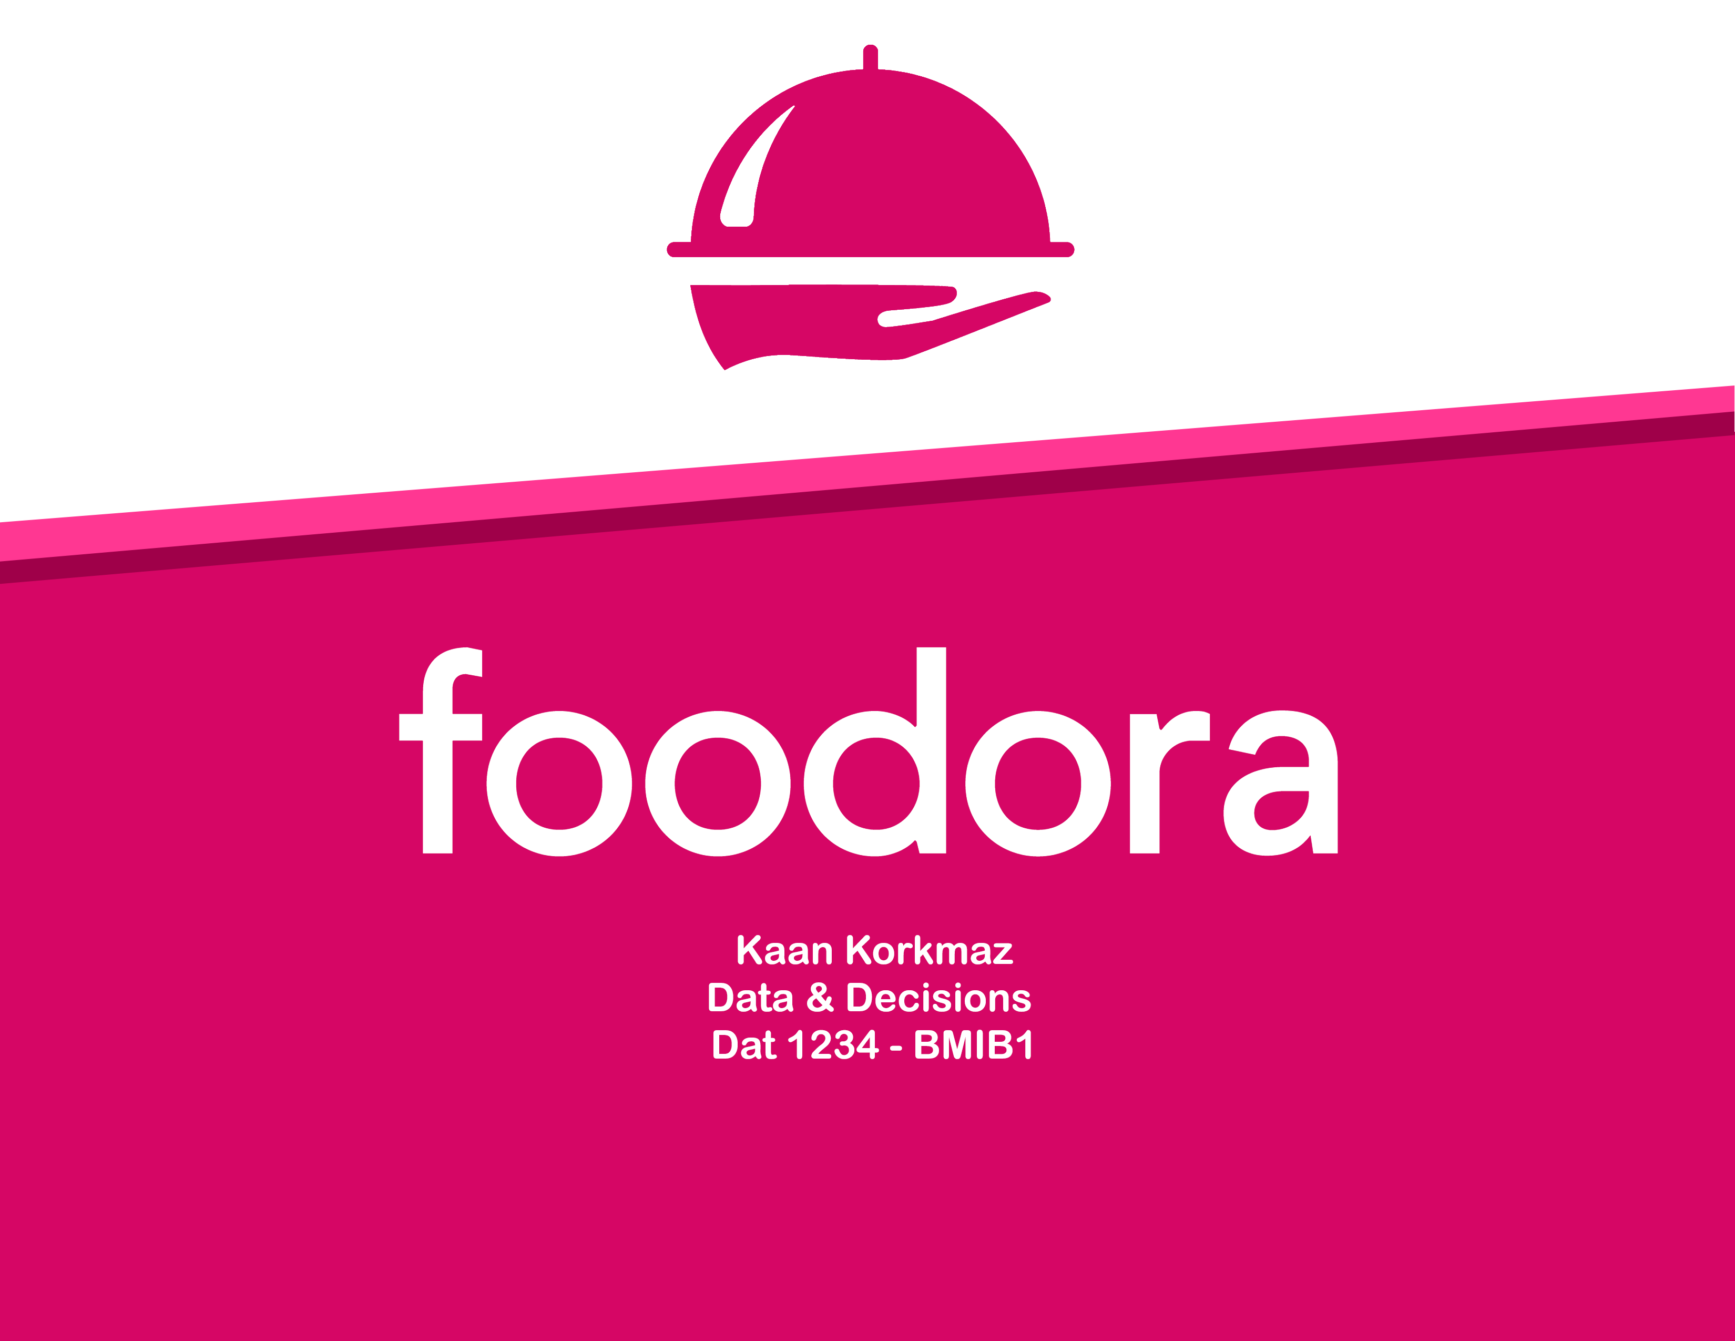

# Executive Summary

This proposal includes suggestions based on market comparison for implementing new ideas and creating new forms of revenue into the Foodora strategy creating more value for the brand and making Foodora the best choice for customers to order and restaurants to work together.

Using the Business Canvas Model, I will determine how Foodora creates value and revenue with its operations, who their customer segments are and how it can be improved and find present possible future problems. Using the ERRC framework, Foodora will eliminate high costs, raise or reduce their operations regarding the industry direction and customer feedback and, create new activities by implementing novel ideas sailing towards the blue ocean.

The online food ordering industry has been growing from day one, and still, there is a lot of countries and segments to penetrate. Growth was 20% in 2018, following by 17.5% in 2019 with more than a billion users in 2018, expected to be 1.75 billion by 2024 [2]. There are more grounds to cover and more opportunities to take. Creating a strategy that helps Foodora to create a unique and differentiated value proposition will open an area for Foodora to move forwards.

# Assessment

## Market Assessment

15 – 20 years ago, when there was no online food ordering, the mother of the family did the cooking. There was a specific time for dinner, and family members ate together. Now, everyone has different schedules and tasks to complete, and there is simply no time for cooking and sitting together to eat every day. On the other hand, children of the home leaving home earlier for education or job, staying at their home, alone. With education and employment rate growing, the online food ordering industry has been growing with them. Multiple regression analysis shows a strong correlation between online order revenue (dependent variable) vs. employment and education rate. Internet and mobile phone usage also have a similar correlation with online food ordering [11].

Users number nearing 1.4 billion, have age distribution of

* 22% for 18-24 years old
* 36% for 25-34 years old
* 25% for 35-44 years old
* 4% for 55-64 years old

Age distribution has broadly the same characteristics of people studying or working, living in their place [2].

Digital ordering and delivery have grown 300% faster than dine-in traffic since 2014. Customer research shows that, reasons for ordering online are

* 43% didn’t feel like cooking
* 30% satisfying a crewing
* 28% saving time for cooking/cleaning
* 25% at-home game night/movie night
* 24% family night dinner [4].

Customer research shows that

* 42% of the food delivery orders were made online
* 92% of restaurateurs agree that technology improves business efficiency
* 60% of consumers order delivery or takeout once a week
* 97% of millennials use their phone for anything [3].

Forecasting these figures for ten more years shows that education rate, employment rate, use of mobile devices will continue increasing, and online food ordering will grow with them. To prepare for this increment, Foodora has to be more robust to be able to handle the demand [5][6][7][9][11].

## Company Assessment

Foodora founded in Germany and facilitated in several countries until bought by Delivery Hero and reducing its operating countries to Norway, Sweden, Finland, and Canada [1].

Unlike other food delivery companies, Foodora does not use motor vehicles like scooters or cars; they only use bikes. With this distinction from competitors, Foodora ads environmental to its value proposition [1].

Following bike only delivery method, comes with its hardships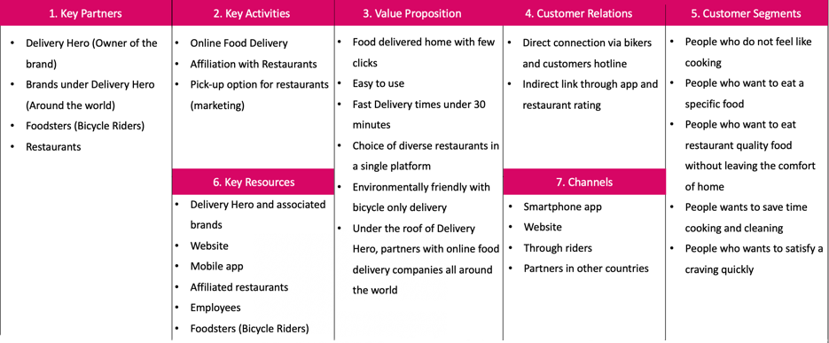.

Foodora has 30 minutes of delivery time, and when the slow speed of bikes added to this range becomes very limited compared to competitors. In Canada, while UberEats works with 1000 restaurants, Foodora works with half of that.

As mentioned, Foodora operates in Norway, Sweden, Finland, and Canada, counties known for their cold weather. For foodsters, dealing with snow, cold, and winds and trying to keep up with 30 minutes delivery time, brings difficulties as well.

## Business Model Canvas

To find solutions to these problems and to create new revenue streams, I will use the Business Model Canvas to analyze Foodora better [10].

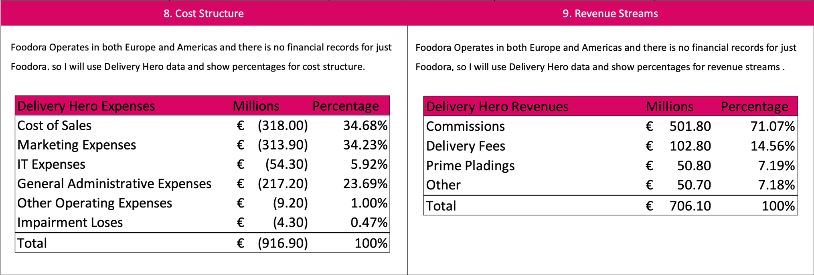

As can be seen from the business model canvas, the mains revenue stream for Foodora brokerage fee from food delivery, and the main cost is the salary for foodsters. Foodora takes 30% commission from each order plus delivery cost paid to riders meaning that Foodora does not pay for a delivery, the customer does. Foodsters make $4.50 per delivery plus $1 per kilometer traveled plus tips. Compared to Doordash's $8 per delivery and UberEats' $6.50 plus $1.85 per kilometer, wages are lower. The difference is, Foodora only uses cyclists, so foodsters don't have any gas cost. The only cost for foodsters is the carrying bag provided [1].

To increase revenue and add more revenue streams, Foodora should look into different opportunities and add key activities, reach other customer segments, add more partners, and do all this with the same resources they have now. This way will create more revenue coming from different sources rather than just one.

# Recommendations

Recommendations will follow the ERRC structure in the direction of the Blue Ocean strategy.

## 30 minutes delivery time

Thirty minutes of delivery time is an essential value for Foodora, but it also causes us not to compete, so we should eliminate. We have to increase our range to compete and be robust for the future. With more people order online, more choices they will want to see and switch to competitor’s platform. Removing the limit will not affect current delivery time, add more restaurant selections, and at the same time, make riders more money because they will be traveling a longer distance.

## Using Restaurant Carriers

Some restaurants like Burger King have their carriers. Foodora can use these carriers to deliver too. The customer will order through Foodora, but the restaurant will do the delivery. This service will have a lower commission rate to Foodora, but the delivery time will be lower as well and will cost less to the customer. Using restaurant carriers will pull more customers to restaurants out the range, making less profit per order but more in total.

## More Gear to Bikers

Foodora does not own any bikes; it just gives a bag to the riders to use on their bicycle. Because foodsters are operating in the cold climate, they will need jackets and protective gear to be safe. Foodora can give additional equipment to its riders to protect them more and also launch a loyalty program for cyclists too. The more orders they deliver, the more gifts they get with the Foodora logo on them. With all these bikers riding around, this will be an advertisement and can create an incentive to work more to get cool gear.

## Additional services

For restaurants getting a high number of orders, Foodora can offer carriers just for that restaurant. They would have hourly wages, but with faster service, the restaurant would sell more.

Foodora has a lot of riders as their resource, and they are only used for food delivery. People order food because they don't want to wait or go out; they want everything to come to them. Delivery service applies to grocery shopping or pick-up services too. Service would be precisely the same; rather than delivering food, they will deliver groceries or amazon packages from drop location.

With these additional services, Foodora can sail into the blue ocean in the industry.

# Implementation Plan

Pilot areas: Foodora should try these new services in pilot areas. Testing will let us see if these services will be profitable or not. After six months of the initial trial, customer feedback and actual net profit would be enough to reach a decision. If there are any improvements needed, they will be done and tried in shorter periods.

The Rollout: After pilot area testing, given that services remain profitable after improvements made, the rollout should be prepared for entire operating countries slowly increasing service areas until reaching full operation. These services can also be applied to sister companies under the Delivery Hero roof, creating more profit for Delivery Hero all around the world.

# Bibliography

Numbers inside brackets (‘[ ]’) indicate to sheet numbers in excel document “F_EXC”.

1. General Info
2. Online Food Delivery – World
3. Restaurant Consumer Data
4. Main Reasons to Order Online
5. Number of Smartphone Users
6. Employment Rate
7. Education Rate
8. Delivery Hero Income Statement
9. Delivery Hero Key Metrics
10. Cost and Revenue
11. Regression
12. Bibliography