Derating Controller System Design Description

## 1.Simulink & Model

Derating Algorithm module is given below. Inputs are positioned on the left side and outputs on the right side. Tunable parameters are added as a mask as shown in figure 2.

Figure 1. Controller Block

The tunable parameters specified in requirments are added as in Figure 2. default values are set.

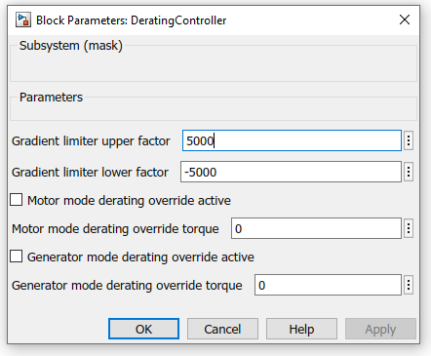

Figure 2. Controller Block Mask

Data type conversion, rate transition and saturation operations were applied on the input ports. Data type conversion operations have been applied fixed point conversion to improve processor performance.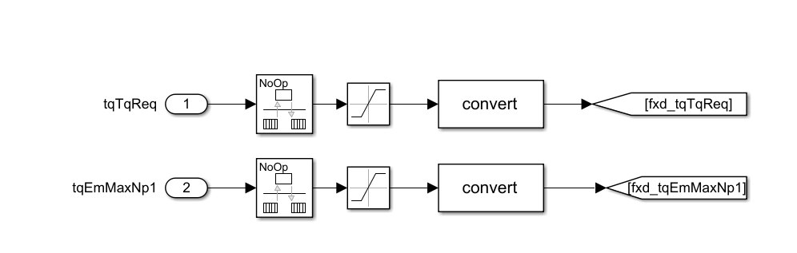

Figure 3. Torque Request & Maximum Torque Input

Engine and generator inputs are separated for the "Inputs separated for motor operation and generator operation" requirement.

In these blocks (figure 4 and figure 5) limit selection and satatus bits were calculated. Bits were set according to the requested torque value exceeding the limits. Output limits were determined according to requirements 3 and 4. The smallest one among the values for the engine mode was defined as the output in the block as the limit. For generator mode, the largest one among the values was defined as the output in the block as limit.

The block that assigns the maximum value among the generator parameters as the output value is given below.

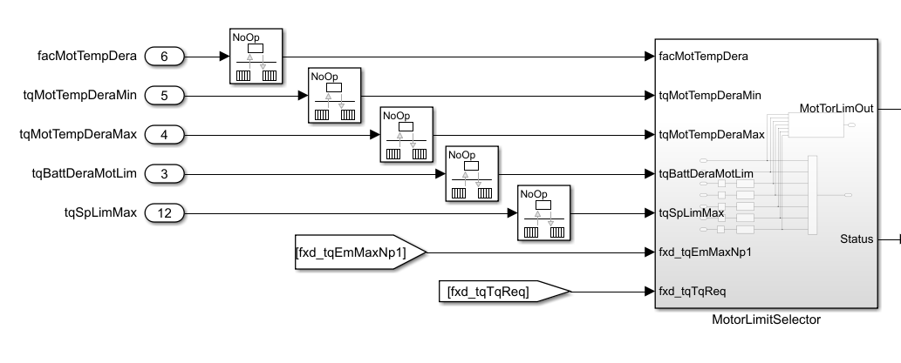

Figure 4. Generator Limit Selector

The block that assigns the minimum value among the motor parameters as the output value is given below.

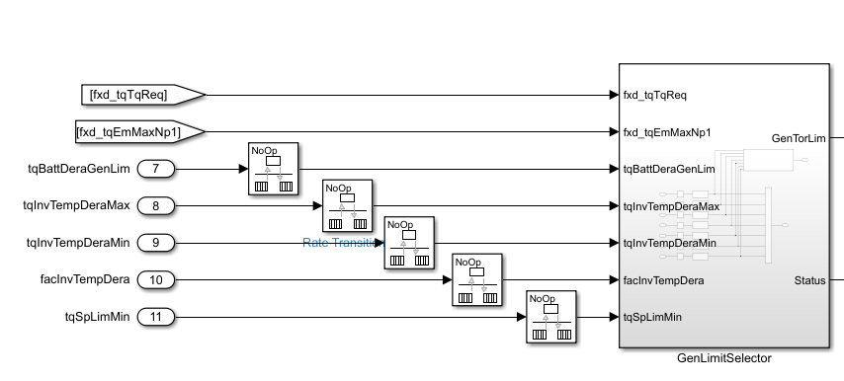

Figure 5. Generator Limit Selector

The blocks that perform bit status calculation are given below.

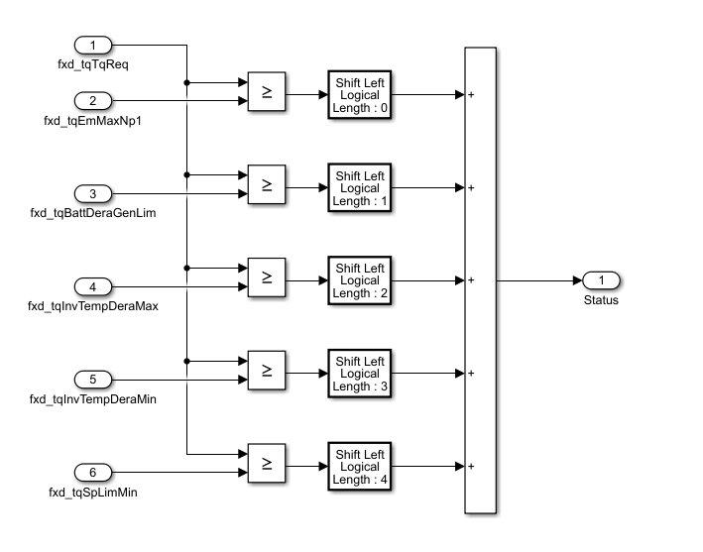

Figure 6. Status Bit Calculation Block

The satus values from motLimSelector and GenLimSelector are combined in the block below and transferred to the output as 16 bit data.

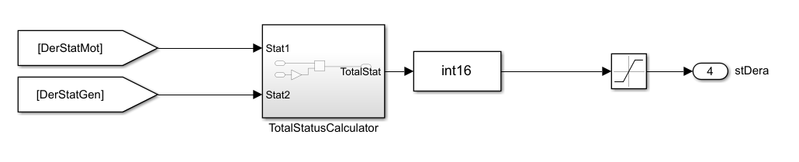 Figure 8. sDera Calculation Block

Generator mode derating override torque entered in the mask by the user when the bDeraGenOvrdActv_C bit is set value as the limit value to the output. If the bit is not set, the calculated value is assigned to the output.

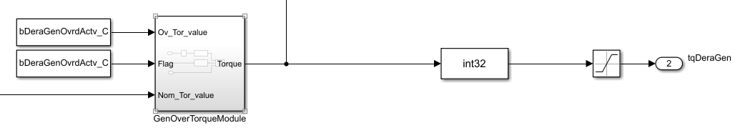

Figure 7. tqDeraGen Calculation Block

Motor mode derating override torque entered in the mask by the user when the bDeraMotOvrdActv_C bit is set value as the limit value to the output. If the bit is not set, the calculated value is assigned to the output.

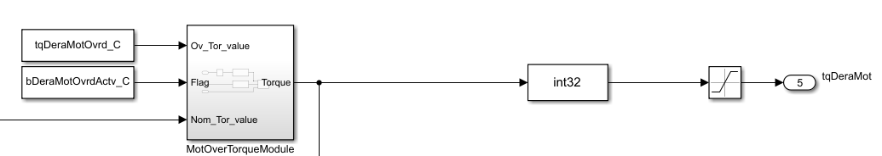

Figure 8. tqDeraMot Calculation Block

In the following block, output derating factor value and tqSpLim values are calculated. If the Requested torque value is greater than 0, it detects that it is in engine mode and reflects the results calculated from the engine value to the output. If the requested torque value is less than 0, it detects that it is in generator mode and reflects the results calculated from the generator value to the output.

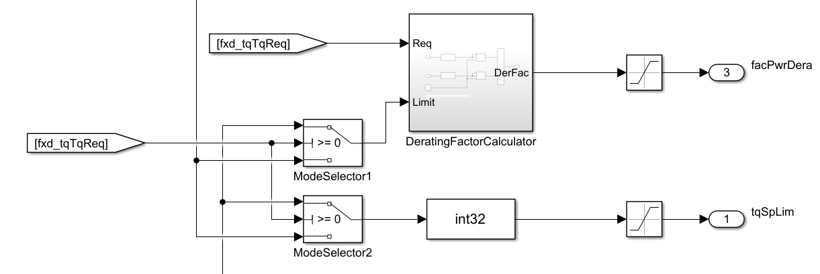

Figure 9. Mode Selection & Output Assignment

This algorithm aims to protect the motor by monitoring the operating parameters of the motor and taking the necessary measures when limit values are reached. However, due to lack of theoretical knowledge and limited time, some computational errors may occur. Therefore, regular evaluation and testing processes are important to ensure the accuracy and effectiveness of the algorithm.