**package** OOP;

**import** javax.swing.*;  
**import** java.awt.*;  
**import** java.awt.event.*;  
**import** java.io.File;  
**import** java.util.Scanner;  
**import** java.io.FileNotFoundException;  
**import** java.io.FileInputStream;  
**import** java.io.IOException;  
  
*// Kaan Özbudak B1505.010016 Computer Engineer Second Grade İstanbul Aydın University  
  
// My github for star: www.github.com/kaanozbudak  
  
// My linkedin  
  
// This program will show you pgm ppm pbm img files. It takes argument first after that it work on and draw this image again in my frame.  
  
// You will fill your name first after you can choose your img file whatever you want.  
  
// You will see new frame on window, it shows you whichever you choosed img file.  
  
// Thanks for download my project.  
  
// Have Fun***public class** quiz **extends** JFrame  
{  
 **private** JLabel **label1**,**label2**,**label3**;  
 **private** JTextField **textField**;  
 **private** JButton **button1**,**button2**,**button3**,**button4**;  
 **private int width**,**height**,**maxVal**=0;  
 **private int array**[];  
 **private** DrawingPanel **dp**;  
 **private** DrawingPanel2 **dp2**;  
 **private int pixs**[];  
 **private** DrawingPanel3 **dp3**;  
 **private** DrawingPanel4 **dp4**;  
 **private int r**,**g**,**b**;  
 **private** Color **p3Color**;  
 **private** Color **ce**;  
 **private int**[][] **coloredPixels**;  
  
 quiz()  
 {  
 **label1**=**new** JLabel(**"Hi, please give me your name: "**);  
 add(**label1**);  
  
 **textField**=**new** JTextField(10);  
 add(**textField**);  
  
 **button1**=**new** JButton(**"Please Click Me"**);  
 add(**button1**);  
 **label2**=**new** JLabel(**""**);  
 add(**label2**);  
 **button1**.addActionListener(**new** clicker());  
  
  
 **dp**=**new** DrawingPanel();  
 **dp2**=**new** DrawingPanel2();  
 **dp3**=**new** DrawingPanel3();  
 **dp4**=**new** DrawingPanel4();  
  
  
 setLayout(**new** FlowLayout());  
  
 }  
 **public class** clicker **implements** ActionListener  
 {  
 **public void** actionPerformed(ActionEvent e)  
 {  
 String name=**textField**.getText();  
 **label2**.setText(**"Welcome to our application "**+name+**". How can I help you ? :)"**);  
 **button2**=**new** JButton(**"Choose ------> P1-P2-P3 "**);  
 add(**button2**);  
 **button4**=**new** JButton(**"Choose ------> P4-P5-P6 "**);  
 add(**button4**);  
  
  
 **button3**=**new** JButton(**"Exit !"**);  
 add(**button3**);  
 **button2**.addActionListener(**new** filer1());  
 **button4**.addActionListener(**new** filer2());  
 **button3**.addActionListener(**new** exiter());  
 }  
 }  
 **public class** filer1 **implements** ActionListener  
 {  
 **public void** actionPerformed(ActionEvent e)  
 {  
 JFileChooser fileChooser = **new** JFileChooser(**"./src/OOP/first"**);  
  
 **int** returnValue = fileChooser.showOpenDialog(**null**);  
  
 **if** (returnValue == JFileChooser.***APPROVE_OPTION***)  
 {  
 File selectedFile = fileChooser.getSelectedFile();  
  
 String fileName=**""**+selectedFile;  
 System.***out***.println(selectedFile);  
  
 **try** {  
 Scanner input=**new** Scanner(**new** File(fileName));  
 String control=**""**+input.next();  
 **if**(control.equals(**"P1"**))  
 {  
 String info=input.nextLine();  
 String info2=input.nextLine();  
  
  
 System.***out***.println(info);  
 System.***out***.println(info2);  
  
 **width**=Integer.*parseInt*(input.next());  
 **height**=Integer.*parseInt*(input.next());  
  
  
 System.***out***.println(**width**+**"\n"**+**height**+**"\n"**);  
  
 **array**=**new int**[**width**\***height**];  
  
 **for** (**int** i=0;i<**height**\***width**;i++)  
 {  
  
 **array**[i]=Integer.*parseInt*(input.next());  
 **if**(**array**[i]==0)  
 {  
 **array**[i]=255;  
 }  
 }  
  
 JFrame frame=**new** JFrame();  
 frame.setDefaultCloseOperation(JFrame.***EXIT_ON_CLOSE***);  
 frame.setSize(**width**,**height**);  
 frame.setTitle(**"P1"**);  
 frame.setVisible(**true**);  
 frame.add(**dp**);  
 }  
 **else if**(control.equals(**"P2"**))  
 {  
 **width**=Integer.*parseInt*(input.next());  
 **height**=Integer.*parseInt*(input.next());  
 **maxVal**=Integer.*parseInt*(input.next());  
  
 System.***out***.println(**width**+**"\n"**+**height**+**"\n"**+**maxVal**+**"\n"**);  
  
 **array**=**new int**[**width**\***height**];  
  
 **for** (**int** i=0;i<**height**\***width**;i++)  
 {  
 **array**[i]=Integer.*parseInt*(input.next());  
 }  
 JFrame frame=**new** JFrame();  
 frame.setDefaultCloseOperation(JFrame.***EXIT_ON_CLOSE***);  
 frame.setSize(**width**,**height**);  
 frame.setTitle(**"P2"**);  
 frame.setVisible(**true**);  
 frame.add(**dp**);  
 }  
 **else if**(control.equals(**"P3"**))  
 {  
 String info=input.nextLine();  
 *//String info2=input.nextLine();* System.***out***.println(info);  
 *//System.out.println(info2);* **width**=Integer.*parseInt*(input.next());  
 **height**=Integer.*parseInt*(input.next());  
 **maxVal**=Integer.*parseInt*(input.next());  
  
  
 System.***out***.println(**width**+**"\n"**+**height**+**"\n"**+**maxVal**+**"\n"**);  
  
  
  
 **coloredPixels** = **new int**[**width** * **height**][3];  
 **for** (**int** i = 0; i < **width** * **height**; i++)  
 {  
 **for**(**int** j = 0 ; j < 3 ; j++)  
 {  
 **coloredPixels**[i][j] = Integer.*parseInt*(input.next());  
 }  
 }  
  
 JFrame frame=**new** JFrame();  
 frame.setDefaultCloseOperation(JFrame.***EXIT_ON_CLOSE***);  
 frame.setSize(**width**,**height**);  
 frame.setTitle(**"P3"**);  
 frame.setVisible(**true**);  
 frame.add(**dp3**);  
 System.***out***.println(**"p3Done"**);  
 }  
 **else** {  
 System.***out***.println(**"Error"**);  
 }  
 }  
 **catch**(FileNotFoundException ex)  
 {  
 ex.printStackTrace();  
 }  
 }  
 }  
 }  
 **public class** filer2 **implements** ActionListener  
 {  
 **public void** actionPerformed(ActionEvent e)  
 {  
 JFileChooser fileChooser2 = **new** JFileChooser(**"./src/OOP/second"**);  
  
 **int** returnValue = fileChooser2.showOpenDialog(**null**);  
  
 **if** (returnValue == JFileChooser.***APPROVE_OPTION***)  
 {  
 **try** {  
 File selectedFile2 = fileChooser2.getSelectedFile();  
  
 String fileName2=**""**+selectedFile2;  
  
 FileInputStream fis=**new** FileInputStream(fileName2);  
  
 **byte** [] magicNum = **new byte**[2];  
  
 fis.read(magicNum);  
 String control=**new** String(magicNum);  
 System.***out***.println(control);  
  
 **if**(control.equals(**"P4"**))  
 {  
 *// IT'S NOT WORKING, I'M SORRY :(* }  
 **else if**(control.equals(**"P5"**))  
 {  
 **char** chByte = (**char**) fis.read();  
 **while**(Character.*isWhitespace*(chByte))  
 {  
 chByte = (**char**) fis.read();  
 }  
 **byte** fb = (**byte**) chByte;  
  
 **int** count = 1;  
 **byte** [] w = **new byte**[3];  
 w[0] = fb;  
  
 **byte** aByte = (**byte**) fis.read();  
 **while**(!Character.*isWhitespace*(aByte))  
 {  
 w[count++] = aByte;  
 aByte = (**byte**) fis.read();  
 }  
 System.***out***.println(**"count: "** + count);  
 **int** i = 0;  
  
 String strWidth = **new** String(w);  
  
 System.***out***.println(strWidth);  
  
 **width** = Integer.*parseInt*(strWidth);  
  
 aByte = (**byte**) fis.read();  
 **while**(Character.*isWhitespace*(aByte))  
 {  
 aByte = (**byte**) fis.read();  
 }  
  
  
 count = 1;  
 **byte** [] h = **new byte**[3];  
 h[0] = aByte;  
  
  
 aByte = (**byte**) fis.read();  
 **while**(!Character.*isWhitespace*(aByte))  
 {  
 h[count++] = aByte;  
 aByte = (**byte**) fis.read();  
 }  
  
 **height** = Integer.*parseInt*(**new** String(h));  
 System.***out***.println(**"height: "** + **height**);  
  
  
 aByte = (**byte**) fis.read();  
 **while**(Character.*isWhitespace*(aByte))  
 {  
 aByte = (**byte**) fis.read();  
 }  
  
  
 count = 1;  
 **byte** [] mv = **new byte**[3];  
 mv[0] = aByte;  
 aByte = (**byte**) fis.read();  
 **while**(!Character.*isWhitespace*(aByte))  
 {  
 mv[count++] = aByte;  
 aByte = (**byte**) fis.read();  
 }  
 System.***out***.println(**"Max.Value: "** + **new** String(mv));  
  
 aByte = (**byte**) fis.read();  
 **while**(Character.*isWhitespace*(aByte))  
 {  
 aByte = (**byte**) fis.read();  
 }  
  
 **pixs** = **new int**[**width**\***height**];  
 **pixs**[0] = aByte;  
 **for**(**int** k = 1; k < **width**\***height**; k++)  
 {  
 **pixs**[k] = fis.read();  
 }  
 JFrame frame=**new** JFrame();  
 frame.setDefaultCloseOperation(JFrame.***EXIT_ON_CLOSE***);  
 frame.setSize(**width**,**height**);  
 frame.setTitle(**"p5"**);  
 frame.setVisible(**true**);  
 frame.setLocation(100,100);  
 frame.add(**dp2**);  
 }  
 **else if**(control.equals(**"P6"**))  
 {  
 **char** chByte = (**char**) fis.read();  
 **while**(Character.*isWhitespace*(chByte))  
 {  
 chByte = (**char**) fis.read();  
 }  
 **byte** fb = (**byte**) chByte;  
  
 **int** count = 1;  
 **byte** [] w = **new byte**[3];  
 w[0] = fb;  
  
 **byte** aByte = (**byte**) fis.read();  
 **while**(!Character.*isWhitespace*(aByte))  
 {  
 w[count++] = aByte;  
 aByte = (**byte**) fis.read();  
 }  
 System.***out***.println(**"count: "** + count);  
 **int** i = 0;  
  
 String strWidth = **new** String(w);  
  
 System.***out***.println(strWidth);  
  
 **width** = Integer.*parseInt*(strWidth);  
  
 aByte = (**byte**) fis.read();  
 **while**(Character.*isWhitespace*(aByte))  
 {  
 aByte = (**byte**) fis.read();  
 }  
  
  
 count = 1;  
 **byte** [] h = **new byte**[3];  
 h[0] = aByte;  
  
  
 aByte = (**byte**) fis.read();  
 **while**(!Character.*isWhitespace*(aByte))  
 {  
 h[count++] = aByte;  
 aByte = (**byte**) fis.read();  
 }  
  
 **height** = Integer.*parseInt*(**new** String(h));  
 System.***out***.println(**"height: "** + **height**);  
  
  
 aByte = (**byte**) fis.read();  
 **while**(Character.*isWhitespace*(aByte))  
 {  
 aByte = (**byte**) fis.read();  
 }  
  
  
 count = 1;  
 **byte** [] mv = **new byte**[3];  
 mv[0] = aByte;  
 aByte = (**byte**) fis.read();  
 **while**(!Character.*isWhitespace*(aByte))  
 {  
 mv[count++] = aByte;  
 aByte = (**byte**) fis.read();  
 }  
 System.***out***.println(**"Max.Value: "** + **new** String(mv));  
  
 aByte = (**byte**) fis.read();  
 **while**(Character.*isWhitespace*(aByte))  
 {  
 aByte = (**byte**) fis.read();  
 }  
  
 *//pixs = new int[width*height][3];  
 //pixs[0] = aByte;* **coloredPixels** = **new int**[**width** * **height**][3];  
 **coloredPixels**[0][0]=aByte;  
 **for** (**int** k = 0; k < **width** * **height**; k++)  
 {  
 **for**(**int** j = 0 ; j < 3 ; j++)  
 {  
 **coloredPixels**[k][j] = fis.read();  
 }  
 }  
 JFrame frame=**new** JFrame();  
 frame.setDefaultCloseOperation(JFrame.***EXIT_ON_CLOSE***);  
 frame.setSize(**width**,**height**);  
 frame.setTitle(**"p6"**);  
 frame.setVisible(**true**);  
 frame.setLocation(100,100);  
 frame.add(**dp3**);  
  
 }  
 **else** {  
 System.***out***.println(**"Error"**);  
 }  
  
 }  
 **catch**(IOException ex)  
 {  
 ex.printStackTrace();  
 }  
  
 }  
 }  
 }  
  
 **class** DrawingPanel **extends** JPanel  
 {  
 **public void** paintComponent(Graphics g)  
 {  
 **super**.paintComponent(g);  
 **for**(**int** row=0;row<**height**;row++)  
 {  
 **for**(**int** col=0;col<**width**;col++)  
 {  
 **int** newColor=**array**[**width**\*row+col];  
 Color c=**new** Color(newColor,newColor,newColor);  
  
 g.setColor(c);  
 g.drawRect(row,col,1,1);  
  
 }  
 }  
 }  
 }  
 **class** DrawingPanel2 **extends** JPanel  
 {  
 **public void** paintComponent(Graphics g)  
 {  
 **super**.paintComponent(g);  
 **for**(**int** row = 0; row < **height**; row++)  
 **for**(**int** col = 0; col < **width**; col++)  
 {  
  
 **try** {  
 Color c = **new** Color(  
 **pixs**[row\***width**+col],  
 **pixs**[row\***width**+col],  
 **pixs**[row\***width**+col]);  
 g.setColor(c);  
 g.fillRect(col,row,1,1);  
 }  
 **catch**(IllegalArgumentException e)  
 {  
  
 }  
 }  
 }  
 }  
 **class** DrawingPanel3 **extends** JPanel  
 {  
 **public void** paintComponent(Graphics gr)  
 {  
 **super**.paintComponent(gr);  
 **for** (**int** row = 0; row < **height**; row++)  
 {  
 **for** (**int** col = 0; col < **width**; col++)  
 {  
 **try** {  
 **p3Color**=**new** Color(**coloredPixels**[row * **width** + col][0] , **coloredPixels**[row * **width** + col][1] , **coloredPixels**[row * **width** + col][2]);  
  
 gr.setColor(**p3Color**);  
 gr.drawRect(col,row,1,1);  
 }  
 **catch**(IllegalArgumentException e)  
 {  
  
 }  
  
 }  
 }  
  
 }  
 }  
 **class** DrawingPanel4 **extends** JPanel  
 {  
 **public void** paintComponent(Graphics gra)  
 {  
 **super**.paintComponent(gra);  
 **for**(**int** row=0;row<**height**;row++)  
 {  
 **for**(**int** col=0;col<**width**;col++)  
 {  
 **int** newColor2=**pixs**[**width**\*row+col];  
 Color ce=**new** Color(newColor2,newColor2,newColor2);  
  
 gra.setColor(ce);  
 gra.drawRect(row,col,1,1);  
  
 }  
 }  
  
 }  
 }  
 **public class** exiter **implements** ActionListener  
 {  
 **public void** actionPerformed(ActionEvent e)  
 {  
 System.*exit*(0);  
 }  
 }  
 **public static void** main(String[] args)  
 {  
 quiz window=**new** quiz();  
 window.setSize(500,500);  
 window.setVisible(**true**);  
 window.setDefaultCloseOperation(***EXIT_ON_CLOSE***);  
 window.setTitle(**"Front Desk"**);  
 }  
}

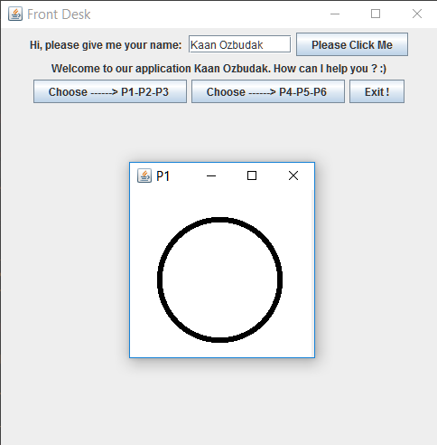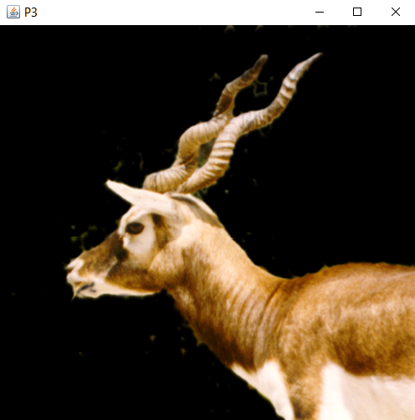

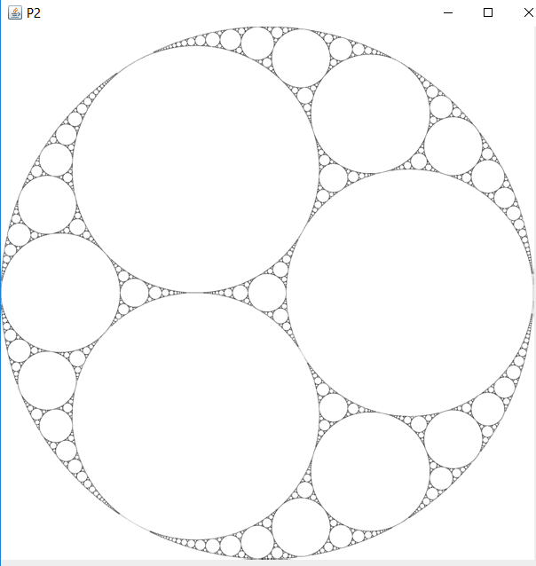

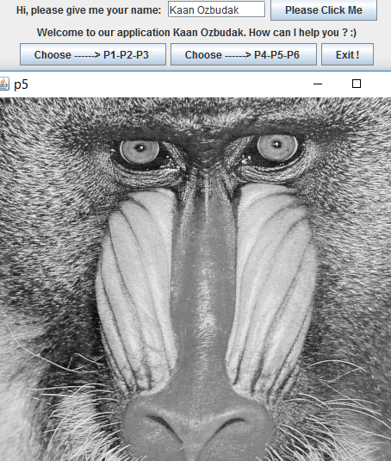

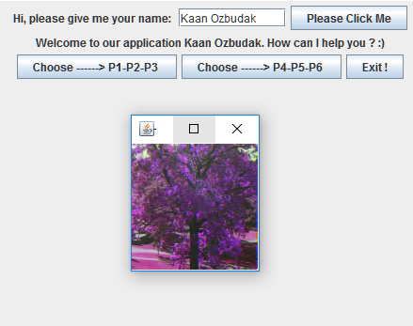



Object Oriented Programming

Computer Engineer 2. Grade

Kaan Özbudak

B1505.010016