Supplementary Material

Machine learning screening of magnetocaloric high-entropy alloys
using a field-normalized ΔSref target

Contents:
Supplementary Figure S1 Distributions of compositional descriptors and magnetocaloric target variable
Supplementary Figure S2 Per-alloy field-scaling exponent n_{i} distribution
Supplementary Figure S3 n-scan: field-agnosticity target as a function of the normalization exponent n
Supplementary Table S1 Sensitivity of screening metrics to percentile threshold choice
Supplementary Table S2 Robust summary statistics of model performance across outer folds
Supplementary Figure S4 Sensitivity of residual field signature to the choice of n

Supplementary Figure S1
Distributions of compositional descriptors and the magnetocaloric target variable

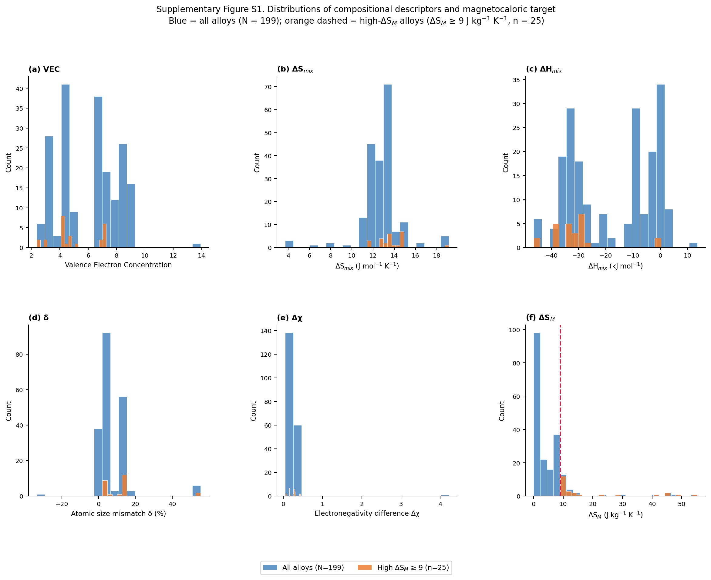
Supplementary Figure S1. ΔSref is the field-normalized target used for model training (see main text). Histograms of the five compositional descriptors and the measured ΔSM (used for the ≥ 9 J kg⁻¹ K⁻¹ screening label) for all 199 HEA compositions in the compiled dataset (blue bars) and for the 25 high-ΔSM alloys with ΔSM ≥ 9 J kg⁻¹ K⁻¹ (orange overlay). (a) VEC: most alloys cluster between 4–8, with high-ΔSM alloys concentrated at VEC < 7.3. (b) ΔSmix: narrow range 11–19 J mol⁻¹ K⁻¹ for the majority of compositions. (c) ΔHmix: bimodal; rare-earth-containing alloys cluster at highly negative values (< −30 kJ mol⁻¹), transition-metal HEAs near 0. (d) δ: atomic size mismatch spans a wide range. (e) Δχ: electronegativity difference is small for most alloys. (f) ΔSM: strongly right-skewed; 87% of values fall below the 9 J kg⁻¹ K⁻¹ classification threshold (crimson dashed line), confirming the class imbalance discussed in the main text.

Supplementary Figure S2
Per-alloy field-scaling exponent n_i distribution (alloys with ≥ 2 distinct field measurements)

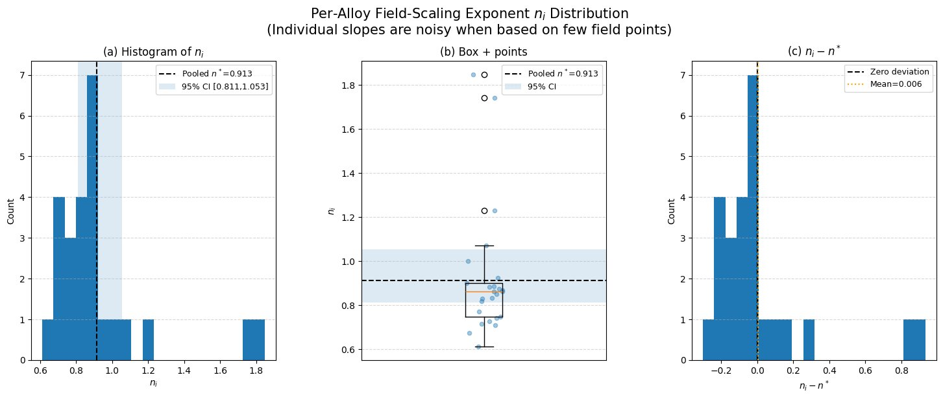
Supplementary Figure S2. Distribution of per-alloy field-scaling exponents n_{i}, computed for the 25 alloys in the dataset that have measurements at ≥ 2 distinct applied fields. (a) Histogram with the pooled fixed-effects estimate n* = 0.913 (black dashed line) and its cluster-bootstrap 95% confidence interval [0.811, 1.053] (blue shading). (b) Box-and-whisker plot with individual data points (jittered); the orange line marks the median (n = 0.861); open circles are outliers. (c) Deviation histogram (n_{i} − n*); the mean deviation is 0.006 (orange dotted line), confirming the absence of systematic bias. The spread (SD = 0.293) reflects genuine variability, primarily due to each per-alloy estimate being based on only 2–3 field points. Note that 99 of 124 alloys have measurements at a single field only and therefore cannot contribute per-alloy slope estimates; the pooled fixed-effects regression provides the statistically stable global estimate for this reason.

Supplementary Figure S3
n-scan: field-agnosticity diagnostic as a function of the normalization exponent

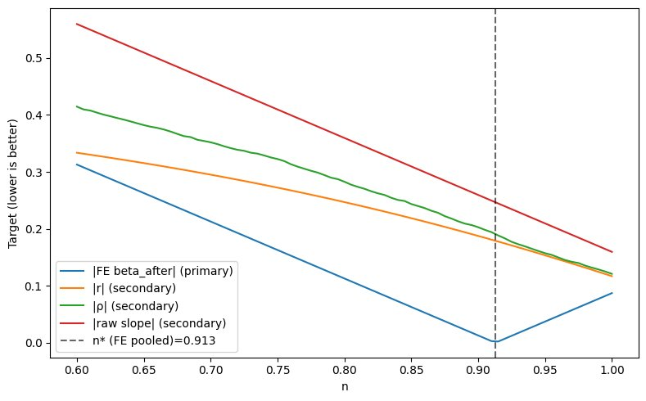
Supplementary Figure S3. Grid search over the field-normalization exponent n ∈ [0.60, 1.00], showing four field-agnosticity diagnostics as a function of n. The primary diagnostic (blue, |FE beta_after|) is the absolute fixed-effects slope of log(ΔS_{ref}) on log(H) after removing alloy-specific intercepts; a value of zero indicates complete field-agnosticity. The secondary diagnostics (|r|: Pearson correlation; |ρ|: Spearman rank correlation; |raw slope|: uncorrected log–log slope) are shown for completeness but are scale-invariant with respect to H_{ref} and therefore not informative for the sensitivity analysis in Comment 2.3. The vertical dashed line marks the pooled fixed-effects estimate n∗ = 0.913 (95% cluster-bootstrap CI: [0.811, 1.053]). The primary curve reaches its minimum at n ≈ 0.915, fully consistent with n*, confirming that n* achieves the best possible field-agnosticity among the values tested. Lower values of |FE beta_after| are better (target = 0).

Supplementary Table S1
Sensitivity of screening metrics to percentile threshold choice

The screening rule is derived by applying simultaneous percentile-based thresholds to three key descriptors (VEC, ΔS_{mix}, ΔH_{mix}). The percentile p defines the interval [p_{lo}, p_{hi}] for each descriptor, where p_{lo} = (100 − p)/2 and p_{hi} = 100 − (100 − p)/2. A higher percentile yields tighter, more selective intervals. Table S1 reports how classification performance changes across three representative choices.

Threshold | Coverage | Recall | Precision | F1 | Enrichment factor | MCC
Narrow | 0.221 | 0.480 | 0.273 | 0.348 | 2.17× | 0.236
Selected | 0.347 | 0.720 | 0.261 | 0.383 | 2.08× | 0.297
Wide | 0.367 | 0.760 | 0.260 | 0.388 | 2.07× | 0.309

Supplementary Table S1. Performance metrics of the composition-only screening rule as a function of the descriptor interval width (percentile threshold). Coverage = fraction of all alloys passing the rule. Recall = fraction of true high-ΔSM alloys correctly captured. Precision = fraction of rule-selected alloys that are truly high-ΔSM. F1 = harmonic mean of precision and recall. Enrichment factor = precision / base rate (base rate = 25/199 = 0.126). MCC = Matthews correlation coefficient (range −1 to 1; 0 = chance-level). Three threshold configurations are compared as a sensitivity analysis: Narrow (2.4 ≤ VEC ≤ 6.8, 11.5 ≤ ΔSmix ≤ 19.1 J mol⁻¹ K⁻¹, and −46.5 ≤ ΔHmix ≤ −27.6 kJ mol⁻¹), Selected (2.4 ≤ VEC ≤ 7.3, 11.5 ≤ ΔSmix ≤ 19.1 J mol⁻¹ K⁻¹, and −46.5 ≤ ΔHmix ≤ −27.6 kJ mol⁻¹; used in the main analysis), and Wide (2.4 ≤ VEC ≤ 7.5, 11.5 ≤ ΔSmix ≤ 19.1 J mol⁻¹ K⁻¹, and −46.5 ≤ ΔHmix ≤ −25.0 kJ mol⁻¹). The Selected threshold maximises F1 (0.383) while maintaining recall (0.720) at coverage 0.347, yielding ~2.1× enrichment. Enrichment is robust across all three configurations (2.07–2.17×), confirming that the practical advantage over random screening is insensitive to moderate threshold changes. All three configurations share the same lower bounds: VEC ≥ 2.4, ΔHmix ≥ −46.5 kJ mol⁻¹, and ΔSmix ≥ 11.5 J mol⁻¹ K⁻¹; only the upper bounds vary as described above.

Supplementary Table S2
Supplementary Table S2. Robust summary statistics (median and interquartile range) of model performance across 10 outer folds of nested cross-validation, reported alongside mean ± SD from Table 1 of the main manuscript.
Algorithm | R² | R² | RMSE (J kg⁻¹ K⁻¹) | RMSE (J kg⁻¹ K⁻¹) | MAE (J kg⁻¹ K⁻¹) | MAE (J kg⁻¹ K⁻¹)
 | Mean ± SD | Median [Q1, Q3] | Mean ± SD | Median [Q1, Q3] | Mean ± SD | Median [Q1, Q3]
LightGBM | 0.801 ± 0.212 | 0.873 [0.842, 0.892] | 2.881 ± 1.290 | 3.109 [1.635, 3.915] | 1.793 ± 0.700 | 2.049 [1.115, 2.339]
Gradient Boosting | 0.755 ± 0.150 | 0.778 [0.641, 0.854] | 3.339 ± 1.605 | 3.554 [2.218, 3.877] | 1.642 ± 0.648 | 1.648 [1.238, 2.026]
XGBoost | 0.747 ± 0.215 | 0.825 [0.604, 0.898] | 3.306 ± 1.958 | 3.048 [1.779, 4.063] | 1.733 ± 0.912 | 1.687 [1.118, 1.993]
Random Forest | 0.745 ± 0.158 | 0.688 [0.631, 0.888] | 3.520 ± 1.793 | 3.013 [2.430, 3.821] | 1.885 ± 0.778 | 1.802 [1.460, 2.050]
SVR | 0.441 ± 0.630 | 0.650 [0.469, 0.747] | 5.216 ± 2.845 | 4.734 [3.231, 8.040] | 2.375 ± 1.208 | 1.900 [1.688, 3.245]
Notes: Metrics are computed for ΔSref prediction. Mean ± SD uses sample standard deviation (ddof = 1) across 10 outer folds. Median [Q1, Q3] denotes the 50th, 25th, and 75th percentiles, respectively. RMSE and MAE are in J kg⁻¹ K⁻¹. For LightGBM, the higher median R² (0.873) relative to mean (0.801) reflects an asymmetric fold distribution: a small number of challenging outer folds pull the mean downward, while the majority of folds achieve consistently high performance [Q1, Q3] = [0.842, 0.892] (IQR = 0.050). For SVR, the large SD (0.630) and mean–median discrepancy indicate fold-level collapse in some splits, consistent with the model’s known sensitivity to the hyperparameter scale in small, heterogeneous datasets.
Notes on Software and Reproducibility
All analyses were performed in Python 3 using NumPy, Pandas, Scikit-learn, LightGBM, and Matplotlib. The complete code, including the fixed-effects n estimation, cluster-bootstrap confidence intervals, n-scan grid search, and nested cross-validation pipeline, is available at:
https://github.com/kaansarlar/Machine-learning-screening-of-magnetocaloric-high-entropy-alloys-using-a-field-normalized-Sref-targ
The compiled dataset (199 compositions with chemical formulas, applied fields, reported ΔSM values, and literature sources) is provided as a Word file (Composition.docx) in the same GitHub repository. The model-ready, composition-only feature matrix used for nested cross-validation, together with the field-normalized target ΔSref, is provided as COMPO_ONLY_model_ready_with_dSref_n0913.csv.

