**KAAN SELÇUK ÖZKAN**  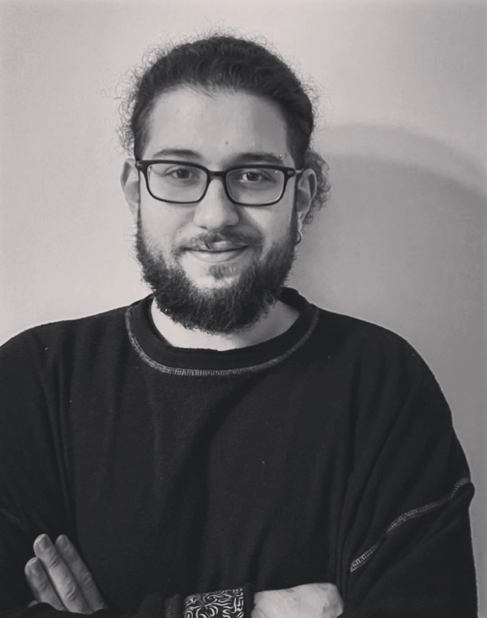

**E-Mail:** ozkann5561@gmail.com

**Mobile:**+90 544 211 20 70

# EDUCATION

**Ankara Yıldırım Beyazıt University**

***Faculty of Managment Information Systems***

**Second Class Student**

## SKILLS AND ABILITIES

***About me:***

I live in Ankara and I am second class managment information systems student. I keep working and improving on the front end. I am willing and open to improve myself.

***Computer Skills:***

* HTML5
* CSS3

***Languages:***

* English: Upper-Intermediate

# ACTIVITIES

* Playing competive computer games
* Taekwondo(2011-2012)
* Swimming(2013-2015)
* Boxing(2017-2018)

## COURSES

● 2021: freeCodeCamp (Responsive Web Design)

2021: Mustafa Murat Coşkun HTML-CSS (Udemy course)

**PERSONAL INFORMATİON**

**Birth Date:** 09.12.2000 **Driver’s License:** B Class

**MY PROJECT**

● I did a lot of little projects on my github. These tiny projects include html and css projects with responsive web design.