Istanbul Aydın University Computer Engineering Department



IoT Home Automation System

Prepared by

Ömer Kaan Seyman

B1405.010143

Submitted in partial fulfillment of the requirement for the Bachelor Degree of Computer Engineering

January 2019

**ABSTRACT**

In recent years, with the techonological development, people use their mobile phone as a remoot.They are controlling their lives like remoting air conditioner and tv. At the same time, these actions bring a new need to people that are curious.

Nowadays, home automation is a topic which gaining popularity day by day, because of large advantages.People Someone can achieve home automation by simply connecting home appliance electrical devices to the internet or cloud storage. The reason fort his surge demand of network enabled home automation is reaching the zenith in recent days for its simlicity and comparable affordability. Platforms based on cloud computing help to connect to the things surroundings everyone so that one can find it easy to Access anything and everything at any time and place in a user friendly manner using custom defined portals. Hence, cloud act as a front end to access Internet of Things(IOT). Here i am assuming a system which can control devices like android mobile phone through wireless based network or cloud based approach.

In Project, I use IOT based home automation system which goal is the develop a home automation system that gives the user complete controll over all air conditioner, house ligths and on any object with on/off switch of his or her home. This automation system will have ability to be controlled from an Ardunio, the internet and also remotely accessed via an android with an android mobile based application. There is a sensor on ardunio that is metan and natural gas meter. If something wrong according to the gas sensor, user can understand from the application. The application of this automation system called “MyHomemate” based on android.

I have used Ardunio, Android, Java, Firebase Database, Adobe XD CC to develop the application and each of the visual design.

Following is the test anlysis section, which discusses whether the propesed system met its objectives.

Contents of Project

1 Chapter 1: Introduction ....................................................................................................... 8

1.1 Background ………………………………………………………………………………………………………………. 8

1.2 Project Motivation ……………………………………………………………………………………………………. 9

1.3 Problem Statement …………………………………………………………………………………………………… 9

1.4 Project Question ……………………………………………………………………………………………………….. 9

1.5 Project Objectives …………………………………………………………………………………………………….. 9

1.6 Project Significance ………………………………………………………………………………………………….. 10

1.7 Project Scope ……………………………………………………………………………………………………………. 10

1.8 First Steps …………………………………………………………………………………………………………………. 10

2 Chapter 2:Literatur Review …………………………………………………………………………………………….. 12

2.1 Home Automation System ……………………………………………………………………………………….. 12

2.2 Definition Home Automation System ……………………………………………………………………….. 12

2.3 Using Arduino ……………………………………………………………………………………………………………. 12

2.4 Why Arduino ……………………………………………………………………………………………………………… 14

2.5 NodeMCU ESP8266 Wi-Fi Development Card ………………………………………………………….. 15

2.6 Relay Board ……………………………………………………………………………………………………………… 16

2.7 Internet of Things ……………………………………………………………………………………………………. 19

2.8 DHT11 Temperature Sensors ……………………………………………………….……………………………. 21

2.9 MQ-4 Natural Gas and Metan Sensors ……………………………………………………….……………. 21

3 Chapter 3:Project Methodology …………………………………………………………………………………….. 24

3.1 Adopted Methodology ………………………………………………………………………………………………. 24

3.2 Waterfall Methodology …………………………………………………………………………………………….. 25

3.3 Why Adopting Waterfall Is Suitable For IoT Automation System ……………………………….. 25

3.4 Implementation Of Waterfall ……………………………………………………………………………………. 25

3.4 Application Summary……………. ……………………………………………………………………………………. 25

4 Chapter 4:Analysis And Design ………………………………………………………………………………………. 28

4.1 Project Description ……………………………………………………………………………………………………. 28

4.2 User Description ……………………………………………………………………………………………………….. 28

4.3 Requirements Development …………………………………………………………………………………… 28

4.4 System Requirements ……………………………………………………………………………………………… 29

4.5 Functional Requirements ………………………………………………………………………………………… 29

4.6 User Requirements ………………………………………………………………………………………………….. 29

4.7 Non-Functional Requirements …………………………………………………………………………………. 29

4.8 System Analysis ……………………………………………………………………………………………………….. 31

4.9 Use-case Diagram …………………………………………………………………………………………………….. 31

4.10 Block Diagram ………………………………………………………………………………………………………… 32

5 Chapter 5:Implementation ……………………………………………………………………………………………. 34

5.1 Design Phase ……………………………………………………………………………………………………………. 34

5.2 Building The Hardware …………………………………………………………………………………………….. 35

5.3 Building The Software ………………………………………………………………………………………………. 36

5.4 Implementation Phase ……………………………………………………………………………………………… 38

5.5 User Interface…………………..………………………………………………………………………………………… 38

5.5 User Interface…………………..………………………………………………………………………………………… 48

6 Chapter 6:Testing And Tools ………………………………………………………………………………………….. -

6.1 Testing ………………………………………………………………………………………………………………………. -

6.2 Performance Testing …………………………………………………………………………………………………. -

6.3 Functionality Testing …………………………………………………………………………………………………. -

6.4 Tools And Techniques ……………………………………………………………………………………………….. -

6.5 Maintance …………………………………………………………………………………………………………………. -

6.6 Conclusion …………………………………………………………………………………………………………………. -

References ………………………………………………………………………………………………………………………… -

List of Tables

2 Table Similar Project Comparisson …………………………………………………………………………………. 19

5 Table Hardware Tools …………………………………………………………………………………………………….. 32

6 Table Tools And Techniques …………………………………………………………………………………………… 42

List of Figures

2 Figure Arduino Uno Chip ………………………………………………………………………………………………… 13

2 Figure Solar Panel …………………………………………………………………………………………………………… 16

2 Figure Solar Charge Controller Circuit …………………………………………………………………………….. 17

2 Figure Inverter Circuit ……………………………………………………………………………………………………. 18

3 Figure Waterfall Methodology ……………………………………………………………………………………….. 21

3 Figure Waterfall Steps ……………………………………………………………………………………………………. 23

4 Figure Non-Functional Requirements …………………………………………………………………………….. 27

4 Figure Use-Case Diagram ……………………………………………………………………………………………….. 28

4 Figure Block Diagram ……………………………………………………………………………………………………… 29

5 Figure System Structure …………………………………………………………………………………………………. 31

5 Figure Real Designs Of The Project …………………………………………………………………………………. 34



**CHAPTER 1: INTRODUCTION**



**1 CHAPTER 1: INTRODUCTION**

Nowadays smart phones are becoming more powerful with reinforced provessors, larger storage capacities, richer entertainmentfunction and more cummunication methods. Since the Android mobile platform was first open sourced by Google in November 2007, it has attracted more than 180,000 developers and the deployment of 50,000 mobile applications in the Android Market. Today more than 60 smart phones from major manufactures run the Android platform. All these numbers show the Android project has gained momentum and has moved forward.

We have remote controls for our television sets and other systems, which have made our lives real easy. Have you ever wondered about home automation which give the facility of controlling tube lights, fans and other electrical appliances at home using a remote control? Arduino based home automation using Wi-Fi. This system is super-cost effective and can give the user, the ability to control any electronic device without even spending for a remote control.

Time is a very valuable thing. Everybody wants to save time as much as they can. New Technologies are being introduced to save our time. To save people’s time we are introducing Home Automation system using Wi-Fi. With the help of this system you can control your mobile phone. You can turn on/off your home appliances whereever you are. The government and some organization are trying to develop our country in high technology. Now high technology is not bound within few features. The thing that take high technology to next level is automatic system. That is way the demanding automatic electronic device is increasing. To accomplish that, home automation is necessary.

* 1. **BACKGROUND**

Until fairly recently, automated central control of building-wide systems was found only in larger commercial buildings and expensive homes. Typically involving only lighting, heating and cooling systems, building automation rarely provided more than basic control, monitoring and scheduling functions and was accessible only from specific control points within the building itself.

Home automation is a step toward what is referred to as the “Internet of Things,” in which everything has an assigned IP address, and can be monitored and accessed remotely.

The first and most obvious beneficiaries of this approach are “smart” devices and appliances that can be connected to a local area network, via Ethernet or Wi-Fi. However, electrical systems and even individual points, like light switches and electrical outlets, were also integrated into home automation networks, and businesses have even explored the potential of IP-based inventory tracking. Although the day is still far off when you’ll be able to use your mobile browser to track down a lost sock, home networks are capable of including an increasing number of devices and systems.

* 1. **PROJECT MOTIVATION**

Nowadays, remote controlling via mobile phones is a requirement which is people interest in. This Project stands for using Google Firebase Database benefits, Ardunio and Android. The Project is an IoT Home Automation System .All the tools in the Android development are free and all the tools in the Ardunio are low-cost and effective . These factors motivated me to practice a home automation system on Ardunio to explore Ardunio’s main compononents and building a working hardware and an application on the Android platform to explore Android’s main components and various building blocks, and to acquire a working knowledge of its developing environment

* 1. **PROBLEM STATEMENT**

The Project is to create an IoT home automation system which is mobilephones to communicate with ardunio for remote controlling on home appliances via Wi-Fi. Cloud should be afforded. The Project should be very easy to use for a novice person or a person who is elder.

* 1. **PROJECT QUESTION**

The focus questions of developing an IoT Home Automation System:

* How to provide a Home Automation?
* What is Internet of Things?
* How to provide a communication between Ardunio and Android platforms?
* How to design an application easy to use?
* How to set-up a low-cost Home Automation System?
* What is NodeMCU?
  1. **PROJECT OBJECTIVES**

The main objectives of this Project can be listed by these:

* Succesfully providing a communication between mobile phones and ardunio hardware section.
* Combining NodeMCU circuit with Ardunio Board.
* Using the main circuit as a NodeMCU.
* Proving a low-cost Home Automation System.
* Offer to user simple, easy to red, less complicated interface.
* Safer, less error and faster account creation and password reset method with Firebase Authentication.
* Helping the people who are interested in home automation systems or IoT.
* Using the lastest technology tools on Android and Ardunio.
  1. **PROJECT SIGNIFICANCE**

The Project allows users to remote control on home appliances like lights and air conditioner whereever they are. This project signifance alsa cam be listed by these matters:

* Linking software with hardware.
* Designing an application easy to use.
* Developing safe and fast account creation system.
* Combining two seperate circuit and making them one.
* Low-cost home automation system.
  1. **PROJECT SCOPE**

The scope of this Project is all people. Any novice user for a mobile user can use this application. Simple, easy, understandable design provides ease of use this application. Thus, i want to reach more user communication and satisfying. Using this application and system people can remoot almost everything in their home. This Project offers something new about IoT Home Automation System. People who insterested in developing IoT Automation System, my Project is really helpful.

* 1. **FIRST STEPS**

Firstly, in the first week. I researched what is a Home Automation System and requirements. Then, i took a course called “Android Mobile Application” from “Udemy”. Because, i was not sure about how can i build this Project. The first step for me was understand to how i can provide communication between ardunio and android. The first concrete step was on Android that is providing login and signup section on Android. Basically, my Project devided by two parts as hardware the ardunio and software the android. I had to develop new methods for each errors. So, i decided to use database system to Firebase Database. Using Firebase Authentication, all errors fixed. A new unique id is identified for each every user. It caused to reset password via e-mail sending. So, i could add a new function for account management.

In the design, firstly i researched which tool i should use for Project. I choosed Adobe XD CC. Firstly, i designed the user interface respectively, login screen, registiration screen, home page in two tabs; home and log pages. Then, application icon and tabs icons are designed. After the design part, i researched Firebase from Google. Google is really helpful for me. I reached all documantations and tutorials from Google.Firebase is a free database service. Every attempt for coding i tested it. I built the Project with less error. When i got error, i can understand the error where it is via testing.The course and gooogle are also helpful for Java language. I started to build this Project these steps.

In the end of first steps, i started to combine componenets of ardunio. Gas sensor, tempereture sensor, relay board and its circuits, ardunio UNO and Wi-Fi module NodeMCU ESP8266. I searched and checked a lot off Project on ardunio sites and github and understood the best and usable circuits in my head. Then i started to bring together software and hardware section.



**Chapter 2: LıTERATURE REVIEW**



1. **CHAPTER 2: LITERATURE REVIEW**

This chapter includes a literature review of IoT Home Automation System,concepts and benefits for users.

* 1. **HOME AUTOMATION SYSTEM**

IoT Home Automation System is divided into three main phases: Building the software part on Ardunio and Android of the project to make the project works as the hardware part of the project which are cointainig two seperate circuits and getting everything done about hardware part.

* 1. **DEFINITION OF HOME AUTOMATION SYSTEM**

It is a circuit consiting of two main circuits which has ardunio UNO to manage home appliances and NodeMCU to provide Wi-Fi connection and manage the database. Thus, users can remote control on any home appliances from their mobile phone via “MyHomemate” application.

* 1. **USING ARDUINO**

To use arduino we must first understand how to use arduino and what is arduino. So what is exactly arduino? Arduino is an open source electronics platform based on easy to use hardware and software.[Arduino boards](https://www.arduino.cc/en/Main/Products) are able to read inputs light on a sensor, a finger on a button or a message and turn it into an output - activating a motor, turning on an LED, publishing something online. You can code your board what to do by sending a set of instructions to the microcontroller on the arduino board. To do so you use the [arduino programming language](https://www.arduino.cc/en/Reference/HomePage) (based on [Wiring](http://wiring.org.co/)), and [the Arduino Software (IDE)](https://www.arduino.cc/en/Main/Software), based on [processing](https://processing.org/).

Over the years Arduino has been the main source of thousands of projects, from daily use items to complex scientific instruments. A worldwide community of creators, programmers, hobbyists, artists, students and professionals has gathered around this open source platform, their contributions have added up to an incredible amount of [accessible knowledge](http://forum.arduino.cc/) that can be of great help to novices and experts alike.

Arduino was born at the Ivrea Interaction Design Institute as an easy tool for fast prototyping, aimed for students without a background in programming and electronics. As soon as it reached a wider community, the arduino board started changing to adapt to new challenges and needs, differentiating its offer from simple 8-bit boards to products for Internet of Things (IoT) applications, wearable, 3D printing, and embedded environments. All arduino boards are completely open-source, enabling users to build them independently and eventually adapt them to their particular needs.  The [software](https://www.arduino.cc/en/Main/Software) is also open source and it is growing through the contributions of users worldwide.

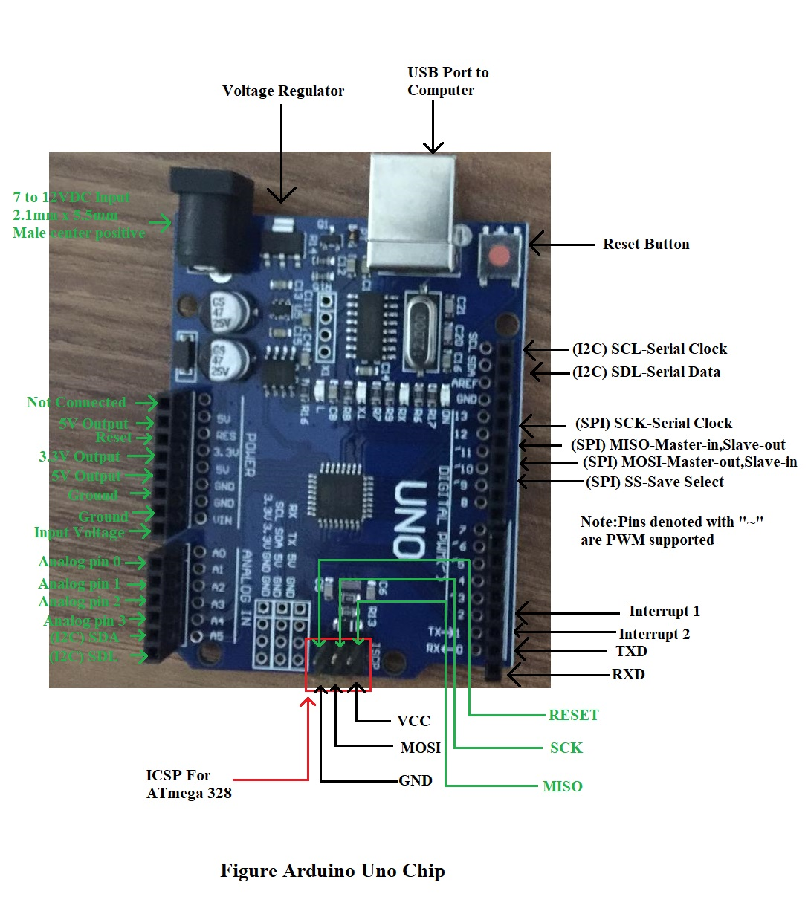

* 1. **WHY ARDUINO**

Thanks to arduino’s accessible and simple user experience, arduino has been used in thousands of different projects and applications. The arduino software is easy to use for beginners, yet flexible enough for advanced users.It runs on every operating system like Linux,Mac and Windows.Both students and teachers use it to build low cost scientific instruments to prove physics and chemistry principles or to get started with programming and robotics.Designers and architects build interactive prototypes, musicians and artists use it for installations and to experiment with new musical instruments.Makers use it to build many of the projects exhibited at the Maker Faire, for example.Arduino is a key instrument to learn new things.Anyone children, hobbyists, artists, programmers can start tinkering just following the step by step instructions of a kit or sharing ideas online with other members of the arduino community.

There are many other microcontrollers and microcontroller platforms available for physical computing. For example Netmedia's BX-24, Parallax Basic Stamp, MIT's Handyboard, Phidgets and many others offer similar functionality.All of these tools take the cluttered details of microcontroller programming and wrap it up in an easy to use package.Arduino also simplifies the process of working with microcontrollers, but it offers some advantage for users over other systems:

* **Inexpensive** - Arduino boards are relatively inexpensive compared to other microcontroller platforms. The least expensive version of the Arduino module can be assembled by hand, and even the pre assembled Arduino modules cost less than 50 liras.
* **Cross-Platform -** The Arduino Software (IDE) runs on all operating systems like Windows, Macintosh OSX, and Linux operating systems. Most microcontroller systems are limited to just Windows operating system.
* **Simple, Clear Programming Environment -** The Arduino Software (IDE) is easy to use for beginners, yet flexible enough for advanced users to take advantage of as well. For teachers, it's conveniently based on the Processing programming environment, so students learning to program in that environment will be familiar with how the Arduino IDE works.
* **Open Source and Extensible Software -** The Arduino software is published as open source tools, available for extension by experienced programmers. The language can be expanded through C++ libraries, and people wanting to understand the technical details can make the leap from Arduino to the AVR C programming language on which it's based. Similarly, you can add AVR-C code directly into your Arduino programs if you want to.
* **Open Source and Extensible Hardware -** he plans of the Arduino boards are published under a Creative Commons license, so experienced circuit designers can make their own version of the module, extending it and improving it. Even relatively inexperienced users can build the [breadboard version of the module](https://www.arduino.cc/en/Main/Standalone) in order to understand how it works and save money.
  1. **NODEMCU ESP8266 Wi-Fi DEVELOPMENT CARD**

NodeMCU is an open source IoT platform. It includes firmware which runs on the ESP8266 Wi-Fi SoC from Espressif Systems, and hardware which is based on the ESP-12 module. The term "NodeMCU" by default refers to the firmware rather than the development kits. The firmware uses the Lua scripting language. It is based on the eLua project, and built on the Espressif Non-OS SDK for ESP8266. It uses many open source projects, such as lua-cjson and SPIFFS.

**NodeMCU History**

NodeMCU was created shortly after the [ESP8266](https://en.wikipedia.org/wiki/ESP8266) came out. On December 30, 2013, [Espressif Systems](https://en.wikipedia.org/w/index.php?title=Espressif_Systems&action=edit&redlink=1)[[6]](https://en.wikipedia.org/wiki/NodeMCU#cite_note-Espressif_Systems-6) began production of the ESP8266. The ESP8266 is a Wi-Fi SoC integrated with a [Tensilica](https://en.wikipedia.org/wiki/Tensilica) Xtensa LX106 core, widely used in IoT applications. NodeMCU started on 13 Oct 2014, when Hong committed the first file of nodemcu-firmware to GitHub. Two months later, the project expanded to include an open-hardware platform when developer Huang R committed the [gerber](https://en.wikipedia.org/wiki/Gerber_format) file of an ESP8266 board, named devkit v0.9. Later that month, Tuan PM ported [MQTT](https://en.wikipedia.org/wiki/MQTT) client library from [Contiki](https://en.wikipedia.org/wiki/Contiki) to the ESP8266 SoC platform, and committed to NodeMCU project, then NodeMCU was able to support the MQTT IoT protocol, using Lua to access the MQTT broker. Another important update was made on 30 Jan 2015, when Devsaurus ported the u8glib to NodeMCU project, enabling NodeMCU to easily drive LCD, Screen, OLED, even VGA displays.

In summer 2015 the creators abandoned the firmware project and a group of independent contributors took over. By summer 2016 the NodeMCU included more than 40 different modules. Due to resource constraints users need to select the modules relevant for their project and build a firmware tailored to their needs.

### ESP8266 Arduino Core

As [Arduino.cc](https://en.wikipedia.org/wiki/Arduino) began developing new MCU boards based on non-[AVR](https://en.wikipedia.org/wiki/AVR_microcontrollers) processors like the ARM/SAM MCU and used in the Arduino Due, they needed to modify the [Arduino IDE](https://en.wikipedia.org/wiki/Arduino_IDE) so that it would be relatively easy to change the IDE to support alternate toolchains to allow Arduino C/C++ to be compiled for these new processors. They did this with the introduction of the Board Manager and the SAM Core. A "core" is the collection of software components required by the Board Manager and the Arduino IDE to compile an Arduino C/C++ source file for the target MCU's machine language. Some ESP8266 enthusiasts developed an Arduino core for the ESP8266 WiFi SoC, popularly called the "ESP8266 Core for the Arduino IDE".[[16]](https://en.wikipedia.org/wiki/NodeMCU#cite_note-16) This has become a leading software development platform for the various ESP8266-based modules and development boards, including NodeMCUs.

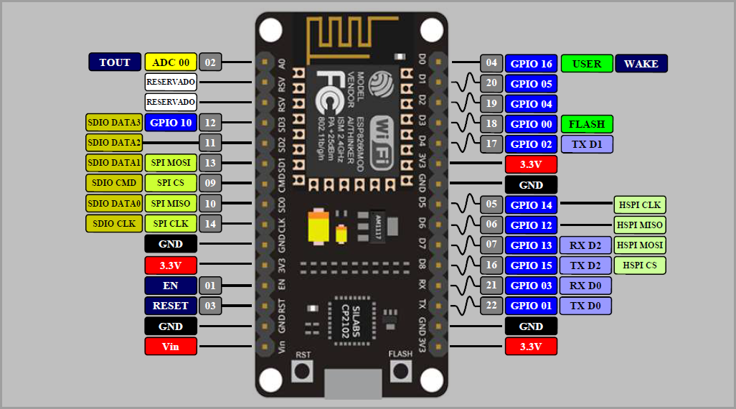

NodeMCU ESP8266 Wi-Fi Development Card

* 1. **RELAY BOARD**

The main usage of the**Relay** was seen in the history for transmitting and receiving the information, that was called as Morse code where the input signals used to be either 1 or 0, these change in signals were mechanically noted in terms of on and off of a light bulb or a beep sound, it means those pulses of 1s and 0s are converted as mechanical on and off using electromagnets. Later this was improvised and used in various applications. Let’s see how this electromagnet acts as a switch and why it is named as Relay.

### What is a Relay?

A relay is classified into many types, a standard and generally used relay is made up of electromagnets which in general used as a switch. Dictionary says that relay means the act of passing something from one thing to another, the same meaning can be applied to this device because the signal received from one side of the device controls the switching operation on the other side. So, relay is a switch which controls (open and close) circuits electromechanically. The main operation of this device is to make or break contact with the help of a signal without any human involvement in order to switch it ON or OFF. It is mainly used to control a high powered circuit using a low power signal. Generally a DC signal is used to control circuit which is driven by high voltage like [controlling AC home appliances with DC signals from microcontrollers](https://circuitdigest.com/home-automation-projects).

An electromechanical relay is basically designed using few mechanical parts like Electromagnet, a movable armature, contacts, yoke, and a spring/frame/stand, these parts are showing in the **internal pictures of Relay** below. All these are arranged logically to form into a relay.

### Picture of internal mechanical parts of relayPicture of internal mechanical parts of relay

Here we have explained the **internal mechanical parts of a Relay**:

**Electromagnet:**

An Electromagnet plays a major role in the **working of a relay**. It is a metal which doesn’t have magnetic property but it can be converted into a magnet with the help of an electrical signal. We know that when current passes through the conductor it acquires the properties of a magnet. So, when a metal winded with a copper wire and driven by the sufficient power supply, that metal can act as a magnet and can attract the metals within its range.

**Movable Armature:**

Movable armature is a simple metal piece which is balanced on a pivot or a stand. It helps in making or breaking the connection with the contacts connected to it.

### **Contacts:**

These are the conductors that exist within the device and are connected to the terminals.

### **Yoke:**

### It is a small metal piece fixed on a core in order to attract and hold the armature when the coil is energized.

### **Spring (optional):**

Few relays don’t need any spring but if it is used, it is connected to one end of the armature to ensure its easy and free movement. Instead of a spring, a metal stand like structure can be used.

### Applications of Relay:

The **applications of the relay** are limitless, its main function is to control the high voltage circuit (230V circuit AC) with the low voltage power supply (a DC voltage).

* Relays are not only used in the large electrical circuits but also used in the computer circuits in order to perform the arithmetic and mathematical operations in it.
* Used to control the electric motor switches. To turn ON an electric motor we need 230V AC supply but in few cases/applications, there may be a situation to switch ON the motor with a DC supply voltage. In those cases, a relay can be used.
* Automatic stabilizers are one of its applications where a relay is used. When the supply voltage is other than the rated voltage, set of relays sense the voltage variations and controls the load circuit with the help of circuit breakers.
* Used for the circuit selection if there exists more than one circuit in a system.
* Used in Televisions. An old picture tube television’s internal circuitry works with the DC voltage but the picture tube needs a very high AC voltage, in order to turn on the picture tube with a DC supply we can use a relay.
* Used in the traffic signal controllers, temperature controllers.

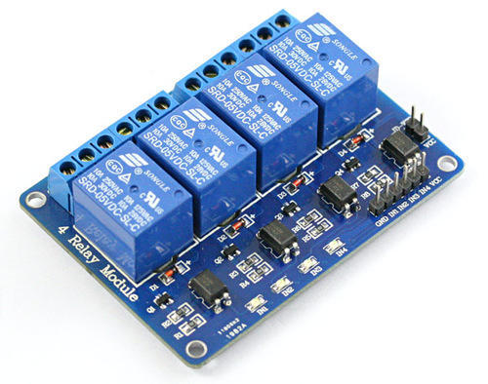

4 Channel 5V Relay Board

* 1. **INTERNET OF THINGS**

**What is the Internet of Things?**

The Internet of Things, or IoT, refers to the billions of physical devices around the world that are now connected to the internet, collecting and sharing data. Thanks to cheap processors and wireless networks, it's possible to turn anything, from [a pill](https://www.zdnet.com/article/how-sensors-enabled-eli-lilly-to-improve-the-patient-experience/)to [an aeroplane](https://www.zdnet.com/article/ten-examples-of-iot-and-big-data-working-well-together/) to a self-driving car into part of the IoT. This adds a level of digital intelligence to devices that would be otherwise dumb, enabling them to communicate real-time data without a human being involved, effectively merging the digital and physical worlds.

**What is an example of an Internet of Things device?**

Pretty much any physical object can be transformed into an IoT device if it can be connected to the internet and controlled that way.

[A lightbulb](https://www.zdnet.com/article/building-my-own-internet-of-things-ambient-experience-one-step-at-a-time/) that can be switched on using a smartphone app is an IoT device, as is a motion sensor or a [smart thermostat](https://www.zdnet.com/article/johnson-controls-cortana-powered-thermostat-is-up-for-preorder-in-march/) in your office or a connected streetlight. An IoT device could be as fluffy as [a child's toy](https://www.zdnet.com/article/fbi-to-parents-beware-your-kids-smart-toy-could-be-a-security-risk/) or as serious as [a driverless truck](https://www.zdnet.com/article/driverless-trucks-are-coming-but-for-now-adoption-is-in-the-slow-lane/), or as complicated as a jet engine that's now filled with thousands of sensors collecting and transmitting data back to make sure it is operating efficiently. At an even bigger scale, [smart cities projects are filling entire regions with sensors](https://www.zdnet.com/article/las-vegas-announces-smart-city-plans-with-cisco/) to help us understand and control the environment.

The term IoT is mainly used for devices that wouldn't usually be generally expected to have an internet connection, and that can communicate with the network independently of human action. For this reason, a PC isn't generally considered an IoT device and neither is a smartphone -- even though the latter is crammed with sensors. A [smartwatch](https://www.zdnet.com/article/could-your-apple-watch-save-your-life-how-smartwatch-sensors-are-helping-tackle-a-dangerous-heart/) or a [fitness band](https://www.zdnet.com/product/fitbit-ionic/) or other wearable device might be counted as an IoT device, however.

**What is the history of the Internet of Things?**

The idea of adding sensor and intelligence to basic objects was discussed throughout the 1980s and 1990s (and there are arguably some [much earlier ancestors](https://innovateuk.blog.gov.uk/2017/07/03/the-history-of-internet-of-things-iot/)), but apart from some early projects -- including an internet-connected vending machine -- progress was slow simply because the technology wasn't ready.

Processors that were cheap and power-frugal enough to be all but disposable were required before it became cost-effective to connect up billions of devices. The [adoption of RFID tags](https://www.zdnet.com/article/rfid-heralds-the-internet-of-things/) -- low-power chips that can communicate wirelessly -- solved some of this issue, along with the increasing availability of broadband internet and cellular and wireless networking. The [adoption of IPv6](https://www.zdnet.com/article/finally-ipv6s-killer-app-the-internet-of-things/)-- which, among other things, should provide enough IP addresses for every device the world (or indeed this galaxy) is ever likely to need -- was also a necessary step for the IoT to scale. [Kevin Ashton](https://en.wikipedia.org/wiki/Kevin_Ashton) coined the phrase 'Internet of Things' in 1999, although it took at least another decade for the technology to catch up with the vision.

The IoT integrates the interconnectedness of human culture -- our 'things' -- with the interconnectedness of our digital information system -- 'the internet.' That's the IoT," Ashton [told ZDNet](https://www.zdnet.com/article/if-you-want-to-succeed-you-must-fail-first-says-the-man-who-dreamt-up-the-internet-of-things/).

Adding RFID tags to [expensive pieces of equipment](https://www.zdnet.com/article/uk-hospitals-embrace-rfid/) to help track their location was one of the first IoT applications. But since then, the cost of adding sensors and an internet connection to objects has continued to fall, and experts predict that this basic functionality could one day cost as little as 10 cents, making it possible to connect nearly everything to the internet.

The IoT was initially most interesting to business and manufacturing, where its application is sometimes known as machine-to-machine (M2M), but the emphasis is now on filling our homes and offices with smart devices, transforming it into something that's relevant to almost everyone. Early suggestions for internet-connected devices included 'blogjects' (objects that blog and record data about themselves to the internet), ubiquitous computing (or 'ubicomp'), invisible computing, and pervasive computing. However, it was Internet of Things and IoT that stuck.  
What are the benefits of the Internet of Things for business?  
The benefits of the IoT for business depend on the particular implementation, but the key is that enterprises should have access to more data about their own products and their own internal systems, and a greater ability to make changes as a result.  
Manufacturers are adding sensors to the components of their products so that they can transmit back data about how they are performing. This can help companies spot when a component is likely to fail and to swap it out before it causes damage. Companies can also use the data generated by these sensors to make their systems and their supply chains more efficient, because they will have much more accurate data about what's really going on.  
"With the introduction of comprehensive, real-time data collection and analysis, production systems can become dramatically more responsive," [say consultants McKinsey](https://www.mckinsey.com/industries/semiconductors/our-insights/whats-new-with-the-internet-of-things).  
Enterprise use of the IoT can be divided into two segments: industry-specific offerings like sensors in a generating plant or real-time location devices for healthcare; and IoT devices that can be used in all industries, like smart air conditioning or security systems.  
While industry-specific products will make the early running, by 2020 Gartner predicts that cross-industry devices will reach 4.4 billion units, while vertical-specific devices will amount to 3.2 billion units. Consumers purchase more devices, but businesses spend more: the analyst group said that while consumer spending on IoT devices was around $725bn last year, businesses spending on IoT hit $964bn. By 2020, business and consumer spending on IoT hardware will hit nearly $3tn.

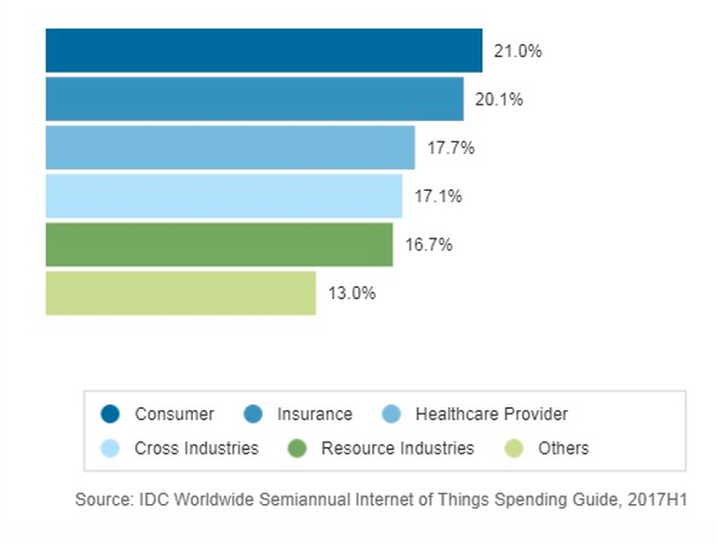

* 1. **DHT11 TEMPERATURE SENSORS**

DHT11 Temperature and Humidity Sensor features a calibrated digital signal output with the temperature and humidity sensor capability. It is integrated  with a high-performance 8-bit microcontroller. Its technology ensures the high reliability and excellent long-term stability.  This sensor includes a resistive element and a sensor for wet NTC temperature measuring devices. It has excellent quality, fast response, anti-interference ability and high performance.

Each DHT11 sensors features extremely accurate calibration of humidity calibration chamber. The calibration coefficients stored in the OTP program memory, internal sensors detect signals in the process, we should call these calibration coefficients. The single-wire serial interface system is integrated to become quick and easy. Small size, low power, signal transmission distance up to 20 meters, enabling a variety of applications and even the most demanding ones. The product is 4-pin single row pin package. Convenient connection, special packages can be provided according to users need.

Specification

* Supply Voltage: +5 V
* Temperature range :0-50 °C error of ± 2 °C
* Humidity :20-90% RH ± 5% RH error
* Interface: Digital

Many low cost sensors have unusual output formats, and in this case, a "Manchester-esque" output that is not SPI, I2C or 1-Wire compatible must be polled continuously.

* 1. **MQ-4 NATURAL GAS AND METAN SENSORS**

A Methane Gas Sensor is a device used as an integral part of a fixed gas detection system for the purposes of monitoring and detecting levels of methane in air in % LEL (Lower Explosive Limit) levels or in percent by volume levels.

There are two technologies used to manufacture Methane Sensors, Catalytic Bead and Infrared sensor technologies. [Catalytic Bead sensors](https://www.gdscorp.com/catalytic-sensor) predate Infrared sensors, and are prone to being poisoned by silicone, lead, sulfur and halogenated compounds. They also require frequent calibration and although less costly than an Infrared sensor, require replacement on a more frequent basis. Because they are lower in cost, some end users still prefer to use Catalytic Bead sensors as a Methane Sensor, especially where there could be other combustible solvent vapors preset that the Catalytic Bead sensor will detect, while an Infrared sensor would not.

As a Methane Sensor, Infrared sensor technology has now become the dominant Methane Gas Sensor in a fixed gas detection system for combustible detection of hazardous levels of methane in air. Because an Infrared Methane Sensor does not require oxygen to operate, [Infrared Methane Sensors](https://www.gdscorp.com/gastype/ir-combustible-gas-sensor) can also be used in a 0-100% by volume methane or other hydrocarbon gas process gas environment, such as in natural gas pipelines, utility applications and bio gas applications.

A Catalytic Bead Methane Sensor works as a simple Wheatstone bridge circuit, where an active and reference filament wound from platinum wire with a palladium based catalyst changes the proportional resistance between the active and reference bead of the methane sensor in proportion to the amount of methane detected in a background of air.

Infrared Gas Detection instruments that use infrared methane sensors often use two wavelengths of infrared energy, with one active wavelength used for gas absorption, and the other as a reference wavelength to compensate the output signal of the Infrared Detection system for the effects of temperature and humidity.

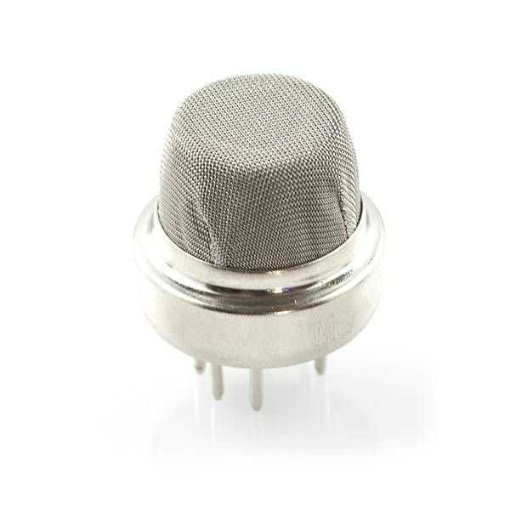



**Chapter 3: PROJECT METHODOLOGY**



1. **CHAPTER 3: PROJECT METHODOLOGY**

In this chapter I will describe the adopted methodology that I used in the project. I will describe the methodology phases that I will use to accomplish the project and the phases that the methodology consist.

* 1. **ADOPTED METHODOLOGY**

The adopted methodology during the development of this project is the waterfall methodology because it was the most suitable methodology for a project like IoT home automation system. Also as I mentioned earlier, I understood the requirements very well for this project. There are five steps in waterfall methodology starts with requirement analyses, followed by design, implementation, verification and finishes with testing and maintenance.

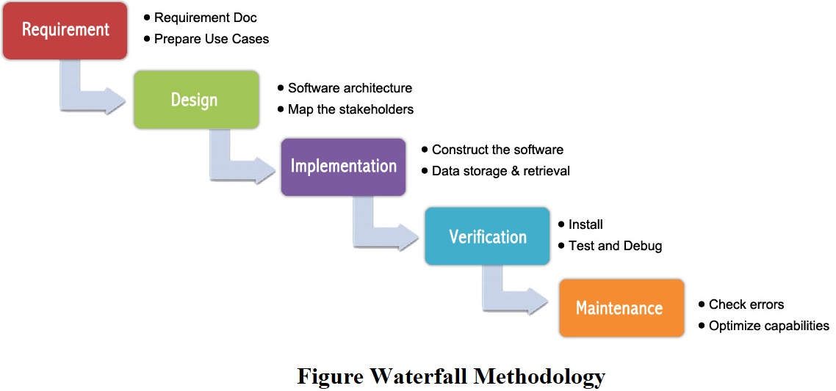

* 1. **WATERFALL METHODOLOGY**

The waterfall methodology was first introduced by Dr. Winston W. Royce in a paper published in 1970. The waterfall methodology emphasizes that a logical progression of steps be taken throughout the software development life cycle. It is now the most used methodology and it gets its name from the analogy of water falling downward. When the waterfall methodology was first introduced it was difficult for usage because it was incomplete in its

original framework and structure. Today, the most used version available includes a

corrective feedback mechanism.

* 1. **WHY ADOPTING WATERFALL IS SUITABLE FOR IoT AUTOMATION SYSTEM ?**

I adopted this methodology for the project because:

1. The requirements are clear, simple, and well understood for the project.
2. It can be developed step by step.
3. I understood the requirements of the project very well.
4. It was very suitable for this project.
   1. **IMPLEMENTATION OF WATERFALL**

The steps of the waterfall will be implemented to achieve this project. Each step has its own functions like in implementation and coding i will make the hardware design, processing design and software design. You can see it on “Figure Waterfall Steps”.

* 1. **APPLICATION SUMMARY**

The user interacts with the tool using GUI. The GUI operates in four forms. Signin Form, Signup Form, Password Reset Form and Homepage Form. Signin Form is an interacting form for login statement. Signup form is for creating a new account in application and system. Password Reset Form is for resetting password that the form sends e-mail for password reset process. In Homepage Form, user is able to switch appliencies and check out home statement.

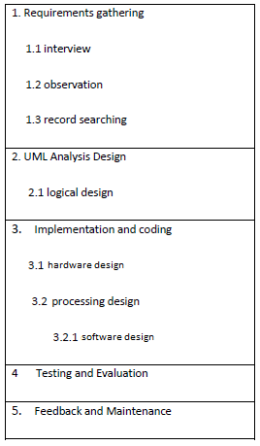

**Figure Waterfall Steps**



**CHAPTER 4: ANALYSIS AND DESIGN**



1. **CHAPTER 4: ANALYSIS AND DESIGN**

This chapter will provide a full description of the project and its users. Then this chapter will provide functional and non-functional requirements that have been collected using various methods. After the determination of the requirements, requirement analysis was adopted using various tools like use-case diagram, block diagram.

* 1. **PROJECT DESCRIPTION**

IoT Home Automation project is a combined project of a circuit on Ardunio and an application on Android. The purpose of the Project is interact with the users for switching and controling on their home appliancies and home statement. The project was developed more than two months.

Firstly, after researches the visual of the application is designed. Images, labels, fonts, background, font colors and icons were created on AdobeXD CC. Layouts has been created and colored form by form. When this’s done, the registiration system was coded. Firebase Authantication and Real-Time Database were integrated on the reisgrtration system. This system provided me extro functions like password reset.  
  
Secondly, i started the combine the circuit on Ardunio. I researched IoT Home Automation Systems on many projects and i reached many IoT methods and libraries. Then, i choosed one of them and used it. At the end, i came together the two parts of Project circuit and application and tested it. I fixed all of errors like crashing. Thus, the Project was finished.

* 1. **USER DESCRIPTION**

User have a circuit on their home and the application on their android mobile devices. Hardware details is given 4.6 User Requirements. .User have to create an account on the application. If user doesn’t create an account, it cannot login and see other sections on the application.

User have a specific account. User can switch and control their home statement on the application freely and in real time.

* 1. **REQUIREMENTS DEVELOPMENT**

To develop the functional and non-functional requirements of the Project, I did many researches from the internet. I brainstormed with some of my friends. I collected these informations and datas. Thus, i generated the requirements.

* 1. **SYSTEM REQUIREMENTS**

According to my researches, i developed the requirements that are functional and non functional. These requirements are determined for users to ease use. After implemantation these requirements the biggest of developing area is software developing. The Project or the application software system is design, coding, testing, implemantation and operation.

These requirements defined the system requirements.

* 1. **FUNCTIONAL REQUIREMENTS**

The functional requirements were developed by reviewing literature review, comparing similar circuits, interviewing and brainstorming with friends and experts.

The user who will use this project will have specific requirements in order to use this project.

* User Registration

Users must be able to register for the application through a valid e-mail. On installing the application, user must be prompted to register their e-mail and password. If user wants to skip this registaration, user must not see homepage other spefications. The email will be the unique identifier of users account on IoT Home Automation System “My Homemate.

* Notifications

The application has some specific notification like alert statement. If android operating system in the user’s mobile device is older than sdk 26 version. The user cannot see the notification in his/her system.

* 1. **USER REQUIREMENTS**

The main requirement is a android device. The Project is tested for android mobile phone. User should use a android mobile phone. But, the given below requirements is mandatory:

* Device must be connected to the internet.
* Android Version 5.1 or newer version User should have a laptop or pc and Arduino
* 128 MB minumum RAM
* Processor with Speed of 500 MHz
* The Project Application must be installed.
  1. **NON-FUNCTIONAL REQUIREMENTS**

So many non-functional requirements can be considered in order to develop this project. For example, the circuit must be simple to achieve its goal, it must be understandable, easy to learn and use. To make that happen I brainstormed with a lot people mostly my friends who have more knowledge than me in this particular subject and adopted non-functional requirements to the circuits.

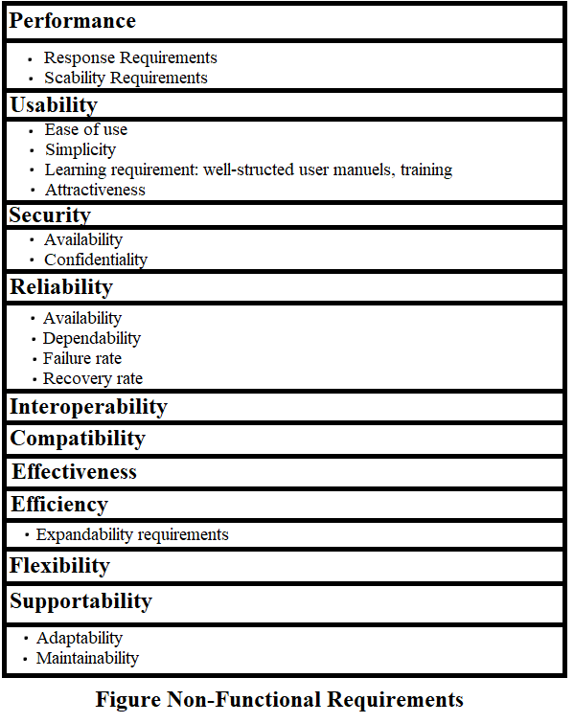

* 1. **SYSTEM ANALYSIS**

This section will contain the analysis of funtional and non-functional requirements of the project using use-case diagram and activities will be analized using a block diagram.

* 1. **USE-CASE DIAGRAM**

To see the main aspects of the project I developed a use-case diagram. The diagram shows the interaction between the user and the system. The use-case diagram was developed in order to clarify, identify and organize system requirements.

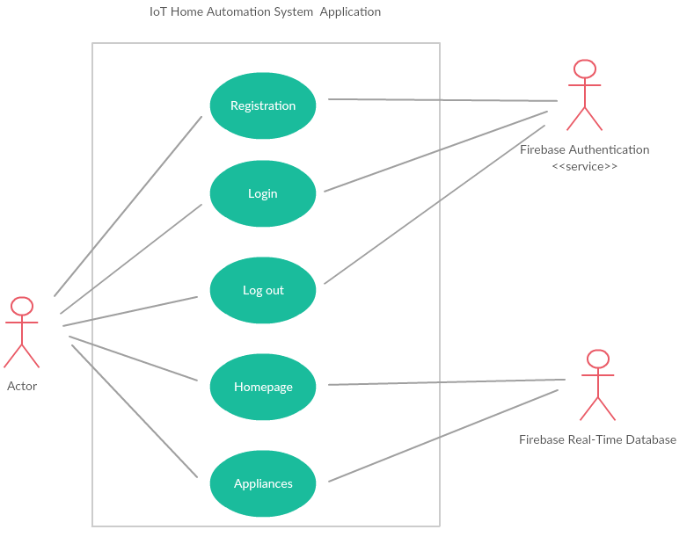

**Use Case Diagram**

* 1. **BLOCK DIAGRAM**

To see the systems main circuit I developed a block diagram. The whole systems controlling devices are the Arduino Nano microcontroller and NodeMCUESP8266.

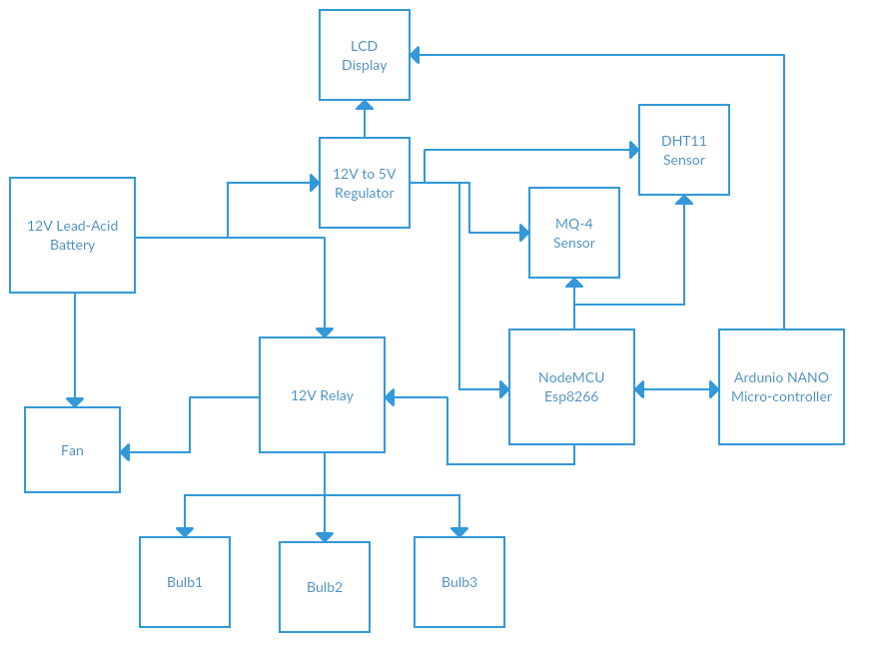



**CHAPTER 5: IMPLEMENTATION**



1. **CHAPTER 5: DESIGN AND IMPLEMENTATION**

This chapter will cover the design and implementation of the project. The implementaion phase combines the design phase outputs, requirements and the technology for usage.

* 1. **DESIGN PHASE**

Designing phase can be explanied by connecting every part of the system together. The software on Android as the application, Firebase database and hardware circuit as bulbs, relay module, fan, nodemcu-esp8266, mq-4 gas sensor, dht11 temperatur and humidity sensor, regulator 12V to 5V Ardunio Nano and battery.

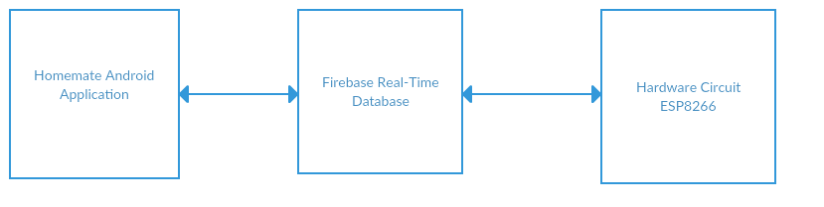

**Design Structure**

* 1. **BUILDING THE HARDWARE**

It took me more than two months to gather the materials and components for the system. Because I couldn’t find all the parts of the system in just one place. That is why I visited a lot of electronic shops in order to find all the necessary parts that I need for the system design. After gathering all the components for the system I started the building the circuit of the system. Here is the list of every hardware component that I used in the project:

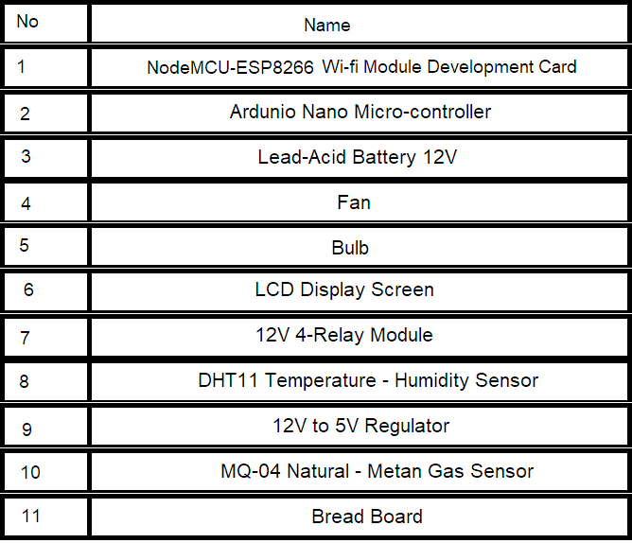

**Hardware Tools List**

* 1. **BUILDING THE SOFTWARE**

After I gathered the hardware materials, I started to software part of the project. I started building the sofware part on Arduino IDE software. My priority was the hardware part and database integration part of the project but I simultaneously developed the hardware and software part of the project. The sofware part was not easy for me at first. However when I did some researches I saw that developing the software part was not that difficult and developed it with minor problems. After the tests I did I also solved that minor problems on the software part. 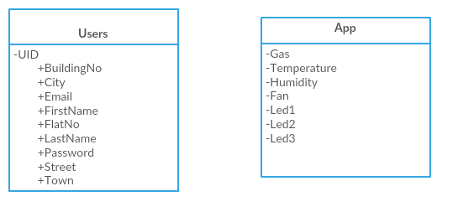

**Firebase Database Table**

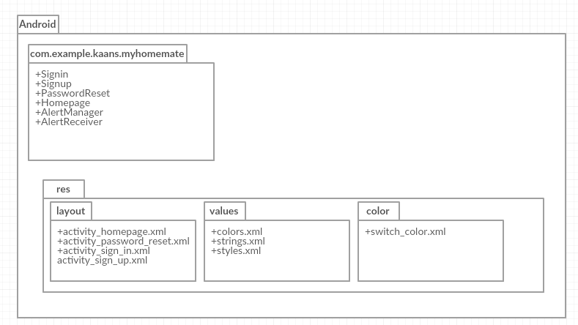

**Package Diagram**

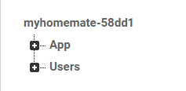

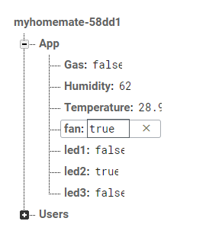

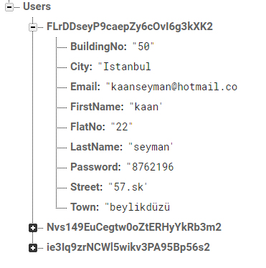

**Firebase Database Screen-shots**

* 1. **IMPLEMENTATION PHASE**

After the development of both hardware and software part of the project I combined them in implementation phase. Firstly, I started building the hardware part of the project and simultaneously I developed the sofware part. After finishing the development of both hardware and sofware part I combined the hardware and software part together.

* 1. **USER INTERFACE**

In this section, you will see user interface of the application on an emulator as screenshots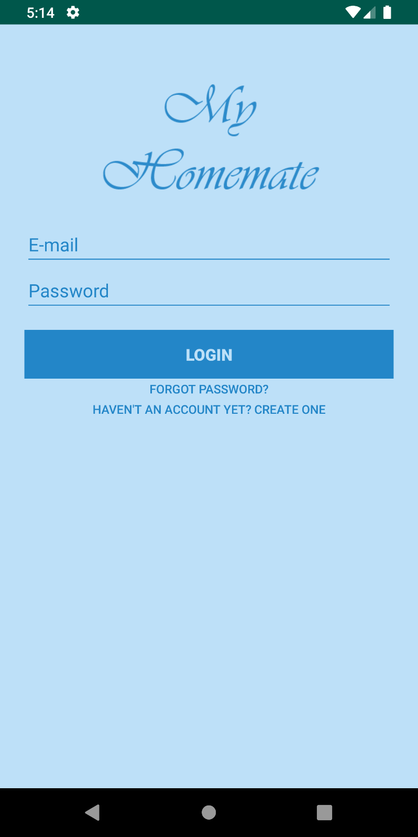

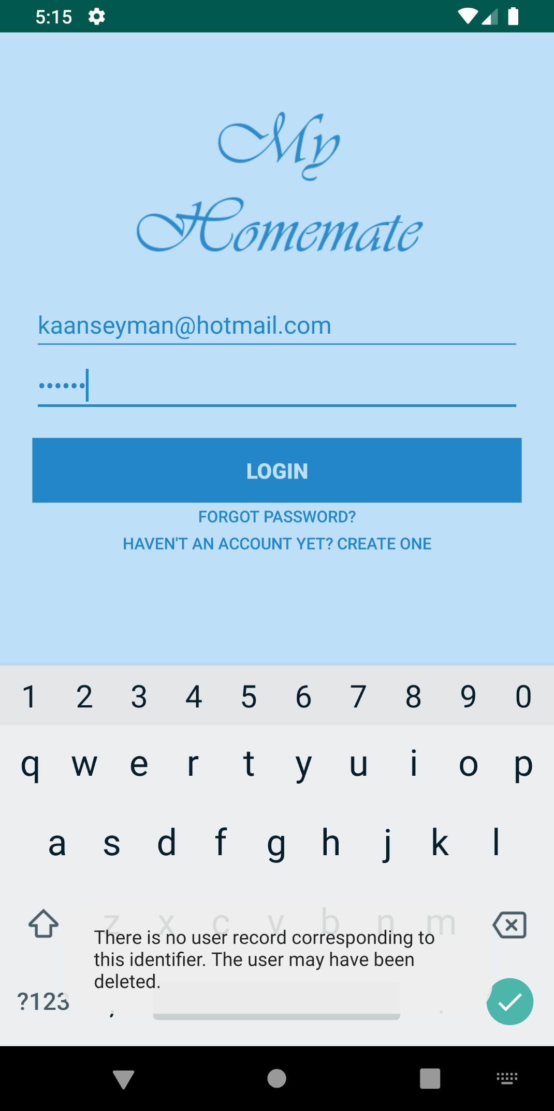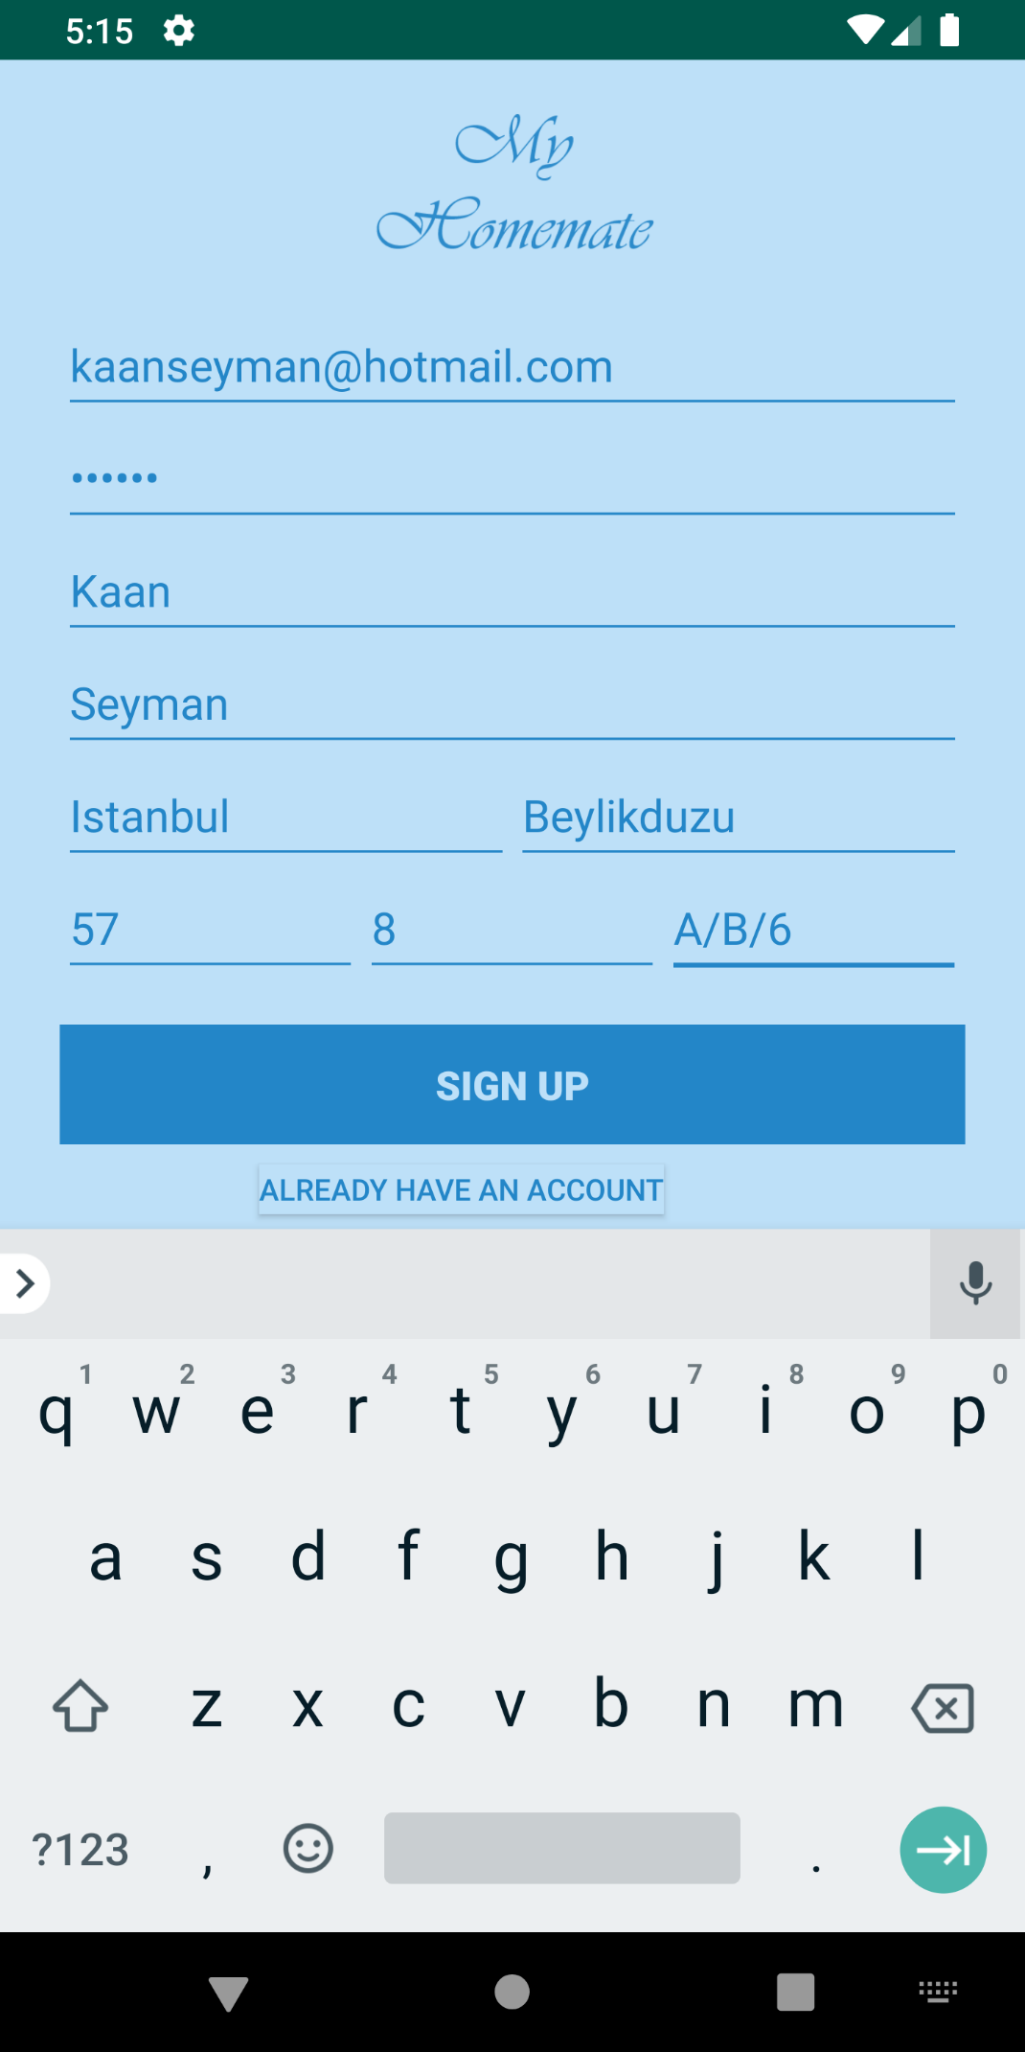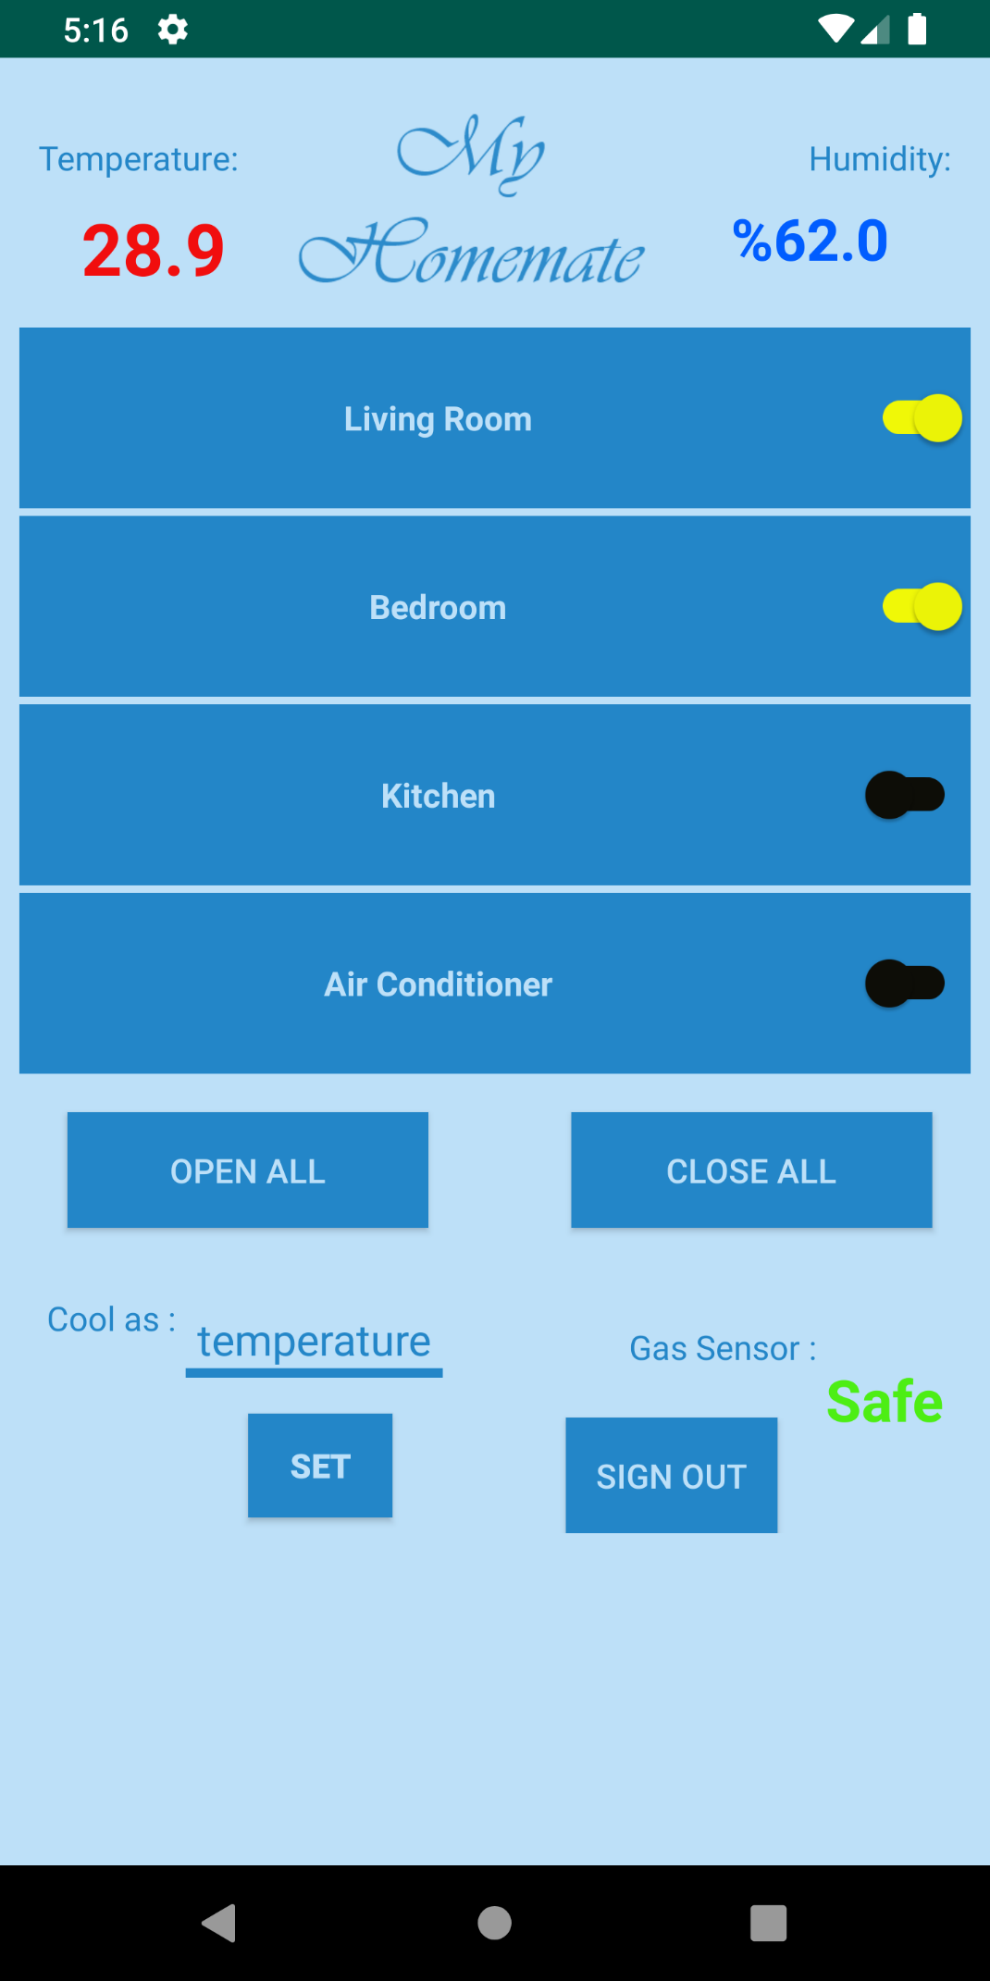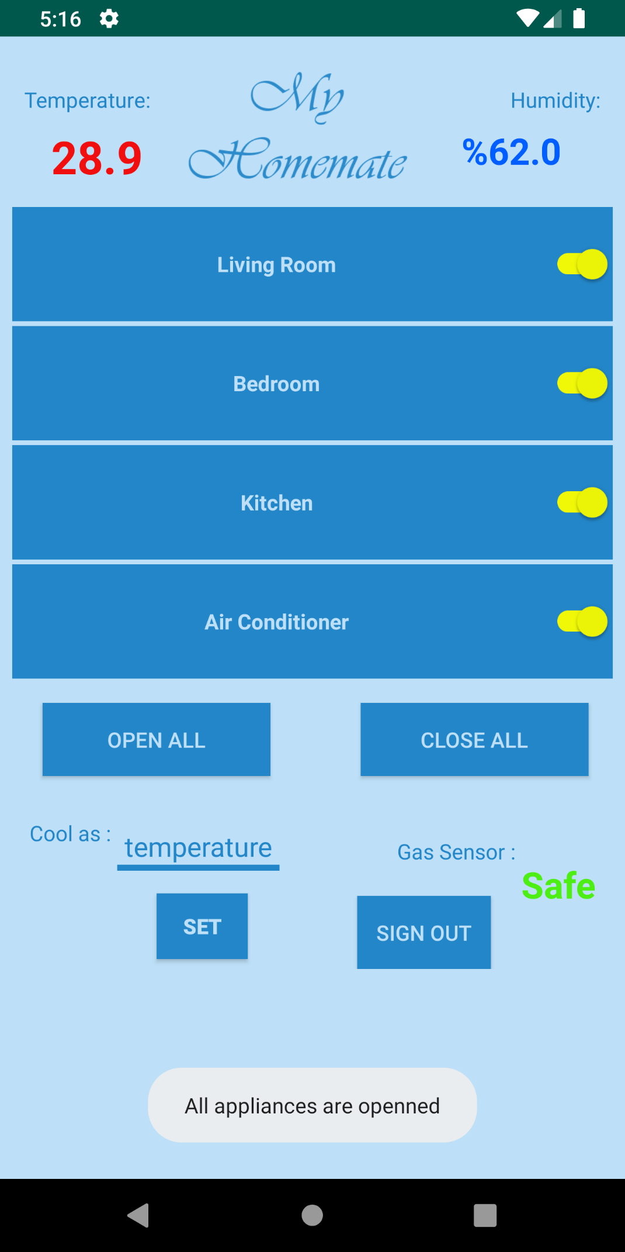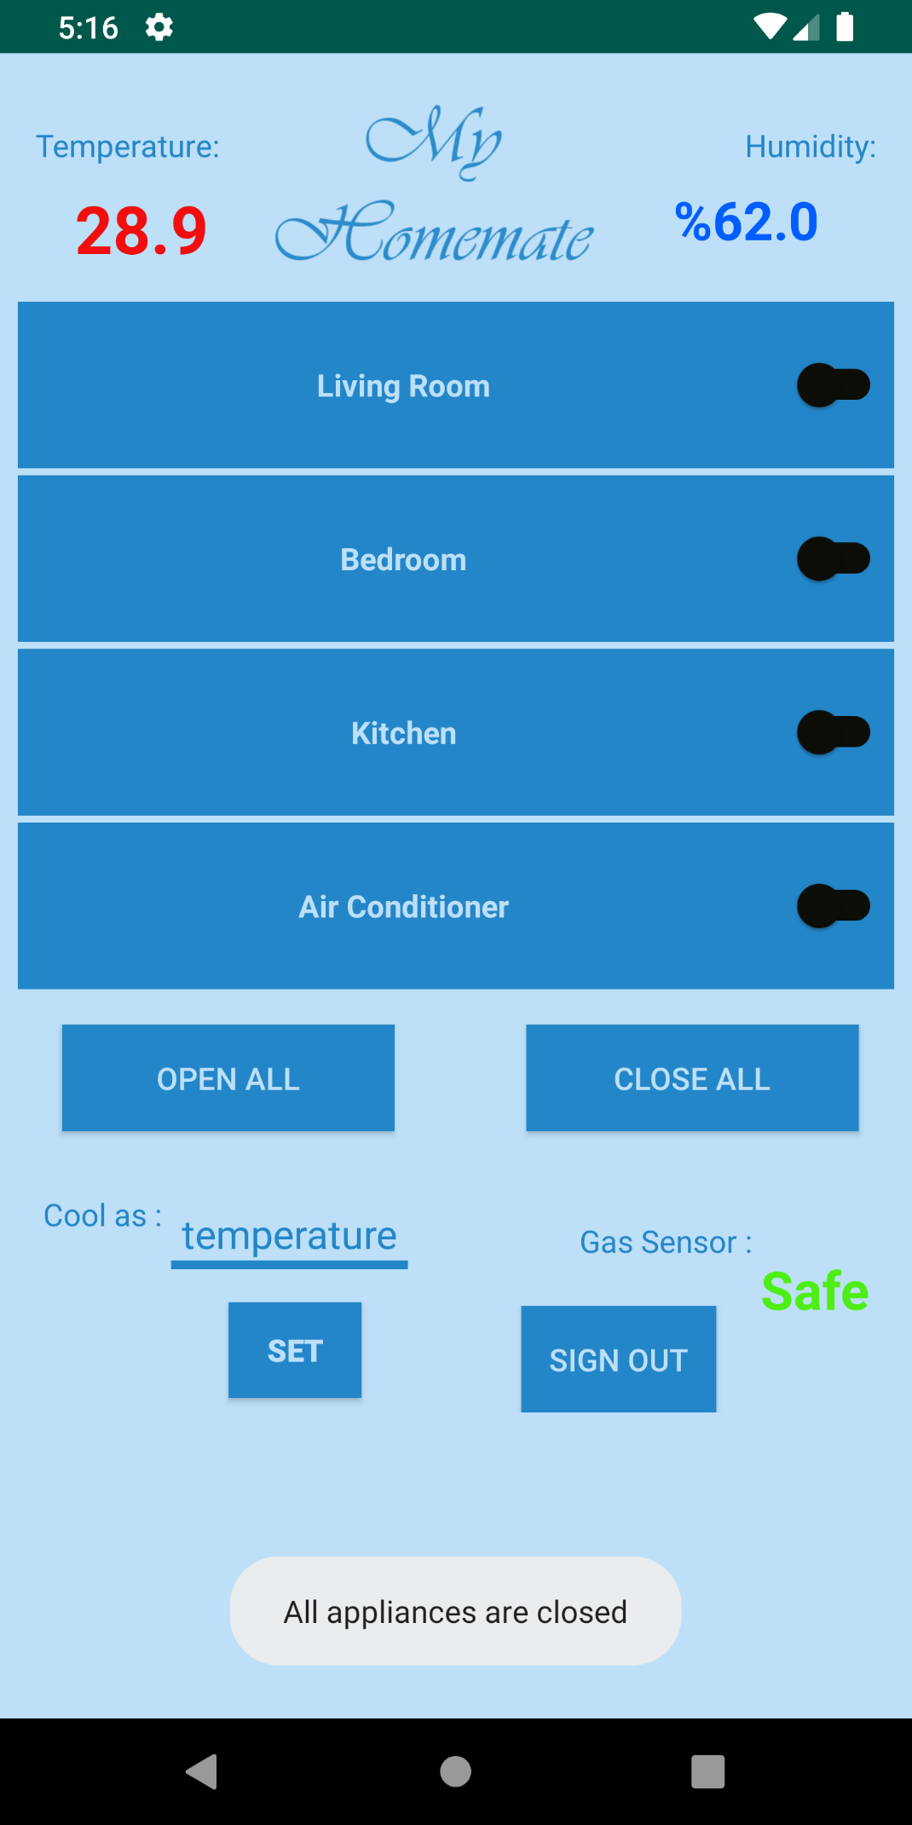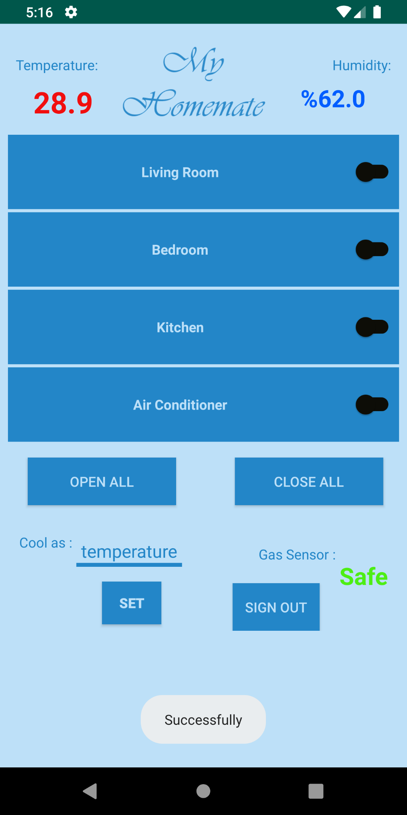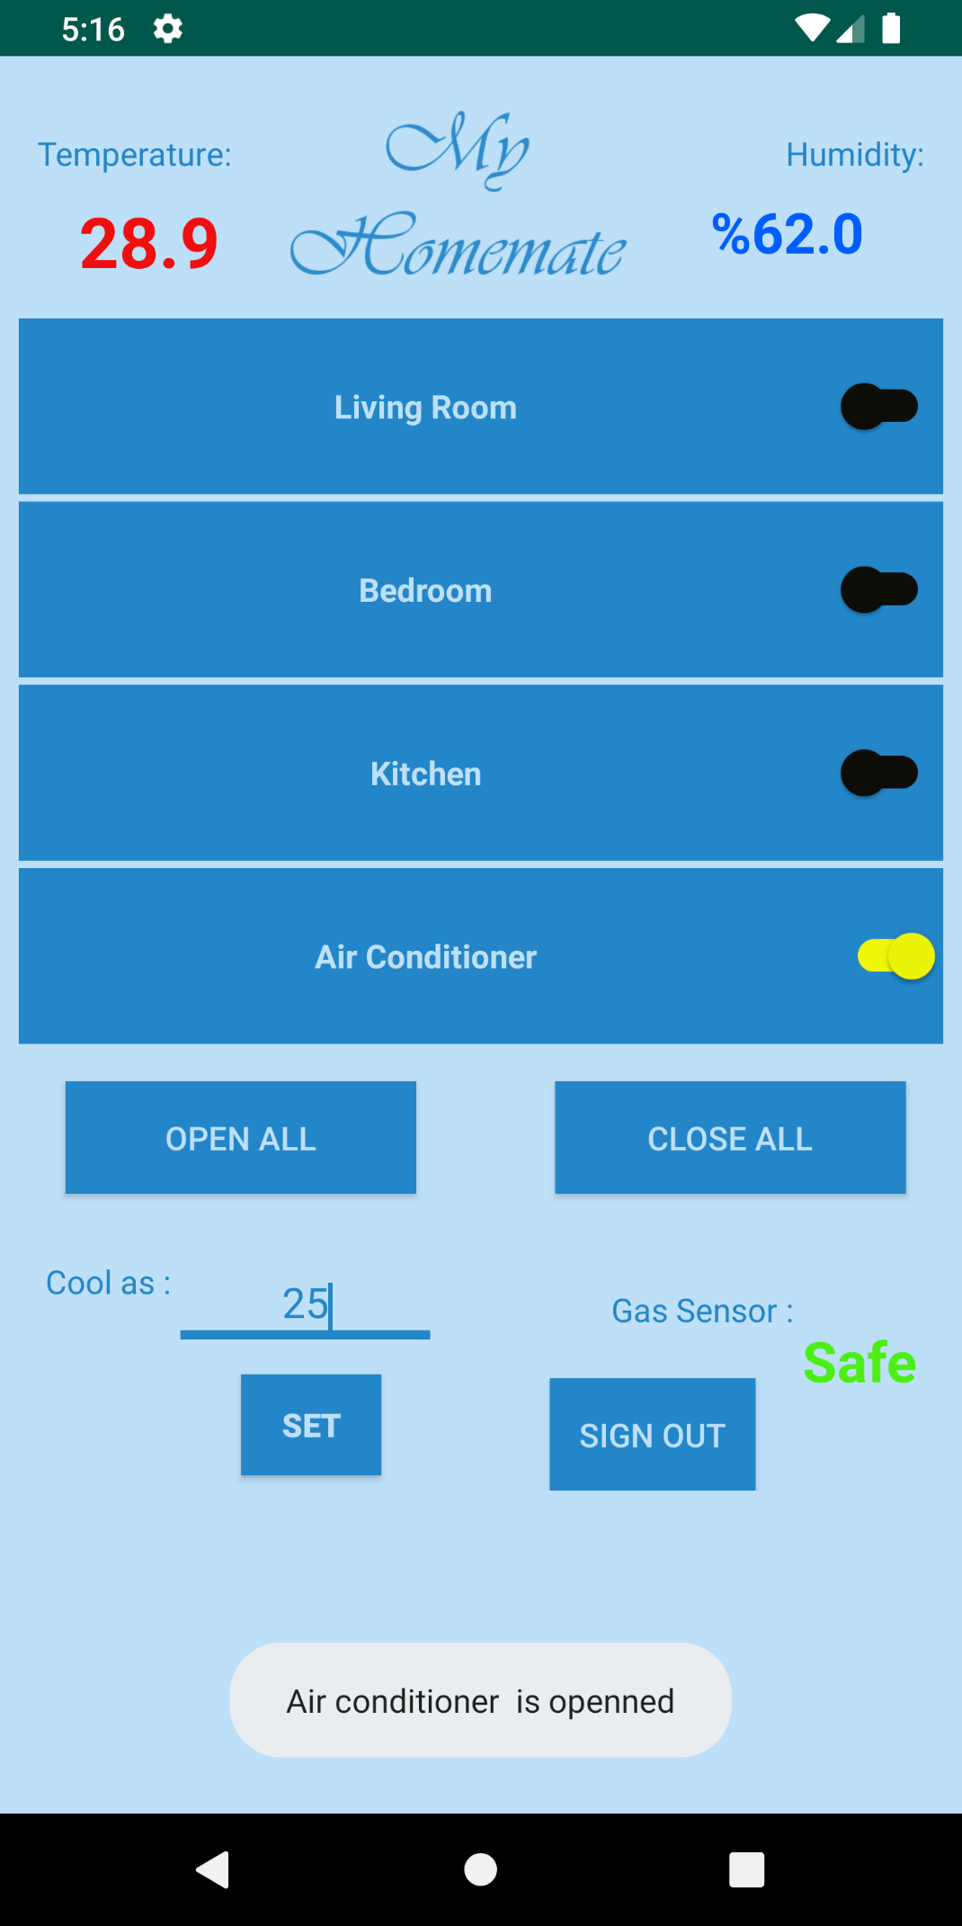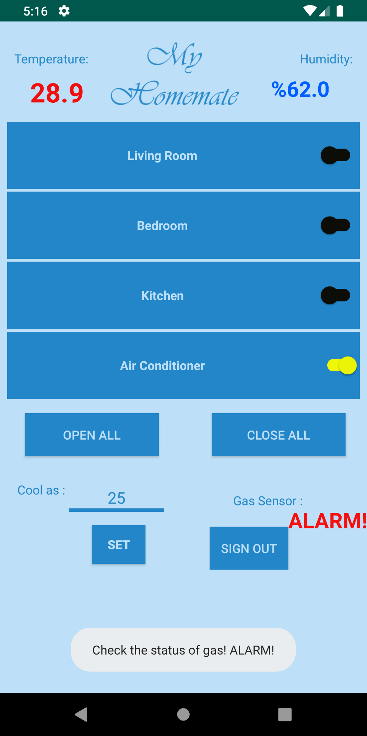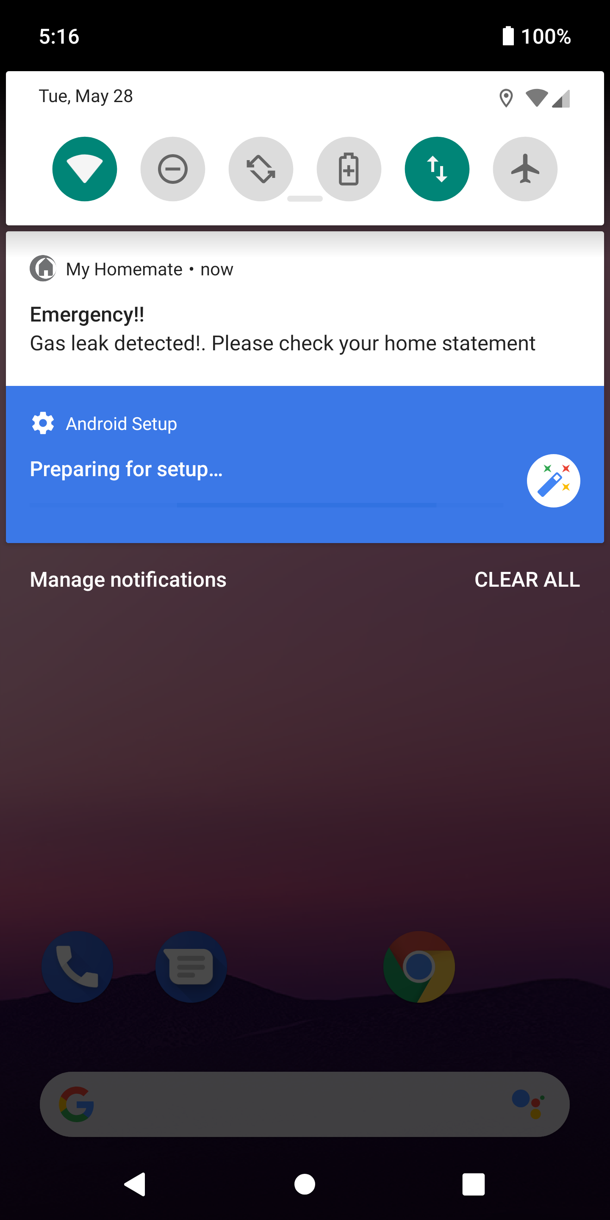

* 1. **REAL DESIGN OF THE PROJECT**

I took the picture of the real design of the project from various angles to show all the details about the design of the project.

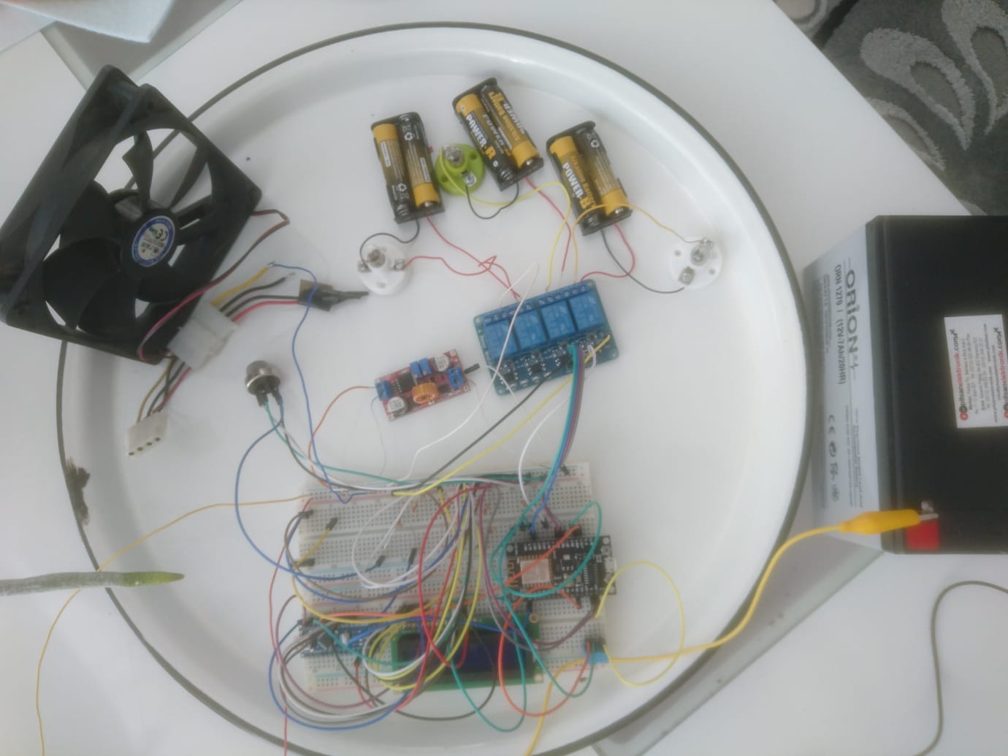

**Hardware of the Project**

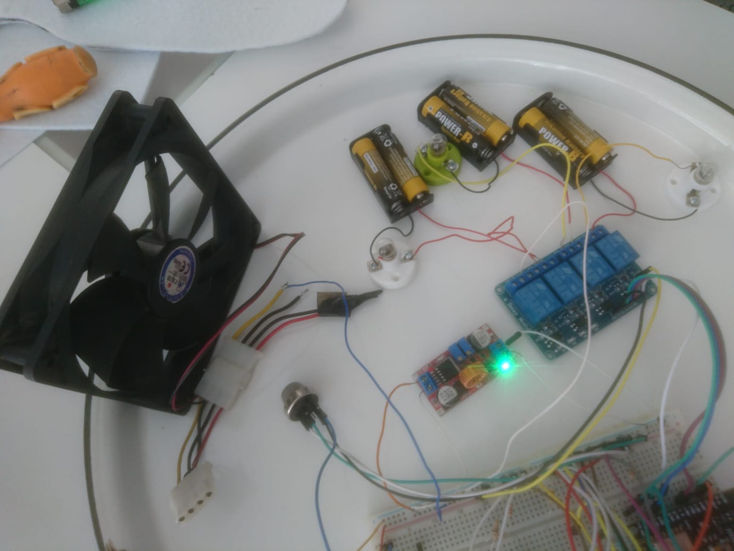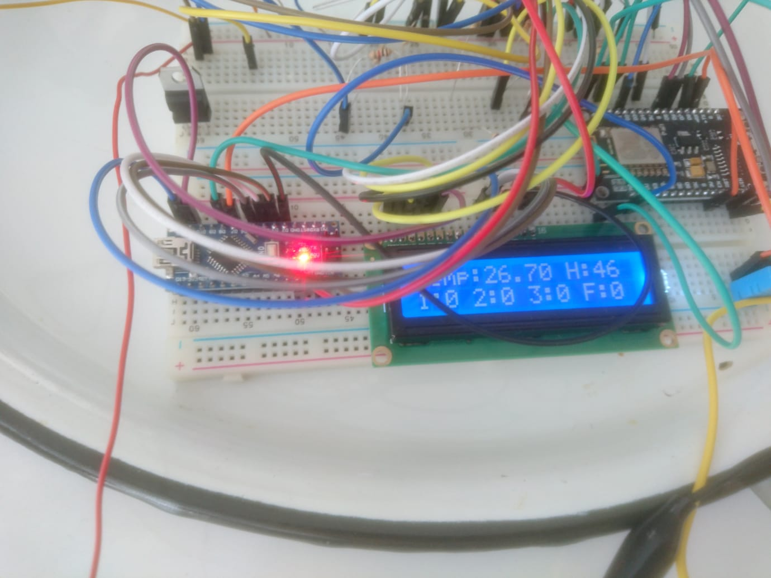



**CHAPTER 6: TESTING AND TOOLS**



1. **CHAPTER 6: TESTING AND TOOLS**

This chapter will contain the last phase of this project, which is testing and tools. In the testing part, performance and functionality testings were performed.

* 1. **TESTING**

Two types of testing was done to test the IoT Home Automation “My Homemate”. These tests were performance and functionality testing.

* 1. **PERFORMANCE TESTING**

After constructing all the parts together of the project and developing the software part using Arduino IDE, I had some critical problems about the hardware part of the project. The wires which were connected to the battery melted due to the problem that they touched each other. This major problem resulted in these two wires to melt. I solved this problem by using stronger and more sheltered wires. Also I tried my best to maket hem not touch each other. With that I solved a critical problem.

* 1. **FUNCTIONALITY TESTING**

After solving the wire problem, I didn’t have any functional problems with the project. I tested this by using Arduino IDE Sofware and with a multimeter but the project worked as I wanted it to work. 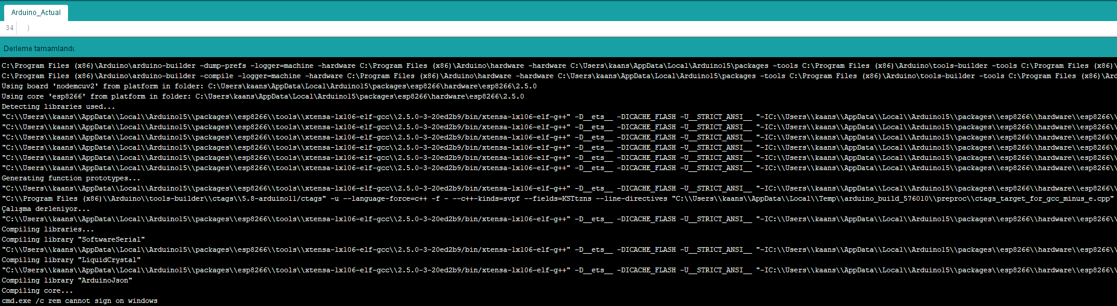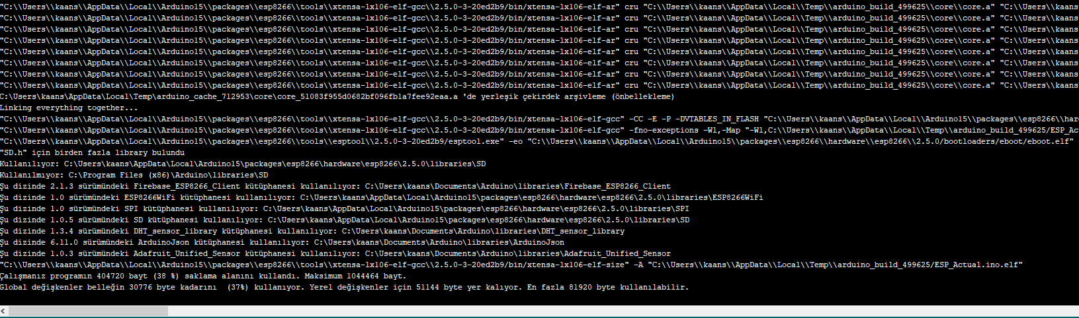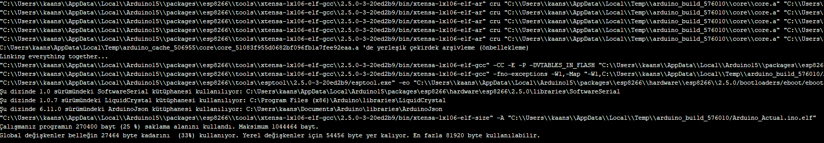

* 1. **TOOLS AND TECHNIQUES**

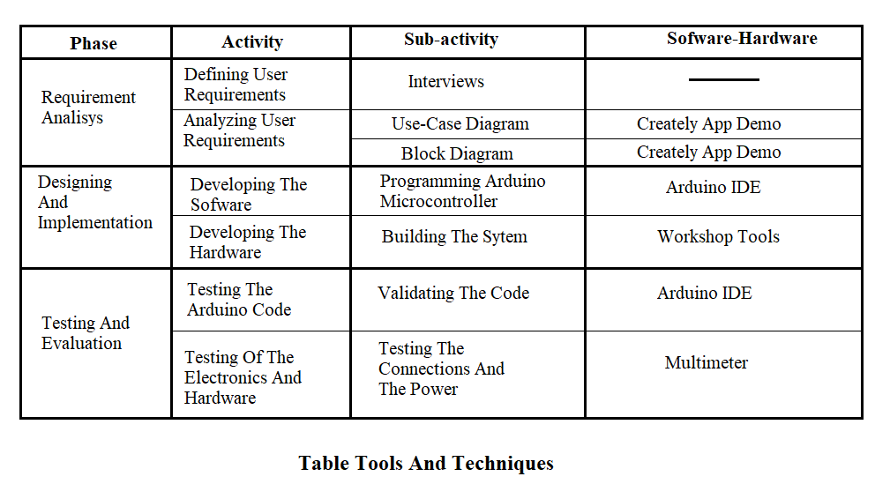

* 1. **MAINTANCE**

This is the final stage of this project. At this stage, maintaining, updating and enhancing the system will take place, which contains all the problems and errors that are met through the usage of the completed system which resulted in a updated and enchanced system.

I am maintaining both the hardware and the sofware components because if something changes in hardware I must change the sofware as well. So I linked all the components together and if anything changes even if it is a simple change, the whole system will be affected. This can lead the need of experience to maintain the components whenever something changes.

* 1. **CONCLUSION**

In today’s World, with the improvement of the technological development, people have become more demanding in terms of quality of life. However, today the usage of IoT Home Automation System is still increasing. This is causing the quality of people’s lives comfort.

So, I decided to make a project which will use real-time database on Android and Ardunio. The Project is IoT Home Automation System. This system could provide a home automatiıon expereince in real-time. I wanted to reach better user satisfaction.

However, this project is working as expected. The Project is succesful according to requirements. Any novice person can use the application on his/her mobile device.

REFERENCES

* To test the circuits virtually. [www.tinkercad.com](http://www.tinkercad.com) (20.02.2019)
* To learn about micro-controller. [www.electroschematics.com](http://www.electroschematics.com) (23.02.2019)
* To maket he diagrams. [www.creately.com](http://www.creately.com) (28.02.2019)
* To see how effectiveness works. [www.york.ac.uk](http://www.york.ac.uk) (01.03.2019)
* To learn what is effectiveness. [www.businessdictionary.com](http://www.businessdictionary.com) (01.03.2019)
* To learn about my requirements. [www.stackoverflow.com](http://www.stackoverflow.com) (01.03.2019)
* To learn what is interoperability. [www.techopedia.com](http://www.techopedia.com) (01.03.2019)
* To download and learn about arduino. [www.arduino.cc](http://www.arduino.cc) (05.03.2019)
* To see the synonyms of the english words. [www.thesaurus.com](http://www.thesaurus.com) (06.03.2019)
* To search methodologies. [www.ukessays.com](http://www.ukessays.com) (10.03.2019)
* To search methodologies. [www.itinfo.am](http://www.itinfo.am) (11.03.2019)
* To search about how to develop software and methodologies. en.wikipedia.org (14.03.2019)
* To see different types of methodologies. [www.quora.com](http://www.quora.com) (15.03.2019)
* For programming methodology tutorial. [www.tutorialspoint.com](http://www.tutorialspoint.com) (15.03.2019)
* To make research about programming methodologies. [www.chegg.com](http://www.chegg.com) (18.03.2019)
* To make research about computer methods. [www.sciencedirect.com](http://www.sciencedirect.com) (20.03.2019)
* To learn how to convert 12V DC to 5V DC. [www.electronicshub.org](http://www.electronicshub.org) (25.03.2019)
* To learn about arduino. [www.robotiksistem.com](http://www.robotiksistem.com) (27.03.2019)
* To learn about circiut with arduino. [www.makingcircuits.com](http://www.makingcircuits.com) (28.03.2019)
* To search about where ardunio componenets. [www.direnc.net](http://www.direnc.net) (31.03.2019)
* To learn what android is: <https://www.android.com/play/> (31.03.2019)
* To learn android development <https://developer.android.com/> (31.03.2019)
* Education for android development: <https://www.udemy.com/android-o-mobil-uygulama-dersi-kotlin-java> (05.04.2019)
* To learn android studio: <https://tr.wikipedia.org/wiki/Android_Studio> (09.04.2019)
* To learn android studio tools: <https://www.tutorialspoint.com/android/android_studio.htm> (11.04.2019)
* To learn android studio: <https://developer.android.com/guide/> (12.04.2019)
* To understand android architecture: <https://www.educba.com/structure-of-an-android-operating-system/> (13.04.2019)
* Be sure about Determining Project Requirements :<https://www.pmi.org/learning/library/determining-project-requirements-best-practices-7278> (14.04.2019)
* Uml Diagrams: <https://tallyfy.com/uml-diagram/> (25.04.2019)
* Online diagram: <https://creately.com> (30.04.2019)
* To learn Adobe XD: <https://helpx.adobe.com/xd/tutorials.html> (01.05.2019)
* More Adobe XD tutorial: <http://www.foreverdansky.com/categories/adobe-xd-tutorials> (03.05.2019)
* To create a new Database: <https://firebase.google.com/docs/database/> (15.05.2019)
* To learn Firebase Authentication System: <https://firebase.google.com/docs/auth/> (17.05.2019)
* Tutorial for integration: <https://www.raywenderlich.com/5114-firebase-tutorial-for-android-getting-started> (18.05.2019)
* To learn error fixing: <https://stackoverflow.com/questions/16561692/android-exception-handling-best-practice> (19.05.2019)
* To learn error fixing <https://android.jlelse.eu/flexible-way-to-handle-exceptions-in-android-9de236f304ad> (19.05.2019)