Predicting Short-Term Popularity Growth of YouTube Trending Videos
Using Platform Metrics and External Search Interest Signals
Course: DSA 210 – Introduction to Data Science
Term: Fall 2025–2026
Author: Kaan Tanıdır
Department: Computer Science and Engineering
University: Sabancı University
Date: January 2026

Abstract
This project investigates whether external search interest data from Google Trends can improve the prediction of short-term popularity growth of YouTube trending videos. Using publicly available YouTube Trending data enriched with category-level Google Trends signals, the study applies exploratory data analysis, statistical hypothesis testing, and supervised machine learning models. Results indicate that while overall predictive performance remains moderate, incorporating Google Trends features provides a consistent improvement, particularly in precision–recall performance for identifying high-growth videos.

1. Introduction and Motivation
YouTube is one of the largest online media platforms, where videos can experience rapid and sometimes unpredictable popularity growth. Understanding the factors that drive short-term surges in attention is valuable for content creators, advertisers, and analysts. While platform-level engagement metrics (e.g., views, likes, comments) provide strong signals, they may not fully capture broader public interest outside the platform. This project explores whether external search behavior, measured via Google Trends, can complement platform metrics in predicting short-term popularity growth among already-trending videos.

2. Research Questions
RQ1: Which video- and channel-level features are associated with higher short-term popularity growth?
RQ2: Does Google Trends search interest improve predictive performance?
RQ3: Can supervised machine learning models reliably classify high-growth videos?

3. Data Sources

3.1 YouTube Trending Dataset
The primary dataset is the YouTube Trending Videos dataset obtained from Kaggle (US subset). It includes video metadata and engagement metrics such as views, likes, dislikes, comment counts, publication time, and category identifiers.

3.2 Google Trends Data
Google Trends data was collected programmatically using the pytrends Python library. Representative search topics were defined per YouTube category, and daily search interest scores (0–100) were retrieved. Category-level time series were merged with the YouTube dataset based on each video’s trending date. All Google Trends features were derived specifically for this project (not downloaded as a pre-existing dataset).

4. Exploratory Data Analysis
Exploratory analysis shows that engagement variables (views, likes, dislikes, comments) are highly skewed, with a small number of videos receiving extremely high engagement. Category-level counts indicate that some categories dominate the trending feed. To reduce scale effects, engagement ratios such as like-to-view and comment-to-view were used in later stages. As shown in Figure 3, engagement ratios exhibit right-skewed distributions with relatively stable central tendencies, supporting their use as normalized predictors in subsequent modeling stages.

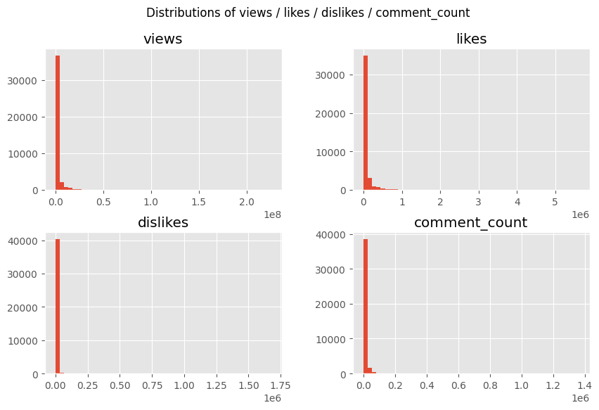
Figure 1. Distributions of engagement metrics in the US trending dataset (from 01_eda.ipynb).

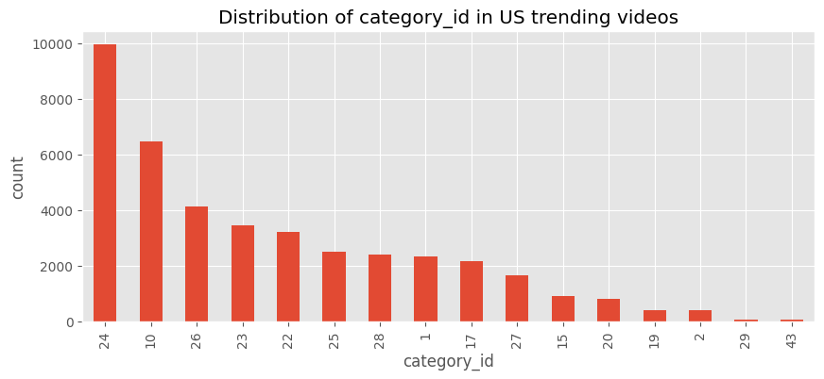
Figure 2. Category distribution for US trending videos (from 01_eda.ipynb).

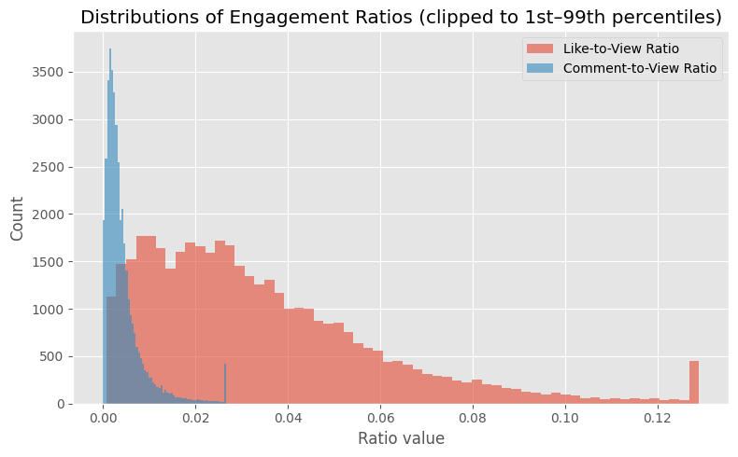
Figure 3. Distributions of engagement ratios (from 01_eda.ipynb).

5. Feature Engineering
Features were engineered from raw engagement and metadata. Core predictors include views, likes, dislikes, comment counts, publication hour, and engagement ratios (like/view and comment/view). Google Trends features include category-level daily trend scores and rolling averages (3-day and 7-day means). A binary target variable, high_growth, was constructed using category-normalized next-day view growth. Growth-based variables were used only to define the target and were excluded from the model feature set to avoid target leakage.

6. Statistical Analysis
To test whether Google Trends search interest differs between high-growth and low-growth videos, a non-parametric Mann–Whitney U test was conducted on Google Trends scores. The test indicates a statistically significant difference (p < 0.001), with higher average trend scores observed for the high-growth group.

Table 1. Mann–Whitney U test summary (Google Trends score vs. high_growth).
Rows used | Mann–Whitney U | p-value | Mean trend (high vs low)
33,409 | 111,591,307.50 | < 0.001 | 66.683 vs 63.701

7. Machine Learning Models
Supervised learning models were trained to classify high-growth videos: Logistic Regression, Random Forest, XGBoost, and LightGBM. A leakage-aware split was used at the video level to prevent the same video from appearing in both training and test sets. Performance was evaluated using accuracy, F1-score, ROC-AUC, and PR-AUC, with emphasis on PR-AUC due to class imbalance. Because the high-growth class represents a minority of observations, precision–recall–based metrics are emphasized to better reflect model performance under class imbalance.

8. Results
Two feature sets were evaluated: (A) YouTube platform metrics only, and (B) YouTube metrics plus Google Trends features. Incorporating Google Trends provides a modest but consistent improvement in predictive performance, particularly in PR-AUC. Although the absolute gains are modest, the consistent improvement across metrics suggests that Google Trends features add complementary information beyond platform engagement signals.
Table 2. Test-set performance for feature sets (from 03_modeling.ipynb).
Feature Set | ROC-AUC | PR-AUC
YouTube only | 0.6139 | 0.3353
YouTube + Trends | 0.6197 | 0.3662

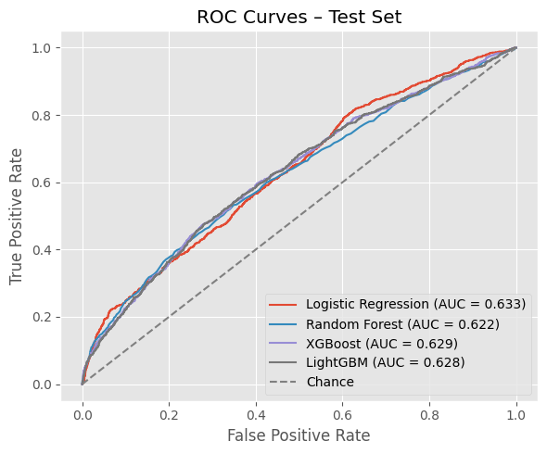
Figure 4. ROC curve figure saved in 03_modeling.ipynb output.

9. Model Interpretation
Feature importance analysis for tree-based models suggests that engagement ratios and trend signals can contribute to decision-making, though the overall effect of Google Trends features is smaller than core platform engagement predictors. The observed improvement is more pronounced in PR-AUC, consistent with the goal of identifying a minority high-growth class.

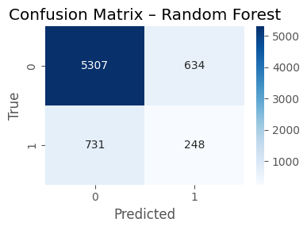
Figure 5. Feature importance visualization from 03_modeling.ipynb output.

10. Limitations and Future Work
This study is limited by the nature of the YouTube Trending dataset, which includes only already-trending (curated) content and may not represent the full YouTube ecosystem. Google Trends measures general topic interest rather than interest in individual videos. Future work could incorporate NLP features from titles/descriptions/tags, multi-country datasets, and time-series models to better capture temporal dynamics and exogenous signals.

11. Ethical Considerations
All data used in this project is publicly available and aggregated. No personal or private user data was collected. Potential biases may arise from YouTube’s trending mechanism, which can favor large channels or specific content categories. Findings should therefore be interpreted as patterns within a curated subset of content.

12. Conclusion
External search interest signals captured via Google Trends provide complementary information for predicting short-term popularity growth among trending YouTube videos. While overall predictive performance remains moderate, the consistent improvement—especially in PR-AUC—suggests that exogenous attention signals can modestly enhance platform-based models.

13. AI Usage Disclosure
AI tools were used in a limited and transparent manner during this project. Specifically, AI assistance was utilized for drafting and refining documentation, brainstorming ideas, and debugging code logic. All data processing, feature engineering, modeling decisions, and result interpretations were performed by the author. No AI-generated outputs were used directly as final results without verification. Details of AI usage, including example prompts and generated outputs, are documented in a separate ai_usage.md file.

14. References
Kaggle – YouTube Trending Videos dataset (US subset). https://www.kaggle.com/datasets/datasnaek/youtube-new
Google Trends via pytrends Python library.

