Public Attention, Market Sentiment, and Short-Term Bitcoin Market Behavior
Using Google Trends and Crypto Fear & Greed Index Signals
Course: DSA 210 – Introduction to Data Science
Term: Spring 2025–2026
Author: Kaan Tanıdır
University: Sabancı University
Date: May 2026

Abstract
This project investigates whether public attention and market sentiment indicators can improve short-term Bitcoin direction prediction and help explain Bitcoin market volatility. Historical Bitcoin market data from CoinGecko is enriched with Google Trends search-interest data and the Alternative.me Crypto Fear & Greed Index. The project applies a full data science pipeline including data collection, preprocessing, feature engineering, exploratory data analysis, hypothesis testing, and supervised machine learning. The results show that next-day Bitcoin direction remains difficult to predict, even after adding attention and sentiment variables. However, Google Trends shows a stronger relationship with 7-day volatility than with daily returns, suggesting that public attention may be more informative about market turbulence than short-term directional movement.

1. Introduction and Motivation
Bitcoin is one of the most visible and volatile financial assets in the cryptocurrency market. Its price behavior is often discussed in relation to public attention, investor sentiment, and sudden changes in market expectations. Because Bitcoin receives substantial search and media attention, it provides a useful case for studying whether publicly observable attention and sentiment indicators can help explain short-term market behavior.
The initial version of this project focused on whether Google Trends search interest could improve next-day Bitcoin direction prediction. After peer feedback, the project was strengthened by reframing the analysis from a simple Bitcoin prediction task into a broader study of public attention, market sentiment, direction prediction, and volatility behavior. A third data source, the Alternative.me Crypto Fear & Greed Index, was added as a sentiment-based enrichment source.

2. Research Questions
- RQ1: Are public attention and sentiment indicators associated with Bitcoin returns and volatility?
- RQ2: Does Google Trends search interest improve next-day Bitcoin direction prediction compared with market-only models?
- RQ3: Does the Alternative.me Crypto Fear & Greed Index add useful sentiment information to the modeling dataset?
- RQ4: Are attention and sentiment indicators more useful for explaining volatility than for predicting next-day direction?

3. Data Sources

3.1 CoinGecko Bitcoin Market Data
Bitcoin historical market data was downloaded from CoinGecko as a CSV file using the maximum available historical range. The raw file covers 2013-04-28 to 2026-03-17 and includes daily Bitcoin price, market capitalization, and total trading volume. Although the raw file begins in 2013, the final modeling period begins later because the dataset is restricted to dates with available Google Trends data after merging and preprocessing.
Source: https://www.coingecko.com/en/coins/bitcoin/historical_data

3.2 Google Trends Data
Google Trends data was manually downloaded for the keyword “Bitcoin” and used as a proxy for public attention. Since the exported Google Trends data is weekly, trend values were forward-filled to align them with daily Bitcoin market observations.
Source: https://trends.google.com/

3.3 Alternative.me Crypto Fear & Greed Index
The Alternative.me Crypto Fear & Greed Index was used as a sentiment-based enrichment source. It provides a daily score between 0 and 100, where lower values indicate fear and higher values indicate greed. The data was downloaded through the public API using the script src/fetch_fear_greed.py.
Source: https://alternative.me/crypto/fear-and-greed-index/
API: https://api.alternative.me/fng/?limit=0&format=json
Source | Role in project | Main variables
CoinGecko | Primary Bitcoin market dataset | price, market_cap, total_volume
Google Trends | Public attention proxy | google_trends_score and derived lag/rolling features
Alternative.me | Sentiment enrichment source | fear_greed_value and derived lag/rolling features

4. Exploratory Data Analysis
Exploratory data analysis was used to inspect the behavior of Bitcoin price, public search interest, sentiment, returns, and volatility. The goal was not only to describe the data, but also to identify whether attention and sentiment signals appear more closely connected with directional returns or with market turbulence.
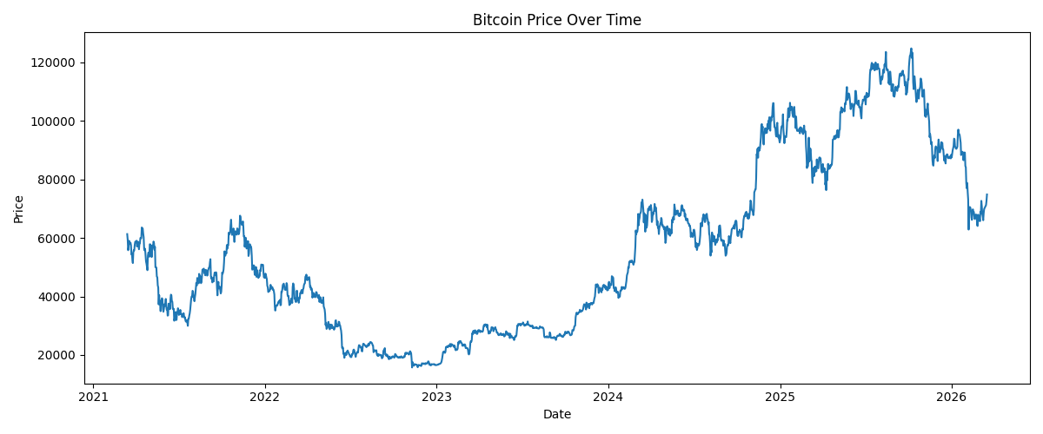Figure 1. Bitcoin price over the analysis period. Replace this placeholder with plot_price.png.
Figure 1 should be used to show the overall price trajectory and the periods of strong price movement. This figure provides the market context for interpreting subsequent attention and sentiment indicators.

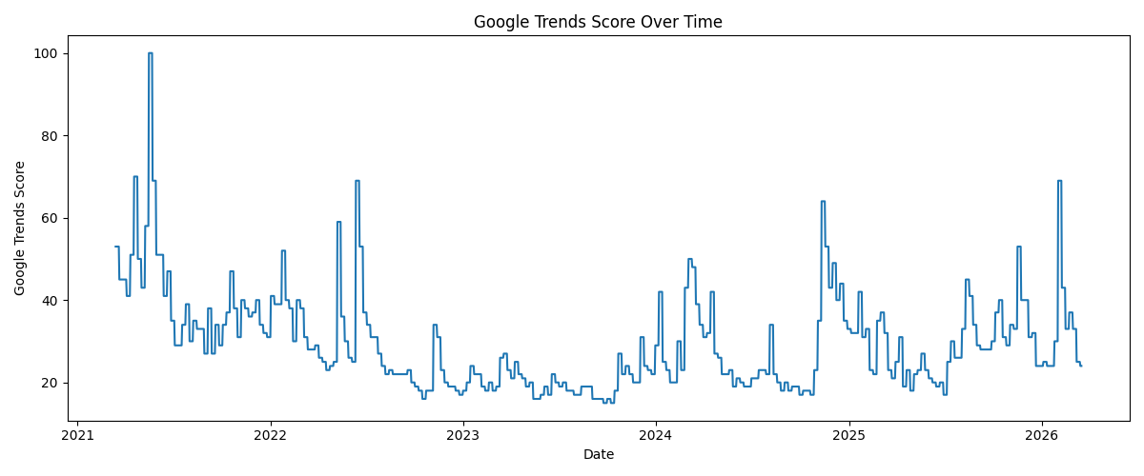
Figure 2. Google Trends search interest for Bitcoin over time. Replace this placeholder with plot_trends.png.
Figure 2 should illustrate changes in public search interest over time. Spikes in Google Trends can be compared with periods of price movement and volatility.

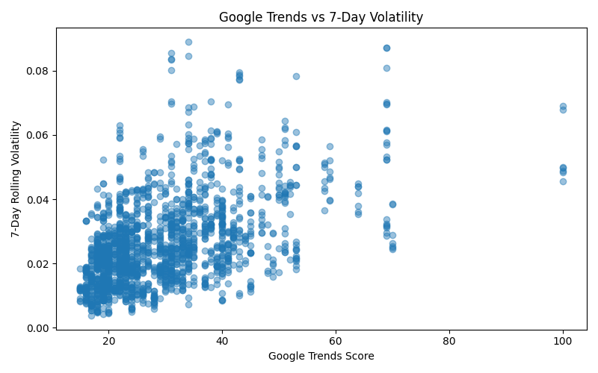
Figure 3. Relationship between Google Trends score and 7-day Bitcoin volatility. Replace this placeholder with plot_trends_vs_volatility.png.
Figure 3 is one of the central visuals in the report. The statistical results indicate that Google Trends has a stronger relationship with volatility than with next-day returns, and this figure should visually support that interpretation.

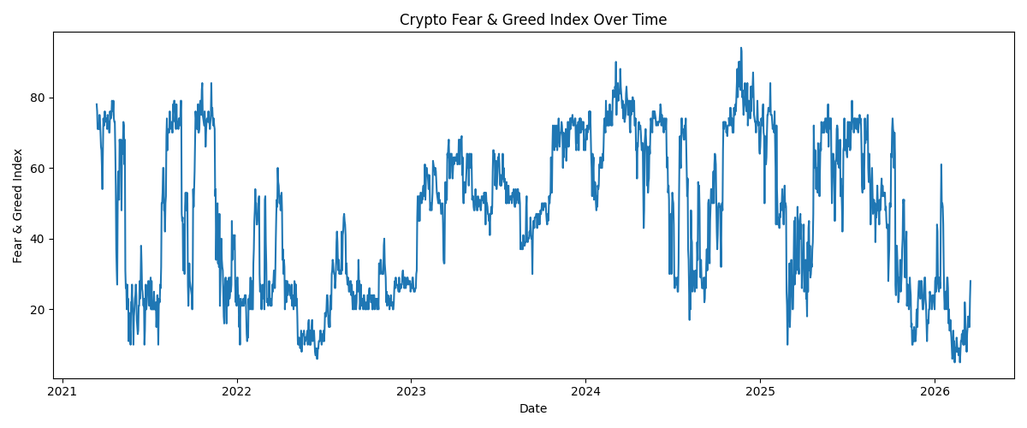
Figure 4. Crypto Fear & Greed Index over time. Replace this placeholder with plot_fear_greed.png.

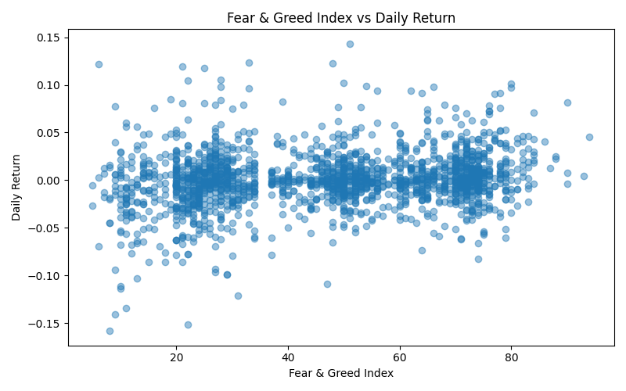
Figure 5. Relationship between Fear & Greed Index and daily Bitcoin return. Replace this placeholder with plot_fear_greed_vs_return.png.
Figures 4 and 5 should show how sentiment varies over time and how sentiment relates to daily return behavior. These figures are useful for explaining the value of the third data source.

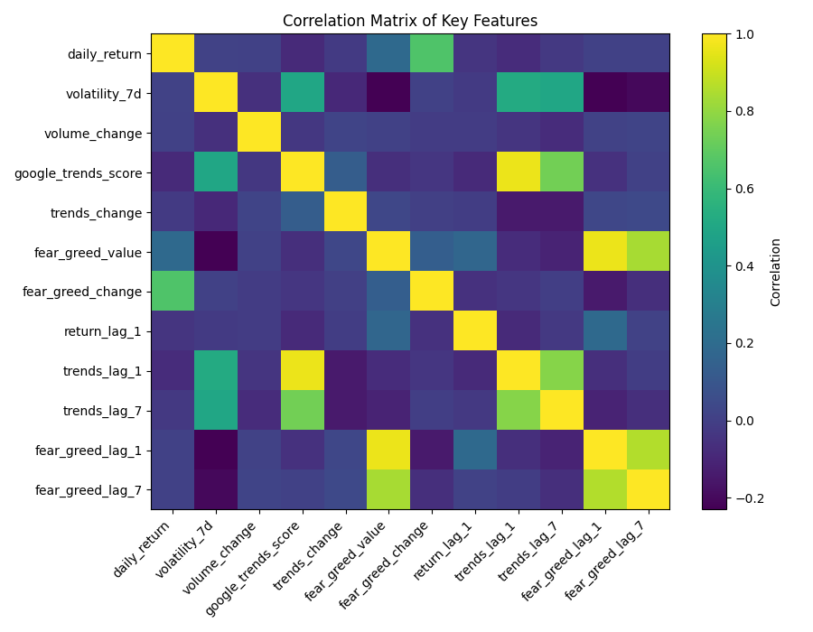
Figure 6. Correlation matrix of selected market, attention, and sentiment features. Replace this placeholder with plot_correlation_matrix.png.

5. Feature Engineering
Features were engineered from raw market data, Google Trends data, and Fear & Greed Index values. The final feature dataset contains 1,830 observations and 65 columns. The final target variable, target_up_next_day, indicates whether the Bitcoin price increased on the following day.
Feature group | Examples
Market-based features | price, market_cap, total_volume, daily_return, log_return, volume_change, moving averages
Volatility features | volatility_7d, volatility_14d, lagged volatility features
Attention features | google_trends_score, trends_change, trends_lag_1, trends_lag_7, rolling trends features
Sentiment features | fear_greed_value, fear_greed_change, fear_greed_lag_1, fear_greed_lag_7, rolling sentiment features
Target variables | target_up_next_day, target_high_volatility_next_7d
Lagged variables were included to evaluate whether earlier values of attention or sentiment contain information about later market behavior. Rolling features were included to capture short-term trends and variability.

6. Statistical Analysis
Hypothesis testing examined whether attention and sentiment indicators are related to Bitcoin returns and volatility. Pearson and Spearman correlations were used for continuous relationships, and a group comparison was used for high- versus low-attention days.
Test | Key result | Interpretation
Google Trends vs daily return | Pearson corr. = -0.082; p < 0.001 | Statistically significant but weak relationship with returns
Google Trends vs 7-day volatility | Spearman corr. = 0.492; p ≈ 7.96e-112 | Strongest relationship; attention is associated with volatility
Previous-week Trends vs volatility | Spearman corr. = 0.462; p ≈ 3.75e-97 | Lagged attention also relates to volatility
Fear & Greed vs return | Spearman corr. = 0.178; p ≈ 1.57e-14 | Same-day sentiment relates to return, but effect is limited
Previous-week Fear & Greed vs return | Spearman corr. = 0.004; p = 0.879 | Lagged sentiment does not strongly predict next-day returns
The strongest evidence comes from the relationship between Google Trends and volatility. This supports the interpretation that public search attention reflects market turbulence and emotional intensity more than reliable next-day price direction.

7. Machine Learning Models
Supervised classification models were trained to predict target_up_next_day. The models included a majority-class baseline, Logistic Regression, and Random Forest. Multiple feature sets were evaluated to test whether attention and sentiment variables add predictive value beyond market-only variables.
- Market-only features
- Google Trends-only features
- Fear & Greed-only features
- Market + Google Trends features
- Market + Fear & Greed features
- Market + Google Trends + Fear & Greed features
Performance was evaluated using accuracy, precision, recall, F1-score, and ROC-AUC. F1-score is useful because it summarizes the balance between precision and recall, while ROC-AUC evaluates ranking ability across decision thresholds.

8. Results
The machine learning results show that next-day Bitcoin direction remains difficult to classify. The best F1-scores were approximately in the 0.49–0.55 range, and ROC-AUC values remained modest.
Model | Feature set | Accuracy | F1 | ROC-AUC
Random Forest | Google Trends only | 0.500 | 0.550 | 0.482
Random Forest | Fear & Greed only | 0.522 | 0.545 | 0.509
Random Forest | Market + Google Trends | 0.538 | 0.540 | 0.528
Random Forest | Market only | 0.546 | 0.531 | 0.545
Logistic Regression | Market only | 0.497 | 0.531 | 0.504
Random Forest | Market + Fear & Greed | 0.538 | 0.529 | 0.540
Although some Random Forest models achieved slightly higher performance than the baseline, the improvement was not strong enough to support reliable short-term trading-style prediction. The combined feature set did not clearly outperform simpler market-only models.

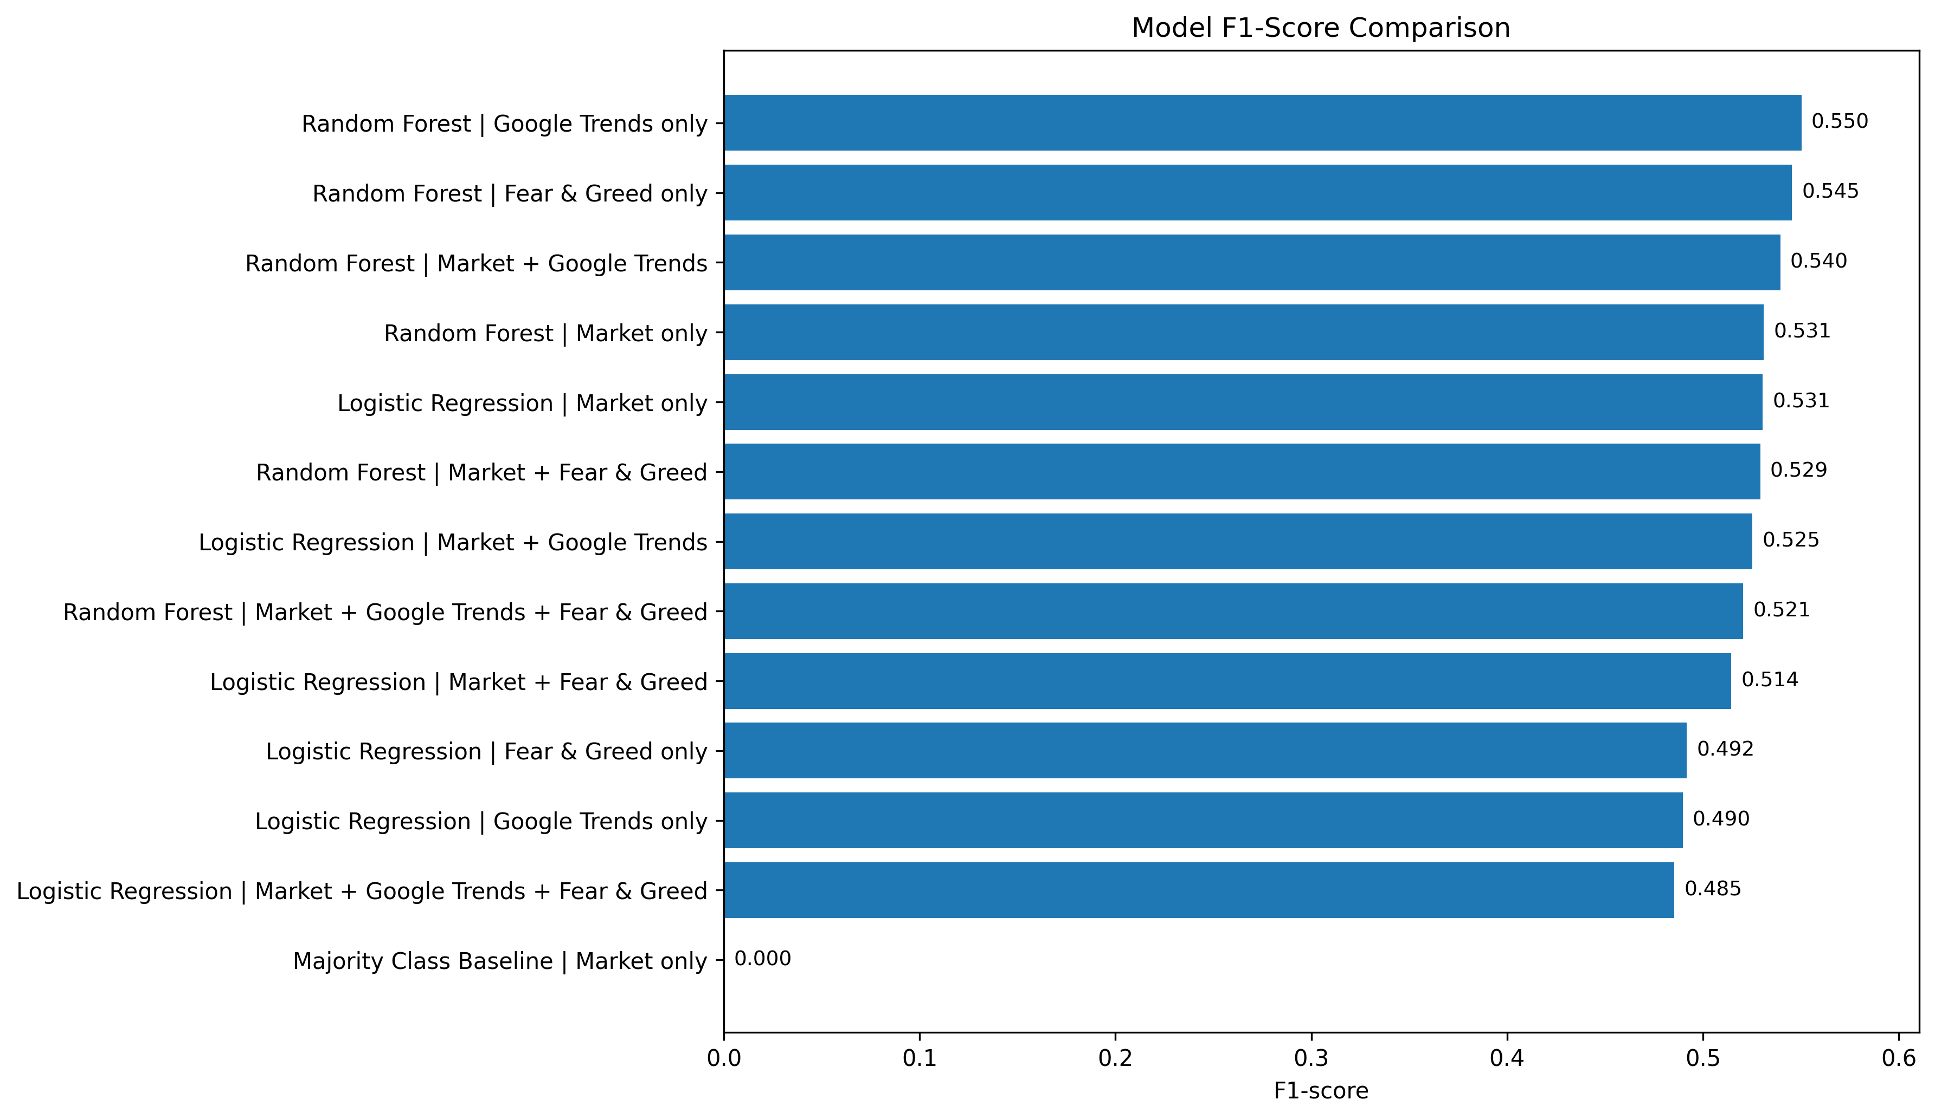
Figure 7. F1-score comparison across model and feature-set combinations. Replace this placeholder with model_f1_comparison.png.

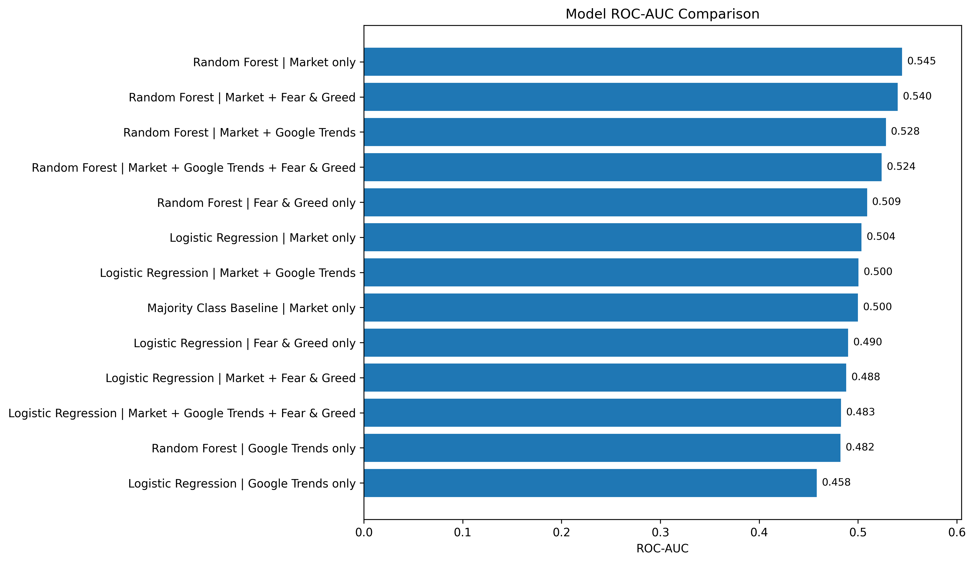
Figure 8. ROC-AUC comparison across model and feature-set combinations. Replace this placeholder with model_roc_auc_comparison.png.

9. Model Interpretation
Feature importance was examined for Random Forest models. For the Google Trends-only Random Forest model, rolling and lagged trend features were among the most important inputs. This suggests that not only the level of search interest, but also recent changes and short-term patterns in attention, are relevant to the model.
Feature | Importance
trends_rolling_mean_7d | 0.190
google_trends_score | 0.163
trends_rolling_std_7d | 0.146
trends_lag_1 | 0.131
trends_lag_7 | 0.121

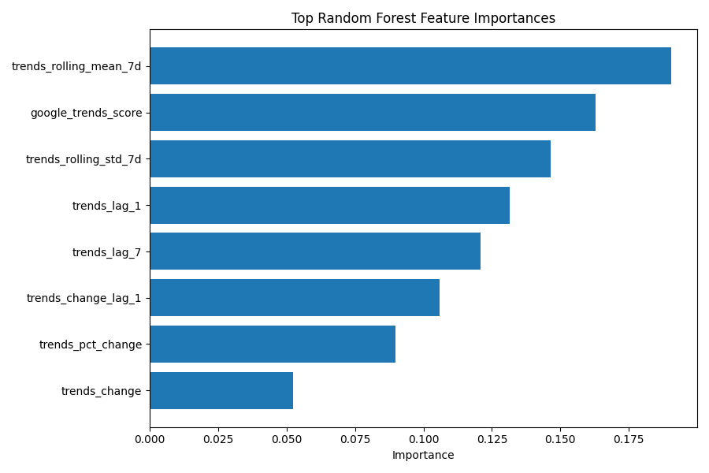
Figure 9. Random Forest feature importance visualization. Replace this placeholder with random_forest_feature_importance.png.
These results should be interpreted carefully. Feature importance does not prove causality, and the overall predictive performance remains limited. However, the feature importance output supports the broader finding that attention features contain information about market conditions, especially when interpreted together with volatility results.

10. Limitations and Future Work
This project has several limitations.
- Google Trends measures search attention, not actual investor intent.
- Google Trends data was weekly and had to be aligned with daily market observations.
- The Fear & Greed Index is a sentiment proxy, not a direct measure of individual investor behavior.
- The models do not directly incorporate event-level news shocks, regulatory announcements, or macroeconomic surprises.
- The machine learning models are relatively simple and do not fully capture time-series dynamics.
Future work could extend the project by:
- adding stable news-intensity features from a reliable archived news dataset or API,
- applying time-series cross-validation or walk-forward validation,
- building a separate volatility prediction model,
- comparing Bitcoin with other major cryptocurrencies,
- testing additional time-aware models,
- exploring richer sentiment sources such as news headlines, Reddit posts, or financial social media data.

11. Ethical Considerations
All data used in this project is publicly available or obtained through public interfaces. No private personal data was collected. The analysis uses aggregated search interest and market-level indicators. The results should not be interpreted as financial advice or as a trading recommendation. Since financial markets are uncertain and influenced by many unobserved factors, the findings should be treated as an academic data science analysis rather than a decision-making tool for investment.

12. Conclusion
This project examined whether public attention and market sentiment indicators improve short-term Bitcoin direction prediction and help explain Bitcoin volatility. The final dataset combined CoinGecko market data, Google Trends public attention data, and Alternative.me Crypto Fear & Greed Index sentiment data.
The results show that adding public attention and sentiment features does not create a strong next-day Bitcoin direction predictor. However, the analysis provides useful evidence that Google Trends is more closely associated with volatility and market turbulence than with directional return prediction. Therefore, the main contribution of the project is not a high-performing trading model, but a clearer understanding of how attention and sentiment indicators relate to Bitcoin market behavior.

13. AI Usage Disclosure
AI tools were used as a support tool for documentation revision, repository organization, debugging assistance, and presentation refinement. AI assistance was also used to help interpret error messages and improve the reproducible pipeline structure. The final processed datasets, statistical test outputs, machine learning outputs, and figures were generated locally by running the project scripts. All project decisions, script execution, result review, interpretation, and final submission responsibility remained with the student.

14. References
- CoinGecko. Bitcoin historical market data. https://www.coingecko.com/en/coins/bitcoin/historical_data
- Google Trends. Search interest data for the keyword “Bitcoin”. https://trends.google.com/
- Alternative.me. Crypto Fear & Greed Index. https://alternative.me/crypto/fear-and-greed-index/
- Alternative.me Fear & Greed API endpoint used in this project. https://api.alternative.me/fng/?limit=0&format=json

