


Analyzing Indoor Air Quality

Submitted By

Furkan Temizel 2100003964
Kaan Yegül 2000005031
Melis Yanık 2100005652

Department of Computer Engineering
İstanbul Kültür University

2024-2025 Fall

ABSTRACT
This project analyzes indoor air quality datasets in a traveler transit area at Brindisi Airport Italy. Using data collected over one year. It leverages IoT-based air monitoring systems to track gas concentrations, CO2 levels, temperature, humidity and particulate matter. This report is for the preprocessing and statistical analyses.

TABLE OF CONTENTS
ABSTRACT I
TABLE OF CONTENTS II
LIST OF FIGURES IIl
1. INTRODUCTION 1
1.1. Problem Statement 1
1.2. Project Purpose 1
1.3. Project Scope 1
1.4. Objectives and Success Criteria of the Project 1
1.5. Report Outline 1
2. METHODOLOGY 2
2.1. Overview of the Dataset/Model 2
2.2. Tools and Technology 2
2.3. Proposed Approach 2
3. EXPERIMENTAL RESULTS 3
4. DISCUSSION 16
REFERENCES 17
APPENDIX 18
LIST OF FIGURES

Figure 3.1.1: CSV file’s values are separated by ‘;’ 3
Figure 3.1.2: Dataset called by the correct delimiter ‘;’ 4
Figure 3.1.3: Finding columns with NULL values 4
Figure 3.1.4: NULL values cleaned from the columns 5
Figure 3.1.5: Dataset after dropping columns 5
Figure 3.1.6: Observing data types of the columns 6
Figure 3.1.7: Data Types after data conversion 6
Figure 3.1.8: Finding how many outlier each column has using IQR calculation 7
Figure 3.1.9: Boxplot visualization before outlier handling 8
Figure 3.1.10: The code for calculation and visualization 8
Figure 3.1.11: Boxplots after outlier handling 9
Figure 3.1.12: Loading all datasets and combining them into one 10
Figure 3.1.13: All datasets combined 10
Figure 3.1.14: Clearing null values 11
Figure 3.1.15: One-hot encoding, dropping columns and changing datatypes 12
Figure 3.1.16: Datatypes and columns of the combined dataset 12
Figure 3.1.17: Outlier handling for the combined dataset 13
Figure 3.1.18: Boxplots after outlier handling for the combined dataset 13
Figure 3.2.1: Correlation Heatmap of the columns 14
Figure 3.2.2: Correlation Heatmap comparison before and after outlier handling 14
Figure 3.2.3: Correlation Heatmap code 15
Figure 3.2.4: Correlation heatmap comparison code 15
Figure 3.2.5: Temp/CO2 Scatterplot for Brown dataset visualization 15
Figure 3.2.6: Temp/CO2 Scatterplot for Gold dataset visualization 15
Figure 3.2.7: Temp/CO2 Scatterplot for Silver dataset visualization 15
Figure 3.2.8: Code for Scatterplot visualization 20
Figure 3.2.9: Code for Scatterplot visualization 18
Figure 3.2.10: Temp – Humidity Scatterplot of all data categorized by different datasets 19
Figure 3.2.11: Code for CO2 – Time Plot visualization 20
Figure 3.2.12: CO2 – Time Plot 2022Q4 20
Figure 3.2.13: CO2 – Time Plot 2023Q1 20
Figure 3.2.14: CO2 – Time Plot 2023Q2 21
Figure 3.2.15: CO2 – Time Plot 2023Q3 21
Figure 3.2.16: CO2 – Time Plot 2023Q4 21
Figure 3.3.1: ANOVA Code and Result 21
Figure 3.3.2: Cluster Sampling Code and Result 23
Figure 3.3.3: Simple Random Sampling Code and Result 23
Figure 3.3.4: Stratified Sampling Code and Result 24

INTRODUCTION

Problem Statement
Ensuring healthy indoor air quality is critical since the increasing air travel and time spent in transit areas. The project focuses on monitoring and analyzing air quality in Brindisi Airport.

Project Purpose
The purpose of this project is to analyze the datasets and observe air quality trends in transit areas for future real-time monitoring systems using low cost IoT sensors.

Project Scope
This report covers preprocessing and statistical analysis of the air quality datasets.

Objectives and Success Criteria of the Project
• Preprocess the 3 datasets (3 CSV files ranging from 7M records to 11M records) to clean and normalize data.
• Identify outliers and handle them.
• Normalize the data for future use.
• Do some statistical analysis on the preprocessed and normalized data.

2. METHODOLOGY

Overview of the Dataset/Model

The dataset contains 16 columns with over 7M records. Variables include gas concentration, CO2 levels, temperature, humidity, particulate matter, and timestamps.

Tools and Technology

- Python Libraries: Pandas, NumPy, Scikit-learn, Seaborn, Matplotlib
- Jupyter Notebook

Proposed Approach

- Preprocessing: Handle missing values, outliers, and type conversions.
- Normalization: Apply Min-Max scaling to prepare data for analysis.
- Statistical Analysis: Identify trends in air quality metrics.

EXPERIMENTAL RESULTS

PREPROCESSING

- Loading and Inspecting the Dataset(s)
We have 3 different csv files for 3 different sensors’ data held which is the measurements of air quality records of each sensor. We are doing the steps on ony the complete_measure_node_airport_gold.csv to apply them to the others later on.

We observe that it separates values using ‘ ; ’ instead of ‘ , ’

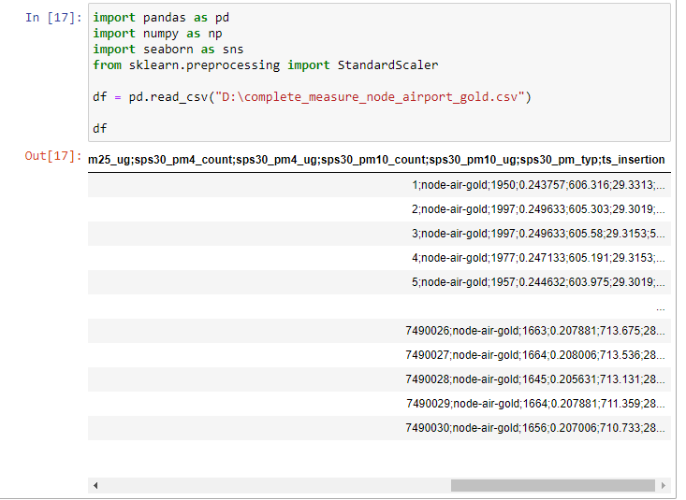
Figure 3.1.1: CSV file’s values are separated by ‘;’

We define a delimiter while calling.

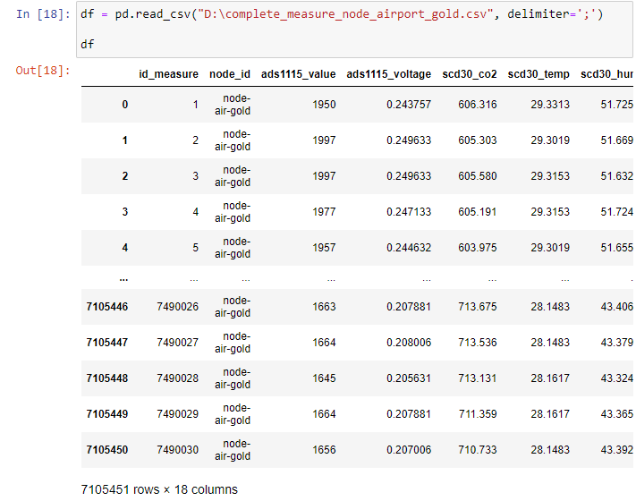
Figure 3.1.2: Dataset called by the correct delimiter ‘;’

Now we can load and inspect the datasets for preprocessing without any problem.

- Checking and Handling NULL Values
We check for the null values using the code line “print(df.isnull().sum())” and we observe that there are some columns that have null values.

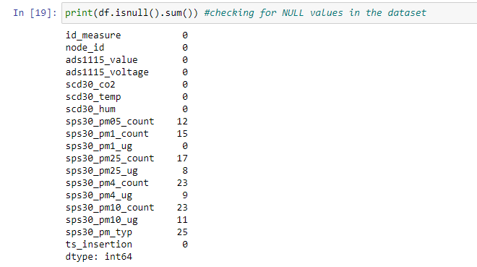
Figure 3.1.3: Finding columns with NULL values

We use this code to replace all the null values in the datasets to 0.

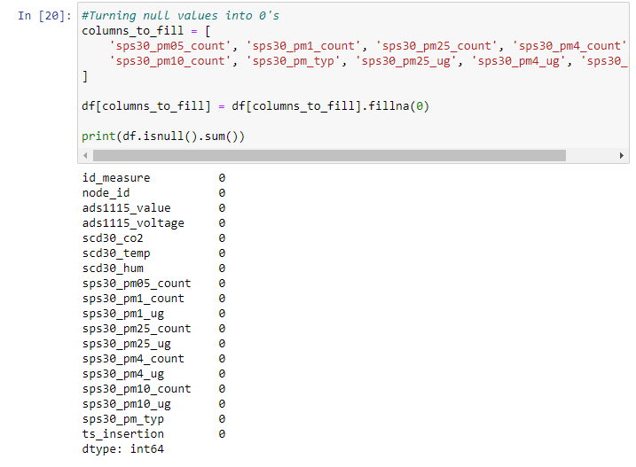
Figure 3.1.4: NULL values cleaned from the columns

- Dropping Irrelevant Columns
We drop these columns: id_measure, node_id and observe the dataset afterwards.

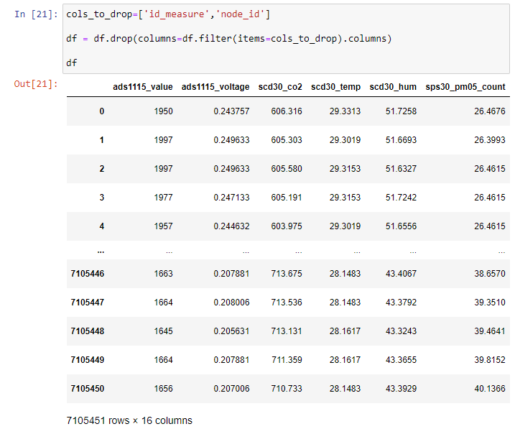
Figure 3.1.5: Dataset after dropping columns

- Converting Data Types
We observe the data types of the columns with df.info()

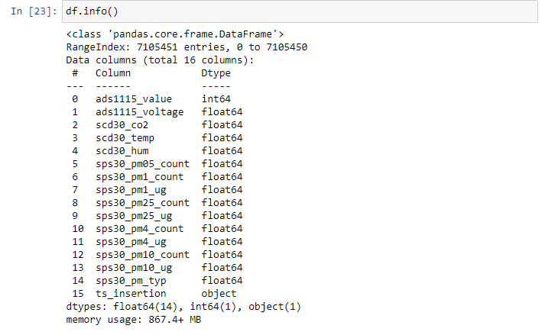
Figure 3.1.6: Observing data types of the columns

We convert the one integer column to float64 and convert the “ts_insertion” object to datetime

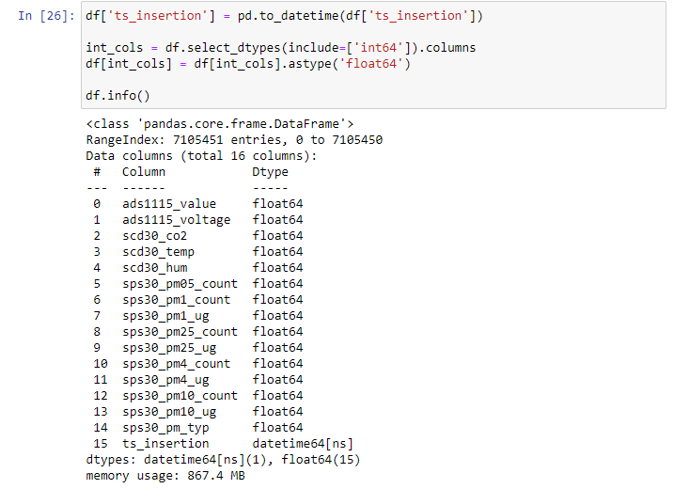
Figure 3.1.7: Data Types after data conversion

- Finding and Handling Outliers

First, we find how many outliers each column has by using IQR calculation.

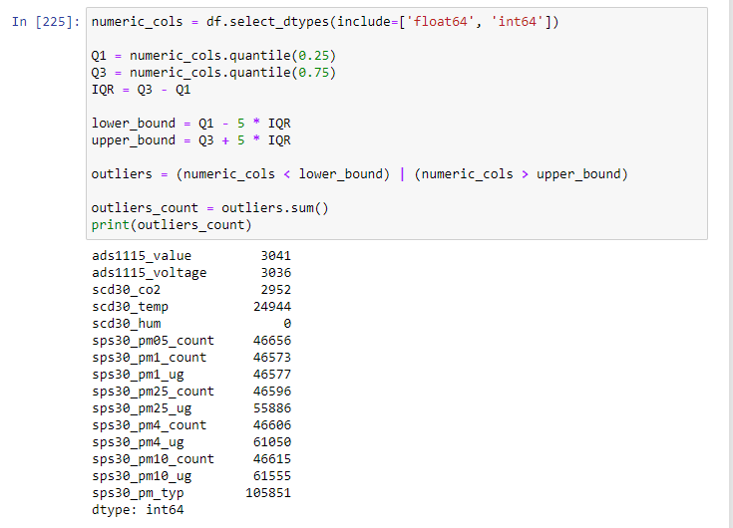
Figure 3.1.8: Finding how many outliers each column has using IQR calculation

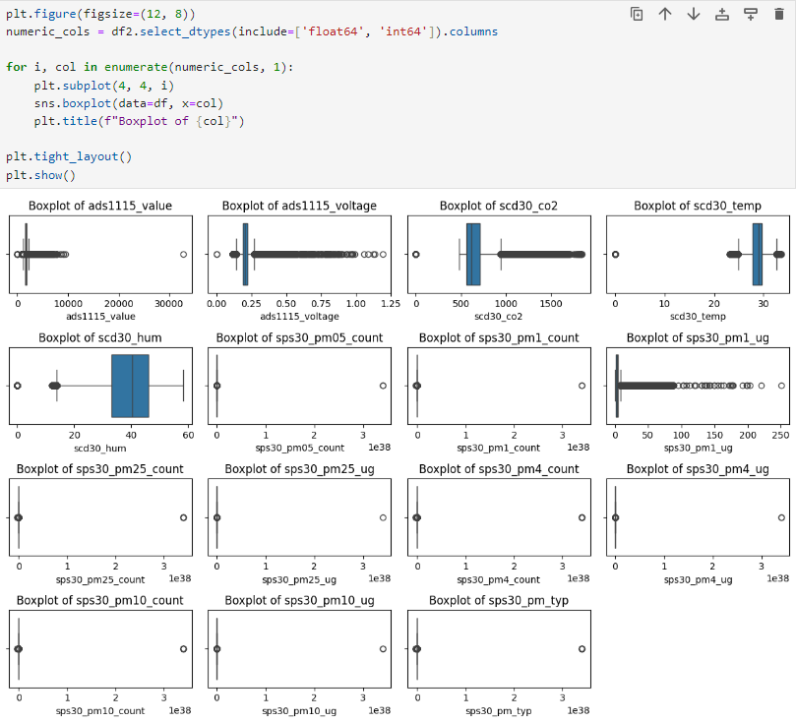
Figure 3.1.9: Boxplot visualization before outlier handling

We handle the outliers by replacing them with the lower or the upper bound determined by the calculation. After the calculation we visualize them in box plots.

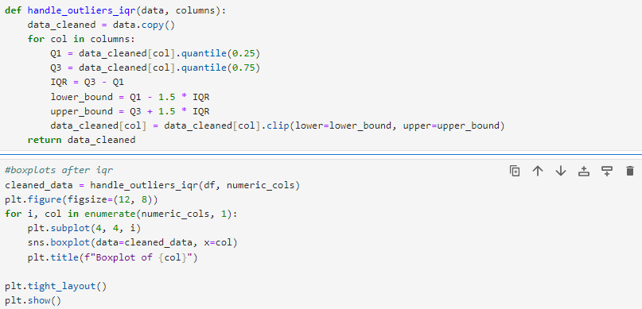
Figure 3.1.10: The code for calculation and visualization

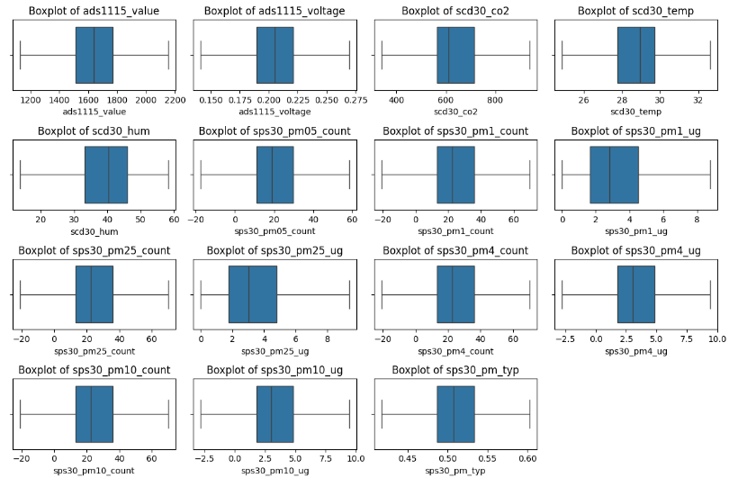
Figure 3.1.11: Boxplots after outlier handling

From the start, we used only one dataset for these processes out of the 3. Now we’ll create a dataset that is the combination of all three datasets. We turn null values into 0 and drop columns.

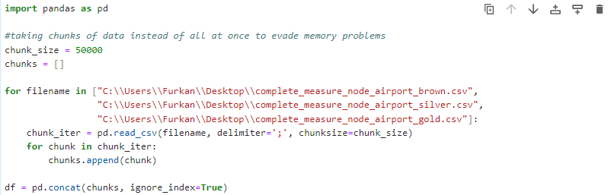 Figure 3.1.12: Loading all datasets and combining them into one

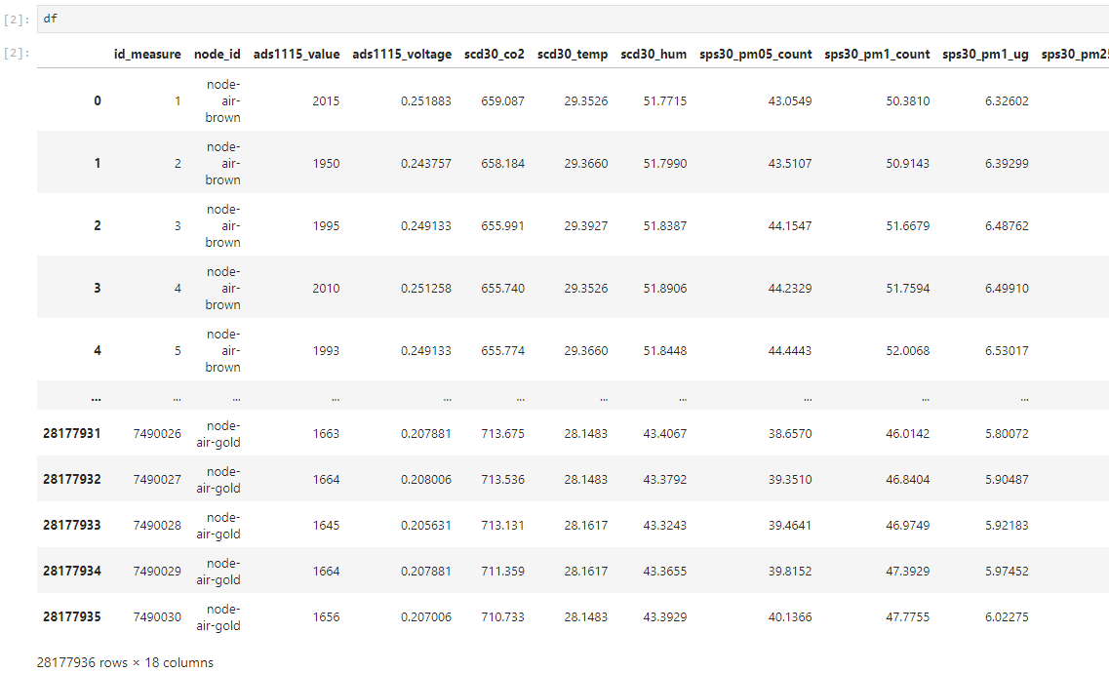
Figure 3.1.13: All datasets combined

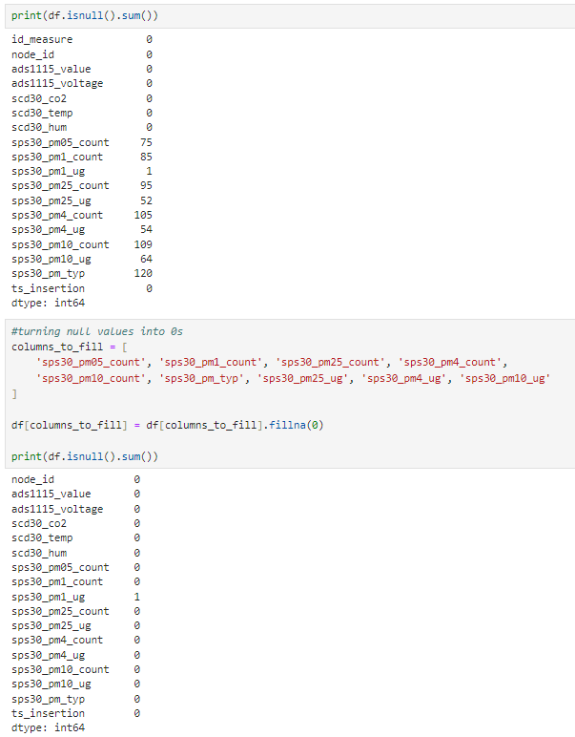
Figure 3.1.14: Clearing null values

We use one-hot encoding to create separate binary columns for each dataset where each column indicates which category a row belongs to. This helps distinguish between the 'brown', 'gold' and 'silver' datasets for easier analysis.

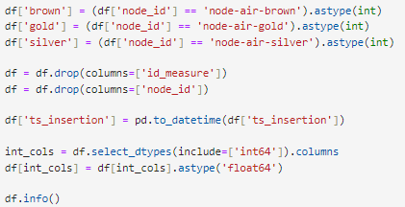
Figure 3.1.15: One-hot encoding, dropping columns and changing datatypes

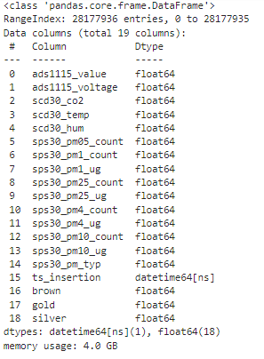
Figure 3.1.16: Datatypes and columns of the combined dataset
We again handle the outliers by replacing them with the lower or the upper bound determined by the calculation. After the calculation we visualize them in box plots.

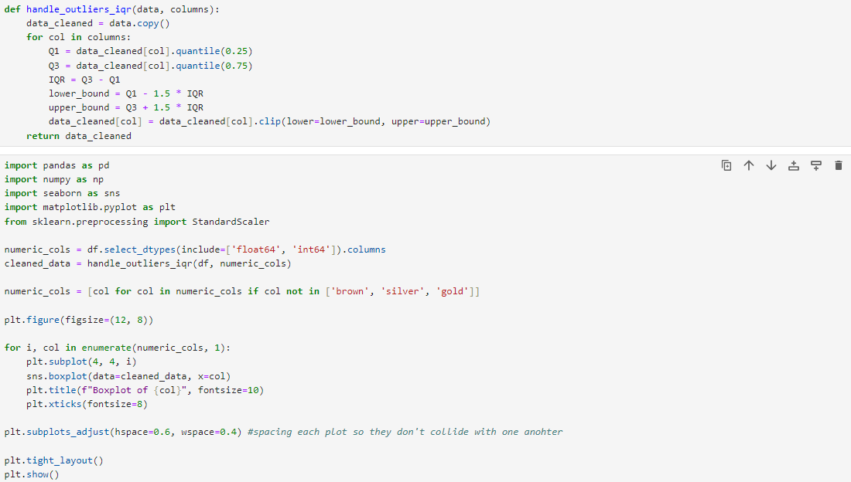
Figure 3.1.17: Outlier handling for the combined dataset

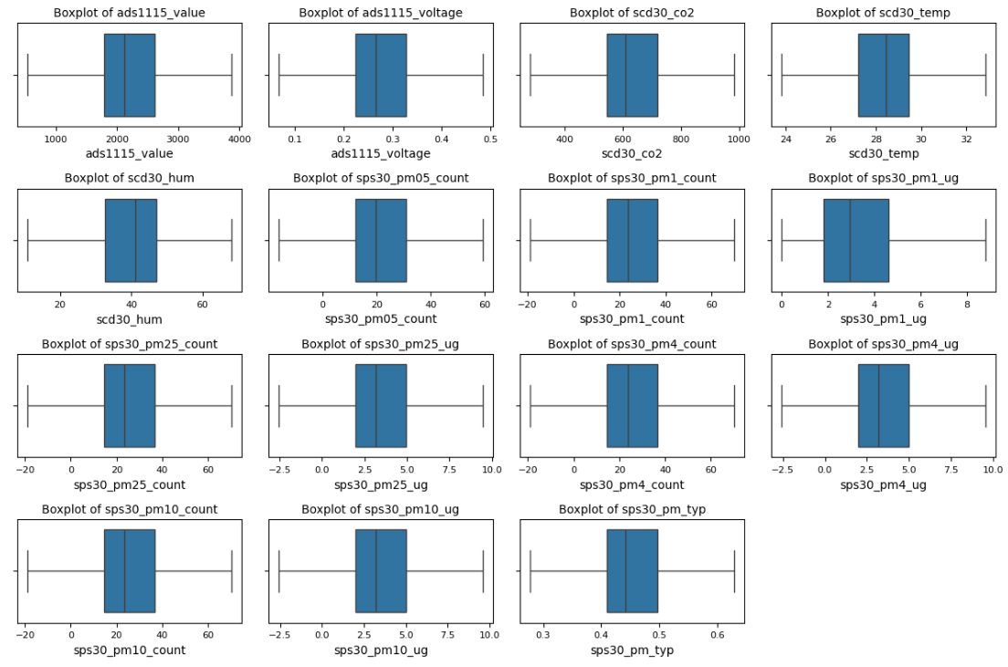
Figure 3.1.18: Boxplots after outlier handling for the combined dataset

3.2 STATISTICAL ANALYSES

- Correlation

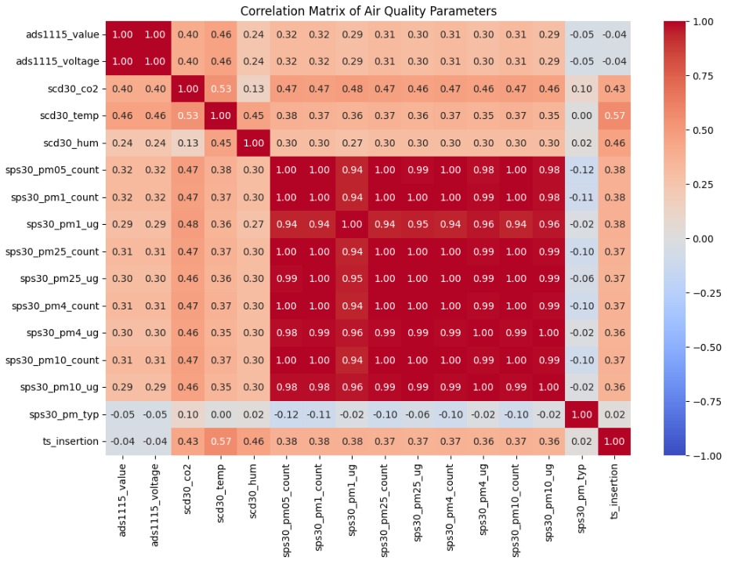
Figure 3.2.1: Correlation Heatmap of the columns

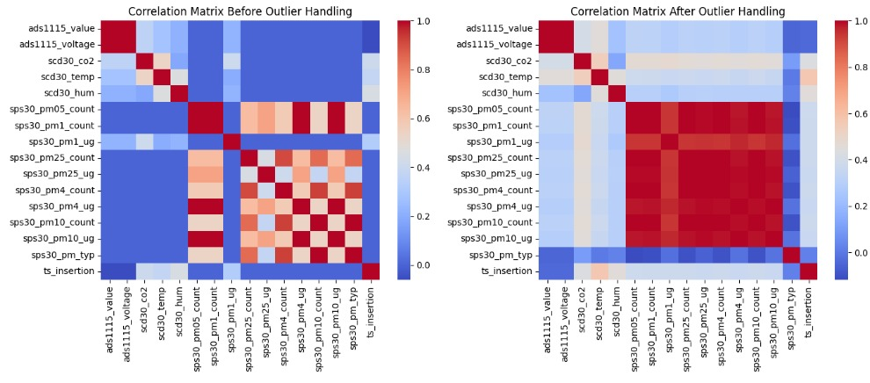,
Figure 3.2.2: Correlation Heatmap comparison of the columns before and after outlier handling

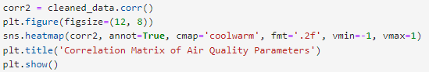
Figure 3.2.3: Correlation heatmap code

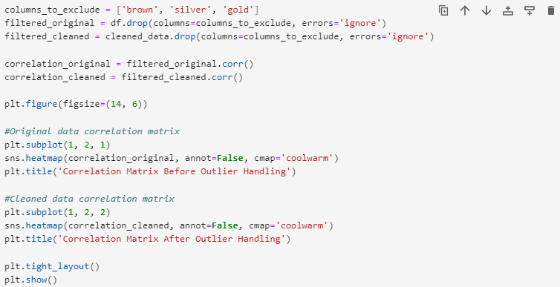
Figure 3.2.4: Correlation heatmap comparison code

In our statistical analysis we used correlation heatmaps to visualize the relationships between columns in the dataset. We compared heatmaps before and after handling outliers to see how outlier removal affected these relationships.
- Temperature – CO2 Scatterplot

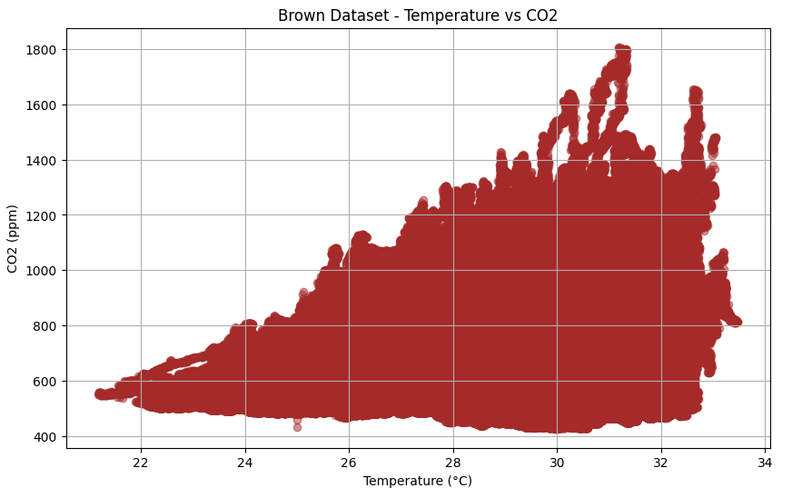
Figure 3.2.5: Temp/CO2 Scatterplot for Brown dataset visualization

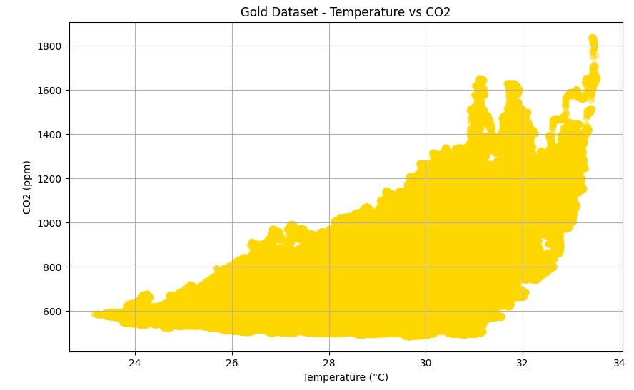
Figure 3.2.6: Temp/CO2 Scatterplot for Gold dataset visualization
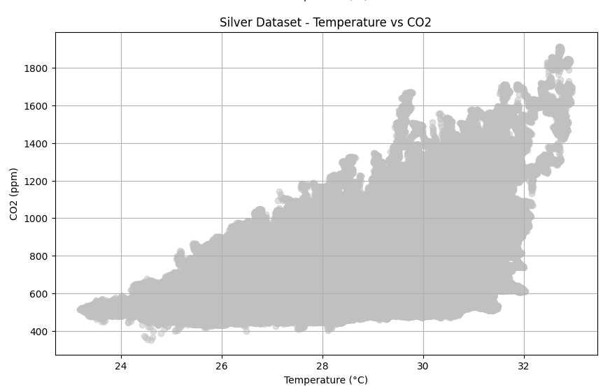
Figure 3.2.7: Temp/CO2 Scatterplot for Silver dataset visualization

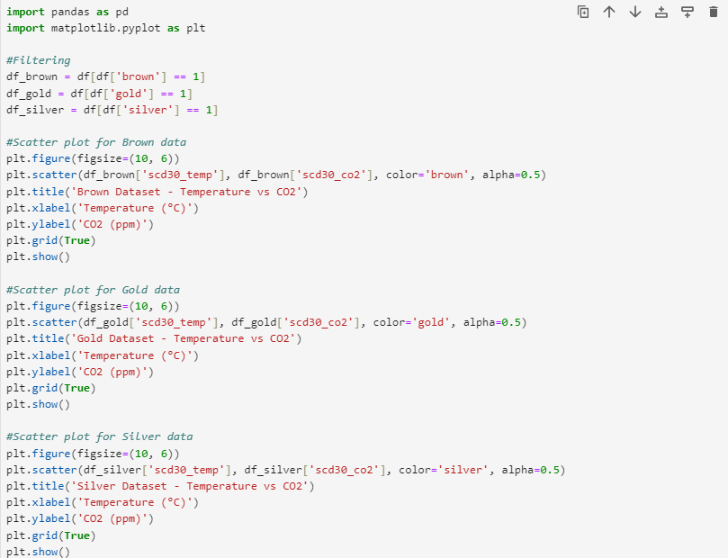
Figure 3.2.8: Code for Scatterplot visualization

The charts display the relationship between temperature and CO2 levels for three distinct datasets: Brown, Gold and Silver. Each scatter plot highlights how CO2 concentrations vary with temperature within each group. It can be analyzed that the CO2 amount increases with temperature increase.

3. Temperature – Humidity Scatterplot

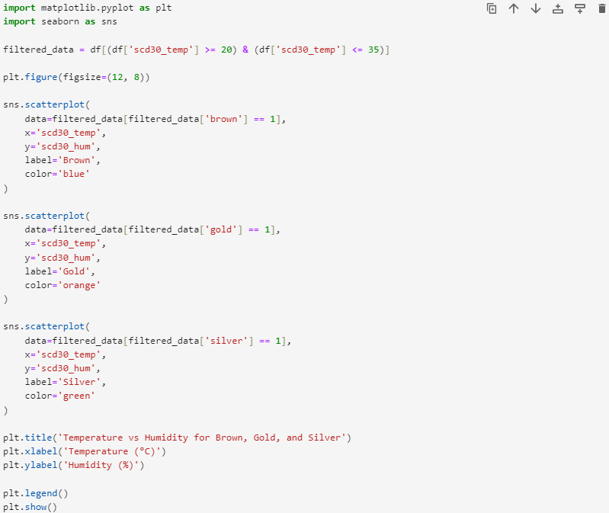
Figure 3.2.9: Code for Scatterplot visualization

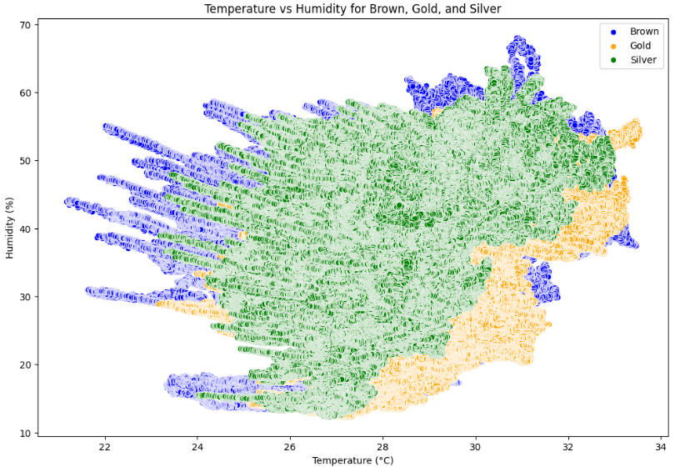
Figure 3.2.10: Temperature – Humidity Scatterplot of all data categorized by different datasets

This scatter plot visualizes the relationship between temperature and humidity for three different datasets (Brown, Gold and Silver). The scd30_temp column represents temperature in degrees Celsius while scd30_hum represents humidity percentage. Data points are color-coded by dataset: blue for Brown, orange for Gold and green for Silver.
4. CO2 – Time Plot

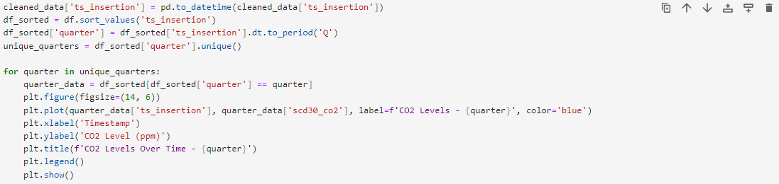
Figure 3.2.11: Code for CO2 – Time Plot visualization

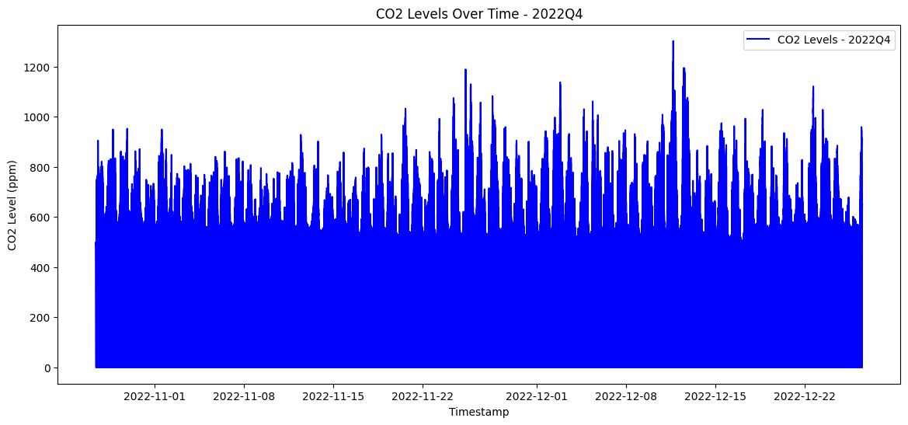
Figure 3.2.12: CO2 – Time Plot 2022Q4

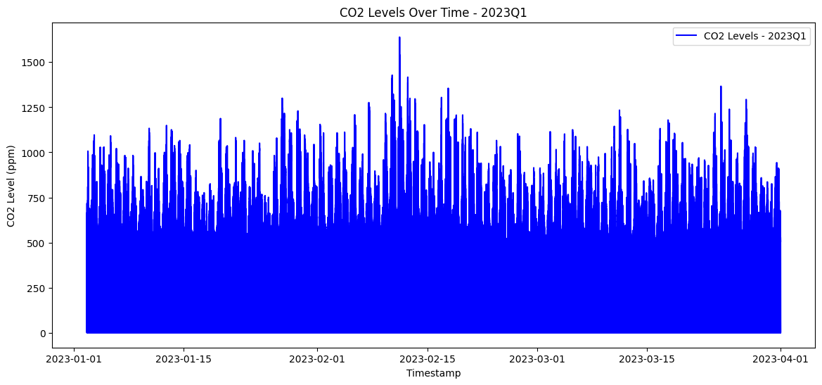
Figure 3.2.13: CO2 – Time Plot 2023Q1

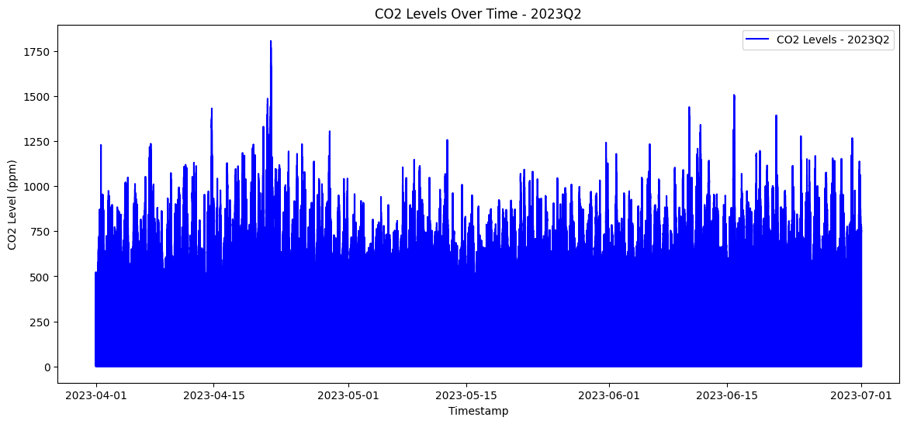
Figure 3.2.14: CO2 – Time Plot 2023Q2

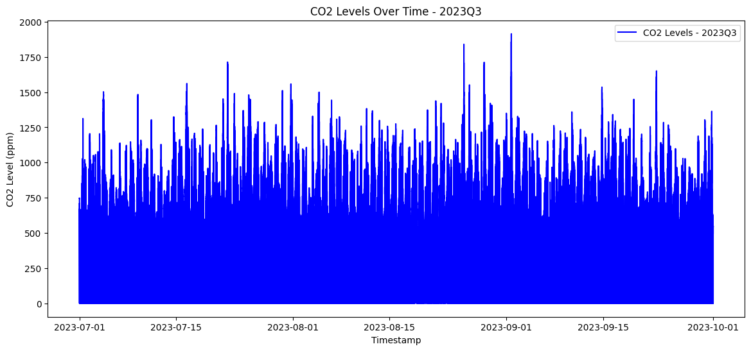
Figure 3.2.15: CO2 – Time Plot 2023Q3

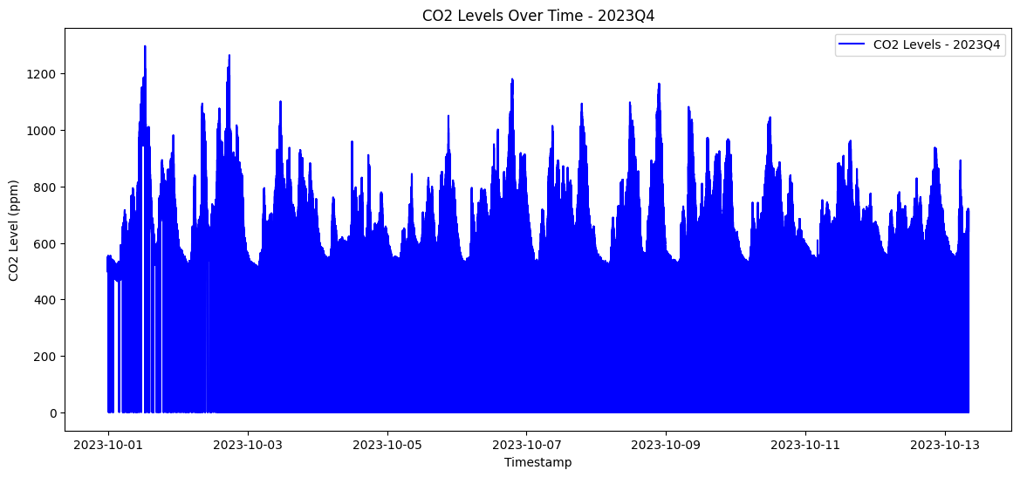
Figure 3.2.16: CO2 – Time Plot 2023Q4

The charts show CO2 levels over time for each yearly quarter. Each plot represents a different quarter and displays how CO2 levels change over time.
3.3 STATISTICAL TESTS

1. ANOVA

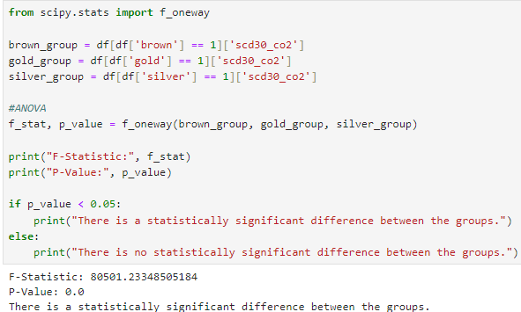
Figure 3.3.1: ANOVA Code and Result

Null Hypothesis (H₀): There is no significant difference between the CO2 means of the three groups (Brown, Gold, and Silver).

Alternative Hypothesis (H₁): There is a significant difference between the CO2 means of at least one group (Brown, Gold, and Silver).

ANOVA Results Interpretation:

The F-statistic is 80501.23, and the p-value is 0.0.

Since the p-value is less than the significance level of 0.05 we reject the null hypothesis (H₀) and accept the alternative hypothesis (H₁). This indicates that there is a statistically significant difference in the CO2 means between the three groups (Brown, Gold, and Silver).
- Sampling

2.1. Cluster Sampling

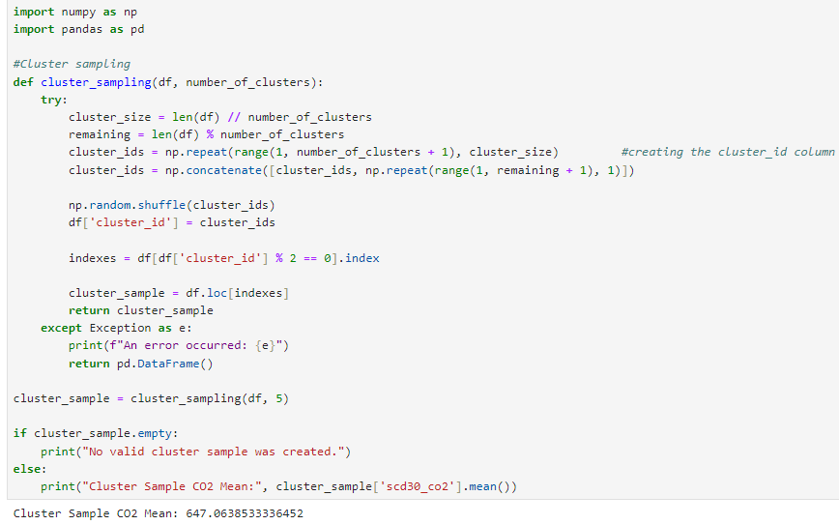
Figure 3.3.2: Cluster Sampling Code and Result

  - Simple Random Sampling

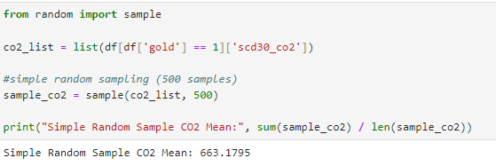
Figure 3.3.3: Simple Random Sampling Code and Result

  - Stratified Sampling

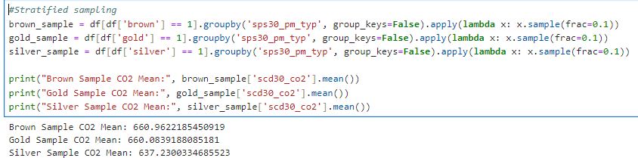
Figure 3.3.4: Stratified Sampling Code and Result

To evaluate the CO2 mean levels across different sampling methods we performed the following sampling techniques: Simple Random Sampling, Cluster Sampling, and Stratified Random Sampling. The CO2 mean values for each sampling method are as follows:

Simple Random Sample CO2 Mean: 663.1795

Cluster Sample CO2 Mean: 647.06

Stratified Random Sampling:
Brown Sample CO2 Mean: 660.96
Gold Sample CO2 Mean: 660.08
Silver Sample CO2 Mean: 637.23

Simple Random Sample showed the highest CO2 mean of 663.18 which suggests that this method may be more representative of the overall population CO2 levels.

Cluster Sample yielded a lower CO2 mean of 647.06 which could reflect a sampling bias, as only certain clusters were chosen based on specific criteria (even numbered clusters).

Stratified Random Sampling provided CO2 means for each dataset (Brown, Gold and Silver):
Brown Sample: 660.96
Gold Sample: 660.08
Silver Sample: 637.23
These results show differences across different datasets with the Silver sample having the lowest CO2 mean which might suggest differences in characteristics within each dataset.

Based on these results the Simple Random Sample method appears to give a higher average CO2 level compared to the other sampling techniques. However the Stratified Random Sampling method provides more detailed insights into the specific groups while the Cluster Sampling method yielded the lowest CO2 mean.

DISCUSSION
The project focused on cleaning and analyzing 3 datasets by handling outliers and merging files and doing some statistical analysis on them. Outliers were reduced using IQR calculations. This improves data quality without losing meaningful information. Visualizations and statistical tests confirmed the success of the approach. This work highlights practical methods for managing big data with applications.

REFERENCES

APPENDIX

Columns and their meaning in the datasets:

1. ads1115_value - ADC raw value
2. ads1115_voltage - ADC voltage reading
3. scd30_co2 - CO₂ concentration
4. scd30_temp - Temperature (°C)
5. scd30_hum - Humidity (%)
6. sps30_pm05_count - PM0.5 particle count
7. sps30_pm1_count - PM1.0 particle count
8. sps30_pm1_ug - PM1.0 mass (µg/m³)
9. sps30_pm25_count - PM2.5 particle count
10. sps30_pm25_ug - PM2.5 mass (µg/m³)
11. sps30_pm4_count - PM4.0 particle count
12. sps30_pm4_ug - PM4.0 mass (µg/m³)
13. sps30_pm10_count - PM10 particle count
14. sps30_pm10_ug - PM10 mass (µg/m³)
15. sps30_pm_typ - Typical particle size
16. ts_insertion - Timestamp of data

