|  |  |
| --- | --- |
| **Topic** | Oracle SQL Language Fundamentals I |
| **Document Name** | SQL01-EX-01-05 |
|  |  |

|  |  |  |  |
| --- | --- | --- | --- |
| **Document Difficulty Level** | | | |
| **Beginner** | **Junior** | **Senior** | **Expert** |
| ■ | □ | □ | □ |

# Oracle SQL Language Fundamentals I

## Exercise SQL01-EX-01:

**Definiton :** Write an SQL query that selects employee’s id, employee’s first name and employee’s department name for all employees. (Please use HR.EMPLOYEES and HR.DEPARTMENTS tables.)

SELECT EMP.EMPLOYEE_ID,  
 EMP.FIRST_NAME ,  
 DEP.DEPARTMENT_NAME  
FROM EMPLOYEES EMP INNER JOIN DEPARTMENTS DEP  
 ON EMP.DEPARTMENT_ID = DEP.DEPARTMENT_ID;

**Sample Output :**

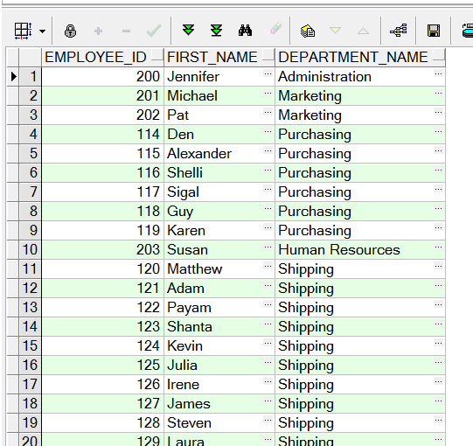

**Objectives** : To learn relations on tables and SQL language keyword JOIN.

**Exercise Keywords:** INNER JOIN, JOIN.

## Exercise SQL01-EX-02:

**Definiton :** Create a report that displays the employee’s id and their manager’s id. (Please use HR.EMPLOYEES table)

SELECT E1.EMPLOYEE_ID AS EMPLOYEE_ID,  
 E2.EMPLOYEE_ID AS MANAGER_ID  
FROM EMPLOYEES E1 LEFT JOIN EMPLOYEES E2  
 ON E1.MANAGER_ID = E2.EMPLOYEE_ID  
ORDER BY E1.EMPLOYEE_ID;

**Sample Output :**

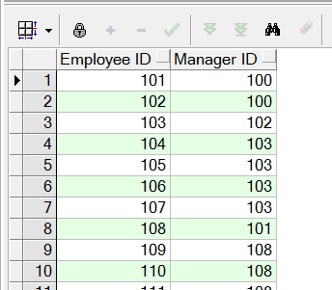

**Objectives** : To learn SQL join logic like SELF JOIN.

## Exercise SQL01-EX-03:

**Definiton :** For example; first three character of PHONE_NUMBER column gives us a operator of employee. Create a report that displays the operators and their total subscriber. But we want two different displays with diffrent queries. (Please use HR.EMPLOYEES table)

SELECT  
 SUBSTR(PHONE_NUMBER, 1, 3) AS OPERATOR,  
 COUNT(*) AS TOTAL  
FROM EMPLOYEES  
GROUP BY SUBSTR(PHONE_NUMBER, 1, 3);

**Sample Output :**

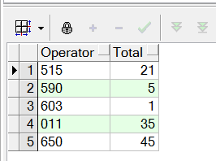

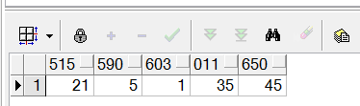

**Objectives** : To learn basic SQL keywords like COUNT, SUM, CASE.

## Exercise SQL01-EX-04:

**Definiton :** Create a table (table name like HR.EMP) from HR.EMPLOYEES table. Insert a new row to HR.EMP table and update this employee’s phone number and salary. Delete your new row and display the HR.EMP table. Finally drop your table HR.EMP.

CREATE TABLE EMP AS SELECT * FROM EMPLOYEES;  
  
INSERT INTO EMP VALUES(  
 250, 'Erman', 'İbrisim', 'erman@ibrisim.com', '5554443322', CURRENT_DATE, 'IT_PROG', 150000, 0, 124, 70  
);  
  
SELECT * FROM EMP WHERE EMPLOYEE_ID=250;  
--250, Erman, İbrisim, erman@ibrisim.com, 5554443322, 2024-07-30 11:00:30, IT_PROG, 150000.00, 0.00, 124, 70  
  
  
UPDATE EMP  
SET PHONE_NUMBER = '5543331122',  
 SALARY = 130000  
WHERE EMPLOYEE_ID = 250;  
--250, Erman, İbrisim, erman@ibrisim.com, 5543331122, 2024-07-30 11:00:30, IT_PROG, 130000.00, 0.00, 124, 70  
  
  
DELETE FROM EMP  
WHERE EMPLOYEE_ID = 250;  
  
DROP TABLE EMP;

**Sample Output :**

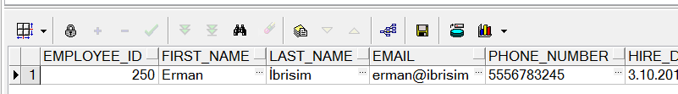

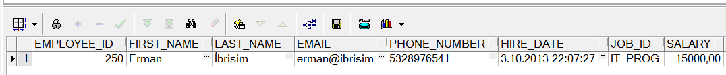

**Objectives** : To learn basic SQL keywords like INSERT, UPDATE, DELETE, DROP and CREATE TABLE from table.

## Exercise SQL01-EX-05:

**Definiton :**

Select employees’ first name and last name as masked with “*” character as shown in sample output below.

SELECT  
 RPAD(SUBSTR(FIRST_NAME, 1, 2), LENGTH(FIRST_NAME), '*')  
 ||  
 ' '  
 ||  
 RPAD(SUBSTR(LAST_NAME, 1, 2), LENGTH(LAST_NAME), '*')  
AS MASKED_FNAME_AND_LNAME  
FROM EMPLOYEES;

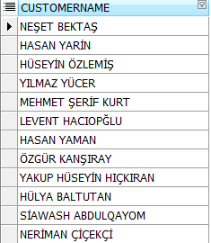

**Sample Output :**

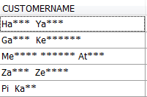

**Objectives** : To learn basic SQL functions like length, substr, instr, trim, initcap, rpad, lpad, regexp_replace, regexp_substr