|  |  |
| --- | --- |
| **Topic** | Oracle SQL Language Fundamentals I |
| **Document Name** | SQL02-EX-01-05 |
|  |  |

## Exercise SQL02-EX-01:

**Definiton :** Write an SQL query that selects employee’s id, employee’s first name, employee’s last name and employee’s **number of months** from hire_date to today for all employees. (Hint:MONTHS_BETWEEN)

**SQL:**

SELECT EMPLOYEE_ID,  
 FIRST_NAME,  
 LAST_NAME,  
 TRUNC(MONTHS_BETWEEN(SYSDATE, HIRE_DATE), 1) AS MONTHS_SINCE_HIRE  
FROM EMPLOYEES;

**Screenshot:**

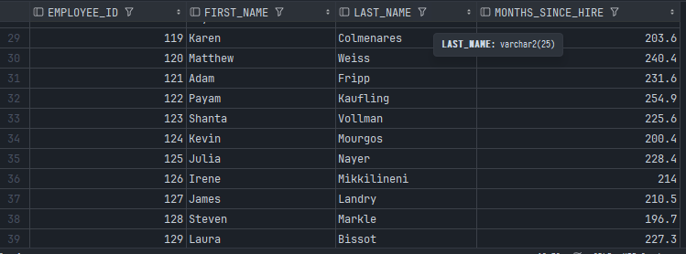

## Exercise SQL02-EX-02:

**Definiton :** Write a query that displays the grade of all employees based on the value of the column JOB_ID, using the following data: (Use DECODE)

|  |  |
| --- | --- |
| **Job** | **Grade** |
| AD_PRES | A |
| ST_MAN | B |
| IT_PROG | C |
| SA_REP | D |
| ST_CLERK | E |
| None of the above | 0 |

**SQL:**

SELECT  
 FIRST_NAME,  
 LAST_NAME,  
 JOB_ID,  
 DECODE(JOB_ID, 'AD_PRES', 'A',  
 'ST_MAN', 'B',  
 'IT_PROG', 'C',  
 'SA_REP', 'D',  
 'ST_CLERK', 'E',  
 'O') AS GRADE  
  
FROM EMPLOYEES  
GROUP BY JOB_ID, FIRST_NAME, LAST_NAME  
ORDER BY JOB_ID;

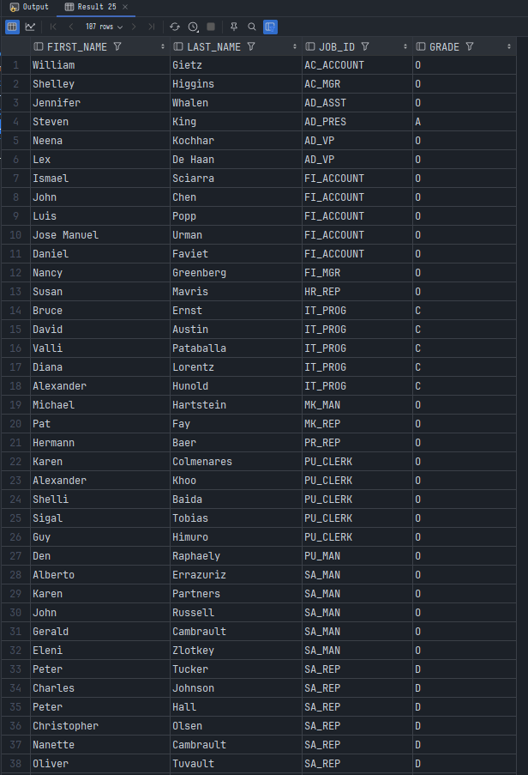**Screenshot:**

## Exercise SQL02-EX-03:

**Definiton :** Write a query for SQL02-EX-02(previous question) with using **CASE WHEN.**

**SQL:**

SELECT FIRST_NAME,  
 LAST_NAME,  
 JOB_ID,  
 CASE JOB_ID  
 WHEN 'AD_PRES' THEN 'A'  
 WHEN 'ST_MAN' THEN 'B'  
 WHEN 'IT_PROG' THEN 'C'  
 WHEN 'SA_REP' THEN 'D'  
 WHEN 'ST_CLERK' THEN 'E'  
 ELSE 'O'  
 END AS GRADE  
FROM EMPLOYEES  
ORDER BY JOB_ID;

**Screenshot:**

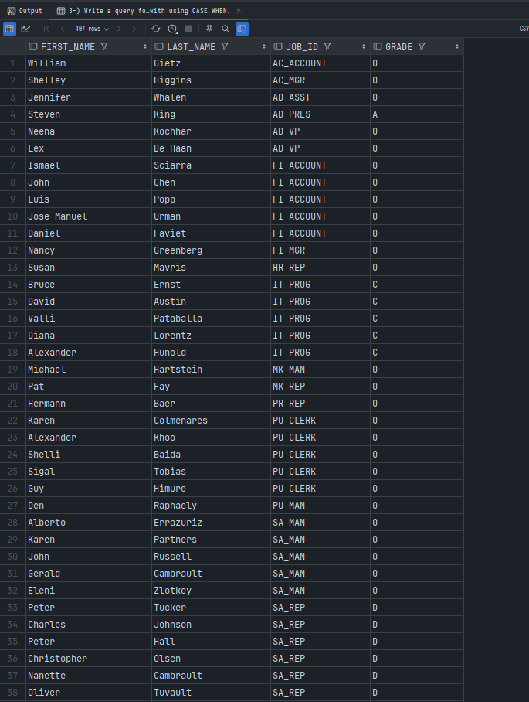

## Exercise SQL02-EX-04:

**Definiton :** Write a query that displays the employee number and last name of all employees who work in a department with any employee whose last name contains a “i”.

**SQL:**

SELECT EMP.EMPLOYEE_ID, EMP.LAST_NAME  
FROM EMPLOYEES EMP  
WHERE EMP.DEPARTMENT_ID IN (SELECT E2.DEPARTMENT_ID  
 FROM EMPLOYEES E2  
 WHERE EMP.LAST_NAME LIKE '%i%');

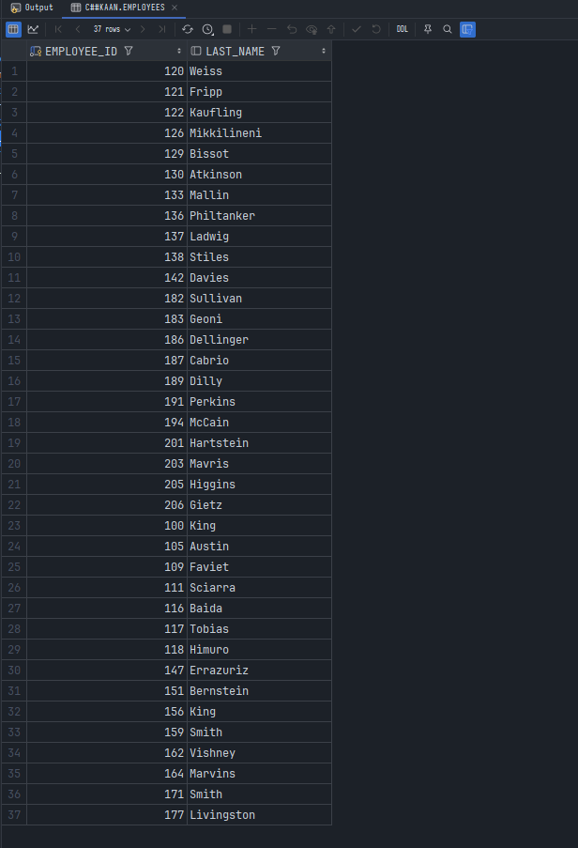**Screenshot:**

## Exercise SQL02-EX-05:

**Definiton :**

* Create a table for MY_EMP_TABLE with following columns
* Insert following rows,
* Update salary with 1.10 times of salary value
* Delete rows which first_name is David
* Truncate table.

|  |  |  |  |
| --- | --- | --- | --- |
| **ID** | **LAST_NAME** | **FIRST_NAME** | **SALARY** |
| 1 | Black | John | 1100 |
| 2 | White | Kent | 1300 |
| 3 | Orange | David | 1700 |
| 4 | Pink | Alissa | 1900 |

**SQL:**

--1  
CREATE TABLE MY_EMP_TABLE (  
 EMP_ID NUMBER(10) NOT NULL,  
 LAST_NAME VARCHAR2(256),  
 FIRST_NAME VARCHAR2(256),  
 SALARY NUMBER(10)  
);  
  
--2  
INSERT INTO MY_EMP_TABLE VALUES (1, 'Black', 'John', 1100);  
INSERT INTO MY_EMP_TABLE VALUES (2, 'White', 'Kent', 1300);  
INSERT INTO MY_EMP_TABLE VALUES (3, 'Orange', 'David', 1700);  
INSERT INTO MY_EMP_TABLE VALUES (4, 'Pink', 'Alissa', 1900);  
  
--3  
UPDATE MY_EMP_TABLE EMP  
SET EMP.SALARY = (EMP.SALARY* 0.1) +EMP.SALARY;  
  
--4  
DELETE FROM MY_EMP_TABLE  
WHERE FIRST_NAME = 'David';  
  
--5  
TRUNCATE TABLE MY_EMP_TABLE;

**Screenshot:**



