|  |  |
| --- | --- |
| **Topic** | Oracle SQL Language Fundamentals I |
| **Document Name** | SQL03-EX-01-05 |
|  |  |

## Exercise SQL03-EX-01:

**Definiton :** Write followig SQL queries:

* Add a colum to employees table named MAX_SALARY.
* Update MAX_SALARY with maximum salary amount with subquery.
* Delete employee who have minimum salary using subquery.

**SQL:**

ALTER TABLE EMPLOYEES  
 ADD MAX_SALARY NUMBER;  
  
UPDATE EMPLOYEES  
SET MAX_SALARY = (SELECT MAX(SALARY) FROM EMPLOYEES);  
  
DELETE EMPLOYEES  
WHERE SALARY = (SELECT MIN(SALARY) FROM EMPLOYEES);

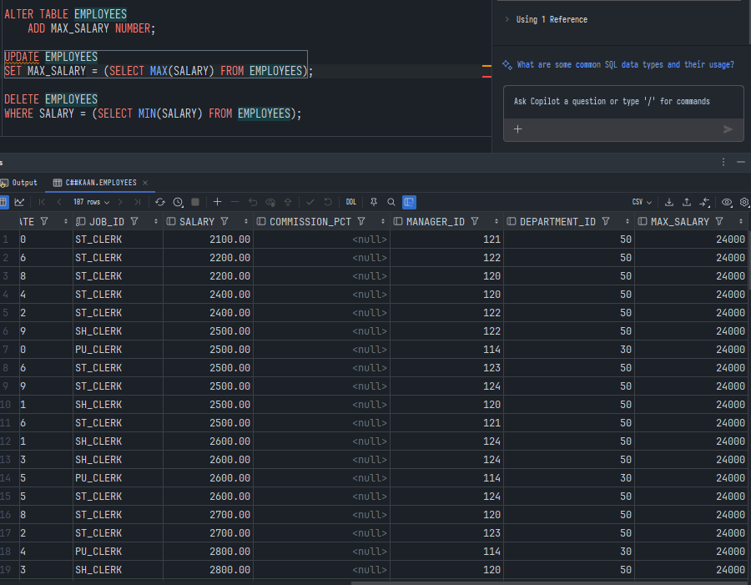**Screenshot:**

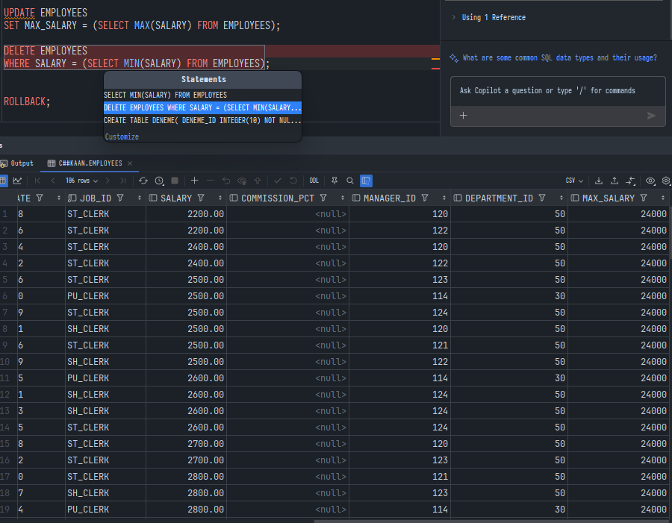

## Exercise SQL03-EX-02:

**Definiton :** Write followig SQL queries:

* Define index (named DPR_NAME_IDX) on DEPARTMENT_NAME column of DEPARTMENTS table.
* Define constraint (named CNSTR_SALARY) on employee salary. (Salary must be between 1000$ and 100.000$)
* Drop defined index.
* Enable, disable, drop defined constraint.

**SQL:**

--1  
CREATE INDEX DPR_NAME_IDX  
ON DEPARTMENTS (DEPARTMENT_NAME);  
  
-- 2  
  
ALTER TABLE EMPLOYEES  
ADD CONSTRAINT CNSTR_SALARY CHECK ( SALARY BETWEEN 1000 AND 100000);  
  
--3  
DROP INDEX DPR_NAME_IDX;  
  
--4  
ALTER TABLE EMPLOYEES  
ENABLE CONSTRAINT CNSTR_SALARY;  
  
ALTER TABLE EMPLOYEES  
DISABLE CONSTRAINT CNSTR_SALARY;  
  
ALTER TABLE EMPLOYEES  
DROP CONSTRAINT CNSTR_SALARY;

**Screenshot:**

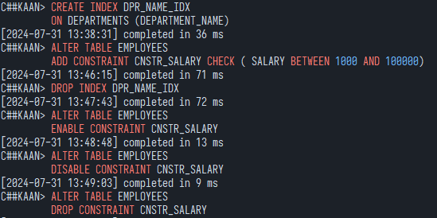

## Exercise SQL03-EX-03:

**Definiton :** Create a table from EMPLOYEES with distinct department_id column. Add department_name to that table. With DEPARTMENTS table, update department_name for included department_ids and insert department_id and department_name values for not included rows. Use MERGE keyword.

**SQL:**

CREATE TABLE EMPLOYEES_DEPT AS  
SELECT DISTINCT DEPARTMENT_ID  
FROM EMPLOYEES;  
  
ALTER TABLE EMPLOYEES_DEPT  
ADD DEPARTMENT_NAME VARCHAR2(256);  
  
MERGE INTO EMPLOYEES_DEPT ED  
USING DEPARTMENTS D  
ON (ED.DEPARTMENT_ID = D.DEPARTMENT_ID)  
WHEN MATCHED THEN  
 UPDATE SET ED.DEPARTMENT_NAME = D.DEPARTMENT_NAME  
WHEN NOT MATCHED THEN  
 INSERT (DEPARTMENT_ID, DEPARTMENT_NAME)  
 VALUES (D.DEPARTMENT_ID, D.DEPARTMENT_NAME);

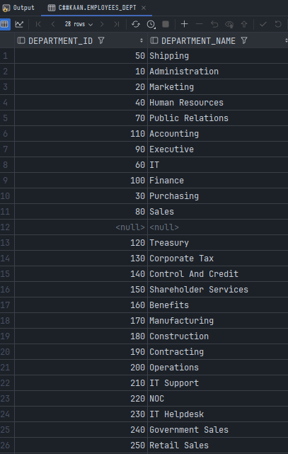**Screenshot:**

## Exercise SQL03-EX-04:

**Definiton :** Using **WITH** keyword, do following jobs:

* Firstly select first_name, last_name, job_id, department_id from employees table whoes job_id starts with ‘S’.
* Additionally select job_title and min-max salary amount.
* Add department_name to that query.
* Lastly concat first_name and last_name with space as full_name alias and list with other selected columns.

**SQL:**

SELECT  
 EMP.FIRST_NAME || ' ' || EMP.LAST_NAME AS FULL_NAME,  
 EMP.JOB_ID,  
 J.JOB_TITLE,  
 EMP.DEPARTMENT_ID,  
 D.DEPARTMENT_NAME,  
 (SELECT MIN(SALARY) FROM EMPLOYEES) AS MIN_SALARY,  
 (SELECT MAX(SALARY) FROM EMPLOYEES) AS MAX_SALARY  
FROM  
 EMPLOYEES EMP  
 INNER JOIN JOBS J ON EMP.JOB_ID = J.JOB_ID  
 INNER JOIN DEPARTMENTS D ON EMP.DEPARTMENT_ID = D.DEPARTMENT_ID  
WHERE  
 EMP.JOB_ID LIKE 'S%';

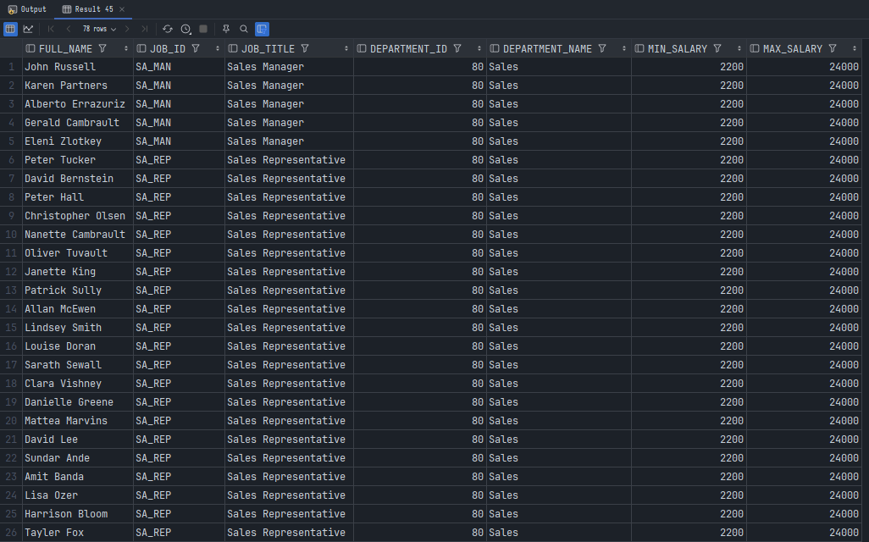**Screenshot:**

## Exercise SQL03-EX-05:

**Definiton :** Search for COMMIT and ROLLBACK keywords and explain them.

*COMMIT:* The COMMIT statement in Oracle is used to save all the changes made in the current transaction to the database. Once a COMMIT is executed, the changes become permanent and are visible to other users. The syntax for committing a transaction is simply COMMIT;

*ROLLBACK:* The ROLLBACK statement in Oracle is used to undo all the changes made in the current transaction. It reverts the database to the state it was in before the transaction began, effectively canceling any data modifications such as INSERT, UPDATE, or DELETE operations performed during the transaction. This is useful for error recovery or if the transaction needs to be aborted for any reason. The syntax for rolling back a transaction is ROLLBACK;