Beyond the Logo: Can We Recognize a Brand Without Its Name?
Presentation Slides, Content & Speaking Notes
Presenters: Kaan & Caner | Planned Duration: 12 Minutes (720 Seconds)

Slide 1: Beyond the Logo
Speaker: Kaan | Planned Timing: 30s
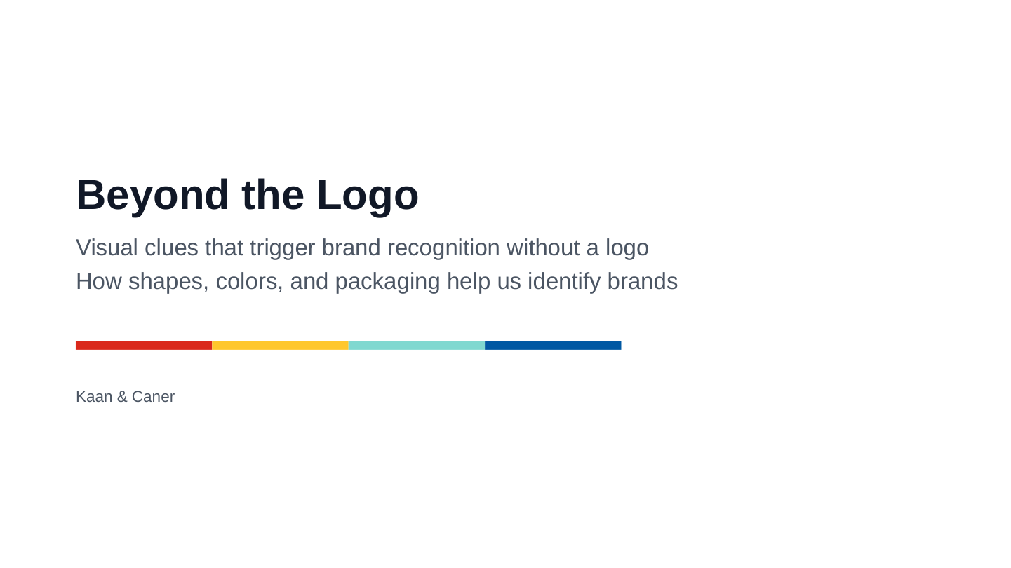
Key Slide Points:
- Visual clues that trigger brand recognition without a logo
- How shapes, colors, and packaging help us identify brands
Spoken Script:
Hi, I’m Kaan, and this is Caner. Today we’ll look at how we recognize brands without their names. Sometimes a color, a shape, or a package is enough. In daily life, we rarely read every logo on a shelf. Instead, we spot familiar bottles and colors. We’ll explore four famous examples to see how this works.

Slide 2: Visual Quiz: Can Color Alone Identify a Brand?
Speaker: Kaan | Planned Timing: 45s
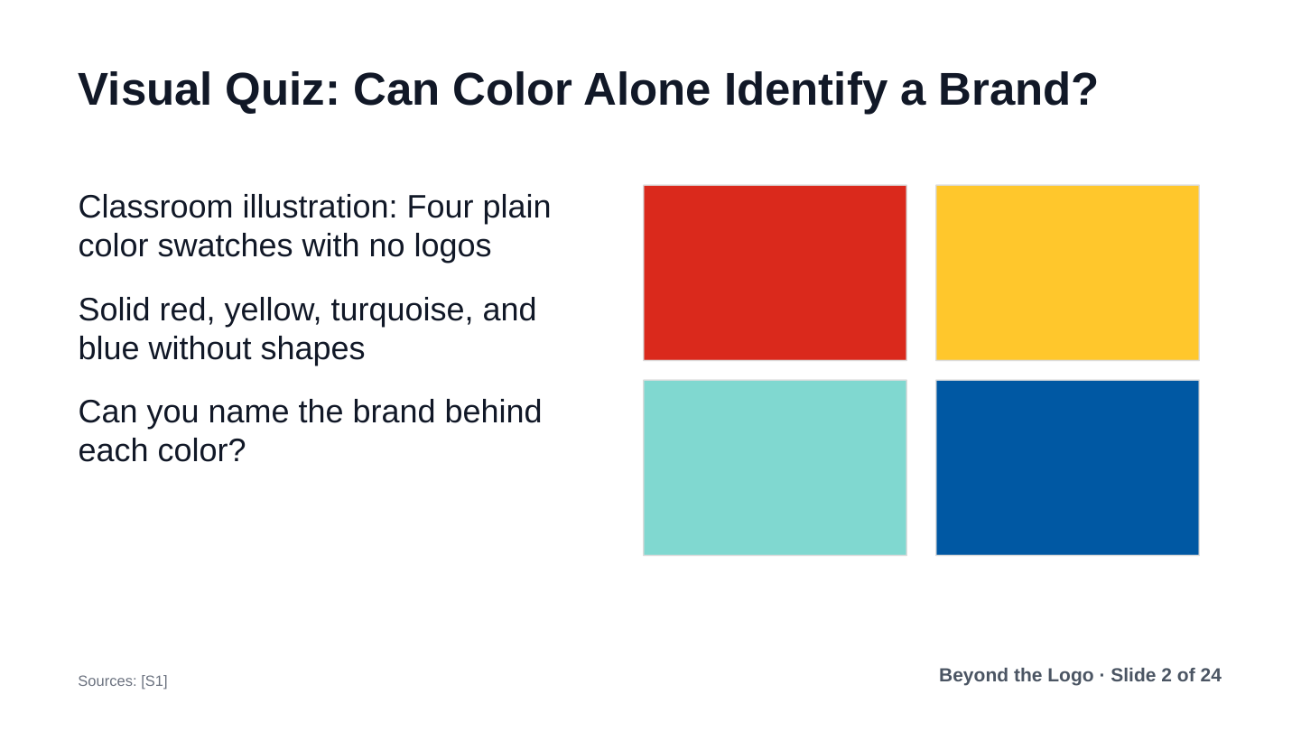
Key Slide Points:
- Classroom illustration: Four plain color swatches with no logos
- Solid red, yellow, turquoise, and blue without shapes
- Can you name the brand behind each color?
Spoken Script:
Let’s start with a quick quiz. Here are four plain colors: red, yellow, turquoise, and blue. There are no names and no shapes here. Color alone is not always enough to identify a brand. Many different companies share red or blue. Without a shape or context, not everyone will recognize them.

Slide 3: Visual Quiz: Adding Product Shapes to Colors
Speaker: Kaan | Planned Timing: 45s
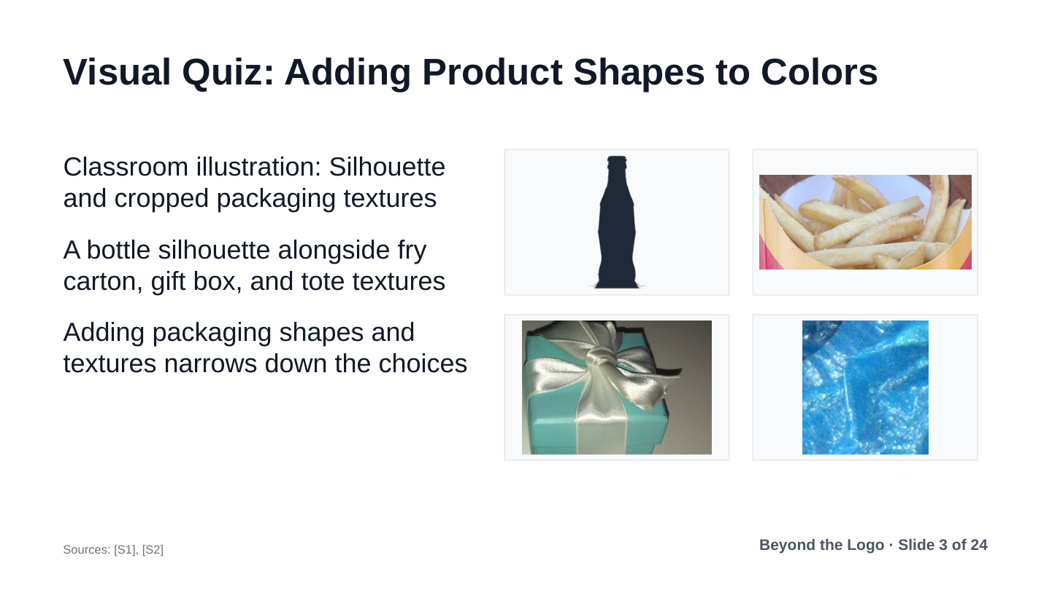
Key Slide Points:
- Classroom illustration: Silhouette and cropped packaging textures
- A bottle silhouette alongside fry carton, gift box, and tote textures
- Adding packaging shapes and textures narrows down the choices
Spoken Script:
Now look at these new clues. Here is a black bottle silhouette, plus packaging textures from three items. We see fry packaging, a gift box, and a bag. Adding a physical shape changes everything. Shape turns a plain color into a real product. The choices become much clearer right away.

Slide 4: The Reveal: Learned Brand Connections in Daily Life
Speaker: Kaan | Planned Timing: 30s
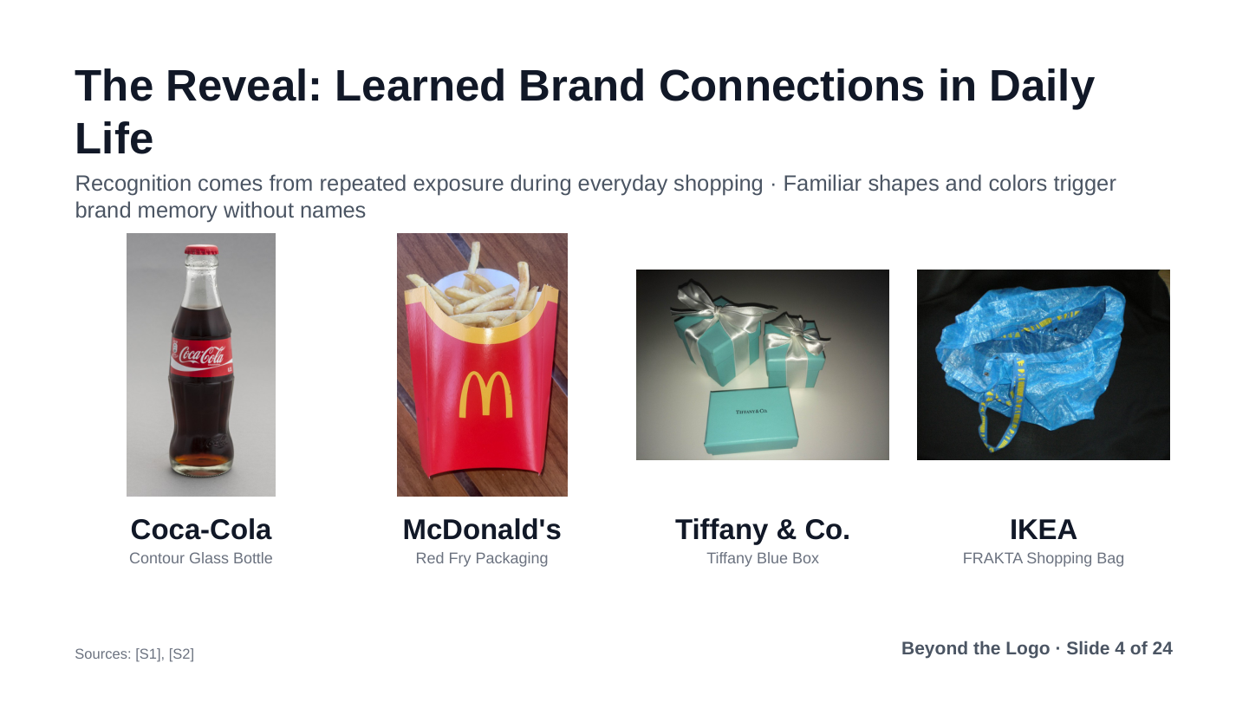
Key Slide Points:
- The four brands: Coca-Cola, McDonald's, Tiffany, and IKEA
- Recognition comes from repeated exposure during everyday shopping
- Familiar shapes and colors trigger brand memory without names
Spoken Script:
Here is the reveal: Coca-Cola, McDonald’s, Tiffany, and IKEA. We did not know these brands from birth. Instead, we learned them by seeing them again and again. We spot them in shops, ads, and street signs. Over time, a familiar shape becomes an easy shortcut. That is how these brands stick in our memory.

Slide 5: How Brand Memory Works: Context Beats Color Myths
Speaker: Kaan | Planned Timing: 30s
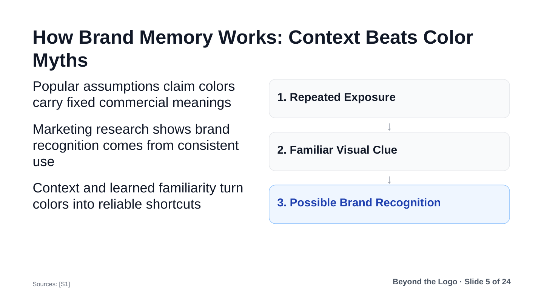
Key Slide Points:
- Popular assumptions claim colors carry fixed commercial meanings
- Marketing research shows brand recognition comes from consistent use
- Context and learned familiarity turn colors into reliable shortcuts
Spoken Script:
We often hear that red creates hunger and blue builds trust. But a color does not mean the same thing to everyone. With brands, we learn these links by seeing the same colors again and again. So using a color consistently matters. Caner will show you some examples.

Slide 6: Case 1: Coca-Cola and the 1915 Bottle Challenge
Speaker: Caner | Planned Timing: 36s
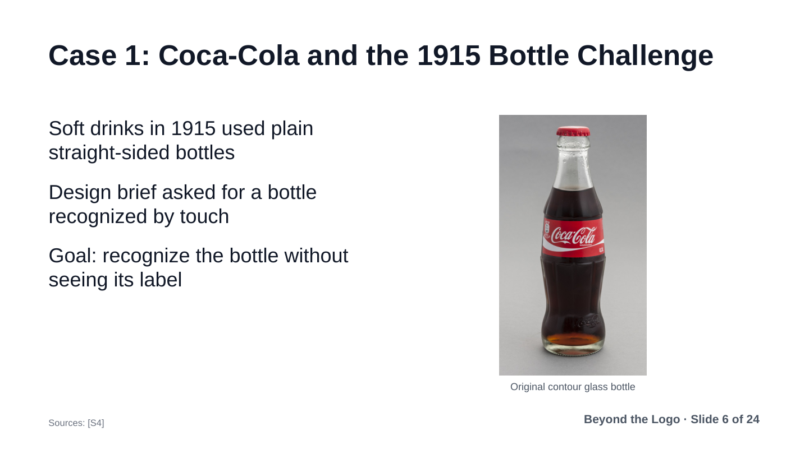
Key Slide Points:
- Soft drinks in 1915 used plain straight-sided bottles
- Design brief asked for a bottle recognized by touch
- Goal: recognize the bottle without seeing its label
Spoken Script:
Our first case study is Coca-Cola. In the early 1900s, sodas used plain glass bottles. Local competitors copied them very easily. Paper labels also peeled off in cold water coolers. In 1915, Coca-Cola asked designers for help. They wanted a bottle you could recognize by touch in the dark.

Slide 7: Coca-Cola: The 1915 Fluted Bottle Design
Speaker: Caner | Planned Timing: 36s
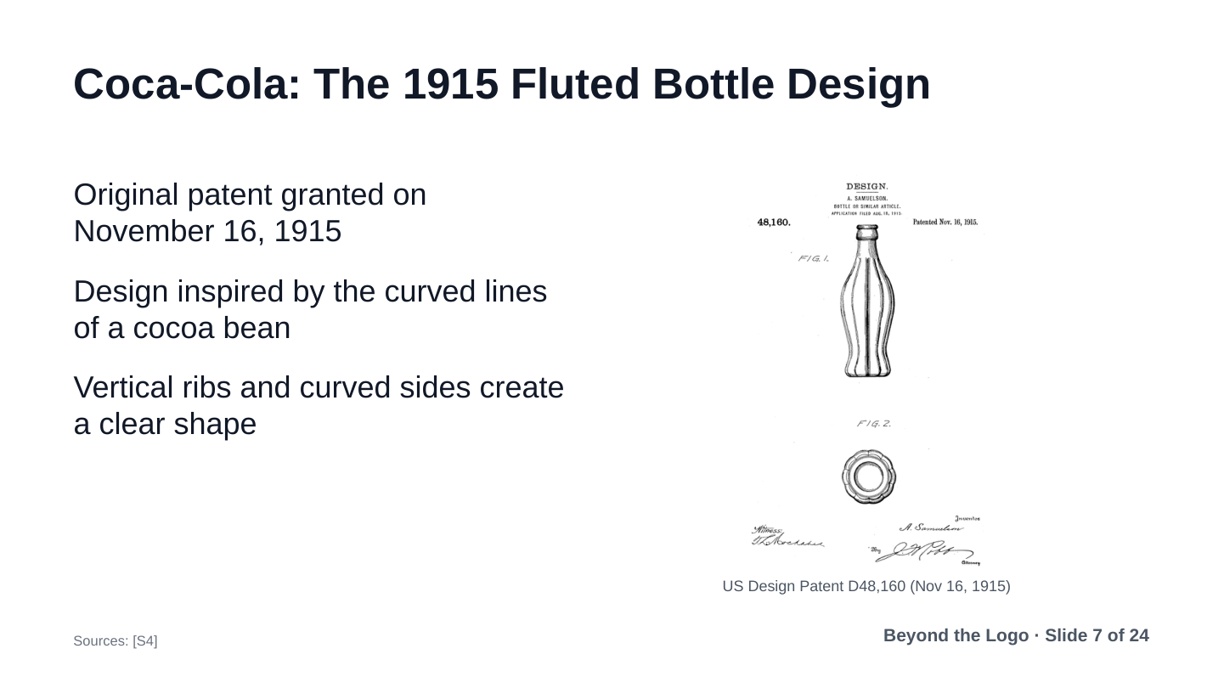
Key Slide Points:
- Original patent granted on November 16, 1915
- Design inspired by the curved lines of a cocoa bean
- Vertical ribs and curved sides create a clear shape
Spoken Script:
The Root Glass Company in Indiana answered the challenge. While researching, designers saw a sketch of a cocoa bean. It had rounded ribs and curved lines. Cocoa was not in the recipe, but the grooves inspired them. Alexander Samuelson patented this fluted shape on November 16, 1915.

Slide 8: Shape Still Matters Without Color
Speaker: Caner | Planned Timing: 36s
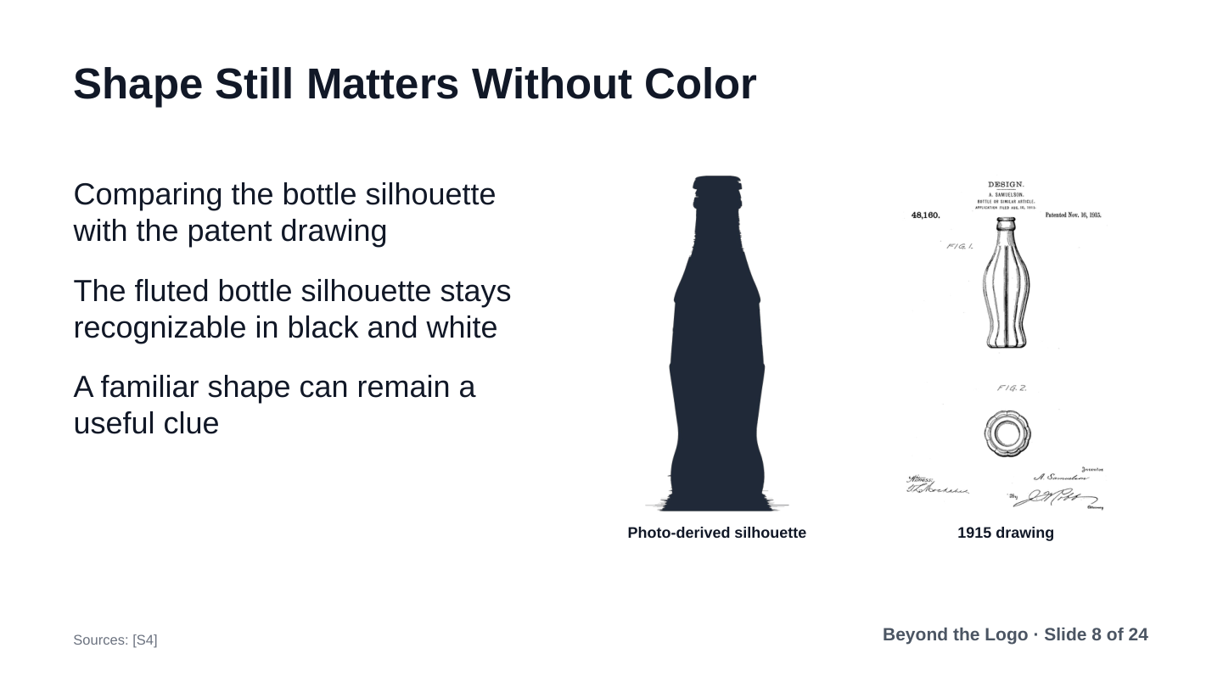
Key Slide Points:
- Comparing the bottle silhouette with the patent drawing
- The fluted bottle silhouette stays recognizable in black and white
- A familiar shape can remain a useful clue
Spoken Script:
Here we compare a photo-derived silhouette with the 1915 patent drawing. Both images are in black and white. There is no red color and no brand name. Yet the curved bottle remains easy to spot. This shows that shape works as a clue all by itself. You do not need color to identify this container.

Slide 9: McDonald’s: More Than Red and Yellow
Speaker: Caner | Planned Timing: 36s
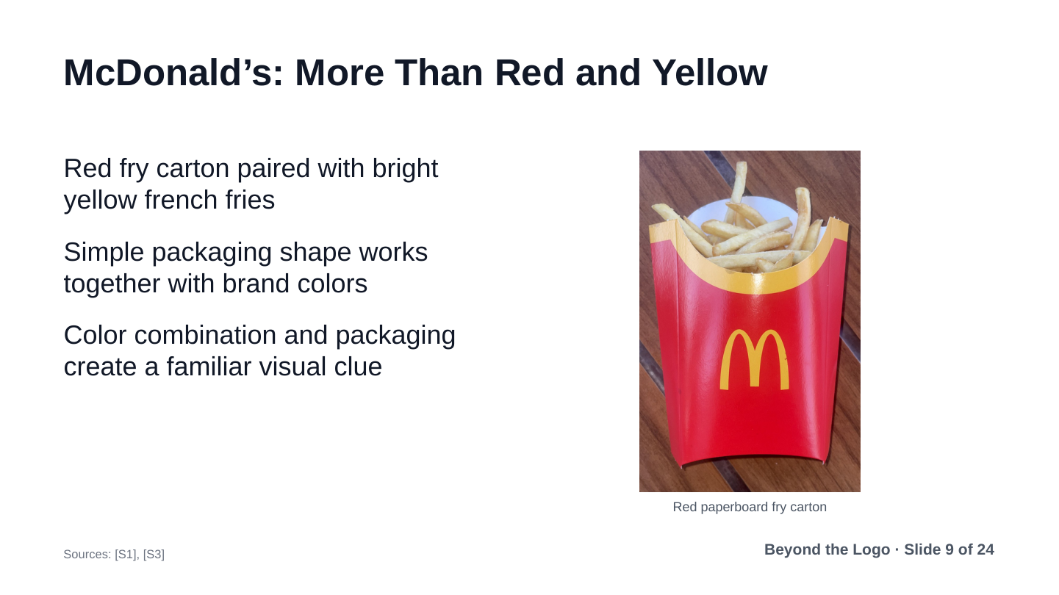
Key Slide Points:
- Red fry carton paired with bright yellow french fries
- Simple packaging shape works together with brand colors
- Color combination and packaging create a familiar visual clue
Spoken Script:
Our second case study is McDonald’s. The logo is visible here. But imagine covering it. The red box and fries still give us clues. The curved red carton and yellow fries work together. Not everyone will recognize it, of course. Still, packaging shape and color support each other well.

Slide 10: McDonald’s: European Green and Cropped Arches
Speaker: Caner | Planned Timing: 36s
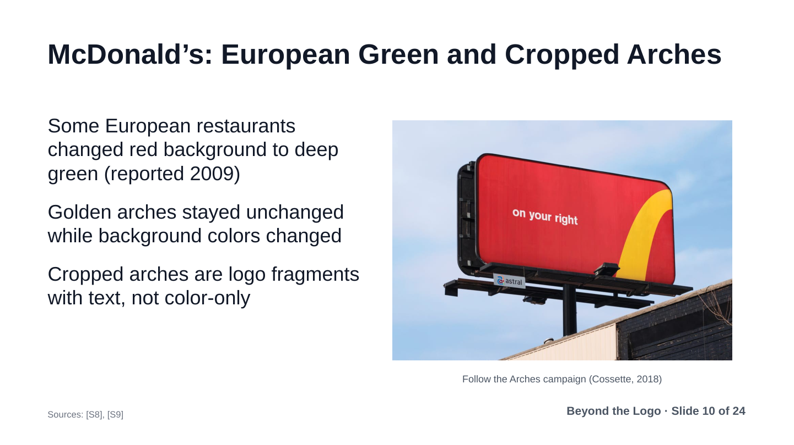
Key Slide Points:
- Some European restaurants changed red background to deep green (reported 2009)
- Golden arches stayed unchanged while background colors changed
- Cropped arches are logo fragments with text, not color-only
Spoken Script:
McDonald’s also shows how visual clues adapt. In 2009, some European restaurants changed red backgrounds to green. The golden arches stayed the same. In 2018, Canadian billboards used cropped pieces of the arches. They pointed drivers toward nearby restaurants. These ads used parts of a familiar logo, not color alone.

Slide 11: Case 3: Tiffany Blue and Luxury Packaging
Speaker: Caner | Planned Timing: 36s
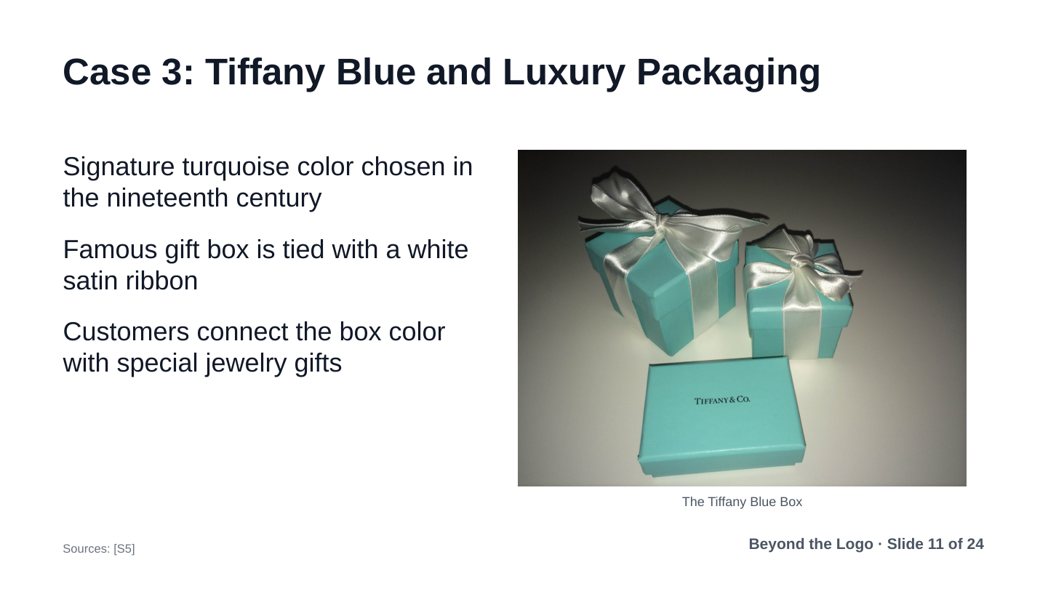
Key Slide Points:
- Signature turquoise color chosen in the nineteenth century
- Famous gift box is tied with a white satin ribbon
- Customers connect the box color with special jewelry gifts
Spoken Script:
Our third case study is Tiffany and Co. They built strong recognition around one signature color. In the 1800s, the founder picked robin’s-egg blue for a catalogue. Soon, the blue box with a white satin ribbon appeared. People learned to connect this color with luxury jewelry gifts. The box itself became as famous as the jewelry.

Slide 12: Tiffany: Store Rules and Presentation
Speaker: Caner | Planned Timing: 36s
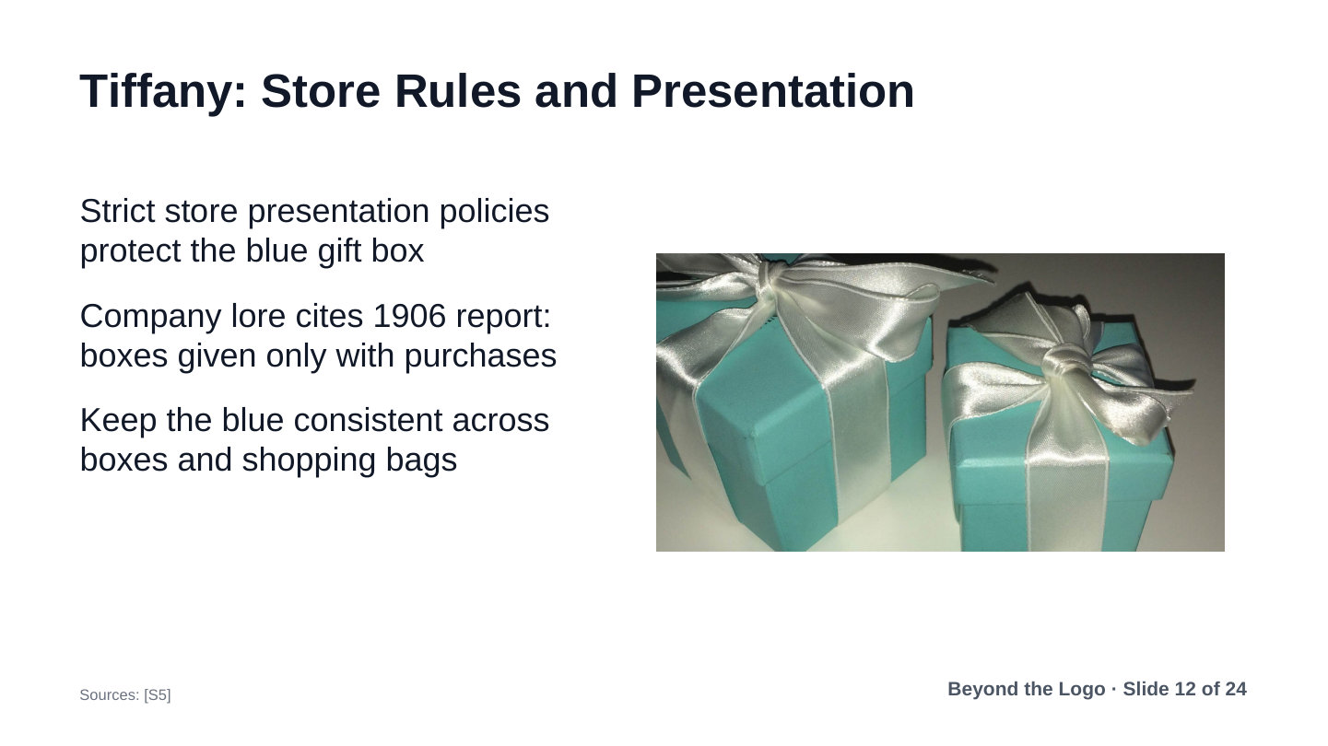
Key Slide Points:
- Strict store presentation policies protect the blue gift box
- Company lore cites 1906 report: boxes given only with purchases
- Keep the blue consistent across boxes and shopping bags
Spoken Script:
Tiffany protected this blue box through strict presentation rules. An old 1906 report said you could never buy an empty box. It only came with a real jewelry purchase. That is Tiffany’s own account, not independent research. Still, it shows how carefully they protected the packaging.

Slide 13: Tiffany: Standard Color and Trademark Scope
Speaker: Caner | Planned Timing: 36s
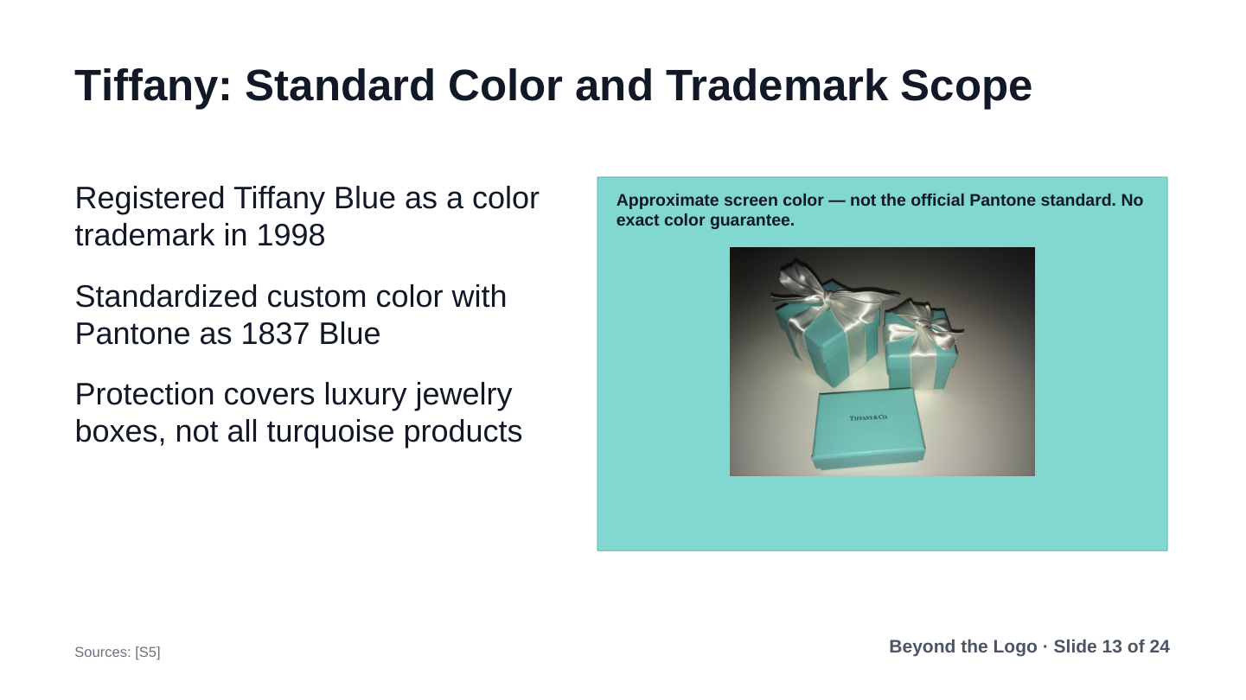
Key Slide Points:
- Registered Tiffany Blue as a color trademark in 1998
- Standardized custom color with Pantone as 1837 Blue
- Protection covers luxury jewelry boxes, not all turquoise products
Spoken Script:
To keep the color consistent, Tiffany worked with Pantone in 2001. They created a custom standard called 1837 Blue. The color on this screen is only an approximation. Tiffany also trademarked the color for packaging in 1998. That rule applies to luxury boxes, not every blue product.

Slide 14: Case 4: IKEA and Store Color Standardization
Speaker: Caner | Planned Timing: 36s
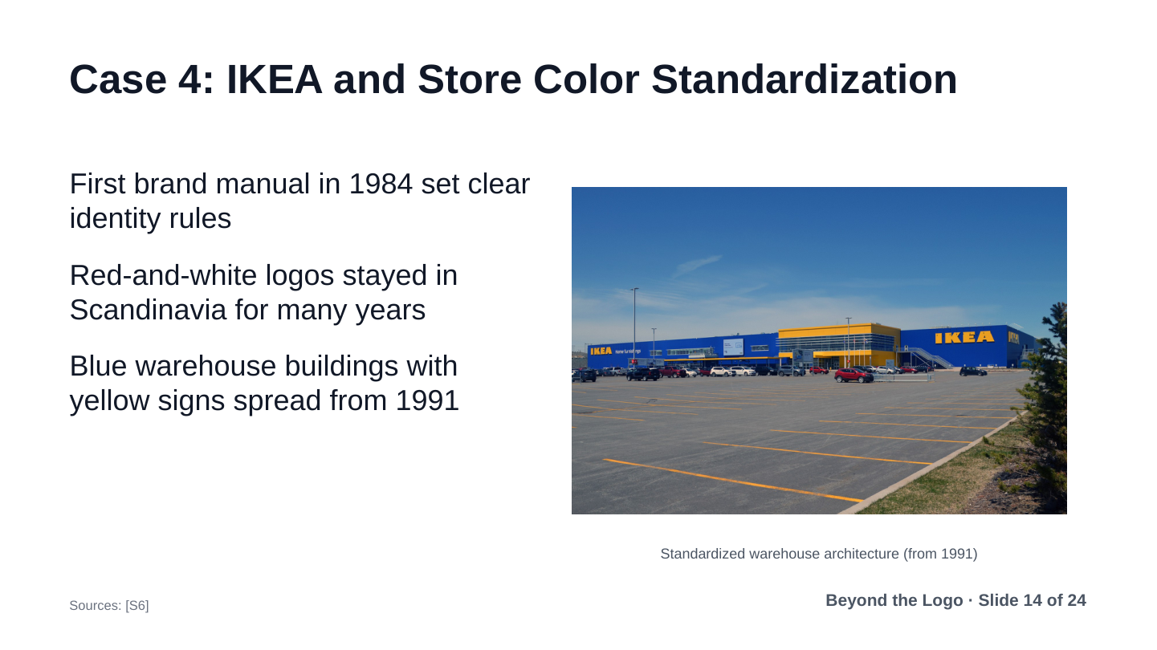
Key Slide Points:
- First brand manual in 1984 set clear identity rules
- Red-and-white logos stayed in Scandinavia for many years
- Blue warehouse buildings with yellow signs spread from 1991
Spoken Script:
Our fourth case study is IKEA. We all know their blue and yellow buildings today. But standardizing these colors took many years. In 1984, IKEA published its first brand manual. From 1991, they built blue warehouse stores with yellow signs. Now, back to Kaan.

Slide 15: IKEA: The Blue FRAKTA Shopping Bag
Speaker: Kaan | Planned Timing: 36s
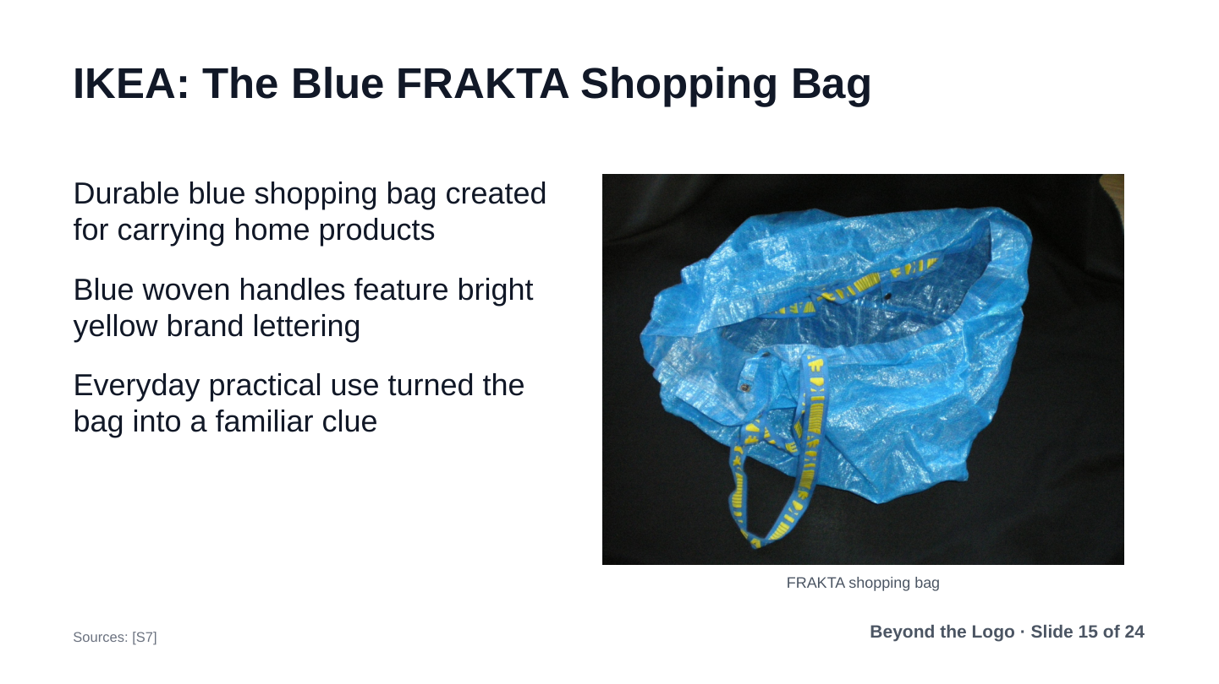
Key Slide Points:
- Durable blue shopping bag created for carrying home products
- Blue woven handles feature bright yellow brand lettering
- Everyday practical use turned the bag into a familiar clue
Spoken Script:
Thanks, Caner. IKEA created another famous clue: the blue FRAKTA bag. In 1986, shoppers got tired carrying heavy goods. IKEA tested yellow bags in 1989, but checkout got confusing. So yellow bags stayed inside for borrowing. Blue bags were sold to take home. That durable bag became a familiar household clue.

Slide 16: Limits of Single Colors: Shared Brand Clues
Speaker: Kaan | Planned Timing: 36s
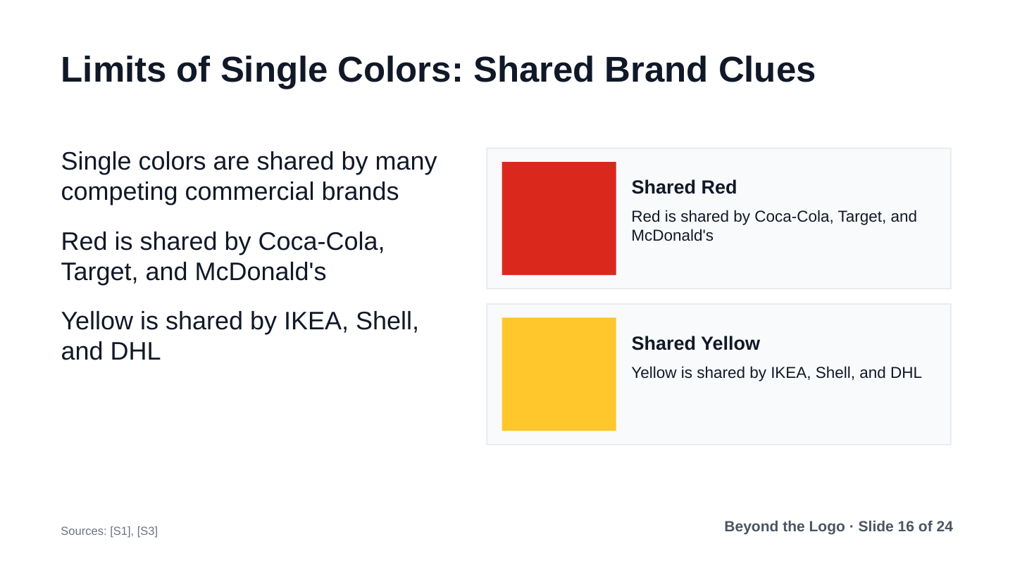
Key Slide Points:
- Single colors are shared by many competing commercial brands
- Red is shared by Coca-Cola, Target, and McDonald's
- Yellow is shared by IKEA, Shell, and DHL
Spoken Script:
What do these examples teach us about design? First, color alone is rarely enough. Many big companies use the same basic colors. Red is used by Coca-Cola, Target, and McDonald’s. Yellow is shared by IKEA, Shell, and DHL. Without context, one color can suggest several brands.

Slide 17: Combining Visual Clues: Color, Shape, and Context
Speaker: Kaan | Planned Timing: 36s
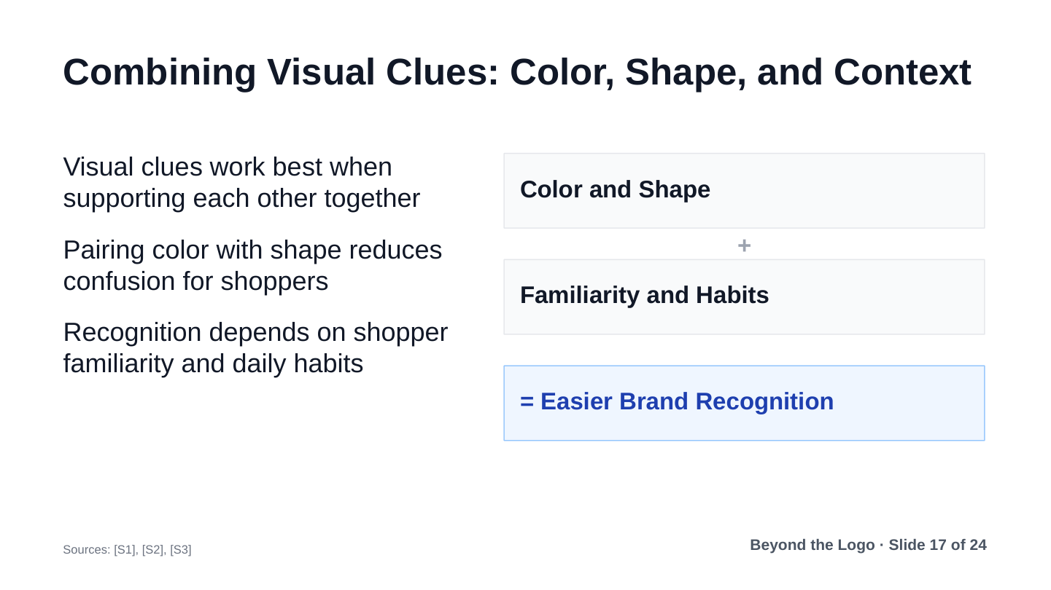
Key Slide Points:
- Visual clues work best when supporting each other together
- Pairing color with shape reduces confusion for shoppers
- Recognition depends on shopper familiarity and daily habits
Spoken Script:
This is why visual clues work best together. A plain bottle outline could be any drink. A solid red square could mean many brands. But when you pair shape with color, recognition becomes easy. Not everyone will spot every clue instantly. Still, multiple clues support each other during shopping.

Slide 18: Redesign Risks: Protecting Familiar Visual Clues
Speaker: Kaan | Planned Timing: 36s
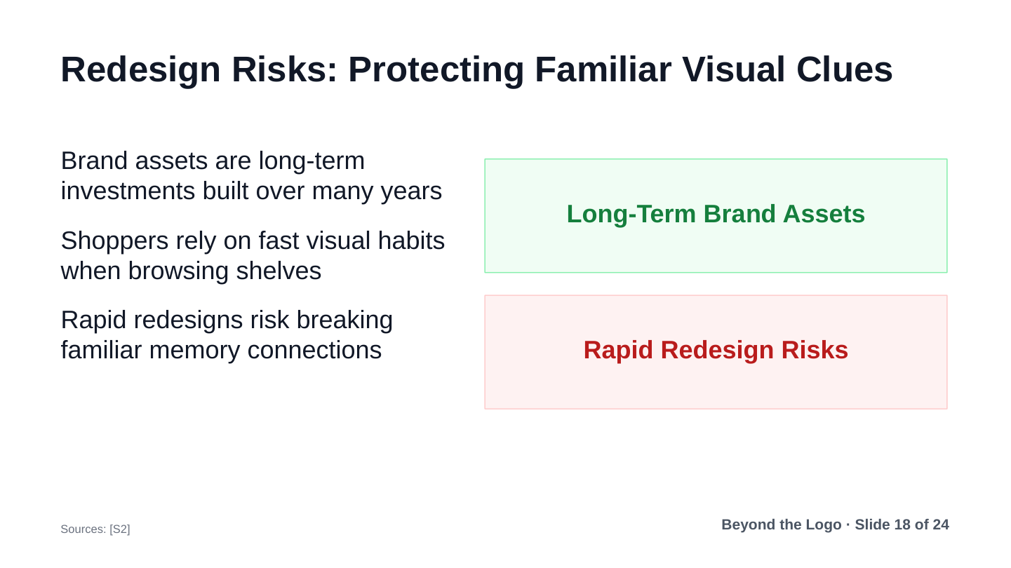
Key Slide Points:
- Brand assets are long-term investments built over many years
- Shoppers rely on fast visual habits when browsing shelves
- Rapid redesigns risk breaking familiar memory connections
Spoken Script:
Our next lesson is about the risk of redesigns. Design teams often want to change packaging for new trends. But shoppers rely on quick visual habits in store aisles. If a company changes colors or shapes too fast, customers get confused. Protecting familiar clues keeps existing buyers happy.

Slide 19: Practical Guidelines for Distinctive Design
Speaker: Kaan | Planned Timing: 36s
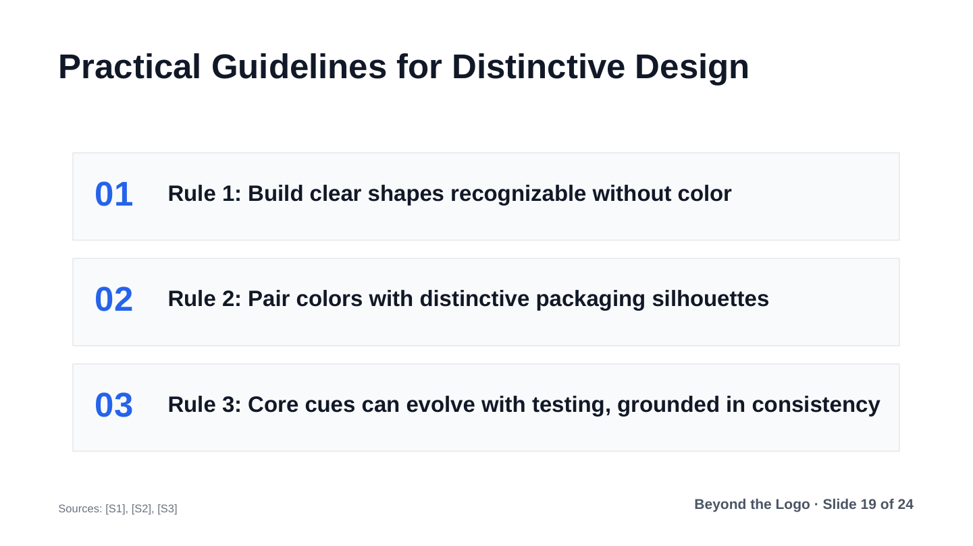
Key Slide Points:
- Rule 1: Build clear shapes recognizable without color
- Rule 2: Pair colors with distinctive packaging silhouettes
- Rule 3: Core cues can evolve with testing, grounded in consistency
Spoken Script:
Here are three practical tips for designers. First, build clear shapes that work in black and white. Second, pair colors with unique packages and fonts. Third, stay consistent over long periods of time. You can evolve cues carefully, but test before changing them. Consistency turns simple designs into lasting memory shortcuts.

Slide 20: Conclusion: Distinctive Clues in Daily Life
Speaker: Kaan | Planned Timing: 36s
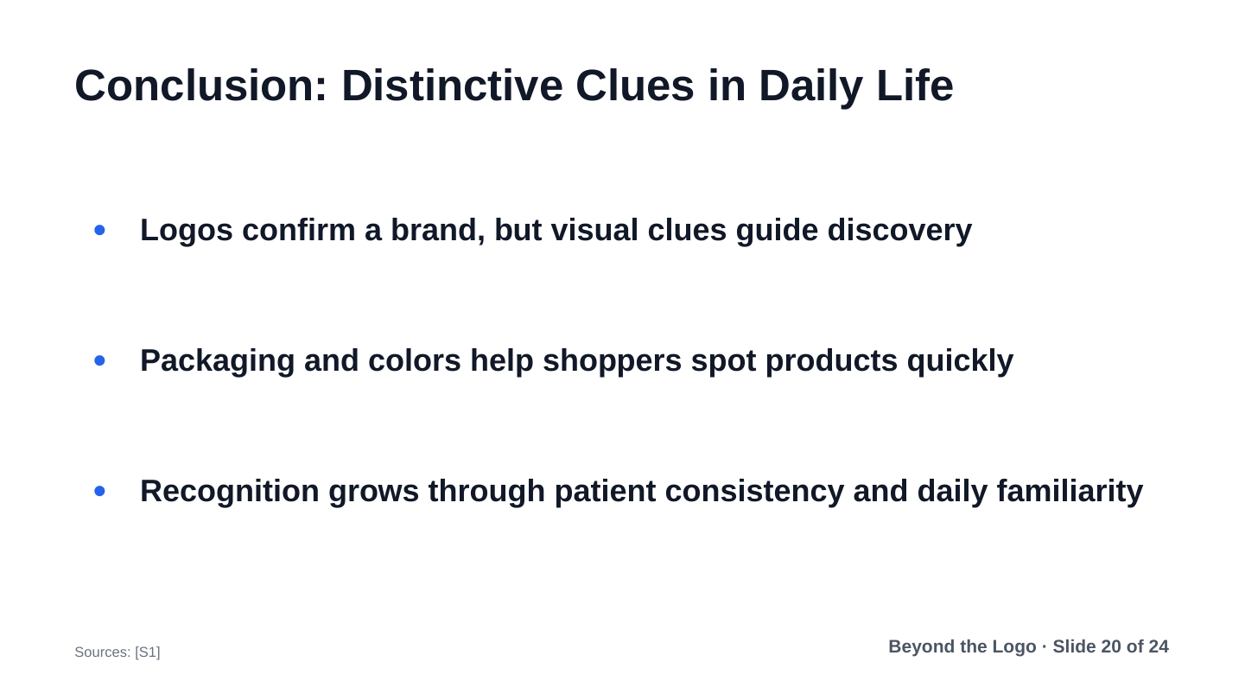
Key Slide Points:
- Logos confirm a brand, but visual clues guide discovery
- Packaging and colors help shoppers spot products quickly
- Recognition grows through patient consistency and daily familiarity
Spoken Script:
To wrap up, logos still matter at the final moment. But in crowded places, shapes and colors catch our attention first. Bottles, fry cartons, and gift boxes guide us without words. Thank you very much for your time. Caner and I are happy to take any questions.

Slide 21: References: Research Studies and Corporate Archives
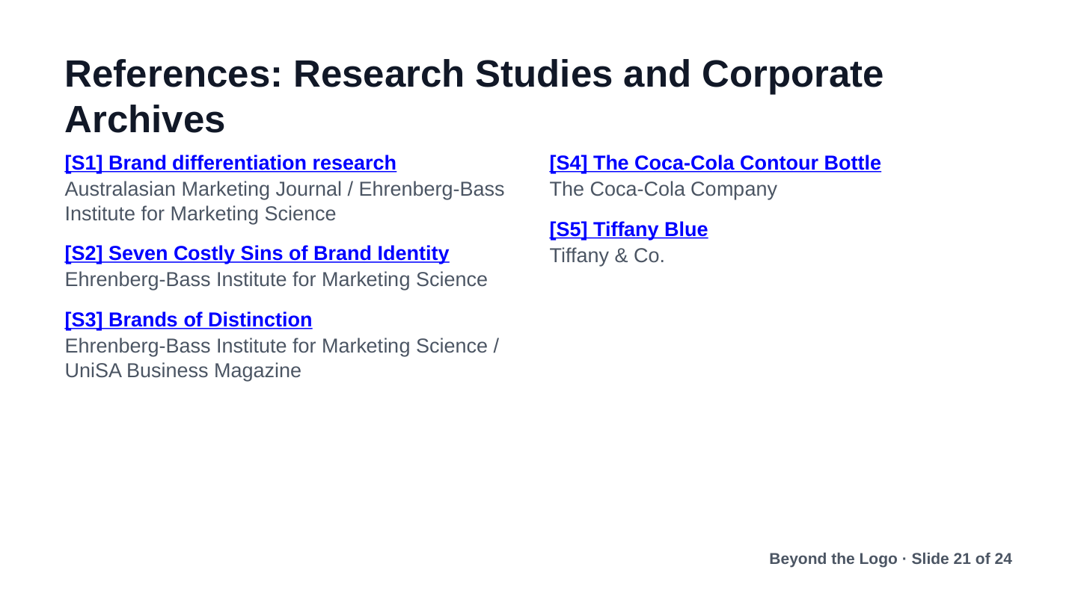
Key Slide Points:
- S1: Romaniuk, J., Sharp, B., & Ehrenberg, A. Evidence concerning the importance of perceived brand differentiation. Australasian Marketing Journal / Ehrenberg-Bass Institute. https://assets.marketingscience.info/different.pdf
- S2: Romaniuk, J. Q&A: Seven Costly Sins of Brand Identity. Ehrenberg-Bass Institute for Marketing Science. https://assets.marketingscience.info/Brand-Identity-QA.pdf
- S3: Romaniuk, J. (2013). Brands of Distinction. UniSA Business Magazine / Ehrenberg-Bass Institute for Marketing Science. https://marketingscience.info/news-and-insights/brands-of-distinction
- S4: The Coca-Cola Company. The History of the Coca-Cola Contour Bottle. The Coca-Cola Company. https://www.coca-colacompany.com/about-us/history/the-history-of-the-coca-cola-contour-bottle
- S5: Tiffany & Co. Tiffany Blue: A Color So Famous, It's Trademarked. Tiffany & Co. https://press.tiffany.com/our-story/tiffany-blue/

Slide 22: References: Museum Archives, News and Agency Records
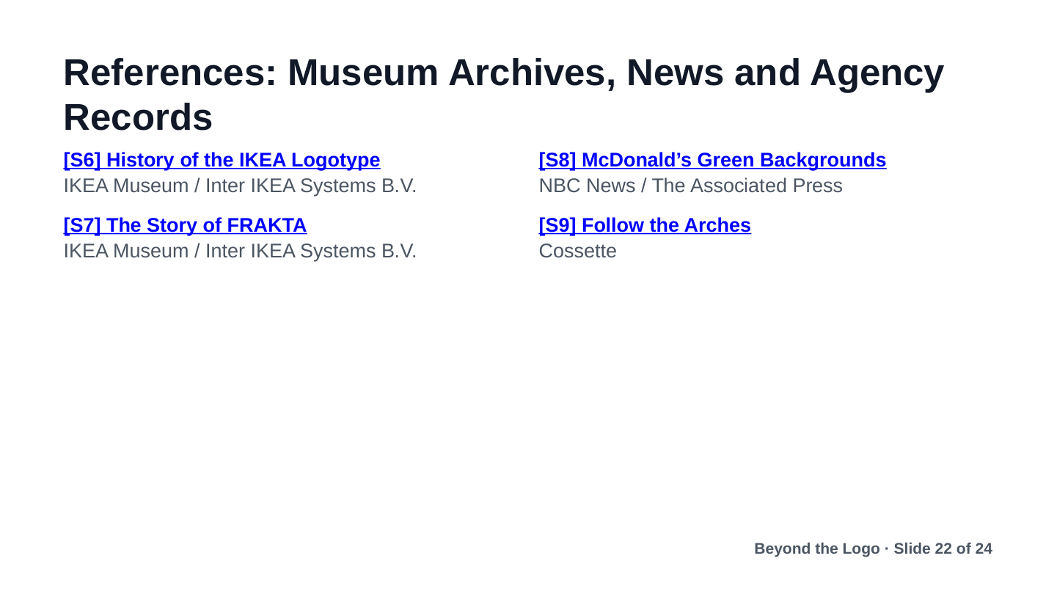
Key Slide Points:
- S6: IKEA Museum. History of the logotype: The small steps of evolution. IKEA Museum / Inter IKEA Systems B.V. https://ikeamuseum.com/en/explore/the-story-of-ikea/history-of-the-logotype/
- S7: IKEA Museum. Beloved bag: The story of FRAKTA. IKEA Museum / Inter IKEA Systems B.V. https://ikeamuseum.com/en/explore/the-story-of-ikea/beloved-bag/
- S8: NBC News / The Associated Press. McDonald’s rolling out green logo in Europe. NBC News. https://www.nbcnews.com/id/wbna34111784
- S9: Cossette. Cossette and McDonald's deconstruct the iconic Golden Arches to direct people to the nearest restaurant (Follow the Arches). Cossette. https://www.cossette.com/en/blog/__temp_icoufkdgyfmhfyeayjfwwthtvmmmmbyghnhu

Slide 23: Slide 23
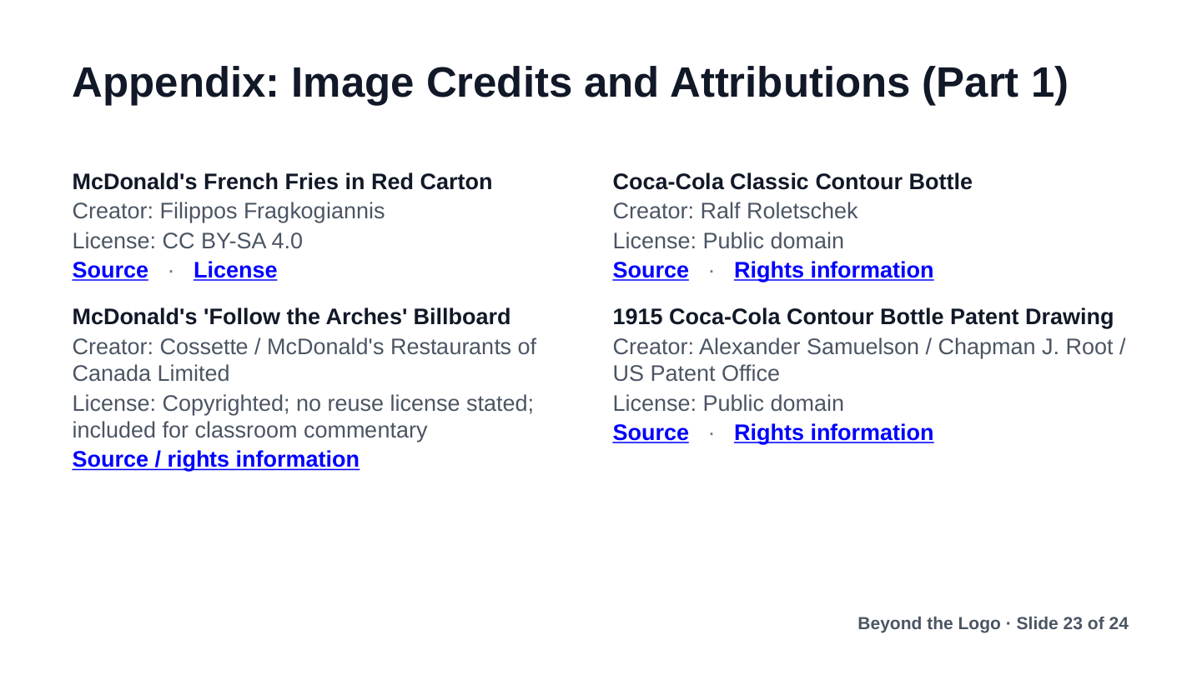

Slide 24: Slide 24
