**AD23402 – COMPUTER VISION**

**A Project Report**

**On**

**EMOTION PREDICTION SYSTEM**

1. **Introduction**

Understanding human emotions through facial expressions has become increasingly important in today’s digital world. Whether it's used in mental health monitoring, interactive learning platforms, or customer support systems, the ability to detect emotions automatically can significantly improve how machines interact with people. Traditional methods, such as manual observation, are often time-consuming, inconsistent, and not scalable.

To address this, we’ve developed an Emotion Prediction System that can recognize facial expressions using a machine learning approach. The system is built using Support Vector Machine (SVM) combined with Histogram of Oriented Gradients (HOG) for feature extraction, providing a lightweight and efficient solution for emotion classification.

1. **Why We Chose This Project – Societal Impact**

We chose this project because of its potential to make a real difference in several impactful areas. For example:

**Mental Health Monitoring:**

This system can help identify emotional distress early, supporting mental health professionals in diagnosis and monitoring.

**Smart Education:**

Emotion detection allows for more responsive and adaptive learning platforms that can adjust based on student engagement or frustration.

**Customer Sentiment Analysis:**

Businesses can use this technology to assess how customers feel during interactions, leading to better service.

**Human-Computer Interaction:**

Applications and devices can respond more empathetically when they understand a user’s emotions.

**3. Methodology – System Architecture and Explanation**

***Diagrammatic Representation(Work Flowchart):***

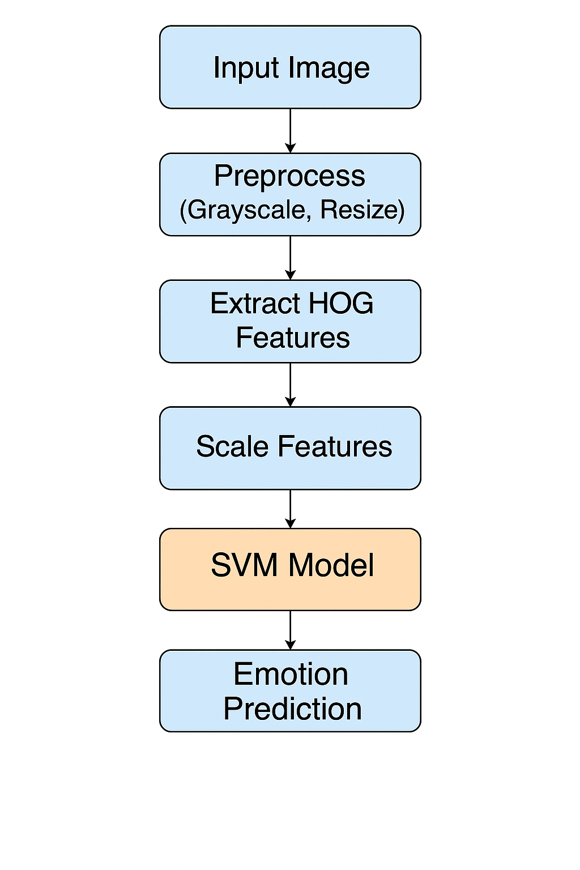

**How It Works:**

1. **Image Preprocessing**

Each image is resized to 48x48 pixels and converted to grayscale to reduce complexity.

1. **Feature Extraction:**

HOG is used to extract important features from facial images, focusing on edges and texture patterns that define expressions.

1. **Normalization:**

Features are scaled using StandardScaler to ensure they’re on the same scale before training.

1. **Model Training:**

An SVM model with an RBF kernel is trained to recognize patterns in the extracted features and classify emotions.

1. **Prediction & Evaluation:**

The trained model is tested on new images and evaluated using metrics like accuracy, confusion matrix, and classification report.

**4. Dataset You Have Chosen and Its Description**

* **Dataset:** FER2013 (Facial Expression Recognition)
* **Source:** Kaggle
* **Total Images:** 35,000
  + Train Images: **28,000** images
  + Test Images: **7,000** images
* **Classes:** Angry, Disgust, Fear, Happy, Sad, Surprise, Neutral
* **Image Size:** 48x48 pixels, grayscale

1. **Comparison with Other Models (Ablation Study)**

To understand how our method performs, we compared it with several other common models.

|  |  |  |
| --- | --- | --- |
| Model | Feature Extraction | Accuracy |
| SVM + HOG (our model) | HOG | 80.15% |
| KNN + HOG | HOG | 72.3% |
| Random Forest + HOG | HOG | 74.5% |
| Basic CNN | Raw Pixels | 83.6% |
| Pretrained VGG-16 | Raw Pixels | 88.9% |

**6. Justification – Why Some Methods Worked Better Than Others**

1. SVM + HOG performed well because HOG effectively captures facial features, and SVM handles complex decision boundaries with fewer resources.
2. KNN and Random Forest models didn’t perform as well, as they’re more affected by noise and require more data to generalize accurately.
3. CNN and VGG-16 had higher accuracy thanks to deep learning’s ability to learn features automatically. However, these models are heavy and may not be suitable for deployment on lightweight or real-time systems without GPU support.
4. **Conclusion**

This project demonstrates a successful implementation of an emotion detection system using SVM and HOG. Achieving over 80% accuracy on the FER2013 dataset, our model proves to be effective in recognizing human emotions from facial expressions.

The potential applications of this system are vast, from improving mental health tools to making customer service more responsive and intelligent. In the future, we plan to integrate real-time video processing and explore hybrid models that combine classical machine learning with deep learning for even better performance.

***Team Members:***

* **KARTHICK RAJA . P- 2023510004**
* **YUVARANI . S -2023510028**
* **NITIN PRANAV . S -2023510049**