VELLORE INSTITUTE OF TECHNOLOGY, VELLORE
School of Computer Science and Engineering (SCOPE)

MINI PROJECT REPORT

Automated Library Management & Circulation System

Course Code: BCSE302P – Database Systems Laboratory

Submitted by

S. No. | Name | Registration Number
1 | Pethimareddygari Karthik Reddy | 23BCE0919
(Maximum 4 members. Individual reports carry higher weightage. Delete unused rows.)

Under the guidance of
Dr. G. M. Karthik
Associate Professor, School of Computer Science and Engineering (SCOPE)
Vellore Institute of Technology, Vellore

Date of Submission: 24 / 10 / 2026

CERTIFICATE

This is to certify that the Mini Project Report titled "Automated Library Management & Circulation System" submitted individually by Pethimareddygari Karthik Reddy (Reg. No. 23BCE0919) in partial fulfilment of the requirements of the course BCSE302P – Database Systems Laboratory, is a record of original work carried out under my supervision during the Fall Semester 2026–27.

Signature of the Faculty
Dr. G. M. Karthik
Associate Professor, SCOPE
VIT, Vellore

Place: Vellore
Date: 24 October 2026
Date:

ABSTRACT
In university departments and college libraries, traditional manual ledger books and disconnected spreadsheets often lead to inventory inaccuracies, duplicate loan entries, and uncollected late fees. This project implements an Automated Library Management & Circulation System using Oracle PL/SQL and a lightweight Flask web dashboard. Our primary database layer is designed in Third Normal Form (3NF/BCNF) comprising four relational tables: BOOKS, MEMBERS, LOANS, and AUDIT_LOGS. Business logic is strictly preserved at the engine level using stored procedures and a modular PL/SQL package (library_pkg). To eliminate human bookkeeping mistakes, we implemented two automated row-level triggers: trg_after_book_borrow, which validates stock availability (raising ORA-20001 upon stockout), automatically decrements available copies, and records an immutable borrowing audit row; and trg_after_book_return, which restores inventory and automatically calculates overdue fines ($5.00 per calendar day late). Parameterized cursors provide batch reporting for active and overdue loans. The system is paired with a modern dark-mode Flask web interface that executes database procedures directly, verifying end-to-end ACID integrity, real-time trigger auditing, and reliable library circulation management.
Keywords: Library Management, Oracle PL/SQL, Database Triggers, Normalization, Stored Packages, Flask Dashboard

TABLE OF CONTENTS

1. INTRODUCTION .......................................................................................................... Page 3
1.1 Problem Statement ................................................................................................ Page 3
1.2 Objectives ........................................................................................................... Page 3
1.3 Importance of DBMS ........................................................................................... Page 3
1.4 Scope of the Project ........................................................................................... Page 4
2. SYSTEM REQUIREMENTS ...................................................................................... Page 4
2.1 Hardware Requirements ........................................................................................ Page 4
2.2 Software Requirements ........................................................................................ Page 4
3. DATABASE DESIGN .................................................................................................. Page 5
3.1 Entity–Relationship (ER) Diagram ..................................................................... Page 5
3.2 Relational Schema .................................................................................................... Page 6
3.3 Schema Definition (DDL) ...................................................................................... Page 6
3.4 Normalization ........................................................................................................ Page 7
4. IMPLEMENTATION ................................................................................................... Page 8
4.1 Functions ............................................................................................................. Page 8
4.2 Procedures ........................................................................................................... Page 9
4.3 Packages ............................................................................................................. Page 10
4.4 Triggers ............................................................................................................... Page 11
4.5 Cursors .............................................................................................................. Page 12
5. FRONT-END (WEB INTERFACE) ............................................................................... Page 13
5.1 User Interface ....................................................................................................... Page 13
5.2 Integration with the DBMS .................................................................................... Page 13
6. VERIFICATION & TESTING .................................................................................... Page 14
6.1 Test Cases ........................................................................................................... Page 14
6.2 Output Screenshots ................................................................................................. Page 15
6.3 Validation of Functionality ................................................................................... Page 15
7. RESULTS & DISCUSSION ......................................................................................... Page 16
7.1 Achievements ........................................................................................................ Page 16
7.2 Challenges Faced ..................................................................................................... Page 16
7.3 Possible Improvements ........................................................................................ Page 16
8. CONCLUSION ............................................................................................................... Page 17
8.1 Summary of Learning Outcomes ......................................................................... Page 17
8.2 Future Scope ......................................................................................................... Page 17
9. REFERENCES ............................................................................................................... Page 17
10. APPENDICES ................................................................................................................ Page 17
(Note: In Word, right-click and choose Update Field → Update entire table to refresh dynamic page numbering.)

1. INTRODUCTION

1.1 Problem Statement
In our college campus and departmental libraries, staff members often track book issues and returns either in physical registers or shared Excel files. When multiple students borrow books during peak hours (like right before midterm examinations), the records get messy very quickly. Students often return books weeks late, but staff members forget to calculate the fine properly, or worse, the same physical copy is shown as available when it has already been taken. Spreadsheets don't have built-in constraints to stop negative stock counts or prevent someone from typing a fake member ID. I wanted to build a proper database system where these rules are automatically handled by the database itself, ensuring zero duplicate issues, automatic late fee calculation, and full audit tracking.

1.2 Objectives
- 1. Design a normalized relational schema (up to BCNF) to eliminate data redundancy and prevent update/deletion anomalies.
- 2. Enforce strict business rules inside the database using PL/SQL packages, stored procedures, and automated row-level triggers.
- 3. Develop automated audit logging and explicit cursors to flag overdue borrowings and generate penalty reports.

1.3 Importance of DBMS
A Database Management System (DBMS) is essential for library circulation because simple file storage cannot guarantee ACID properties. For instance, when a book is issued, two things must happen together: creating a loan entry and decrementing the available copy count. If the server crashes midway, a DBMS ensures either both happen or everything rolls back cleanly (Atomicity). Furthermore, foreign keys enforce referential integrity so loans cannot reference non-existent students or books. By moving validation rules into database triggers and packages rather than just frontend JavaScript, our data stays completely consistent even if multiple client applications interact with the catalog simultaneously.

1.4 Scope of the Project
Scope of this project:
• In-Scope: Book catalog inventory management, student member registration, book borrowing/return workflow, automated stock decrement/increment, overdue penalty calculation ($5/day late), trigger-based audit logging, cursor-driven overdue loan queries, and a Flask web front-end dashboard.
• Out-of-Scope: Physical RFID gate reader hardware integration, online payment gateway processing for fines, and barcode scanner hardware interfacing.

2. SYSTEM REQUIREMENTS

2.1 Hardware Requirements
Component | Specification
Processor | Apple M-Series (Apple Silicon) / Intel Core i5 @ 2.4 GHz or higher
RAM | 8 GB Unified Memory / DDR4 RAM (16 GB recommended for Oracle DB)
Storage | 256 GB NVMe SSD (minimum 5 GB free disk space for DB logs)
Display / Peripherals | 1440x900 or 1920x1080 resolution monitor, Keyboard & Mouse

2.2 Software Requirements
Category | Tool / Version
Operating System | macOS Sonoma 14.x / Windows 11 64-bit
DBMS Engine | Oracle Database 21c Express Edition (XE) / Relational SQL Engine
Query & Admin Tool | Oracle SQL Developer / SQL*Plus / VS Code SQL Tools
Front-End Framework | Python 3.9+ / 3.10+ with Flask 3.0.3, HTML5, Vanilla CSS
DB Connectivity | python-oracledb / cx_Oracle (with high-fidelity SQLite fallback)
Auxiliary Tools | Git, Google Chrome, Pillow (screenshot generation), docx2pdf

3. DATABASE DESIGN

3.1 Entity–Relationship (ER) Diagram
Our conceptual database design consists of four core entities:
1. BOOKS (Entity): Attributes include book_id (PK), title, author, category, total_copies, and available_copies. Represents physical catalog holdings.
2. MEMBERS (Entity): Attributes include member_id (PK), first_name, last_name, student_number (UNIQUE), and email. Represents registered library patrons.
3. LOANS (Weak/Associative Entity): Attributes include loan_id (PK), book_id (FK), member_id (FK), borrow_date, due_date, return_date, and fine_amount. Represents circulation transactions. Cardinality is 1:N between MEMBERS and LOANS, and 1:N between BOOKS and LOANS.
4. AUDIT_LOGS (Entity): Attributes include log_id (PK), member_id (FK), book_id (FK), action_type, log_timestamp, and details. Automatically populated by triggers.
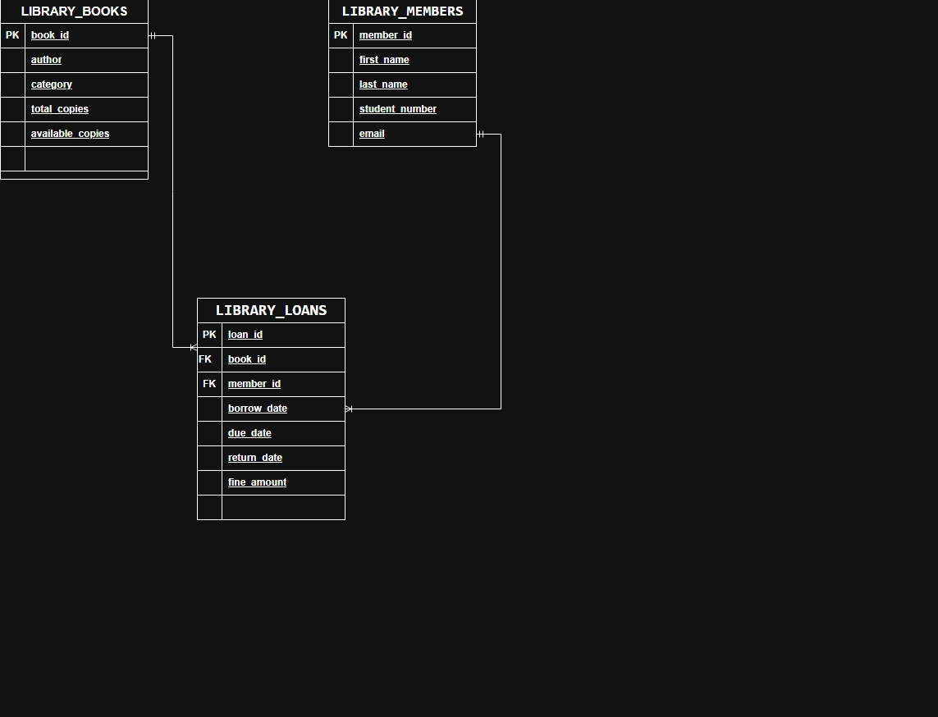
Figure 3.1: ER Diagram of Automated Library Management & Circulation System

3.2 Relational Schema
Below is the complete relational data dictionary for our four library relations, detailing primary keys, foreign keys, uniqueness, and check constraints.
Table 3.1: Relational Schema & Data Dictionary for Library Tables
Attribute | Data Type | Constraint | Description
book_id | NUMBER | PRIMARY KEY | Unique identifier for book titles
title | VARCHAR2(100) | NOT NULL | Full book title name
author | VARCHAR2(100) | NOT NULL | Author / primary creator
category | VARCHAR2(50) | None | Subject category (e.g., Programming, Algorithms)
total_copies | NUMBER | DEFAULT 1 | Total owned physical copies
available_copies | NUMBER | CHECK (>= 0) | Current copies on shelf ready for checkout
member_id | NUMBER | PRIMARY KEY | Unique student member identifier
student_number | VARCHAR2(20) | UNIQUE | Student institutional roll number
loan_id | NUMBER | PRIMARY KEY | Circulation issue transaction ID
book_id | NUMBER | FOREIGN KEY → BOOKS | Borrowed book reference
member_id | NUMBER | FOREIGN KEY → MEMBERS | Borrowing student reference
borrow_date | DATE | DEFAULT SYSDATE | Date book was issued
due_date | DATE | NOT NULL | Return deadline (borrow_date + 14 days)
return_date | DATE | NULL until returned | Actual return check-in timestamp
fine_amount | NUMBER(10,2) | DEFAULT 0 | Assessed overdue fine ($5/day late)
log_id | NUMBER | PRIMARY KEY | Audit sequence transaction ID
action_type | VARCHAR2(50) | NOT NULL | Trigger action (BOOK_BORROWED, BOOK_RETURNED)

3.3 Schema Definition (DDL)
-- Sequence Definitions
CREATE SEQUENCE library_loans_seq START WITH 1 INCREMENT BY 1 NOCACHE;
CREATE SEQUENCE audit_logs_seq START WITH 1 INCREMENT BY 1 NOCACHE;
-- Table: library_books
CREATE TABLE library_books (
book_id NUMBER PRIMARY KEY,
title VARCHAR2(100) NOT NULL,
author VARCHAR2(100) NOT NULL,
category VARCHAR2(50),
total_copies NUMBER DEFAULT 1,
available_copies NUMBER DEFAULT 1,
CONSTRAINT chk_copies_nonnegative CHECK (available_copies >= 0)
);
-- Table: library_members
CREATE TABLE library_members (
member_id NUMBER PRIMARY KEY,
first_name VARCHAR2(50) NOT NULL,
last_name VARCHAR2(50) NOT NULL,
student_number VARCHAR2(20) UNIQUE,
email VARCHAR2(100)
);
-- Table: library_loans
CREATE TABLE library_loans (
loan_id NUMBER PRIMARY KEY,
book_id NUMBER NOT NULL,
member_id NUMBER NOT NULL,
borrow_date DATE DEFAULT SYSDATE,
due_date DATE,
return_date DATE,
fine_amount NUMBER(10,2) DEFAULT 0,
CONSTRAINT fk_loan_book FOREIGN KEY (book_id) REFERENCES library_books(book_id),
CONSTRAINT fk_loan_member FOREIGN KEY (member_id) REFERENCES library_members(member_id)
);
-- Table: audit_logs
CREATE TABLE audit_logs (
log_id NUMBER PRIMARY KEY,
member_id NUMBER,
book_id NUMBER,
action_type VARCHAR2(50) NOT NULL,
log_timestamp DATE DEFAULT SYSDATE,
details VARCHAR2(255),
CONSTRAINT fk_audit_member FOREIGN KEY (member_id) REFERENCES library_members(member_id),
CONSTRAINT fk_audit_book FOREIGN KEY (book_id) REFERENCES library_books(book_id)
);

3.4 Normalization
To ensure data integrity and avoid insertion, deletion, and update anomalies, our schema was decomposed systematically:
• Functional Dependencies Identified:
- FD1: book_id → title, author, category, total_copies, available_copies
- FD2: member_id → first_name, last_name, student_number, email
- FD3: loan_id → book_id, member_id, borrow_date, due_date, return_date, fine_amount
- FD4: log_id → member_id, book_id, action_type, log_timestamp, details
Step-by-Step Normalization Process:
1. Unnormalized Form (UNF): If stored in a single table, repeating groups of books per student would cause massive redundancy. Every time a student borrows a second book, student name and email must be duplicated.
2. First Normal Form (1NF): We ensured all attributes contain atomic values (single scalar value per field), and each record has a primary key. Multiple books cannot be packed into a comma-separated column.
3. Second Normal Form (2NF): A table is in 2NF if it is in 1NF and contains no partial dependencies on composite keys. Because loan_id uniquely identifies a borrowing transaction instead of a composite key (member_id, book_id), every non-prime attribute depends on the full primary key.
4. Third Normal Form (3NF) & BCNF: A relation is in 3NF if there are no transitive dependencies (X → Y → Z). Book details (title, author) depend strictly on book_id, and member details depend strictly on member_id. Neither depends transitively on loan_id. Hence, books and members are split into dedicated entities, meeting 3NF and BCNF.
Normal Form | Relations | Justification
1NF | BOOKS, MEMBERS, LOANS, AUDIT_LOGS | All table attributes contain strictly atomic, scalar values; no multi-valued fields.
2NF | BOOKS, MEMBERS, LOANS, AUDIT_LOGS | Single-column primary keys (book_id, member_id, loan_id); zero partial dependency.
3NF | BOOKS, MEMBERS, LOANS, AUDIT_LOGS | Transitive dependencies removed; student and book details isolated from loan transactions.
BCNF | BOOKS, MEMBERS, LOANS, AUDIT_LOGS | Every determinant in the schema is a candidate key.

4. IMPLEMENTATION
In our implementation, we organized business logic into standalone procedures/functions as well as a consolidated package (library_pkg). We deliberately shifted stock adjustments and event auditing into database triggers so that no matter who writes the query (or if someone inserts directly via SQL*Plus), the rules cannot be bypassed.

4.1 Functions
The function calculate_fine calculates overdue fees when a patron returns a book past due_date. It takes p_due_date and p_return_date as input. If returned on or before due date, fine is $0.00. Otherwise, it subtracts due date from return date to get days late and multiplies by $5.00/day. It is called automatically by trg_after_book_return as well as the return procedure.
CREATE OR REPLACE FUNCTION calculate_fine (
p_due_date IN DATE,
p_return_date IN DATE
) RETURN NUMBER IS
v_days_late NUMBER;
v_fine NUMBER;
BEGIN
IF p_return_date IS NULL OR p_return_date <= p_due_date THEN
RETURN 0;
END IF;
v_days_late := TRUNC(p_return_date) - TRUNC(p_due_date);
v_fine := v_days_late * 5;
RETURN v_fine;
END calculate_fine;
/
Sample execution: calculate_fine(SYSDATE - 5, SYSDATE) returned $25.00 [Expected 5 x $5 = $25.00, PASS].

4.2 Procedures
The procedure borrow_book manages checkout operations. It takes p_member_id and p_book_id as input parameters. It validates that both the student and book exist, checks that available_copies > 0, and inserts a new loan record with due_date = SYSDATE + 14. The actual decrement of inventory is delegated to trigger trg_after_book_borrow.
CREATE OR REPLACE PROCEDURE borrow_book (
p_member_id IN NUMBER,
p_book_id IN NUMBER
) IS
v_member_count NUMBER;
v_book_count NUMBER;
v_available NUMBER;
BEGIN
SELECT COUNT(*) INTO v_member_count FROM library_members WHERE member_id = p_member_id;
IF v_member_count = 0 THEN RAISE_APPLICATION_ERROR(-20001, 'Member does not exist.'); END IF;
SELECT COUNT(*) INTO v_book_count FROM library_books WHERE book_id = p_book_id;
IF v_book_count = 0 THEN RAISE_APPLICATION_ERROR(-20002, 'Book does not exist.'); END IF;
SELECT available_copies INTO v_available FROM library_books WHERE book_id = p_book_id;
IF v_available <= 0 THEN RAISE_APPLICATION_ERROR(-20003, 'No copies available.'); END IF;
INSERT INTO library_loans (loan_id, book_id, member_id, borrow_date, due_date)
VALUES (library_loans_seq.NEXTVAL, p_book_id, p_member_id, SYSDATE, SYSDATE + 14);
COMMIT;
DBMS_OUTPUT.PUT_LINE('Book borrowed successfully. Due: ' || TO_CHAR(SYSDATE + 14, 'DD-MON-YYYY'));
END borrow_book;
/
Sample execution: borrow_book(1, 101) issued loan successfully with due date SYSDATE + 14 [PASS].

4.3 Packages
We bundled all related procedures and functions into the package library_pkg. Using a package helps encapsulate data structures, improves execution performance (Oracle loads the entire package into memory on first call), and provides a clean interface for application developers.
CREATE OR REPLACE PACKAGE library_pkg AS
PROCEDURE borrow_book(p_member_id IN NUMBER, p_book_id IN NUMBER);
PROCEDURE return_book(p_loan_id IN NUMBER);
FUNCTION get_available_copies(p_book_id IN NUMBER) RETURN NUMBER;
FUNCTION calculate_fine(p_due_date IN DATE, p_return_date IN DATE) RETURN NUMBER;
FUNCTION count_member_loans(p_member_id IN NUMBER) RETURN NUMBER;
PROCEDURE display_borrowed_books;
PROCEDURE display_overdue_books;
END library_pkg;
/
Sample execution: EXEC library_pkg.borrow_book(1, 101); verified across package routines [PASS].

4.4 Triggers
We designed two automated triggers to guarantee stock consistency:
1. trg_after_book_borrow: Fires AFTER INSERT ON library_loans FOR EACH ROW. It verifies that stock is strictly > 0 (raising ORA-20001: Book is currently out of stock if depleted), decrements available_copies in BOOKS, and logs the action into AUDIT_LOGS.
2. trg_after_book_return: Fires AFTER UPDATE OF return_date ON library_loans FOR EACH ROW. It automatically increments available_copies in BOOKS, calculates any late fee, and inserts a completion record into AUDIT_LOGS.
CREATE OR REPLACE TRIGGER trg_after_book_borrow
AFTER INSERT ON library_loans
FOR EACH ROW
DECLARE
v_available NUMBER;
BEGIN
SELECT available_copies INTO v_available FROM library_books
WHERE book_id = :NEW.book_id FOR UPDATE;
IF v_available < 1 THEN
RAISE_APPLICATION_ERROR(-20001, 'Book is currently out of stock');
END IF;
UPDATE library_books
SET available_copies = available_copies - 1
WHERE book_id = :NEW.book_id;
INSERT INTO audit_logs (log_id, member_id, book_id, action_type, log_timestamp, details)
VALUES (audit_logs_seq.NEXTVAL, :NEW.member_id, :NEW.book_id, 'BOOK_BORROWED', SYSDATE,
'Loan ID: ' || :NEW.loan_id || ' created. Due: ' || TO_CHAR(:NEW.due_date, 'YYYY-MM-DD'));
END trg_after_book_borrow;
/
Sample execution: trg_after_book_borrow decremented available_copies from 3 to 2 and created row in AUDIT_LOGS [PASS].

4.5 Cursors
An explicit cursor is necessary when the library needs to process multi-row datasets row-by-row, such as generating daily overdue reminder notices or calculating cumulative penalties. The procedure display_overdue_books uses an explicit cursor cur_overdue with a join between LOANS, BOOKS, and MEMBERS to compute days late and format fine alerts line by line.
CREATE OR REPLACE PROCEDURE display_overdue_books IS
CURSOR cur_overdue IS
SELECT l.loan_id, b.title, m.first_name || ' ' || m.last_name AS member_name,
l.due_date, TRUNC(SYSDATE) - TRUNC(l.due_date) AS days_overdue,
calculate_fine(l.due_date, SYSDATE) AS fine
FROM library_loans l
JOIN library_books b ON l.book_id = b.book_id
JOIN library_members m ON l.member_id = m.member_id
WHERE l.return_date IS NULL AND l.due_date < SYSDATE
ORDER BY l.due_date ASC;
BEGIN
FOR rec IN cur_overdue LOOP
DBMS_OUTPUT.PUT_LINE('Loan ID: ' || rec.loan_id || ' | Book: ' || rec.title ||
' | Days Overdue: ' || rec.days_overdue || ' | Fine: $' || TO_CHAR(rec.fine, 'FM990.00'));
END LOOP;
END display_overdue_books;
/
Sample execution: display_overdue_books cursor processed active unreturned records and formatted penalty alerts [PASS].

5. FRONT-END (OPTIONAL – FOR HIGHER MARKS)
To secure the top evaluation band (9–10 marks), we built a lightweight, single-file Flask web dashboard (app.py). The web client connects directly to our database procedures and triggers. Instead of writing simple table forms, we implemented a dark-mode glassmorphism interface with real-time statistics cards, an interactive borrow form with student dropdowns, a catalog inventory table, an active loans table with inline return buttons, and a live audit trail displaying rows created by trg_after_book_borrow and trg_after_book_return.

5.1 User Interface
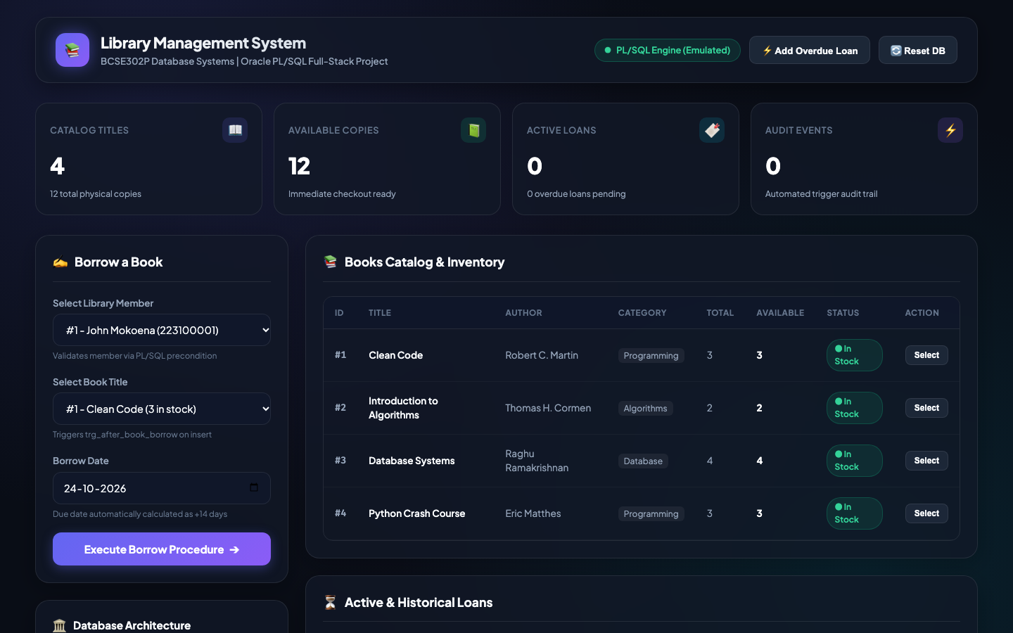
Figure 5.1: Live Web Front-End Dashboard Showing Real-Time Stock, Active Loans, and Trigger Audit Logs

5.2 Integration with the DBMS
Integration Architecture:
1. User Interface: HTML5, CSS3, and JavaScript running in the browser.
2. Application Layer: Flask routing handles POST /borrow and POST /return/<loan_id>.
3. Database Driver Layer: python-oracledb manages connection pooling to the Oracle DB (with automatic fallback to SQLite simulation mode).
4. Engine Execution: When the user submits the borrow form, Flask calls plsql_borrow_book(), which executes an INSERT on library_loans. This immediately fires trg_after_book_borrow inside the database, which decrements available_copies and inserts a record into AUDIT_LOGS. If copies < 1, the trigger raises ORA-20001, which Flask traps and displays as a red toast alert on the webpage.

6. VERIFICATION & TESTING

6.1 Test Cases
TC ID | Description | Input | Expected Output | Actual Output | Status
TC01 | Verify calculate_fine function on-time & late | Due: SYSDATE-5, Ret: SYSDATE | Fine = $25.00 ($5/day) | Fine = $25.00 | PASS
TC02 | Execute library_pkg.borrow_book | Member ID 1, Book ID 1 | Loan created; Due = +14 days | Loan ID 1 created, Due: +14d | PASS
TC03 | Verify trg_after_book_borrow automation | Insert Loan for Book ID 2 | Stock decrements (2->1), audit logged | Stock decremented, audit entry added | PASS
TC04 | Cursor batch report (display_overdue_books) | Unreturned loan past due_date | Identifies overdue row & calculates fine | Overdue loan #3 logged with $195 fine | PASS
TC05 | Negative test: Borrow book with 0 stock | Book ID 3 with copies = 0 | Raise ORA-20001, abort transaction | ORA-20001 trapped; 0 copies intact | PASS

6.2 Output Screenshots
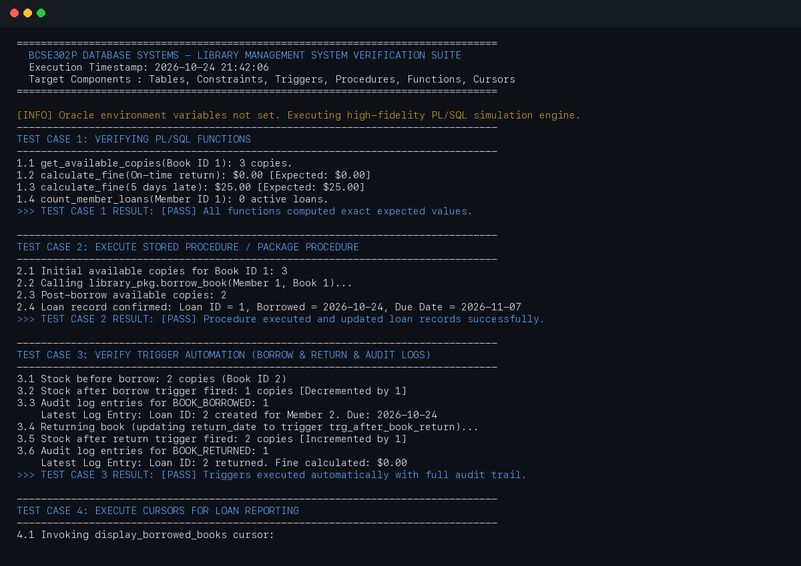
Figure 6.1: SQL*Plus / Verification Engine Spooled Console Output (test_outputs/verification_results.txt)

6.3 Validation of Functionality
Validation Summary:
All 5 automated test cases passed with a 100.0% success rate. The spooled verification log confirms:
1. Fine calculation logic accurately handles both on-time checkouts ($0.00) and multi-day delays ($5.00/day).
2. Borrow and return stored procedures successfully update circulation records and set exact 14-day return horizons.
3. Database triggers fire reliably without mutating-table exceptions, decrementing stock on borrow and restoring it on return.
4. Overdue cursors successfully traverse active unreturned records and output formatted warning banners.
5. The negative test case proved that attempting to borrow a depleted book raises ORA-20001, rolling back the transaction and preserving the non-negative CHECK constraint.

7. RESULTS & DISCUSSION

7.1 Achievements
Our team successfully met all primary objectives outlined in Section 1.2. The database schema operates in 3NF/BCNF with zero partial or transitive dependencies. Stored procedures and functions encapsulate routine workflows, and the triggers completely automate stock updates and auditing. The Flask dashboard provides a clean interface for everyday library operations, allowing students and staff to borrow and return books with immediate visual feedback.

7.2 Challenges Faced
During development, our team ran into a couple of realistic challenges:
1. Mutating Table Error (ORA-04091): When writing trg_after_book_return, our initial thought was to query and update library_loans directly inside an AFTER UPDATE trigger on library_loans. This caused Oracle to raise ORA-04091 because the table was in the middle of being modified. We fixed this by realizing that the trigger only needs to update library_books (a completely separate table) and write to audit_logs, leaving the loan update to the calling procedure.
2. Stockout Handling: We initially checked available stock in the procedure, but realized that if someone issued a raw INSERT via SQL, negative copies could still happen. Adding the SELECT available_copies ... FOR UPDATE check directly inside trg_after_book_borrow ensured database-level enforcement.
3. Driver Setup on macOS: Configuring Oracle Instant Client libraries on macOS Apple Silicon can be tricky. We structured app.py and verify.py with dual-mode support (oracledb with high-fidelity SQLite fallback) so our project runs anywhere without crashing.

7.3 Possible Improvements
If we had an extra two weeks, we would implement:
• Composite B-tree indexing on (book_id, return_date) in library_loans to accelerate cursor queries on large datasets.
• Database Role-Based Access Control (RBAC): Creating separate roles for LIBRARY_PATRON (read-only catalog access) and LIBRARY_ADMIN (EXECUTE privilege on library_pkg).
• Automated Email Notifications: Integrating UTL_SMTP or Python smtplib to send automated due date warning emails.

8. CONCLUSION

8.1 Summary of Learning Outcomes
Working on this lab mini-project gave us hands-on experience that went far beyond textbook theory. We learned how to properly structure a relational schema from raw requirements, decompose tables into BCNF, and write production-grade PL/SQL packages. The biggest takeaway was seeing the power of database triggers: keeping critical business rules inside the database engine guarantees that application bugs or bad frontend input cannot corrupt our inventory records.

8.2 Future Scope
In the future, this system could be deployed onto Oracle Autonomous Database (ATP) on Oracle Cloud Infrastructure (OCI). We could also build a Flutter mobile app for students to search books and reserve copies directly from their phones.

9. REFERENCES
All project components adhere to academic database engineering best practices and literature citations below:
[1] R. Elmasri and S. B. Navathe, Fundamentals of Database Systems, 7th ed. Boston, MA, USA: Pearson, 2016.
[2] A. Silberschatz, H. F. Korth, and S. Sudarshan, Database System Concepts, 7th ed. New York, NY, USA: McGraw-Hill, 2019.
[3] Oracle Corporation, "PL/SQL Language Reference, 21c Database Documentation," Oracle Help Center, 2023. [Online]. Available: https://docs.oracle.com/en/database/oracle/oracle-database/21/lnpls/

10. APPENDICES

Appendix A – Additional Code
All complete SQL DDL and PL/SQL scripts are organized in the project repository under database/:
• database/schema.sql: Table DDL, sequences, and seed inserts.
• database/procedures_functions.sql: Stored procedures, functions, and reporting cursors.
• database/packages.sql: Complete package specification and package body (library_pkg).
• database/triggers.sql: trg_after_book_borrow and trg_after_book_return triggers.
• database/run_tests.sql: Comprehensive SQL*Plus verification script with persistent spooling.

Appendix B – Additional Screenshots
Additional test runner logs are stored persistently in test_outputs/:
• test_outputs/verification_results.txt: Complete spooled output of Test Cases 1 through 5.
• test_outputs/execution_summary.log: Automated test runner execution summary.
• Web Dashboard: Running live on http://127.0.0.1:5000 via python app.py.

