**Backend for Online Contact Management System**

**API Endpoints and Logging Screenshots**

**Kaarthik R**

Endpoint Results:

1)

2)

3)

4)

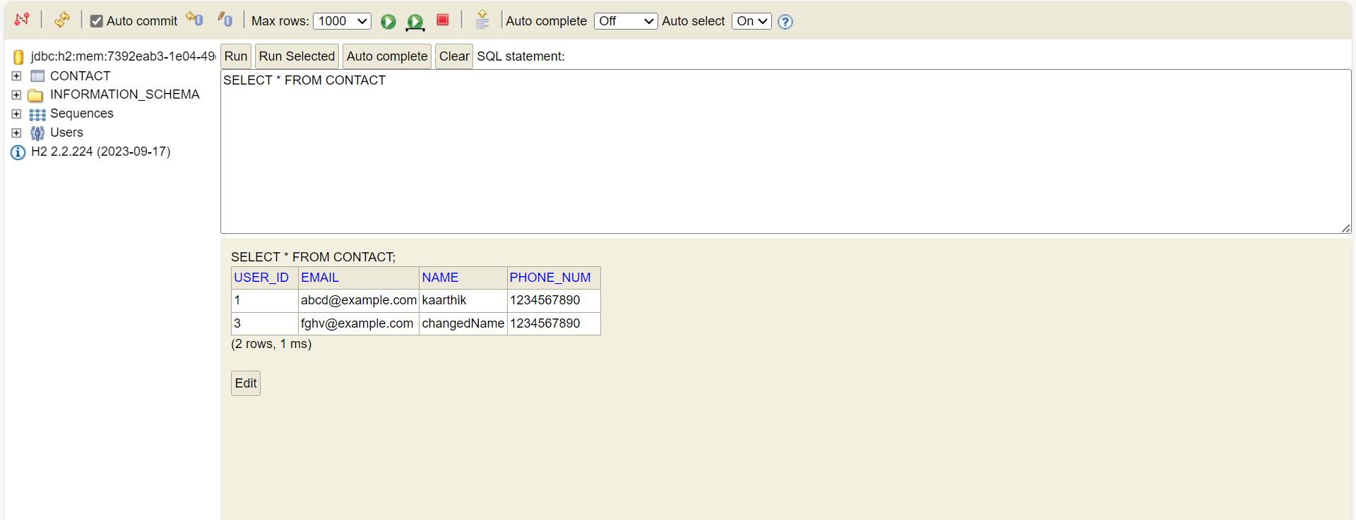

LOGGING:

1. POST METHOD

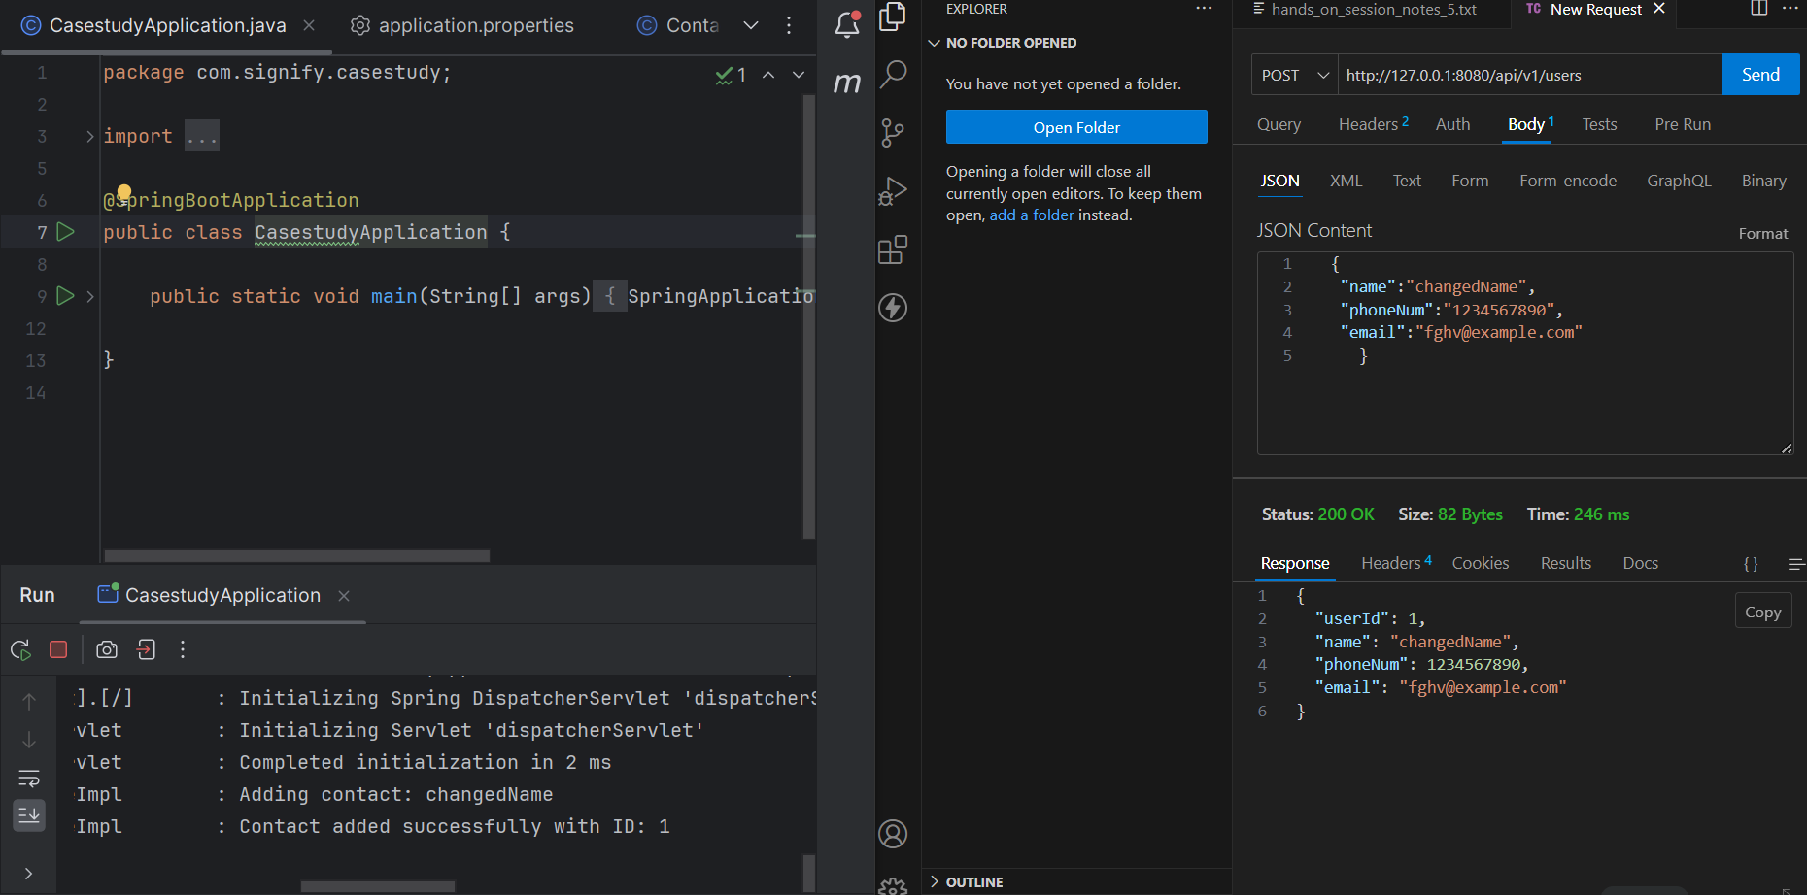

1. GET Method

1. PUT Method

1. DELETE Method

