Image Citation

File Name: penny-black-stamp.jpg

File Size: 17.3 KB

Found At: <http://www.2-clicks-stamps.com/images/image/penny-black-stamp.jpg>

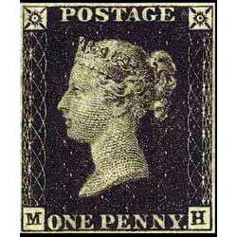

*Note: This image has been slightly modified to fit the website.*

From 2-clicks-stamps.com

File Name: Hawaiian%20Missionary%20stamps.jpg

File Size: 16.0 KB

Found At: <http://www.2-clicks-stamps.com/images/image/Hawaiian%20Missionary%20stamps.jpg>

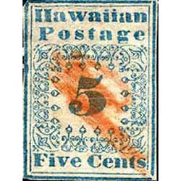

*Note: This image has been slightly modified to fit the website.*

From 2-clicks-stamps.com

File Name: Inverted%20Jenny%20airmail%20stamp.jpg

File Size: 18.3 KB

Found At: <http://www.2-clicks-stamps.com/images/image/Inverted%20Jenny%20airmail%20stamp.jpg>

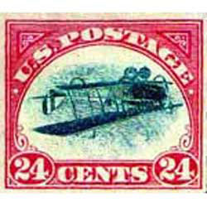

*Note: This image has been slightly modified to fit the website.*

From 2-clicks-stamps.com

File Name: Dag%20Hammarskjold%20invert.jpg

File Size: 19.1 KB

Found At: <http://www.2-clicks-stamps.com/images/image/Dag%20Hammarskjold%20invert.jpg>

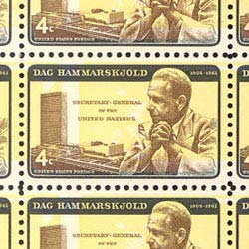

*Note: This image has been slightly modified to fit the website.*

From 2-clicks-stamps.com

File Name: Treskilling%20yellow%20rare%20stamp.jpg

File Size: 16.8 KB

Found At: <http://www.2-clicks-stamps.com/images/image/Treskilling%20yellow%20rare%20stamp.jpg>

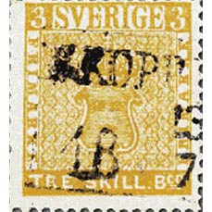

*Note: This image has been slightly modified to fit the website.*

From 2-clicks-stamps.com

File Name: British_Guiana_13.jpg

File Size: 1.1MB (has been modified to reduce size)

Found At: <https://upload.wikimedia.org/wikipedia/commons/c/cf/British_Guiana_13.jpg>

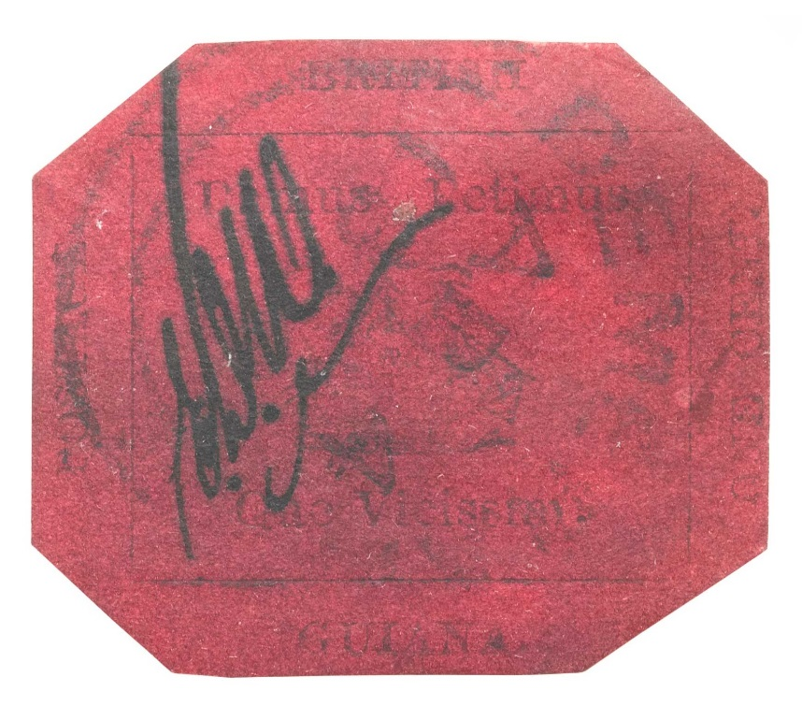

*Note: This image has been slightly modified to fit the website.*

From Wikimedia.org

Works Cited

"Rare Postage Stamps." Rare Postage Stamps. Web. 16 Oct. 2015. <http://www.2-clicks-stamps.com/article/rare-postage-stamps.html>

Salloum, Nick. "Animating CSS-Only Hamburger Menu Icons - Call Me Nick." Call Me Nick. 25 Jan. 2015. Web. 18 Nov. 2015. <http://callmenick.com/post/animating-css-only-hamburger-menu-icons>

"The Queen's Own: Stamps That Changed the World." The Queen's Own. Smithsonian Postal Museum. Web. 16 Oct. 2015. <http://postalmuseum.si.edu/queen's/worldsfirststamps.html>