**Chapter 1**

**THE PROBLEM AND ITS SCOPE**

**Introduction**

In this study, the researchers aim to create a Chatbot Inquiry System for the students at College of Computer Studies at Jose Rizal Memorial State University. The project is focused on developing a chatbot that students can use to quickly receive answers to their inquiries from the Department of Computer Studies. A Chatbot is a piece of software designed to simulate human-to-computer communication using natural language. Additionally, A Chatbot is a computer program that simulates human conversation through voice commands or text chats or both and Chatbot, short for chatterbot, is an artificial intelligence (AI) feature that can be embedded and used through any major messaging application. Students rely on asking their professors/instructors via phone conversations, emails sent through Google Mail, Facebook applications, and text or chat messages through Messenger. How can we come up with a more current system that can render all the questions or inquiries from the students when most of the time some cannot render all the arriving inquiries from various students, where information is very crucial as well as communication? With the huge number of students, staff can’t easily response to students’ inquiries. Due to this, the researcher implements the Chatbot system to solve these issues. Using this system students can ask, and it takes seconds for them to get the answer for their inquiries, also can save their time answering questions from students.

According to Ujaliben Kalpesh Bavishi (2019) that the most essential downside he has found while utilizing the previously mentioned chatbots is absence of personality and conversational flow. Understanding basic language and specific scenarios is a big problem for bots because they can't relate to humans. Chatbot will also as another spam delivery method, businesses will have to resist the strong impulse to employ bots as an additional channel for sending SPAM, reused material, and push notifications. Another possible problem for Chatbot is robotic, clumsy, and irritating or perhaps it should refer to it as “cold user experiences.”

Given the current environment, the researcher chose this study because many students have trouble responding to their inquiries. Students frequently use technology today. It will assist in providing quicker and more accurate answers to their questions through Chatbot. In Georgia State University, a summer melt or a group of students who were accepted but did not enroll due to the lack of information is an issue that the university has need to address. However, following the Covid incident at Loyola University of Chicago, many student inquiries frequently required a phone call or some web inquiry. According to Arthur Franke (2019), a data scientist and director of data and analytics at KPMG in New York City, "One of the most visible applications of artificial intelligence are conversational agents—Chatbots and intelligent assistants that interact with people via voice or text channels", he also indicate that "When conversational agents are built properly, end users do not have to speak any differently to the machine than they would to a human". As stated by Jeff Mike (2019), vice president and head of research ideation for Bersin, Deloitte Consulting "AI and conversational Chatbot in particular are useful in enhancing and automating the experience of repeatable tasks". Jeff Mike continued by saying "You want the experience to be as conversational as possible, and not mechanical. The algorithms and the data used to train the bots need to be continuously monitored and audited against bias. Chatbot also needs to be able to continuously learn about individual users to enhance personalization."

Given the issues that universities are currently facing, a system that can answer all the questions asked by students is desperately needed. ([Brandtzaeg and Følstad, 2018](https://www.sciencedirect.com/science/article/pii/S1071581921000197" \l "bib0008)) Chatbot are software agents that provide access to services and information through interaction in the users' everyday language through text or voice. The System responds to the question using built-in artificial intelligence and natural language processing (NLP) technologies so they can both understand queries and respond in a natural conversational way. This Chatbot is more effective thanks to its speech recognition and text-to-speech functions because it responds to users' questions with conversational text and can also vocal out the response. With its effective Graphical User Interface, the machine communicates with the user as though it were a real person. Through the system, students can query any college activities without personally going to the college for inquiry. The purpose of developing this Chatbot system is to deal with the academically related inquiries as well as any college related activities of the students, especially the College of Computer Studies. With this system it will be easy for the students to directly clear the queries in less time conveniently. The goal of the system is to help the students to stay updated with their college activities. The main motive of the project is to reduce the workload on the college office staff and reduce the response time to the user’s query. The chatbot's ability to learn from its interactions with users must be built into its programming, according to one potential solution. To be effective, the Chatbot must also be able to relate to and associate with the user. Fallback may help your Chatbot retain the discussion in the event of a mistake. The answers to these questions should be used by the system to create a bot that provides a pleasurable user experience based on empathy. Additionally, a chatbot should have a clear goal in mind while interacting with users, and conversations should be focused on getting the user to do the desired action.

**Statement of the Problem**

This study aims to implement a Chatbot Inquiries system in the College of Computer Studies at Jose Rizal Memorial State University – Main Campus, Academic Year 2022-2023.

Specifically, it answers the following questions:

1. What is the impact of Information Inquiry to the CCS department in JRMSU?
2. What is the effective web application for information inquiry in JRMSU CCS Department?
3. What algorithm can be used for information through Chatbot inquiry?
4. How does the system be assessed in terms of functionality, reliability, and usability?

**Significance of the Study**

This study was conducted with the intention of clearly outlining facts and giving prompt assistance to the primary beneficiaries. The study was made with the aim of providing crucial information and knowledge regarding the system from the respondents. The result of this study will benefit the following:

*Students.* They will immediately have the answers to their inquiries; it will save time and effort in communicating with the school staff. The students won’t be confused about the instructions provided by the system. The students can also use the program anytime and anywhere if they’re connected to internet.

*Instructors or Professors.* Instructor can also benefit in this study. They can save time answering the different questions of the students. Instructor can contact the students who really need help and have the hard time easily without interruption by the other students. Instructor can also monitor the concern of the students and their suggestions.

*University.* This will benefit them in terms of rendering many information inquiries of the students. University staff can save time in answering students’ inquiry and even the procedure in certain activity. This study can be a new platform for a high and advanced way of answering inquiry.

*Community and other Colleges/Universities*. Students, instructors, and University are not the only one who can benefit with this study. Community and other College University can also benefit with this for some concerns with the flaw and what happening inside the campus parent, guardians can have the knowledge what is happening inside the campus.

**Scope and Delimitation of the Study**

This study aims to help or give aid for students in terms of information inquiries. It also aims to make instructors and university staff work handier and on time. This web-based solution gives users access to a software platform through a computer, smartphone, and an internet connection. It contains text-to-speech functionality that reads out the text supplied by the students as well as voice recognition technology and converts voice to text. In general, students can communicate with the system using voice or text. This study will concentrate on creating a Chatbot for the students at College of Computing Studies in Jose Rizal Memorial State University (JRMSU) Dapitan City, Zamboanga del Norte.

**Definition of Terms**

To achieve a common frame of reference, the following study terms are operationally and textually defined:

*AIML*: (Artificial Intelligence Markup Language) is a programming language that is used to create chatbot and other conversational agents. AIML provides a framework in chatbot inquiry that can understand and respond to natural language input. It consists of a set of rules that define the chatbot's behavior, as well as a set of templates that specify how the chatbot should respond to different inputs.

*Phyton*: Refers to a programming language used in building chatbot inquiry. It is a great language for building chatbot systems due to its ease of use, versatility, and the availability of libraries and frameworks that make it easy to build sophisticated chatbots.

*Algorithm*: Refers to a set of instructions or steps that chatbot inquiry follows to perform a particular task or solve a specific problem. Our chatbot system makes use of customized AIML with NLP, also known as NLTK in Phyton.

*Django*: Refers to a web framework in Python that is used in building chatbot inquiry. Django provides a robust framework in chatbot inquiry that can handle user input, manage conversations, store data, and integrate with external services. Its flexibility and scalability make it a popular choice for building chatbots in Python.

*MySQL*: Refers to an open-source relational database management system that is used in developing chatbot inquiry system. It provides a reliable and scalable database solution in chatbot that can store user data, manage conversations, generate analytics and reports, and integrate with external services.

*Inquiry*: Refers to the act of a user asking a question or seeking information from the chatbot system. Chatbot are designed to understand natural language input from users and respond with appropriate information or actions.

*Chatbot*: This refers to the automatic system to be carried out by a machine or computer without needing human control. It is a computer program that is designed to simulate conversation with human users, specifically through websites. Chatbot inquiry uses natural language processing (NLP) and artificial intelligence (AI) to understand user input and respond with appropriate output.

*System*: Generally, refers to the software or program that powers the chatbot inquiry and enables it to understand user input, process that input, and generate appropriate responses.

*Functionality*: Refers to the set of features and capabilities that the chatbot inquiry offers to its users. Functionality refers to the various tasks and services that the chatbot system can perform.

*Reliability*: Refers to the ability of the chatbot to provide the intended functionality and perform as expected consistently and accurately. Chatbot systems are relied upon by users to perform a variety of tasks, and their reliability is critical to ensuring a positive user experience.

*Usability*: Refers to the ease with which users can interact with and navigate the chatbot interface to achieve their desired goals. It is the quality of users experience in interacting with the chatbot system.

**Theoretical framework/ Conceptual framework**

The researcher developed the Chatbot inquiry for the College of Computer Studies at Jose Rizal Memorial State University using the capabilities of the Daria Zaboj chatbot and the CCS chatbot. According to this study, which is based on Daria Zaboj (2022), a fallback interaction is initiated when your chatbot is unable to recognize the user's message. With the CCS Chatbot features including User Friendly, Web Widget, Voice Recognition, Text-to-Speech, Expandable Knowledge, Multilingual Support, and Frequently Asked Question can develop the Chatbot to be progressive and usefulness.

*Figure 1. Theoretical framework*

**Schema of the Study**

*Figure 2. Schematic Diagram*

The Schematic diagram shows the Input, Processes, Output, and feedback of/from the System. The Inputs are the computer, computer serve as a visual interface of the chatbot system. HTML and MySql are both being used for web development on creating the chatbot inquiry system. Student information, Teacher information, School Information, Program Information will serve as the foundation in creating our desired Automated System. The Processes which is the SDLC or System Development Life Cycle are the Data Gathering, Requirement Analysis, Designing, Coding, Testing and Evaluation, Implementation, Documentation which is the process of planning, creating, testing and the deployment of Automated Information Inquiry System. The Output phase is the System that can automatically answer Students Inquiry which is the result of all the processes done in the previous phase. And finally, the Feedback from the users after using the System which are the errors encountered, comments, suggestions, and feature customization to improve the current chatbot inquiry system.

**Chapter 2**

**REVIEW OF RELATED LITERATURE AND STUDIES**

In this chapter it presents the review of related literature and studies from different articles that is grouped into two, namely: Foreign and Local. The information gathered is reliable and has relevance to the study that can serve as reference in understanding the research topic. The information is believed to be enough to provide further evidence and could stand in establishing the justification and additional insights to the study under consideration.

**Foreign Literature**

In facing industry revolution 4.0, utilizing advanced information and computer technology in educational environment is crucial. One of the advanced computation technologies that can be used for learning, especially language learning, is chatbot. Chatbot is a computer program based on artificial intelligence that can carry out conversations through audio or text. (Nuria Haristiani 2019). The researcher’s study intends to find out and analyze the types of artificial intelligence in the form of Chatbots and the possibility of its use as language learning medium. The data in the study obtained from literature review on Chatbot research, and from observation results on chatbot-based language learning medium developed by the author. The results indicated that chatbots have a high potential to be used as a language learning medium, both as tutor in practicing language, and as independent learning medium. Moreover, research results revealed that language learners are interested in using chatbots because the researchers can be used anytime and anywhere, and it is more confident in learning languages using Chatbots than when dealing directly with human tutors. (Nuria Haristiani 2019).

According to Yin, Q., &Satar, M. (2020), Chatbots, whose potential for language learning have caused controversy among Second Language Acquisition (SLA) researchers are intelligent conversational systems stimulating human interlocutors with voice or text. In this paper, two different types of Chatbots (pedagogical chatbot Tutor Mike and conversational chatbot Mitsuku) were selected to investigate their potential for foreign language learning by exploring the frequency and patterns of Negotiation for Meaning (NfM) in CMC interactions. 8 Chinese EFL leaners were randomly divided into two groups (lower and higher-level learners), and all learners interacted with both the pedagogical and conversational chatbot in a switching replications research design. Data were analyzed through content analysis to identify the number of NfM instances observed, the different stages of NfM, trigger types, modified output and learners’ perceptions. The findings of this study indicate that while learners with low language levels would benefit most from interactions with pedagogical agents, high language level learners expressed dissatisfaction with chatbots, and a low level of engagement was observed in interactions with the pedagogical chatbot.

In the article of SviatlanaHöhn, (2017) he describes a model of other-initiated self-repair for a chatbot that helps to practice conversation in a foreign language. The model was developed using a corpus of instant messaging conversations between German native and non-native speakers. Conversation Analysis helped to create computational models from a small number of examples. The model has been validated in an AIML-based chatbot. Unlike typical retrieval-based dialogue systems, the explanations are generated at run-time from a linguistic database. The study shows that CA methods provide a valuable set of tools for computational modeling of rare phenomena in talk from a small number of examples. To be successful, such approaches require datasets replicating the speech exchange systems that are envisioned in the communication with the agent. In particular, the research showed that native/nonnative speaker chat data can be used for computational models of dialogues in a Commercial application.

Chatbots are a promising technology with the potential to enhance workplaces and everyday life. In terms of scalability and accessibility, it also has special opportunities as tools for information and communication in digital learning. In this paper, the researchers present a systematic literature review investigating the areas of education where chatbots have already been applied, explore the pedagogical roles of chatbots, the use of chatbots for mentoring purposes, and the potential to personalize education. Wollny, S., Schneider, J., Di Mitri, D., Weidlich, J., Rittberger, M., &Drachsler, H. (2021) conducted a preliminary analysis of 2,678 publications to perform this literature review, which allowed us to identify 74 relevant publications for chatbots’ application in education. Through this, researchers address five research questions that, together, allow them to explore the current state-of-the-art of this educational technology. The researchers conclude that systematic review by pointing to three main research challenges: 1) Aligning chatbot evaluations with implementation objectives, 2) Exploring the potential of chatbots for mentoring students, and 3) Exploring and leveraging adaptation capabilities of Chatbots. For all three challenges, they discuss opportunities for future research. (Wollny, S., Schneider, J., Di Mitri, D., Weidlich, J., Rittberger, M., &Drachsler, H. (2021).

Chatbots or artificially intelligent conversational tools are the automatically new tools designed to interact humans and computers. The tool of chatbot system is very effective in marketing and launching new products. Using chatbot as a tool of learning with logical sequences of cognition has attracted a lot of attention from many foreign language centers, such as VUS, ILA, etc. This research is conducted to apply AI chatbot for helping students to learn a specific knowledge of a foreign language. The research also discusses student’s interests and engagements, and performances in two ways of learning: with and without the help of AI chatbot via the case of teaching some English prepositions. 200 students were selected and divided into experimental and control groups (100 students for each respectively). The purpose of this empirical experiment is to test whether the AI chatbot is effective and useful for enhancing student’s performance and engagement in learning a specific point of a foreign language. With the preliminary results, the students benefit a lot from a new learning experience with the use AI chatbot in teaching. The majority of the respondents believed that using AI chatbots was crucial to their learning process. The AI chatbot also generates excitement and fun for their learning. The research may open a field for language teachers to explore and apply for their teaching in the digital era. Chatbots have proved themselves as a very useful tool to help students engage in the lessons, especially in practice activities with mobile-based applications through social networks. Students are eager to share their understandings and their performance with their peers. According to data from the current study, a grammar point is best understood when students are autonomous in its learning and are having a good time. It was concluded that the research was consistent with previous research in applying ITC in language teaching and learning. Then the students had to manage to complete the duties assigned by ITC applications to them and soon they loved the new way of learning, especially with a chatbot in the experimental. When a student is learning a foreign language through a chatbot in addition to class meetings, its performance is significantly improved. (Nghi, T. T., Phuc, T. H., & Thang, N. T. (2019)).

**Local Literature**

According to the study of Serrano, J. V., Belegal, J. A. C., Cañas-Llamas, A. M. E. F., Petrasanta, L. P., &Almodiel, M. C. (2021), in the educational domain, artificial intelligence (AI) is one of the information and communication technologies gaining popularity for its advantages in teaching and learning, especially in information support services. The University of the Philippines Open University (UPOU), as a leader of open and distance e-learning in the country, explored this technology and came up with its own tool to streamline its information support services. The UPOU chatbot, personified as Iska and IskOU, provides immediate and appropriate human-like conversations when prompted by users. The tool is able to deliver these conservations through its intelligence database or knowledge base, which is a result of a university-wide effort to collate relevant information. This chatbot intelligence influences user satisfaction as it is the basis of the tool’s performance. Therefore, the study aimed to evaluate the UPOU chatbot’s performance as an information support tool by determining the level of satisfaction of UPOU chatbot users. Data was collected through a post-interaction survey with the users and was analyzed using descriptive statistics and thematic analysis. Results showed mixed experiences among UPOU chatbot users. It was mainly reported that the tool has issues in interpretations and addressing complex, multiple, and specific/unique queries. Nonetheless, users evaluated the UPOU chatbot as a satisfying and helpful tool. A number of areas and topics for future investigations were also listed.

The study of Jacobe, B., Pascua, M. L., Tumbali, B. J., &Gumabay, M. V. (2021) which aimed to develop an Interactive Chatbot for Customer Service with Voice Recognition for St. Paul University Philippines students, employees, parents, visitors, and stakeholders. It aimed to provide real-time answers to inquiries from the concerned participants. The researcher employed a qualitative approach using descriptive research design and systems development in collecting, analyzing the data and the design and development of the system. The researchers conclude that the chatbot is a real time mobile application for the university that provides frequently asked questions to all Paulinian users anytime and anywhere. Moreover, it will also provide an opportunity to have access to the appointed Head of Marketing and Promotions during office hours.

A study that proposes an intelligent knowledge-based conversational agent system architecture to support customer services in e-commerce sales and marketing. A pilot implementation of a chatbot for customer services is reported in a leading women’s intimate apparel manufacturing firm. The proposed system incorporates various emerging technologies, including web crawling, natural language processing, knowledge bases, and artificial intelligence. In this study, a prototype system is built in a real-world setting. The results of the system prototype evaluation are satisfactory and support the contention that the system is effective. The study also discusses the challenges and lessons learned during system implementation and the theoretical and managerial implications of this study. (Ngai, E. W., Lee, M. C., Luo, M., Chan, P. S., & Liang, T. (2021)).

In the study of Ureta, J., & Rivera, J. P. (2018). Using chatbots to teach stem related research concepts to high school students. Research or capstone subject is not in the curriculum of ICT strand, but it is only offered in the Academic track. However, given the current technology trends, it can be deduced that research is also essential to help the students become active and creative professionals in respective fields in the future. In this paper, it presents the use of chatbots for teaching research concepts to senior high school students. The students were tasked to create chatbots for the different domains that they were interested in through the use of Dialog flow. This paper also discusses the teaching methodology that was used to deliver the course. Chatbot projects can help introduce research concepts to students with the flexibility of allowing them to choose the domain based on their interests, and at the same time it also introduces them to basic concepts in Computer Science. Overall, the implementation of the course was a success and the school officials from the high school where it was offered wanted to offer the same course again for the next batch. For future work, the school officials recommend that the course must include a module for teaching how to collect and analyze data. The researchers would also like to recommend comparing the output produced by students and their experience when using chatbots versus other modes of teaching research.

Businesses are using digital channels to accommodate customer inquiries. However, customers still complain about long response times or worse, the lack of it. Customers of Foam-Pom Pangasinan usually encounter problems in inquiry and customer service response. This study aims to identify and analyze the design elements, features, architectural model, and usability of the AI chatbot application for the business. The different features for the User and Admin were created that involved the Product List, Schedule Appointment, AI Chatbot, and Feedback. The chatbot architectural model implemented was a retrieval-based model to successfully answer the user's inquiries regarding Foam-Pom. This allows the application to retrieve the most appropriate response to a conversational input from a whole pool of candidate responses. The chatbot was trained to rank the best response from the set of predefined responses through the use of Dialog flow as an engine. The researchers utilized USE Questionnaires for the preliminary testing of 130 respondents from which it received an above-average score and garnered positive perception from the customers. Further studies can: a) create a dynamic application with more design features, b) add more regional dialects, c) add voice generated response and speech-to-text transcription, d) create the system using other architectural models, and e) test the system on a larger number of respondents. (Marcelino, F. J. G., Escubio, M. T., Ocampo, J. P. M., &Beninsig, M. A. (2021, December)).

**Foreign Studies**

The paper of Jia, J. (2004) reports the findings of a study conducted on the application of a web-based human-computer dialog system with natural language (chatbot) on the teaching of foreign languages. An experiment has been made using this system to work as a chat partner with the users learning foreign languages. The dialogs have been collected. Statistical results of the dialogs are shown and analyzed. Findings indicate that the dialogs between the human and the computer are mostly short, but also indicate that many participants in this experiment are interested in the system. The reasons are it is accessible anywhere at any time on contrary to that it is not easy to find a human chatting partner speaking this language as the mother language, and the learners are more confident confronting with a robot or a computer program which is obviously less intelligent as the human themselves.

Novel technology can be a powerful tool for enhancing students' interest in many learning domains. However, the sustainability and overall impact of such an interest is unclear. This study tests the longer-term effects of technology on students' task and course interest. The experimental study was conducted with students in foreign language classes (*n* = 122): a 12-week experimental trial that included pre- and post-course interest, and a sequence of task interest measures. Employing a counterbalanced design, at three-week intervals students engaged in separate speaking tasks with each of a Human and “Chatbot” partner. Students' interest in successive tasks and in the course (pre-post), were used to assess differential partner effects and course interest development trajectories. Comparisons of task interest under different partner conditions over time indicated a significant drop in students' task interest with the Chatbot but not Human partner. After accounting for initial course interest, Structural Equation Modelling indicated that only task interest with the Human partner contributed to developing course interest. While Human partner task interest predicted future course interest, task interest under Chatbot partner conditions did not. Under Chatbot partner conditions there was a drop in task interest after the first task: a novelty effect. Implications for theory and practice are discussed. (Fryer, L. K., Ainley, M., Thompson, A., Gibson, A., & Sherlock, Z. (2017)).

The present study of Jiang, H., Cheng, Y., Yang, J., & Gao, S. (2022) is grounded in social exchange theory and resource exchange theory. By exploring customers' satisfaction with chatbot services and their social media engagement, it examined the effects of responsiveness and a conversational tone in dialogic chatbot communication on customers. To test the proposed mediation model, we surveyed a representative sample of customers (N = 965) living in the U.S. After examining the validity and reliability of our measurement model, we tested the hypothesized model using structural equation modeling (SEM) procedures. All proposed hypotheses were supported, indicating the significant direct effects of (1) responsiveness and a conversational tone on customers' satisfaction with chatbot services, (2) customers' chatbot use satisfaction on social media engagement, (3) customers’ social media engagement on price premium and purchase intention, and (4) purchase intention on price premium. In addition, we examined satisfaction, social media engagement, and purchase intention as significant mediators in the proposed model. Theoretical and practical implications of the study were then discussed.

The application of automatic conversational system (chatbot) in learning foreign language is still limited. In this study, we built a chatbot dedicated to English learners. The system is named English Practice is installed on the mobile devices to interact with users through a window chat. Chatbot can automatically remind learners to study and suggest some answers to multiple choice questions. It also can help users in learning vocabulary and new lessons. The result shows that most of the basic functions of the system are used by the users and this this promises to be applied widely in the future. (Pham, X. L., Pham, T., Nguyen, Q. M., Nguyen, T. H., & Cao, T. T. H. (2018, November)).

Learning spoken English can be irritating and challenging for many English language learners, especially when learners must communicate with English-speaking foreigners. They typically feel quite intimidated to speak English since people are unfamiliar with the spoken form of the language and are concerned about committing grammatical mistakes. Furthermore, spoken language and reading differ in many ways. For instance, when seeing text containing new words, learners can stop and look up words in a dictionary. Additionally, a passage can be read multiple times by learners to understand it. Conversely, spoken language must be understood immediately to communicate effectively. The purpose of this study is to propose an interactive chatbot system named TPBOT which stands for “TOEIC Practice Chatbot” for EFL learners to eliminate their fear of speaking English and enable them to chat with online chatbots to practice spoken English at any time. This TPBOT would be very helpful to eliminate learners’ anxiety about speaking a foreign language with foreigners. Participants in this study are Taiwanese students whose oral scores on the TOEIC® test are below 100. Researchers hope to improve their oral English ability after participating in the four-month experiment. The results have shown that students are satisfied with using this TPBOT and believe that it has indeed helped them improve their English-speaking skills. Obviously, the TPBOT was very effective for the intended purpose. For educators, the TPBOT is very useful to build learning content in the TPBOT, provide learners with interactive exercises and improve learning effects. (Hsu, M. H., Chen, P. S., & Yu, C. S. (2021)).

**Local Studies**

A new countermeasure recently appeared to fight back against unwanted phone calls (such as, telemarketing, survey, or scam calls), which consists in connecting back the telemarketer with a phone bot ("robocallee") which mimics a real persona. Lenny is such a bot (a computer program) which plays a set of pre-recorded voice messages to interact with the spammers. Although not based on any sophisticated artificial intelligence, Lenny is surprisingly effective in keeping the conversation going for tens of minutes. Moreover, it is clearly recognized as a bot in only 5% of the calls recorded in our dataset. In this paper, the researchers try to understand why Lenny is so successful in dealing with spam calls. To this end, it will analyze the recorded conversations of Lenny with various types of spammers. Among 487 publicly available call recordings, we selected 200 calls and transcribed them using a commercial service. With this dataset, the researchers first explore the spam ecosystem captured by this Chatbot, presenting several statistics on Lenny's interaction with spammers. Then, it will use conversation analysis to understand how Lenny is adjusted with the sequential context of such spam calls, keeping a natural flow of conversation. Finally, the researchers discuss a range of research and design issues to gain a better understanding of Chatbot conversations and to improve theefficiency. (Sahin, M., Relieu, M., &Francillon, A. (2017)).

Chatbots have been shown to be a viable alternative to customer service agents in addressing customer questions and concerns. The airline sector has developed chatbots to meet the needs of their customers. In this paper, the study presents findings from a questionnaire involving 417 chatbot users. The assessment revealed that the quality of the airline chatbot service was deemed good, and users were satisfied with the airline chatbot service. This study also tested the relationship between the variables of the study. The outcomes revealed a significant relationship between users' profiles and the quality of the service provided by the chatbot. A significant relationship manifested between the users' profile and their satisfaction with the airline chatbot service. The results also discover a highly significant relationship between the quality of airline chatbot service and the users' satisfaction. Drawing on the findings, Developers should enhance chatbots to provide better service and boost customer satisfaction. (Arreza, M. K. B. (2022)).

In the study of Bacalso, P. L., Feliscuzo, L. S., &Aliac, C. J. C. Cutie: Interviewer Bot, the interviews allow an organization to determine whether a candidate is suited for a job or not and even the most qualified ones could fail it. And for a graduating student, it is critical to prepare for it. This paper presents a study on a journey of developing an interviewer bot named CUTIE which stands for CIT University Tutoring Interviewer Environment. CUTIE was developed using open-sourced applications like Vue.js and Django. The bot performs real-time analysis of the sentiment and the emotional response of the student. The study started by analyzing 114 videos of students submitted as answers to an interview questionnaire. The videos were then manually analyzed by experts for scoring. The videos were then fed to CUTIE for scoring comparison and the result shows no correlation. Upon investigation, it was found that there were factors that affect the performance of CUTIE video scoring. The videos were then categorized according to their lighting set-up and audio equipment used which led to 57 videos remaining. Then it was found that from 57 recorded videos, 60% of the students earned an 80% sentiment score while 56% of them used a mic from a smartphone or laptop which contributed to getting a high score during the interview session. It is also advised to incorporate performance tracking analytics for the next study.

In the study of Montaner, Tristan &Patlonag, Ray &Sullan, Joseph Benedict. (2022), their research aimed to develop a web-based application that will help customers to troubleshoot their mobile phone device issues. Specifically, it allows the user to choose Cebuano or binisaya as both formal and informal language in dealing with the application to lessen the customer's anxiety of speaking another language whenever it will not comfortable explaining details in English. With a thoroughly constructed and evaluated conversational flow, Madasigon is aimed towards building a good rapport with target end users, which is essential in customer support service. For the application, the researchers utilized the waterfall method as their design procedure and used Alpha Testing to examine the conversational capability and the degree of consistency of the chatbot. For the respondents of the system, the researchers handed out UTAUT questionnaires to Filipino People who mainly speak binisaya. The review results provided a comprehensive understanding of the choice of language integrated in the Madasigon application. Results showed that the overwhelming majority preferred to speak in their mother tongue when interacting with the chatbot, while the rest preferred to speak in English. It also demonstrated that a majority found it easy to comprehend the bisaya terms used by Madasigon. The implications of the findings were discussed, and suggestions were made.

Brands are shifting to digital services to cater to their customers who have been spending more time online. The technology that exists today enhances customer experience and actualizes customer expectations through virtual service agents or “e-service agents” during real-time interactions. Brands in most countries have to deal with bilingual customers as globalization occurs. Business process outsourcing is among the Philippines' top foreign exchange earner aside from overseas workers' remittances. These Philippine companies offer customer service but are mostly left manned-needing constant supervision. As a solution, the researchers present a bilingual retail chatbot that could handle the two official languages of the Philippines, Filipino-based on Tagalog-and English, and their code-switching variant Taglish. The proposed bilingual retail chatbot uses k-fold grid search cross-validation on a dataset constructed by a bilingual automatic corpus engine and a combination of both (1) support vector classifier-for intent identification, and (2) hash set containment-for attribute identification. (Catapang, J. K., Solano, G. A., &Oco, N. (2020, February)).

**Synthesis/Justification**

Consequently, these determine that the gathered related literature and studies have significantly provide further evidence to our study about “Chatbot Inquiries for Students of College of Computer Studies in Jose Rizal Memorial State University” that helps it established and gives justification that this research study could be considered effective. Also, the related literature and studies are chosen based on how closely they connect to the current study. Overall research findings demonstrate that using chatbot systems is highly productive and effective in every sector. The fact that this instrument aids humans in every manner is indisputable, despite some of its limitations when it comes to interpreting and responding to complex queries, it provides consistent responses, is always ready to communicate with people 24/7, is very practical, easy to use, and most importantly, it is user-friendly.

Current researchers aim to implement a chatbot system that will cater to all the inquiries from the students at College of Computer Studies in Jose Rizal Memorial State University. Findings from the related literature and studies will help the present researchers in improving their proposed system to become more effective, consistent, efficient, and more likely to have a human like emotional level or consciousness.

**Chapter 3**

**RESEARCH METHODOLOGY**

The methodology of the study is presented in this chapter. This includes a discussion of the research method, research environment, project development process (including data collection, requirements analysis, system design or software architecture, coding, testing and evaluation, implementation, documentation, and maintenance), study respondent, sampling design and techniques, statistical tools, and activity calendar.

**The Design/Research Method**

The researchers employed these two (2) methodologies such as constructive and action research. According to the study of Kasanen et al. (1993) they claim that these two research approaches have been extensively used in the development or implementation of new approaches to computing and information technology as a usage for several domains namely action research and constructive research. The constructive research method is a systematic approach to research methodology that allows for the deliberate development of methods, modules, tools, and techniques that have become far-reaching implications beyond the case study that is inspired by its illustration. It is a study in computer science, mathematics, operations analysis, and clinical medicine, a research paradigm where it is widely employed. The emphasis is on construction, with both theoretical as demonstrations and practical for implementations is to have a genuine research outcome.

As the name implies, action research, the study of Koshy et al. (2011) discussed what it imposes as an activity, evaluation, and critical contemplation. Within the field of study in computers and information technology, it refers to the act of introducing computing and information technology solutions and a value that is evaluated and reflected. In the study of Djanibekov et al. (2012) it stated that the effectiveness of action research has been established in transdisciplinary and the use of participatory and collaborative focus used as a lead interaction between several disciplines, as well as the broader context of acting on a broad scale cross-disciplinary creativity.

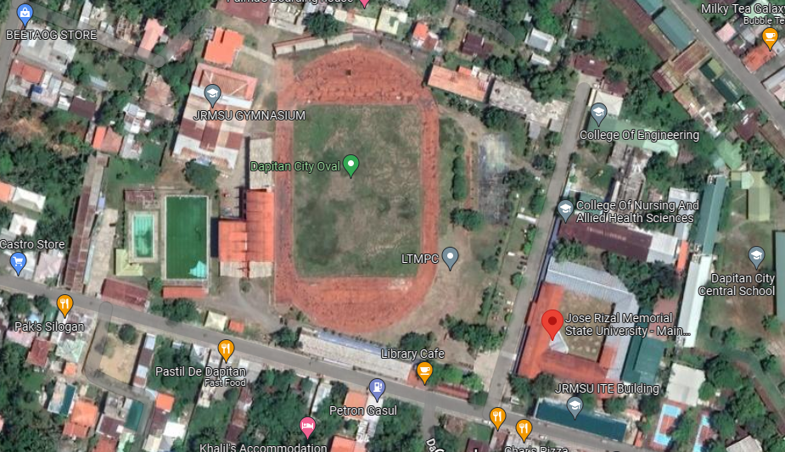**Research Setting**

*Figure 3. Jose Rizal Memorial State University Aerial view Map*

The researchers conducted this study entitled, “Basic Chatbot Inquiries for Students of College of Computer Studies in Jose Rizal Memorial State University”, where the respondents were the students enrolled in Jose Rizal Memorial State University during the SY 2021-2022.

Jose Rizal Memorial State University is an institution of higher learning. It is a believer of holistic and human development. It is the only State University in Zamboanga Del Norte. Created by virtue of RA 9852. JRMSU is located in Gov. Guading Adasa St. Sta. Cruz, Dapitan City. It is well equipped and has matters’ degree instructors in different fields of expertise. It is a field and institution which is government owned. With the innovation of new gadgets and technology nowadays, this institution can be used to represent the user’s needs to cope up with the latest technology in getting more and well- updated in the world of high technology.

**Respondents of the Study**

Respondents are essential in any research study since their responses will be used to assess the system’s functionality and other factors. In relation to this study, the respondents to this survey are all students and instructors/professors in the College of Computer Studies department at Jose Rizal Memorial State University.

The researchers employ simple random sampling in gathering the respondents of the study in which individuals from the population were selected at random.

**Table 1: Respondents of the study**

|  |  |  |
| --- | --- | --- |
| **RESPONDENTS** | **FREQUENCY** | **PERCENTAGE** |
| CCS Students | 10 | 66.66% |
| CCS Instructors/Professors | 5 | 33.33% |
| Total | 15 | 100% |

The table above shows the respondents of the study, the number of respondents and their equivalent percentage. The researchers had a total of 15 evaluators, 10 are CCS students and 5 are CCS instructors/professors in order to come up with their equivalent percentage. The respondents were given an evaluation sheet for them to provide information intended to get results on the behavior of the Chatbot system that will be developed.

**Research Instruments**

A standard evaluation sheet from ISO/IEC 9126 was used by the research instrument. A worldwide standard was proposed to ensure the "quality of all software-intensive products," including safety-critical systems that put lives in danger in the event of software failure. ISO i.e. IEC, or the International Organization for Standardization, The ISO/IEC 9126 standards for software engineering, Product Quality were created by the International Electrotechnical Commission to offer a comprehensive specification and evaluation model for the quality of the software product.

There are three software qualities that is being used by the system namely: Functionality, Reliability, Usability, Functionality are those that will satisfy implied needs such as suitability, accuracy, interoperability, security, and functionality compliance. While reliability is a set of attributes that will bear on the capability of software to maintain the level of performance such as maturity, fault tolerance, recoverability, and reliability compliance. Lastly, usability is set of attributes that bear on the effort needed for use by an implied set of users such as understandability, learn ability, operability, attractiveness, usability compliance.

**Validation of Instruments**

As emphasized by Maricon (1975), an instrument is considered valid if it measures what it intends to measure and has the ability to gather data suited to the specific purpose of the study.

The reliability test was conducted to prove its validity, the evaluation sheet was distributed to the respondents for the actual rating of the developed system and was revised multiple times to better capture the purpose of the questions. The researcher tried it out on 10 students and 5 professors to know the depth of the reliability of the instrument and using Cronbach’s Alpha with a value of 0.82 in functionality, 0.79 in reliability, 0.84 in usability and the overall average is 4.36, the range of 0.61 – 0.80 is considered reliable, showing the evaluation sheet is reliable.

To further the content validation, the validity of its content determines the level of functionality, reliability, and efficiency follows the ISO standard.

**Scoring Procedure**

The researchers applied the two methods of selecting respondents. They determined the following groups: College Computer Studies (CCS) students and College Computer Studies (CCS) instructor/professor at Jose Rizal Memorial State University Dapitan.

**Functionality.** A set of attributes that bear on the existence of a set of functions and their specified properties. The functions are those that satisfy stated or implied needs.

**Table 2: Functionality Scaling**

|  |  |  |
| --- | --- | --- |
| **Scale** | **Range of the Mean** | **Descriptive Rating** |
| 5 | 4.21 – 5.00 | Very Much Functional – Processing takes approximately five seconds and system responds inquiry of the end-user automatically |
| 4 | 3.41 – 4.20 | Much Functional – Processing takes approximately ten seconds and system responds inquiry of the end-user and it satisfies the end-user. |
| 3 | 2.61 – 3.40 | Moderately Functional – Processing takes approximately fifteen seconds and system responds inquiry of the end-user and it moderately satisfies the end-user. |
| 2 | 1.81 – 2.60 | Less Functional – Processing takes approximately one minute, and system responds inquiry of the end-user but it does not satisfies the end-user. |
| 1 | 1.00 – 1.80 | Not Functional – Processing does not generate response to the end-user. |

**Reliability –** The ability of a system to perform its required functions under stated conditions whenever required having along means time between failures.

**Table 3: Reliability Scaling**

|  |  |  |
| --- | --- | --- |
| **Scale** | **Range of the Mean** | **Descriptive Rating** |
| 5 | 4.21 – 5.00 | Very Much Reliable – System generates precise data without error on the entry of information. |
| 4 | 3.41 – 4.20 | Much Reliable – System generates precise data but contains 4% error on the entry of information. |
| 3 | 2.61 – 3.@ | Moderately Reliable – System generates precise data but contains 6% error on the entry of elimination. |
| 2 | 1.81 – 2.60 | Less Reliable – System generates precise data contains 10% error on the entry of information. |
| 1 | 1.00 – 1.80 | Not Reliable – System does not generate data. |

**Usability -** A set of attributes that bear on the effort method for use, and on the individual’s assessment of such by a stated or implied set of users.

**Table 4: Usability Scaling**

|  |  |  |
| --- | --- | --- |
| **Scale** | **Range of the Mean** | **Descriptive Rating** |
| 5 | 4.21 – 5.00 | Very Much Usable – System can perform unlimited service to the users any time. |
| 4 | 3.41 – 4.20 | Much Usable – System can perform unlimited service to the users only at certain time |
| 3 | 2.61 – 3.40 | Moderately Usable – System can perform unlimited service to the users only if the server is open. |
| 2 | 1.81 – 2.60 | Less Usable -System can perform limited service to the users only if there is no internet connection. |
| 1 | 1.00 – 1.80 | Not Usable – System does not allow unlimited service to the user. |

**Data Gathering Procedure**

In obtaining the data from the respondents of the system that will be developed, first, research will send a letter to seek permission and approval from Head of Jose Rizal Memorial State University, Main Campus for the researchers to dispense the evaluation sheet to the CCS students and CCS instructor/ professors, After getting the approval, the researchers will prepare another letter to the respondents to ask their permission in answering the evaluation sheet involving the testing of the software that will be developed, ensuring to test the quality of the system if it answered its requirements/goals. In terms of functionality, reliability, and usability.

**Statistical Treatment of Data**

The following statistical tools will be employed namely the Frequency and Percentage that will be applied to identify the evaluators or the numbers of CCS students, CCS instructor / professor, in testing the data gathered in the study. The Mean will be used to determine the extent of functionality, reliability and usability of the software that will be developed.

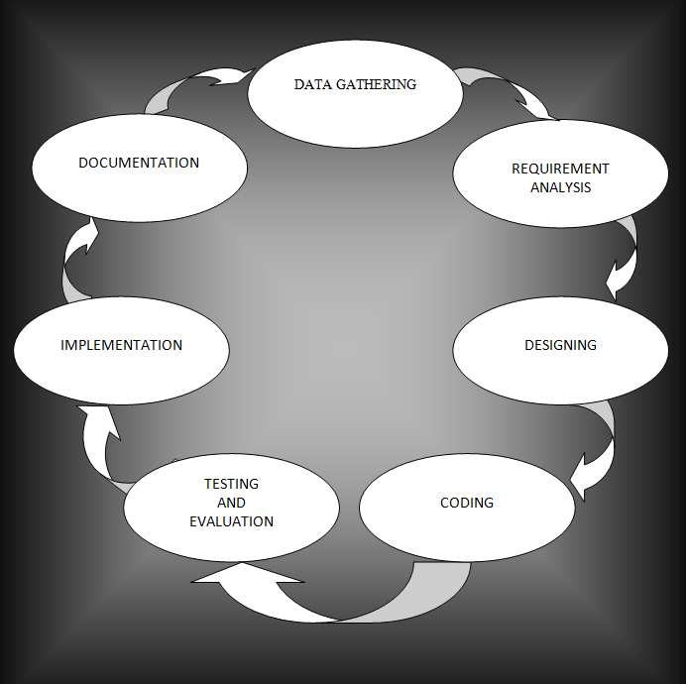**Project Development Process**

*Figure 4. Project Development Life Cycle*

The project development life cycle was a conceptual model used in project management that describes those stages involved in an information system development project, from an initial feasibility study through maintenance of the completed application. Each phase in the life cycle has its own process and deliverables that feed into the next phase. There are typically 7 phases starting with Data Gathering, Requirement analysis, Designing, Coding, Testing and Evaluation, Implementation, and Documentation. From conception to completion, a transportation upgrade goes through the project development process. Prior to the use of large resources, it is necessary to identify project needs, goals and objectives, issues, and impacts through a variety of activities such as early planning, public outreach, and evaluation.

It takes a lot of work to take a project from conception to completion. It can be defined using both a project life cycle and a system development life cycle, in which various activities occur. The "Project Life Cycle" refers to the four stages of the project completion process: Initiation (starting the project), Planning (organizing and preparing), Execution (carrying out the task), and Closure (Closing the project).

The System Development Life Cycle (SDLC) is a process for organizing, designing, testing, and deploying information systems. It's also used to maintain and upgrade computer systems. It focuses on the software engineering stages, procedures, tools, and methods used to build and/or deploy the IT solution. The figure on the following page depicts the project development life cycle. Each process is numbered from 1 to 7 and is linked to the others by arrows. It starts with data collection and progresses to requirements analysis, design, coding, testing and evaluation, implementation, implementation documentation, and documentation. To begin, the researchers gathered information and data from online sources.

The software and hardware requirements that consumers will need are determined and designed through requirements analysis. after obtaining all the necessary information, the system after collecting and analyzing the data. They started working on the program while it was still in the design phase, using the Django and Phyton programming languages, as well as MySql for the database. At this point, the system has been tested and evaluated. The researchers double-checked each step and procedure to ensure that the software was working properly and producing accurate results. When faults are discovered, the preceding process is started so that a different software verification method can be used. Everyone who uses this study as their proposal method will receive information from it, and it will be able to assist them in confirming the proper procedure and workings of the system known as "Basic Chatbot Inquiries for Students of College of Computer Studies in Jose Rizal Memorial State University”.

The waterfall model is used by the researchers for the development of Chatbot inquiry system in a sense that to develop the software it should follow a series of steps. These are the requirements analysis, design, implementation, testing, integration, and maintenance. To develop the software researchers must first identify its requirements, the software and hardware requirements. After, researchers should plan for the design of the software that will be implemented, its features etc. Then implement it together with the old software to compare whether the new software is better than the old. Then test it to be able to know if it's working as expected. Lastly, after testing the software and it doesn't meet its objectives this is when the maintenance phase work begins.

**Requirements Analysis**

After gathering all the needed information and requirements for the study, the researcher made a thorough analysis of the requirements and proceeded directly with designing the project. This involved problem analysis, and the algorithm properly solved the current problems of the study.

**Table 5: Hardware Requirements**

|  |  |  |
| --- | --- | --- |
| **Components** | **Minimum** | **Recommended** |
| Memory | 2 GB RAM | 4 GB RAM |
| Processor | Intel Core i3 | Intel Core i5 |

**System Designing**

* 1. Diagram

     Description automatically generated**System Architectural Design**

*Figure 5. System Architectural Design*

A System architectural design is the process of designing the overall structure of a software system. It involves defining the various components of the system, their interactions, and their relationships with each other. The goal of system architectural design is to create a blueprint for the system that meets the functional and non-functional requirements of the system while ensuring that the system is scalable, maintainable, and easy to evolve. And it is the foundation of the software system, and it determines how the system will be built and how it will perform. A well-designed system architecture can improve the quality, reliability, and maintainability of the software system, while a poorly designed architecture can lead to increased complexity, reduced performance, and increased development costs.

Chatbot query System illustrated above the architectural design of the system. Admin input the knowledge and pending knowledge or the unanswerable query in order to answer the pending question, given by the user and it goes into the database of chatbot and stored. Chatbot will get the existing knowledge stored on the system and directly give to the student who asked the questions.

* 1. **Hierarchical Input and Output Process (HIPO)**

*Figure 6.* *Hierarchical Input and Output Process*

Hierarchical Input and Output Process (HIPO) is a structured approach for designing and documenting the process flow of a software system. In the context of a chatbot system, HIPO can be used to describe the input and output process of the chatbot engine. The HIPO chart consists of a hierarchical structure of input and output processes. Each process is broken down into smaller subprocesses, creating a hierarchy of processes. Each process has a specific input and output, which is defined in the HIPO chart.

Chatbot Hierarchical Input and Output Process (HIPO) illustrated below the overall input and output flow of the chatbot system from the student's perspective. The input is the student's question or request, and the output is the chatbot's response. And process generates a response based on the relevant information retrieved from the knowledge base. Lastly admin adds data and updates the knowledge to the chat consisting of pending knowledge address.

* 1. **Use Case Diagram**

*Figure 7. Use Case Diagram*

A Use Case Diagram is a graphical representation of the interactions between actors (users or other systems) and a system, describing the functional requirements and intended behavior of the system. The diagram depicts how the actors interact with the system to achieve their goals and objectives. In addition, use case diagrams are useful in understanding the requirements of the system and how users will interact with it. They help in identifying the primary use cases, defining the system's scope, and providing a high-level view of the system's behavior. They can also be used to identify system limitations, potential errors, and edge cases that might not be immediately apparent.

Chatbot query system illustrated above the students: Represent the users or external systems that interact with the system. System will generate response with the help of AIML Functions, that store in database as knowledge of chatbot where Admin: input the information to be additional knowledge of the system.

* 1. **Diagram

     Description automatically generatedClass Diagram**

*Figure 8. Class Diagram*

A class diagram is a type of diagram used in object-oriented programming to visually represent the classes and their relationships in a software system. Classes are represented as rectangles with the class name inside, and class attributes and methods listed below. Class diagrams can show the relationships between classes, such as inheritance (i.e., a subclass inheriting attributes and methods from a superclass) and composition (i.e., a class composed of one or more other classes). Relationships are represented as lines between classes, with arrows indicating the direction of the relationship.

Chatbot class diagram illustrated 4 classes: Chatbot, AIML, Knowledge and Pending Knowledge. The Chatbot class represents the chatbot system and has attributes such as Validate User Message and Generate Response. The AIML class represents the machine learning of the system and has attributes New pending knowledge, evaluate pending knowledge, and Get knowledge which is responsible of collecting answer stored in database. The Knowledge class represents knowledge storage of the system and has attributes of list that responsible of holding the list of answer of queries given by the student. The Pending knowledge class represents additional knowledge of the system and has methods such as question and answer.

* 1. Diagram

     Description automatically generated**Sequence Diagram**

*Figure 9. Sequence Diagram*

A sequence diagram is a type of UML (Unified Modeling Language) diagram that depicts interactions between objects or entities in a system in a time-ordered sequence. It shows the flow of messages or events between the objects, as well as the order in which they occur. The objects or entities are represented as vertical bars called "lifelines," which show the lifespan of the object during the interaction. The messages or events exchanged between the objects are represented by horizontal arrows, with the time of occurrence indicated by vertical dotted lines called "activation bars."

The figure above illustrates the chatbot sequence diagram the user requests a chatbot development from the developer. The developer gathers requirements from the user and defines the chatbot purpose, functionalities, responses, interactions, and platform. The developer then tests the chatbot and fixes errors before getting approval from the user. Once the chatbot is approved, it is deployed, and the user can interact with it. The chatbot responds to the user's input.

* 1. **Swimlane Activity Diagram**

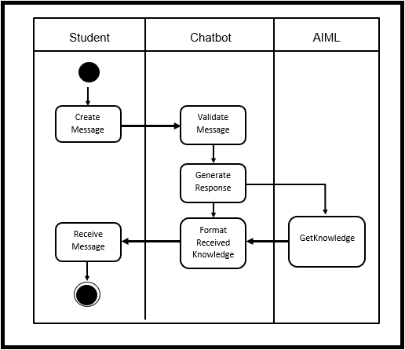

*Figure 10. Swimlane Activity Diagram*

A swimlane activity diagram is a type of activity diagram in which the activities are arranged in lanes representing different actors or departments involved in the process. It is a visual representation of a business process that shows the flow of activities, decisions, and communication between different entities in a system. The lanes are usually labeled with the names of the actors or departments involved in the process. The activities are represented as rectangular boxes, with arrows indicating the sequence of activities and the flow of control between them. The decisions are represented by diamond-shaped boxes, with the branching paths labeled with conditions that determine which path to follow.

The figure above illustrates the Swimlane Diagram of chatbot inquiry the different actors involved in the process of defining a chatbot are represented in separate lanes. The user requests chatbot development from the developer, who gathers requirements. The user then defines the chatbot purpose, functionalities, responses, interactions, and platform, which the developer sets. The user tests the chatbot and reports errors to the developer, who fixes them before getting approval from the user. Once the chatbot is approved, the developer deploys it and the user can interact with it. The chatbot responds to the user's input.

1. 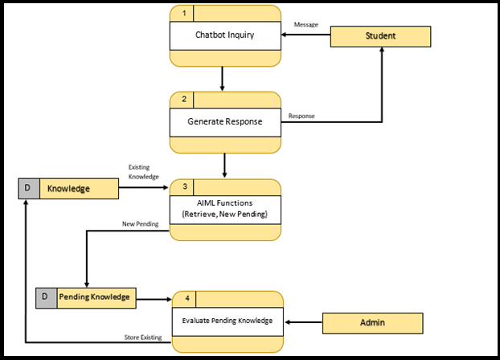**Data Flow Diagram**

*Figure 11. Data Flow Diagram*

A Data Flow Diagram (DFD) is a graphical representation of the flow of data through a system. In the case of a chatbot inquiry system, a DFD could be used to illustrate how data flows through the system from the user's inquiry to the chatbot's response. The Data Flow Diagram above shows the data flow of Chatbot Inquiry System for the students of College of Computer Studies at Jose Rizal Memorial State University; Student will log in on the and input question on the system; The Chatbot inquiry system generates the answer itself using the custom AIML that the researcher made. AIML collecting data from existing knowledge of the system; If true the system will response precise answer, If false system will store query in the pending knowledge. Admin will responsible to answer and evaluate pending knowledge time by time the system will expand knowledge until it can answer by the chatbot itself.

1. Diagram

   Description automatically generated**Entity Relationship Diagram**

*Figure 12. Entity Relationship Diagram*

An Entity Relationship Diagram (ERD) is a visual representation of the relationships between entities or objects in a database. It is a type of data model that shows the structure of a database and the relationships between different tables or entities. In an ERD, entities are represented as rectangles, with the name of the entity inside the rectangle. Relationships between entities are represented as lines connecting the entities, with the relationship type indicated on the line. The type of relationship between entities can be one-to-one, one-to-many, or many-to-many.

In this ERD, there are three main entities: Knowledge, AIML and Pending knowledge. The Knowledge entity represents the knowledge of a system where all the information will be listed. The AIML entity represents the Artificial Intelligence Machine Learning of a system that serves as expandable knowledge. The Pending knowledge entity represents the additional knowledge many is to one of the AIML of the system.

1. **Calendar of Activity**

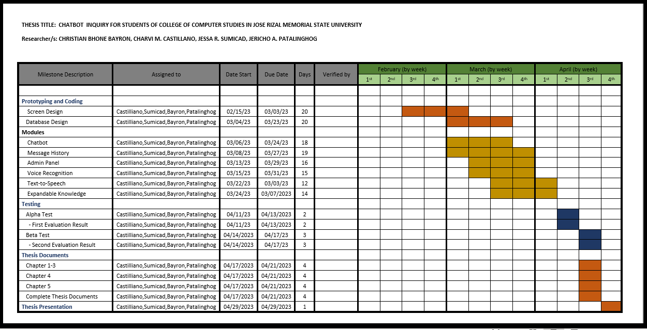**Table 6. Calendar of Activity**

A graph or table is the most common style display for a chart, which is a visual representation of facts or information. A chart’s main objective is to simplify difficult facts for the user by making it more accessible and understood. The schedule presents the system flow and the date of the schedule for each action, and the Chatbot Inquiry for Students Chart demonstrates and highlights the system as well as the systems characteristics. The milestone description is listed in the table as including prototype and coding, modules, testing, thesis documentation, and thesis presentation. There are deadlines for each component of that.

**Coding**

After the analysis, creating an algorithm that uses a customized AIML approach, the analyzed data was encoded as commands in coding to make the program and instructions, thus, from concrete analysis, data was translated into computer commands and instructions using Python programming language that will run as system software of the proposed study.

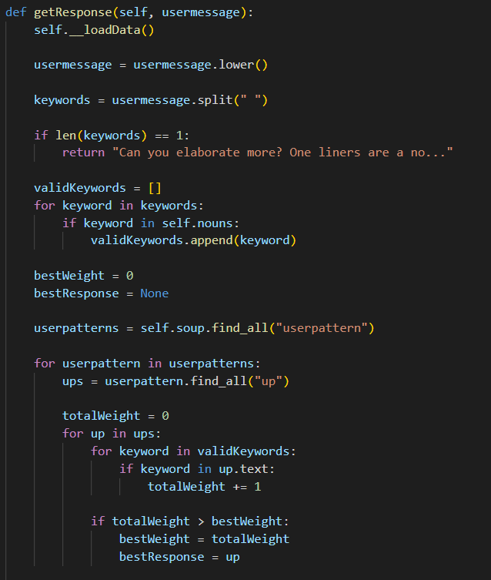**Chatbot using AIML Code with NLP**

*Figure 13.* *Chatbot using AIML Code with NLP*

The function getResponse() takes a user message and validates it a few times before attempting to get a response from the AIML functions, once passed, it takes every word considered as a noun and runs through a Weighting algorithm which attempts to find the best user patterns using weights, and if it find one, it returns a list of all possible answers for that particular question.

The initial requirement is for the response to at least contain something or the Weight to be at least greater than or equal to 3, the bestResponse contains a userPattern object which came from the repository of existing knowledge collected by the Chatbot, it simply randomizes between the list of possibilities within this userPattern and return that value. If it doesn’t find any, it create a new entry of Pending Knowledge, in the Admin can view and create a response for.

*Figure 14.* *bestResponse FAQ*

This is similar to the AIML approach of tagging data, it is how knowledge is stored as it is an efficient way to categorize and traverse through a list of possible questions with their respective answers. A tag called category which serves a wrapper for every different question is created, each containing a userpattern and possibility tag, comparison becomes efficient as each tag is easily traversable with how the html is strctured.

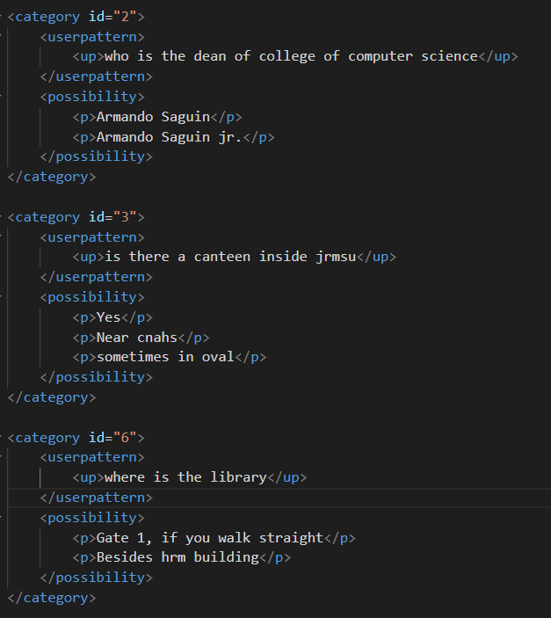*Figure 15. Knowledge category*

**Testing and Evaluation**

1. **System Testing Procedure**

The testing method was adopted while making the program software. Both manual and computerized procedures will be running and will observe its accuracy through its different methods and strategies. The procedure for this individual event will be referred to in its diagram.

**Alpha Testing Procedure:**

1. Testing method of both manual and computerized

2. Collaborate the manual and computerized into the newly developed system

3. Then observed the accuracy and the efficiency of events in the system.

4. Check the data that is used in the system if it is necessary.

5. Set up the system if it is working properly.

6. Use similar software testing procedures as the integration test.

7. Confirm that the system test achieves system test objectives.

8. After checking the study.

1. **System Evaluation**

The proponents believe that all software cannot be implemented without proper research, test and evaluate before the operation. The process can help the researchers in attaining their goals for the exact output. The respondents of the system study evaluated the selected respondents including computer course professionals and some selected respondents who are considered as professional evaluators as well as the users. Each respondent rated the study according to the criteria created by the researchers.

**Functionality.** This is a set of attributes that bear on the existence of a set of functions and their specified properties. The functions are those that satisfy state or implied set of users.

**Numerical Rating Ranges of Mean Description**

5 4.21 – 5.00 Very Much Functional

4 3.41 – 4.20 Much Functional

3 2.61 – 3.40 Functional

2 1.81 – 2.60 Less Functional

1 1.00 – 1.80 Not Functional

**Reliability.** Is the ability of a system to perform its required function under stated condition whenever required-having a long mean time between failures?

5 4.21 – 5.00 Very Much Reliable

4 3.41 – 4.20 Much Reliable

3 2.61 – 3.40 Reliable

2 1.81 – 2.60 Less Reliable

1 1.00 – 1.80 Not Reliable

**Usability** - A set of attributes that bear on the effort method for use, and on the individual’s assessment of such by a stated or implied set of users.

**Numerical Rating Ranges of Mean Description**

5 4.21 – 5.00 Very Much Usable

4 3.41 – 4.20 Much Usable

3 2.61 – 3.40 Moderately Usable

2 1.81 – 2.60 Less Usable

1 1.00 – 1.80 Not Usable

**Range of Mean Descriptive Rating**

4.21 – 5.0 Very Much Functional/Reliable/Usable.

Processing takes approximately 5 seconds and systems response inquiry of the end-user automatically.

3.41 – 4.20 Much Functional/Reliable/Usable.

Processing takes approximately 10 seconds and system responds inquiry of the end-user and it satisfies the end-user.

2.61 – 3.40 Functional/Reliable/Usable.

Processing takes approximately 15 seconds and system respond inquiry of the end-user and it moderately satisfies the end-user.

1.81 – 2.60 Less Functional/Reliable/Usable.

Processing takes approximately 1 minute, and system responds inquiry of the end-user but it does not satisfy the end-user.

1.00 – 1.80 Not Functional/Reliable/Usable.

Processing does not generate response to the end-user bear on the effort needed to make specified modifications.

**System Implementation**

The process is to give input to chatbot and observe its output to determine its functionality, reliability, and usability. The chatbot's results are to ascertain the level of the response, relevance, thoroughness, accuracy, and context. This might be accomplished by allowing students to interact with the chatbot in a controlled way and using the feedback to ascertain its performance. Semantic analysis of the feedback given (i.e., whether reviews are positive or negative, and why this is the case), asking users to complete a satisfaction survey and performing statistical analysis on this, or even just rating satisfaction on a response-by-response level are all ways to evaluate the output of the chatbot. With this procedure, the researchers will be able to know if the system implemented is reaching its objectives and perform as expected. The desired system is to answer student queries of the College of Computer Studies in Jose Rizal Memorial State University.

**Chapter 4**

**RESULT AND DISCUSSIONS**

This chapter presents detailed discussion of the main topics and precise problems of the study is stated in the problem statement. Specifically, the researchers aimed to respond to the following queries:

**Problem 1**. What is the impact of Information Inquiry to the CCS department in JRMSU?

The Chatbot Inquiry System for the students at College of Computer Studies at Jose Rizal Memorial State University is currently in the state of research. It will be created as soon as the research is accepted and properly examined. CCS student in JRMSU is inquiring information by asking random fellow students and their professors. And wasting of time, hassle because we do not even know how dependable and precise the information it is. With this help of chatbot inquiry system instructor will not be disturb in the middle of their classes and paper works. Student will not waste their time searching their question regarding of the Department information.

**Problem 2.** What is the effective web application for information in inquiry in JRMSU CCS Department?

The JRMSU CCS Department is currently using a webpage which is student will rely on information posted in the page, their queries will not be addressed. The researchers are developing a system that will help students get information what they want anywhere and anytime. Information on CCS Department is available to inquire using the Chatbot inquiry that the researcher made.

**Problem 3.** What algorithm can be used for information through Chatbot inquiry?

The researchers are aiming to design a web-based system that will enable the CCS Department Information in JRMSU will be given automatically to students faster and reliable.

Algorithm Process of the study, it is where the overall concept of the system is located. This figure guides the user for the process of the study. This algorithm provides the sufficient and essential process of the system study.

**ALGORITHM:**

1.Start

2.Login Student

3.Inquire queries on chatbot

4.Chatbot get queries and process using AIML then Display answer

6.Admin update new information

7.Stop

*Figure 16. Algorithm of Chatbot*

**Problem 4.** How does the system be assessed in terms of **functionality**, **reliability**, and **usability**?

**Evaluation Process:**

The findings that proved the functionality, reliability, and Usability of the Chatbot Inquiries system in the College of Computer Studies at Jose Rizal Memorial State University – Main Campus Division are presented here.

The respondents were composed of 15 end-users (10 students and 5 instructors) who evaluated the system. The evaluation process was done individually, and each respondent rated the study according to the criteria created by the researchers. The criterion was used to measure the functionality, reliability, and Usability of the system. The criteria were rated from 1-5, where five (5) was the highest rate as to the degree of possibility whether this study is acceptable for everyone; or one (1), the rate given to the least degree.

The rate had the corresponding equivalents:

**A. Functionality**

**Table 7.** **Evaluation of Software Quality Factor: Functionality**

|  |  |  |
| --- | --- | --- |
| **Criteria** | **Weighted Mean** | **Description** |
| 1. Accurate response of query on the chatbot inquiry system. | 4.67 | Very Much Functional |
| 2.Relevance of answer on the question provided by the chatbot inquiry system. | 3.40 | Much Functional |
| 3. Chatbot responses timely. | 4.20 | Much Functional |
| 4. Easy to start chatbot conversation. | 4.47 | Very Much Functional |
| 5.Chatbot follow-up inquiries conversation. | 4.47 | Very Much Functional |
| **Average Weighted Mean** | **4.35** | **Very Much Functional** |

Table 7 above shows the functionality of the system. The criterion, 1. Accurate response of query on the chatbot inquiry system earns the weighted mean of 4.67 or very much functional, 2. Relevance of answer on the question provided by the chatbot inquiry system earn 3.40 or much functional, 3. Chatbot responses timely earns 4.20 or much functional 4. Easy to start chatbot conversation has a weighted mean of 4.47 or very much functional.; 5. Chatbot follow-up inquiries conversation earns the weighted mean of 4.47 or very much functional. The average weighted mean is 4.07 which means that the system is very much functional. To summarize, the system was trusted for inquiry information and could answer student queries automatically.

**B. Reliability**

**Table 8:** **Respondents Rating on the Proposed System in terms of Reliability.**

|  |  |  |
| --- | --- | --- |
| **Criteria** | **Weighted Mean** | **Description** |
| 1.Chatbot responses helpful information about College Computer Science Department. | 4.53 | Very Much Reliable |
| 2.Updated College of Computer Science Department information provided by the chatbot. | 4.27 | Very Much Reliable |
| 3.Chatbot provide clear information. | 4.20 | Much Reliable |
| 4.Concise information provided by the chatbot. | 4.47 | Very Much Reliable |
| 5.Chatbot provide consistent responses to similar inquiries. | 4.13 | Much Reliable |
| **Average Weighted Mean** | **4.32** | **Very much Reliable** |

Table 3 shows the reliability of the system. Chatbot responses helpful information about College Computer Science Department earns the mean of 4.53 or very much reliable; Updated College of Computer Science Department information provided by the chatbot earns 4.27 or very much reliable; Chatbot provide clear information earns 4.20 or much reliable; Concise information provided by the chatbot has a mean of 4.47 or very much reliable; Chatbot provide consistent responses to similar inquiries has a weighted mean of 4.13 or much reliable. The average weighted mean is 4.32 which mean the system is much reliable in terms of information.

**C. Usability**

**Table 9.** **Evaluation of Software Quality Factor: Usability**

|  |  |  |
| --- | --- | --- |
| **Criteria** | **Weighted Mean** | **Description** |
| 1.Chatbot response efficiently on the query. | 4.67 | Very Much Usable |
| 2.Chatbot 24/7 available to use. | 4.33 | Very Much Usable |
| 3.Answer of chatbot depends on inquiry input. | 4.07 | Much Usable |
| 4.Language and tone of chatbot are easy to understand. | 4.47 | Very Much Usable |
| 5.Chabot Handle of multiple languages | 4.47 | Very Much Usable |
| **Average Weighted Mean** | **4.4** | **Very Much Usable** |

Table 4 shows the evaluation of the software quality factors as to its usability. Usability is composed of five criteria which are rated as very much usable: Chatbot response efficiently on the query got the mean of 4.67 which implied that users get information immediately by just asking the system.; Chatbot 24/7 available to use revealed the mean of 4.33. This means that the webpage would display on time and chatbot will be available anytime; Answer of chatbot depends on inquiry input with the mean of 4.07 implied that users satisfy of answer base on what the user input in the system. Language and tone of chatbot are easy to understand revealed the mean of 4.47 which means that the system responded the query of the user using the common language and speaker; Chabot Handle of multiple languages has the mean of 4.47 implied the user that even they use their dialect chatbot will response and understand. Generally, the software quality factor is very much usable with the Average weighted mean of 4.4.

**Table 10.** **Summary of the Ratings of Software Quality Factors**

|  |  |  |
| --- | --- | --- |
| **Software Quality Factor** | **Mean Average** | **Descriptive Rating** |
| **Functionality** | 4.35 | **Very Much Functional** |
| **Reliability** | 4.32 | **Very Much Reliable** |
| **Usability** | 4.4 | **Very Much Usable** |
| **OVERALL** | **4.36** | **Very Acceptable** |

The researchers used different software criteria factors suited for the evaluation such as functionality, reliability, and usability of the system. The above-mentioned criteria of the software quality factor were included in the evaluation of the instrument together with the corresponding ratings and equivalent descriptions which were exemplified and discussed in this section. Table 5 shows the result of the technical evaluation that proved the functionality, reliability, and usability of the development of the system software. It revealed further the descriptive rating “very acceptable” with the average mean of 4.35 as to the functionality of the proposed system. It could mean that users fully understood the functions and features that were found in the system. They knew that the system could respond to precise information and was convenient to use in gathering data.

The system was very acceptable with an average mean of 4.32 as to its reliability. It also signifies that the system can stand without errors and bugs and speed in data processing, deliver understandable reports regarding the student information and display information with completeness and appropriateness with details of the required information. It was very acceptable with an average mean of 4.4 as to its Usability. This could only mean that the student will rely on information clear and precise in the chatbot and “very acceptable” in terms of usability, convenient to use when asking question or information in CCS Department

Therefore, with all the criteria ratings being summed up, the overall weighted average of the proposed system means that the software quality factor is acceptable with the total average mean of 4.36 as per evaluation results.

**Chapter 5**

**SUMMARY, FINDINGS, CONCLUSION, AND RECOMMENDATION**

This chapter presents the summary and conclusion of the study. It also covers the presentation of the findings, the conclusions which are drawn based on the findings, and recommendations offered**.**

**Summary**

The researchers investigated the “Chatbot Inquiry System for the students of College of Computer Studies at Jose Rizal Memorial State University” and answers for the sub problems stated in the statement of the problem were sought. This was accomplished through a process called the project development cycle which includes Data Gathering, Requirements and Analysis, Designing, Coding, and Testing and Evaluation. This system can give students more accurate, reliable and less time consuming, especially of asking information in CCS Department.

Answers to the following sub problems were sought. Below were the questions that include:

1. What is the impact of Information Inquiry to the CCS department in JRMSU?
2. What is the effective web application for information inquiry in JRMSU CCS Department?
3. What algorithm can be used for information through Chatbot inquiry?
4. How does the system be assessed in terms of functionality, reliability, and usability?

The method used in this study was developmental research method employing documentary analysis wherein the data gathered from an interview and other resource documents were carefully examined and analyzed in order to produce the desired result and accurate output of the study.

**Findings**

Summary of findings is the last part of the thesis. It is where the results of the study are written. This part is the heart of the system “Chatbot Inquiry System for the students at College of Computer Studies at Jose Rizal Memorial State University” with which the value of the thesis will stand or fall on the validity and quality of the thesis findings. Based on the reviewed literature, the researchers created a research design and formulated hypotheses from the research questions.

After all the necessary data of the study were treated accordingly, the following findings were exposed:

1. Researcher found out that student struggle in finding answer on their question in the CCS Department in JRMSU. Which is the chatbot inquiry has a huge impact in their school lifestyle. Student will not disturb their instructor or informant to answer their own queries; Giving them much time to do other activity than findings informant to fulfill their queries; can rely in chatbot information because it is clear, true, and precise coming from CCS Department organization.

2. Researchers want to implement a technological system entitled “Chatbot Inquiry System for the students of College of Computer Studies at Jose Rizal Memorial State University” for a new fast process in giving information and convenient to use in answering the student questions regarding in CCS Department.

3. The algorithms or processes involved in designing the Chatbot Inquiry System for the students of College of Computer Studies at Jose Rizal Memorial State University are shown using the Entity- Relationship Diagram, Data Flow Diagram, and the System Flow Diagram.

4. The overall results as evaluated by the respondents proved that the system software is highly acceptable in terms of functionality, reliability, and usability.

4.1 The system software bears a set of functions and their specified properties. The functions stated were proven to be much functional with an average mean of 4.35.

4.2 The software quality in terms of reliability which determines the ability of a system to perform its required functions under the stated conditions whenever required having a long time between failures was much reliable as supported by an average mean of 4.32.

4.3 The software quality in terms of usability was proven to be very much usable with an average mean of 4.4.

4.4 The overall average rating of the software quality factors which was interpreted as 4.36 is acceptable. The system works functionally, quickly, reliable, and precisely of giving information on the user.

**Conclusion**

The researcher concluded that the “Chatbot Inquiry System for the students at College of Computer Studies at Jose Rizal Memorial State University” is more accurate, not time consuming and makes their questions answer easier and faster. It provides students with a convenient and easy to use system that can be done anywhere, anytime. The purpose of the system is to provide information and answer their query accurately and easily in a timely manner.

**Recommendation**

The researchers would like to recommend that the “Chatbot Inquiry System for the students at College of Computer Studies at Jose Rizal Memorial State University” will be implemented and using of chatbot inquiry on the JRMSU not just in the CCS Department but in the entire Department and school. Adoption of this system basically means faster and efficient results.

**References:**

1. Arreza, M. K. B. (2022). The quality of service and user satisfaction of airline

chatbots. Journal of Business on Hospitality and Tourism, 8(1), 197-215. <https://media.neliti.com/media/publications/420052-the-quality-of-service-and-user-satisfac-952f0cba.pdf>

1. Arthur Franke (2019) and Jeff Mike (2019), HR and Chatbots Are Learning Together. <https://www.shrm.org/resourcesandtools/hr-topics/technology/pages/hr-chatbots-are-learning-together.aspx?fbclid=IwAR3J21NapHkggVkayMHvFLUepDl_OUi_0qqXoR2qm5aSn4lC2cO4AlqOjfU>
2. . BACALSO, P. L., FELISCUZO, L. S., &amp; ALIAC, C. J. C. CUTIE: INTERVIEWER BOT. <http://jestec.taylors.edu.my/Speccial%20Issue%20ICITE2021/Special%20issue%20ICITE21_09.pdf>
3. Petter Bae Brandtzaeg and AsbjørnFølstad, Chatbot: Changing User needs and motivations. <https://www.researchgate.net/publication/327191388_Chatbots_changing_user_needs_and_motivations>
4. Catapang, J. K., Solano, G. A., &amp; Oco, N. (2020, February). A bilingual chatbot using support vector classifier on an automatic corpus engine dataset. In 2020 International Conference on Artificial Intelligence in Information and Communication (ICAIIC) (pp. 187-192). IEEE. <https://ieeexplore.ieee.org/abstract/document/9065208>
5. Daria Zaboj, Fallback can help your chatbot sustain a conversation when a misunderstanding happens. <https://www.chatbot.com/help/interactions/what-is-fallback-interaction/#:~:text=The%20fallback%20interaction%20is%20triggered,agent%20when%20integrated%20with%20LiveChat>
6. Fryer, L. K., Ainley, M., Thompson, A., Gibson, A., &amp; Sherlock, Z. (2017).Stimulating and sustaining interest in a language course: An experimental comparison of Chatbot and Human task partners. Computers in Human Behavior, 75, 461-468.<https://www.researchgate.net/publication/317270477_Stimulating_and_sustaining_interest_in_a_language_course_An_experimental_comparison_of_Chatbot_and_Human_task_partners>
7. Haristiani, N. (2019, November). Artificial Intelligence (AI) chatbot as language learningmedium: An inquiry. In Journal of Physics: Conference Series (Vol. 1387, No. 1, p. 012020).<https://ui.adsabs.harvard.edu/abs/2019JPhCS1387a2020H/abstract>
8. Höhn, S. (2017, August). A data-driven model of explanations for a chatbot that helps topractice conversation in a foreign language. In Proceedings of the 18th Annual SIGdialMeeting on Discourse and Dialogue (pp. 395-405).<https://aclanthology.org/W17-5547/>
9. Hsu, M. H., Chen, P. S., &amp; Yu, C. S. (2021). Proposing a task-oriented chatbot system forEFL learners speaking practice. Interactive Learning Environments, 1-12.<https://www.semanticscholar.org/paper/Proposing-a-task-oriented-chatbot-system-for-EFL-Hsu-Chen/f4b7a80d2866de24d346f1e5fa1b0ae87687257d>
10. Jacobe, B., Pascua, M. L., Tumbali, B. J., &amp; Gumabay, M. V. (2021). Interactive Chatbot for Customer Service with Voice Recognition. International Journal, 10(4). <https://d1wqtxts1xzle7.cloudfront.net/68678972/ijatcse141042021-libre.pdf?1628582281=&response-content-disposition=inline%3B+filename%3DInteractive_Chatbot_for_Customer_Service.pdf&Expires=1672973197&Signature=Kloq4eXkyYxLcG-B9TLGMrnR8X0WKNYrsQOPytGtw9hbA-H4zTQSQdRA4VIiUCamCjYkeJ3jjHEjyGYyYH7waYe3sEooRv8WRNQBhQ8Q6dXBVHNHwi9fdixWFw0ZXMC2jxgl3GUtnqMfbESMMe7rDqUHhLL8qU0CKJWI278HJg4-ahfIzHS~tpNK4yoXmETpS8lkKkc~px0QwfQziDbUjawTUKFZ27KqxCYtoiNDU2zufFMiHndsGt4MPUuvNK92p9z0NOIsL3pzxGah6Kzb5SB9QFa-1bASrOy3J90JzeBXTyOq0ebaIReek8fplxGDrN62qPU3Wo80fC0FwvF5BA__&Key-Pair-Id=APKAJLOHF5GGSLRBV4ZA>
11. Jia, J. (2004). The study of the application of a web-based chatbot system on the teaching of foreign languages. In Society for Information Technology &amp; Teacher Education International Conference (pp. 1201-1207). Association for the Advancement of Computing in Education (AACE). <https://www.learntechlib.org/p/13633/>
12. Jiang, H., Cheng, Y., Yang, J., &amp; Gao, S. (2022). AI-powered chatbot communication with customers: Dialogic interactions, satisfaction, engagement, and customer behavior. Computers in Human Behavior, 107329. <https://www.sciencedirect.com/science/article/abs/pii/S0747563222001510>
13. Marcelino, F. J. G., Escubio, M. T., Ocampo, J. P. M., &amp; Beninsig, M. A. (2021, December).Cheerbot: A Customer Service AI Chatbot for Foam-Pom Pangasinan. In 2021 1stInternational Conference in Information and Computing Research (iCORE) (pp. 23-28). IEEE. <https://ieeexplore.ieee.org/abstract/document/9681419/>
14. Montaner, Tristan &amp; Patlonag, Ray &amp; Sullan, Joseph Benedict. (2022). MADASIGON: A BINISAYA CHATBOT FOR CUSTOMER SERVICE DEVICE TROUBLESHOOTING. <https://www.researchgate.net/publication/360933086_MADASIGON_A_BINISAYA_CHATBOT_FOR_CUSTOMER_SERVICE_DEVICE_TROUBLESHOOTING>
15. Nghi, T. T., Phuc, T. H., &amp; Thang, N. T. (2019). Applying ai chatbot for teaching a foreign language: An empirical research. Int. J. Sci. Res, 8. <http://www.ijstr.org/final-print/dec2019/Applying-Ai-Chatbot-For-Teaching-A-Foreign-Language-An-Empirical-Research-.pdf>
16. Pham, X. L., Pham, T., Nguyen, Q. M., Nguyen, T. H., &amp; Cao, T. T. H. (2018, November). Chatbot as an intelligent personal assistant for mobile language learning. In Proceedings of the 2018 2nd International Conference on Education and E-Learning (pp. 16-21). <https://dl.acm.org/doi/abs/10.1145/3291078.3291115>
17. Sahin, M., Relieu, M., &amp; Francillon, A. (2017). Using chatbots against voice spam: Analyzing {Lenny’s} effectiveness. In Thirteenth Symposium on Usable Privacy and Security (SOUPS 2017) (pp. 319-337). <https://www.usenix.org/conference/soups2017/technical-sessions/presentation/sahin>
18. Serrano, J. V., Belegal, J. A. C., Cañas-Llamas, A. M. E. F., Petrasanta, L. P., &amp; Almodiel, M. C. (2021). Ask Iska and IskOU: Analysis of UPOU&#39;s Chatbot for Information Support services. International Journal on Open and Distance e-Learning, 7(1). <https://ijodel.com/index.php/ijodel/article/view/45>
19. UjilabenKapleshBavishi (2019), Implementing a college inquiry chatbot. <https://scholarworks.calstate.edu/downloads/8s45q927v>
20. Ureta, J., &amp; Rivera, J. P. (2018). Using chatbots to teach stem related research concepts to high school students. <https://www.researchgate.net/profile/Joanna-Rivera-2/publication/336141844_Using_Chatbots_to_Teach_STEM_Related_Research_Concepts_to_High_School_Students/links/5d948a1392851c33e94fd881/Using-Chatbots-to-Teach-STEM-Related-Research-Concepts-to-High-School-Students.pdf>
21. Wollny, S., Schneider, J., Di Mitri, D., Weidlich, J., Rittberger, M., &amp; Drachsler, H. (2021). Are we there yet?-A systematic literature review on chatbots in education. Frontiers in artificial intelligence. <https://www.frontiersin.org/articles/10.3389/frai.2021.654924/full>
22. Yin, Q., &amp; Satar, M. (2020). English as a foreign language learner interactions with chatbots:Negotiation for meaning. International Online Journal of Education and Teaching (IOJET).<https://files.eric.ed.gov/fulltext/EJ1250583.pdf>

**Appendices**

**Appendix A**

**User’s Manual**

**Using the web page as students**

**STEP 1**

**Log in as students.**

**Step 2**

**Conversation inquiry**

**Using the web page as Admin**

**Step 1**

**Log in as admin.**

**Step 2**

**Merging inquiry and answer questions.**

**Appendix B**

**Letter to the Panelist**

Republic of the Philippines**

**JOSE RIZAL MEMORIAL STATE UNIVERSITY**

**The Premier University in Zamboanga Del Norte**

**Main Campus, Dapitan City**

April 26, 2023

**Engr. JOSEPH AURELIUS P. JACINTO, MSIT**

College of Computer Science

Jose Rizal Memorial State University

Sir:

We, the undersigned are 4th year BS Computer Science who will have our Thesis Final Defense entitled “Chatbot **Inquiry for students of College of Computer Studies at Jose Rizal Memorial State University’’.** This is a partial fulfillment of the requirements of the subject Project Thesis.

We would like to request that presence as one of the panelists on April 28, 2023.

We are hoping for your kind response on this request.

Respectfully yours,

Jericho A. Patalinghog

Charvi M. Castillano

Christian Bhone P. Bayron

Jessa R. Sumicad

Approved:

**PROF. JOHN D. SAGAPSAPAN, MSIT**

Thesis Adviser

Republic of the Philippines**

**JOSE RIZAL MEMORIAL STATE UNIVERSITY**

**The Premier University in Zamboanga Del Norte**

**Main Campus, Dapitan City**

April 26, 2023

**PROF. JUVY LITO MARTINEZ**

College of Computer Science

Jose Rizal Memorial State University

Sir:

We, the undersigned are 4th year BS Computer Science who will have our Thesis Final Defense entitled “Chatbot **Inquiry for students of College of Computer Studies at Jose Rizal Memorial State University’’.** This is a partial fulfillment of the requirements of the subject Project Thesis.

We would like to request that presence as one of the panelists on April 28, 2023.

We are hoping for your kind response on this request.

Respectfully yours,

Jericho A. Patalinghog

Charvi M. Castillano

Christian Bhone P. Bayron

Jessa R. Sumicad

Approved:

**PROF. JOHN D. SAGAPSAPAN, MSIT**

Thesis Adviser

Republic of the Philippines**

**JOSE RIZAL MEMORIAL STATE UNIVERSITY**

**The Premier University in Zamboanga Del Norte**

**Main Campus, Dapitan City**

April 26, 2023

**PROF. ARMANDO T. SAGUIN JR. MSIT**

College of Computer Science

Jose Rizal Memorial State University

Sir:

We, the undersigned are 4th year BS Computer Science who will have our Thesis Final Defense entitled “Chatbot **Inquiry for students of College of Computer Studies at Jose Rizal Memorial State University’’.** This is a partial fulfillment of the requirements of the subject Project Thesis.

We would like to request that presence as one of the panelists on April 28, 2023.

We are hoping for your kind response on this request.

Respectfully yours,

Jericho A. Patalinghog

Charvi M. Castillano

Christian Bhone P. Bayron

Jessa R. Sumicad

Approved:

**PROF. JOHN D. SAGAPSAPAN, MSIT**

Thesis Adviser

Republic of the Philippines**

**JOSE RIZAL MEMORIAL STATE UNIVERSITY**

**The Premier University in Zamboanga Del Norte**

**Main Campus, Dapitan City**

April 26, 2023

**PROF. JOHN D. SAGAPSAPAN MSIT**

College of Computer Science

Jose Rizal Memorial State University

Sir:

We, the undersigned are 4th year BS Computer Science who will have our Thesis Final Defense entitled “Chatbot **Inquiry for students of College of Computer Studies at Jose Rizal Memorial State University’’.** This is a partial fulfillment of the requirements of the subject Project Thesis.

We would like to request that presence as one of the panelists on April 28, 2023.

We are hoping for your kind response on this request.

Respectfully yours,

Jericho A. Patalinghog

Charvi M. Castillano

Christian Bhone P. Bayron

Jessa R. Sumicad

Approved:

**PROF. JOHN D. SAGAPSAPAN, MSIT**

Thesis Adviser

Republic of the Philippines**

**JOSE RIZAL MEMORIAL STATE UNIVERSITY**

**The Premier University in Zamboanga Del Norte**

**Main Campus, Dapitan City**

April 26, 2023

**PROF. EDGARDO OLMOGUEZ II MSIT**

College of Computer Science

Jose Rizal Memorial State University

Sir:

We, the undersigned are 4th year BS Computer Science who will have our Thesis Final Defense entitled “Chatbot **Inquiry for students of College of Computer Studies at Jose Rizal Memorial State University’’.** This is a partial fulfillment of the requirements of the subject Project Thesis.

We would like to request that presence as one of the panelists on April 28, 2023.

We are hoping for your kind response on this request.

Respectfully yours,

Jericho A. Patalinghog

Charvi M. Castillano

Christian Bhone P. Bayron

Jessa R. Sumicad

Approved:

**PROF. JOHN D. SAGAPSAPAN, MSIT**

Thesis Adviser

Appendix C

Letter of Request

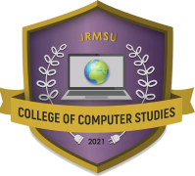Republic of the Philippines

**JOSE RIZAL MEMORIAL STATE UNIVERSITY**

The Premier University in Zamboanga Del Norte

Main Campus, Dapitan City

May 10, 2023

**ARMANDO T. SAGUIN JR., MSIT**

Associate Dean, College of Computer Studies

Jose Rizal Memorial State University- Main Campus

Sir:

I would like to request permission from your good office to allow me to administer the research instrument of my study entitled “**Chatbot Inquiry for students of College of Computer Studies in Jose Rizal Memorial State University**” to the respondents who are CCS Students, CCS Faculty/Instructors of the JRMSU-Main Campus and randomly selected CCS students, and CCS Instructors/Professors of Jose Rizal Memorial State University, Main Campus, Dapitan City, Zamboanga del Norte.

I fervently hope for your full support and cooperation on this matter.

Sincerely yours,

**CHARVI M. CASTILLANO JESSA R. SUMICAD**

Researcher Researcher

**CHRISTIAN BHONE P. BAYRON JERICHO A. PATALINGHOG**

Researcher Researcher

Noted:

**JOHN D. SAGAPSAPAN, MSIT**

Adviser

Appendix D

Endorsement Letter

Republic of the Philippines

**JOSE RIZAL MEMORIAL STATE UNIVERSITY**

The Premier University in Zamboanga Del Norte

Main Campus, Dapitan City

**1st Endorsement**

**________________**

(Date)

Respectfully forwarded to the IT instructors/professors of Jose Rizal Memorial State University-Main Campus and the randomly selected CCS students, and CCS Instructors/Professors of Jose Rizal Memorial State University-Main Campus, Dapitan City, Zamboanga del Norte the here in request **CHARVI M. CASTILLANO, JERICHO A. PATALINGHOG, CHRISTIAN BHONE P. BAYRON, JESSA R. SUMICAD,** a candidate leading to the Bachelor of Science in Computer Science, to administer the instrument for her thesis entitled “**Chatbot Inquiry for students of College of Computer Studies in Jose Rizal Memorial State University**” for your favorable action and support.

**ARMANDO T. SAGUIN JR., MSIT**

Associate Dean, Computer Science

Appendix E

Evaluation Sheet



Republic of the Philippines

**JOSE RIZAL MEMORIAL STATE UNIVERSITY**

*The Premier University in the Philippines of the Zamboanga Del Norte*

Main Campus, Dapitan City

EVALUATION SHEET

Name (Optional)________________________________________________________

Sex:

|  |
| --- |
|  |

Male

|  |
| --- |
|  |

Female

|  |
| --- |
|  |

Respondents Type:

College of Computer Studies Students

|  |
| --- |
|  |

CCS Instructor / Professor

Direction: Evaluate the software and give your rating for each criterion. To rate the software, please put a check (✔) mark on the box that corresponds to your desired rate.

**Functionality.** It refers to the ability of chatbot inquiry to perform its range of task and actions. The result should be functional and effectiveness.

|  |  |  |  |  |  |
| --- | --- | --- | --- | --- | --- |
| FUNCTIONALITY | | | | | |
| ITEMS | **RATING SCALE** (Put a check mark) | | | | |
| 5 - Very Much Functional | 4 - Much Functional | 3 – Moderately Functional | 2 – Less Functional | 1 – Not Functional |
| 1.Accurate response of query on the chatbot inquiry system. |  |  |  |  |  |
| 2.Relevance of answer on the question provided by the chatbot inquiry system. |  |  |  |  |  |
| 3.Chatbot responses timely. |  |  |  |  |  |
| 4.Easy to start chatbot conversation. |  |  |  |  |  |
| 5.Chatbot follow-up inquiries conversation. |  |  |  |  |  |

**Reliability:** It refers to the chatbot inquiry system consistency and dependability of the system's performance. The result should be clear and concise.

|  |  |  |  |  |  |
| --- | --- | --- | --- | --- | --- |
| RELIABLITY | | | | | |
| ITEMS | **RATING SCALE** (Put a check mark) | | | | |
| 5 - Very Much Reliable | 4 - Much Reliable | 3 – Moderately Reliable | 2 – Less Reliable | 1 – Not Reliable |
| 1. Chatbot responses helpful information about College Computer Science Department. |  |  |  |  |  |
| 2.Updated College of Computer Science Department information provided by the chatbot. |  |  |  |  |  |
| 3.Chatbot provide clear information. |  |  |  |  |  |
| 4.Concise information provide by the chatbot. |  |  |  |  |  |
| 5.Chatbot provide consistent responses to similar inquiries. |  |  |  |  |  |

**Usability:** It refers to the chatbot ability to meet the needs of its users effectively and efficiently. The result should be easy to use, understand.

|  |  |  |  |  |  |
| --- | --- | --- | --- | --- | --- |
| USABILTIY | | | | | |
| ITEMS | **RATING SCALE** (Put a check mark) | | | | |
| 5 - Very Much Usable | 4 – Much Usable | 3 – Moderately Usable | 2 – Less Usable | 1 – Not Usable |
| 1.Chatbot response efficiently on the query. |  |  |  |  |  |
| 2.Chatbot 24/7 available to use. |  |  |  |  |  |
| 3.Answer of chatbot depends on inquiry input. |  |  |  |  |  |
| 4.Language and tone of chatbot are easy to understand. |  |  |  |  |  |
| 5.Chabot Handle of multiple languages. |  |  |  |  |  |

Appendix F

Permission Letter to Conduct the Study

Republic of the Philippines

**Jose Rizal Memorial State University**

*The Premier University in Zamboanga del Norte*

Main Campus, Dapitan City

May 10, 2023

**ARMANDO T. SAGUIN JR., MSIT**

Associate Dean, College of Computer Studies

Jose Rizal Memorial State University- Main Campus

Sir:

We would like to ask permission from your good office to allow us to present the Survey Instruments of our study entitled “**Chatbot Inquiry for students of College of Computer Studies in Jose Rizal Memorial State University**” to determine the content validity of this instrument to (10) CCS Students, and (5) CCS Instructors/Faculty of Jose Rizal Memorial State University-Main Campus, Dapitan, Zamboanga del Norte. The survey instrument has three criteria: Functionality, Reliability and Usability of the system.

Attached is the letter to the instructors/professors and the instrument of my study seeking for formal endorsement from your office.

I fervently hope for your full support and cooperation on this matter.

Sincerely yours,

**CHARVI M. CASTILLANO JESSA R. SUMICAD**

Researcher Researcher

**CHRISTIAN BHONE P. BAYRON JERICHO A. PATALINGHOG**

Researcher Researcher

Note:

**JOHN D. SAGAPSAPAN, MSIT**

Adviser

Appendix G

Certification for Validation

Republic of the Philippines

**JOSE RIZAL MEMORIAL STATE UNIVERSITY**

The Premier University in Zamboanga Del Norte

Main Campus, Dapitan City

**CERTIFICATE OF CONTENT VALIDATION**

This is to certify that the instrument for the study entitled ‘Chatbot Inquiry for students of College of Computer Studies in Jose Rizal Memorial State University,' prepared and submitted by Charvi M. Castillano, Jericho A. Patalinghog, Christian Bhone P. Bayron and Jessa R. Sumicad has been evaluated and found to conform to the required standard of scholarly research.

In view thereof, we, the evaluators, have affixed our signatures below as confirmation of the examination and approval we have made.

Research Coordinator Statistician

**JOHN D. SAGAPSAPAN, MSIT KIRT JOSEPH SALAVERIA, MA-English**

Research Adviser English Critic

**ARMANDO T. SAGUIN JR., MSIT**

Associate Dean

Appendix H

Tally of Evaluation Scores and Mean

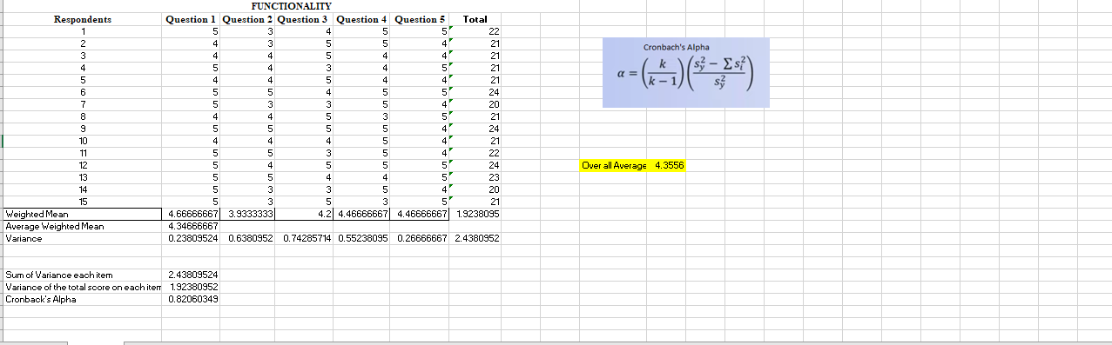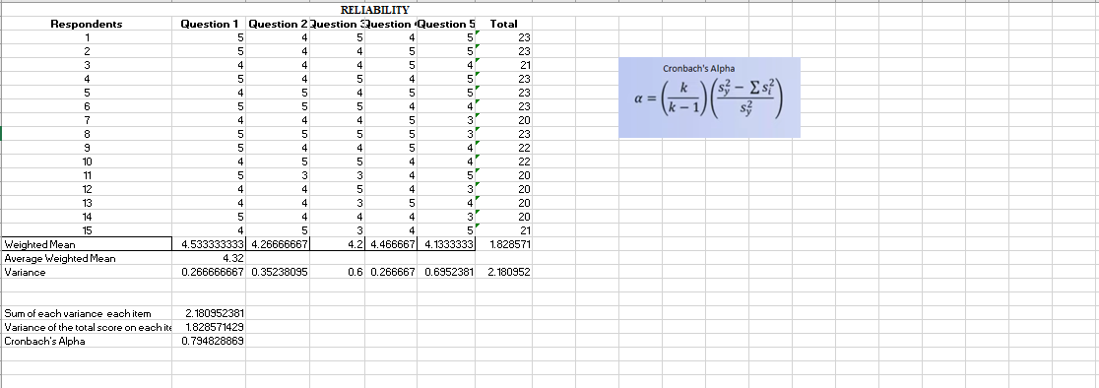

Appendix I

Curriculum Vitae

**JERICHO A. PATALINGHOG**

Address: Sicayab Bucana, Dapitan City

Province: Zamboanga Del Norte

Contact#:09569345018

Email:patalinghogjericho@gmail.com

**EDUCATIONAL BACKGROUND**

Degree: Bachelor of Science in Computer Science

College: Jose Rizal Memorial State University

Senior High: Jose Rizal Memorial State University

Junior High: Sicayab National High School

Primary: Sicayab Bucana Elementary School

**PERSONAL INFORMATION**

Gender: Male

Age: 23

Date of Birth: May 31, 1999

Civil Status: Single

Citizenship: Filipino

Height: 5’7

Weight: 78 kg

Religion: Roman Catholic

Dialect: Bisaya, Tagalog, English

Mothers name: Nelfa A. Patalinghog

Fathers name:Gomer A. Patalinghog

**TRAINING / SEMINARS ATTENDED**

**CHARVI M. CASTILLANO**

Address: Sta.cruz, Plaridel

Province: Misamis Occidental

Contact#: 09350624696

Email: charvicastillano@gmail.com

**EDUCATIONAL BACKGROUND**

Degree: Bachelor of Science in Computer Science

College: Jose Rizal Memorial State University

Senior High: Looc National High School

Junior High: Looc National High School

Primary: Iponan Elementary School

**PERSONAL INFORMATION**

Gender: Gay

Age: 23

Date of Birth: March 24, 2000

Civil Status: Single

Citizenship: Filipino

Height: 5’7

Weight: 47

Religion: Iglesia Filipina Independiente

Dialect: Bisaya, tagalog, English

Mothers name: Vilma Monte Castillano

Fathers name: Alivar Tumanda Castillano

**TRAINING / SEMINARS ATTENDED**

**JESSA R. SUMICAD**

Address: Imelda, Labason

Province: Zamboanga Del Norte

Contact#: 09068420454

Email: jessasumicad9@gmail.com

**EDUCATIONAL BACKGROUND**

Degree: Bachelor of Science in Computer Science

College: Jose Rizal Memorial State University

Senior High: Saint Mary’s College of Labason

Junior High: Saint Mary’s College of Labason

Primary: Imelda Elementary School

**PERSONAL INFORMATION**

Gender: Female

Age: 22

Date of Birth: October 11, 2000

Civil Status: Single

Citizenship: Filipino

Height: 5’3

Weight: 50 kg

Religion: Roman Catholic

Dialect: Bisaya, Tagalog, English

Mothers name: Teresita R. Sumicad

Fathers name: Joselito R. Sumicad

**TRAINING / SEMINARS ATTENDED**

**CHRISTIAN BHONE P. BAYRON**

Address: San Pedro, Dapitan City

Province: Zamboanga Del Norte

Contact#: 09068662825

Email: bayron08.pb@gmail.com

**EDUCATIONAL BACKGROUND**

Degree: Bachelor of Science in Computer Science

College: Jose Rizal Memorial State University

Senior High: Dapitan City National High School

Junior High: San Pedro National High School

Primary: San Pedro Elementary School

**PERSONAL INFORMATION**

Gender: Male

Age: 22

Date of Birth: December 29, 2000

Civil Status: Single

Citizenship: Filipino

Height: 5’10

Weight: 85 kg

Religion: Roman Catholic

Dialect: Bisaya, Tagalog, English

Mothers name: Gina P. Bayron

Fathers name: Bonifacio P. Bayron

**TRAINING / SEMINARS ATTENDED**