Birmingham City University
Department of Computing, Engineering and Built Environment

Intelligent System to predict human Movement near IoT Devices

Author: Supervisor:
Aman Gupta (20101021) Dr. HOSSEIN GHOMESHI

A report submitted in partial fulfillment for the degree of:
Master of Science Advanced Computer Science
JUNE 10, 2021
Acknowledgement
Firstly, I would like to thank my research dissertation supervisor Dr. Hossein Ghomeshi and my module leader Dr. Mariam Adedoyin-Olowe. Their suggestion, significant investigation and steady assistance have been inestimable all through the connection of this work.
I have taken help from the people who have knowledge about the IoT based devices and machine learning. I have also taken help from the friend who have good knowledge about the information technology and the computer. I also share my thankfulness towards them to make me help to make the completion of the research. I also share my outmost gratitude towards all people who have helped me to make this research to be completed.
Abstract
Chapter 1: In this chapter the introduction is given related to the data mining and the types of the methods which are used in the data-based analytics. Apart from that, the IoT based devices which have played a major role in the industry have been also interpreted. The main aim of this chapter is to study the things which need to be done that are associated with the IoT based devices.
Chapter 2: This chapter deals with the secondary type of an analysis where the past researches are there done associated with the IoT based devices and their interpretation. It is seen that why the IoT based devices are useful are mainly told in this chapter. The logical arrangements and the data mining related instruction are there given in this chapter.
Chapter 3: This chapter deals with the research method and the techniques which are there used in the research to make the completion of the research. This is called to be the chapter which help to give the basic understanding that what is been implemented in the research.
Chapter 4: The chapter is called to be one of the most important part of the research where the data analysis is mainly done. The coding related all the data and the statistical interpretation has been done in this part to make the research to be understood.
Chapter 5: This is the last chapter of the research where the recommendation and the conclusion are mainly given. Apart from that, this is called the last chapter where their management of the limitation ad the future scope study has been also understood.
Table of Contents
Chapter 1: Introduction 7
1.0 Introduction 7
1.1 Background 8
1.3 Research Aim and Objective 10
1.3.1 Research Aim 10
1.3.2 Research Objectives 10
1.4 Research Questions 11
1.5 Ethical Considerations 11
1.6 Gaps of the research 11
1.7 Significance of Research 12
1.8 Data Acquisition 12
1.9 Structure of Research 12
1.10 Summary 13
Chapter 2: Literature Review 15
2. Literature Review 15
2.1 Analyzation of Environmental Sensory based Telemetry Data 15
2.2 Pre-Processing of the sensor data of various gadgets of different locations 17
2.3 Data Mining Techniques and its Implementation 18
2. 4 Visualization of all telemetry data using Matplotlib libraries. 19
2.5 Implementing Data Models and evaluating the outcome. 20
2.6 Ideas on the usefulness of data mining models to improve accuracy score. 20
Chapter 3: Research Methodology 22
3.1 Introduction 22
3.2 Research Design 23
3.2 1 Descriptive 23
3.2.2 Experimental 23
3.2.3 Explanatory 24
3.3 Implementation Task 24
3.4 Approaches to Perform the Task 25
3.5 Project Considerations 26
3. 6 Estimated Time Plan 27
3. 7 Conclusion 28
Chapter 4: Data Analysis 30
4. Experimental Work 30
4.1 Python IDE 30
4.2 Data Summary 31
4.3 Using Machine Learning to Detect Movements 38
4.4 ML techniques to tackle the problems identifying human movements in IoT data. 42
4.4.1 Classification method to predict human movement using IoT sensor data 42
4.4.2 Implementation of Classification Algorithms. 50
4.4.3 Model Tuning-hyperparameters 53
Chapter 5: Conclusion 55
5.1 Summary of Research Findings 55
5.2 Importance of Study 55
5.3 Realization of the Objectives 55
5.4 Recommendations 58
5.5 Future Scope Study 58
Reference 60
Bibliography 69
Appendices 73
Appendix 73

List of Figures
Figure 1.1: Internet of Things 7
Figure 1.2: Cloud Computing 9
Figure 1.8: Structure of Study 13
Figure 2.3: Data Mining with IoT 19
Figure 3.1.1: Research Design 23
Figure 3.5: Gantt Chart 27
Figure 3.5.1: Project Timeline 28
Figure 4.2.1: Dataset 31
Figure 4.2.2: Missing values 32
Figure 4.2.3: Visualization of data 33
Figure 4.2.4: Visualization of data 34
Figure 4.2.5: Visualization of data 35
Figure 4.2.6: Visualization of data 35
Figure 4.2.7: Visualization of data 36
Figure 4.2.8: Visualization of data 37
Figure 4.2.9: Visualization of data 37
Figure 4.2.10: Visualization of data 38
Figure 4.3.1: Data frame being used for machine learning 39
Figure 4.3.2: Data frame columns 40
Figure 4.3.3: Data frame heatmap 41
Figure 4.4.1: Confusion matrix for KNN classifier 43
Figure 4.4.2: Confusion matrix for Random Forest classifier 44
Figure 4.4.3: Confusion matrix for Decision tree classifier 45
Figure 4.4.4: Confusion matrix for XG Boost classifier 46
Figure 4.4.5: Confusion matrix for Gaussian NB classifier 47
Figure 4.4.6: Confusion matrix for SVC classifier 48
Figure 4.4.7: Confusion matrix for Gradient Boosting classifier 49
Figure 4.4.8: Confusion matrix for logistic regression classifier 49
Figure 4.4.9: Classifier accuracy for different models 51
Figure 4.4.10: Classifier algorithm comparison for different models 52
Figure 4.4.11: Classifier algorithm comparison for different models 53

Chapter 1: Introduction

1.0 Introduction
This introductory chapter aims to describe necessary objectives for predicting human movement near IoT devices. In recent times, a computing device that can be connected wirelessly to a network is termed an IoT device. An IoT device possesses the capability of transmitting data like other devices in IoT. However, being embedded with technology, IoT devices have the potential of communicating and interacting over the internet. This chapter attempts to explain the entire scenario of IoT and predicts the human behaviour near IoT devices. Moreover, it discusses the framework necessary for preserving the effectiveness and continuity of systems. Along with these, the chapter further discusses background information related to the operating process of current frameworks and how they are being used by systems. Another important aspect of this study seems to be associated with how third-party trust companies determine trust as well as interrogates whether there is any firm definition of trust or trust can have no logical definition at all.

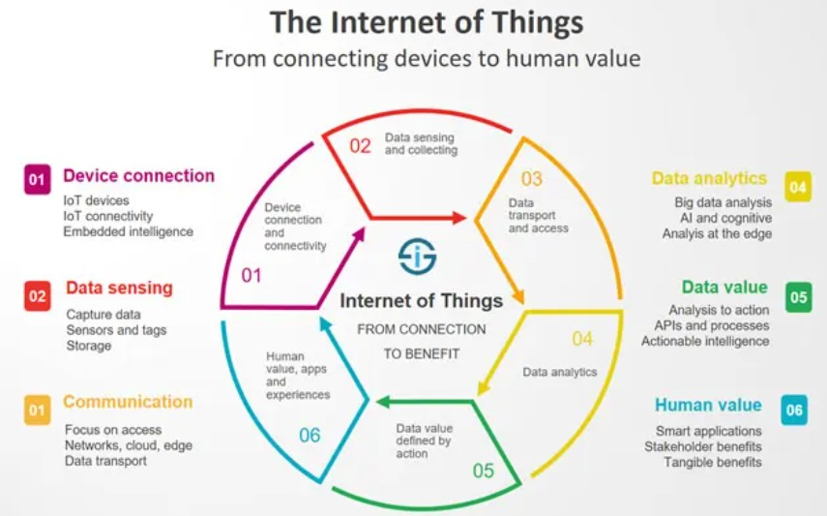

Figure 1.1: Internet of Things
(Source: Huh et al. 2017)

Telemetry data has been used here to pursue this study and the data has been collected with the help of physically located environmental sensors. Multiple environmental conditions using an environmental sensor network have been considered for generating data through IoT devices. However, the term Telemetry seems to be associated with telecommunication or a set of measurement data remotely through the diverse environment and returning that data to its corresponding location. Mediums such as optic fibre or radio band have been used by the measurement data to perform this task.
The research further discusses an application that tends to transmit data through an environmental sensor-network server for various remote devices. Multiple advanced techniques along with other instruments for implementing data have been used to develop data models that provide plans between specific events and the common response to those triggers. However, the primary concern of this research topic revolves around human interactions with its surrounding environment and its effects on sensor data. Moreover, data mining processes are applied to real-time sensor data for analysing its complexity and developing a system to denote human activities near IoT devices.
The chapter is divided into various parts that discuss different aspects of this research topic. The background of the research deals with previous researches that have been conducted upon human behaviour near IoT devices, whereas research aims, and objects forecast the reason for conducting the research. The entire procedure that has been segmented and discussed prepares the base for the next chapters of this study.

1.1 Background
A computing device that can be connected wirelessly to a network is termed an IoT device. An IoT device possesses the capability of transmitting data like other devices in IoT. However, being embedded with technology, IoT devices have the potential of communicating and interacting over the internet (Akyildiz et al. 2002). Along with the advancement of technology, the domain of IoT devices has gone through various transformations and modifications. However, various researches have conducted to analyse and evaluate human movement near IoT devices since their invention. As recorded by the past research, considering algorithms of data mining can be helpful for gathering more information about the entire research framework (Suciu et al. 2012). On the other hand, the consequences of human interaction within it encourage to imply a system to predict human movement. It has been further recorded that IoT data has regular imperative holes and defiled messages along with counterfeit readings that are required to be cleaned up before the occurrence of the assessment.

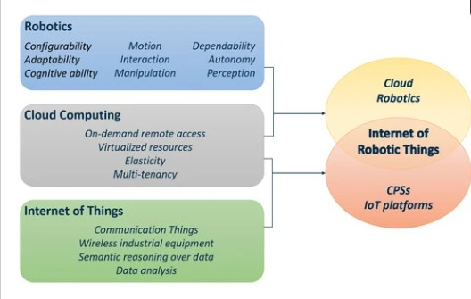

Figure 1.2: Cloud Computing
(Source: Wurm et al. 2016)
It has been identified by various researchers that five basic parts: Channels, Pipelines, Data stores, Data sets, and Notebooks seem to be responsible for developing IoT Analytics. These aspects help a researcher to be engaged with assembling, preparing, storing, examining, and imagining IoT data (Ding and Yekhanin, 2017). However, to expand its domain, IoT data required to be improved and changed regularly. It has been identified that to conduct an examination, IoT data requires to be channeled, changed, and upgraded by IoT analytics, though no progression is identified to understand the matter (Ochian et al. 2014). However, after ample research, researchers have determined the fact that data mining and learning algorithms can help to improve the efficiency of IoT.

1.3 Research Aim and Objective

1.3.1 Research Aim
The primary aim of this research study is to predict as well as identify, examine, and evaluate human movement near IoT devices. The research further aims to develop a system application with the help of machine learning algorithms as well as a python programming language for predicting human movement near IoT devices (De Sanctis et al. 2016). The research aims to establish the effectiveness of implementing data mining in IoT along with learning analytics, hence building a prototype for the system to maximize efficiency of IoT devices. However, the research discusses the aptness of diverse data science techniques accepted by users through the built system. It further denotes that it can be used to determine the prototype for the intelligent system (Bin et al. 2010). However, based on these aims, the researcher has developed research objectives as well as research questions to reaching research goals.

1.3.2 Research Objectives
In this study, Research Objectives have been formulated to predict as well as identify, examine, and evaluate the human movement near IoT devices. It would further assess the negative and positive impact of identified research factors and help to propose viable recommendations (Marczyk et al. 2005). Research objectives that have been framed from research aims are as follows:
      - To evaluate the prediction of human movement near IoT devices
      - To introduce a machine learning model that helps to predict human movement near IoT devices out of telemetric data
      - To assess the Environmental Sensor-based Telemetry Data
      - To pre-process the sensor-based data of various gadgets of different locations
      - To exercise various Data Mining procedures as well as imply those procedures to get an accurate prediction based on subset test data
      - To visualize all telemetry data associated with Matplotlib libraries
      - To perform Data Models as well as evaluate their outcomes
      - To identify the usefulness of data mining models for improving accuracy score.

1.4 Research Questions
The primary aim of this research study is to investigate human movement near IoT devices. Given research topic has been evaluated with the help of research questions as follows:

- What are the impacts of machine learning models on human movement near IoT devices?
- How does the system application along with the influence of human behaviour within it helps to develop a system for flagging human activity?
- What are the ways of human interaction with its surrounding environment and how would it influence the domain of sensor data?
- Can we consider human proximity as an anomaly? Or is it a regular occurrence?
- What are the consequences of various data mining algorithms on the entire research framework?

1.5 Ethical Considerations
The research study has considered various ethical aspects at its initial stage that are as follows:
- The examination engages reasonable data test,
- The research procedure ensures straightforwardness behind the varied range of data,
- Confirming straightforwardness in multiple reasons on the background of data variety,
- Confirming the data reference and ensuring that it only used for a prompt as well as a detailed explanation
- Mentioned focal points of all information that has been used for the project
- Ensuring the user data has been oriented in the correct territory
- All correspondence has been managed straightforwardness according to the examination.

1.6 Gaps of the research
As the research topic deals with unique aspects of technology and predicts human behaviour with a special reference to this topic, various gaps have been identified within the research framework. Firstly, the research cannot identify the intensity of human behaviour near IoT devices (Shadroo and Rahmani, 2018). On the other hand, as every person reacts differently to a given situation, the prediction cannot be accurate. Furthermore, the data mining procedures as well as the machine learning model that help to predict human movement near IoT devices out of telemetric data fail to perform accurately sometimes.

1.7 Significance of Research
The research deals with an exclusive research topic that describes the prediction of human behaviour near IoT devices. As opined by Chen et al. (2015), the use of IoT devices has increased since the last decade and researchers have observed that human beings behave in a particular way when near IoT devices (Sowe et al. 2014). However, in relation to research, it has been identified that the collected data can be of use in an academic context and can serve as a base for further research.

1.8 Data Acquisition
Data used in this research, has been collected from three-identical specially constructed, breadboard-based sensor clusters. It has been identified that each cluster developed a firm bonding with a Raspberry Pi gadget. However, all three IoT devices have been placed in areas with varied ecological conditions (Klösgen and Zytkow, 2002). The data set also contains a huge amount of telemetry data.

1.9 Structure of Research
Chapter 1 of the research deals with the introductory part of the research topic that describes the prediction of human behavior near IoT devices. Along with these, the chapter further discusses background information related to the operating process of current frameworks and how they are being used by systems (Witten and Frank, 2002). Another important aspect of this study seems to be associated with how third-party trust companies determine trust as well as interrogates whether there is any firm definition of trust or trust can have no logical definition at all.
The chapter has determined research aims and objectives as well as developed certain research questions to interrogate and evaluate the whole research scenario to recommend viable solutions (Khair et al. 2005). On the other hand, the segment mentions research gaps, research significance, as well as a data acquisition technique to offer a better insight into the research scenario
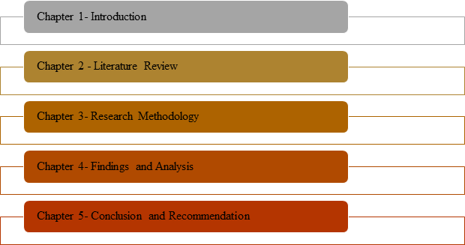

Figure 1.8: Structure of Study
(Source: Created by the Researcher)

Chapter 2 of the research deals with the literature review of the research and develops independent variables and dependent variables of the research topic. This chapter can be considered the most important chapter of the research as the entire research framework has been structured on the given topic (Sivanathan et al. 2020). It also deals with the research gaps that have been identified during the study as well as discusses various theories for accessing a deep analytical perspective related to human behaviour near IoT devices.
Chapter 3 constructs the research methodology and provides a detailed description of research methods that have been used for collecting data, processing it, analyzing as well as evaluating it to establish the research framework (Hart and Martinez, 2006). Moreover, it provides the sources of data collection and gives suitable justification for them.
Chapter 4 deals with the finding and analysis of collected data, whereas Chapter 5 deals with the complete discussion of the research and draws viable recommendations and conclusions.

1.10 Summary
According to the previous discussion, it can be concluded that Data Mining (DM) techniques are generally used in IoT analytics services recently. The use of IoT devices has increased since the last decade and researchers have observed that human beings behave in a particular way when near IoT devices (Cephus, 1992). However, the use of IoT devices produced a huge

amount of data that plays a predominant role in the advancement of the data mining industry. The introductory chapter deals with the prediction of human behaviour near IoT devices. Along with these, the chapter further discusses background information related to the operating process of current frameworks and how they are being used by systems (Armbruster et al. 2020). The chapter has determined research aims and objectives as well as developed certain research questions to interrogate and evaluate the whole research scenario to recommend viable solutions (Cheng et al. 2019). On the other hand, the segment mentions research gaps, research significance, as well as a data acquisition technique to offer a better insight into the research scenario.

Chapter 2: Literature Review

2. Literature Review

2.1 Analyzation of Environmental Sensory based Telemetry Data
Environmental sensors have been used to detect and resolve the issues of the environment that might be creating issues in the future. The study has been following the approach that has been associated with the electrical and mechanical description of the sensors that have been used. Sensors could detect the scanning and feeding behaviors as well as to find the predicted human movement out of telemetric data. The chapter has been playing an important role in the understanding of the sensors-based telemetry data and their behaviors that have been used to analyze the environmental effects. It has been seen that sensors and actuators have been described as the devices that have been used for the interaction of the physical environment. The processing and storage of the data that has been used in the sensors have been achieved with the help of a network in a remote server. The storage and processing capabilities have been decided by the availability of the sources for the devices. The challenging things of the research have been associated with getting the information in the right and correct manners. The communication of the IoT devices has been associated with the areas and geographical location of the devices and thesis communication is usually wireless.
Data mining is that process that has been used to extracting hidden information from the data that has been generated throughout the IoT. This generated has been useful for the generation of highly business and the algorithm has been IoT programming for the extraction of the data. The data mining algorithm has been also applied to find the logical pattern and evaluation of those logical patterns and discover logical knowledge. It has been seen that the functions of data mining have been including classification, association analysis, outlier analysis, discrimination, time series analysis, and characterization. There have been many applications of data mining that have been associated witty the Internet of things (IoT). Those applications are functionality analysis, intrusion detection, high education spatial data mining, telecommunication industry, retail industry, the energy industry, and the biological analysis of data. In addition to this, there has been also the application of data mining in the loan payment system and the analysis of the customer credit policy as well as data of the warehouses. It has been useful for the prediction of future trends and helps to identify the significance of customer habits. These have been used for the generation of the company revenue and effective for the decision-making process. Data mining has been proving the information baked-on the market analysis and that has been useful for the detention of the fraud event on the online platform. There have been four main types of data mining too have been used that have been useful for the IoT business process.
- Query and reporting tools
- Multi-dimensional analysis tool
- Intelligent agents
- Statistical tool
Query and reporting tools have been defined as the simple tools that have been used for the operation of data manipulation and look like the QBE and SQL. These kinds of data tools have been used in the warehouses for the generation of reports and queries. Intelligent agents have been tools that have been associated with the building business as well as information discovery in the OLAP. These have been used for the analyzing of the real-time based technical process associated with the Online analytical processing (OLAP) tools. Multi-dimensional analysis tool has been defined as the tools that has been using the techniques of a slice as well as dice and has been used to view the data in a multidimensional view. The statistical tools have been used for the analysis of the data that are based on the analysis of the statistical techniques. It has been observed that the algorithm of data mining has been playing an important role in the analytics of the internet of things (IoT). Data mining has been associated with the data of the sensors as well as the algorithm of machine learning has been effective for the improvement of IoT learning. It has been useful for the development of the performance of the learning model of the IoT system and has had an impact on the learning outcomes. These have been useful for the creation and implications of the tremendous sets of data values that have been used for the training and checking the development of intelligent machines. It has been seen that numerous learning techniques have been used for the introduction and classifications of the system and their implications. There has been a technique called the clustering techniques that has been used for the data mining techniques and has been effective. There have been basically four techniques that have been used for the data mining techniques and those have been playing an important role.
- Regression
- Classification
- Association Rule Discovery
- Clustering
The regression has been defined as the techniques that have been used for the analysis of the predictable values as well as the values of other featured based data. Regression techniques has been seen to be very fruit able in data science and has been associated with the important features. Regression has been appeared in all perspective of the field. It is seen that there are many has been very useful for all kind of business with positive output. The techniques of data mining have been effective for the business as well as for the organization development. These have been playing a most important part for the business as well as for the organization's productive implementation with the unique approach. The approach that has been used in the data mining has been also effective for the business as well as for the organization development.

2.2 Pre-Processing of the sensor data of various gadgets of different locations
The process of pre-processing is called to be one of operations which is mainly used for the restorations of the images as well as used for the rectification to be done and positively managed. The type of distortions which are there used in are called radiometric and geometric. It is seen that there are many quantitative types of an application which are used for the remote sensing of the data which are used for the conversion of the digital based remotes which make the representation of the actual reflectance. There is a simple process which is used in the gadgets to make the preprocessing to be done which is called as the geometric registration type of a process in which the involvement of the coordinates is there which are done and evaluated. The snores which are there used in the pre-processing are called to be the internal type of devices where the data which are there are mainly collected from the infernal devices.
According to author Ochian et al., (2014), data mining applications are highly useful in IoT analytics. Moreover, the concept and involvement of data mining in IoT help in engaging the IoT analytics to deal with a huge amount of sensor data. Since data mining deals with sensor data and machine-learning algorithms, this improves the performance of learning models in the system. This article discussed an application that delivers information to remote external devices through an environmental sensor data center. To complete this assignment, we employed central entity devices along with a few advanced strategies for establishing data models that are supposed to provide links between occurrences and the general response to all those triggers (Suciu and Poenaru, 2012). In this article, it has been examined at how humans communicate with actual surroundings and how that influences sensor information. As a consequence, data mining algorithms have been widely applied to resolve this issue, resulting in improved outcomes where AI data mining calculations are involved are authorized to understand visual data, permitting the executive's skills and bounds to be maintained throughout network activity, providing for efficient execution in actual conditions (De Sanctis and Araniti, 2016). To evaluate the complexities of sensor information and develop methods to track human behavior nearby IoT devices, data analysis learning methods are developed for real-time sensor information.
As per previous papers Learning techniques in data mining, as per previous works, requires more understanding about the structure and the impact of human intervention in it to develop the system to indicate human movement. According to Bin and Yuan (2010), IoT data contains numerous important gaps, taint messages, and fraudulent signals which must be cleared away before analysis can occur.
Streams, Transmission lines, Databases, Data Sources, and Notepads are all examples of data structures. These sections will then have you collecting, organizing, preserving, evaluating, and displaying your IoT data. To be significant, IoT data should be updated and changed on a routine basis. IoT Analytics might transmit, modify, and improve IoT data and store it for evaluation in a brief course of actions data. Environmental sensors have been used to identify and address environmental conditions that may create issues in the future.
The investigation was carried out using a technique that was linked with the mechanical and electrical characteristics of the sensors utilized. The segment has so far been important in getting a greater understanding of sensor-based telemetry and their characteristics, which have been employed to examine ecological impact. Sensors and actuators have been described as instruments that are being used to communicate with physical surroundings.
Even though past researchers attempted to address this matter in a couple of ways. There's been little advancement in identifying the situation and distinguishing the suggested approach from the help direct of Data Mining and Learning algorithms technologies to evaluate modelling that can assist enhance IoT effectiveness. The initiative's aim is to create a system algorithm that helps machine learning techniques as well as the Python programming language. This report concentrated on integrating data mining and digital tools within IoT devices, leading to the creation of a concept for an intelligent system to maximize the productivity of IoT devices.

2.3 Data Mining Techniques and its Implementation
The way of digging through the set of data to identify the hidden relationship and from that prediction of future trends of those data has decades long history. As opined by Shadroo and Rahmani (2018), the process of data mining has enabled the scope of data manipulation in modern computation in an effective way. In addition to that, data mining can be defined as the process of identifying the correlation, pattern, and anomalies in a huge data set to develop a possible outcome. On the other hand, data mining applications have an immense effect on the growth of any organization. As stated by Kumar et al. (2019), data mining techniques are an effective way to increase the business revenue, enhance customer relationships, and mitigate risk, and many others.
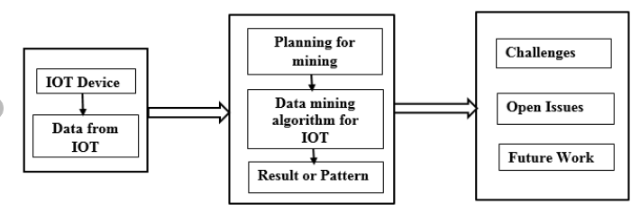

Figure 2.3: Data Mining with IoT
(Source: Researchgate.net, 2020)
Internet of Things (IoT) enables the scope to connect the daily usable devices in the internet connectivity. As opined by Wlodarczak et al. (2017), IoT enhances the process of generating and assessing a huge quantity of data that is necessary to be maintained in an organized way. Data mining is an important approach for the IoT system to make the system smart enough to give the desired services to the environment. The data mining process follows an iterative sequence like data cleaning, integration, selection, transformation, mining, pattern evaluation, and knowledge presentation. As opined by Zhou et al. (2019), IoT gathers the necessary data from various places and those data are transferred into serviceable information when it passes through the data mining process. In addition to that, all that information is transferred to knowledge that can be used by humans.

2. 4 Visualization of all telemetry data using Matplotlib libraries.
Data visualization is an effective part of any organization to gather a huge amount of data in modern days. Sensors used in IoT systems are collecting the environmental data, climate change-related data, and user data through clicks. As stated by Farhan et al. (2018), data visualization is an effective procedure to analyze and incorporate information and in addition to that, visualization helps to analyze different complex problems very easily. The study has observed that data visualization can be done in different packages using Python programming and one of these packages is Matplotlib libraries.
Matplotlib is a 2-dimensional plotting library that is focused on visualization and it enhances Matlab-like visualization and graphs. It has been identified that plotting in Matlab is an easy process as while plotting the step is the same for every plot. As stated by Muangprathub et al. (2019), in addition to that, Matplotlib has an important module named pyplot and jupiter is necessary to run the plots. Matplotlib provides a huge number of visualizations that are bar graph, box plot, histogram, scatter plot, and many others.

2.5 Implementing Data Models and evaluating the outcome.
Data modeling is an important tool for organizations for intensifying their application development and unlocking the data value. It has been identified that data modeling allows the visualization description of a business by understanding, analyzing, and clarifying the required data and how they control the business process. As opined by Gaber et al. (2019), data modeling has some important benefits that are why the implementation of proper data modeling techniques will enhance the outcome. In addition to that, data modeling mitigates complexity and the risk of data insecurity. Moreover, it has become a necessary data model that denotes a suitable diagram of the process that will enhance the full visibility of the data process. It can be identified that this enables the insight visualization of the data and it has been no longer observed that transformation, filers, metadata are scattered.
Data modeling gives a positive impact on the collaboration between the members and enhances the communication in a technologically neutral manner. In addition to that, it has been observed in this study that the right implementation of a data modeling strategy can enhance a complete control on defined data and metadata. Moreover, effective data modeling can enable the improvement in business processes. On the other hand, As stated by Oralhan et al. (2017), if it is not known how the activities of a business are performed it is impossible to properly define the data. In addition to that, if a business wants to develop a dataset for the customers it needs to know about the available data related to the customers. Moreover, the creation of the customer data set also requires the information about how the business is currently using the customers' available data. It has been necessary to implement proper data modeling techniques so that all the required data are well-manipulated.

2.6 Ideas on the usefulness of data mining models to improve accuracy score.
In the process of data manipulation, data mining is an effective way to manage data and evaluate the relationship among a huge number of available data. In addition to that, data mining techniques are used on the algorithm to develop the required manipulation of the raw data. As stated by Khedr et al. (2019), there are two important data mining techniques that are used in different cases and these are descriptive data mining techniques and predictive data mining techniques. In addition to those descriptive techniques are used to develop correlation, cross tabular, frequency, and all. On the other hand, predictive techniques are used to focus on futuristic outcomes instead of the present tendency of the data.
Different data mining models are also observed and some of them are Fraud Claiming Model, Response Model, Customer clone model, and many others. As opined by Marjani et al. (2017), it has been observed that response models enhance the identification of usage patterns by segregating the customer base and developing contacts with those customers. In this model of data mining organizations are focused to target a particular customer base that is effective for the organization to promote a particular product. In addition to that, the response model is used to incorporate the customer who preferred the products of the same characteristics that the company has promoted.

Chapter 3: Research Methodology

3.1 Introduction
Research methodology provides a detailed description of research methods that have been used for collecting data, processing it, analysing as well as evaluating it to establish the research framework. Moreover, it provides the sources of data collection and gives suitable justification for them (Ma et al. 2021). In this research, the successful development of an IoT system for real-time sensor data completely depends on a strategic outline. The strategy provides a firm definition of the data mining procedure along with the learning analytics services for the system framework (Manna et al. 2020). However, the research methodology includes various suitable modules including the significant factors of the system that mention protocols, analysis strategy, and others (Granata et al. 2017). On the other hand, the focal point of IoT analytics seems to be associated with Data Mining and Machine Learning (Mazhnik and Oganov, 2020). It helps to examine the algorithms and systems that explore the data, develop the model, pattern recognition, and give pieces of information.
As defined by various researchers, data mining can be termed as a computational procedure that exclusively deals with data in any given space that initiates to secure critical models and information (Pandey et al. 2019). The research particularly deals with data mining within an environmental sensor network as well as interactive communication and can be applied to data gathered from various sources. Moreover, it has been identified that these techniques tend to form an association with controlled learning (Popov et al. 2017). On the other hand, Machine Learning gives a particular reason for data mining that uses algorithms for predicting sensor data. The process uses various methods to deal with two issues: supervised and unsupervised learning such as classification, regression, and clustering (Heinrichs and Eickhoff, 2020).
The entire research has been developed based on a deductive approach to reach the final outcomes with a particular reference to the research objectives and research aims. The research coincides with a qualitative research approach where the resources are collected from different academic sources as well as over the internet. In addition to this, the research will also focus on the primary analysis since it will implement different models and theories from different sources. The research has been done based on grounded theories as any involvement of new theories has not been identified within the research framework. The overall research focuses on the development of the application system with the help of Python programming and machine learning techniques. There are several tasks and approaches that are required to be conducted to reach the desired outcomes.

3.2 Research Design
This is called to be one of the most important parts of the research where the overall strategy which is used in the research is mainly optimized (Sacha et al. 2018). Apart from that, it is also called to be a special type of process through which the establishment of the research question is mainly done through the process of the collection and the interpretation (Ibrahim and Abdulazeez 2021).

3.2 1 Descriptive
It is seen that the descriptive type of research is called to be one of the best methods and the significant type of method which is used in the research. It is called to be the process where the systematic implementation is done to give the description of the population and situation (Sharma et al. 2021). Apart from that, it is called to be one of the best and the significant method through which the wide variety of the research methods are there which can be used to make the investigation of the variables to be done and manipulated (Latif et al. 2019).

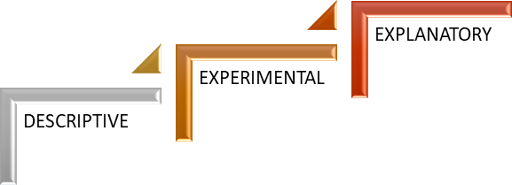

Figure 3.1.1: Research Design
(Source: Created by the Researcher)

3.2.2 Experimental
The experimental type of research design is called to be a task that helps to give the definition to be maintained of the task with the explanation of the variation in the task (Wei et al. 2018). It is called to be one of the special types of method which is used to make the management of the hypothesized reflection of the variation to be determined (Liu et al. 2017).

3.2.3 Explanatory
Explanatory research design is called to be one of the most important parts of h research. It is mainly used in research when the problems which are there are not investigated properly (Osisanwo et al. 2017). Apart from that, it is called to be a special type of research that is used to make the product to be done in the aspect of the study (Tseng et al. 2017). On other hand, it is especially done when there is unstructured data or there are no past records that have been there in the research. It is called to be a specific time when there is a use of this research design that is mainly used positively (Pan et al. 2019).
Justification
It can be seen from the research that the research which is mainly done in this research is in relation to IoT-based devices (Pehrson et al. 2019). Apart from that, data mining and the devices which are mainly used nowadays in the industry which the machine learning in Allahabad to be very important (Silva et al. 2021). Hence, it is seen that for each step experimental type of research which is also called to be a scientific method is used in the research.

3.3 Implementation Task
The primary task related to this research is associated with the use of Machine Learning to determine when a person is near an IoT device.
- As the labels of time stamps where people are near the IoT device are not available to the researcher, the research is limited to supervised methods.
- The research implants three different devices in three different areas, each of which performs for a week to record necessary data at a particular sampling interval of 5-10 seconds between measurements.
- As every person reacts differently to a given situation, it has been identified that their proximity to IoT devices differs from each other. However, it is important as the proximity of a person could affect the recorded parameters in various ways as follows:
- CO levels are strongly impacted by the presence of an individual. It has been identified that if they are breathing the air near the sensor, the CO of the system shows a tendency of sticking to their Hemoglobin permanently. Moreover, it effectively scrubs some of it from the atmosphere like a filter and leads to a detectable reduction in CO ppm.
- If a person is exhaling into the room, humidity might increase.

- If a person is occluding the light sensor, the light levels might drop. On the other hand, the light levels might be increased if a person turns on a light or opens a window/door.
- If a person breathes it in and thereby filters it from the local atmosphere, the LPG levels might drop.
- The movement of a human being near a sensor can create detectable motion, though it requires some information about other sources of motion or vibration to attribute it to a nearby person.
- The filtering effect of a person's lungs can reduce the smoke levels or increase it if a person lights up a cigarette in front of the smoke sensor.
- The ambient temperature might be increased by the presence of an individual near the temperature sensor for some time.

3.4 Approaches to Perform the Task
Primarily, the researcher plots the time frame with a meaningful and relevant time scale to conduct the research in a strategic way (Pospieszny et al. 2018). It can be stated, for example, that the researcher prefers time of day more as it increases the scope of recording accurate data as people are more likely to be nearby at that time (Silva et al. 2021). It helps the researcher to predict and record human behaviour near an IoT device
- At the next step, the researcher examines the gathered data and figures out if there are any regular pattern or not.
- Then a significant difference between the sensor time series between the three locations have been conducted.
However, after completing all these approaches, a conceptual model has been developed by the researcher to carry out a different implementation process. To pursue this, the model; follows a particular sequence as follows:

Gathering data: This step creates the objective dataset.

Data cleaning and pre-preparing: All gathered data cannot be relevant to this research topic, therefore requires a data-cleaning and pre-preparing process for further advancement of the research (Abdi, 2020). However, it can be stated that the pre-handling of information possesses the potential of improving the model precision and being dynamically strong. Then the information will be examined along with the help of certifiable and graphical techniques to isolate models and essential inclinations and tune the information to eliminate the best outcomes (Ray, 2019).

Data Transformation: measurement decreases along with highlight determination and extraction as well as quality change with a special reference to the discretization of the mathematical highlights has been conducted.

Choosing the Data Mining Techniques: To decide the Data Mining strategies and executing them to discover the best exactness of the forecast, considering a subset of test information (Ağbulut et al. 2021). The classification algorithm is used to tackle this problem in our dataset. Thus, an assessment of the impacts of multicollinearity on the presentation of the AI models is made (Real et al. 2020).

Interpretation and Evaluation: Evaluations of the calculations by utilizing the exactness grid and deciphering the removed examples with the help of visualization methods have been conducted.

Comparison: A comparison of models gives an opinion about the accuracy of models. However, Data models utilizing sensor-based information of more than one motion identifying readings to predict results (Almseidin et al. 2017). So, we will implement a graphical representation of data for quick comparison between all models.

3.5 Project Considerations
This research proposal has given a record of the system and the LR to help data mining in IoT. Additionally, this examination plans to propose an AI system that gives an expectation of human movement near IoT devices dependent on Environmental sensor information. To make the project to be considered there are some potential features are there which need to be implemented which are as follows:
    - Cost: There are smart IoT-based manufacturers and sellers, but it is seen that one of the best things which can be implemented within the technology is making use of less costly technology with the proper data mining process (Bui et al. 2020).
    - Features: One of the most important things which need to be used in programming is called the features (Chandran et al. 2021). It is seen that nowadays different types of functions are available with the technology which can be implemented properly to make the management of the system and the technologies for better work.
    - Network: To make IoT-based devices it is important to see the gateways and the router-based issues. It is said to be one of the major components which need to be implemented and used for the management of these devices (Deist et al. 2018).
    - User Interface: The type of interface is also called to be very important for example use of the LED-based buttons or the type of display that is used in the product.
    - Size: Finally, that is also called to be a very important type of feature called to be the size of the technology which is used.
Hence these are called to be some of the things which need to be potential things that need to
be followed for the maintenance of the IoT-based devices.

3. 6 Estimated Time Plan
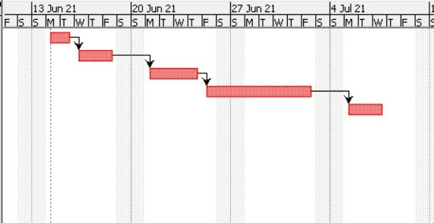

Figure 3.5: Gantt Chart

(Source: Created by the Author)

The above Figure shows the Gantt diagram showing the plan undertaken with various significant steps like Analysis, Design, Development, Testing, and Evaluation with proper subcategories of exercises (Deng et al. 2021). The achievements have been demonstrated through the Gantt graph for the "Task Proposal Submission" and " Dissertation Report Submission" events.

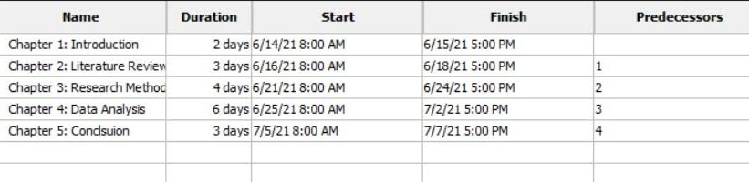

Figure 3.5.1: Project Timeline
(Source: Project Libre)

As shown in the project timeline, the introduction segment was done within 2 days, starting on 6/14/2021 at 8:00 AM sharp and ending on 6/15/2021 at 5:00 PM. The segment named Literature Review was done within 3 days, starting on 6/16/2021 at 8:00 AM sharp and ending on 6/18/2021 by 5:00 PM. The research methodology took 4 days to be completed, starting on 6/21/2021 at 8:00 AM sharp and ending on 6/24/2021 by 5:00 PM. The Finding and Analysis process took 6 days to be conducted, starting on 6/25/2021 at 8:00 AM sharp and ending on 7/2/2021 by 5:00 PM. The Discussion segment was done within 3 days, starting on 7/5/2021 at 8:00 AM sharp and ending on 7/7/2021 by 5:00 PM. However, by following the time structure closely, the entire research framework has been conducted to reach the outcome. Hence, it is called the total time that is consumed for the management of the entire research which is also called to be the total estimated plan taken to make this research to be properly completed.

3. 7 Conclusion
In conclusion, this research proposal has given a record of the system and the LR to help data mining in IoT. Additionally, this examination plans to propose an AI system that gives an expectation of human movement near IoT devices dependent on Environmental sensor information. There will be a few difficulties that would emerge, for example, getting reasonable datasets, which would take into consideration such cases, ensuring that the venture would not go to any ethical issues that were included. The past investigations have assisted with understanding the advantages of growing datasets in the number of courses, administrations, and overviews and to additionally investigate forefront procedures like idea examination and AI algorithms that can give more bits of knowledge. It can be also acknowledged from the study that it has shown the vital challenges to be faced in the process of the conventional process of data mining. It can be also concluded from the research that there is a use of the project management planning is also done to make the estimation of the time and the management of the work to be done with proper techniques and feasibility. It can be also concluded that the use of Internet devices around the world is continuously increasing to a great extent due to which machine learning has also increased.

Chapter 4: Data Analysis

4. Experimental Work

4.1 Python IDE
Python is a well-known IDE that is widely used by different programmers and other developers to ensure a successful model design. It has been seen that test developed models and associated application designs are often taken into critical consideration for any Python-related development projects. In addition to this, different implications of the developed ideas and their impact on the overall effect can be understood by visualizing different aspects of the operation. This IDE is especially beneficial for a project development process as it contains already developed analysis models and software ideas. These are crucial in conducting a critical evaluation of the complete study context and their implications on the process. In addition to this, different factors that are required to be taken into consideration are evaluated by selecting the digital language.
It has been observed that the implantation of Python and Python-related digital solutions are instrumental in terms of ensuring a relevant solution. A critical aspect of this process can be seen in the digital tools and technologies currently being used in global industries. In this specific task, a software application is being developed to detect human presence near IoT devices. This is being done using ML relation solutions and using other relevant data science ideas. One of the critical needs in this process has been observed to be the need for large data sets. To teach the machine or the developed software model regarding elements of the human presence, large information groups are required. This specific task has been solved by using Python and its related application. Spyder Notebook has been used as an IDE in this process to ensure the appropriate development of the research tools and applications present in the system. IN this project, different environmental elements had been used to evaluate the closeness of a human being to a certain IoT device. These factors are further analyzed using relevant technological solutions that can be used to acquire information. However, Python continues to be a critical part in this aspect due to its ability to train the model regarding the implication of the data. This is further considered to be a critical nature of the mentioned digital solution that is identified as a major factor in machine learning.

4.2 Data Summary
The data set that has been developed for this study can be considered relevant to the topic and able to provide critical information on the environmental factors. This is collected as a large data structure that is yet to be cleaned properly. In addition to this, different factors and ideas are seen to be influencing this assumption on the data and its relation to the selected topic. It is observed from the evaluation of the dataset that it contains information on different devices and their surrounding environmental factors.
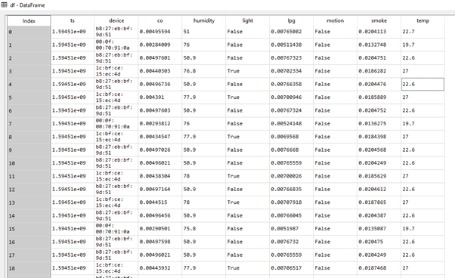

Figure 4.2.1: Dataset
(Source: Acquired from Spyder notebook)

However, it is yet to be determined whether this data has been collected for an actual situation related to IoT devices and human interactions. In addition to this, various factors related to this information accumulation can be indicative of an appropriate machine learning process. Additional changes have been made to the dataset to make it more applicable for this specific study. These changes include data cleaning and restructuring ideas that have been used to develop the dataset as per the requirements of the identified implication.
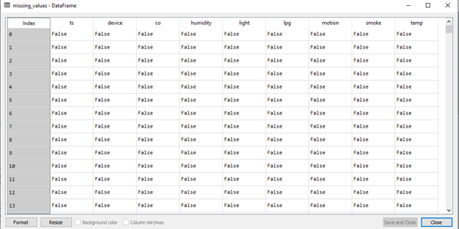

Figure 4.2.2: Missing values
(Source: Acquired from Spyder IDE)
Despite this, it has been seen that the dataset contains multiple missing values. This is critical implication that is regulated by using innovative data mining solutions. In addition to this, the information available on the dataset has been closely analyzed to identify any complications. The null value present in the dataset has been cleaned using python functions and related codes. This is a necessity in ensuring an appropriate outcome for the data analysis process and developing an appropriate application design. The critical nature of this application can be understood by using various data analysis tools and modules present in the IDE. This process is followed in this research to develop a data frame that can be easily analyzed in accordance with different analysis models. Further ideas related to the data evaluation and application of strategies can be identified in the initial stages of the research process. The data also contains timestamps to mark out information that can be used by the data to ensure an appropriate outcome.
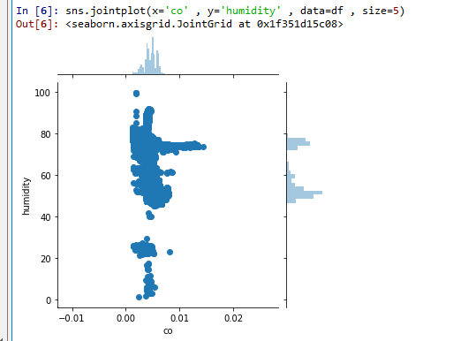

Figure 4.2.3: Visualization of data
(Source: Acquired from Spyder IDE)
In this process, the seaborn module in python has been used to visualize the datasets and their associated pieces of information. The selected data frame and its primary column have been analyzed by implementing this approach in the research study. This has been further used to ensure a relevant finding for the complete research process and associated study. For instance, the above figure depicts the data related to humidity in the data frame. This can be further used to acquire information on the nature of distribution for the mentioned dataset.
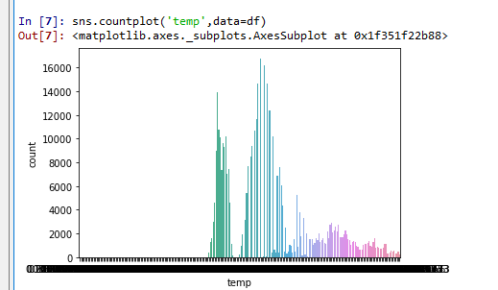

Figure 4.2.4: Visualization of data
(Source: Acquired from Spyder IDE)
In addition to this, different implications of the data frame can be understood by using valuation ideas, which can be seen above. This provides a detailed overview of the dataset and its implication on the chosen topic. Moreover, it enables the developer to be critically aware of any development areas that are required to be taken into consideration in the study. It is seen in the initial stages of the research process that a dataset has been selected to provide key pieces of information on the subject. In addition to this, various implications of the selected dataset are indicative of an appropriate design that can be used to ensure operational efficiency. The machine learning solution in this context has been used to analyze key information available in this selected dataset and its major variables. These factors and their implication on the data analysis idea can be considered as relevant in ensuring an appropriate outcome.
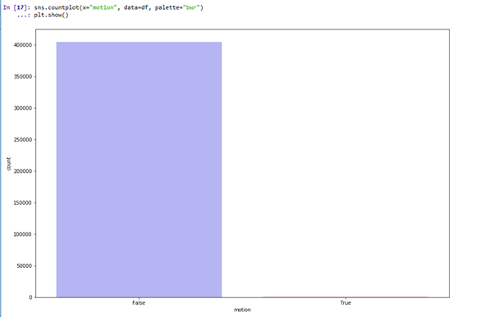

Figure 4.2.5: Visualization of data
(Source: Acquired from Spyder IDE)
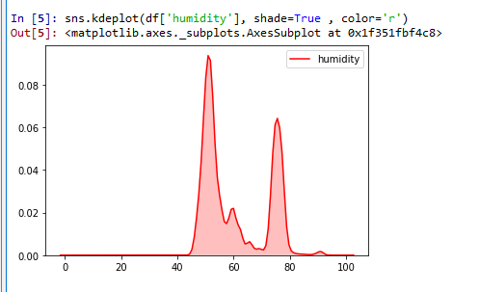

Figure 4.2.6: Visualization of data
(Source: Acquired from Spyder IDE)
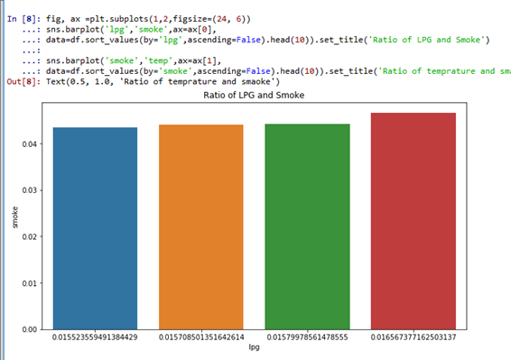

Figure 4.2.7: Visualization of data
(Source: Acquired from Spyder IDE)
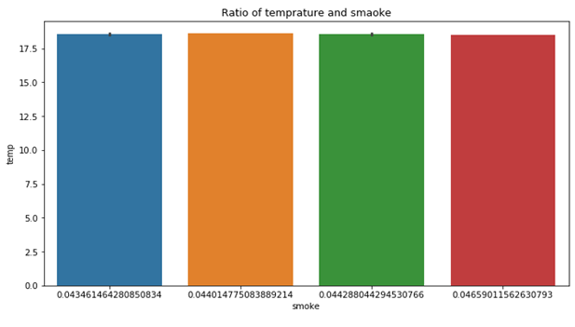

Figure 4.2.8: Visualization of data
(Source: Acquired from Spyder IDE)
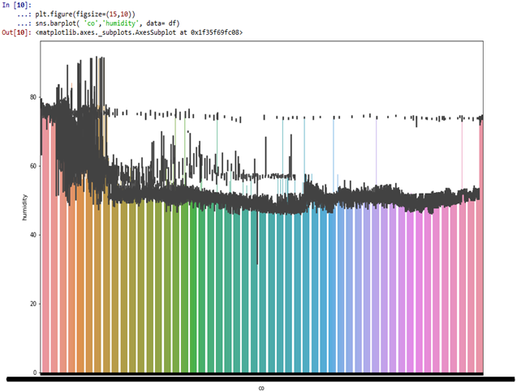

Figure 4.2.9: Visualization of data
(Source: Acquired from Spyder IDE)
It is seen in the initial stages of the research process that a dataset has been selected to provide key pieces of information on the subject. In addition to this, various implications of the selected dataset are indicative of an appropriate design that can be used to ensure operational efficiency. The machine learning solution in this context has been used to analyze key information available in this selected dataset and its major variables. These factors and their implication on the data analysis idea can be considered as relevant in ensuring an appropriate outcome. Another critical factor that is seen during the development of the machine learning model is the necessity of training the application. This implication is appropriately taken into consideration during the development of this research tool.
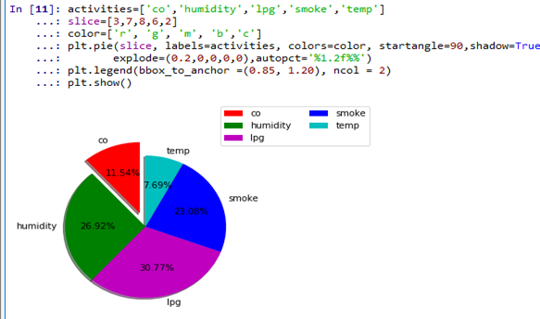

Figure 4.2.10: Visualization of data
(Source: Acquired from Spyder IDE)
Spyder IDE has been used as an IDE in this process to ensure the appropriate development of the research tools and applications present in the system. In this project, different environmental elements had been used to evaluate the closeness of a human being to a certain IoT device. These factors are further analyzed using relevant technological solutions that can be used to acquire information.

4.3 Using Machine Learning to Detect Movements
Machine learning tools are often used by different industrial areas to develop innovative solutions to model complications. A critical factor in this context has been seen in the sudden rise in the popularity of IoT tools and technologies. In addition to this, different ideas related to operational procedures and efficiency can be ensured by using related analysis and development ideas. It can be speculated that implementation of the said tools and ideas has been critical in terms of providing an idea about the technologies to be implemented during machine learning. Additional changes in the operational contexts can be observed in this process, which is speculated to be instrumental to the complete development process.
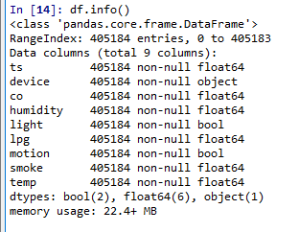

Figure 4.3.1: Data frame being used for machine learning
(Source: Acquired from Spyder IDE)
In this specific study, machine learning and its associated tools and solution approaches have been used to detect movement near IoT devices. This is done to provide a sense of intelligence to the IoT device currently being used by the global population. It has been seen that implication of the developed model and its impact on operational efficiency can be easily understood by using various analysis ideas. In addition to this, the critical nature of the business operation and efficiency can be used to ensure a relevant result for most of the related research areas.
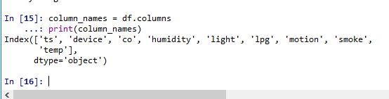

Figure 4.3.2: Data frame columns
(Source: Acquired from Spyder IDE)
It is seen in the initial stages of the research process that a dataset has been selected to provide key pieces of information on the subject. In addition to this, various implications of the selected dataset are indicative of an appropriate design that can be used to ensure operational efficiency. The machine learning solution in this context has been used to analyze key information available in this selected dataset and its major variables. These factors and their implication on the data analysis idea can be considered as relevant in ensuring an appropriate outcome. Another critical factor that is seen during the development of the machine learning model is the necessity of training the application. This implication is appropriately taken into consideration during the development of this research tool. Another critical concern that has been successfully averted in this machine learning process is the accuracy of the generated results. It has been observed that the developed machine learning model analyzes different information and data sources to identify critical factors related to the study. In addition to this, the extent of the impact of each of these variables on the research process itself cannot be understood without completing the research. Henceforth, the machine learning program developed for this specific study has been designed to consider different critical factors that may affect the efficiency of the designed module.
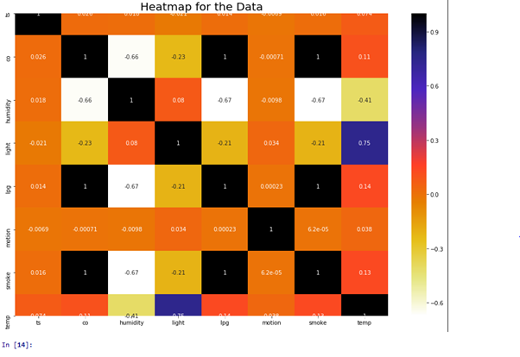

Figure 4.3.3: Data frame heatmap
(Source: Acquired from Spyder IDE)
In addition to this, the critical nature of this developed model is further indicative of an appropriate data analysis technique that has been used in the machine learning application. This is being done using ML relation solutions and using other relevant data science ideas. One of the critical needs in this process has been observed to be the need for large data sets. To teach the machine or the developed software model regarding elements of the human presence, large information groups are required. This specific task has been solved by using Python and its related application. This is a necessity in ensuring an appropriate outcome for the data analysis process and developing an appropriate application design. Spyder IDE has been used as an IDE in this process to ensure the appropriate development of the research tools and applications present in the system. In this project, different environmental elements had been used to evaluate the closeness of a human being to a certain IoT device. The critical nature of this application can be understood by using various data analysis tools and modules present in the IDE. This process is followed in this research to develop a data frame that can be easily analyzed in accordance with different analysis models.

4.4 ML techniques to tackle the problems identifying human movements in IoT data.
The implication of the selected research ideas has been critical in terms of its actual implementation process. It is seen in the initial stage of the implication that critical aspects of the identified factor can be regulated to determine human presence. However, the relevance of these models and their actual application has been a major issue for the data science industry. Henceforth, the selection of this subject can be considered crucial for the research process to ensure an appropriate answer to the present issue. This is an instrumental step in developing artificial intelligence that can be improved by human and device interactions. Despite this, the critical nature of the identified issues can be considered as a relevant step towards ensuring an appropriate outcome. These issues and challenges identified in the project have been discussed in the following parts.

4.4.1 Classification method to predict human movement using IoT sensor data
One of the critical factors that are required to be taken into consideration for the development process is the usage of appropriate classifiers. It has been observed that the implantation of classifiers and Python-related digital solutions are instrumental in terms of ensuring a relevant solution. This is being done using ML relation solutions and using other relevant data science ideas. One of the critical needs in this process has been observed to be the need for large data sets. To teach the machine or the developed software model regarding elements of the human presence, large information groups are required. This specific task has been solved by using Python and its related application.
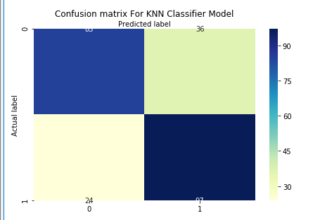

Figure 4.4.1: Confusion matrix for KNN classifier
(Source: Acquired from Spyder IDE)
A critical aspect of this process can be seen in the digital tools and technologies currently being used in global industries. In this specific task, a software application is being developed to detect human presence near IoT devices. Spyder IDE has been used as an IDE in this process to ensure the appropriate development of the research tools and applications present in the system. In this project, different environmental elements had been used to evaluate the closeness of a human being to a certain IoT device. These factors are further analyzed using relevant technological solutions that can be used to acquire information.
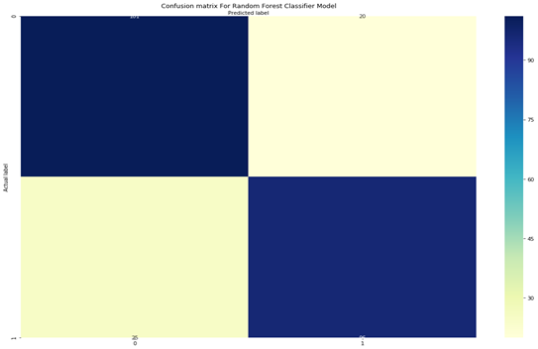

Figure 4.4.2: Confusion matrix for Random Forest classifier
(Source: Acquired from Spyder IDE)
It is seen in the initial stages of the research process that a dataset has been selected to provide key pieces of information on the subject. In addition to this, various implications of the selected dataset are indicative of an appropriate design that can be used to ensure operational efficiency. The machine learning solution in this context has been used to analyze key information available in this selected dataset and its major variables.
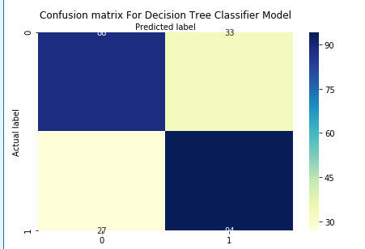

Figure 4.4.3: Confusion matrix for Decision tree classifier
(Source: Acquired from Spyder IDE)
These factors and their implication on the data analysis idea can be considered as relevant in ensuring an appropriate outcome. Another critical factor that is seen during the development of the machine learning model is the necessity of training the application. This implication is appropriately taken into consideration during the development of this research tool.
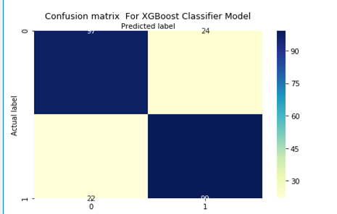

Figure 4.4.4: Confusion matrix for XG Boost classifier
(Source: Acquired from Spyder IDE)
Another critical concern that has been successfully averted in this machine learning process is the accuracy of the generated results. It has been observed that the developed machine learning model analyzes different information and data sources to identify critical factors related to the study.
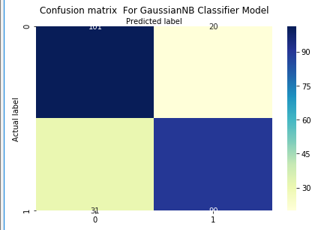

Figure 4.4.5: Confusion matrix for Gaussian NB classifier
(Source: Acquired from Spyder IDE)
These factors are further analyzed using different classifiers and other related tools and technologies related to the operation. In this research process, multiple types of classifiers have been used to ensure relevant findings. In addition to this, the classifiers have been designed using python and its existing modules. This can be crucial in terms of acquiring results that are relevant to the topic and maintaining an effective machine learning model.
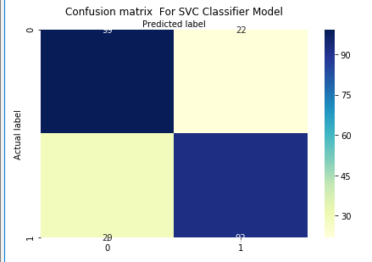

Figure 4.4.6: Confusion matrix for SVC classifier
(Source: Acquired from Spyder IDE)
The classifiers that have been used in this research can be considered as relevant to the topic and able to provide an in-depth idea about the selected context. It is seen from this process that different aspects of the selected dataset can be understood by developing appropriate classifier algorithms. This implication of the machine learning solution has been crucial to the study.
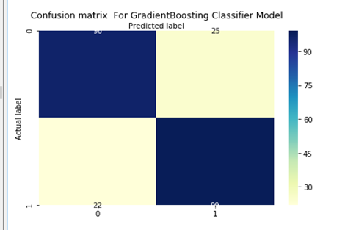

Figure 4.4.7: Confusion matrix for Gradient Boosting classifier
(Source: Acquired from Spyder IDE)
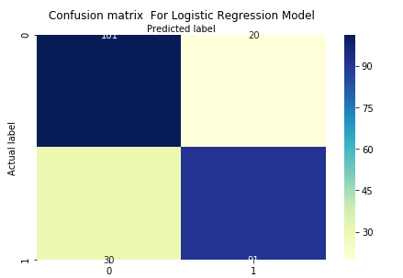

Figure 4.4.8: Confusion matrix for logistic regression classifier
(Source: Acquired from Spyder IDE)
The confusion matrices have been developed in accordance with the classifier algorithms for this study. These algorithms have been developed as per the requirement of the identified solution and as per the implication of the study. It can be speculated that the implementation of these ideas has been crucial for ensuring an appropriate outcome for the study analysis process. These have been discussed further in the following sections of the project.

4.4.2 Implementation of Classification Algorithms.
The classifiers algorithm has been used specifically for certain machine learning areas. These areas have been identified based on their relation to the topic and in accordance with the overall effect. The factors and variables present in this process can be considered as relevant to the topic and in relation to the identified research area. It is seen in the initial stage of the implication that critical aspects of the identified factor can be regulated to determine human presence. However, the relevance of these models and their actual application has been a major issue for the data science industry. Henceforth, the selection of this subject can be considered crucial for the research process to ensure an appropriate answer to the present issue. This is an instrumental step in developing artificial intelligence that can be improved by human and device interactions. Despite this, the critical nature of the identified issues can be considered as a relevant step towards ensuring an appropriate outcome. These issues and challenges identified in the project have been discussed in the following parts. A comparison between the models and their accuracy can further indicate the differences between the implemented classifier algorithms.
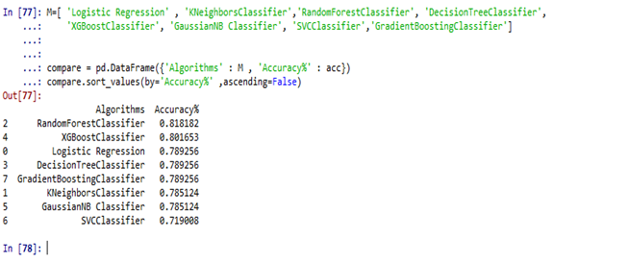

Figure 4.4.9: Classifier accuracy for different models
(Source: Acquired from Spyder IDE)
As it can be seen from the above figure, a Random Forest classifier has been identified as the most accurate data analysis tool for the mentioned process. This is further used to develop ideas related to the operational procedure and machine learning solutions related to the study. These factors and their implication on the data analysis idea can be considered as relevant in ensuring an appropriate outcome. Another critical factor that is seen during the development of the machine learning model is the necessity of training the application. This implication is appropriately taken into consideration during the development of this research tool.
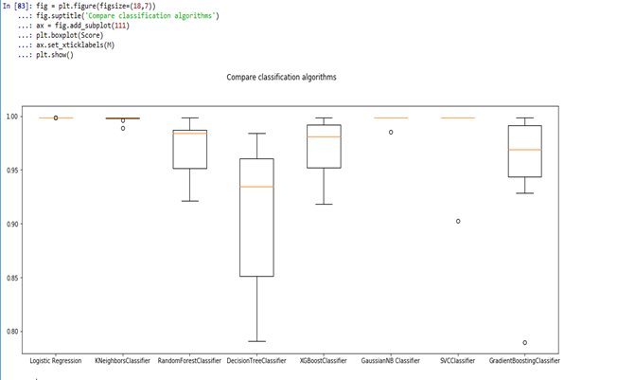
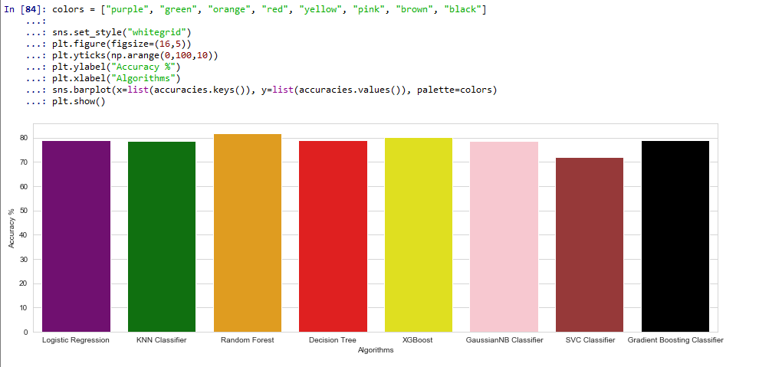

Figure 4.4.10: Classifier algorithm comparison for different models
(Source: Acquired from Spyder IDE)
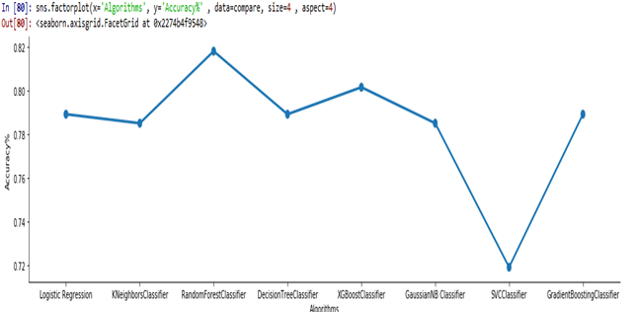

Figure 4.4.11: Classifier algorithm comparison for different models
(Source: Acquired from Spyder IDE)
One of the critical factors that are required to be taken into consideration for the development process is the usage of appropriate classifiers and related hyperparameters. It has been observed that the implantation of classifiers and Python-related digital solutions are instrumental in terms of ensuring a relevant solution. This is being done using ML relation solutions and using other relevant data science ideas.

4.4.3 Model Tuning-hyperparameters
It has been observed from the machine learning model that the random forest classifier had the highest accuracy amongst all the mentioned models. This is contributed to the different hyperparameters that have been set in the classifier algorithm itself. Moreover, it was seen that implementation of this process has been critical in ensuring a relevant result for the tools and application currently in use by the movement detection programming. In addition to this, modules such as params have been used in this process to ensure an improved result for most of the classifier models. The implication of this tool can further be seen in the ideas related to implementation and modelling the machine learning process. It is seen in the initial stage of the implication that critical aspects of the identified factor can be regulated to determine human presence. However, the relevance of these models and their actual application has been a major issue for the data science industry. Henceforth, the selection of this subject can be considered crucial for the research process to ensure an appropriate answer to the present issue. This is an instrumental step in developing artificial intelligence that can be improved by human and device interactions. The results of this study also indicate this to be a reality as the implementation of the hyperparameters has been seen to improve the overall accuracy of the calcification models.

Chapter 5: Conclusion

5.1 Summary of Research Findings
The research has been useful for the data mining process and has been effective for the environmental effects and becomes the data and the research has been effective for the business perspective and has been proving the all details of the data mining and their possession of the development. The process has been given an effective approach for the business as well as their associated patterns and has been dealing with the all-necessary fundamental deals.

5.2 Importance of Study
Machine learning model has been given an impact on the fairness and interpretability which is the critical analysis for the data scientist. They have been playing an important role for the developer and researcher for the understanding behaviors of the machine learning model. These have been used in daily life and have been performed basically on manual mode and the machine learning makes them to be automatics. These have been playing a major role for the video transcript and have been useful for the business as well as their organization development. The technology of machine learning has been useful for the chunk type of data accumulation and has been important for the business as well as organization development.

5.3 Realization of the Objectives
Connect with Objective 1: To analyze the Environmental Sensor-based Telemetry Data
The objective has been covered to the literature review and data analysis part of the dissertation. This study utilized telemetry information got by the genuinely found environmental sensor. The information is produced through IoT gadgets from different ecological conditions utilizing a natural sensor process. Telemetry associated to the term (media transmission) an analysis of estimation information distantly through the diverse climate and returns that information to the comparing area. The estimation information utilized a vehicle medium like optic fiber and radio band to perform each of the associative tasks.
Connect with Objective 2: To pre-processing the sensor data of various gadgets of different locations
This study has depicted an application that communicates information through a natural sensor-network worker for various distant gadgets. For execute the process, we utilized instruments for carrying out information and few progressed methods for building information models which are apparently going to give plans between explicit occasions and the regular reaction to those triggers. In this paper, it will be portrayed how people collaborate with the climate and how might this influence the sensor information. Hence, Data mining methods have been enough used to address moreover, improved reactions for this issue where AI estimations of information mining are allowed to fathom sensor-information so the leader's abilities and limits will be revived all through network action to recognize ideal execution in genuine conditions. Information mining learning strategies are applied to continuous sensor information to examine the intricacy of sensor information, and to fabricate a framework to hail human action close to IoT gadgets.
Connect with Objective 3: To study the Data Mining techniques and implementing them to find the best accuracy of the prediction based on a subset of test data
As per the literature review analysis, machine learning algorithm of data mining need more data about the structure and the impact of human collaboration inside it, to carry out a framework to flag human development. IoT information routinely has basic openings, contaminated messages, and fake readings that need to be tidied up before implementation will happen. These IOT bits draw in you to collect, plan, store, look at, and envision your IoT data. IoT information should routinely be improved and changed to be immense. IoT Analytics can channel, change, and update IoT information prior to dealing with it in a period course of the activity information store for assessment. There is no movement is made to comprehend the difficulties and to perceive the suggested philosophy from the application spaces of Data Mining and Learning calculations frameworks to examine models that can assist with improving the productivity of IoT.

Connect with Objective 4: To visualization of all telemetry data using Matplotlib libraries
The visualization process is utilized information which is acquired by three-indistinguishable uniquely developed, breadboard-based sensor bunch. Each group was related with a Raspberry Pi device (towardsdatascience.com). The entirety of the three IoT gadgets was set in real region with various natural conditions. Telemetry information comprises 405,184 lines and nine sections in the dataset. Figure1 shows detail information about IoT gadgets and their ecological condition. Each IoT contraption accumulated an amount of seven readings from the four sensors on a typical range. Sensor readings join temperature, carbon monoxide (CO), moistness, fluid oil gas (LPG), smoke, light, and development (Kaggle.com). The information crosses the time from 13/04/2021 00:00:00 UTC – 20/04/2021 23:59:59 UTC. There is a measure of 405,184 lines of information. The sensor readings, nearby a novel gadget ID and timestamp, were flowed as a solitary message, utilizing the ISO standard Message Queuing Telemetry Transport (MQTT) network show. The following is an outline of a MQTT message payload.
Connect with Objective 5: To Implemented Data Models and evaluate the outcome
Throughout the research it has been found that the initiative's main objective is to create a software platform that provides machine learning techniques and the Python programming language. This research concentrates on implementing data analysis and digital tools into IoT devices, resulting in the formation of a concept for an integrated process to increase efficiency of IoT devices. Various data scientific methods will be analyzed to determine the concept for the optimization technique such that the customer may also be recognized through the designed application. The study proposal has outlined the following objectives that help to achieve the goals based on the goals. The proposed research has developed a framework and LR database to facilitate data collection in IoT. Furthermore, focusing on ecological sensor data, this research hopes to give an AI system that forecasts human behavior around IoT devices. There'll be a few obstacles; including such having sufficient datasets which are taken into consideration such instances & guaranteeing that now the venture does not involve any ethical concerns.
Connect with Objective 6: Usefulness of data mining models to improve accuracy score
It has been found that the telematics information gathered by the geographically situated atmospheric detector was included in this analysis. Data is collected from different environmental factors employing IoT devices and an environmental sensor network (Akyildiz and Cayirci, 2002). Telemetry is a word that refers to the monitoring of measurement data remotely via changing contexts and transmitting that information to the right spot (Ochian et al., 2014). To accomplish this task, the data collection utilized a transit media including fiber optics and a wireless band (Fratu, 2012).

5.4 Recommendations
Based on the above analysis, it can be concluded that if this project is used the Raspberry Pie, then it would take less time to obtain the result. Each Raspberry Pi is enlisted with IoT center which, licenses customers to interface with gadgets quickly and securely (towarsdatascience.com). Moreover, IoT center gives a gadget door, which manages all unique gadget affiliations and supports MQTT associations. In addition, IoT investigation utilize a pipeline to move the MQTT payload message through a movement of pipeline exercises and a while later stores the resulting message in the Data store. Moreover, IoT Analytics Data store stores masterminded information from an IoT investigation pipeline, in a totally supervised informational index (towardsdatascience.com). Thus, an IoT analytics informational collection customarily gives common, remarkable pieces of data for information experts by investigating a Data store utilizing standard SQL. There is a sum of nine segments in the dataset which dependent on telemetry information created from arrangement of IoT gadgets.

5.5 Future Scope Study
The future scope of the proposition is to take the value as zero for making a framework application utilizing AI calculations and python programming language. This research work centers around executing information mining in IoT and learning investigation, consequently fostering a model for the astute framework to improve the proficiency of IoT gadgets In discovering the model for the framework, diverse information science methods will be utilized with the goal that the client can be acknowledged through the fabricated framework. In view of the points, the examination proposition will cover the key destinations that assistance to arrive at the objectives.

Reference
Abdi, A.M., 2020. Land cover and land use classification performance of machine learning algorithms in a boreal landscape using Sentinel-2 data. GIScience & Remote Sensing, 57(1), pp.1-20.
Ağbulut, Ü., Gürel, A.E. and Biçen, Y., 2021. Prediction of daily global solar radiation using different machine learning algorithms: Evaluation and comparison. Renewable and Sustainable Energy Reviews, 135, p.110114.
Akyildiz, I.F., Su, W., Sankarasubramaniam, Y. and Cayirci, E., 2002. A survey on sensor networks. IEEE Communications magazine, 40(8), pp.102-114.
Akyildiz, I.F., Su, W., Sankarasubramaniam, Y. and Cayirci, E., 2002. A survey on sensor networks. IEEE Communications magazine, 40(8), pp.102-114.
Almseidin, M., Alzubi, M., Kovacs, S. and Alkasassbeh, M., 2017, September. Evaluation of machine learning algorithms for intrusion detection system. In 2017 IEEE 15th International Symposium on Intelligent Systems and Informatics (SISY) (pp. 000277-000282). IEEE.
Armbruster, M., Dulla, C.G. and Diamond, J.S., 2020. Effects of fluorescent glutamate indicators on neurotransmitter diffusion and uptake. Elife, 9, p.e54441.
Bin, S., Yuan, L. and Xiaoyi, W., 2010, April. Research on data mining models for the internet of things. In 2010 International Conference on Image Analysis and Signal Processing (pp. 127-132). IEEE.
Bin, S., Yuan, L. and Xiaoyi, W., 2010, April. Research on data mining models for the internet of things. In 2010 International Conference on Image Analysis and Signal Processing (pp. 127-132). IEEE.
Bui, D.T., Khosravi, K., Tiefenbacher, J., Nguyen, H. and Kazakis, N., 2020. Improving prediction of water quality indices using novel hybrid machine-learning algorithms. Science of The Total Environment, 721, p.137612.
Cephus, J.L., Robotic Guard Systems Inc, 1992. Environmental sensor data acquisition system. U.S. Patent 5,132,
Cephus, J.L., Robotic Guard Systems Inc, 1992. Environmental sensor data acquisition system. U.S. Patent 5,132,
Chandran, V., K Patil, C., Karthick, A., Ganeshaperumal, D., Rahim, R. and Ghosh, A., 2021. State of charge estimation of lithium-ion battery for electric vehicles using machine learning algorithms. World Electric Vehicle Journal, 12(1), p.38.
Chen, F., Deng, P., Wan, J., Zhang, D., Vasilakos, A.V. and Rong, X., 2015. Data mining for the internet of things: literature review and challenges. International Journal of Distributed Sensor Networks, 11(8), p.431047.
Chen, F., Deng, P., Wan, J., Zhang, D., Vasilakos, A.V. and Rong, X., 2015. Data mining for the internet of things: literature review and challenges. International Journal of Distributed Sensor Networks, 11(8), p.431047.
Cheng, L., Kovachki, N.B., Welborn, M. and Miller III, T.F., 2019. Regression clustering for improved accuracy and training costs with molecular-orbital-based machine learning. Journal of chemical theory and computation, 15(12), pp.6668-6677.
Chi, Z., Li, Y., Sun, H., Yao, Y., Lu, Z. and Zhu, T., 2016, November. B2w2: N-way concurrent communication for iot devices. In Proceedings of the 14th ACM Conference on Embedded Network Sensor Systems CD-ROM (pp. 245-258).
Conference on Cloud Computing, Data Science & Engineering (Confluence) (pp. 1019-1022). IEEE.
Csce.ucmss.com, 2020. Implementing Data Mining Methods to Predict Diamond Prices, Available at: https://csce.ucmss.com/cr/books/2018/LFS/CSREA2018/ICD8070.pdf [Accessed on: 5/6/2021]
De Sanctis, M., Bisio, I. and Araniti, G., 2016. Data mining algorithms for communication networks control: concepts, survey, and guidelines. IEEE Network, 30(1), pp.24-29.
De Sanctis, M., Bisio, I. and Araniti, G., 2016. Data mining algorithms for communication networks control: concepts, survey, and guidelines. IEEE Network, 30(1), pp.24-29.
Deist, T.M., Dankers, F.J., Valdes, G., Wijsman, R., Hsu, I.C., Oberije, C., Lustberg, T., van Soest, J., Hoebers, F., Jochems, A. and El Naqa, I., 2018. Machine learning algorithms for outcome prediction in (chemo) radiotherapy: An empirical comparison of classifiers. Medical physics, 45(7), pp.3449-3459.
Deng, F., Huang, J., Yuan, X., Cheng, C. and Zhang, L., 2021. Performance and efficiency of machine learning algorithms for analyzing rectangular biomedical data. Laboratory Investigation, 101(4), pp.430-441.
Dimensionless.in, 2020. Data Science and Data Mining, Available at: https://dimensionless.in/what-is-the-difference-between-data-science-data-mining-and-machine-learning/ [Accessed on: 5/6/2021]
Ding, B., , J. and Yekhanin, S., 2017. Collecting telemetry data privately. arXiv preprint arXiv:1712.01524.
Ding, B., , J. and Yekhanin, S., 2017. Collecting telemetry data privately. arXiv preprint arXiv:1712.01524.
Farhan, M., Jabbar, S., Aslam, M., Ahmad, A., Iqbal, M.M., Khan, M. and Maria, M.E.A., 2018. A real-time data mining approach for interaction analytics assessment: IoT based student interaction framework. International Journal of Parallel Programming, 46(5), pp.886-903.
Fivestepguide.com, 2020. 100% ML: Diamond price prediction using machine learning, python, SVM, KNN, Neural networks, Available at: https://fivestepguide.com/technology/machine-learning/diamond-price-prediction-using-machine-learning/ [Accessed on: 5/6/2021]
Gaber, M.M., Aneiba, A., Basurra, S., Batty, O., Elmisery, A.M., Kovalchuk, Y. and Rehman, M.H.U., 2019. Internet of Things and data mining: From applications to techniques and systems. Wiley Interdisciplinary Reviews: Data Mining and Knowledge Discovery, 9(3), p.e1292.
Getting Started with IoT Analytics (2020). Available through: https://towardsdatascience.com/getting-started-with-iot-analytics-on-aws [Accessed 15 July 2020].
Granata, F., Papirio, S., Esposito, G., Gargano, R. and De Marinis, G., 2017. Machine learning algorithms for the forecasting of wastewater quality indicators. Water, 9(2), p.105.
Hart, J.K. and Martinez, K., 2006. Environmental sensor networks: A revolution in the earth system science? Earth-Science Reviews, 78(3-4), pp.177-191.
Hart, J.K. and Martinez, K., 2006. Environmental sensor networks: A revolution in the earth system science? Earth-Science Reviews, 78(3-4), pp.177-191.
Heinrichs, B. and Eickhoff, S.B., 2020. Your evidence? Machine learning algorithms for medical diagnosis and prediction. Human brain mapping, 41(6), pp.1435-1444.
Huh, S., Cho, S. and Kim, S., 2017, February. Managing IoT devices using blockchain platform. In 2017 19th international conference on advanced communication technology (ICACT) (pp. 464-467). IEEE.
Ibrahim, I. and Abdulazeez, A., 2021. The Role of Machine Learning Algorithms for Diagnosing Diseases. Journal of Applied Science and Technology Trends, 2(01), pp.10-19.
Khair, M., Lopez, S., Ng, R., Ghaem, S. and Olson, W.L., Motorola Solutions Inc, 2005. Wireless system protocol for telemetry monitoring. U.S. Patent 6,897,788.
Khedr, A.M., Osamy, W., Salim, A., and Salem, A.A., 2019. Privacy preserving data mining approach for IoT based WSN in smart city. International Journal of Advanced Computer Science and Applications, 10(8), pp.555-563.
Klösgen, W. and Zytkow, J.M. eds., 2002. Handbook of data mining and knowledge discovery. Oxford University Press, Inc.
Kumar, R., Zhang, X., Khan, R.U. and Sharif, A., 2019. Research on data mining of permission-induced risk for android IoT devices. Applied Sciences, 9(2), p.277.
Latif, J., Xiao, C., Imran, A. and Tu, S., 2019, January. Medical imaging using machine learning and deep learning algorithms: a review. In 2019 2nd International Conference on Computing, Mathematics and Engineering Technologies (iCoMET) (pp. 1-5). IEEE.
Liu, Y., Bi, J.W. and Fan, Z.P., 2017. Multi-class sentiment classification: The experimental comparisons of feature selection and machine learning algorithms. Expert Systems with Applications, 80, pp.323-339.
Ma, J., Fong, S.H., Luo, Y., Bakkenist, C.J., Shen, J.P., Mourragui, S., Wessels, L.F., Hafner, M., Sharan, R., Peng, J. and Ideker, T., 2021. Few-shot learning creates predictive models of drug response that translate from high-throughput screens to individual patients. Nature Cancer, 2(2), pp.233-244.
Manna, S., Wruble, J., Maron, S.Z., Toussie, D., Voutsinas, N., Finkelstein, M., Cedillo, M.A., Diamond, J., Eber, C., Jacobi, A. and Chung, M., 2020. COVID-19: a multimodality review of radiologic techniques, clinical utility, and imaging features. Radiology: Cardiothoracic Imaging, 2(3), p.e200210.
Marczyk, G., DeMatteo, D. and Festinger, D., 2005. Essentials of research design and methodology. John wiley & sons, Inc.
Marczyk, G., DeMatteo, D. and Festinger, D., 2005. Essentials of research design and methodology. John wiley & sons, Inc.
Marjani, M., Nasaruddin, F., Gani, A., Karim, A., Hashem, I.A.T., Siddiqa, A. and Yaqoob, I., 2017. Big IoT data analytics: architecture, opportunities, and open research challenges. ieee access, 5, pp.5247-5261.
Martinez, B., Monton, M., Vilajosana, I. and Prades, J.D., 2015. The power of models: Modeling power consumption for IoT devices. IEEE Sensors Journal, 15(10), pp.5777-5789.
Mazhnik, E. and Oganov, A.R., 2020. Application of machine learning methods for predicting new superhard materials. Journal of Applied Physics, 128(7), p.075102.
Meneghello, F., Calore, M., Zucchetto, D., Polese, M. and Zanella, A., 2019. IoT: Internet of threats? A survey of practical security vulnerabilities in real IoT devices. IEEE Internet of Things Journal, 6(5), pp.8182-8201.
Mittal, M., Tanwar, S., Agarwal, B. and Goyal, L.M., 2019. Energy conservation for IoT devices. Concepts, Paradigms and Solutions, Studies in Systems, Decision and Control, In Preparation. Springer Nature Singapore Pte Ltd., Singapore, pp.1-356.
Muangprathub, J., Boonnam, N., Kajornkasirat, S., Lekbangpong, N., Wanichsombat, A. and Nillaor, P., 2019. IoT and agriculture data analysis for smart farm. Computers and electronics in agriculture, 156, pp.467-474.
Ochian, A., Suciu, G., Fratu, O. and Suciu, V., 2014, May. Big data search for environmental telemetry. In 2014 IEEE International Black Sea Conference on Communications and Networking (BlackSeaCom) (pp. 182-184). IEEE.
Oralhan, Z., Oralhan, B. and Yiğit, Y., 2017. Smart city application: Internet of things (IoT) technologies based smart waste collection using data mining approach and ant colony optimization. Internet Things, 14(4), p.5.
Osisanwo, F.Y., Akinsola, J.E.T., Awodele, O., Hinmikaiye, J.O., Olakanmi, O. and Akinjobi, J., 2017. Supervised machine learning algorithms: classification and comparison. International Journal of Computer Trends and Technology (IJCTT), 48(3), pp.128-138.
Pan, X., Chen, L., Feng, K.Y., Hu, X.H., Zhang, Y.H., Kong, X.Y., Huang, T. and Cai, Y.D., 2019. Analysis of expression pattern of snoRNAs in different cancer types with machine learning algorithms. International journal of molecular sciences, 20(9), p.2185.
Pandey, A.C., Misra, S. and Saxena, M., 2019, August. Gold and diamond price prediction using enhanced ensemble learning. In 2019 Twelfth International Conference on Contemporary Computing (IC3) (pp. 1-4). IEEE.
Pehrson, L.M., Nielsen, M.B. and Ammitzbøl Lauridsen, C., 2019. Automatic pulmonary nodule detection applying deep learning or machine learning algorithms to the LIDC-IDRI database: a systematic review. Diagnostics, 9(1), p.29.
Popov, V., Rychkov, D. and Arkhipov, P., 2017. Defects in diamonds as the basic adhesion grinding. In MATEC Web of Conferences (Vol. 129, p. 01003). EDP Sciences.
Pospieszny, P., Czarnacka-Chrobot, B. and Kobylinski, A., 2018. An effective approach for software project effort and duration estimation with machine learning algorithms. Journal of Systems and Software, 137, pp.184-196.
Rao, S., Chendanda, D., Deshpande, C. and Lakkundi, V., 2015, August. Implementing LWM2M in constrained IoT devices. In 2015 IEEE Conference on Wireless Sensors (ICWiSe) (pp. 52-57). IEEE.
Ray, S., 2019, February. A quick review of machine learning algorithms. In 2019 International conference on machine learning, big data, cloud and parallel computing (COMITCon) (pp. 35-39). IEEE.
Real, E., Liang, C., So, D. and Le, Q., 2020, November. AutoML-zero: evolving machine learning algorithms from scratch. In International Conference on Machine Learning (pp. 8007-8019). PMLR.
Researchgate.net, 2020. Roadmap of Data Mining with IOT, Available at: https://www.researchgate.net/figure/Roadmap-of-Data-Mining-with-IOT-4_fig1_317593421 [Accessed on: 8/6/2021]
Sacha, D., Kraus, M., Keim, D.A. and Chen, M., 2018. Vis4ml: An ontology for visual analytics assisted machine learning. IEEE transactions on visualization and computer graphics, 25(1), pp.385-395.
Shadroo, S. and Rahmani, A.M., 2018. Systematic survey of big data and data mining in internet of things. Computer Networks, 139, pp.19-47.
Sharma, G., Tripathi, V., Mahajan, M., and Srivastava, A.K., 2021, January. Comparative Analysis of Supervised Models for Diamond Price Prediction. In 2021 11th International
Silva, J., Cervantes, E.G., Cabrera, D., García, S., Binda, M.A., Lezama, O.B.P., Lamby, J. and Mercado, C.V., 2021. Model for Predicting Academic Performance in Virtual Courses Through Supervised Learning. In Proceedings of International Conference on Recent Trends in Machine Learning, IoT, Smart Cities and Applications (pp. 967-975). Springer, Singapore.
Sivanathan, A., Gharakheili, H.H. and Sivaraman, V., 2020. Managing IoT cyber-security using programmable telemetry and machine learning. IEEE Transactions on Network and Service Management, 17(1), pp.60-74.
Sivaraman, V., Gharakheili, H.H., Vishwanath, A., Boreli, R. and Mehani, O., 2015, October. Network-level security and privacy control for smart-home IoT devices. In 2015 IEEE 11th International conference on wireless and mobile computing, networking, and communications (WiMob) (pp. 163-167). IEEE.
Sowe, S.K., Kimata, T., Dong, M. and Zettsu, K., 2014, July. Managing heterogeneous sensor data on a big data platform: IoT services for data-intensive science. In 2014 IEEE 38th International Computer Software and Applications Conference Workshop
Suciu, G., Fratu, O. and Poenaru, V., 2012. Cloud systems for environmental telemetry-A case study for ecological monitoring in agriculture. In XLVII International Scientific Conference on Information, Communication and Energy Systems and Technologies, ICEST (pp. 273-276).
Tseng, F.H., Wang, X., Chou, L.D., Chao, H.C. and Leung, V.C., 2017. Dynamic resource prediction and allocation for cloud data center using the multiobjective genetic algorithm. IEEE Systems Journal, 12(2), pp.1688-1699.
Wei, H., Zhao, S., Rong, Q. and Bao, H., 2018. Predicting the effective thermal conductivities of composite materials and porous media by machine learning methods. International Journal of Heat and Mass Transfer, 127, pp.908-916.
Witten, I.H. and Frank, E., 2002. Data mining: practical machine learning tools and techniques with Java implementations. Acm Sigmod Record, 31(1), pp.76-77.
Wlodarczak, P., Ally, M. and Soar, J., 2017, August. Data mining in iot: Data analysis for a new paradigm on the internet. In Proceedings of the international conference on web intelligence (pp. 1100-1103).
Wurm, J., Hoang, K., Arias, O., Sadeghi, A.R. and Jin, Y., 2016, January. Security analysis on consumer and industrial IoT devices. In 2016 21st Asia and South Pacific Design Automation Conference (ASP-DAC) (pp. 519-524). IEEE.
Xiao, G., Guo, J., Da Xu, L. and Gong, Z., 2014. User interoperability with heterogeneous IoT devices through transformation. IEEE Transactions on Industrial Informatics, 10(2), pp.1486-1496.
Xiao, L., Wan, X., Lu, X., Zhang, Y. and Wu, D., 2018. IoT security techniques based on machine learning: How do IoT devices use AI to enhance security? IEEE Signal Processing Magazine, 35(5), pp.41-49.
Zhou, H., Sun, G., Fu, S., Liu, J., Zhou, X. and Zhou, J., 2019. A big data mining approach of PSO-based BP neural network for financial risk management with IoT. IEEE Access, 7, pp.154035-154043.

Bibliography
Lin, Y.W., Lin, Y.B. and Liu, C.Y., 2019. AItalk: a tutorial to implement AI as IoT devices. IET Networks, 8(3), pp.195-202.
Tang, J., Sun, D., Liu, S. and Gaudiot, J.L., 2017. Enabling deep learning on IoT devices. Computer, 50(10), pp.92-96.
Meidan, Y., Bohadana, M., Shabtai, A., Ochoa, M., Tippenhauer, N.O., Guarnizo, J.D. and Elovici, Y., 2017. Detection of unauthorized IoT devices using machine learning techniques. arXiv preprint arXiv:1709.04647.
Gandhi, U.D., Kumar, P.M., Varatharajan, R., Manogaran, G., Sundarasekar, R. and Kadu, S., 2018. HIoTPOT: surveillance on IoT devices against recent threats. Wireless personal communications, 103(2), pp.1179-1194.
Lin, Y.B., Chen, L.K., Shieh, M.Z., Lin, Y.W. and Yen, T.H., 2018. CampusTalk: IoT devices and their interesting features on campus applications. IEEE Access, 6, pp.26036-26046.
Sivanathan, A., Gharakheili, H.H., Loi, F., Radford, A., Wijenayake, C., Vishwanath, A. and Sivaraman, V., 2018. Classifying IoT devices in smart environments using network traffic characteristics. IEEE Transactions on Mobile Computing, 18(8), pp.1745-1759.
Ren, J., Dubois, D.J., Choffnes, D., Mandalari, A.M., Kolcun, R. and Haddadi, H., 2019, October. Information exposure from consumer iot devices: A multidimensional, network-informed measurement approach. In Proceedings of the Internet Measurement Conference (pp. 267-279).
Pa, Y.M.P., Suzuki, S., Yoshioka, K., Matsumoto, T., Kasama, T. and Rossow, C., 2015. IoTPOT: Analysing the rise of IoT compromises. In 9th {USENIX} Workshop on Offensive Technologies ({WOOT} 15).
Van der Elzen, I. and van Heugten, J., 2017. Techniques for detecting compromised IoT devices. University of Amsterdam.
Kumar, D., Shen, K., Case, B., Garg, D., Alperovich, G., Kuznetsov, D., Gupta, R. and Durumeric, Z., 2019. All things considered: an analysis of IoT devices on home networks. In 28th {USENIX} Security Symposium ({USENIX} Security 19) (pp. 1169-1185).
Benazzouz, Y., Munilla, C., Günalp, O., Gallissot, M. and Gürgen, L., 2014, March. Sharing user IoT devices in the cloud. In 2014 IEEE world forum on internet of things (WF-IoT) (pp. 373-374). IEEE.
Lin, Y.B., Lin, Y.W., Chih, C.Y., Li, T.Y., Tai, C.C., Wang, Y.C., Lin, F.J., Kuo, H.C., Huang, C.C. and Hsu, S.C., 2015. EasyConnect: A management system for IoT devices and its applications for interactive design and art. IEEE Internet of Things Journal, 2(6), pp.551-561.
Edwards, S. and Profetis, I., 2016. Hajime: Analysis of a decentralized internet worm for IoT devices. Rapidity Networks, 16, pp.1-18.
Košťál, K., Helebrandt, P., Belluš, M., Ries, M. and Kotuliak, I., 2019. Management and monitoring of IoT devices using blockchain. Sensors, 19(4), p.856.
Loi, F., Sivanathan, A., Gharakheili, H.H., Radford, A. and Sivaraman, V., 2017, November. Systematically evaluating security and privacy for consumer IoT devices. In Proceedings of the 2017 Workshop on Internet of Things Security and Privacy (pp. 1-6).
Dang, F., Li, Z., Liu, Y., Zhai, E., Chen, Q.A., Xu, T., Chen, Y. and Yang, J., 2019, June. Understanding fileless attacks on linux-based iot devices with honeycloud. In Proceedings of the 17th Annual International Conference on Mobile Systems, Applications, and Services (pp. 482-493).
Nguyen, T.D., Marchal, S., Miettinen, M., Asokan, N. and Sadeghi, A., 2018. DÏoT: A self-learning system for detecting compromised IoT devices. CoRR, pp.1-12.
Bezawada, B., Bachani, M., Peterson, J., Shirazi, H., Ray, I. and Ray, I., 2018, January. Behavioral fingerprinting of iot devices. In Proceedings of the 2018 Workshop on Attacks and Solutions in Hardware Security (pp. 41-50).
Sikder, A.K., Petracca, G., Aksu, H., Jaeger, T. and Uluagac, A.S., 2018. A survey on sensor-based threats to internet-of-things (iot) devices and applications. arXiv preprint arXiv:1802.02041.
Singh, S., Sharma, P.K., Moon, S.Y. and Park, J.H., 2017. Advanced lightweight encryption algorithms for IoT devices: survey, challenges, and solutions. Journal of Ambient Intelligence and Humanized Computing, pp.1-18.
Sedjelmaci, H., Senouci, S.M. and Taleb, T., 2017. An accurate security game for low-resource IoT devices. IEEE Transactions on Vehicular Technology, 66(10), pp.9381-9393.
Noura, H., Chehab, A., Sleem, L., Noura, M., Couturier, R. and Mansour, M.M., 2018. One round cipher algorithm for multimedia IoT devices. Multimedia tools and applications, 77(14), pp.18383-18413.
Luo, T., Xu, Z., Jin, X., Jia, Y. and Ouyang, X., 2017. Iotcandyjar: Towards an intelligent-interaction honeypot for iot devices. Black Hat, pp.1-11.
Dezfouli, B., Amirtharaj, I. and Li, C.C.C., 2018. EMPIOT: An energy measurement platform for wireless IoT devices. Journal of Network and Computer Applications, 121, pp.135-148.

Subasi, A., Radhwan, M., Kurdi, R. and Khateeb, K., 2018, February. IoT based mobile healthcare system for human activity recognition. In 2018 15th learning and technology conference (L&T) (pp. 29-34). IEEE.
Rashid, M.M., Kamruzzaman, J., Hassan, M.M., Shafin, S.S. and Bhuiyan, M.Z.A., 2020. A survey on behavioral pattern mining from sensor data in Internet of Things. IEEE Access, 8, pp.33318-33341.
Verma, P. and Sood, S.K., 2018. Fog assisted-IoT enabled patient health monitoring in smart homes. IEEE Internet of Things Journal, 5(3), pp.1789-1796.

Meyer, S., Ruppen, A. and Magerkurth, C., 2013, June. Internet of things-aware process modeling: integrating IoT devices as business process resources. In International conference on advanced information systems engineering (pp. 84-98). Springer, Berlin, Heidelberg.
Gaur, P. and Tahiliani, M.P., 2015, May. Operating systems for IoT devices: A critical survey. In 2015 IEEE region 10 symposium (pp. 33-36). IEEE.
Ronen, E. and Shamir, A., 2016, March. Extended functionality attacks on IoT devices: The case of smart lights. In 2016 IEEE European Symposium on Security and Privacy (EuroS&P) (pp. 3-12). IEEE.
Simpson, A.K., Roesner, F. and Kohno, T., 2017, March. Securing vulnerable home IoT devices with an in-hub security manager. In 2017 IEEE International Conference on Pervasive Computing and Communications Workshops (PerCom Workshops) (pp. 551-556). IEEE.
Rezazadeh, J., Sandrasegaran, K. and Kong, X., 2018, February. A location-based smart shopping system with IoT technology. In 2018 IEEE 4th World Forum on Internet of Things (WF-IoT) (pp. 748-753). IEEE.
Li, Y., Chi, Z., Liu, X. and Zhu, T., 2018, June. Chiron: Concurrent high throughput communication for iot devices. In Proceedings of the 16th Annual International Conference on Mobile Systems, Applications, and Services (pp. 204-216).
Shahid, M.R., Blanc, G., Zhang, Z. and Debar, H., 2018, December. Iot devices recognition through network traffic analysis. In 2018 IEEE International Conference on Big Data (Big Data) (pp. 5187-5192). IEEE.
Hajiheydari, N., Talafidaryani, M. and Khabiri, S., 2019, January. IoT big data value map: how to generate value from IoT data. In Proceedings of the 2019 the 5th International Conference on e-Society, e-Learning, and e-Technologies (pp. 98-103).

Appendices

Appendix
Coding:
#By:- Aman Gupta, Student Id:- 20101021.

# Importing Libraries into spyder IDE
import numpy as np
import pandas as pd

# Ignore warnings
import warnings
warnings.filterwarnings('ignore')

#for Visualisation the data
import matplotlib.pyplot as plt
import seaborn as sns

#for preprocessing the data
from sklearn.preprocessing import StandardScaler, LabelEncoder

# for Modelling Helping
from sklearn.model_selection import train_test_split
from sklearn.model_selection import GridSearchCV , cross_val_score

# Applying ML Classification Models
from sklearn.ensemble import RandomForestClassifier
from sklearn.linear_model import LogisticRegression
from sklearn.neighbors import KNeighborsClassifier
from sklearn.svm import SVC
from xgboost import XGBClassifier
from sklearn.naive_bayes import GaussianNB
from sklearn.tree import DecisionTreeClassifier
from sklearn.ensemble import GradientBoostingClassifier
from sklearn.metrics import accuracy_score,confusion_matrix
from sklearn.metrics import roc_auc_score

#To calculate model traning and prediction time
from time import time

#Loading of dataset into Pandas DataFrame

#Extract Dataset
#Specify the location to the Dataset and Import them.
df = pd.read_csv('iotdata.csv')
print(df)

# How the data looks
df.head()

df.device.unique()

#We have 3 devices.

#array(['b8:27:eb:bf:9d:51', '00:0f:00:70:91:0a', '1c:bf:ce:15:ec:4d'] dtype=object)

#Find Missing Values
missing_values=df.isnull()
print(missing_values)

#No null value found in

#To print Top 5 rows
print(df.head(5))

#To print bottom 5 rows
print(df.tail(5 ))

#finding additional information aboout data
df.info()

#<class 'pandas.core.frame.DataFrame'>
#RangeIndex: 405184 entries, 0 to 405183
#Data columns (total 9 columns):
#ts 405184 non-null float64
#device 405184 non-null object
#co 405184 non-null float64
#humidity 405184 non-null float64
#light 405184 non-null bool
#lpg 405184 non-null float64
#motion 405184 non-null bool
#smoke 405184 non-null float64
#temp 405184 non-null float64
#dtypes: bool(2), float64(6), object(1)
#memory usage: 22.4+ MB

#To print coloumns
column_names = df.columns
print(column_names)

# checking variable types in datset
df.dtypes

#Out[7]:
#ts float64
#device object
#co float64
#humidity float64
#light bool
#lpg float64
#motion bool
#smoke float64
#temp float64
#dtype: object

#using descibe as std mean etc

a1= df.describe()
print(a1)

# group by device
groups = df.groupby('device')

print('-------------')
print('Record count:\n{}'.format(groups.size()))

#Finding humdity and Temperature values max and min:

print('Temperature (min): {:.2f}'.format(df['temp'].min()))
print('Temperature (max): {:.2f}'.format(df['temp'].max()))
print('Humidity (min): {:.2f}{}'.format(df['humidity'].min(), '%'))
print('Humidity (max): {:.2f}{}'.format(df['humidity'].max(), '%'))

#Data Visualization using Seaborn
sns.kdeplot(df['humidity'], shade=True , color='r')

#Jointplot

sns.jointplot(x='co' , y='humidity' , data=df , size=5)

#Countplot

sns.countplot('temp',data=df)

#Barplot

fig, ax =plt.subplots(1,2,figsize=(24, 6))
sns.barplot('lpg','smoke',ax=ax[0],
data=df.sort_values(by='lpg',ascending=False).head(10)).set_title('Ratio of LPG and Smoke')

sns.barplot('smoke','temp',ax=ax[1],
data=df.sort_values(by='smoke',ascending=False).head(10)).set_title('Ratio of temprature and smaoke')

plt.figure(figsize=(15,10))
sns.barplot( 'co','humidity', data= df)

#Pie chart

activities=['co','humidity','lpg','smoke','temp']
slice=[3,7,8,6,2]
color=['r', 'g', 'm', 'b','c']
plt.pie(slice, labels=activities, colors=color, startangle=90,shadow=True,
explode=(0.2,0,0,0,0),autopct='%1.2f%%')
plt.legend(bbox_to_anchor =(0.85, 1.20), ncol = 2)
plt.show()

#Scatter plot between Humdity and Temperature

fig, ax = plt.subplots(1, 1, figsize=(18, 9))
for device, group in groups:
ax.plot(group.temp,
group.humidity,
marker='o',
linestyle='',
alpha=.5,
ms=10,
label=device)
ax.grid()
ax.margins(0.05)
ax.legend()
plt.title('Temperature vs. Humidity')
plt.xlabel('Temperature (˚F)')
plt.ylabel('Humidity (%)')
plt.show()

#Temperature Graph using Moving Average

#Smoothing data using the mean average of a 1 minute rolling window (moving average).
#1 minutes == (20) data-points @ 3 second intervals

fig, ax = plt.subplots(1, 1, figsize=(18, 9))
for device, group in groups:
group.mean = group.temp.rolling(window=20).mean()
ax.plot(group.mean,
label=device)
fig.autofmt_xdate()
ax.grid()
ax.margins(0.05)
ax.legend()
plt.title('Temperature Comparison over Time')
plt.ylabel('Temperature (˚F)')
plt.xlabel('Time')
plt.show()

#Humidity Graph using Moving Average

fig, ax = plt.subplots(1, 1, figsize=(18, 9))
for device, group in groups:
group.mean = group.humidity.rolling(window=20).mean()
ax.plot(group.mean,
label=device)
fig.autofmt_xdate()
ax.grid()
ax.margins(0.05)
ax.legend()
plt.title('Humidity Comparison over Time')
plt.ylabel('Humidity (%)')
plt.xlabel('Time')
plt.show()

#heatmap
plt.rcParams['figure.figsize'] = (15, 10)
sns.heatmap(df.corr(), cmap=plt.cm.CMRmap_r, annot = True)
plt.title('Heatmap for the Data', fontsize = 20)
plt.show()

df.head()

#Converting timestamp to hours, minutes, seconds and microseconds.

df['hour'] = pd.to_datetime(df['ts'],unit='s').dt.hour
df['minute'] = pd.to_datetime(df['ts'],unit='s').dt.minute
df['second'] = pd.to_datetime(df['ts'],unit='s').dt.second
df['microsecond'] = pd.to_datetime(df['ts'],unit='s').dt.microsecond

#To print dimension of dataset
print('Number of rows in the dataset: ',df.shape[0])
print('Number of columns in the dataset: ',df.shape[1])

#We don't need 'ts' column any more.
df = df.drop('ts', axis = 1)

#Let's make factors.

codes, uniques = df.device.factorize()
print(codes)
print(uniques)

df['deviceFactor'] = codes

df = df.drop('device', axis = 1)

sns.countplot(x="motion", data=df, palette="bwr")
plt.show()

#After analyzing motion countmap we find out set isn't balanced.
# Let's make more balanced set.

#Find true motion of detection and false motion detection count

df[df.motion == True].motion.count()
# 482

df[df.motion == False].motion.count()
#404702

#We can see set isn't balanced.
#Let's make more balanced set.
# We need near 480 samples in motion_false set.

#Our model must predict motion.
#Recall(for negative samples) is more important than Precission.

#Total number of attributes in motion colunm
df.motion.count()
#405184

# Feature Encoding

#Label the Categorical Features with digits to Distinguish.
#As we can't feed String data for Modelling.
#Changing coloumns datatype to numeric

label = LabelEncoder()
df['light'] = label.fit_transform(df['light'])
df['motion'] = label.fit_transform(df['motion'])

df.head()

#Feature Scaling
#Divide the Dataset into Train and Test, So that we can fit the Train for Modelling Algos and Predict on Test.

##Split data in Training and Test sets
#We can split the data into training and validation sets and use Machine Learning
#to create an estimator that can learn from the training set and then check its performance on the test set.

df_true_train, df_true_test = train_test_split(df[df.motion == 1],
test_size = 0.25, random_state = 42)

df_true_train.motion.count()
#361

df_true_test.motion.count()
#121

df_false_big, df_false_lit = train_test_split(df[df.motion == 0],
test_size = 0.00119, random_state = 42)

df_false_lit.motion.count()
#482

df_false_train, df_false_test = train_test_split(df_false_lit, test_size = 0.25,
random_state = 42)

df_false_train.motion.count()
# 361

df_false_test.motion.count()
#121

result_train = pd.concat([df_true_train, df_false_train])
result_train.motion.count()
#722

result_train[result_train.motion == True].motion.count()
# 361

result_test = pd.concat([df_true_test, df_false_test])

result_test.motion.count()
# 242

result_test[result_test.motion == True].motion.count()
# 121

#Okay. Our set is balanced. Let's make X_train, y_train, X_test, y_test sets.

X_train = result_train.drop('motion', axis = 1)
y_train = result_train.motion
X_test = result_test.drop('motion', axis = 1)
y_test = result_test.motion

X_train.shape , X_test.shape # ((722, 12), (242, 12))
y_train.shape , y_test.shape # ((722,), (242,))

X = df.drop('motion', axis = 1)
y = df.motion
#It's full set with all 400000 samples.

df.head()

# Applying Feature Scaling
#( StandardScaler )
sc = StandardScaler()
X = sc.fit_transform(X)

X_train = sc.fit_transform(X_train)
X_test = sc.transform(X_test)

#Implementing Machine Learning Models:
#Applying Classsification algorithms to find best accuracy and best roc_auc_score

accuracies={}
Score=[]

#1. Logistic Regression

lr = LogisticRegression()
start=time()
lr.fit(X_train, y_train)
print(f"Training time: {time() - start}s")
stop=time()
print(f"Predict time: {time() - stop}s")
y_pred = lr.predict(X_test)

print('Logistic Regression:')
lr_train_acc = lr.score(X_train, y_train)
print('Training Score: ', lr_train_acc)
lr_test_acc = lr.score(X_test, y_test)
print('Testing Score: ', lr_test_acc)

#Logistic Regression:
#Training Score: 0.7271468144044322
#Testing Score: 0.7851239669421488

#cross validation for logistic regression

log = LogisticRegression()
scores1= cross_val_score( log,X,y, cv = 10)
print("Cross-Validation scores:{}".format(scores1))
print("Average Cross-Validation score:{:.2f}".format(scores1.mean()))
Score.append(scores1)

#Cross-Validation scores:[0.99879072 0.99879072 0.99881534 0.99881534 0.99881534 0.99881534
# 0.99881534 0.99881534 0.99881534 0.99881534]
#Average Cross-Validation score:1.00

#Checking Accuracy:
print("Accuracy score of the model is:",accuracy_score(y_test,y_pred)*100,"%")
print()
print('roc_auc: ' + str(roc_auc_score(y_test, y_pred)))
print()
matrx = confusion_matrix(y_test, y_pred)
print('recall for negative samples(motion = False): ' + str(matrx[1][1] / (matrx[1][0] + matrx[1][1])))

#Accuracy score of the model is: 78.51239669421489 %
#roc_auc: 0.7851239669421487
#recall for negative samples(motion = False): 0.7272727272727273

#Confusion matrix:
#A confusion matrix is a summary of prediction results on a classification problem.
#The number of correct and incorrect predictions are summarized with count values and broken down by each class. This is the key to the confusion matrix.

print('Confusion Matrix: \n', confusion_matrix(y_test, y_pred))
print()

#Confusion Matrix:
# [[102 19]
# [ 33 88]]

cnf_matrix = confusion_matrix(y_test,y_pred)
cnf_matrix
class_names = [0,1]
fig,ax = plt.subplots()
tick_marks = np.arange(len(class_names))
plt.xticks(tick_marks,class_names)
plt.yticks(tick_marks,class_names)

#create a heat map
sns.heatmap(pd.DataFrame(cnf_matrix), annot = True, cmap = 'YlGnBu',
fmt = 'g')
ax.xaxis.set_label_position('top')
plt.tight_layout()
plt.title('Confusion matrix For Logistic Regression Model', y = 1.1)
plt.ylabel('Actual label')
plt.xlabel('Predicted label')
plt.show()

#2.K Nearest Neighbour Classifier

knn = KNeighborsClassifier()
start=time()
knn.fit(X_train, y_train)
print(f"Training time: {time() - start}s")
stop=time()
y_pred = knn.predict(X_test)
print(f"Predict time: {time() - start}s")

print(' KNeighborsClassifier:')
knn_train_acc = knn.score(X_train, y_train)
print('Training Score: ', knn_train_acc)
knn_test_acc = knn.score(X_test, y_test)
print('Testing Score: ', knn_test_acc)

#KNeighborsClassifier:
#Training Score: 0.8088642659279779
#Testing Score: 0.7520661157024794

#K Nearest Neighbour Classifier using cross validation
knn =KNeighborsClassifier()
scores2= cross_val_score( knn, X,y, cv = 10)
print("Cross-Validation scores:{}".format(scores2))
print("Average Cross-Validation score:{:.2f}".format(scores2.mean()))
Score.append(scores2)

#Cross-Validation scores:[0.99874136 0.99851925 0.99881534 0.99632262 0.99819833 0.99879066
# 0.98894319 0.99881534 0.99814897 0.99881534]
#Average Cross-Validation score:1.00

#Checking Accuracy
print("Accuracy score of the model is:",accuracy_score(y_test,y_pred)*100,"%")
print()
print('roc_auc: ' + str(roc_auc_score(y_test, y_pred)))
print()
matrx = confusion_matrix(y_test, y_pred)
print('recall for negative samples(motion = False): ' + str(matrx[1][1] / (matrx[1][0] + matrx[1][1])))

#Accuracy score of the model is: 75.20661157024794 %
#roc_auc: 0.7520661157024794
#recall for negative samples(motion = False): 0.8016528925619835

#Confusion Matrix:
print('Confusion Matrix: \n', confusion_matrix(y_test, y_pred))
print()

#Confusion Matrix:
# [[85 36]
# [24 97]]
cnf_matrix = confusion_matrix(y_test,y_pred)
cnf_matrix
class_names = [0,1]
fig,ax = plt.subplots()
tick_marks = np.arange(len(class_names))
plt.xticks(tick_marks,class_names)
plt.yticks(tick_marks,class_names)

#create a heat map
sns.heatmap(pd.DataFrame(cnf_matrix), annot = True, cmap = 'YlGnBu',
fmt = 'g')
ax.xaxis.set_label_position('top')
plt.tight_layout()
plt.title('Confusion matrix For KNN Classifier Model', y = 1.1)
plt.ylabel('Actual label')
plt.xlabel('Predicted label')
plt.show()

#3.Random Forest Classifier

rf = RandomForestClassifier()
start=time()
rf.fit(X_train, y_train)
print(f"Training time: {time() - start}s")
stop=time()
y_pred = rf.predict(X_test)
print(f"Predict time: {time() - start}s")

print('RandomForestClassifier:')
rf_train_acc = rf.score(X_train, y_train)
print('Training Score: ', rf_train_acc)
rf_test_acc = rf.score(X_test, y_test)
print('Testing Score: ', rf_test_acc)

#RandomForestClassifier:
#Training Score: 0.9944598337950139
#Testing Score: 0.8140495867768595

#Random Forest Classifier using cross validation

rf = RandomForestClassifier()
scores3= cross_val_score(rf,X,y,cv=10)
print("Cross-Validation scores:{}".format(scores3))
print("Average Cross-Validation score:{:.2f}".format(scores3.mean()))
Score.append(scores3)

#Cross-Validation scores:[0.98534057 0.98600691 0.99452095 0.92630436 0.94955328 0.97035885
# 0.9273903 0.99871662 0.95189792 0.99881534]
#Average Cross-Validation score:0.97

#Checking Accuracy
print("Accuracy score of the model is:",accuracy_score(y_test,y_pred)*100,"%")
print()
print('roc_auc: ' + str(roc_auc_score(y_test, y_pred)))
print()
matrx = confusion_matrix(y_test, y_pred)
print('recall for negative samples(motion = False): ' + str(matrx[1][1] / (matrx[1][0] + matrx[1][1])))

#Accuracy score of the model is: 81.40495867768594 %
#roc_auc: 0.8140495867768595
#recall for negative samples(motion = False): 0.7933884297520661

#Confusion matrix:
print('Confusion Matrix: \n', confusion_matrix(y_test, y_pred))
print()

#Confusion Matrix:
# [[109 12]
# [ 25 96]]

cnf_matrix = confusion_matrix(y_test,y_pred)
cnf_matrix
class_names = [0,1]
fig,ax = plt.subplots()
tick_marks = np.arange(len(class_names))
plt.xticks(tick_marks,class_names)
plt.yticks(tick_marks,class_names)

#create a heat map
sns.heatmap(pd.DataFrame(cnf_matrix), annot = True, cmap = 'YlGnBu',
fmt = 'g')
ax.xaxis.set_label_position('top')
plt.tight_layout()
plt.title('Confusion matrix For Random Forest Classifier Model', y = 1.1)
plt.ylabel('Actual label')
plt.xlabel('Predicted label')
plt.show()

#4. Decision Tree Classifier

Dt= DecisionTreeClassifier(random_state = 42)
start=time()
Dt.fit(X_train, y_train)
print(f"Training time: {time() - start}s")
stop=time()
y_pred = Dt.predict(X_test)
print(f"Predict time: {time() - start}s")

print('Decision Tree Classifier:')
Dt_train_acc = Dt.score(X_train, y_train)
print('Training Score: ', Dt_train_acc)
Dt_test_acc = Dt.score(X_test, y_test)
print('Testing Score: ', Dt_test_acc)

#Decision Tree Classifier:
#Training Score: 1.0
#Testing Score: 0.7520661157024794

#Decision Tree Classifier using cross validation
Dt= DecisionTreeClassifier()
scores4= cross_val_score(Dt,X,y,cv=10)
print("Cross-Validation scores:{}".format(scores4))
print("Average Cross-Validation score:{:.2f}".format(scores4.mean()))
Score.append(scores4)

#Cross-Validation scores:[0.96283317 0.93872162 0.92808135 0.81995656 0.88622341 0.84135446
# 0.80672787 0.95957352 0.96416408 0.98227948]
#Average Cross-Validation score:0.91

#Checking Accuracy
print("Accuracy score of the model is:",accuracy_score(y_test,y_pred)*100,"%")
print()
print('roc_auc: ' + str(roc_auc_score(y_test, y_pred)))
print()
matrx = confusion_matrix(y_test, y_pred)
print('recall for negative samples(motion = False): ' + str(matrx[1][1] / (matrx[1][0] + matrx[1][1])))

#Accuracy score of the model is: 75.20661157024794 %
#roc_auc: 0.7520661157024794
#recall for negative samples(motion = False): 0.7768595041322314

#Confusion matrix:
print('Confusion Matrix: \n', confusion_matrix(y_test, y_pred))
print()

#Confusion Matrix:
# [[88 33]
# [27 94]]

cnf_matrix = confusion_matrix(y_test,y_pred)
cnf_matrix
class_names = [0,1]
fig,ax = plt.subplots()
tick_marks = np.arange(len(class_names))
plt.xticks(tick_marks,class_names)
plt.yticks(tick_marks,class_names)

#create a heat map
sns.heatmap(pd.DataFrame(cnf_matrix), annot = True, cmap = 'YlGnBu',
fmt = 'g')
ax.xaxis.set_label_position('top')
plt.tight_layout()
plt.title('Confusion matrix For Decision Tree Classifier Model', y = 1.1)
plt.ylabel('Actual label')
plt.xlabel('Predicted label')
plt.show()

#5.xgboost Classifier

xgb = XGBClassifier()
start=time()
xgb.fit(X_train, y_train)
print(f"Training time: {time() - start}s")
stop=time()
y_pred = xgb.predict(X_test)
print(f"Predict time: {time() - start}s")

print(' XGBoost Classifier:')
xgb_train_acc = xgb.score(X_train, y_train)
print('Training Score: ', xgb_train_acc)
xgb_test_acc = xgb.score(X_test, y_test)
print('Testing Score: ', xgb_test_acc)

# XGBoost Classifier:
#Training Score: 1.0
#Testing Score: 0.8099173553719008

#XGBoost Classifier using cross validation

xgb = XGBClassifier()
scores5= cross_val_score(xgb,X,y,cv=10)
print("Cross-Validation scores:{}".format(scores5))
print("Average Cross-Validation score:{:.2f}".format(scores5.mean()))
Score.append(scores5)

#Cross-Validation scores:[0.98800592 0.99274432 0.99049805 0.91833259 0.94614739 0.97040821
# 0.93227701 0.9987413 0.97388815 0.99881534]
#Average Cross-Validation score:0.97

#Checking Accuracy
print("Accuracy score of the model is:",accuracy_score(y_test,y_pred)*100,"%")
print()
print('roc_auc: ' + str(roc_auc_score(y_test, y_pred)))
print()
matrx = confusion_matrix(y_test, y_pred)
print('recall for negative samples(motion = False): ' + str(matrx[1][1] / (matrx[1][0] + matrx[1][1])))

#Accuracy score of the model is: 80.99173553719008 %
#roc_auc: 0.8099173553719008
#recall for negative samples(motion = False): 0.8181818181818182

#Confusion matrix:
print('Confusion Matrix: \n', confusion_matrix(y_test, y_pred))
print()

#Confusion Matrix:
# [[97 24]
# [22 99]]

cnf_matrix = confusion_matrix(y_test,y_pred)
cnf_matrix
class_names = [0,1]
fig,ax = plt.subplots()
tick_marks = np.arange(len(class_names))
plt.xticks(tick_marks,class_names)
plt.yticks(tick_marks,class_names)

#create a heat map
sns.heatmap(pd.DataFrame(cnf_matrix), annot = True, cmap = 'YlGnBu',
fmt = 'g')
ax.xaxis.set_label_position('top')
plt.tight_layout()
plt.title('Confusion matrix For XGBoost Classifier Model', y = 1.1)
plt.ylabel('Actual label')
plt.xlabel('Predicted label')
plt.show()
#6. Naive Bayes classifier

GNB = GaussianNB()
start=time()
GNB.fit(X_train, y_train)
print(f"Training time: {time() - start}s")
stop=time()
y_pred = GNB.predict(X_test)
print(f"Predict time: {time() - start}s")

print('Naive Bayes Classifier:')
GNB_train_acc = GNB.score(X_train, y_train)
print('Training Score: ', GNB_train_acc)
GNB_test_acc = GNB.score(X_test, y_test)
print('Testing Score: ', GNB_test_acc)

#Naive Bayes Classifier:
#Training Score: 0.7285318559556787
#Testing Score: 0.78925619834710758

# GaussianNB Classifier using cross validation

GNB = GaussianNB()
scores6= cross_val_score(GNB,X,y,cv=10)
print("Cross-Validation scores:{}".format(scores6))
print("Average Cross-Validation score:{:.2f}".format(scores6.mean()))
Score.append(scores6)

#Cross-Validation scores:[0.99879072 0.99879072 0.99881534 0.99881534 0.99881534 0.99881534
# 0.99881534 0.99881534 0.98538921 0.99881534]
#Average Cross-Validation score:1.005

#Checking Accuracy
print("Accuracy score of the model is:",accuracy_score(y_test,y_pred)*100,"%")
print()
print('roc_auc: ' + str(roc_auc_score(y_test, y_pred)))
print()
matrx = confusion_matrix(y_test, y_pred)
print('recall for negative samples(motion = False): ' + str(matrx[1][1] / (matrx[1][0] + matrx[1][1])))

#Accuracy score of the model is: 78.92561983471074 %
#roc_auc: 0.7892561983471074
#recall for negative samples(motion = False): 0.743801652892562

#Confusion Matrix:
print('Confusion Matrix: \n', confusion_matrix(y_test, y_pred))
print()

#Confusion Matrix:
# [[101 20]
# [ 31 90]]

cnf_matrix = confusion_matrix(y_test,y_pred)
cnf_matrix
class_names = [0,1]
fig,ax = plt.subplots()
tick_marks = np.arange(len(class_names))
plt.xticks(tick_marks,class_names)
plt.yticks(tick_marks,class_names)

#create a heat map
sns.heatmap(pd.DataFrame(cnf_matrix), annot = True, cmap = 'YlGnBu',
fmt = 'g')
ax.xaxis.set_label_position('top')
plt.tight_layout()
plt.title('Confusion matrix For GaussianNB Classifier Model', y = 1.1)
plt.ylabel('Actual label')
plt.xlabel('Predicted label')
plt.show()

#7. SVC Classifier

svc = SVC()
start=time()
svc.fit(X_train, y_train)
print(f"Training time: {time() - start}s")
stop=time()
y_pred = svc.predict(X_test)
print(f"Predict time: {time() - start}s")

print('SVC Classifier:')
svc_train_acc = svc.score(X_train, y_train)
print('Training Score: ', svc_train_acc)
svc_test_acc = svc.score(X_test, y_test)
print('Testing Score: ', svc_test_acc)

#SVC Classifier:
#Training Score: 0.7659279778393352
#Testing Score: 0.7892561983471075

# SVC Classifier using cross validation
svc = SVC()
scores7= cross_val_score(svc,X,y,cv=10)
print("Cross-Validation scores:{}".format(scores7))
print("Average Cross-Validation score:{:.2f}".format(scores7.mean()))
Score.append(scores7)

#Cross-Validation scores:[0.99879072 0.99879072 0.99881534 0.99881534 0.99881534 0.99881534
# 0.99881534 0.99881534 0.98538921 0.99881534]
#Average Cross-Validation score:1.005

#Checking Accuracy
print("Accuracy score of the model is:",accuracy_score(y_test,y_pred)*100,"%")
print()
print('roc_auc: ' + str(roc_auc_score(y_test, y_pred)))
print()
matrx = confusion_matrix(y_test, y_pred)
print('recall for negative samples(motion = False): ' + str(matrx[1][1] / (matrx[1][0] + matrx[1][1])))

#Accuracy score of the model is: 78.92561983471074 %
#roc_auc: 0.7892561983471074
#recall for negative samples(motion = False): 0.7603305785123967
#Confusion Matrix:
print('Confusion Matrix: \n', confusion_matrix(y_test, y_pred))
print()

#Confusion Matrix:
# [[99 22]
# [29 92]]

cnf_matrix = confusion_matrix(y_test,y_pred)
cnf_matrix
class_names = [0,1]
fig,ax = plt.subplots()
tick_marks = np.arange(len(class_names))
plt.xticks(tick_marks,class_names)
plt.yticks(tick_marks,class_names)

#create a heat map
sns.heatmap(pd.DataFrame(cnf_matrix), annot = True, cmap = 'YlGnBu',
fmt = 'g')
ax.xaxis.set_label_position('top')
plt.tight_layout()
plt.title('Confusion matrix For SVC Classifier Model', y = 1.1)
plt.ylabel('Actual label')
plt.xlabel('Predicted label')
plt.show()

#.8 Gradient Boosting Classifier

gbc = GradientBoostingClassifier()
start=time()
gbc.fit(X_train, y_train)
print(f"Training time: {time() - start}s")
stop=time()
y_pred = gbc.predict(X_test)
print(f"Predict time: {time() - start}s")

print(' GradientBoosting Classifier:')
gbc_train_acc = gbc.score(X_train, y_train)
print('Training Score: ', gbc_train_acc)
gbc_test_acc = gbc.score(X_test, y_test)
print('Testing Score: ', gbc_test_acc)

# GradientBoosting Classifier:
#Training Score: 0.945983379501385
#Testing Score: 0.8099173553719008

#GradientBoosting Classifier using cross validation

gbc = GradientBoostingClassifier()
scores8= cross_val_score(gbc,X,y,cv=10)
print("Cross-Validation scores:{}".format(scores8))
print("Average Cross-Validation score:{:.2f}".format(scores8.mean()))
Score.append(scores8)

#Cross-Validation scores:[0.9945459 0.99879072 0.98156375 0.94330915 0.94360531 0.91867812
# 0.78883459 0.99842046 0.9621156 0.97539365]
#Average Cross-Validation score:0.95

#Checking Accuracy
print("Accuracy score of the model is:",accuracy_score(y_test,y_pred)*100,"%")
print()
print('roc_auc: ' + str(roc_auc_score(y_test, y_pred)))
print()
matrx = confusion_matrix(y_test, y_pred)
print('recall for negative samples(motion = False): ' + str(matrx[1][1] / (matrx[1][0] + matrx[1][1])))

#Accuracy score of the model is: 80.99173553719008 %
#roc_auc: 0.8099173553719008
#recall for negative samples(motion = False): 0.8181818181818182

#Confusion Matrix:
print('Confusion Matrix: \n', confusion_matrix(y_test, y_pred))
print()

#Confusion Matrix:
# [[97 24]
# [22 99]]

cnf_matrix = confusion_matrix(y_test,y_pred)
cnf_matrix
class_names = [0,1]
fig,ax = plt.subplots()
tick_marks = np.arange(len(class_names))
plt.xticks(tick_marks,class_names)
plt.yticks(tick_marks,class_names)

#create a heat map
sns.heatmap(pd.DataFrame(cnf_matrix), annot = True, cmap = 'YlGnBu',
fmt = 'g')
ax.xaxis.set_label_position('top')
plt.tight_layout()
plt.title('Confusion matrix For GradientBoosting Classifier Model', y = 1.1)
plt.ylabel('Actual label')
plt.xlabel('Predicted label')
plt.show()

#Model Tuning :

#A model hyperparameter is external configuration of model.
#They are often tuned for a predictive problem.
#Grid-search is used to find the optimal hyperparameters for more accurate predictions and estimate model performance on unseen data.
# We tried to enhance our performance score by using grid search cv and passing parameters on classification algorithms.

acc=[]

#1. Grid SearchCV using Logistic Regression
#Setting parameters

log= LogisticRegression()
params = {'penalty':['l1','l2'],'C':[0.01,0.1,1,10,100],'class_weight':['balanced',None],}
model = GridSearchCV(log,param_grid=params,cv=10)
model.fit(X_train,y_train)

# Printing best parameters choosen through GridSearchCV
model.best_params_

#Making predictions

predict = model.predict(X_test)

#Accuracy Metrics after applying Hyperparameters:

print('Logistic Regression we get an accuracy score of: ',round(accuracy_score(y_test,predict),5)*100,'%')
print('roc_auc: ' + str(roc_auc_score(y_test, predict)))
print()
matrx = confusion_matrix(y_test, predict)
print('recall for negative samples(motion = False): ' + str(matrx[1][1] / (matrx[1][0] + matrx[1][1])))
accuracies['Logistic Regression']=accuracy_score(y_test,predict)*100
acc1= accuracy_score(y_test,predict)
acc.append(acc1)

#Logistic Regression we get an accuracy score of: 79.339 %
#roc_auc: 0.7933884297520661
#recall for negative samples(motion = False): 0.7520661157024794

#Confusion matrix:
print('Confusion Matrix: \n', confusion_matrix(y_test, predict))
print()

#Confusion Matrix:
# [[101 20]
# [ 30 91]]

cnf_matrix = confusion_matrix(y_test, predict)
cnf_matrix
class_names = [0,1]
fig,ax = plt.subplots()
tick_marks = np.arange(len(class_names))
plt.xticks(tick_marks,class_names)
plt.yticks(tick_marks,class_names)

#create a heat map
sns.heatmap(pd.DataFrame(cnf_matrix), annot = True, cmap = 'YlGnBu',
fmt = 'g')
ax.xaxis.set_label_position('top')
plt.tight_layout()
plt.title('Confusion matrix For Logistic Regression Model', y = 1.1)
plt.ylabel('Actual label')
plt.xlabel('Predicted label')
plt.show()

#2. Grid SearchCV using K Nearest Neighbour Classifier
#Setting parameters
knn =KNeighborsClassifier()
params = {'n_neighbors':list(range(1,20)), 'p':[3,5,7,10],'leaf_size':list(range(1,20)),
'weights':['uniform', 'distance']}
model1 = GridSearchCV(knn,params,cv=10, n_jobs=-1)
model1.fit(X_train,y_train)

model1.best_params_
#print's parameters best values

#Making predictions

predict = model1.predict(X_test)

#Checking accuracy of KNN classifier after applying Hyperparameters:
print('Using k-NN we get an accuracy score of: ',
round(accuracy_score(y_test,predict),5)*100,'%')
print('roc_auc: ' + str(roc_auc_score(y_test, predict)))
print()
matrx = confusion_matrix(y_test, predict)
print('recall for negative samples(motion = False): ' + str(matrx[1][1] / (matrx[1][0] + matrx[1][1])))
accuracies['KNN Classifier']=accuracy_score(y_test,predict)*100
acc2= accuracy_score(y_test,predict)
acc.append(acc2)

#Using k-NN we get an accuracy score of: 78.512 %
#roc_auc: 0.7851239669421488
#recall for negative samples(motion = False): 0.793388429752066

#Confusion matrix:
print('Confusion Matrix: \n', confusion_matrix(y_test, predict))
print()

#Confusion Matrix:
# [[94 27]
# [25 96]]

cnf_matrix = confusion_matrix(y_test, predict)
cnf_matrix

class_names = [0,1]
fig,ax = plt.subplots()
tick_marks = np.arange(len(class_names))
plt.xticks(tick_marks,class_names)
plt.yticks(tick_marks,class_names)

#create a heat map
sns.heatmap(pd.DataFrame(cnf_matrix), annot = True, cmap = 'YlGnBu',
fmt = 'g')
ax.xaxis.set_label_position('top')
plt.tight_layout()
plt.title('Confusion matrix For KNN Classifier Model', y = 1.1)
plt.ylabel('Actual label')
plt.xlabel('Predicted label')
plt.show()

#3.Grid SearchCV using Random Forest Classifier
#Setting parameters
random = RandomForestClassifier()
no_of_test=[150]
params_dict={'n_estimators':no_of_test,'n_jobs':[-2],'max_depth':[2,3,5,7,10],'random_state':[0],'max_features':["auto",'sqrt','log2'], 'criterion':['gini']}
model2=GridSearchCV(random,param_grid=params_dict,cv=10)
model2.fit(X_train,y_train)

model2.best_params_
#print's parameters best values

#Making predictions

predict = model2.predict(X_test)

#Checking accuracy of classifier after applying Hyperparameters:
print('Using Random Forest Classifier we get an accuracy score of: ',
round(accuracy_score(y_test,predict),5)*100,'%')
print('roc_auc: ' + str(roc_auc_score(y_test, predict)))
print()
matrx = confusion_matrix(y_test, predict)
print('recall for negative samples(motion = False): ' + str(matrx[1][1] / (matrx[1][0] + matrx[1][1])))
accuracies['Random Forest']=accuracy_score(y_test,predict)*100
acc3=accuracy_score(y_test,predict)
acc.append(acc3)

#Using Random Forest Classifier we get an accuracy score of: 81.818 %
#roc_auc: 0.8181818181818181
#recall for negative samples(motion = False): 0.7933884297520661

#Confusion matrix:
print('Confusion Matrix: \n', confusion_matrix(y_test, predict))
print()

#Confusion Matrix:
# [[102 19]
# [ 25 96]]

cnf_matrix = confusion_matrix(y_test, predict)
cnf_matrix
class_names = [0,1]
fig,ax = plt.subplots()
tick_marks = np.arange(len(class_names))
plt.xticks(tick_marks,class_names)
plt.yticks(tick_marks,class_names)

#create a heat map
sns.heatmap(pd.DataFrame(cnf_matrix), annot = True, cmap = 'YlGnBu',
fmt = 'g')
ax.xaxis.set_label_position('top')
plt.tight_layout()
plt.title('Confusion matrix For Random Forest Classifier Model', y = 1.1)
plt.ylabel('Actual label')
plt.xlabel('Predicted label')
plt.show()

#4.Grid SearchCV using Decision Tree Classifier
#Setting parameters
Dtree= DecisionTreeClassifier()
params = {'max_features': ['auto', 'sqrt', 'log2'],'random_state':[7],
'criterion' : ['gini', 'entropy'],
'max_depth' : [3, 5, 7, 10],
'min_samples_split': [2,3,4,5,6,7,8,9,10,11,12,13,14,15],
'min_samples_leaf':[1,2,3,4,5,6,7,8,9,10,11]}
model3 = GridSearchCV(Dtree, param_grid=params, n_jobs=-1, cv=10)
model3.fit(X_train,y_train)

model3.best_params_
#print's parameters best values

#Making predictions

predict = model3.predict(X_test)

#Checking accuracy of classifier after applying Hyperparameters:
print('Using Decision Tree Classifier we get an accuracy score of: ',
round(accuracy_score(y_test,predict),5)*100,'%')
print('roc_auc: ' + str(roc_auc_score(y_test, predict)))
print()
matrx = confusion_matrix(y_test, predict)
print('recall for negative samples(motion = False): ' + str(matrx[1][1] / (matrx[1][0] + matrx[1][1])))
accuracies['Decision Tree']=accuracy_score(y_test,predict)*100
acc4= accuracy_score(y_test,predict)
acc.append(acc4)

#Using Decision Tree Classifier we get an accuracy score of: 78.926 %
#roc_auc: 0.7892561983471075
#recall for negative samples(motion = False): 0.801652892561983

#Confusion matrix:
print('Confusion Matrix: \n', confusion_matrix(y_test, predict))
print()

#Confusion Matrix:
# [[94 27]
# [24 97]]

cnf_matrix = confusion_matrix(y_test, predict)
cnf_matrix
class_names = [0,1]
fig,ax = plt.subplots()
tick_marks = np.arange(len(class_names))
plt.xticks(tick_marks,class_names)
plt.yticks(tick_marks,class_names)

#create a heat map
sns.heatmap(pd.DataFrame(cnf_matrix), annot = True, cmap = 'YlGnBu',
fmt = 'g')
ax.xaxis.set_label_position('top')
plt.tight_layout()
plt.title('Confusion matrix For Decision Tree Classifier Model', y = 1.1)
plt.ylabel('Actual label')
plt.xlabel('Predicted label')
plt.show()

#5.Grid SearchCV using XGBoost Classifier
#Setting parameters
xgb = XGBClassifier()
params = {'objective':['binary:logistic'],
'n_estimators': [5,10, 20, 30],
'learning_rate': [0.001, 0.1, 1, 10],
'max_depth' : [3, 5, 7, 10]}
model4 = GridSearchCV(xgb, param_grid=params, n_jobs=5, cv=10,)
model4.fit(X_train,y_train)

model4.best_params_
#print's parameters best values

#Making predictions
predict = model4.predict(X_test)
#Checking accuracy of classifier after applying Hyperparameters:
print('Using XGBoost Classifier we get an accuracy score of: ',
round(accuracy_score(y_test,predict),5)*100,'%')
print('roc_auc: ' + str(roc_auc_score(y_test, predict)))
print()
matrx = confusion_matrix(y_test, predict)
print('recall for negative samples(motion = False): ' + str(matrx[1][1] / (matrx[1][0] + matrx[1][1])))
accuracies['XGBoost']=accuracy_score(y_test,predict)*100
acc5= accuracy_score(y_test,predict)
acc.append(acc5)

#Using XGBoost Classifier we get an accuracy score of: 80.16499999999999 %
#roc_auc: 0.8016528925619834
#recall for negative samples(motion = False): 0.8264462809917356

#Confusion matrix:
print('Confusion Matrix: \n', confusion_matrix(y_test, predict))
print()

#Confusion Matrix:
# [[ 94 27]
# [ 21 100]]
cnf_matrix = confusion_matrix(y_test, predict)
cnf_matrix
class_names = [0,1]
fig,ax = plt.subplots()
tick_marks = np.arange(len(class_names))
plt.xticks(tick_marks,class_names)
plt.yticks(tick_marks,class_names)

#create a heat map
sns.heatmap(pd.DataFrame(cnf_matrix), annot = True, cmap = 'YlGnBu',
fmt = 'g')
ax.xaxis.set_label_position('top')
plt.tight_layout()
plt.title('Confusion matrix For XGBoost Classifier Model', y = 1.1)
plt.ylabel('Actual label')
plt.xlabel('Predicted label')
plt.show()

#6.Grid SearchCV using Gaussian Navie Base Classifier
#Setting parameters
GNB = GaussianNB()
params = {'var_smoothing':np.logspace(0,-9,num=100), 'priors':[None]}
model5 = GridSearchCV(GNB, param_grid=params, cv=10, verbose=1)
model5.fit(X_train,y_train)

model5.best_params_
#print's parameters best values

#Making predictions

predict = model5.predict(X_test)

#Checking accuracy of classifier after applying Hyperparameters:
print('Using GaussianNB Classifier we get an accuracy score of: ',
round(accuracy_score(y_test,predict),5)*100,'%')
print('roc_auc: ' + str(roc_auc_score(y_test, predict)))
print()
matrx = confusion_matrix(y_test, predict)
print('recall for negative samples(motion = False): ' + str(matrx[1][1] / (matrx[1][0] + matrx[1][1])))
accuracies[' GaussianNB Classifier']=accuracy_score(y_test,predict)*100
acc6= accuracy_score(y_test,predict)
acc.append(acc6)

#Using GaussianNB Classifier we get an accuracy score of: 78.512 %
#roc_auc: 0.7851239669421488
#recall for negative samples(motion = False): 0.7603305785123967

#Confusion matrix:
print('Confusion Matrix: \n', confusion_matrix(y_test, predict))
print()

#Confusion Matrix:
# [[98 23]
# [29 92]]

cnf_matrix = confusion_matrix(y_test, predict)
cnf_matrix

class_names = [0,1]
fig,ax = plt.subplots()
tick_marks = np.arange(len(class_names))
plt.xticks(tick_marks,class_names)
plt.yticks(tick_marks,class_names)

#create a heat map
sns.heatmap(pd.DataFrame(cnf_matrix), annot = True, cmap = 'YlGnBu',
fmt = 'g')
ax.xaxis.set_label_position('top')
plt.tight_layout()
plt.title('Confusion matrix For GaussianNB Classifier Model', y = 1.1)
plt.ylabel('Actual label')
plt.xlabel('Predicted label')
plt.show()

#7.Grid SearchCV using SVC Classifier

#Setting parameters
svc = SVC()
params = {'C':[1,10,100], 'gamma':[1,0.1,0.001], 'kernel':['linear','rbf']}
model6 = GridSearchCV(svc, param_grid=params, cv=10, refit= True, verbose=2)
model6.fit(X_train,y_train)

model6.best_params_
#print's parameters best values

#Making predictions

predict = model6.predict(X_test)

#Checking accuracy of classifier after applying Hyperparameters:
print('Using SVC Classifier we get an accuracy score of: ',
round(accuracy_score(y_test,predict),5)*100,'%')
print('roc_auc: ' + str(roc_auc_score(y_test, predict)))
print()
matrx = confusion_matrix(y_test, predict)
print('recall for negative samples(motion = False): ' + str(matrx[1][1] / (matrx[1][0] + matrx[1][1])))
accuracies[' SVC Classifier']=accuracy_score(y_test,predict)*100
acc7= accuracy_score(y_test,predict)
acc.append(acc7)

#Using SVC Classifier we get an accuracy score of: 71.90100000000001 %
#roc_auc: 0.71900826446281
#recall for negative samples(motion = False): 0.7272727272727273

#Confusion matrix:
print('Confusion Matrix: \n', confusion_matrix(y_test, predict))
print()

#Confusion Matrix:
# [[86 35]
# [33 88]]

cnf_matrix = confusion_matrix(y_test, predict)
cnf_matrix
class_names = [0,1]
fig,ax = plt.subplots()
tick_marks = np.arange(len(class_names))
plt.xticks(tick_marks,class_names)
plt.yticks(tick_marks,class_names)

#create a heat map
sns.heatmap(pd.DataFrame(cnf_matrix), annot = True, cmap = 'YlGnBu',
fmt = 'g')
ax.xaxis.set_label_position('top')
plt.tight_layout()
plt.title('Confusion matrix For SVC Classifier Model', y = 1.1)
plt.ylabel('Actual label')
plt.xlabel('Predicted label')
plt.show()

#8.Grid SearchCV using Gradient Boosting Classifier
#Setting parameters
gbc= GradientBoostingClassifier(random_state = 42)
params = {'loss': ['deviance', 'exponential'],
'learning_rate': [0.001, 0.1, 1, 10],
'n_estimators': [100, 150, 180, 200,500,750,1000]}
model7 = GridSearchCV(gbc, param_grid=params, cv=10, n_jobs = -1, verbose = 1)
model7.fit(X_train,y_train)

model7.best_params_
#print's parameters best values

#Making predictions
predict = model7.predict(X_test)

#Checking accuracy of classifier after applying Hyperparameters:
print('Using Gradient Boosting Classifier we get an accuracy score of: ',
round(accuracy_score(y_test,predict),5)*100,'%')
print('roc_auc: ' + str(roc_auc_score(y_test, predict)))
print()
matrx = confusion_matrix(y_test, predict)
print('recall for negative samples(motion = False): ' + str(matrx[1][1] / (matrx[1][0] + matrx[1][1])))
accuracies[' Gradient Boosting Classifier']=accuracy_score(y_test,predict)*100
acc8= accuracy_score(y_test,predict)
acc.append(acc8)

#Using Gradient Boosting Classifier we get an accuracy score of: 78.926 %
#roc_auc: 0.7892561983471075
#recall for negative samples(motion = False): 0.785123966942148873

#Confusion matrix:
print('Confusion Matrix: \n', confusion_matrix(y_test, predict))
print()

#Confusion Matrix:
# [[96 25]
# [26 95]]

cnf_matrix = confusion_matrix(y_test, predict)
cnf_matrix
class_names = [0,1]
fig,ax = plt.subplots()
tick_marks = np.arange(len(class_names))
plt.xticks(tick_marks,class_names)
plt.yticks(tick_marks,class_names)

#create a heat map
sns.heatmap(pd.DataFrame(cnf_matrix), annot = True, cmap = 'YlGnBu',
fmt = 'g')
ax.xaxis.set_label_position('top')
plt.tight_layout()
plt.title('Confusion matrix For Gradient Boosting Classifier Model', y = 1.1)
plt.ylabel('Actual label')
plt.xlabel('Predicted label')
plt.show()

#Model Comparisions:
#Making a array list of all models name:

M=[ 'Logistic Regression' , 'KNeighborsClassifier','RandomForestClassifier', 'DecisionTreeClassifier',
'XGBoostClassifier', 'GaussianNB Classifier', 'SVCClassifier','GradientBoostingClassifier']

compare = pd.DataFrame({'Algorithms' : M , 'Accuracy%' : acc})
compare.sort_values(by='Accuracy%' ,ascending=False)

#Out[76]:
# Algorithms Accuracy%
#2 RandomForestClassifier 0.818182
#4 XGBoostClassifier 0.801653
#0 Logistic Regression 0.789256
#3 DecisionTreeClassifier 0.789256
#7 GradientBoostingClassifier 0.789256
#1 KNeighborsClassifier 0.785124
#5 GaussianNB Classifier 0.785124
#6 SVCClassifier 0.719008

#From above dataframe we can see that Random Forest classifier gives 81.81% accuracy after implementing Model Tuning.

# Boxplot algorithm comparison
# Boxplot feeding the series of 10scores output by cross-validation for each algorithms.
fig = plt.figure(figsize=(16,7))
fig.suptitle('Compare classification algorithms')
ax = fig.add_subplot(111)
plt.boxplot(Score)
ax.set_xticklabels(M)
plt.show()

#Using factorplot to compare results
sns.factorplot(x='Algorithms', y='Accuracy%' , data=compare, size=4 , aspect=4)

#Using Barplot for algorithm comparison
colors = ["purple", "green", "orange", "red", "yellow", "pink", "brown", "black"]

sns.set_style("whitegrid")
plt.figure(figsize=(16,5))
plt.yticks(np.arange(0,100,10))
plt.ylabel("Accuracy %")
plt.xlabel("Algorithms")
sns.barplot(x=list(accuracies.keys()), y=list(accuracies.values()), palette=colors)
plt.show()

Outputs:
Dataset:
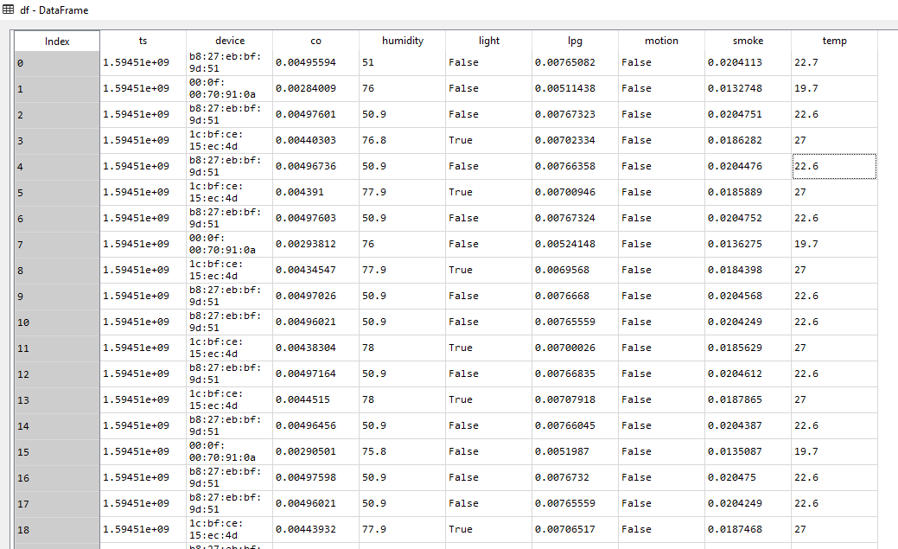

Missing Values:

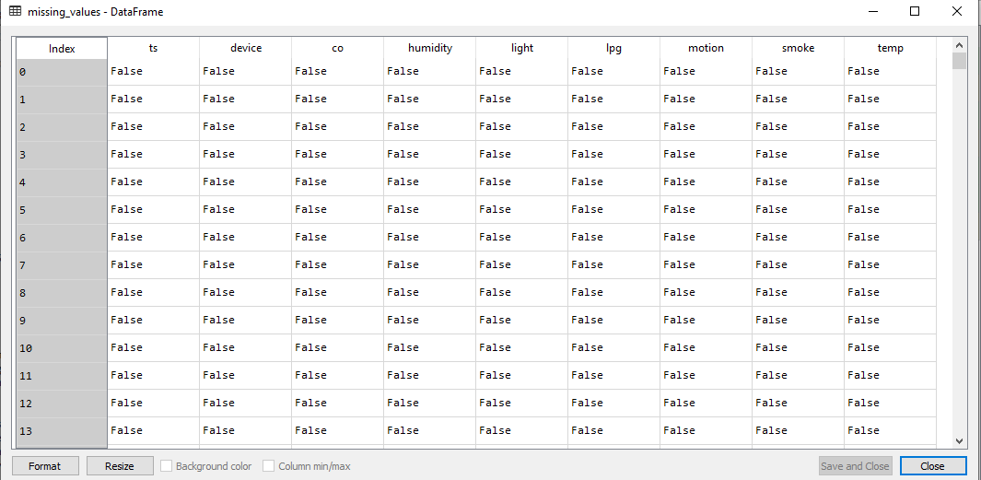

Information about Dataset:
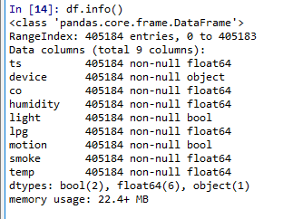
Column in dataset:

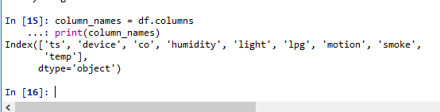

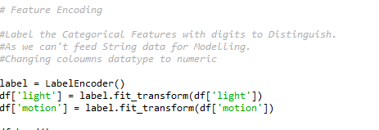

Visualization of all Data:
Motion True and False detection using count plot:
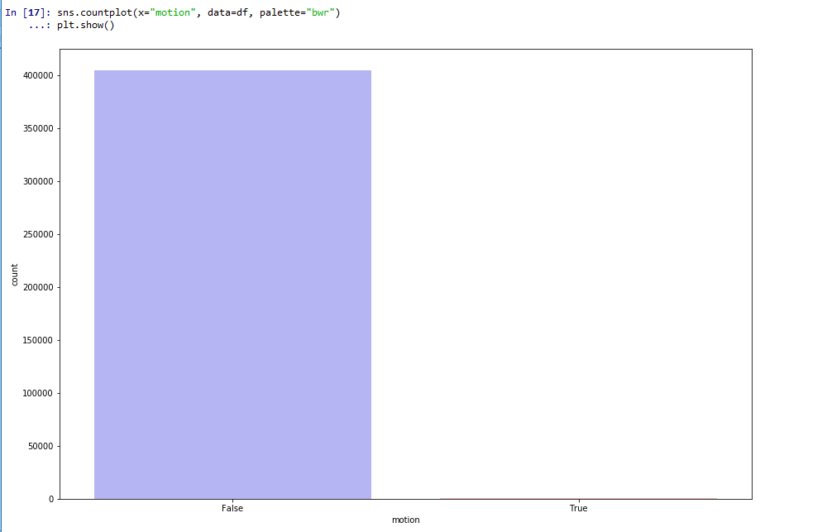

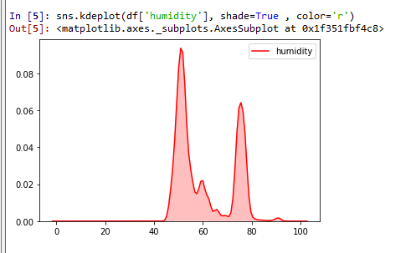

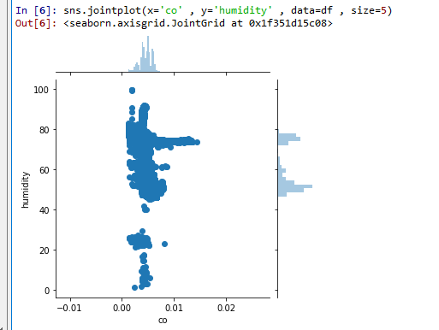

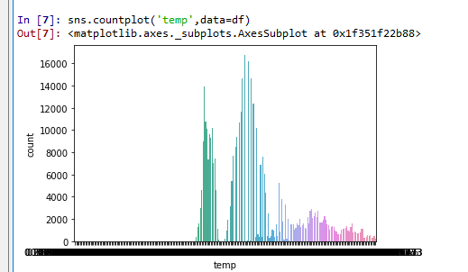

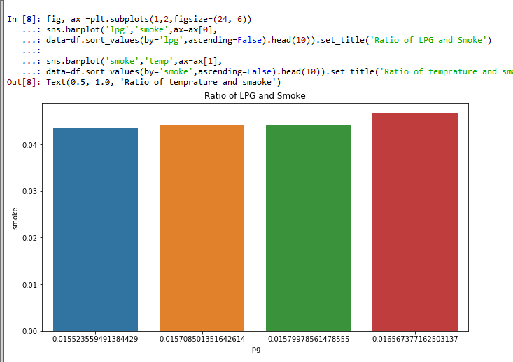

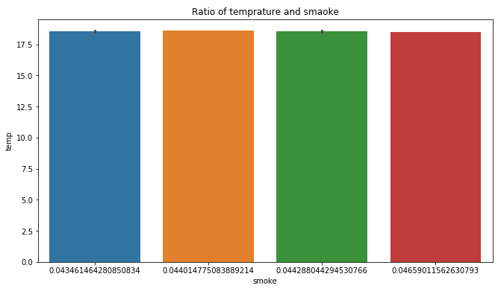

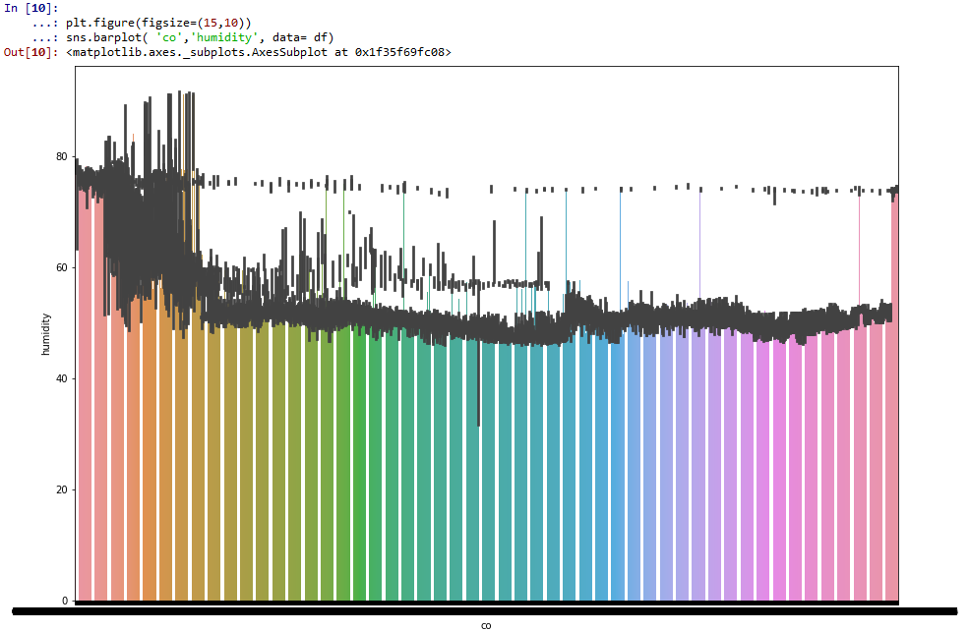

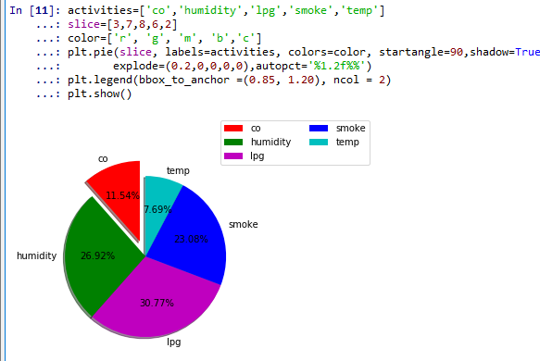

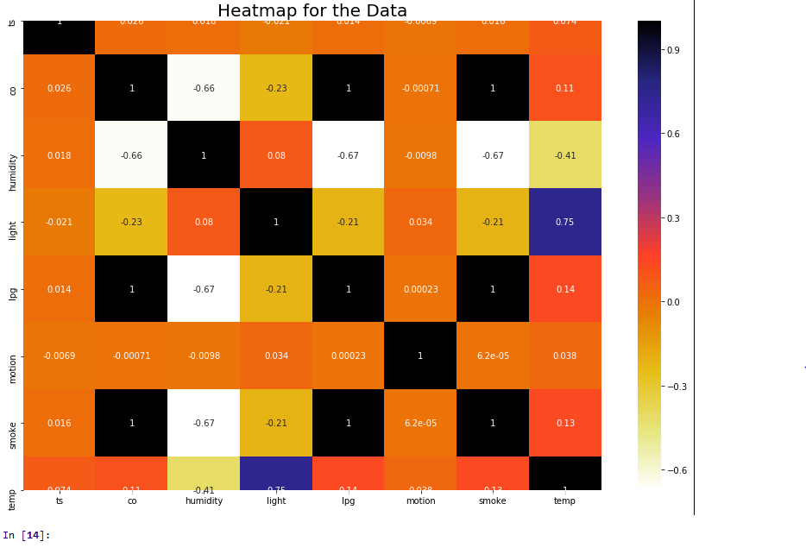

Scaling: apply StandardScaler to standardize the data.

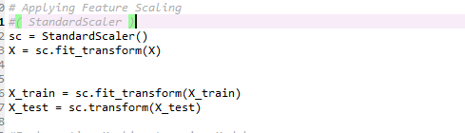

Applying Algos:
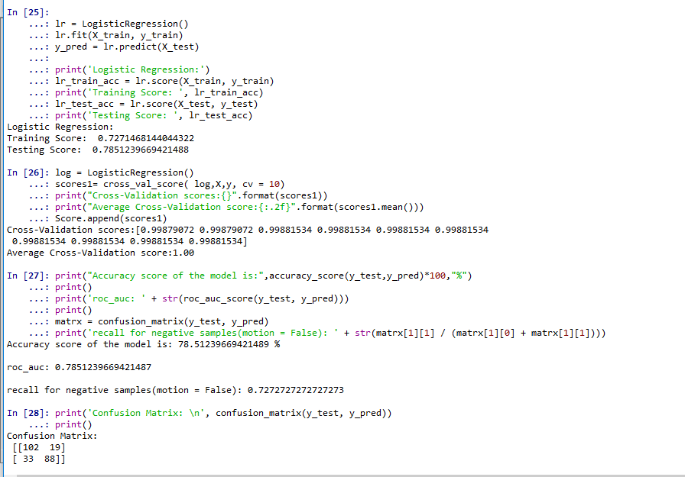

Confusion Matrix:
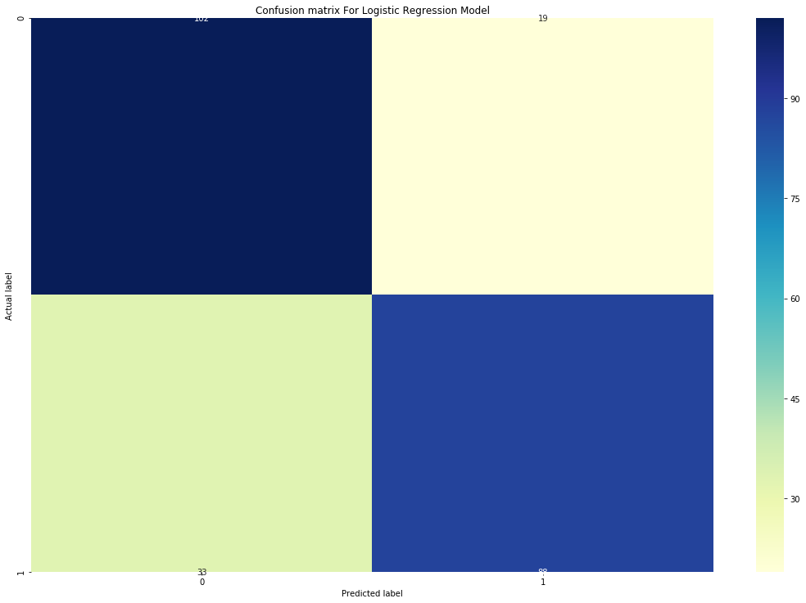
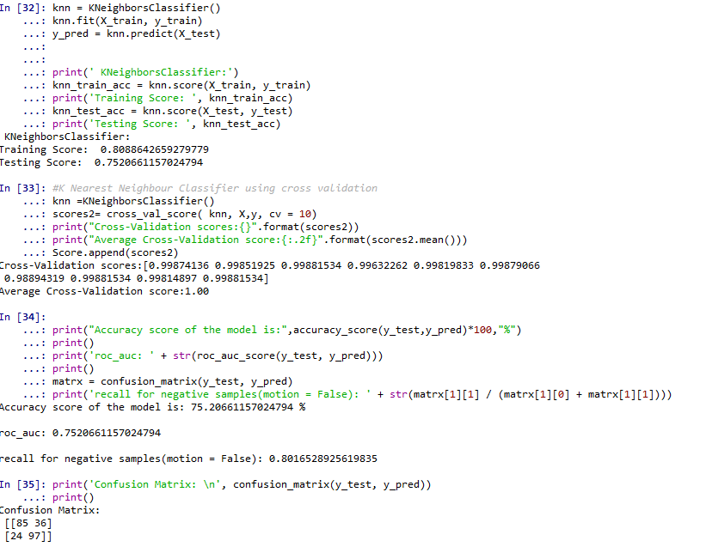
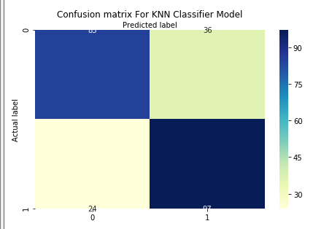

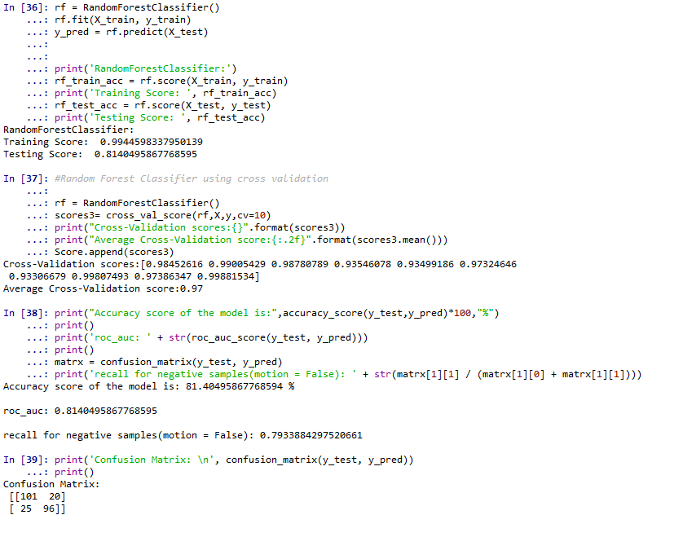
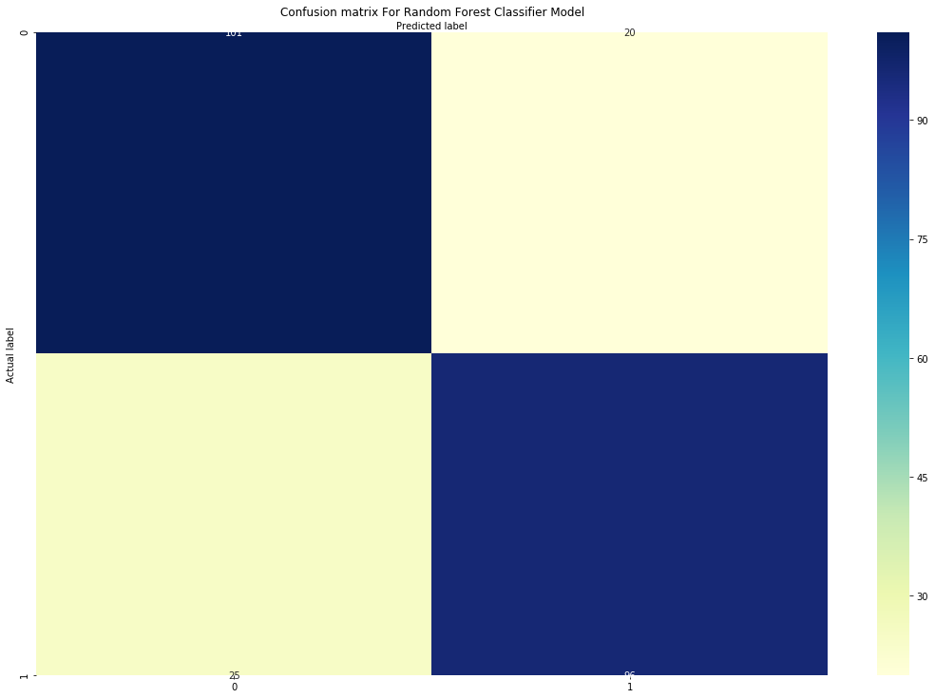

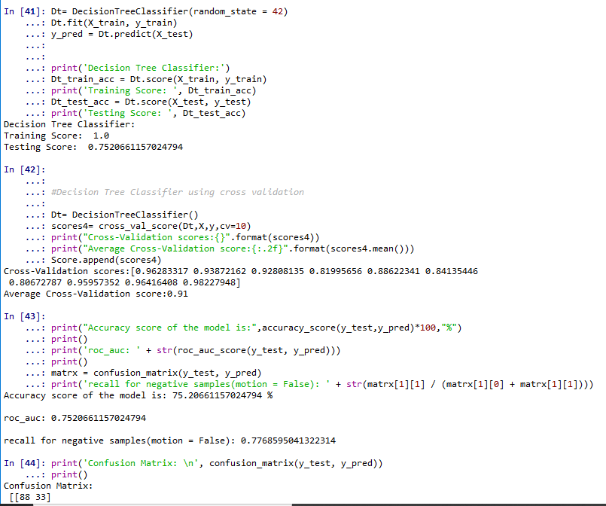
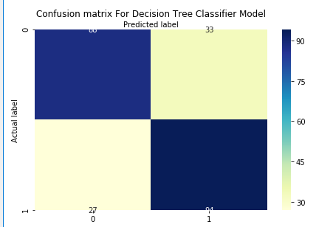

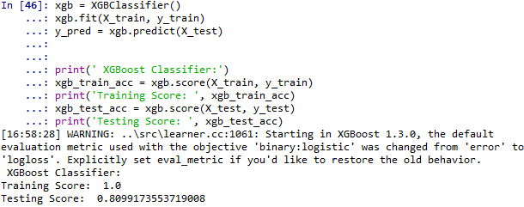
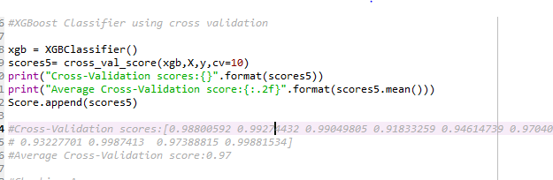
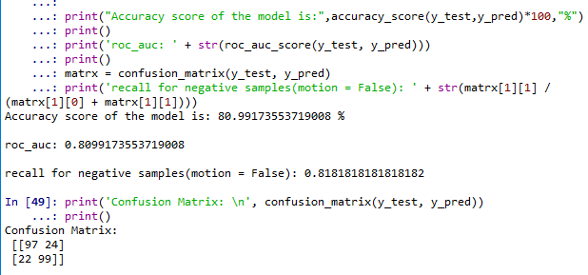
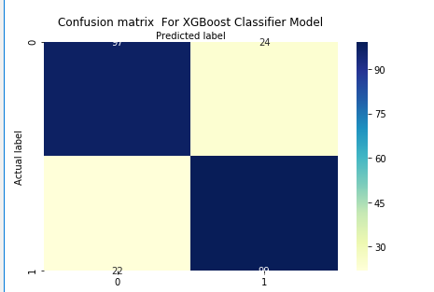
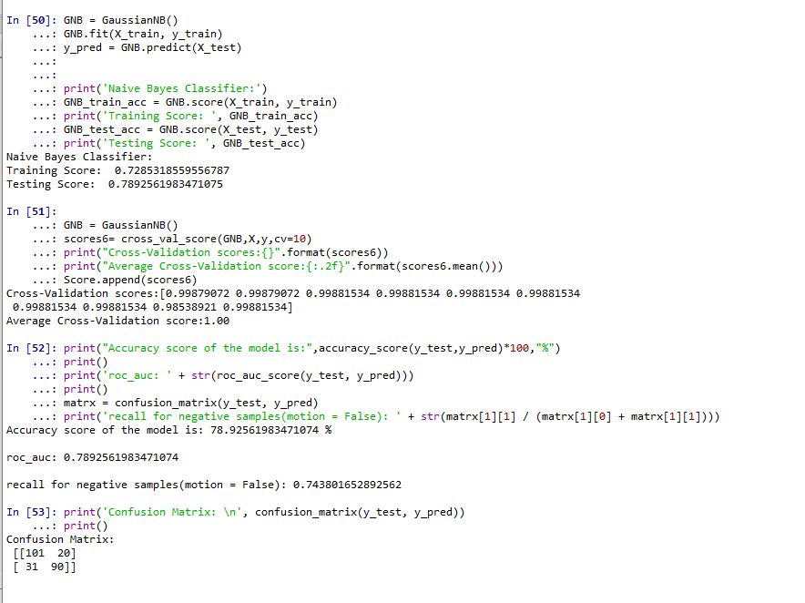
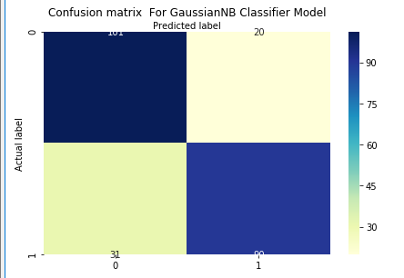

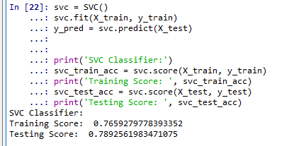
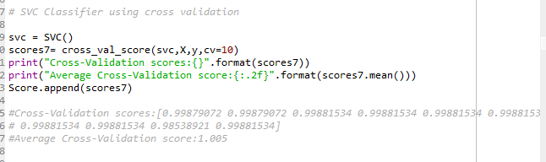
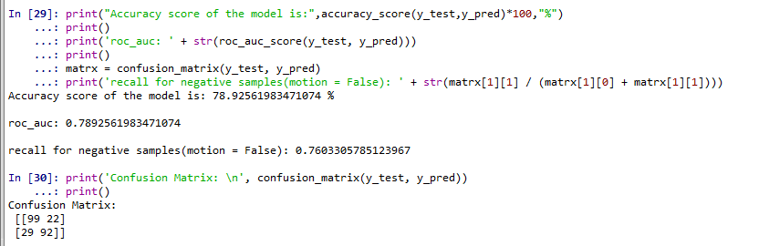
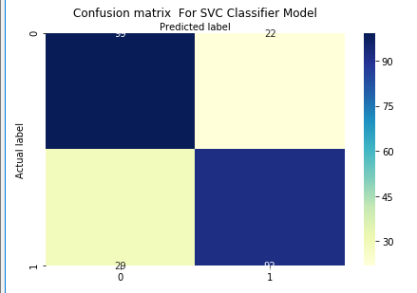
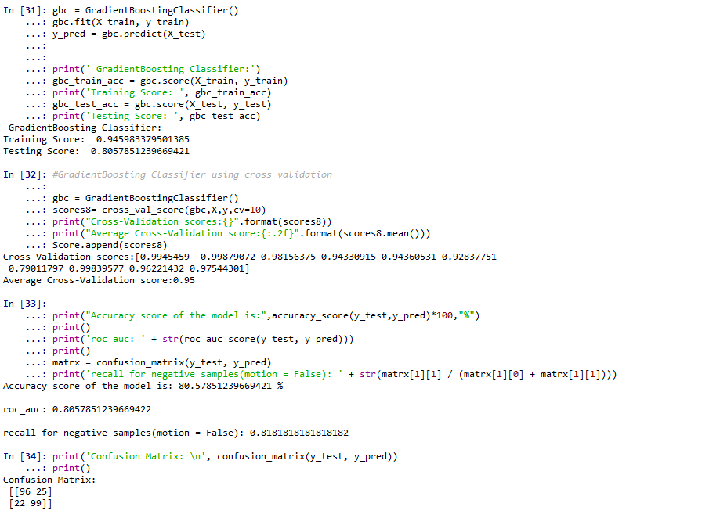
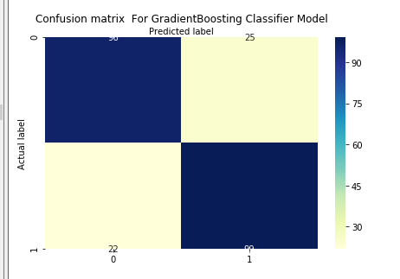

Applying Hyperparameters :
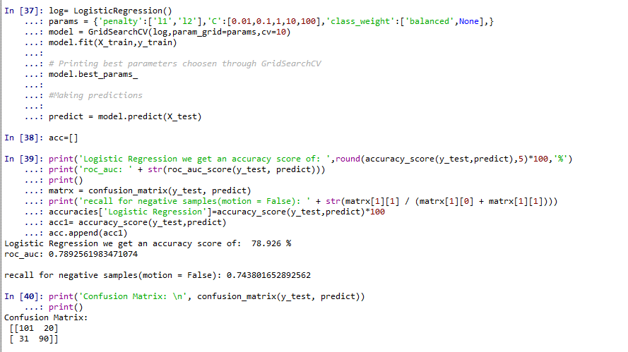

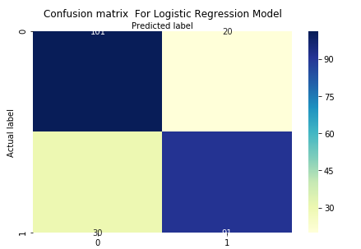

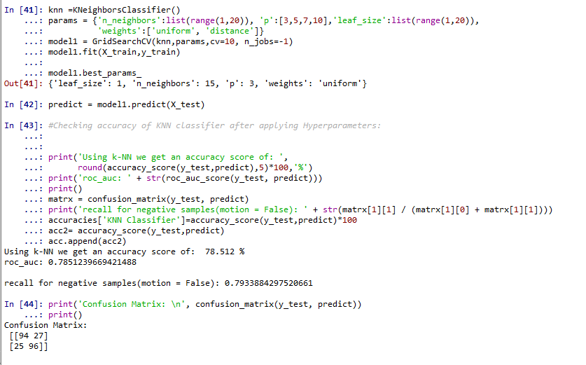
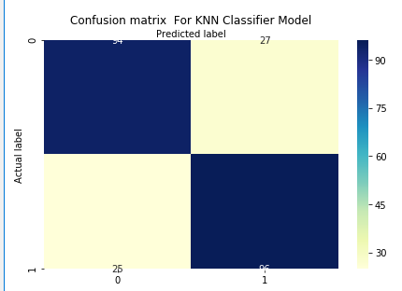

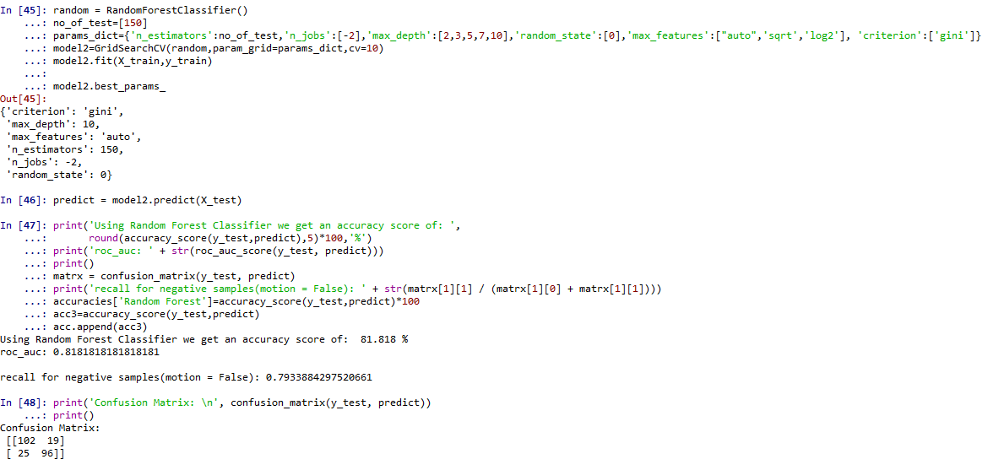
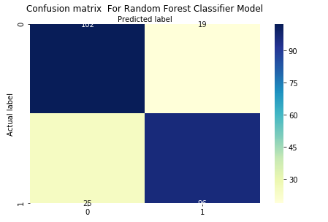

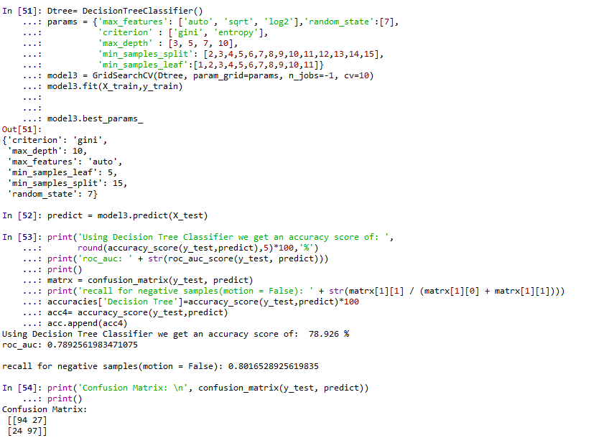
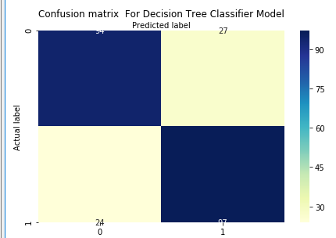

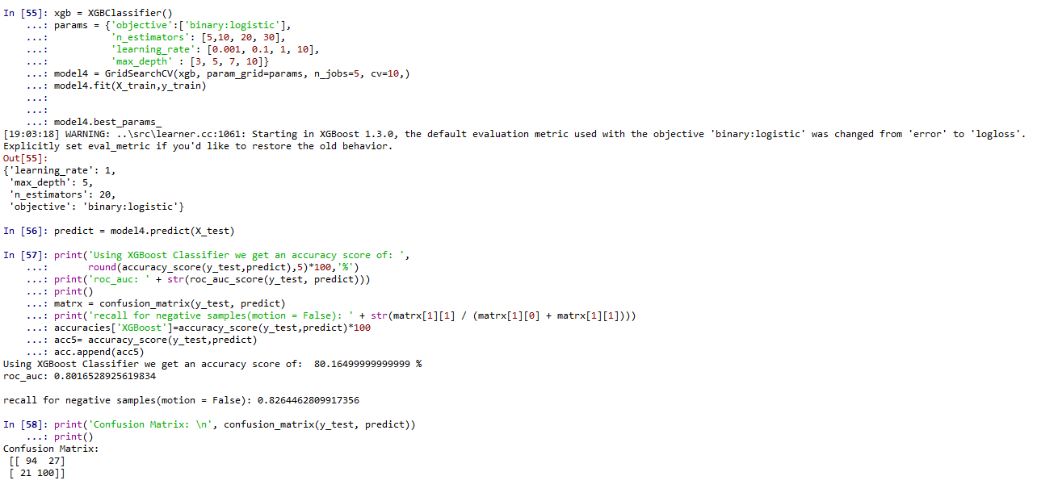

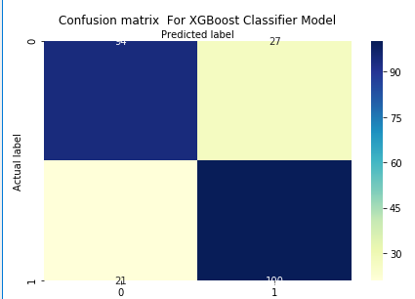
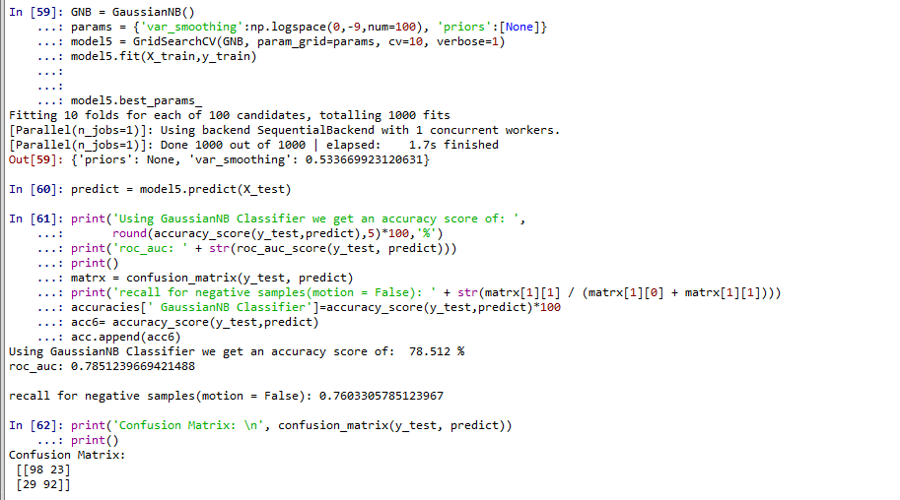
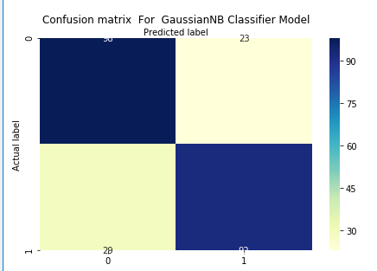
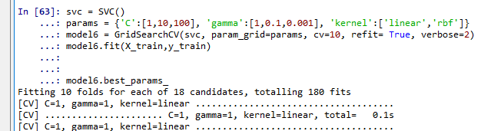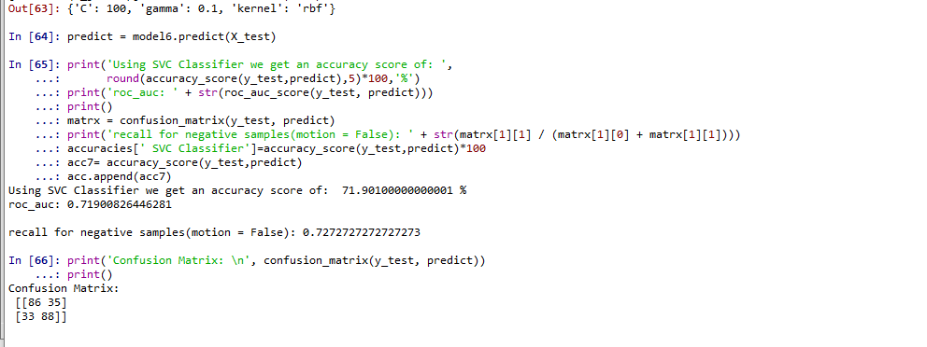

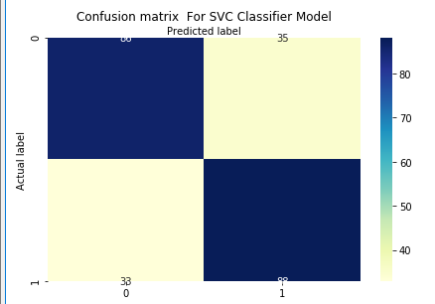

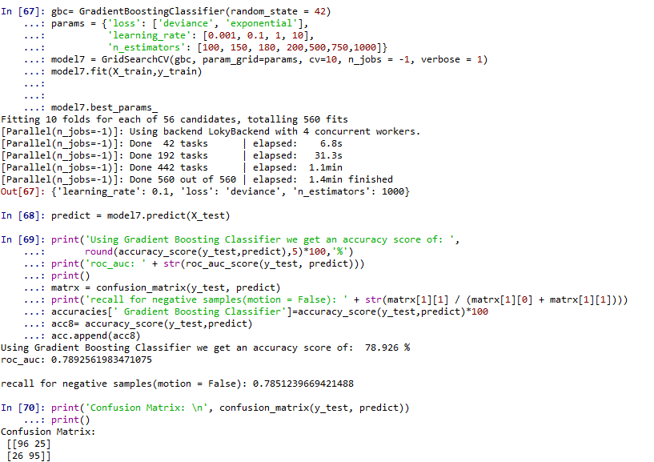
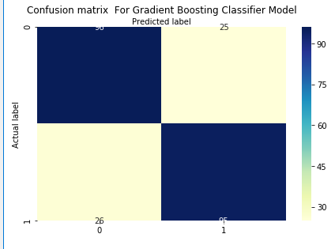
Model Comparison:
1.
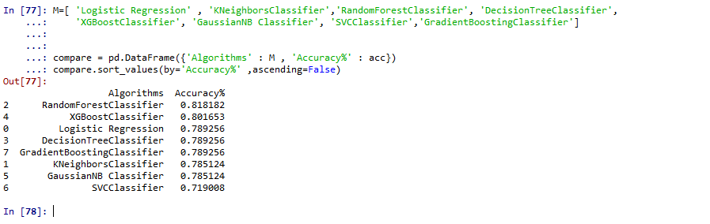
From above dataframe we can see that Random Forest classifier gives 81.81% accuracy after implementing Model Tuning.

2. Boxplot algorithm comparison
Boxplot feeding the series of 10scores output by cross-validation for each algorithms.

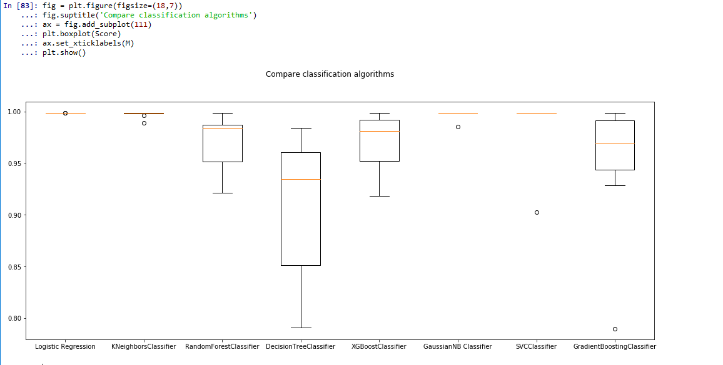
3. Using factorplot to compare results.

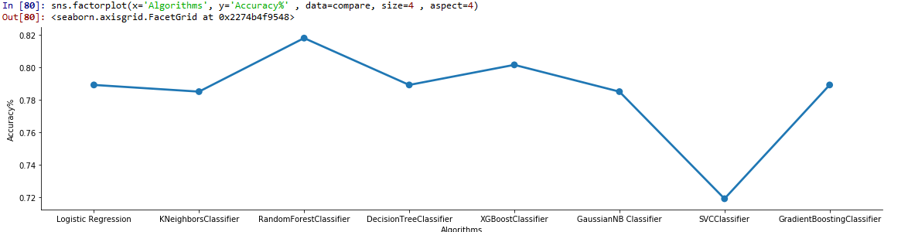

4. Using Barplot for algorithm comparison.

Results:
After analyzing Factor plot and Bar plot we can say that:
- After applying hyperparameters Random Forest Classifier gives us the best accuracy of 81.81% which is highest among all models.

- After applying hyperparameters Decision Tree and XGBoost Classifier gives the best recall value of near 80-82% in all classification models.

