[University of Bedfordshire]
[Patan College for Professional Studies]
FINAL YEAR PROJECT REPORT
LAND CHAIN
A Blockchain-Based Real Estate System with Government-Verified NFT Property Registration
Student Name: Manish Rakaskoti
Student Number: 2337729
Degree Pathway: BSc (Hons) Software Engineering
Supervisor: Mr. Pawan KC
Submission Date: [date]

ABSTRACT
Land Chain is a blockchain-based real estate system that securely stores property ownership records. It creates a transparent, decentralised ledger in which every property is registered as a unique NFT only after government verification. Any user can sell or buy property, with no fixed buyer or seller roles. A purchase follows a request-based process: the buyer sends a request with supporting documents, which stay encrypted and hidden until the seller accepts; the government then verifies the documents and the transaction; and the buyer pays through a smart contract, after which ownership moves to the buyer automatically. The system shows not only the current owner of a property but also its full ownership history. This improves traceability, protects against fraud, and removes the need for brokers. The project designs and builds a prototype on an Ethereum test network with a web and mobile interface, and evaluates it against its aim and objectives. [Add one sentence with your main result after finishing Chapter 10.]

ACKNOWLEDGEMENT
I wish to convey my heartfelt thanks to everybody who stood by me during the development of this project.
First of all, I would like to express my gratitude to my project supervisor, Mr. Pawan KC, for his guidance, suggestions and motivation throughout the project. His expertise and patience helped me deal with the many challenges I faced during development.
I would also like to thank the unit coordinator [name] and the teaching staff for their assistance and for providing a supportive environment in which to carry out this project.
I am sincerely grateful to the University of Bedfordshire and [Patan College for Professional Studies – confirm] for giving me the opportunity and the academic environment to complete this project.
[Optional: thank any person who helped you with information, testing or feedback, such as friends who took part in the user trial.]
Finally, I would like to express my deep appreciation to my family for their constant support, motivation and love throughout my studies.

Manish Rakaskoti
2337729
BSc (Hons) Software Engineering

TABLE OF CONTENTS

[Right-click the table above in Word and choose "Update Field" → "Update entire table" to fill in page numbers.]

LIST OF FIGURES
Figure 1: Gantt chart of the 12-week plan
Figure 2: Land Chain system architecture
Figure 3: Purchase request flow
Figure 4: [Entity-relationship diagram]
Figure 5: [User interface wireframes]
Figure 6 onwards: [Contract code extracts, screenshots of screens and test results from Chapters 8–9]

LIST OF ABBREVIATIONS
Abbreviation | Meaning
AES | Advanced Encryption Standard
API | Application Programming Interface
dApp | Decentralised Application
ERC | Ethereum Request for Comments (token standards)
ERC-721 | Ethereum standard for non-fungible tokens
ETH | Ether, the native cryptocurrency of Ethereum
EVM | Ethereum Virtual Machine
IDE | Integrated Development Environment
NFT | Non-Fungible Token
NPR | Nepalese Rupee
UI | User Interface

Chapter 1 – INTRODUCTION

Background
Land and property are among the most valuable assets a person can own, and the records that prove ownership must therefore be accurate, permanent and trusted. In many countries, including Nepal, ownership records are still maintained largely through paper files, local land offices and manual verification. This makes the process slow, dependent on intermediaries, and open to forged documents, duplicate sales, and the alteration or loss of records. A buyer often cannot easily confirm who truly owns a property or how it has changed hands in the past, and relies instead on brokers and personal trust.
Blockchain technology offers a different way to keep such records. A blockchain is a distributed ledger in which entries are added in a time-ordered sequence and, once confirmed, are extremely difficult to alter (Nakamoto, 2008; Zheng et al., 2017). Platforms such as Ethereum extend this idea with smart contracts, which are programs stored on the blockchain that run exactly as written (Buterin, 2014). Combined with the ERC-721 non-fungible token (NFT) standard, in which every token is unique (Entriken et al., 2018), these tools make it possible to represent each property as one unique digital asset with a verifiable ownership trail.
This project, Land Chain, applies these technologies to property ownership. It is a blockchain-based real estate system in which a property is registered as a unique NFT only after government verification, and in which any user can buy or sell through a request-based process that is verified by the government before payment is released.

Problem Statement
Traditional property transactions suffer from several connected problems. Ownership records are held in centralised or paper-based systems that can be tampered with, lost or forged. Fake or duplicate property entries can be created, and the same property can be offered to more than one buyer. A buyer cannot easily trace the full ownership history of a property. Brokers are commonly needed to connect buyers and sellers and to manage the paperwork, which adds cost and can reduce transparency. Finally, a buyer must share sensitive personal and financial documents with a seller before the seller has even agreed to deal with them, creating a privacy risk.
Some blockchain land-registry projects exist, but many focus only on recording ownership and do not combine government-verified registration, a protected-document request process, government verification of each transfer, and a visible ownership history in one workflow. There is therefore a need for a system that gives all of these in a single, simple platform.

Proposed Solution
Land Chain is a decentralised platform in which verified properties are represented as NFTs. A user submits a property for registration; the government verifier checks it and, only if it is approved, the property is minted as a unique NFT. This prevents fake and duplicate entries from entering the system.
There are no fixed buyer or seller roles: every user has the same permissions and can both buy and sell. The only separate account type is the government verifier. A transfer follows a request-based process. The buyer sends a purchase request together with the supporting documents, which remain encrypted and hidden from the seller. The seller accepts or rejects the request, and only on acceptance are the documents unlocked. The government then verifies the documents and the transaction. After approval the buyer pays through the smart contract, and ownership moves to the buyer automatically. Every change is recorded on the blockchain, so each property page can show the current owner and the full list of previous owners with dates and transaction records.

Aim and Objectives

Aim
To develop a transparent and decentralised system for managing property ownership records using blockchain, with verified registration, request-based buying and selling, and a complete ownership history.

Objectives
- To use blockchain to register properties and manage ownership records.
- To mint a property as an NFT only after government verification.
- To allow any user to buy or sell without fixed roles.
- To let a buyer request a property with documents that stay hidden until the seller accepts.
- To require government verification after the seller accepts and before payment.
- To show the current owner and all previous owners of every property.
- To provide a simple, user-friendly web and mobile interface.

Scope and Boundaries
The project delivers a working prototype running on an Ethereum test network, not a production system holding real property or real money. The prototype covers government-verified registration, the purchase request flow, government verification of transfers, payment and automatic ownership transfer, ownership history, and a web and mobile interface. The following are outside the scope: integration with Nepal's actual government land-record databases, legal recognition of NFTs as title deeds, conversion between Nepali rupees and cryptocurrency, mortgages, inheritance and co-ownership, and deployment on the Ethereum main network.

Structure of the Report
Chapter 2 presents the project plan and schedule. Chapter 3 reviews the relevant literature and Chapter 4 reports the market research. Chapter 5 describes the planning of the artefact, and Chapters 6 and 7 set out the testing and evaluation plans. Chapter 8 documents the development, Chapter 9 the testing and Chapter 10 the evaluation. Chapter 11 gives a critical analysis, Chapter 12 the limitations and future scope, and Chapter 13 the conclusion. References and appendices follow.

Chapter 2 – PROJECT PLAN / SCHEDULE

Development Approach
The project follows an iterative, module-by-module approach influenced by agile principles (Beck et al., 2001; Sommerville, 2016). Because blockchain development is new to the author and smart contracts cannot easily be changed once deployed, the work is split into three separable modules: the smart contracts, the backend, and the user interface. Each module is built and tested on its own before integration. The riskiest parts, the smart contract flow and the locked documents, are scheduled early and given extra time. Work is tracked in a GitHub repository with regular commits and is reviewed with the supervisor, Mr. Pawan KC.

Schedule
The project is planned for about 12 weeks of part-time work, at roughly 15 to 20 hours per week. Table 1 gives the plan and Figure 1 shows it as a Gantt chart.
Table 1: Weekly project schedule
Weeks | Task
1 | Finalise requirements, design flow diagrams and set up the development environment
2–3 | Learn Solidity and write the property NFT and registration contract (government approval before minting)
4–5 | Write the transfer contract: request, accept, government verify, pay, transfer and ownership history
6–7 | Backend: authentication, request handling and encrypted document storage with locked access
8–10 | Frontend: registration, listing and request screens, government verification screen and ownership history page
11 | Integration and testing of the full flow
12 | Bug fixes, documentation and report writing

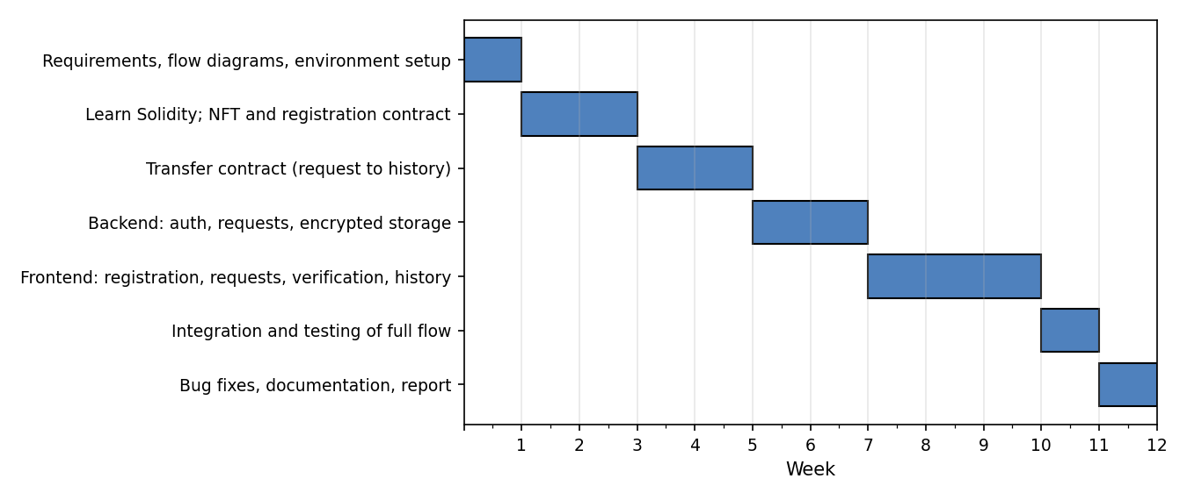
Figure 1: Gantt chart of the 12-week plan
[Optional: add the actual dates you worked on each phase, and note any week where the plan changed, for example "Week 5 extended by 3 days because of the document-unlock logic".]

Risk Analysis
Table 2 summarises the main risks identified at the start of the project and how each is managed.
Table 2: Risk analysis
Risk | Description | Severity | Mitigation
Technical complexity | Blockchain, NFTs and smart contracts are new to the author. | Medium | Split the work into modules (contract, backend, UI), test each separately, and use tutorials, libraries and community resources.
Data security and privacy | Contract vulnerabilities could cause unauthorised access or loss, deployed contracts cannot be changed, and blockchain data is public so documents must not be stored on-chain. | Medium | Write and test contracts carefully. Store documents encrypted off-chain with only their hash on-chain, and unlock them only after seller acceptance.
Legal and regulatory | Government rules may change and affect the workflow. | High | Follow local regulations and keep the verification step configurable.
Time | The request, verification and payment flow adds scope. | Medium | Build only the core requirements first and skip extras. If behind schedule, deliver the web version only.

Resources
The tools used are Visual Studio Code, React and React Native for the interface, PostgreSQL for off-chain data, Node.js [or Django – state which one you used] for the backend, Solidity with an Ethereum test network and MetaMask for the blockchain layer, and Git with GitHub for version control. No paid services were required.

Ethical Considerations
The ethics form was completed and submitted. The prototype uses test data and a test network only. No real land records, real personal documents or real money are used, and any sample documents in testing are fictitious.

Chapter 3 – LITERATURE REVIEW

Introduction
This chapter reviews the literature relevant to Land Chain: the weaknesses of conventional land registries, blockchain and smart contract fundamentals, NFTs as a representation of unique assets, real-world land-registry experiments, and the privacy and security issues that shape the design.

Problems with Conventional Land Registries
A land registry works only if people trust it. Where records are kept on paper or in a single centralised database, trust depends on the honesty and security of whoever controls that database. A single point of control can be attacked, corrupted or simply fail, and altered or forged records may be hard to detect. Intermediaries such as brokers, lawyers and clerks are needed to carry information between parties, and each adds cost and delay. In Nepal, land is a major store of wealth and land disputes are widely reported, so improving the reliability and traceability of ownership records is a worthwhile problem. [Add 1–2 citations here on Nepal land-record problems or land disputes from sources you have actually read, for example reports from the Department of Land Management and Archive or a Nepali journal article.]

Blockchain Fundamentals
Blockchain was introduced as the technology underlying Bitcoin, where transactions are grouped into blocks that are chained together using cryptographic hashes, so that changing an old block would invalidate all later blocks (Nakamoto, 2008). Nodes in a peer-to-peer network follow a consensus mechanism to agree on the next block, which removes the need for a trusted central party (Zheng et al., 2017). Swan (2015) describes how this property allows blockchains to be used beyond currency, including for registries of ownership. For Land Chain, the important properties are immutability of past records, transparency, and the ability for anyone to verify the history independently.

Smart Contracts and Ethereum
The idea of smart contracts, computer protocols that carry out the terms of an agreement automatically, was proposed by Szabo (1997). Ethereum made this practical by providing a blockchain with a built-in programming environment, so that contract code and its state live on the chain and execute deterministically on every node (Buterin, 2014; Wood, 2014). Christidis and Devetsikiotis (2016) note that smart contracts can enforce rules without a trusted intermediary, which is why they suit workflows such as payment and transfer.
However, smart contracts introduce their own risks. Once deployed, code usually cannot be changed, so bugs become permanent. Atzei, Bartoletti and Cimoli (2017) catalogue attacks on Ethereum contracts, including reentrancy, where an external call allows an attacker to call back into a contract before its state has been updated, and problems with access control and unchecked calls. These findings directly influence Land Chain's design: access to minting and verification functions must be restricted, state must be updated before funds are sent, and well-tested libraries should be preferred over custom code.

Non-Fungible Tokens for Property
Fungible tokens are interchangeable, like units of a currency, but real estate is unique: each parcel has its own location, boundaries and history. The ERC-721 standard defines non-fungible tokens in which every token has a unique identifier and a single owner, together with standard functions for ownership queries and transfers (Entriken et al., 2018). This matches the needs of a land registry, where one parcel must correspond to exactly one record and have exactly one owner at a time. The standard also emits events on each transfer, which provides a natural basis for an ownership history. An important caveat is that a token is only a digital record; its link to the physical land and its legal force depend on the authority that verifies it, which is why Land Chain mints a token only after government verification.

Blockchain Land Registry Initiatives
Several governments and organisations have tested blockchain for land records. The Republic of Georgia worked with a blockchain provider to anchor land-title records, and Shang and Price (2019) discuss the project as a way of rebuilding public trust and the lessons it offers for future pilots. In Sweden, the national land authority ran a testbed to examine how a land registry and the steps of a property purchase could be handled on a blockchain (Lantmäteriet, 2017). Both examples suggest that blockchain can improve trust and traceability, but they also show that success depends on the quality of existing records, on legal and institutional support, and on a trusted authority that confirms the information entering the system. This supports the Land Chain design decision of keeping government verification as a required step rather than attempting to remove the authority altogether.

Privacy and Document Security
Public blockchains are transparent by design, so personal documents such as citizenship papers, tax clearance or sale agreements must never be stored directly on-chain. A common pattern is to store the files off-chain in encrypted form and keep only a cryptographic hash on-chain, which proves that a file has not been changed without revealing its contents. Symmetric encryption such as AES (National Institute of Standards and Technology, 2001) can be used for the files, with access to the key controlled by application rules. Land Chain applies this pattern and ties the release of the key to the seller's acceptance of the request, so that documents stay locked until then.

Summary and Gap
The literature shows that blockchain, smart contracts and NFTs are well suited to unique-asset registries, and that earlier land-registry projects improved trust but depend on authority verification and sound legal support. It also shows that smart contract security and document privacy need careful design. What is less common in the examples reviewed is a single workflow that combines (1) government-verified minting, (2) role-free buying and selling, (3) a protected-document request process that unlocks only on seller acceptance, (4) a second government verification before payment, and (5) a public ownership history. Land Chain is designed to address this combination.

Chapter 4 – MARKET RESEARCH

Purpose
The market research examines how property ownership and transfer are handled today, what existing blockchain real estate products offer, and what users need, in order to show where Land Chain fits.

The Existing Process
In the conventional process, a buyer typically finds a property through a broker or personal contacts, negotiates privately, and then completes the transfer at the relevant government land office with a set of paper documents. The buyer and seller usually share documents with each other early, ownership history is checked by manually searching records, and payment is arranged outside any system that links it to the transfer. The weaknesses of this process, namely dependence on brokers, limited traceability, exposure of documents and the risk of forgery, form the starting point for Land Chain. [Add one or two sentences from your own observation or an interview, for example with a local land office, lawyer or broker, if you have one.]

Existing Blockchain Real Estate Solutions
Table 3 compares Land Chain with examples of existing approaches. The comparison is based on publicly described features and should be checked against the products' current documentation before submission.
Table 3: Comparison with existing approaches
Feature | Traditional process | Government pilots (e.g. Georgia, Sweden) | Property platforms (e.g. Propy, Ubitquity) | Land Chain
Tamper-resistant records | No | Yes | Yes | Yes
Government-verified registration before record exists | Yes (manual) | Yes | Varies | Yes (before NFT is minted)
Unique token per property | No | Not always | Varies | Yes (ERC-721)
Buyer documents hidden until seller accepts | No | Not described | Not described | Yes
Government check before payment | Yes (manual) | Yes | Varies | Yes
Smart contract payment and automatic transfer | No | Limited | Yes | Yes
Public ownership history | Manual search | Yes | Varies | Yes
Broker required | Usually | No | Optional | No

From the comparison, Land Chain's distinguishing combination is the protected-document request flow together with verification both before minting and before payment, in a role-free marketplace. [Replace the "Varies / Not described" cells with facts you have confirmed from each product's website.]

Target Users and Needs
Land Chain has three groups of users. Property owners and sellers want a safe way to list a property, receive serious requests, and avoid dealing with intermediaries. Buyers want confidence that a property is genuine, that its history is clear, and that their documents will not be exposed unnecessarily. Government verifiers want a structured screen on which to review registrations and transfers and record their decision. Because every ordinary user can both buy and sell, there are only two kinds of account: the normal user and the government verifier.

Survey / Interview Findings
[If you carried out a survey or interviews, summarise them here: number of respondents, who they were, and 3–5 key findings (for example, "X% said they worry about forged documents"). If you did not, delete this section or replace it with a short justification based on the literature.]

Findings and Implications for Design
- Trust and traceability are the strongest needs, so ownership history and government verification are core features.
- Document privacy matters to buyers, so documents are encrypted and locked until the seller accepts.
- Removing the need for brokers is a clear value, so the request, verification and payment process is fully inside the system.
- Because laws may change, the verification step is kept configurable.

Chapter 5 – ARTEFACT PLANNING

Users and Roles
The system has two account types. A normal user can register properties, list owned properties for sale, send purchase requests, accept or reject requests, pay, and view ownership history. A government verifier can approve or reject property registrations and approve or reject transfers. There are no fixed buyer or seller roles; the same user may buy one property and sell another.

Functional Requirements
Table 4: Functional requirements
ID | Requirement | Priority
FR1 | Users can register and log in securely. | Must
FR2 | A user can submit a property for registration with its details and documents. | Must
FR3 | The government verifier can approve or reject a registration; only approved properties are minted as NFTs. | Must
FR4 | An owner can list a verified property for sale. | Must
FR5 | A buyer can send a purchase request with required documents, which are stored encrypted. | Must
FR6 | Documents remain locked and hidden from the seller until the seller accepts the request. | Must
FR7 | The seller can accept or reject a request. | Must
FR8 | After acceptance, the government verifier reviews the documents and transaction and approves or rejects. | Must
FR9 | After approval, the buyer pays through the smart contract and ownership transfers automatically. | Must
FR10 | Each property page shows the current owner and all previous owners with dates and transaction records. | Must
FR11 | Each request shows its status: pending, accepted, verified, paid or rejected. | Should
FR12 | A mobile interface provides the main user functions. | Could

Non-Functional Requirements
- Security: only the government account can mint or verify; documents are encrypted off-chain and only a hash is stored on-chain; contracts guard against reentrancy and unauthorised calls.
- Integrity and transparency: ownership changes are recorded on-chain and cannot be altered afterwards.
- Usability: a simple interface that guides the user through each step and shows the request status.
- Reliability: a transfer must either complete fully or not at all, so that payment and ownership never end up out of step.
- Maintainability: modular design (contracts, backend, frontend) and a configurable verification step.

System Architecture
Land Chain has three layers (Figure 2). The client layer contains the web and mobile applications and a government portal, with MetaMask used to sign blockchain transactions. The off-chain backend provides authentication, request handling and access control, and an encryption service, with PostgreSQL storing user data, request status and encrypted documents. The blockchain layer on an Ethereum test network contains the smart contracts. This split follows the privacy principle in Chapter 3: sensitive documents stay off-chain, while ownership, status and payment rules live on-chain.
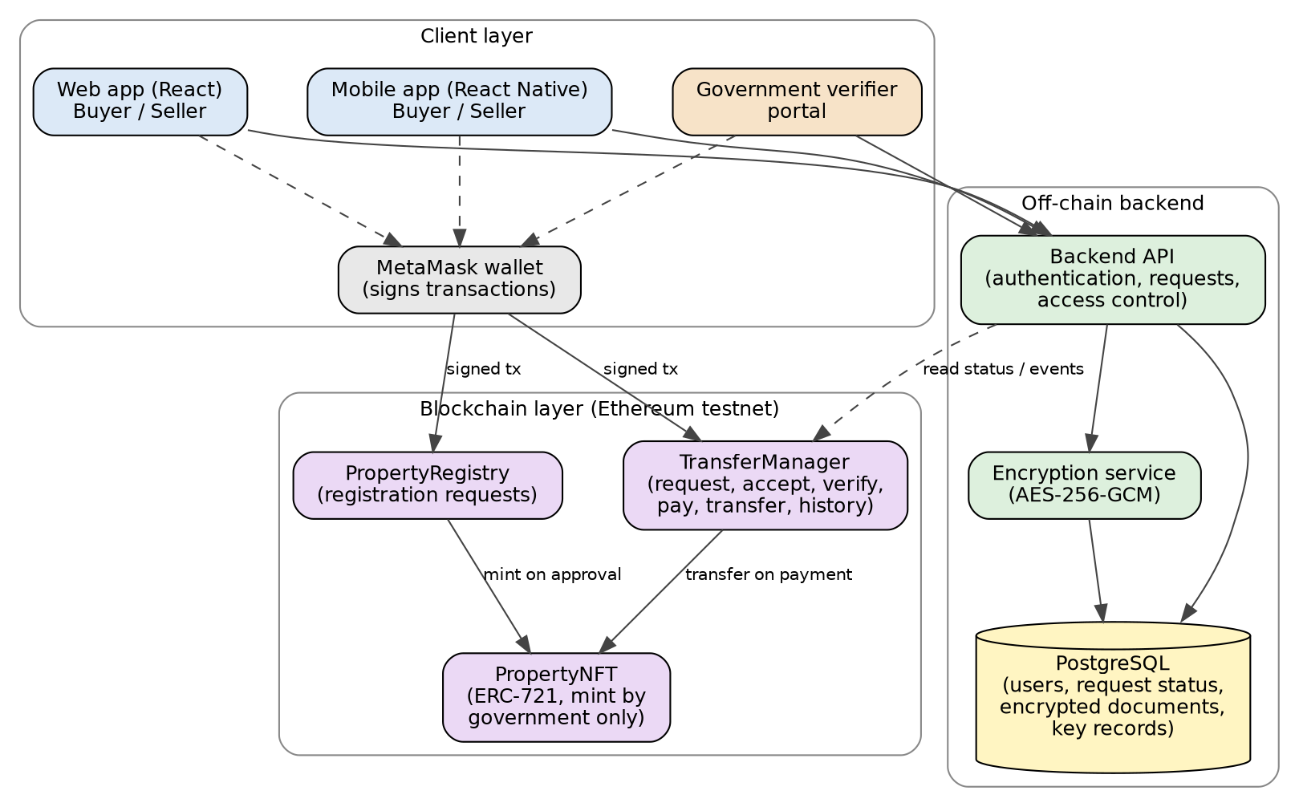
Figure 2: Land Chain system architecture

Purchase Flow
Figure 3 shows the purchase flow. The sequence is: the owner lists a verified property; the buyer sends a request with documents that stay encrypted and locked; the seller accepts or rejects; on acceptance the documents are unlocked for the seller; the government reviews the documents and transaction and approves or rejects; if approved, the buyer pays through the smart contract; and ownership transfers to the buyer, with the previous owner added to the property's history.
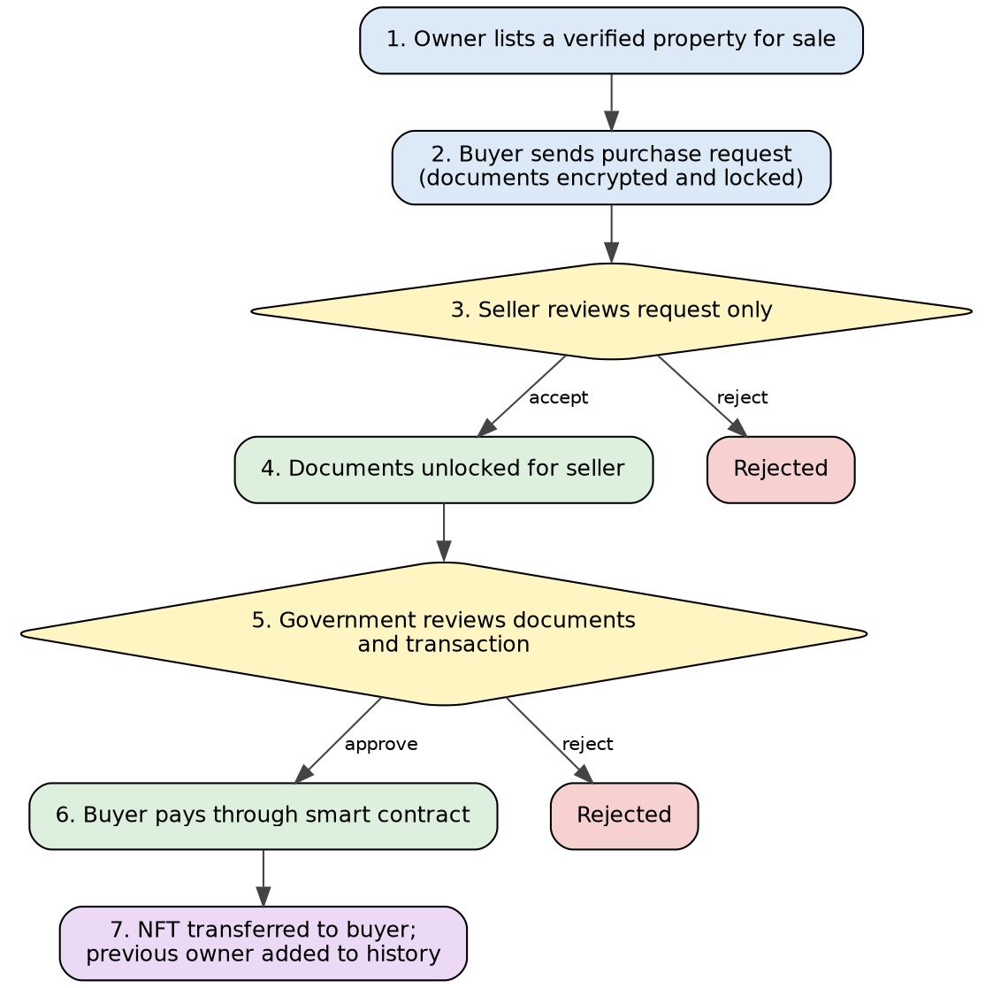
Figure 3: Purchase request flow

Smart Contract Design
Three contracts are planned. PropertyNFT is an ERC-721 contract in which each token represents one verified property; minting is restricted to the government account. PropertyRegistry holds registration requests and their state (submitted, approved, rejected) and calls PropertyNFT to mint only on approval. TransferManager manages the purchase request lifecycle and payment. A request moves through the states Pending, Accepted, Verified, Paid and Rejected, and each transition can be made only by the correct party: the seller for accept or reject, the government for verify, and the buyer for payment. On payment, the contract transfers the token to the buyer, sends the payment to the seller, and appends a record (previous owner, dates, transaction reference) to the property's ownership history. State is updated before funds are sent, and OpenZeppelin's audited ERC-721, access-control and reentrancy-guard components are preferred over custom code.

Document Protection Design
When a buyer submits a request, the documents are encrypted with a symmetric key (for example AES-256-GCM) and stored off-chain, and a hash of the encrypted file is recorded on-chain. The key is held by the backend and is released to the seller only after the backend confirms from the blockchain that the request has been accepted. The government verifier can access the documents after acceptance for the purpose of verification. Because the hash is on-chain, anyone can later check that the documents have not been altered. This design keeps files private without placing them on a public ledger.

Data Design
Off-chain data in PostgreSQL includes users, property details and images, purchase requests with their current status, and encrypted document records with their hashes and key references. On-chain data includes token ownership, registration and request states, payments and the ownership history. [Insert your ER diagram here as Figure 4 if you have one.]

User Interface Plan
The interface is planned around a small number of screens: register and log in; submit a property; browse and view a property page with its ownership history; list a property for sale; send and manage purchase requests with status tracking; seller request review; a payment screen; and a government verification screen for registrations and transfers. [Insert wireframes here as Figure 5.]

Technology Choices
Table 5: Technology choices and reasons
Layer | Choice | Reason
Smart contracts | Solidity, Ethereum test network | Widely used, supports ERC-721 and has strong tooling and community support.
Wallet | MetaMask | Common wallet for signing transactions in browsers.
Web frontend | React | Builds on web development units; reusable components.
Mobile frontend | React Native | Shares knowledge with React; builds on mobile development unit.
Backend | Node.js [or Django] | Handles authentication, requests and encryption.
Database | PostgreSQL | Builds on database units; reliable relational storage.
Version control | Git and GitHub | History, backup and supervisor review.

Chapter 6 – TESTING PLAN

Testing Strategy
Testing is planned at four levels, following the module structure of the project (Myers, Sandler and Badgett, 2011). Because deployed contracts cannot easily be changed, the smart contracts receive the most thorough testing and are tested first on a local blockchain before deployment to the test network.
Table 6: Testing levels
Level | Scope | Approach
Smart contract unit testing | Each contract function: minting, registration, request, accept, verify, pay, transfer, history. | Automated tests on a local blockchain; positive and negative cases, including unauthorised callers.
Backend testing | Authentication, request handling, document encryption and locked access. | API tests, checking that documents cannot be read before acceptance.
Integration testing | Interface, backend and contracts working together through the full purchase flow. | End-to-end walk-through on the test network with several test accounts.
User interface and usability testing | Web and mobile screens, status display, error messages. | Manual testing and feedback from a small group of users.

Test Environment
Contract tests run on a local development blockchain, and integration tests run on an Ethereum test network with test Ether. Separate test accounts are used for the government verifier, two ordinary users (seller and buyer) and a third unrelated user to test unauthorised access. All documents are fictitious.

Planned Test Cases
Table 7: Planned test cases
ID | Test | Expected result | Type
T1 | Government approves a registration. | Property NFT is minted to the owner. | Contract
T2 | Non-government account tries to mint. | Transaction is rejected. | Contract / security
T3 | Government rejects a registration. | No NFT is minted; status is Rejected. | Contract
T4 | Same property submitted twice. | Duplicate is prevented or flagged. | Contract
T5 | Buyer sends a purchase request. | Request is created with status Pending; documents stored encrypted. | Integration
T6 | Seller tries to read documents before accepting. | Access is denied; documents remain locked. | Backend / security
T7 | Seller accepts the request. | Status becomes Accepted; documents unlock for the seller. | Integration
T8 | Buyer tries to pay before government verification. | Payment is rejected. | Contract
T9 | Government verifies the transfer. | Status becomes Verified; payment is allowed. | Contract
T10 | Buyer pays the correct amount. | NFT moves to buyer; seller receives payment; history updated. | Contract
T11 | Buyer pays the wrong amount. | Transaction is rejected. | Contract
T12 | Non-owner tries to accept a request. | Transaction is rejected. | Contract / security
T13 | Seller or government rejects a request. | Status becomes Rejected; no transfer occurs. | Integration
T14 | View ownership history after two transfers. | Current and all previous owners are listed with dates. | UI
T15 | Attempt to call payment function twice (reentrancy-style). | Second call fails; funds and ownership are not duplicated. | Contract / security
T16 | Invalid login and access to a page without logging in. | Access is refused. | Backend

Test cases are designed to check both that the system does what it should and that it refuses what it should not, which is especially important for a system handling ownership and payment.

Chapter 7 – EVALUATION PLAN
Testing checks whether the system works; evaluation asks whether it achieves what it set out to do. The evaluation plan therefore measures the finished artefact against the aim and objectives in Chapter 1.

Evaluation Criteria
Table 8: Evaluation criteria and methods
Criterion | Question | Method
Objective coverage | Is each objective in Chapter 1 delivered? | Checklist against objectives, with evidence (screenshots, test results).
Functional correctness | Does the full flow work from registration to transfer? | Results of the Chapter 9 test cases.
Security | Are minting, verification and document access properly restricted? | Security-focused test cases and review against known vulnerabilities (Atzei, Bartoletti and Cimoli, 2017).
Usability | Can a new user complete the main tasks easily? | Task-based trial and short questionnaire with a small group of users.
Performance and cost | How long do transactions take and how much gas do they use? | Record gas used per contract function on the test network.
Comparison with existing process | Does Land Chain improve on the traditional process? | Compare against the weaknesses identified in Chapter 4.

User Evaluation Plan
A small group of participants [number, e.g. 5–10] will be asked to complete tasks such as registering a property, sending a purchase request and viewing the ownership history, after which they will answer a short questionnaire using a five-point scale on ease of use, clarity of the steps, and trust in the system, with space for comments. Participation is voluntary and no personal data other than anonymous responses is collected.

Chapter 8 – DEVELOPMENT
[Important: this chapter is written from the planned design. Before submitting, update each section so it matches exactly what you built, and add your own screenshots and short code extracts. Remove any feature you did not implement.]

Development Environment
Development was carried out in Visual Studio Code. Smart contracts were written in Solidity and first tested on a local blockchain, then deployed to an Ethereum test network. MetaMask was used to sign transactions. The frontend was built with React for the web and React Native for mobile, and the backend with [Node.js / Django] and PostgreSQL. All code was kept in a GitHub repository.

Smart Contract Development

Property NFT and Registration
The property token follows the ERC-721 standard using audited OpenZeppelin components. A role-based access control ensures that only the government account can approve a registration and trigger minting. A user submits a property with its details and a hash of its supporting documents; the registration is stored as Submitted; and on government approval the contract mints a token to the submitting user. A rejected registration produces no token, which prevents fake or duplicate entries from entering the system. [Insert a short code extract of the mint-on-approval function and a screenshot of the test passing as Figure 6.]

Transfer Manager
The transfer contract implements the purchase request lifecycle. A request is created by the buyer for a property that is listed for sale and starts as Pending. The seller can accept or reject; the government can then verify or reject an accepted request; and the buyer can pay only after verification. Each function checks the caller and the current state before changing anything, so steps cannot be skipped or performed by the wrong party. On payment, the contract updates its state first, then transfers the token and the funds, and appends a history record containing the previous owner, the dates and the transaction reference. This order, together with a reentrancy guard, follows the guidance on contract attacks discussed in Chapter 3. [Insert code extract of the pay function as Figure 7.]

Ownership History
Each property keeps an on-chain list of ownership records. The property page reads the current owner from the NFT and the previous owners from this list, and each record shows its date and transaction reference so that it can be traced on a block explorer.

Backend Development
The backend provides user registration and login with hashed passwords, and endpoints for properties, requests and verification. For document protection, files are encrypted before storage and only the hash is written to the blockchain. When a seller asks to view a request's documents, the backend first checks the request status on the blockchain and releases the decryption key only if the status is Accepted (or later). The government account has access to the documents for verification. [Describe how you actually implemented the key handling, and insert a screenshot of a denied access attempt before acceptance.]

Frontend Development
The web application provides the screens planned in Chapter 5: registration and login, property submission, property pages with ownership history, listing for sale, request creation and tracking with a visible status, seller review, payment, and the government verification screen. The mobile application [provides the same main functions / provides a subset – state which]. MetaMask prompts the user to confirm each blockchain action. [Insert screenshots of each main screen as Figures 8 onwards.]

Integration
Integration connected the interface, backend and contracts so that the entire flow could be carried out with test accounts: register a property, approve it, list it, request, accept, verify, pay and view the new owner and history. Integration problems encountered, such as mismatches between on-chain and off-chain status or wallet connection errors, are discussed in Chapter 11. [List the real problems you faced and how you solved them.]

Version Control and Documentation
Work was committed regularly to GitHub, with commit history serving as a record of progress. [Insert the repository link.]

Chapter 9 – TESTING
[Fill in the "Actual result" and "Status" columns from your real test runs, and add screenshots as evidence. Do not mark a test as passed unless it was run. If a test failed, record how you fixed it; this strengthens the report.]

Smart Contract Test Results
Table 9: Test results
ID | Test | Expected result | Actual result | Status
T1 | Government approves a registration. | NFT minted to owner. | [ ] | [ ]
T2 | Non-government account tries to mint. | Rejected. | [ ] | [ ]
T3 | Government rejects a registration. | No NFT minted. | [ ] | [ ]
T4 | Duplicate property submitted. | Prevented or flagged. | [ ] | [ ]
T5 | Buyer sends purchase request. | Pending; documents encrypted. | [ ] | [ ]
T6 | Seller reads documents before accepting. | Access denied. | [ ] | [ ]
T7 | Seller accepts the request. | Accepted; documents unlock. | [ ] | [ ]
T8 | Pay before verification. | Rejected. | [ ] | [ ]
T9 | Government verifies transfer. | Verified; payment allowed. | [ ] | [ ]
T10 | Pay correct amount. | NFT moves; seller paid; history updated. | [ ] | [ ]
T11 | Pay wrong amount. | Rejected. | [ ] | [ ]
T12 | Non-owner accepts a request. | Rejected. | [ ] | [ ]
T13 | Request rejected. | Rejected; no transfer. | [ ] | [ ]
T14 | View history after two transfers. | All owners listed with dates. | [ ] | [ ]
T15 | Repeated payment call. | Second call fails. | [ ] | [ ]
T16 | Invalid login / unauthenticated access. | Refused. | [ ] | [ ]

Bugs Found and Fixed
[List the main defects found during testing, what caused them and how they were fixed. For example: a status mismatch between the database and the contract, or a missing check on the caller.]

Summary of Testing
[Summarise: number of tests run, number passed on first run, number fixed, and any known issues that remain.]

Chapter 10 – EVALUATION
[Complete this chapter using your real results. The structure below follows the Evaluation Plan in Chapter 7.]

Evaluation Against Objectives
Table 10: Objectives checklist
Objective | Met? | Evidence
Use blockchain to register properties and manage ownership records. | [Yes/Partly/No] | [Test T1, T10; Fig. __]
Mint a property as an NFT only after government verification. | [ ] | [Test T1–T3]
Allow any user to buy or sell without fixed roles. | [ ] | [Demo with two users in both roles]
Documents hidden until the seller accepts. | [ ] | [Test T6–T7]
Government verification after acceptance and before payment. | [ ] | [Test T8–T9]
Show the current owner and all previous owners. | [ ] | [Test T14]
Provide a simple, user-friendly interface. | [ ] | [User feedback]

Security Evaluation
[Describe which attacks or misuse cases you tested (unauthorised minting, early payment, reentrancy-style repeated calls, reading documents early) and the outcomes. Be honest about any risk you did not test, such as a full professional audit.]

Usability Evaluation
[Report the user trial: number of participants, tasks, average ratings, and 2–3 representative comments. Say what you changed as a result.]

Performance and Cost
Table 11: Gas used per main function
Function | Gas used | Comment
Submit registration | [ ] | [ ]
Approve and mint | [ ] | [ ]
Create purchase request | [ ] | [ ]
Accept / verify | [ ] | [ ]
Pay and transfer | [ ] | [ ]

Comparison with the Existing Process
Compared with the traditional process described in Chapter 4, Land Chain provides a tamper-resistant record, a visible ownership history, protected documents, and a payment that is tied directly to the transfer without a broker. [Add your own judgement of how well the prototype actually achieved each of these.]

Chapter 11 – CRITICAL ANALYSIS

Design Decisions and Trade-offs
Government as a trusted verifier. Land Chain does not try to remove the authority from the process; it uses the government to decide which properties may be minted and which transfers may proceed. This is a deliberate choice. A token is only meaningful if it is tied to a real, legally recognised property, and the earlier land-registry initiatives discussed in Chapter 3 also depend on an authority confirming what enters the system. The cost is that the system is not fully decentralised: the verifier account is a point of trust, and if its keys were lost or misused, the integrity of the registry would be affected. A stronger design would use several verifiers or a multi-signature arrangement.
Off-chain documents. Keeping documents off-chain protects privacy, because a public blockchain would expose them to anyone. The trade-off is that the backend holds the encrypted files and controls the release of keys, so this part of the system relies on a conventional server and is not as trustless as the on-chain parts. The on-chain hash lets users detect tampering, but it cannot prevent the backend from refusing access.
Request-based flow. Requiring seller acceptance before documents unlock, and government verification before payment, adds steps compared with a simple "buy now" button. This was accepted because it protects buyers' privacy and prevents unverified transfers, but it also adds time and more transactions, which means more gas costs for users.
Payment in cryptocurrency. Using the smart contract for payment makes the transfer atomic, so payment and ownership move together and neither party can be left half-way. However, the price is held in cryptocurrency, whose value can change quickly, which is a real obstacle for real-estate-sized payments in Nepal. [If you implemented a price display in NPR, mention it here.]

Strengths of the Artefact
- A clear combination of government-verified minting, protected documents, government-verified transfer and visible history in one workflow.
- Use of audited, standard components for the NFT and access control rather than custom code, reducing risk.
- Modular structure that allows each part to be tested and replaced independently.
- Role-free users, which keeps the system simple and fits the real situation in which people both buy and sell.

Weaknesses
- The system runs on a test network with fictitious data and has not been audited by an independent security professional.
- The government verifier is a single trusted account in the prototype.
- Off-chain document storage depends on the backend server.
- The prototype is not connected to real land-record databases, so the quality of the data entering the system depends entirely on the verifier.
- [Add any weaknesses you found in your own implementation, such as unfinished mobile features.]

Challenges Faced
The main technical challenge was learning Solidity and the way smart contracts differ from ordinary programs, in particular that state changes cost gas and that deployed code cannot be edited. Another difficulty was keeping the on-chain request state and the off-chain document access consistent. [Replace or extend with the real problems you faced and how you solved them.]

Legal and Ethical Considerations
The legal status of a token as proof of land ownership is uncertain and would require recognition by law and by the land authority; the prototype demonstrates the technical workflow only. Ethically, the system handles sensitive documents, so access has to be limited and encrypted, and the prototype uses only fictitious data. The configurable verification step was kept so that the workflow could be adapted if government rules change, as identified in the risk analysis.

Chapter 12 – LIMITATIONS AND FUTURE SCOPE

Limitations
- Test network only: the prototype is not deployed on a main network and handles no real property or money.
- No legal recognition: an NFT is not currently a legal title deed in Nepal; the workflow would need legal support.
- Single verifier: one government account is a single point of trust.
- No integration with national land databases: registration relies on documents submitted by users.
- Cryptocurrency price volatility and no NPR payment: payments are made in the test currency of the network.
- Limited property types: mortgages, inheritance, co-ownership and partial sales are not supported.
- No independent security audit.

Future Scope
- Multi-signature or multi-authority verification, so no single account can approve alone.
- Integration with official land-record systems and digital identity.
- Stable-value payment options or conversion to Nepali rupees.
- Support for mortgages, co-ownership, inheritance and partial transfers.
- A professional security audit and formal verification of the contracts.
- Map and boundary integration so a token is linked to a precise location.
- Lower-cost networks or layer-2 solutions to reduce transaction fees.
- Notifications and a richer mobile experience.

Chapter 13 – CONCLUSION
This project set out to build a transparent and decentralised system for managing property ownership records, and the resulting design, Land Chain, combines government-verified registration, role-free buying and selling, a request process with protected documents, government verification before payment, and a full ownership history. By minting a property as an NFT only after verification, the system aims to prevent fake and duplicate entries; by locking documents until the seller accepts, it protects buyers' privacy; and by tying payment and transfer together in a smart contract, it removes the need for brokers and makes the transfer atomic.
The work also gave the author practical experience of blockchain concepts, NFTs and smart contracts, which had not been formally studied before, while applying existing knowledge of web development, mobile development and databases. [Add one sentence on how well the final prototype met the objectives, based on Chapter 10.]
The prototype has clear limitations, in particular its reliance on a trusted government verifier, its use of a test network and the uncertain legal position of tokenised land. Even so, it demonstrates that blockchain can make property records more traceable and transfers more transparent, and it provides a base for future work toward a real land-registry system.

Chapter 14 – REFERENCES
Atzei, N., Bartoletti, M. and Cimoli, T. (2017) 'A survey of attacks on Ethereum smart contracts (SoK)', in Principles of Security and Trust (POST 2017), Lecture Notes in Computer Science, vol. 10204. Berlin: Springer, pp. 164–186.
Beck, K. et al. (2001) Manifesto for Agile Software Development. Available at: https://agilemanifesto.org (Accessed: [date]).
Buterin, V. (2014) Ethereum White Paper: A Next-Generation Smart Contract and Decentralized Application Platform. Available at: https://ethereum.org/en/whitepaper/ (Accessed: [date]).
Christidis, K. and Devetsikiotis, M. (2016) 'Blockchains and smart contracts for the Internet of Things', IEEE Access, 4, pp. 2292–2303.
Entriken, W., Shirley, D., Evans, J. and Sachs, N. (2018) EIP-721: Non-Fungible Token Standard. Ethereum Improvement Proposals, no. 721. Available at: https://eips.ethereum.org/EIPS/eip-721 (Accessed: [date]).
Lantmäteriet (2017) The Land Registry in the Blockchain – Testbed. Gävle: Lantmäteriet. [Confirm title and URL before submitting.]
Myers, G.J., Sandler, C. and Badgett, T. (2011) The Art of Software Testing. 3rd edn. Hoboken, NJ: John Wiley & Sons.
Nakamoto, S. (2008) Bitcoin: A Peer-to-Peer Electronic Cash System. Available at: https://bitcoin.org/bitcoin.pdf (Accessed: [date]).
National Institute of Standards and Technology (2001) FIPS PUB 197: Advanced Encryption Standard (AES). Gaithersburg, MD: NIST.
Shang, Q. and Price, A. (2019) 'A blockchain-based land titling project in the Republic of Georgia: Rebuilding public trust and lessons for future pilot projects', Innovations: Technology, Governance, Globalization, 12(3–4), pp. 72–78.
Sommerville, I. (2016) Software Engineering. 10th edn. Harlow: Pearson.
Swan, M. (2015) Blockchain: Blueprint for a New Economy. Sebastopol, CA: O'Reilly Media.
Szabo, N. (1997) 'Formalizing and securing relationships on public networks', First Monday, 2(9).
Wood, G. (2014) Ethereum: A Secure Decentralised Generalised Transaction Ledger. Available at: https://ethereum.github.io/yellowpaper/paper.pdf (Accessed: [date]).
Zheng, Z., Xie, S., Dai, H., Chen, X. and Wang, H. (2017) 'An overview of blockchain technology: Architecture, consensus, and future trends', in 2017 IEEE International Congress on Big Data. IEEE, pp. 557–564.

Chapter 15 – APPENDIX

Appendix A – Project Proposal
The updated project proposal, "Land Chain: Updated Project Proposal" (Student number 2337729; Supervisor: Pawan KC), is attached. [Attach or insert the proposal PDF.]

Appendix B – Ethics Form
[Insert the completed and submitted ethics form.]

Appendix C – Smart Contract Source Code
[Paste the final PropertyNFT, PropertyRegistry and TransferManager source code, or give the GitHub link.]

Appendix D – Additional Screenshots
[Insert additional screenshots of each screen and of the test network transactions.]

Appendix E – Supervisor Meeting Log
[Insert meeting dates and short notes if required by your college.]

Appendix F – User Survey Questionnaire and Responses
[Insert the questionnaire and a summary of anonymous responses.]

