**Project Title: Customer Segmentation Analysis for E-Commerce Using Excel and Statistics**

**Objective:**

Analyze customer data to understand customer behavior, preferences, and purchase patterns. Segment customers into distinct groups to guide targeted marketing strategies and personalized product recommendations.

**Steps:**

**1. Data Collection**

* Use or simulate a dataset with the following columns:
  + Customer ID
  + Age
  + Gender
  + Location
  + Annual Income
  + Purchase Frequency
  + Average Order Value
  + Total Expenditure
  + Last Purchase Date

**2. Data Cleaning**

* Handle missing values and outliers.
* Standardize data formats (e.g., dates, numerical values).

**3. Exploratory Data Analysis (EDA)**

* **Descriptive Statistics:**
  + Calculate mean, median, mode, and standard deviation for numerical columns.
* **Visualization:**
  + Create histograms for income and purchase frequency.
  + Use scatter plots to show relationships between variables like Annual Income and Total Expenditure.
  + Gender-based purchase analysis with pie charts or bar graphs.

**4. Segmentation Approach**

* **Statistical Techniques:**
  + Use **RFM (Recency, Frequency, Monetary)** analysis:
    - Recency: Days since last purchase.
    - Frequency: Number of purchases.
    - Monetary: Total expenditure.
  + Score each customer and group them into segments (e.g., "High-value," "Moderate," and "Low-value").

**5. Customer Segmentation**

* Group customers based on patterns:
  + Age and Gender.
  + Spending habits and frequency.
* Examples of segments:
  + **Frequent Buyers:** High frequency, moderate spending.
  + **Premium Customers:** High total expenditure, low frequency.
  + **Inactive Customers:** Low spending, high recency value.

**Outputs:**

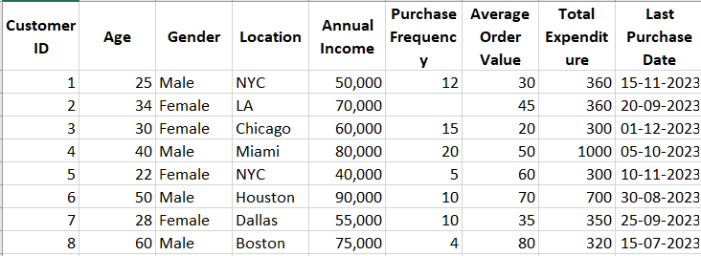

**STEP: 1**

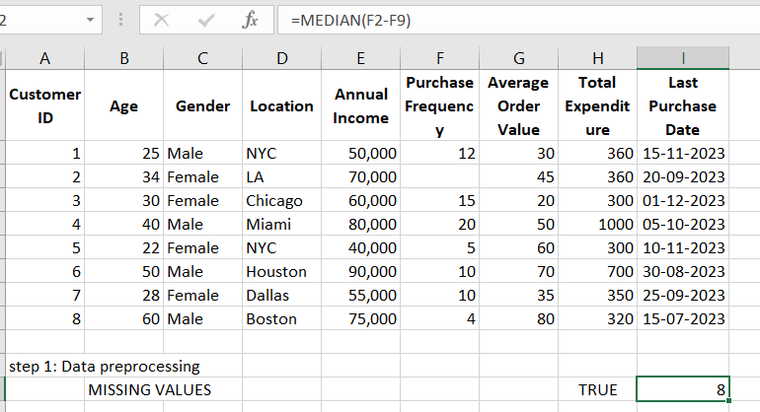

**STEP:2**

**Not required**

**STEP:3**

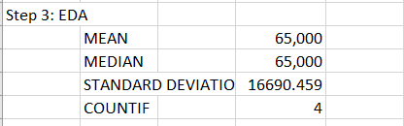

**STEP: 4**

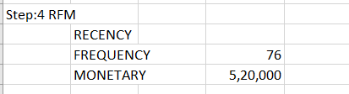

**STEP: 4**

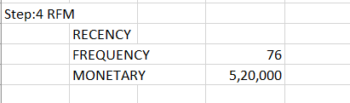

**STEP:5**

