**CSE1901 - Technical Answers to Real World Problems (TARP)**

**Project Report**

**DIGITAL ELECTRIC METER READING USING AUTOMATIC IMAGE CAPTURING SYSTEM**

*By*

19BCE1519 Devansh Kumar

19BCE1576 Ayushi Jain

19BPS1054 Priyadarshini S

19BAI1051 Akshat Sai Kadam

19BPS1108 Kaavyaa R M

B. Tech Computer Science and Engineering

*Submitted to*

**Dr. Geetha S**

**School of Computer Science and Engineering**



*April 2022*

**DECLARATION**

I hereby declare that the report titled “**DIGITAL ELECTRIC METER READING USING AUTOMATIC IMAGE CAPTURING SYSTEM”** submitted by me to VIT Chennai is a record of bona-fide work undertaken by me under the supervision of **Dr.Geetha S**, School of Computer Science and Engineering, Vellore Institute of Technology, Chennai.

Signature of the Candidate

 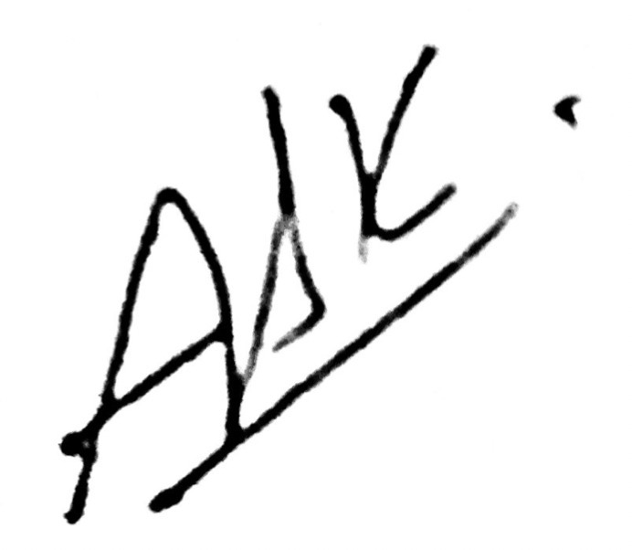

**Priyadarshini S Akshat Sai Kadam**

**Reg. No. 19BPS1054 19BCE1051**

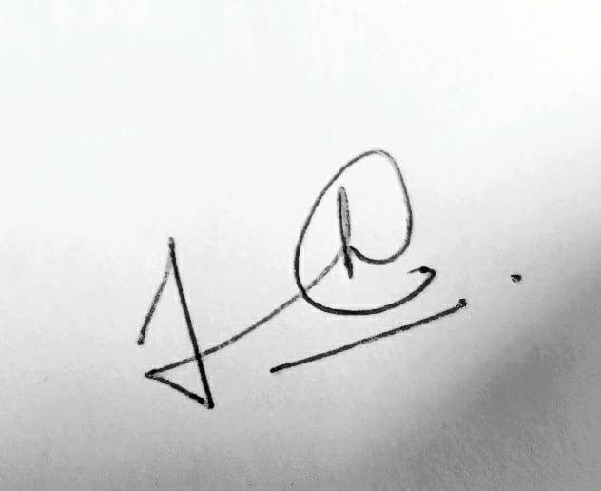

**Kaavyaa R M Ayushi Jain Devansh Kumar**

**Reg. No. 19BPS1108 19BCE1576 19BCE1519**

i

**CERTIFICATE**

Certified that this project report entitled “**DIGITAL ELECTRIC METER READING USING AUTOMATIC IMAGE CAPTURING SYSTEM”** is a bonafide work of **Priyadarshini S(19BPS1054), Ayushi Jain(19BCE1576) , Devansh Kumar(19BCE1519), Akshat Sai Kadam(19BCE1051), Kaavyaa R M(19BPS1108)** and they carried out the Project work under my supervision and guidance for CSE1901 - Technical Answers to Real World Problems (TARP).

**Dr.Geetha S**

SCOPE, VIT Chennai

ii

**ACKNOWLEDGEMENT**

We are thankful to Prof **GEETHA S** for providing me with her valuable guidance and spending her valuable time to help us accomplish this report on DIGITAL ELECTRIC METER READING USING AUTOMATIC IMAGE CAPTURING SYSTEM.

.

We take this opportunity to thank our management of the Vellore Institute of Technology for their continuous support and encouragement.

Signature of the Candidate

 

**Priyadarshini S Akshat Sai Kadam**

**Reg. No. 19BPS1054 19BCE1051**



**Kaavyaa R M Ayushi Jain Devansh Kumar**

**Reg. No. 19BPS1108 19BCE1576 19BCE1519**

iii

**ABSTRACT**

The extraction of data from meters is the first stage in the smart grid era. Data extraction from non-communicable meters has traditionally been done by hand. Utilities are contemplating a mass rollout of smart meters to give entire smart solutions to customers, which has been estimated to be a costly affair, as they plan to completely replace the existing perfectly working meters. We proposed a method that analyzes the snapshot of an analogue meter to automatically retrieve the data from utility meters. Furthermore, it sends extracted data to both customers as well as suppliers. However, there are several issues that have been highlighted in previous work such as the issue of accuracy of the digit extraction from the meters and the feedback loop using a hybrid of the camera and digital reading to continuously improve the accuracy. This research work is focused on providing better accuracy for the digit extraction as well as an efficient framework to completely digitalize the meter reading task and overall help in monitoring the energy in a community-based distribution network.

**Keywords**— image processing, image data retrieval, digit recognition, meter reading framework

iv

**CONTENTS**

Declaration i

Certificate ii

Acknowledgement iii

Abstract iv

1 Introduction 1

2 Literature Survey 2

3 Proposed Work 4

4 System Design 9

5 Results and Analysis 11

6 Conclusion and Future Works 12

7 References 13

v

**1. Introduction**

**1.1 Objective and goal of the project . . . . . . . . . . . . . . . . . …….1**

The Goal of the project is to evaluate the existing methods and algorithms of image based digit extraction from electric meters and suggest a better and efficient framework and method for developing the Automatic meter reading system.

**1.2 Problem Statement. …. . . . . . . . . . . . . . . . . . . . . . . . . . . . . . 2**

Utilities are contemplating a mass roll out of smart meters to give entire smart solutions to customers, which has been estimated to be a costly affair, as they plan to completely replace the existing perfectly working meters which has estimated to cost around 2500 crore rupees. This is a huge amount and therefore tons of research has been put into developing a smart system that has great accuracy and also is cost effective.

**1.3 Motivation . . . . . . . . . . . . . . . . . . . . . . . . . . . . . …………...3**

With the advancement of technology, reading electrical data through meters has become increasingly important. Automatic meter reading is the process of reading data

from a meter utilizing electronics, a computer network, and sensors and then processing it. The current system of manually reading data from meters by sending a person door to door has a number of drawbacks, including incorrect readings, estimated readings, and late readings[1].

Furthermore, it necessitates a significant amount of manpower and energy. As a result, an automatic meter reading system is required as is being planned to be made mandatory by the government of India[2].

The vast majority of the meters in use are inherently noncommunicable. To read electrical data, old meters would have to be replaced with communicable meters, requiring a change in the existing installation.

This research work is focused on providing better accuracy for the digit extraction as well as an efficient framework to completely digitalize the meter reading task and overall help in monitoring the energy in a community-based distribution network.

**1.4 Challenges . . . . . . . . . . . . . . . . . . . . . . . . . . . . . …………....5**

The extant research work is somewhat limited so therefore new frame work needs to be suggested from its foundation.

The digit extraction module of the project needs to be as accurate as possible to avoid dissatisfaction.

There are different module of the project which need to work in co-ordination with each other for the framework to be executed seamlessly.

**2. Literature Survey**

With the advancement of technology, reading electrical data through meters has become increasingly important. Automatic meter reading is the process of reading data

from a meter utilizing electronics, a computer network, and sensors and then processing it. The current system of manually reading data from meters by sending a person door to door has a number of drawbacks, including incorrect readings, estimated readings, and late readings[1].

Furthermore, it necessitates a significant amount of manpower and energy. As a result, an automatic meter reading system is required as is being planned to be made mandatory by the government of India[2].

The vast majority of the meters in use are inherently noncommunicable. To read electrical data, old meters would have to be replaced with communicable meters, requiring a change in the existing installation. As a result, reading meters becomes difficult and a more expensive task, proved by the allocation of Rs22500 crore for this particular project[3]. A solution that allows for accurate, easy and comparatively inexpensive reading of the meter while also not disrupting the current configuration is required.

Because it must dependably extract text information from images collected under varying settings, Automatic Meter Reading overlaps with other Optical Character Recognition (OCR) applications, such as license plate recognition and robust reading. Despite the fact that AMR is not as well-known in the literature as these applications, a sufficient number of papers have been published in recent years.

There are two main stages identified in the implementation of image-based digital meter reading systems. The first one is the image capturing system which is followed by digit recognition and extraction.

There were several methods researched and suggested for the purpose of capturing the image of the digital meter. One suggested connecting a camera to a raspberry pi which is a single board computer. The camera sends the image to the raspberry pi which then uses wifi to wirelessly upload the image to the cloud-like dropbox from where the further steps involved in the image processing take place[4]. However, there are a few points of friction such as a raspberry pi is quite expensive to deploy. Also, there has been no mention of where the image processing algorithm is deployed and where the processing is taking place. Another methodology that was discussed involved using the camera to capture the image and directly moving on to Google’s Optical character recognition algorithm/service. There are several holes in the proposed method such as no mentioning of how the camera will be transferring the image or which protocol would be used. Another problem is using Google OCR which is a general-purpose algorithm and not specifically made for extracting digits from a digital meter, hence there is a big accuracy issue[5].

There has been some research work done in using wireless sensor networks for the purpose of transferring of images which solved the bandwidth problem, enabling sending of 150 KB to 4 bytes of images over the internet. However, the image processing algorithms are suggested for the pointer-based electric meters which have already been replaced with the numerically-based ones hence the use case has been very limited[6]. Another major work was done using Deep Learning to read the electric meters based on R-CNN and Fast YOLO(you only look once) algorithm however again limited in the use case as it is only implemented for the pointer-based electric meters. This paper also goes into detail about the several edge cases or conditions under which the image reading becomes difficult such as neighbour value(mistaking the numbers for the neighbouring digit), dirt and flashing light. Such conditions must be taken into account while developing the image processing algorithms[7].

There has been a suggested mechanism for capturing images and sending the data using the ZigBee module. But had a major drawback due to the ZigBee module's limited range. Because of this limitation, it is difficult and not feasible to use the protocol to deploy in remote areas and monitor from a central point[8].

As suggested in [14] there are three main phases of Automatic meter reading using image processing namely (i) counter detection, (ii) digit segmentation and (iii) digit recognition.

Counter detection is the most important stage, as its accuracy and processing speed dictate the total accuracy and speed of the automatic meter reading system.

For counter detection, many pioneering systems used vertical and horizontal pixel projection histograms. [15], [16] The rotation of the counter can readily impact projection-based approaches. References [13], [12] made advantage of prior knowledge such as the position and/or colours of the counter (e.g., green background and red decimal digits). These systems have a number of drawbacks, including the fact that they may not operate with all types of meters and that the colour information may not be stable when the lighting changes. The use of template matching [17] and the AdaBoost classifier are examples of such works. [18]As low-level feature descriptors, normalized gradient magnitude, Histogram of Oriented Gradients (HOG), and LUV colour channels were used.

For digit segmentation, projection and colour-based techniques have also been frequently used[9][10][11]. The use of morphological techniques in conjunction with Connected Components Analysis (CCA) was examined in [12]. However, because it cannot segment digits accurately if they are connected or broken, it has the disadvantage of relying heavily on the outcome of binarization[8]. While Gallo[13] used Maximally Stable Extremal Regions, a binary digit/non-digit Support Vector Machine (SVM) was used in a sliding window form in a binary digit/non-digit binary digit/non-digit binary digit/non-digit binary digit/non-digit binary digit/non-digit binary digit/non-digit binary (MSER). The MSER algorithm was unable to correctly segment digits in images with blurring and perspective distortions.

For digit recognition, template matching and basic metrics of similarity [19][10][11] have been widely utilized. However, it is well understood that if a digit deviates from the template due to font change, rotation, or noise, this approach will result in inaccurate recognition. [20] As a result, numerous writers have used an SVM classifier to recognise digits. In Refs. [16], [21], simple features like pixel intensity were employed in training, but in Refs. [13],[17], HOG descriptors were used as features. Although some promising results have been obtained, it should be highlighted that determining the right SVM classifier hyper-parameters as well as the optimal features to be extracted is not easy.

**4 Proposed Work**

There are three different stages of the Automatic Meter Reading system as explained in the figure 1.



Figure 1 Stages of Automatic Meter Reading System

**Image Capturing**

This step has two constraints which need to be abided by. The first one is the cost, as the intention is mass applicability, smartphone cameras can’t be used as suggested in [10] as it is going to increase the cost of deployment. However, as smartphones have a built-in wifi module, it doesn’t require an external one, but it is essential for the suggested method in this paper.  
  
**Hardware requirements**

1. Camera Module
2. Interface Board
3. Microcontroller[22]
4. Battery

A great camera module can be acquired for around ₹300, one of the suggested models is CMOS Ov7670. Another component which is required is the EPS-32 development board. This is a wifi and Bluetooth enabled development board which is capable of handling small programmable tasks along with uploading timely images to the cloud. The built model can be[26] programmed to take a timed monthly photograph and can be uploaded wirelessly to the cloud[27].

To ensure that the uploaded photographs are clear of noise, and background disturbance the module should be programmed to take up to 10 different images within a 10 minute period. This ensures the highest possibility of recording the most appropriate image and therefore increases the accuracy of the system.

**Image Transfer**

EPS-32 development board provides a programmable, WiFi-enabled microcontroller. ESP-WROOM-32 fig 2 [26] module on the development board is powered by a Tensilica Xtensa® Dual-Core 32-bit LX6 CPU. This processor includes two CPU cores (each of which can be operated separately), a clock frequency of 80 to 240 MHz, and a performance of up to 600 DMIPS.[26]

There's also 448 KB of ROM, 520 KB of SRAM, and 4MB of Flash memory (for software and data storage), which is just adequate for web pages, JSON/XML data, and other long strings.

WiFi Direct is also supported by the ESP32,[26] which is a suitable alternative for peer-to-peer connections that don't require an access point. WiFi Direct is easier to set up and has substantially faster data transmission.

**Power requirements**

The board has an LDO voltage regulator to maintain the voltage stable at 3.3V, while the ESP32's operational voltage range is 2.2V to 3.6V. It can supply up to 600mA with no problems.

The on-board MicroB USB port provides power to the ESP32 development board. If you have a controlled 5V voltage source, you can use the VIN pin to power the ESP32 and its peripherals directly.

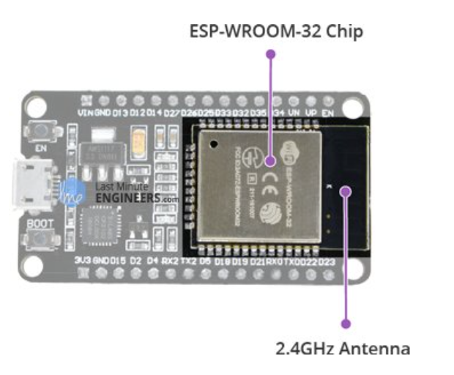

**Image Processing**

Three main algorithms will be deployed in the cloud which will be simultaneously working on the input image to isolate digits from the electric meter as shown in the figure.



Lightweight CNN Based Algorithm[22]

Because OpenCV handles black and white images fast, the acquired image is first converted to black and white. This minimizes the size of the image, making further processing easier.

Processing on the image is convenient, i.e., detecting the digital display from the meter. The Gaussian filter is used to smooth out the image and then scale and remove any noise from the image obtaining the edged image using Canny edge detection. In computer vision, canny edge detection is commonly employed.

The recognition of digital digits is based on a lightweight DNN.The proposed algorithm works by merging two separate convolution techniques,

Depthwise and pointwise convolutions are used for filtering and combining, respectively. Depthwise convolution separates the picture and filters into three channels, each of which is subjected to the convolution operation. Normal convolution is the same as pointwise convolution, but the combining operation is done with a 1x1 filter. The size of the model is reduced and computing costs are reduced when separable convolution is used.

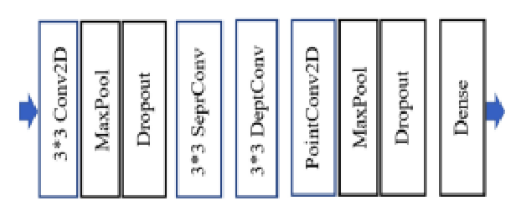

Template Matching Algorithm[23]

Digit segmentation is proposed as a method of producing six segmented digits by scanning the cropped numeric area vertically and horizontally from left to right. Then, to make the recognition stage easier, resize all segmented digits to make them similar in size.

Because the digit recognition technique is reliant on the quantity of white pixels, all segmented images are scaled to 32x32 images to ensure that the white pixel range on all digits does not exceed 1024 pixels. Feature extraction and template matching are the two steps in the stage of digit recognition.

**Feature extraction**

Take a few segmented photos of the meter reading digits and use them as templates to extract various features. Each digit requires one sample, which implies 10 segmented photos representing ten different digits must be used as templates. Start with the initial zero digit template, divide it into four quadrants, then compute the number of white pixels in each quadrant (q1, q2, q3, and q4). Then, for the remaining nine samples, repeat these processes. For each digit, four values are generated for the four quadrants, and these values are saved for future comparison.

Template Matching takes the six segmented digits, divides each digit image into four quadrants and calculates the number of white pixels in each quadrant q1, q2, q3, q4. Assume for a digit image X, we calculate difference values *DVi*

as in (1):



Where *qjX* and *qjT* are the numbers of the white pixels in

quadrant *j=1,2,3,4* for the segmented digit image and the template respectively. We end up having ten *DV* values.

The segmented digit is recognized to be digit *i* with the

minimum *DVi* value.

MSER Algorithm[24]

In order to detect text sections in an image, the MSER technique is utilized. On unstructured scenes, MSER detection is a common task. The regions are determined purely by the intensity function's extremal feature in the region and on its outer boundary. The MSER is made up of the location of a local intensity minimum (or maximum) as well as a threshold.

The MSER method has the advantage of being well-suited to locating text character candidates. The MSER algorithm is invariant to affine transforms, which can be used on low-quality images.

**4. System Design**

The main issue with the previous automatic meter reading system has been with the accuracy of the meter readings. For the successful implementation

of the proposed method, there should be near 100% accuracy for customer satisfaction. Fig 4 provides an efficient system design for the purpose of overcoming this particular challenge

The three algorithms i.e. Lightweight CNN, Template-based and MSER are all based on the concept of digit segmentation i.e the method of separating and isolating each digit from the adjacent digits. This step is crucial for the proposed method as the first step after selecting the best out of 10 images is to implement digit segmentation and identify all the separate digits from the meters.

Once the separate digits are identified, each digit obtained from all the three algorithms will be matched and if all the digits match then the extracted data

will be sent for further processing. However, if there is a mismatch then the position of the mismatch will be noted and the original image will be cropped around

that particular digit and then the cropped image will be run through the three algorithms for identification. This particular step will provide a much clear image

for the purpose of extraction of the data. If the digit obtained after this particular step matches all three algorithms the original number will be updated with the newly identified digit.

However, if there are still differences in the extracted digits the entire image with the highlighted error digit will be updated to the admin page where a human can update the error digit which then can be fed into the dataset to be utilized to train the models for improving the accuracy.



Solving the Dataset Problem

The previous works have highlighted the pertaining issue of the lack of real-life datasets. This issue can be resolved by utilizing the already existing smart electric meters. There are currently 3.73 million smart electric meters in India according to the National Smart Grid Mission[25].

If each of the smart electric meters is fitted with the automatic image capturing system and cross-reference the digit extracted from the captured images with the physical readings of the smart meters and then feeds the images and the correct reading to a collective dataset a large and accurate dataset could be developed which then can be used to refine and fine-tune the learning model.

**5. Results and Discussion**

| Isolated Algorithms | Accuracy |
| --- | --- |
| Lightweight CNN | 93% |
| MSER | 96.5% |
| Template Matching | 94.5% |
| Proposed Method | 98.5% |

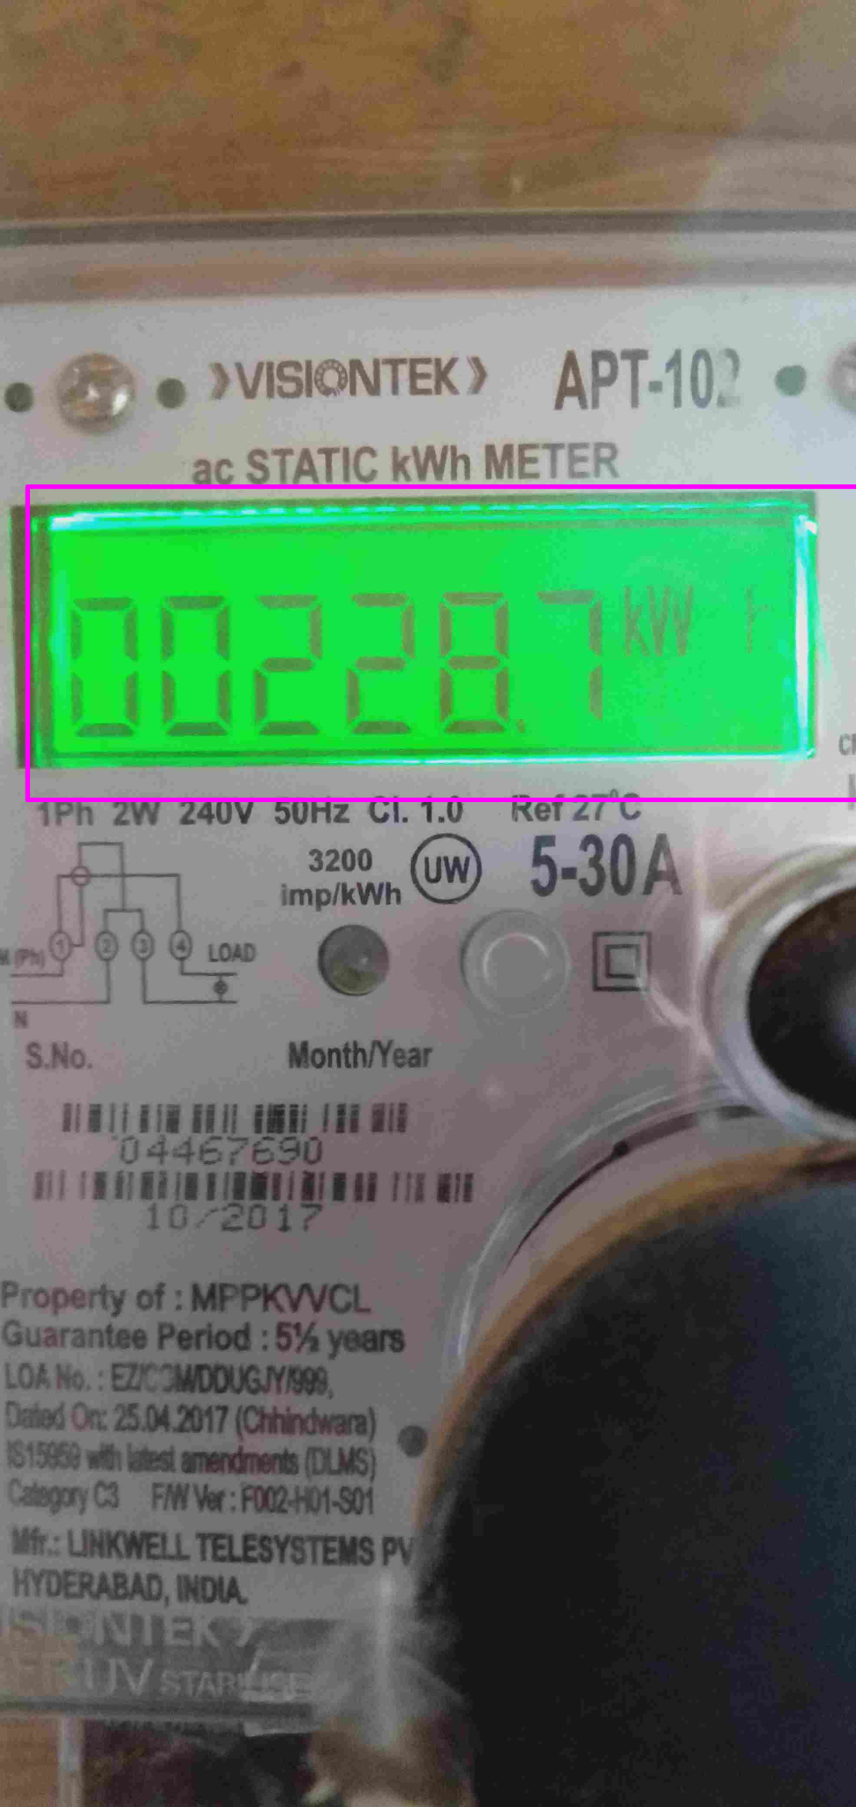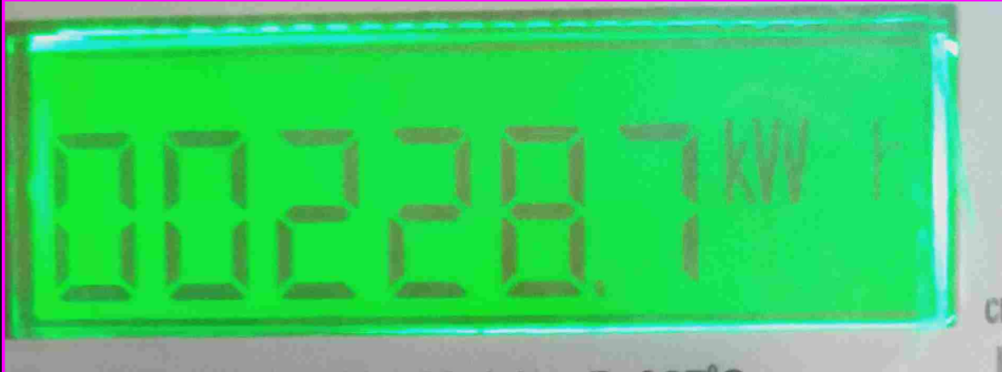

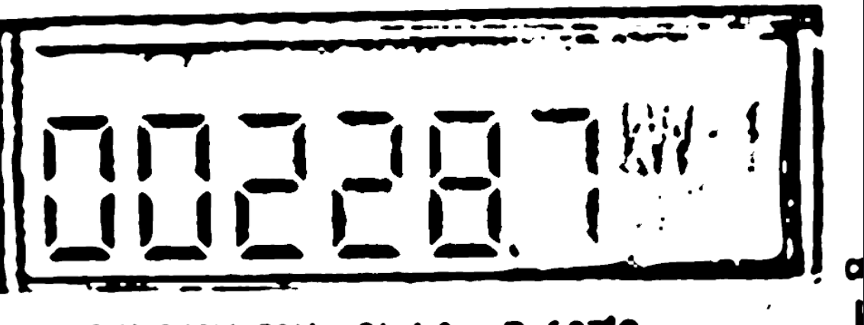

**6. Conclusion and Future Work**

There have been several proposed methods to solve this particular problem of automatic image-based meter reading however all of those work depends on only one algorithm and are mostly non-iterative in nature which has resulted in not maximizing the accuracy. There is also an issue of lack of real life dataset of meter readings due to which the model accuracy was not improving and it failed to work in real-life scenarios (with background and foreground disturbance such as flashing light dust etc). The proposed method utilizes 3 different algorithms and finds the discrepancies and iterates through a higher quality image again. It also creates a system for real-life datasets with the utilization of already installed 3.73 million smart electric meters. Overall the proposed method is sure to improve accuracy in multiple ways upto 98.5%.

**7**. **REFERENCES**

[1][D. Shu, S. Ma, and C. Jing, “Study of the automatic reading of watt meter based on image processing technology,” in 2007 2nd IEEE Conference on Industrial Electronics and Applications. IEEE, 2007, pp. 2214–2217.

[2]<https://www.livemint.com/news/india/govt-notifies-timeline-to-replace-existing-meters-with-smart-prepaid-meters-details-here-11629379333801.html>

[3]<https://www.financialexpress.com/industry/govt-earmarks-rs-22500-crore-for-smart-pre-paid-meters-under-new-discom-scheme/2295876/>

[4] Simran Bajaj, Charan Teja, Pradeep kumar, 2020 First International Conference on Power, Control and Computing Technologies, IEEE 3-5 Jan. 2020

[5]Shrutika Tirpude , Hitesh Murkute , Yogesh Likhar,, R. M. Bhombe, IJESC, Volume 11 Issue No.05

[6]Hou, L., Zhang, Q., & Qu, H. (2021). Automatic reading recognition system of pointer meters using WSNs with on-sensor image processing. Engineering Research Express, 3.

[7]Salomon, Gabriel & Laroca, Rayson & Menotti, David. (2020). Deep Learning for Image-based Automatic Dial Meter Reading: Dataset and Baselines. 1-8. 10.1109/IJCNN48605.2020.9207318.

[8]M. V. Shinde and P. W. Kulkarni, “Camera click energy meter reading system,” in 2015 International Conference on Pervasive Computing (ICPC). IEEE, 2015, pp. 1–4.

[9]. Zhang, S. Yang, X. Su,

et al., “Automatic reading of domestic electric meter: an intelligent

device based on image processing and ZigBee/Ethernet communication,”

Journal of Real-Time Image Processing 12,133–143 (2016).

[10]L. A. Elrefaei, A. Bajaber, S. Natheir,et al., “Automatic electricity meter reading based on image processing,” in IEEE Jordan Conference on Applied Electrical Engineering and Computing Technologies (AEECT), 1–5 (2015)

[11]M. Rodriguez, G. Berdugo, D. Jabba, et al., “HD MR: a new algorithm for number recogni-

tion in electrical meters,” Turkish Journal of Elec. Engineering & Comp. Sciences 22,87–96 (2014).

[12]M. Cerman, G. Shalunts, and D. Albertini, “A mobile recognition system for analog energy

meter scanning,” in Advances in Visual Computing, 247–256, Springer International Pub-

lisher (2016).

[13]I. Gallo, A. Zamberletti, and L. Noce, “Robust angle invariant GAS meter reading,” in

Inter-national Conference on Digital Image Computing: Techniques and Applications

, 1–7 (2015).

[14]Laroca, Rayson & Barroso, Victor & Diniz, Matheus & Gonçalves, Gabriel & Schwartz, William & Menotti, David. (2019). Convolutional Neural Networks for Automatic Meter Reading. Journal of Electronic Imaging. 28. 013023. 10.1117/1.JEI.28.1.013023.

[15]D. Shu, S. Ma, and C. Jing, “Study of the automatic reading of watt meter based on im

age processing technology,” in *IEEE Conference on Industrial Electronics and Applications*,2214–2217 (2007)

[16]V. C. P. Edward, “Support vector machine based automatic electric meter reading system,”in *IEEE International Conference on Computational Intelligence and Computing Research*,1–5 (2013).

[17]D. Quintanilha *et al.*, “Automatic consumption reading on electromechanical meters using HoG and SVM,” in *Latin American Conference on Networked and Electronic Media*, 11–15(2017).

[18]Y. Gao, C. Zhao, J. Wang, *et al.*, “Automatic watermeter digit recognition on mobile devices,”in *Internet Multimedia Computing and Service*, 87–95, Springer Singapore (2018).

[19]S. Zhao, B. Li, J. Yuan, *et al.*, “Research on remote meter automatic reading based on computer vision,” in *IEEE PES Transmission and Distribution Conference and Exposition*, 1–4(2005).

[20]S. Du, M. Ibrahim, M. Shehata, *et al.*, “Automatic license plate recognition (ALPR): A state

of-the-art review,” *Trans. on Circuits and Systems for Video Technology* **23**, 311–325 (2013).

[21]M. Vanetti, I. Gallo, and A. Nodari, “Gas meter reading from real world images using a

multi-net system,” *Pattern Recognition Letters* **34**(5), 519–526 (2013).

[22]Sharma, Akshay & Kim, Kyung. (2021). Lightweight CNN based Meter Digit Recognition. JOURNAL OF SENSOR SCIENCE AND TECHNOLOGY. 30. 15-19. 10.46670/JSST.2021.30.1.15.

[23]Elrefaei, Lamiaa A. et al. “Automatic electricity meter reading based on image processing.” *2015 IEEE Jordan Conference on Applied Electrical Engineering and Computing Technologies (AEECT)* (2015): 1-5.

[24]Kanagarathinam, K. and Sekar, K., 2019. Text detection and recognition in raw image dataset of seven segment digital energy meter display. *Energy Reports*, *5*, pp.842-852.

[25]<https://mercomindia.com/smart-meter-installations-grow-steadily/#:~:text=According%20to%20the%20recent%20data,meters%20as%20of%20January%202022>.

[26]<https://lastminuteengineers.com/esp32-arduino-ide-tutorial/>

[27]https://randomnerdtutorials.com/esp32-cam-video-streaming-face-recognition-arduino-ide/

\