5DATA005W DATA ENGINEERING
Tutorial Week 10

Reminder: Have you swiped your card? You can swipe in no earlier than 15 minutes before the tutorial and up to 15 minutes before your class ends. Ensure you see a green tick and your student ID number on the reader.

Tasks:
- Complete seminars for weeks 7, 8, and 9. Week 7 covered the ingestion of images and text; Week 8 covered image and text processing; Week 9 covered storage for image, text, and their metadata in MongoDB.
- Ensure you understand and can modify seminar materials, particularly for CWK2 assessment.

If you are done with Task 1 and Task 2.

- Create a GitHub account or sign in if you already have one.
- Create a public repository; you can name it UoW_Data_Engineering
- Create a readme file. In the readme, provide a good document briefly explaining what each week covered and what each folder you will be creating contains.
- Go to the Google account that is usually used to implement all seminars.
- Then go into the drive, and you will find all the seminar ipynb files. Download them all, alternatively, download all the weekly ipynb from BB
- Upload all the ipynb directly to your GitHub repo UoW_Data_Engineering.
- Click on commit when the upload is finished.
- Click on the repository and then click on code to start the GitHub codespace. A codespace is a development environment that's hosted in the cloud.

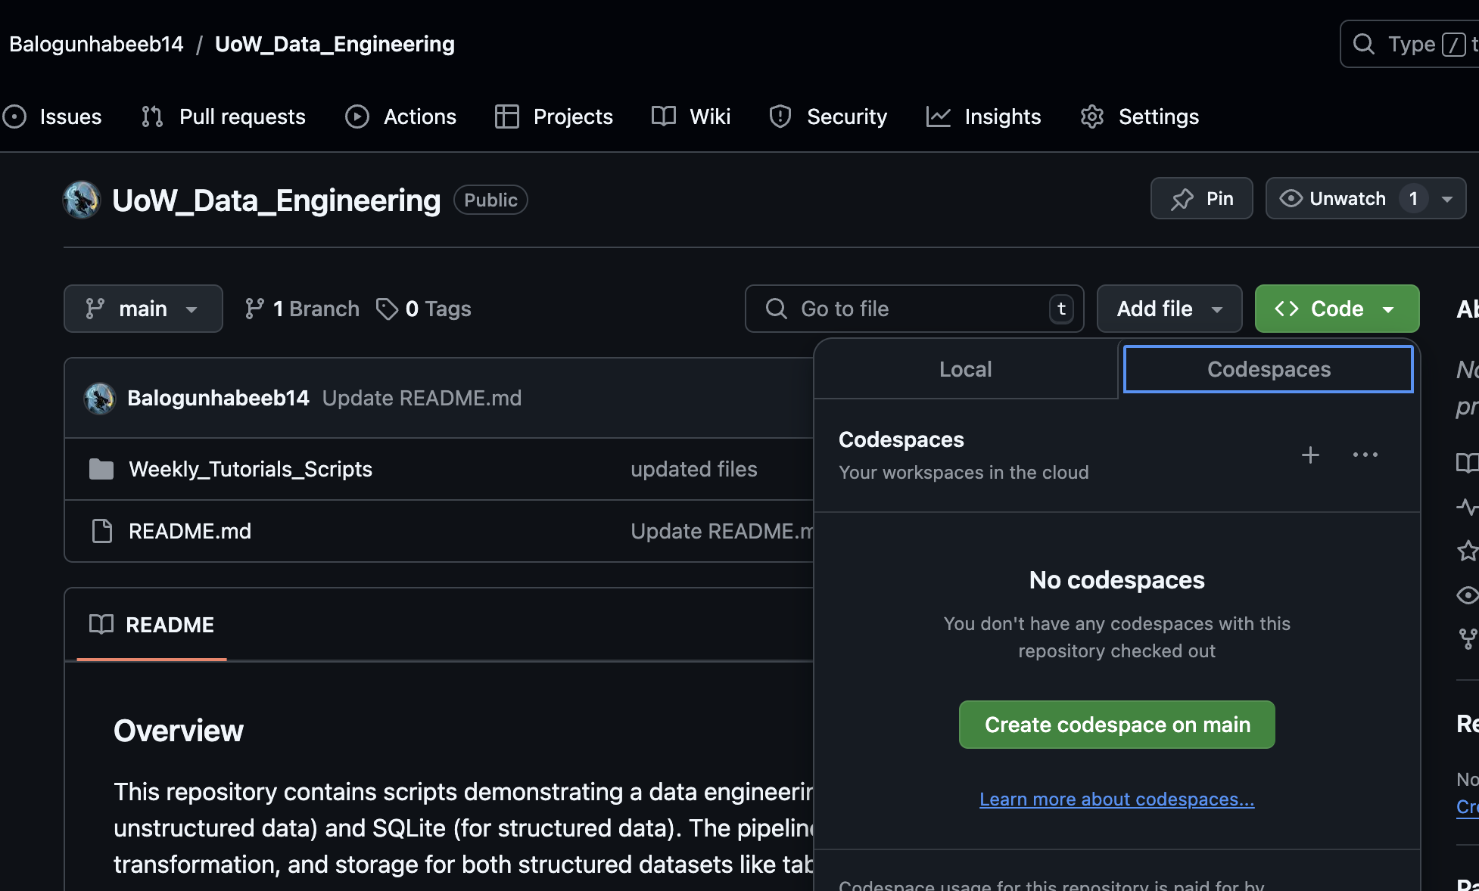

Like a typical visual studio code, the codespace will open on a new tab. It will ask to install Python and some plugins; allow that installation.

- Once the installation is done, go to the terminal.
- Check your current location and create a folder named Weekly_Tutorial_Scripts by typing.

- Move all the. ipynb in the root directory to Weekly_Tutorial_Scripts

- Add all the files and commit to the repository. Use the following commands, one after the other.

git add .
git commit -m ‘Created folder and added all the weekly scripts to it’
git push

- Once the push is complete. Close the Tab. Then, go to your repository to shut down the codespace by clicking on delete.
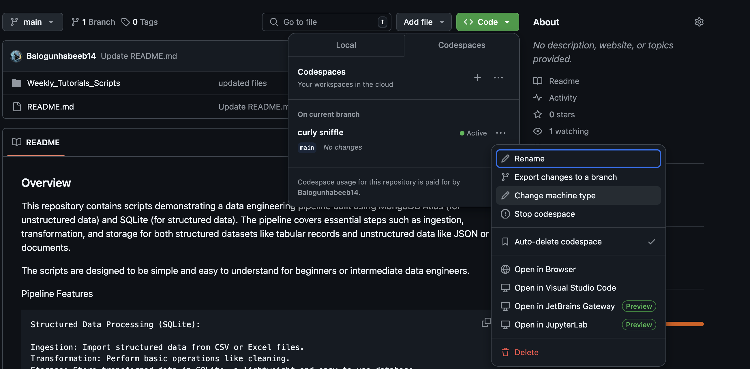

- Star UoW_Data_Engineering on my repository. Link

