5DATA005W DATA ENGINEERING
Tutorial Week 9: Unstructured data; storage

Reminder: Have you swiped your card? You can swipe in no earlier than 15 minutes before the tutorial and up to 15 minutes before your class ends. Ensure you see a green tick and your student ID number on the reader.

Objective: In this lab session, you will learn:
- Image data storage
- Text data storage

MongoDB is a NoSQL database management system known for its flexibility, scalability, and ease of use. Unlike traditional relational databases, MongoDB stores data in flexible, JSON-like documents, making it suitable for various applications.

This section will use MongoDB Atlas and Google Colab.

MongoDB Atlas is a fully managed cloud database service provided by MongoDB, offering a hassle-free way to deploy, manage, and scale MongoDB databases in the cloud.

Step 1. Register on MongoDB Atlas
- Visit the MongoDB Atlas website here.
- Click the “Try Free” button to create an account and follow the registration process.

Step 2: Setting up Users
- After logging in to MongoDB Atlas
- Create a new project, and select the project
- Navigate to the “Database Access” tab from the left sidebar.
- Click the “Add New Database User” button to create a new user
- Enter the username and password for the new user and assign appropriate permissions

Step 3: Setting up IPs
- In the MongoDB Atlas dashboard, go to the “Network Access” tab from the left sidebar.
- Click on the “Add IP Address” button.
- Add your current IP address to the whitelist to allow connections from your location.
- Add IP address: 0.0.0.0/0 to access the database from Google Collab

Step 4: Creating Clusters
- Go to the “Clusters” tab from the left sidebar and click on the “Create New Cluster”
- Choose the free cluster – M0, choose AWS as a cloud provider, Ireland as the region
- Click on the “Create Cluster” button to provision the cluster.

Step 5: Create a database and collection name
- Go to the cluster then click on add my own data
- Enter database and collection name. Enter one collection name while defining database.
- Come back to the created database, and click on the + to create another collection
- For the Image data, create CBIR db. and two collections: processed images and image metadata
- For the text data, create an NLP db. And two collections: processed doc and doc metadata
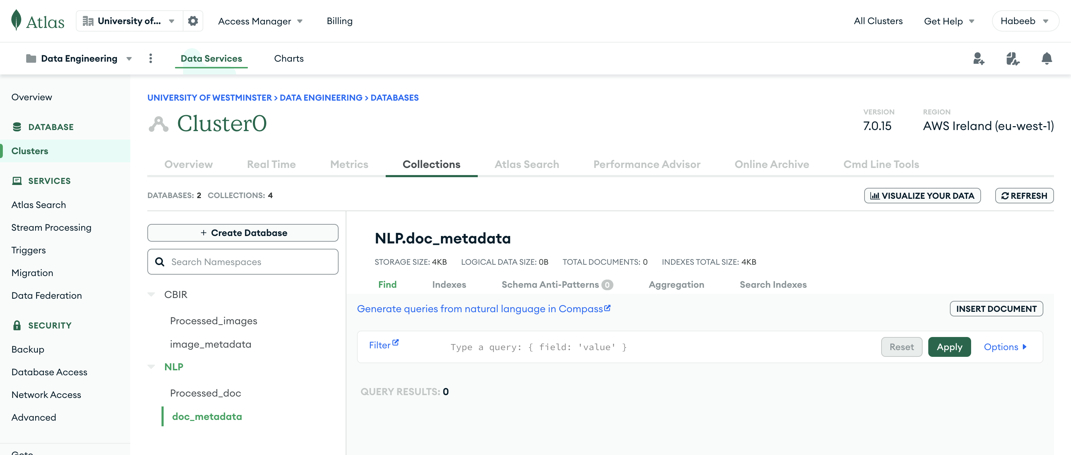

Step 6: Getting Connection String
- Once the cluster is created, click on the “Connect” button.
- Select “Connect Your Application” and copy the connection string provided. This string will be used to connect to MongoDB Atlas from Google Colab.
- Make sure you refer to the correct database and collection every time you make the connections

Step 7: Basic Installation
- Open Google Colab in your browser.
- Create a new notebook and name it week9_tutorial.

Step 8: Basic Installation
- In the first code cell, install the pymongo library by running ‘pip install pymongo’.
- Import the necessary libraries in the next code cell:

Step 9: Connect to MongoDB Atlas:
- Paste the connection string obtained from MongoDB Atlas into your code.
- Replace <password> with the password for the MongoDB user you created and <dbname> with the database name you want to connect to.
- Use the following code snippet:

Step 10: Accessing the Database:
- Once connected, you can access your MongoDB database and perform operations like querying, inserting, updating, and deleting data.

Step 11: Test the connection by listing the collections
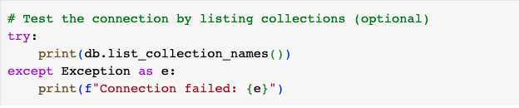

Step 12: Storing the Image metadata files into the database
- Upload the metadata file BB
- Select the collection where you want to query/load into the CBIR database
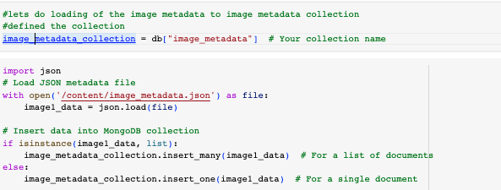

Step 13: Load the processed image data from a folder to the database
- Upload the image data folder from BB
- Select the collection where you want to query/load into the CBIR database

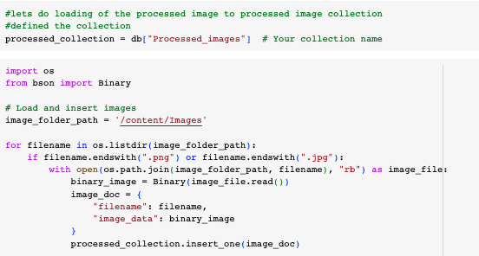

Step 14: Query the database to see if the processed image was loaded
- Let’s check if one of the images, for example, image12.jpg, is in the DB

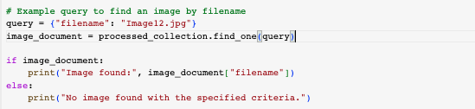

Text data storage in MongoDB Atlas
Building on the earlier connection created, metadata was loaded, and textual data from week 8 was processed in MongoDB.

Step 1: Create a new connection; refer to NLP as a database.
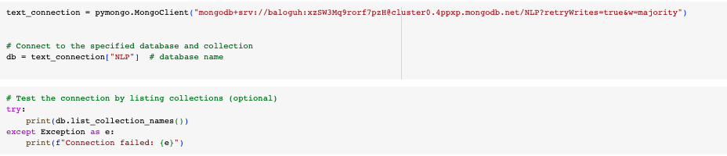

Step 2: load the metadata of the processed document file.
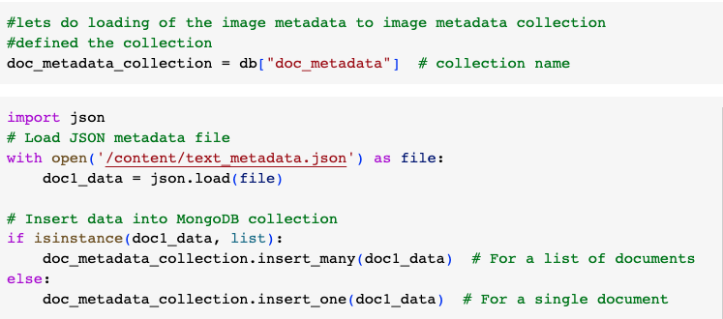

Step 3: load the processed document files
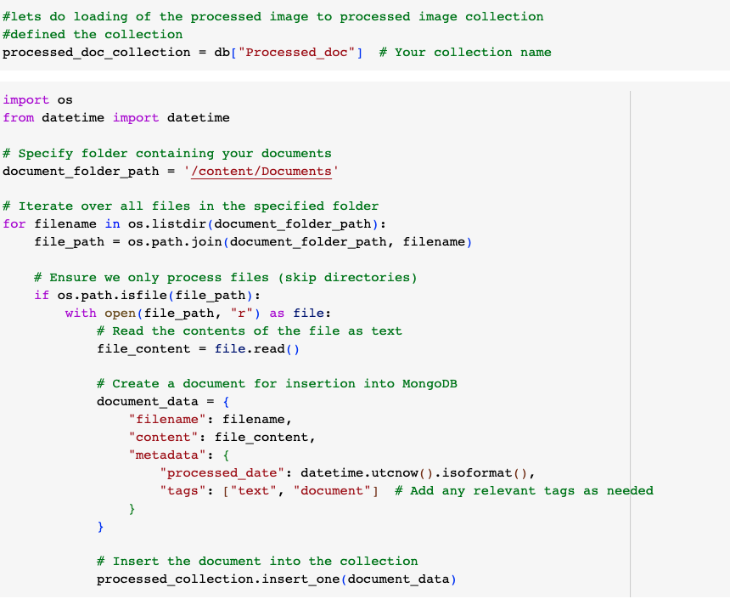

Extra activities.
This is part of the image texture extraction from week 8.
Here, Features like Contrast, and dissimilarity among others from GLCM are computed.
