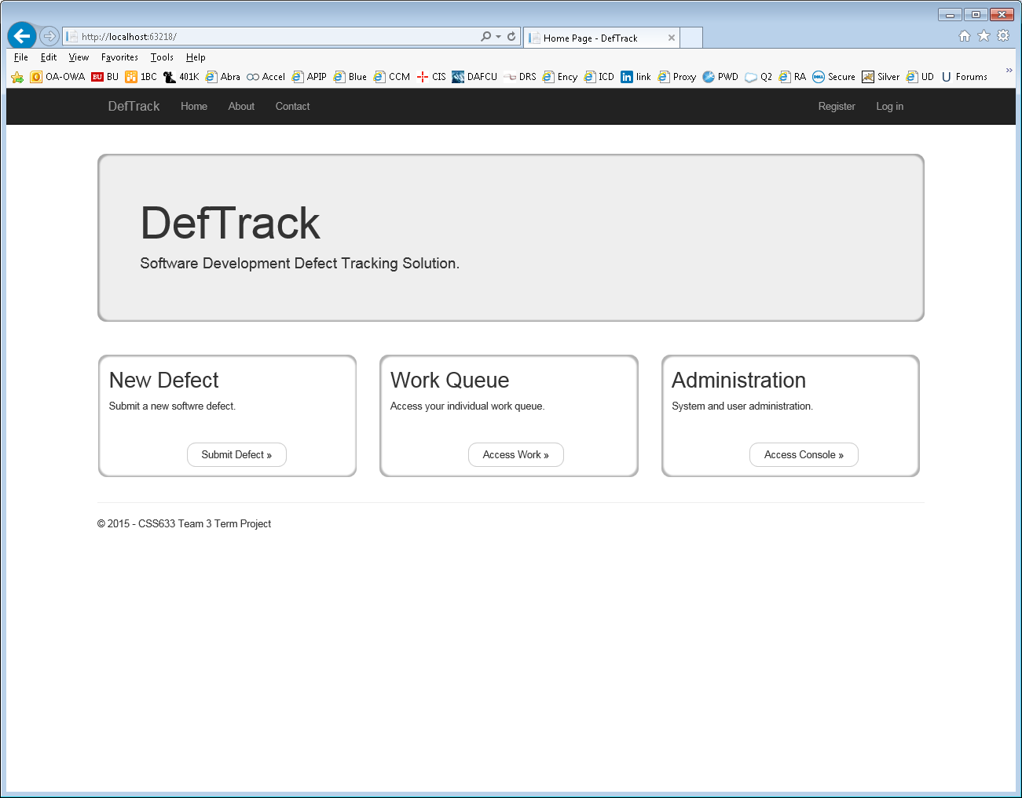

Record New Defect:

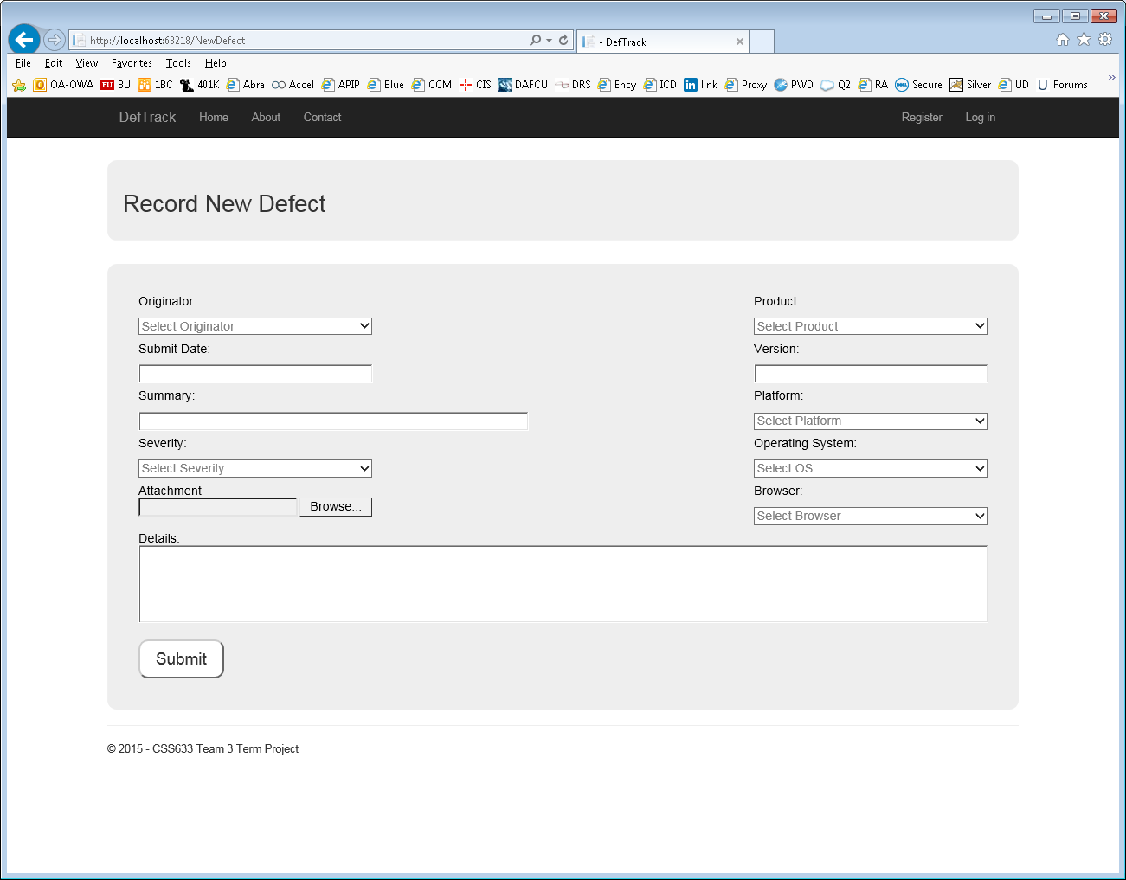

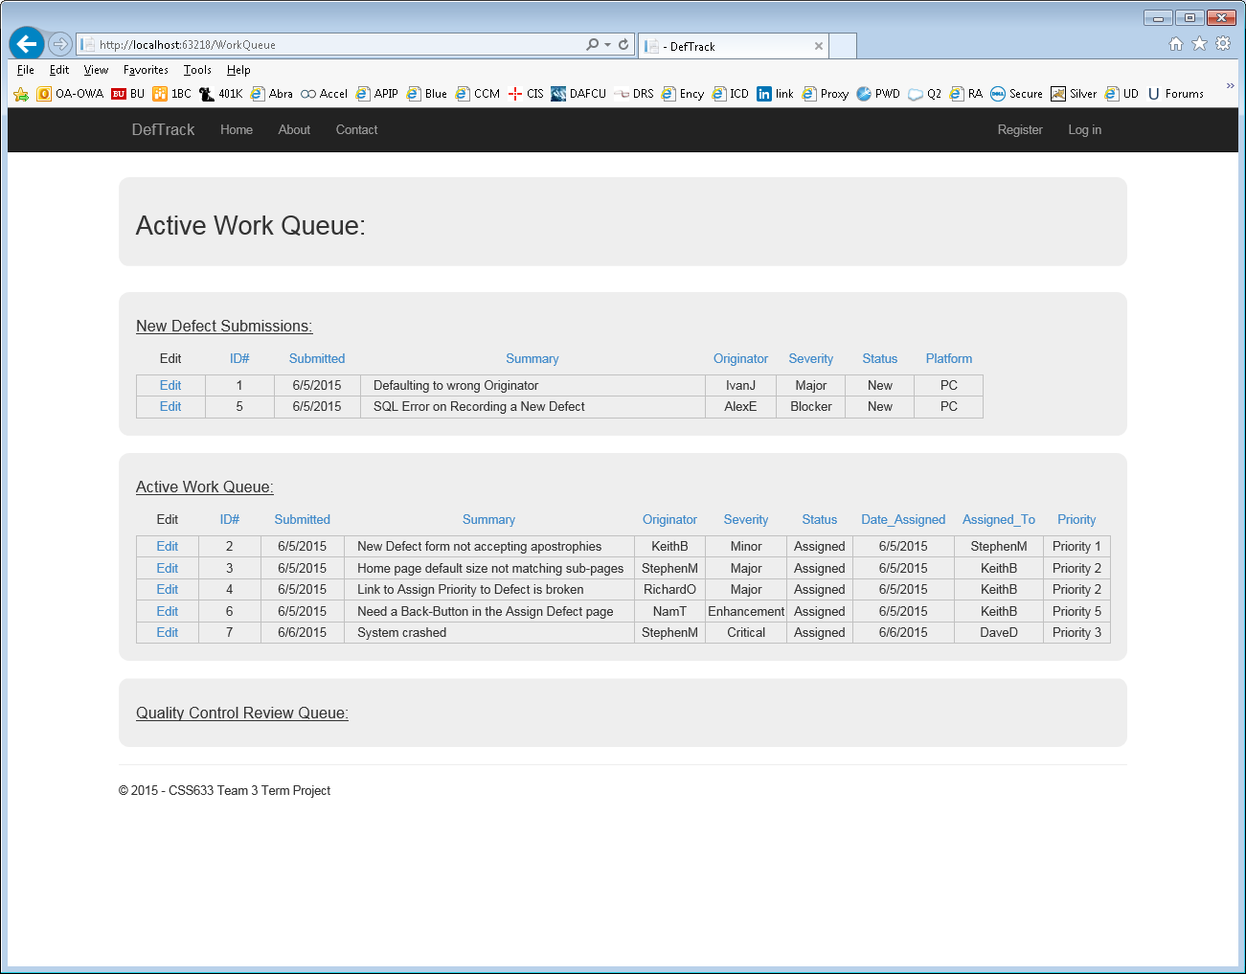

Active Work Queue page:

This page will have the following Queues:

* PM Queue (New Defect Submissions)
  + This Queue will display Defects with Status Code of New and Priority Level = NULL
* Lead Developer Queue
  + This Queue will display Defects with Status Code of New and Priority Level != NULL
* Developer Queue
  + This Queue will display Defects with Status Code of:
    - Assigned
    - Returned from QC (QC found an issue with defect resolution)
* Quality Control Queue
  + This Queue will display Defects with Status Code of:
    - Resolved (the status a developer loads when they are finished)
* Customer Acceptance
  + This Queue will display Defects with Status Code of:
    - Awaiting Customer Acceptance
    - Closed

Project Manager View – will split this off into two screens. One for the PM to assign Priority and one for the Lead Developer to assign to a Developer.

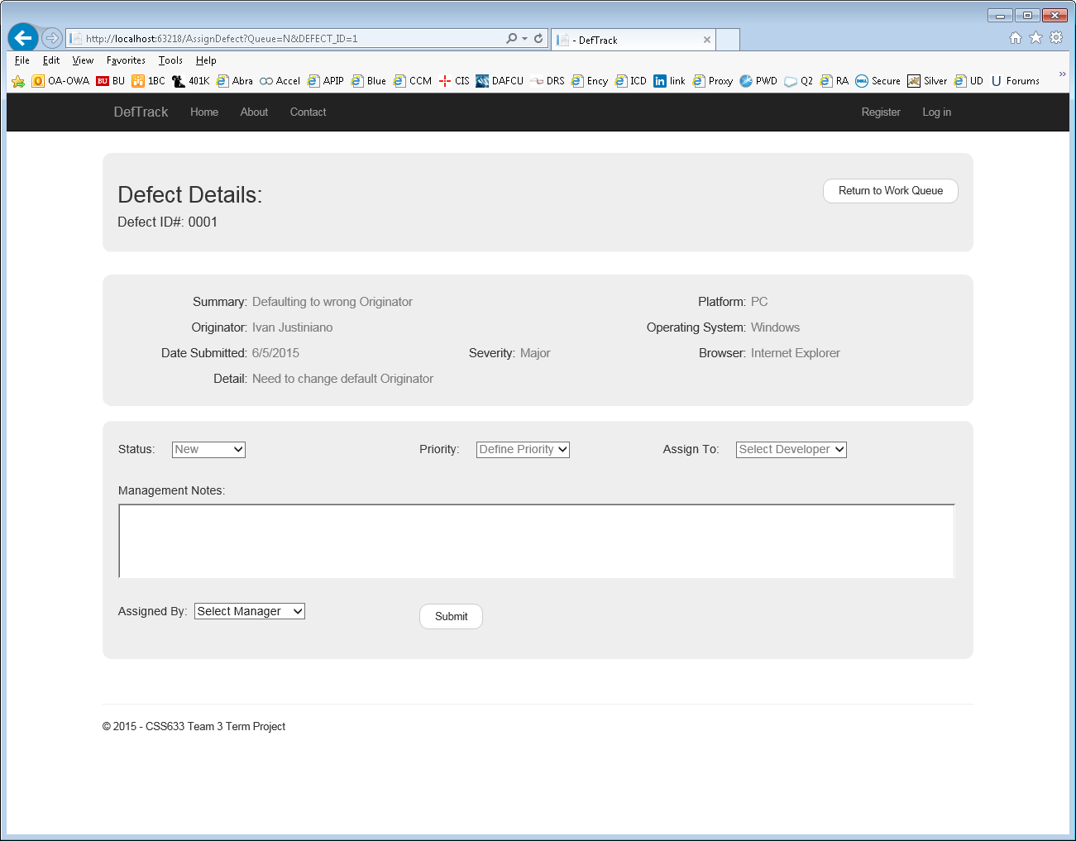

Developer Details page. Page will display:

1. Original defect posted by User
2. Priority set by PM with any comments PM includes
3. Assigned to and Notes entered by Lead Developer
4. Will have an area for Developer to make notes and update status
5. If Developer goes into work order multiple times, screen will display all former Developer comments in chronological order.

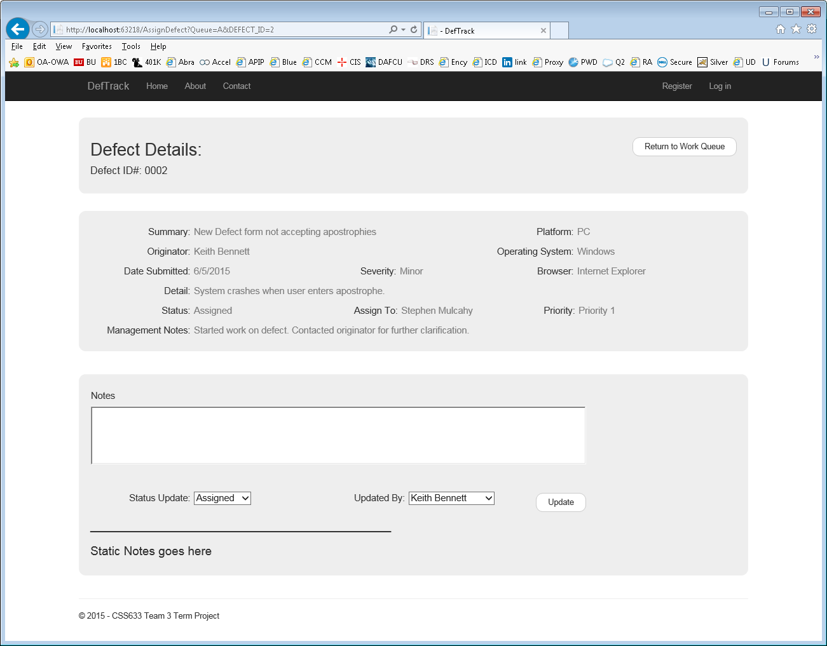

Quality Control Review Page:

This will show everything from all previous steps of the workflow. All fields will be read-only.

The QC person will have their section to add comments and update Status. Will add a status of “Waiting User Acceptance”.

Register Page: Need to add the following fields:

* First Name
* Last Name
* Login ID

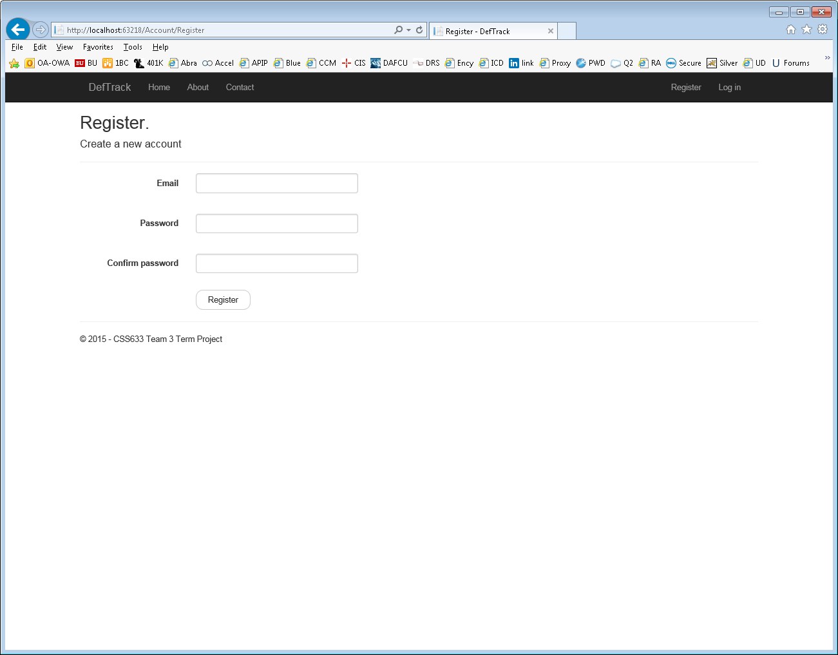

Login Page:

Will be changing “Email” to “Login ID” and will be removing the “Use another service to log in.)

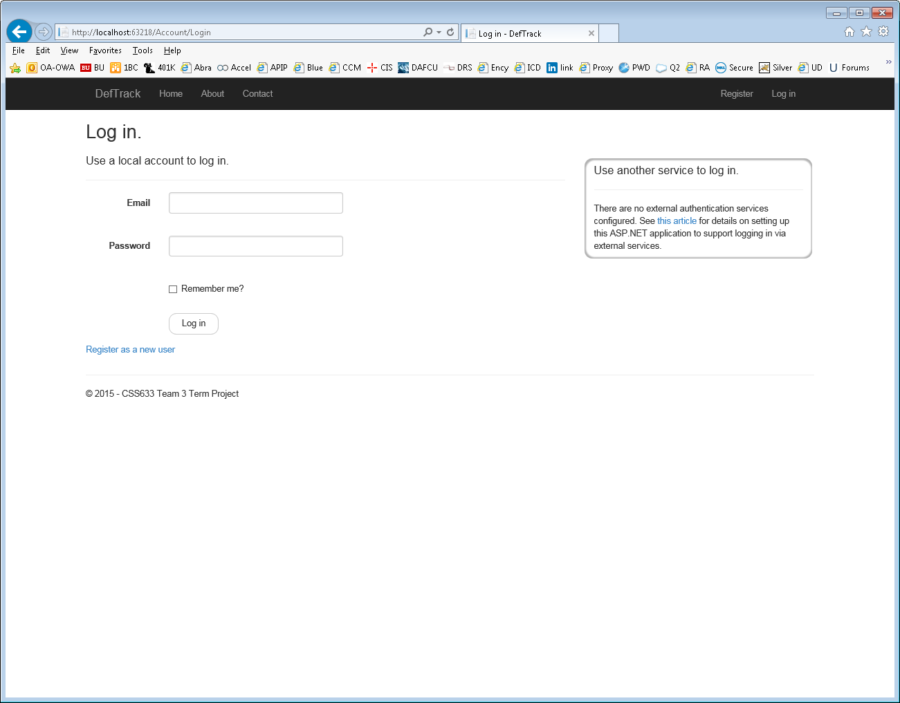

About Page:

Describes basic work flow.

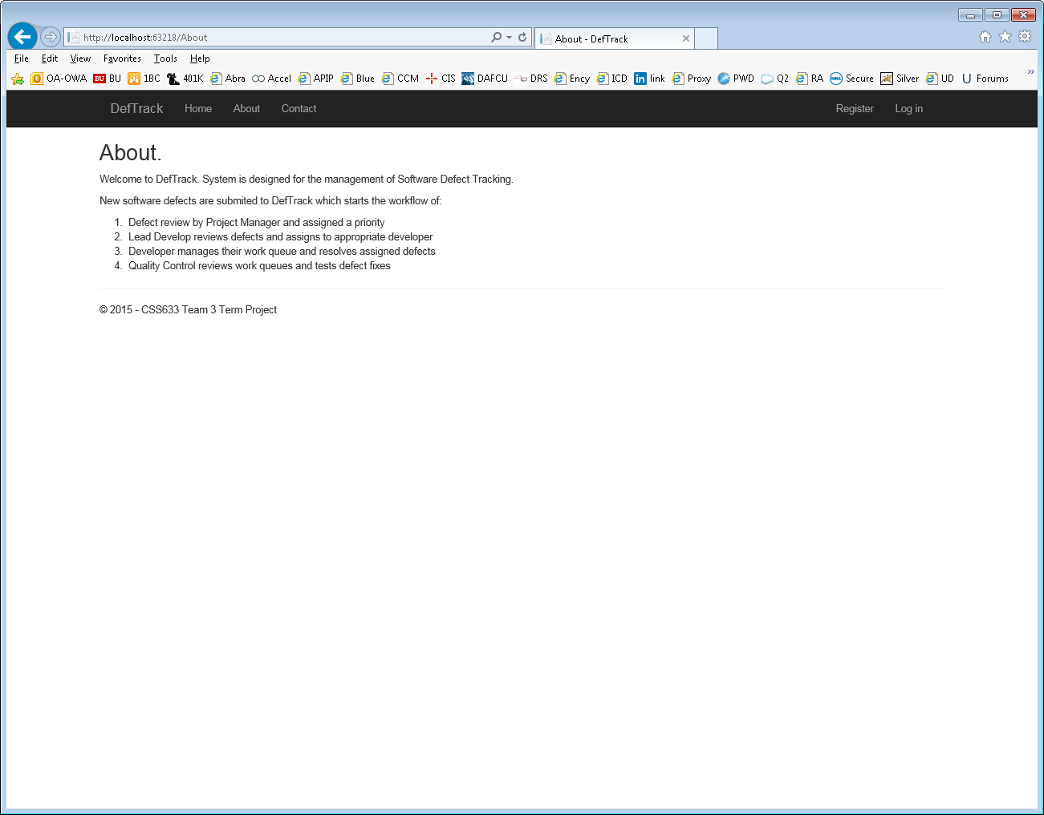

Contacts Page:

Displays Team Contact Info.

