In this unit Petra and Rémi will introduce you to the memory organization. You will better understand how a computer is organized and where the memory processes take place in the computer.

Discover the Von Neumann architecture

a computer's architecture is about what's inside a computer. The von Neumann architecture, used in all modern computers, is named after John von Neumann. This computer architecture is an abstract model that splits a computer into four distinct parts.
The first part is the arithmetic logic unit, also called ALU. Its role is to perform basic operations, such as plus, minus, times, division, as well as logical operations, such as and, or, and not.
The second part is the control unit that coordinates the operation and sequence of data movements between the other parts of the architecture.
Here's an example. Imagine we wanted to add two numbers stored in memory. The following sequence of operations will accomplish this task if it is performed in the given order. The timing of such a sequence of operations is crucial and is dictated by the control unit. Read the first value from memory. Read the second value from memory. Add the two values. Store the result of the addition back in memory.
Together, the arithmetic logic unit and the control unit form the so-called central processing unit, or CPU, of the computer.
The third part is the computer's memory. It serves both data and programs. Memory comes in two flavors, temporary memory, also called RAM, short for random access memory, and lasting memory, such as hard drives.
The final part of the Princeton architecture model consists of the computer's input and output. This enables communication between the computer and the external world, such as the user, peripherals, and even other computers.

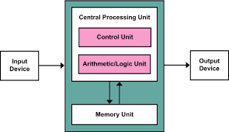

Memory representation, RAM, cells, word, byte, bit, memory address

One role of the computer's operating system is to manage the memory of the computer. The term memory refers to the hardware in the computer that is involved in storing information for use in the computer. We distinguish between two different types of memory.
RAM, short for Random Access Memory, is temporary memory that is easy and quick to access and, for example, used to execute programs. We also call this type of storage volatile memory.

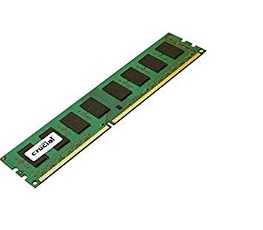

On the other hand, there is nonvolatile, or lasting memory for more permanent storage of data,
for example, used to store files on the hard drive.

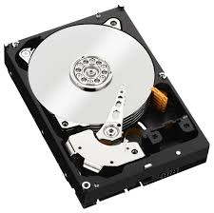

In the technical specification of a computer's hardware, you can see the distinction between the amount of storage available via the RAM and the available hard drive space.
The vast majority of computer programs uses the computer's RAM during execution. Values of variables, for example, are stored in – meaningful written to and read from – Random Access Memory. For simplicity, we may represent the Random Access Memory as a sequence of binary memory cells, each populated with a 0 or a 1. We call each such cell 1 bit. By grouping several of these cells or bits together, we create what is called a word. A word is the fundamental unit of data that can be moved between the RAM and the computer processor. The size of a word is thus expressed in number of bits – that is, number of memory cells – or in bytes. Recall that 1 byte equals 8 bits.
Modern personal computers and modern processors more ordinarily tend to use 8, 16, 32, or even 64 bits to form one word, though other word sizes are possible. These particular word sizes emerge historically as a result of the hardware architecture, but they have evolved over time.
Grouping memory cells into words allows for the addressing of memory. In fact, an address is assigned to each word. We also call this a memory address. The computer address is a whole number that describes the location of the word in the computer memory. For example, imagine the computer whose word length is 8 bits. Suppose, in addition, that this computer can store a total of four words. It's not a very big computer. One could then address the computer's memory by assigning an address to each of the four words, just like you would assign an address to each of four houses on a street. Each word gets a number as its address.
The address 0 would be used for the first word : that is, the first 8 memory cells. The address 1 would be used for the second word : the next 8 memory cells. The address 2 would be used for the third word, and the address 3 would be used for the fourth word.
In the C programming language, it is possible to get these memory addresses during the execution of a program. For example, if I use a variable in my program that stores an integer value, then not only could I find and use this value during my program, but equally well, I could obtain the memory location - that is, the address where the value is stored.
The use of memory addresses allows low-level access to the computer by allowing direct access to the computer's memory. One could literally move through the computer's memory from word to word. This technique allows for optimization of memory usage at a very precise level, or of performance in terms of execution speed. This is an extremely powerful tool for application developers.
So now you know that each variable has its own address, and that memory is composed of bits – cells – that are organized into words.

