Numerical Methods HW 4
Submitted by Tomer Catabi
The code used for all calculations and plots is attached (HW_4_numerical_methodes.py). It is divided into 3 sections (one for each question, separated by #%% cells); each section begins with the required functions for the relevant question and ends with a script that uses the functions to produce the required results and plots. To run it, open the file in VS Code / Spyder and run the cells one by one (or run "python HW_4_numerical_methodes.py"); it only needs numpy and matplotlib. The numerical values quoted below are printed by the script.

1) Relaxation methods for the Poisson equation
a) The 2D Poisson equation ∇²Φ = −ρ (units with ε₀ = 1) was solved on the unit square with a 101×101 grid (Δx = 0.01) using the SOR (successive over-relaxation) method with red-black ordering and the optimal relaxation parameter for a square grid, ω = 2/(1+sin(π/(N−1))) ≈ 1.94. Every point is updated as Φᵢⱼ ← Φᵢⱼ + ω[¼(Φᵢ₊₁ⱼ + Φᵢ₋₁ⱼ + Φᵢⱼ₊₁ + Φᵢⱼ₋₁ + Δx²ρᵢⱼ) − Φᵢⱼ], and the iterations stop when the maximal change is smaller than 10⁻⁸ (271 iterations; plain Gauss-Seidel would need ~10⁴). A single charge q = 1 is placed in the center cell (ρ = q/Δx²) and Φ = 0 on the boundaries.
In 2D a point charge is really an infinite line charge, so the free-space potential is Φ = −(q/2π) ln r + C. The constant is arbitrary; we chose it so that Φ = 0 at r = 0.5 (the distance to the middle of the walls). Below are maps of the numerical potential and of the free-space potential.
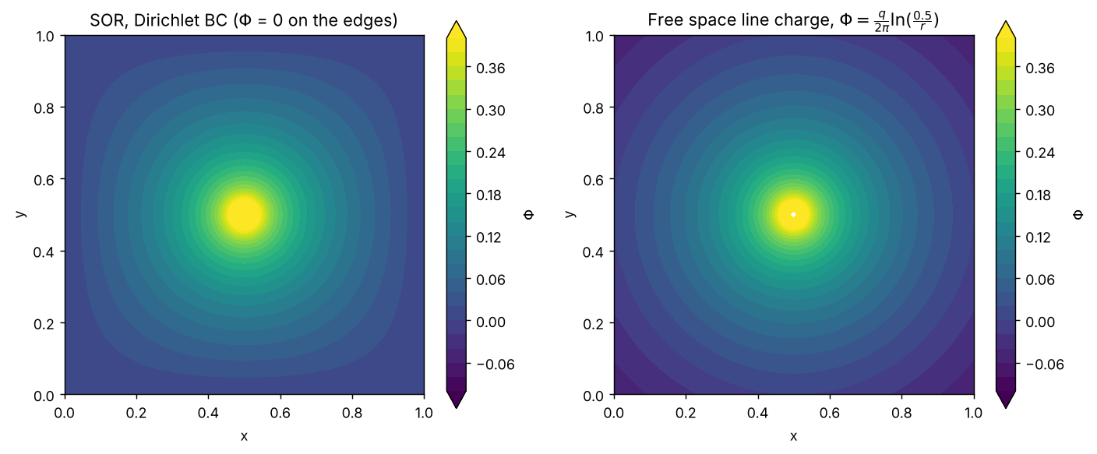
Below is the numerical potential as a function of the distance from the charge, along the line y = 0.5 and along the diagonal, compared with the free-space potential. Close to the charge the solution is identical to the free-space logarithmic potential (the singular part of the solution is set by the charge only). Far from the charge the grounded walls change the solution: the equipotentials become square-like, and along the diagonal the potential goes to 0 at the corner (r = 0.71) while the free-space potential keeps decreasing. The difference between the two solutions is a harmonic function (∇²(Φ−Φ_free) = 0 inside the box), which is the potential of the image charges induced by the grounded walls.
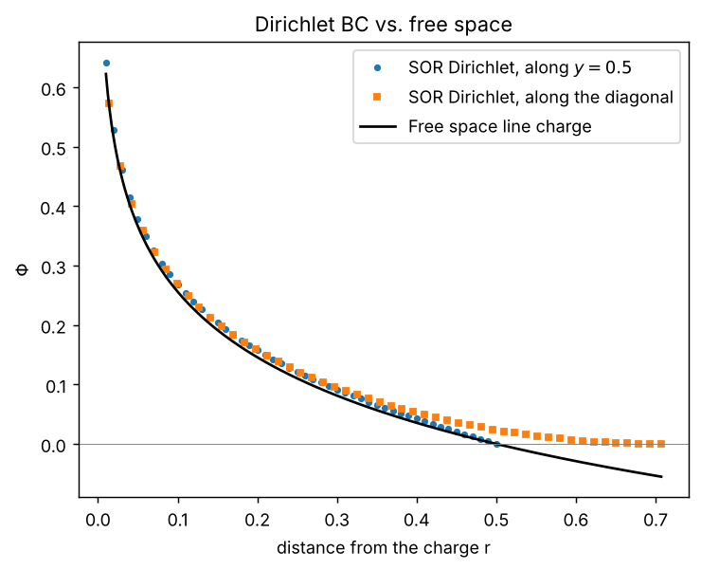
b) The same program was modified to use periodic boundary conditions (the neighbours of the edge points are taken from the other side of the grid with np.roll, 100×100 grid with the same Δx). A periodic Poisson problem has a solution only if the total charge in the box is zero (integrating ∇²Φ over the box gives zero for a periodic Φ), so a uniform neutralizing background ρ̄ = −q/L² was added. Also the potential is defined only up to a constant, which we fixed by ⟨Φ⟩ = 0. The solution converged after 242 iterations.
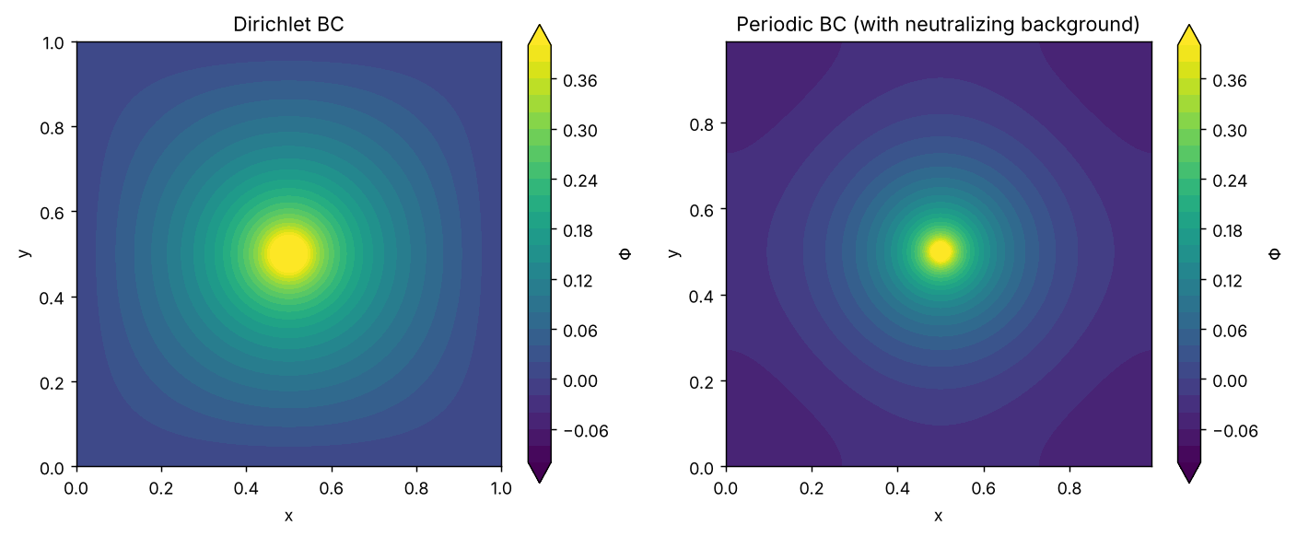
Below is a cut along y = 0.5 for both boundary conditions and for the free-space potential (all shifted to be 0 at r = 0.1). Near the charge all three solutions agree. Far from the charge, the periodic solution is flatter: it has zero slope at the edges (by symmetry, since the box is surrounded by an infinite lattice of identical charges, the field at the edges cancels), while the Dirichlet solution has a finite field at the walls, and the potential there is lower. In the periodic case the equipotentials take the symmetry of the lattice of charges, and the minimum of the potential is at the corners, which are the farthest points from all the charges.
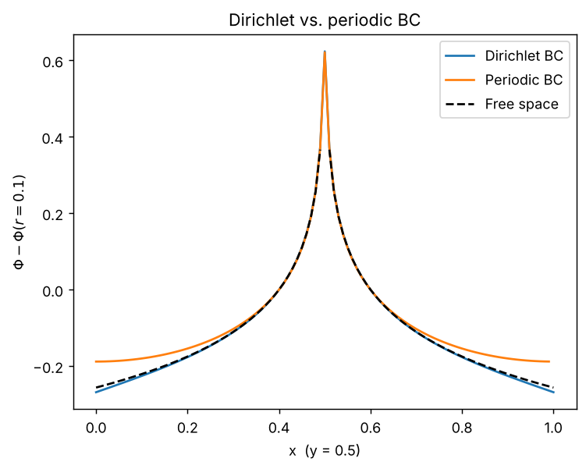

2) Solutions to Burgers' equation
Both schemes were run on x ∈ [0,1] with N cells, outflow boundary conditions (the ghost cells copy the edge cells) and the initial step u = 2 for x < 0.5, u = 1 for x ≥ 0.5. Since u > 0 everywhere, the upwind direction is always to the left. The time step is set every step by the CFL condition Δt = C·Δx/max|u| with C = 0.5.
a) Non-conservative form u_t + u u_x = 0, first order upwind: uᵢⁿ⁺¹ = uᵢⁿ − (Δt/Δx) uᵢⁿ (uᵢⁿ − uᵢ₋₁ⁿ). Below is the shock at different times for N = 256. The dotted lines show the exact shock position x_s = 0.5 + 1.5t. One can see that the shock stays sharp (a few cells), but it lags behind the exact position, and the lag grows with time.
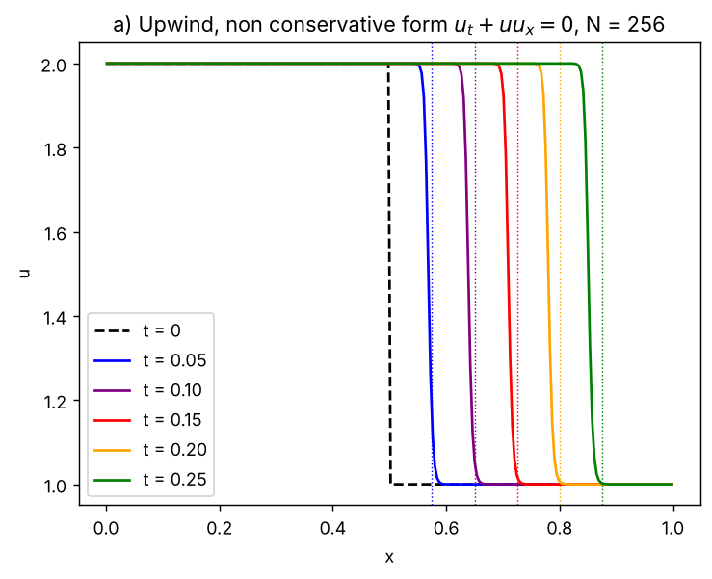
b) Conservative form u_t + (u²/2)_x = 0, first order upwind: uᵢⁿ⁺¹ = uᵢⁿ − (Δt/Δx)(Fᵢⁿ − Fᵢ₋₁ⁿ), F = u²/2. Below is the shock at the same times for N = 256. Here the shock is located on the exact position at all times.
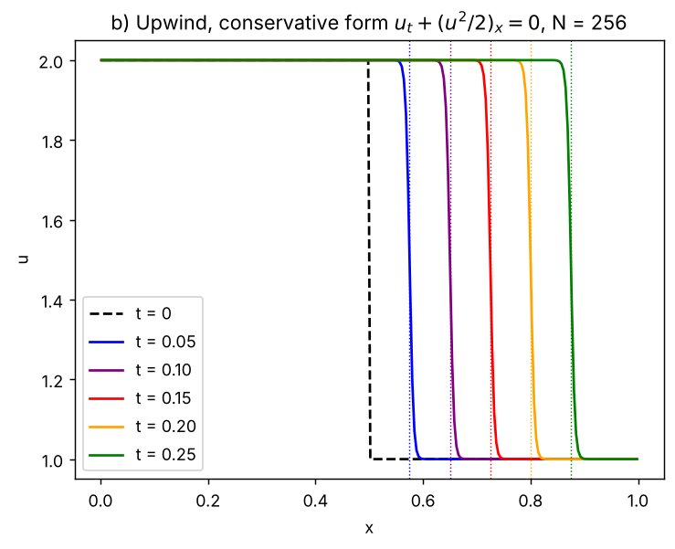
c) The shock position was defined as the first zone where u drops below 1.5 (the middle between the two states) and the shock speed was found from a linear fit of the position vs. time for 0.05 < t < 0.25.
N | Non-conservative s | Conservative s
128 | 1.4107 | 1.4997
256 | 1.4113 | 1.4999
512 | 1.4116 | 1.5000
1024 | 1.4121 | 1.5000
Exact (Rankine-Hugoniot) | 1.5 | 1.5
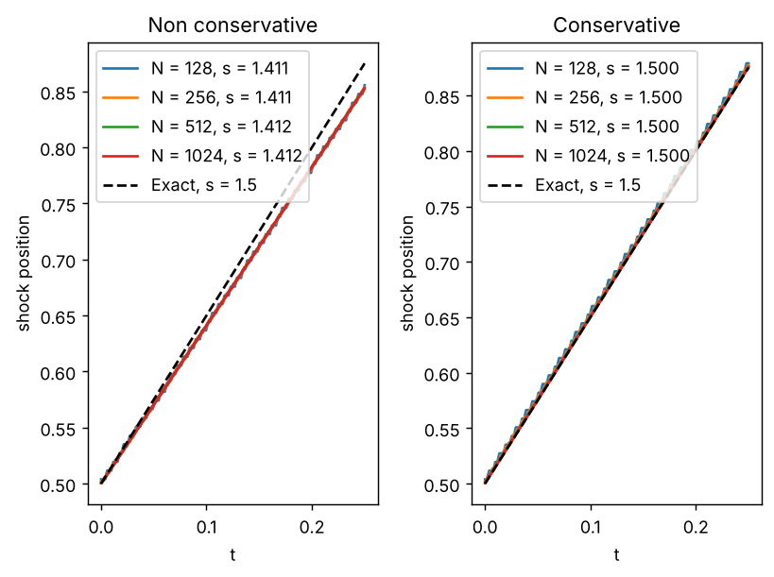
The exact shock speed is given by the Rankine-Hugoniot condition, s = [F]/[u] = ½(u_L² − u_R²)/(u_L − u_R) = (u_L + u_R)/2 = 1.5. The conservative scheme gets the correct shock speed for all resolutions, and the small difference converges to zero as N increases. The non-conservative scheme gives s ≈ 1.41 (≈6% too slow), and this error does not go away with resolution - increasing N only makes the shock thinner, it does not make it faster.
The reason is that a shock is a discontinuous (weak) solution, and for those the two forms are not equivalent - u u_x is not defined across a discontinuity. The conservative scheme is written as a difference of fluxes, so the sum of u over the grid changes only by the fluxes at the boundaries, i.e. the scheme conserves ∫u dx exactly at the discrete level. Since the shock speed is set exactly by this conservation (Rankine-Hugoniot), by the Lax-Wendroff theorem a converging conservative scheme must converge to the weak solution with the correct speed. The non-conservative scheme does not conserve ∫u dx: its numerical diffusion (∝ Δx) acting inside the shock, where the gradients are ∝ 1/Δx, produces an error in the conserved quantity that stays finite as Δx → 0, and therefore the shock moves with a wrong speed independent of the resolution.

3) Motion of a charged particle in an electromagnetic field
The equations of motion (with q/m = 1) were solved with a leapfrog scheme: the position is known at integer time steps and the velocity at half steps, xⁿ⁺¹ = xⁿ + Δt vⁿ⁺¹ᐟ². The velocity is advanced with the Boris algorithm: a half kick by the electric field v⁻ = vⁿ⁻¹ᐟ² + (Δt/2)E, a rotation by the magnetic field (t = BΔt/2, v′ = v⁻ + v⁻×t, s = 2t/(1+t²), v⁺ = v⁻ + v′×s) and another half kick vⁿ⁺¹ᐟ² = v⁺ + (Δt/2)E. The rotation keeps |v| exactly, so the particle energy does not drift. To start the leapfrog, v at t = −Δt/2 was found by pushing v₀ half a step backwards. The time step is Δt = 2π/100 (100 steps per gyration).
a) Uniform B = ẑ and E = 0, with x₀ = (0,1), v₀ = (1,0). Below is the path of the particle for 10 periods; it is a closed circle around the origin and the 10 orbits lie on top of each other. The radius was calculated as the mean distance from the center of the orbit, and the frequency from the times in which x crosses zero.
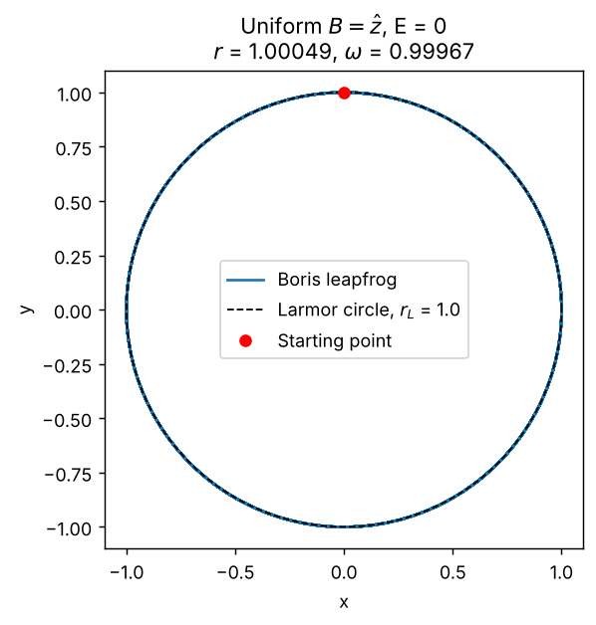
 | Numerical | Theory
Radius | 1.0005 | r_L = mv/(qB) = 1
Frequency | 0.99967 | ω_L = qB/m = 1
Period | 6.2853 | 2π = 6.2832
Both agree with the theoretical Larmor radius and frequency to better than 0.05%. The small frequency error is a known property of the Boris rotation: it rotates by an angle 2·arctan(ωΔt/2) instead of ωΔt per step, i.e. ω_num = (2/Δt)·arctan(ωΔt/2) = 0.999671, which is exactly the measured value. This error is O(Δt²), as expected from a second order scheme.
b) Uniform B = ẑ and E = −0.5ŷ with the same initial conditions. Below is the path of the particle for the first 6 periods. The particle gyrates and drifts in the −x direction, drawing a looped trochoid. The drift velocity was calculated from the guiding center R = r + v×B/B² - one can show that dR/dt = E×B/B² exactly, so R moves in a straight line (dashed line), and its velocity was found from a linear fit over 20 periods.
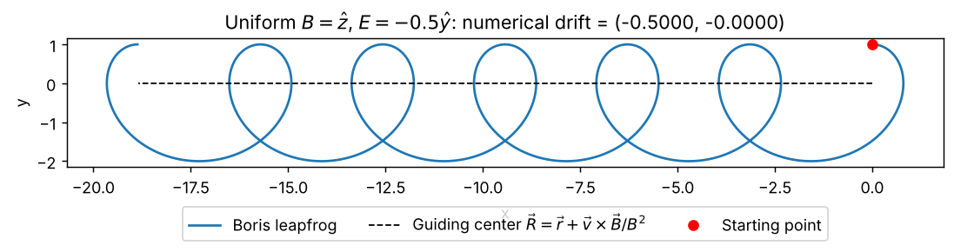
The theoretical drift is the E×B drift: v_E = E×B/B² = (−0.5ŷ)×ẑ = −0.5x̂. The numerical drift velocity is (−0.50000, 0.00000), in agreement with the theory (and independent of the charge and mass of the particle). In the frame moving with v_E the electric field vanishes and the particle has velocity v₀ − v_E = (1.5, 0), so it gyrates with radius 1.5 around the guiding center y = −0.5, which is why the orbit spans −2 < y < 1. Since the gyration speed (1.5) is larger than the drift speed (0.5), the orbit has loops.

