

Project Phase III: A Simple RESTful Web Service Development with Spring Boot and Automated

Software Testing

Test Report

Atakan Gundeger - 2587673

Mete kabakci – 2151983

|  |  |  |  |  |  |
| --- | --- | --- | --- | --- | --- |
| **ID** | **Description** | **Input Test Data** | **Pre-condition (if any)** | **Expected Output** | **Pass/Fail** |
| 1 | Unit Test for longest Concert  We have applied 2 tests, first test checks the size of the result list and second test checks the result value (duration) | * Tarkan Concert with duration 3 * Ajdar Concert with duration 2 * Murat Boz Concert with duration 3 | - | Result list size=2  Result value (duration)= 3 | Pass Criteria for the result list size= 2 and duration=3  Other than these results test fails |
| 2 | Unit Test for longest Concert  We have applied 2 tests, first test checks the size of the result list and second test checks the result value (number of performers) | * Show1 with 2 performers * Show2 with 3 performers | - | Result list size=1  Result value (performers)= 3 | Pass Criteria for the result list size= 1 and performers=3  Other than these results test fails |
| 3 | Integration Test for longest Concert | * Nafiz Dölek Concert with duration=0 * Fikri Karayel Concert with duration=2 * Manga Concert with duration=3 * Morveötesi Concert with duration=3 | Necessary data should be added to database before the test | Result list size=2 | Pass Criteria for the result list size= 2. Other than this result test fails |
| 4 | Integration Test for popular Festivals | Summer festival with five festival runs and Grape festival with 3 festivalruns | Necessary data should be added to database before the test | Result List size= 1 | Pass Criteria for the result list size= 1. Other than this result test fails |
| 5 | Integration Test for Organisers with multiple runs | - | - | - | Error in the testing stage |
| 6 | Integration Test for max Performers | Dance Show with 2 performers and Boxing Match with 3 performers | Necessary data should be added to database before the test | Result list size=1 | Test fails because the result list size value is not equal to 1 |

**ID1**

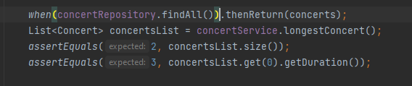

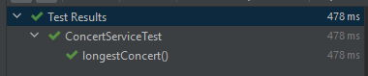

So Test ID#1 passes.

**ID2**

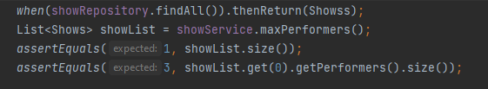

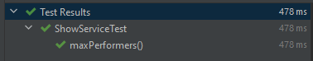

So Test ID#2 passes.

**ID3**

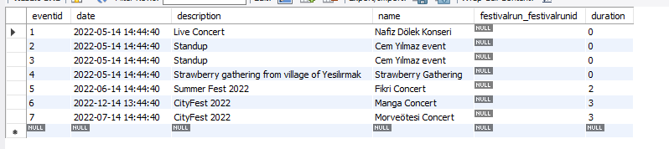

Figure 1: Event Table

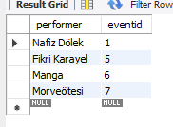

Figure 2: Concert Table

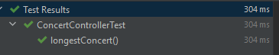

So Test ID#3 passes.

**ID4**



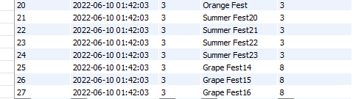

Figure 3: Festivalrun Table

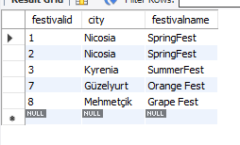

Figure 4: Festival Table

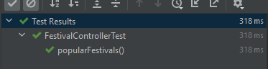

So Test ID#4 passes.

**ID6**

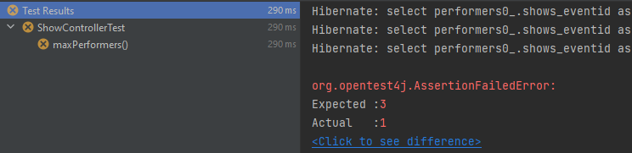

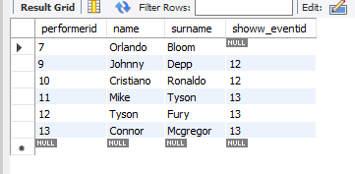

Figurel 5: Performer Table

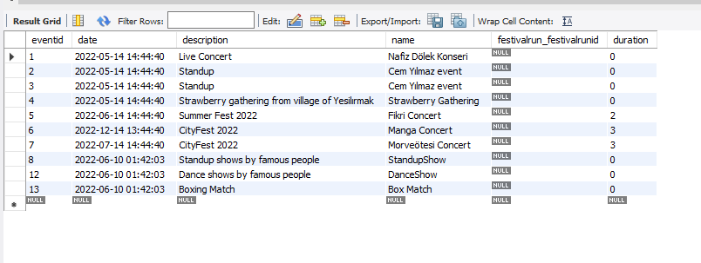

Figure 6: Event Table