

**Topic: REENGINEERING BANK LOAN PROCESS**

FACULTY OF INFORMATION TECHNOLOGY

DEPARTMENT: SOFTWARE ENGINEERING

ACADEMIC YEAR: 2021-2022

Course code: INSY 226

COURSE: Management Information System

LECTURER: MUNEZERO Jean De Dieu

GROUP MEMBERS

ID NAMES

23403 KABALISA Manasseh

23399 NIYIBIZI Alex CHRINT

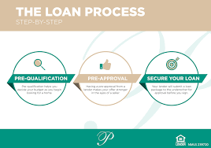 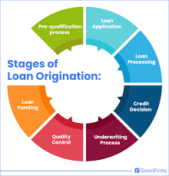

* **Overview of Scenario**

**Scenario Background**

* **Client:** Management of loan process
* **Problem:** Delay of getting a loan, Credit score issues, and the need for collateral, high interest rates on personal loans for borrowers.
* **Challenge:** Allow Clients to fill loan application remotely so that they only come to the Bank to take their cash according to their request.
* **Scenario Approach**

**DMAIC OR DMADV?**

Since we already have an existing system, we are going to use **DMAIC (**Define Measure Analyze Improve Control**).**

* **The Problem Statement**

“The Bank loan process is delaying due to the fact that some components of the process require clients to come to the BANK and there is many activities needed from different sector, and some Clients have to cancel their plans due to the long-term it take to complete loan requirements. ”

“BANK is losing about 1.5% (Approximately) of the clients due to the fact that the Bank ask clients to bring many documents, it ends up client changed their mind or trying to find the cash illegal way like Lambert

* **The Problem Ecosystem**
* **What is the System? –** BANK
* **What is the process? –** Bank loan process which allows clients to fill loan application remotely.
* **Who are the stakeholders?** Clients, Loan officer, BANK Managers,
* **Critical To Quality (CTQ) Measures**

**CTQ #1:** Average clients’ time to complete loan requirement (ACTCLR)

**CTQ #2:** Average Processes that require Clients to come to the BANK (APRCCB)

**CTQ #3:** Clients Satisfaction Index (CSI)

* **Process goals and CTQ goals**

**#1. Goals for Process**

* Reduce ACTCLR
* Reduce APRCCB
* Enhance CSI

**#2. CTQs GOALS**

* ACTCLR: 3 Day
* APRCCB: 2 Process
* CSI: 0.8 (Scale of 0 -1)

**Current Process:**

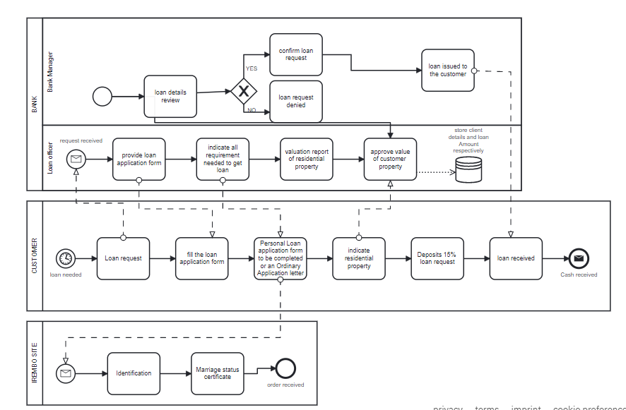

* **Scenario >Measures**

**CTQS**

**#1:** **ACTCLR:** Average clients’ time to complete loan requirement (ACTCLR)

**#2: APRCCB:** Average Processes that require Clients to come to the BANK (APRCCB)

**#3: CSI:** Clients Satisfaction Index (CSI)

**Other Measures**

**#1.** Number of steps in process

**#2.** Duration of each Step

**#3.** Waiting time between processes

**#4.** How many Client claim for poor service?

**Measure > ACTCLR**

**Method #**

**1.** Create more advertisement via social media platforms

**2.** Monitor time Clients spent on loan application process

**3.** Follow client who came to the bank to complete his/her loan application process

**4.** Give a timer for client who came in bank for loan application at the Bank gate and ask her/him to give it back when they received the loan.

**Measure > APRCCB**

**Method # Interview**

**1.** Set goals and objectives

**2.** Set questions and avoid biases

**3.** Invite randomly client who came to the Bank for loan application to give you an interview

**4.** Analyze the result and evaluate if goals and objectives has achieved

**Measures > CSI**

**Method # Survey**

**1.** Write Survey goal statement

**2.** Write questions (avoiding biases! To any side use the reality)

**3.** Determine the score methodology

**4.** Distribute survey to the random client

**5.** Analyze the result according to what you have gained

**Measure >number of steps**

**NB:** it will depend on case of each client, for some client it may be few days and for other it may take long time to complete all requirement needed to get loan.

**Measure >duration of each step**

**1.** Using software that monitor each action Customers works on online loan application

**2.** Convince Customers in interview the role of our survey, so he/she may be honesty and tell the truth

**3.** We may use our timer also to know duration Customer spent on bank for couple of steps

**Measure >waiting time between process**

**1.** Software will help us to monitor each action Customers works on online loan application

**2.** We may use our timer also to know duration Customer spent on bank for couple of steps

**Measure >How many Client delay during loan application process**

**For two Reasons:**

**1.** Because of this measure, it will impact another metric, **CSI**

**2.** Because some client will not have time to queue long time on the Bank to complete their loan application process

**How?**

* By comparing clients, we have received their loan already and those who currently completing the requirement needed to get loan

**Data from Measured phase**

NB: This measure has collected for client or customer who has completed the all requirement needed and given time.

|  |  |  |  |  |  |
| --- | --- | --- | --- | --- | --- |
| No | Name of process | Type | Time/M or H / D (day) | How can it be done | V.A/N.V.A |
|  | Customer decide to apply loan application | Event | 0.0 |  |  |
| 1 | Customer Goes to the bank for loan process details | Activities | 2Hours | Physically | V.A |
| 2 | Reception orient Customer in loan office | Event | 0.0 | Physically | V.A |
| 3 | Loan office provide all requirement needed to get loan | Activities | 5mins/2Hour | Physically | V.A |
| 4 | Customer wait to enter in loan office | Activities | 30min | Physically | N.V.A |
| 5 | Customer fill loan application his/her Identification and Bank Account Number | Activities | 1min | Remotely | V.A |
| 6 | Validation of his/her Identification | Activities | 30sec | Physically | V.A |
| 7 | Validate of his/her Bank Account Number | Activities | 30ses | Physically | V.A |
| 8 | Customer checks the loan details | Activities | 2mins | Physically | N.V.A |
| 9 | Customer decide whether to take loan or leave it | Activities | 10mins | Remotely | N.V.A |
| 10 | Customer takes all copies of loan application form to the bank | Activities | 30mins | Physically | V.A |
| 10 | Loan office take your passport photo | Activities | 20mins | Physically | V.A |
| 11 | Loan office scan your fingerprint | Activities | 5mins | Physically | V.A |
| 12 | Loan office Document all identification of Customers | Activities | 4Days | Physically | V.A |
| 13 | Loan office submit customer identification to the bank manager | Activities | 5mins | Physically | V.A |
| 14 | Bank manager review customer identification | Activities | 30mins | Physically | N.V.A |
| 15 | Bank manager review customer bank statement transaction | Activities | 10mins | Physically | N.V.A |
| 16 | Bank manager view type of loan customer want if its equivalent to your  Surety property | Activities | 20mins | Physically | V.A |
| 17 | Loan office visit customer’s surety property | Activities | 3Days | Physically | N.V.A |
| 18 | Bank expertize confirm if surety is equivalent to what customer stated | Activities | 30mins | Physically | V.A |
| 19 | Bank manager hold meeting to confirm or denied customer loan request | Activities | 2Hours | Physically | V.A |
| 20 | Customer went out of the bank | Activities | 7min | Physically | N.V.A |
| 21 | Receive notification that money has been transferred to your account | Event | 2mins | Remotely | V.A |

Total remotely process: 2 Processes

Total process that are physically: 19 Processes

Clients Satisfaction Index (CSI): 0.53

Total of Client who failed to get loan: 13%

**Improvement**

Goal: Design and implement our improved process.

Non-value-added Steps and some physically activity

|  |  |  |
| --- | --- | --- |
| Steps | Activities | Types of Wastes |
| 1 | Customer Goes to the bank for loan process details | Transport |
| 2 | Reception orient Customer in loan office | Waiting |
| 4 | Customer wait to enter in loan office | Waiting |
| 10 | Customer takes all copies of loan application form to the bank | Motion |
| 17 | Loan office visit customer’s surety property | Transport |
| 18 | Bank expertize confirm if surety is equivalent to what customer stated | Motion |
|  |  |  |
|  |  |  |

**Improving step 1**

|  |  |  |
| --- | --- | --- |
| 1 | Customer goes to the bank for loan process details | Transport |

**Idea for improvement**

* Improve BANK Loan process so that application form of loan can be signed online
* Allow customers to send his/her Application form of loan online

**Improve step 2**

|  |  |  |
| --- | --- | --- |
| 2 | Reception orient Customer in loan office | Waiting |

* **Ideas for Improvement**
* Allow Loan officer to receive customer’s application of loan online and send after the feedback

**Improve step 4**

|  |  |  |
| --- | --- | --- |
| 4 | Customer wait to enter in loan office | waiting |

**Ideas for improvement**

* Be empathetic and see the problem from the customer's perspective
* customer care by motivating staff to work hard by providing good service

**Improve step 10**

|  |  |  |
| --- | --- | --- |
| 10 | Customer takes all copies of loan application form to the bank | Motion |

**Ideas for improvement**

* Allow customers to save their Application form of loan.
* Allow customer to fulfill the application remotely

**Improve step 17**

|  |  |  |
| --- | --- | --- |
| 17 | Loan office visit customer’s surety property | Transport |

**Ideas for improvement**

* reduce day it take, 3 days to 1 day
* hire skilled labor to ensure that they work effectively

**Improve step 18**

|  |  |  |
| --- | --- | --- |
| 18 | Bank expertize confirm if surety is equivalent to what customer stated | Motion |

**Ideas for improvement**

* Customer will be having his/her expertise who have degree on it while he/she apply online
* Avoid bias and team and condition settled by bank to be followed

**The improved Process**

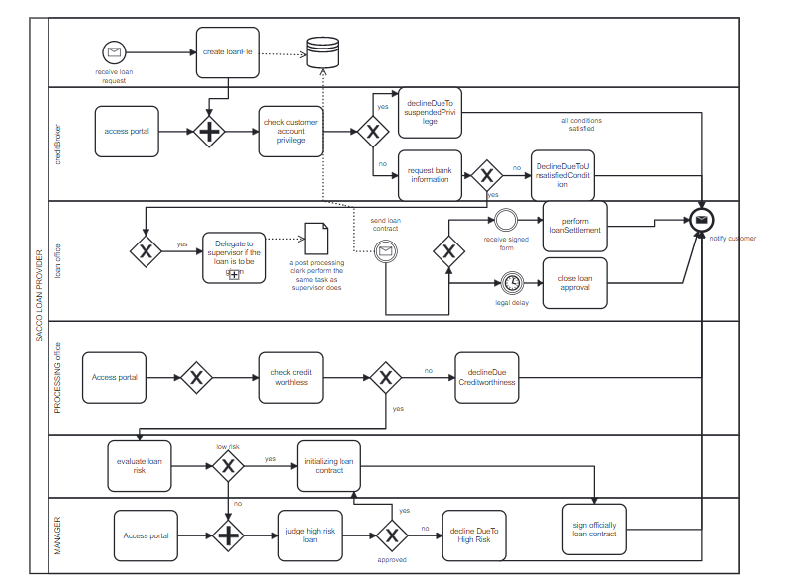

**Scenario>Conclusion**

**Table of Process after improvement**

|  |  |  |  |  |  |
| --- | --- | --- | --- | --- | --- |
| No | Name of process | Type | Time/M or H / D (day) | How can it be done | V.A/N.V.A |
|  | Customer decide to apply loan application | Event | 0.0 |  |  |
| 1 | Customer apply loan application | Activities | 30min | Remotely | V.A |
| 2 | Loan office provide all requirement needed to get loan online | Activities | 15min | Remotely | V.A |
| 3 | Validation of his/her Identification | Activities | 1min | Remotely | V.A |
| 4 | Validate of his/her Bank Account Number | Activities | 30ses | Remotely | V.A |
| 5 | Customer takes all copies of loan application form to the bank | Activities | 30mins | Physically | V.A |
| 6 | Loan office take your passport photo | Activities | 15mins | Physically | V.A |
| 7 | Loan office scan your fingerprint | Activities | 5mins | Physically | V.A |
| 8 | Loan office Document all identification of Customers | Activities | 1Day | Physically | V.A |
| 9 | Loan office submit customer identification to the bank manager | Activities | 2mins | Remotely | V.A |
| 10 | Bank manager review customer identification | Activities | 20mins | Physically | V.A |
| 11 | Loan office visit customer’s surety property | Activities | 1Day | Physically | V.A |
| 12 | Bank manager hold meeting to confirm or denied customer loan request | Activities | 2Hours | Physically | V.A |
| 13 | Receive notification that money has been transferred to your account | Event | 2mins | Remotely | V.A |

**Before And After**

|  |  |  |  |  |
| --- | --- | --- | --- | --- |
| CTQ Measure | After Improvement | Before Improvement | Difference | Goals |
| **ACTCLR** | 2 to 3 days | 7 to 8 days | 5 days | 3days |
| **APRCCB** | 2 process | 13 Processes | 11 Processes | 2 process |
| **CSI** | 0.8 | 0.23 | 0.57 | 0.8 |

After observation, we can see that the time has considerably reduced.

According to JDD “Automating a bad process does not make it better

We should “reengineer” our businesses”