Technology & Communication Services Command (TCSC)
NSW Police Force

EPSS period 2 SAP BRD design

Owner | Group Director, Shared Services
Status | Review
Version No. | 0.2
Version Date | 07/08/2025

Copyright of this document is vested in the Commissioner of Police © 2024

EPSS ‘SAP’ functional design for releases since June’25

Index
Index 2
Document history 8
Abbreviations 8
Introduction 8
SAP configuration period 2 June ’25 release Phase 3. 8
Employees included for period 2. 8
Technical and Functional 9
Assumptions 9
Period 2 definition 9
Technical 9
Corrections to the week table for retrospective changes 9
Payroll operation change for period 1 or 2 9
Functional 10
Supplementary payment period 2 10
Definition of ‘Salary’ used as comparison for supplementary payment. 10
Technical: 11
External earnings 12
Supplementary payment calculation 12
Manual adjustment WT for period 2 12
Monthly cap 12
Options 12
Option a Use the SAP monthly totals 12
Option b define a fortnight cap 13
Option c Complex build for factors to EOM 13
SAP configuration period Oct ’25 release Phase 4. 13
Oct’25 go live date. 13
Test phases. 13
Period 2 CPI and Weekly cap increases 14
Current setup/issue 14
Period 2 salary 14
Weekly cap 15
Changes required. 15
Functional 15
Technical 16
OLIMS 16
SAP 16
P2 salary operation Z75S 16
Force payroll split on 1 Oct 17
Business impact 18
Salary factor- Paid leave marked as unpaid and the effects on EPSS factoring. WIP 18
Current setup/issue definition 18
Changes required 20
Functional 20
Cutover impact 20
Business cutover impact 20
External earnings for Period 1 20
Current setup/issue 20
Changes required. 21
Functional 21
Cutover impact 21
Business cutover impact 21
Pause Period 2 commencement. 21
Current setup/issue 21
Changes required. 22
Functional 22
Technical 22
OLIMS 22
SAP 22
Cutover impact 23
Business impact 23
Tick/check Period 2 commencement flag. 23
Set retro to P2 (week 40) if P2 commencement flag should remain unchecked/not ticked. 23
BR019 Leave impact to EPSS payments. 23
Current setup/issue 23
Changes required. 24
Functional 24
New actual earnings WT effective retrospectively. 24
Notes from previous implementations 26
Full paid leave before P23 2024 26
Full paid leave From P23 2024 26
Half paid leave Before P23 2024: 26
Half paid leave From P23 2024: 26
Extended double Before P23 2024: 27
Extended double From P23 2024 onwards: 27
EPSS rules using WT 9WCA 27
Use of WT 3670 27
Technical 27
OLIMS 27
SAP 27
Cutover impact 28
Business Cutover impact 28
Period 1 salary – basic pay used 28
Current setup/issue 28
Changes required. 28
Functional 28
Technical 28
OLIMS 28
SAP 28
Cutover impact 29
Business cutover impact 29
BRD06 ICARE recoup report 29
Current setup/issue 29
Changes required. 29
Functional 29
Technical 29
SAP 29
Business impact 32
Section 36/37 Period 1 weeks 32
Current setup/issue 32
Changes required. 33
Functional 33
Technical 33
SAP 33
Cutover 34
Business impact 34
EPSS age driven employee contributions 34
Current setup/issue 34
Changes required. 34
Functional 34
Effective date 34
Super fund changes 35
Technical 35
SAP 35
Cutover impact 35
Functional 35
Testing impact - all 35
EPSS payments cease at retirement. 36
Current setup/issue 36
Changes required. 36
Functional 36
Effective date 36
Payroll rules 36
Technical 36
SAP 36
Business impact 37
Sign-off – Oct ’25 release phase 4 38
SAP configuration released TBC – kept for future FYI. 38
IT15 external earnings - Integration 38
Current setup/issue definition 38
Changes required 38
Functional 38
WT 3670 38
Technical (from a payroll perspective) 39
Olims 39
WT 3670 39
SAP 41
WT 3670 41
Business 41
Security (NSWPf) 42
Period 2 ends mid pay week, no pay split for P3 to commence. Phase 5? 42
Current setup/issue 42
Changes required 42
Functional 42
Technical 43
SAP 43
Business impact 43
Period 2 weeks movement 43
Current setup/issue 43
Changes required. 43
Functional 43
Rule Z319 that check if period 2 is mid-week 43
Technical 44
OLIMS 44
New field for P2 week commencement 44
Table ZIM_IN_ORP 44
SAP 44
Week table 44
Operation ZORP 44
Operation Z75S 44
Period 1 and 2 no payments for a period IT14 44
Current setup/issue 44
Changes required 45
Functional 45
Technical 45
Olims 45
SAP 45
BR002 Detached EPSS officer (keep notes for future) 45
Current setup/issue 45
Changes required. 46
Functional 46
New ESG 46
Technical 46
Olims 46
SAP 47
Downstream impacts – NSWPf team 47
Business impact 47
BR002 Detached EPSS officer (interim solution) 47
Current setup/issue 47
Changes required. 48
Functional 48
Changes for the new EE & ESG 48
New ESG 48
EE/ESG groupings 48
Work schedule 49
Time management status 49
Basic pay 49
Employee number range 49
Feature Quomo (leave accrual selection rules) 49
New hire action: 49
Termination 50
STP2 employment basis 50
EPSS adjustment WT’s 50
Technical 50
NSWPf team - Downstream impacts 50
STP2 user-exit 51
Business impact 51
Cutover impact 51
Business cutover impact 51
Force payroll split P3 commencement 51
Salary factoring WC absences 52
Note on design (for future use) 52

Document history
Release | Responsible | Status | Date | Comment
Phase 3 June ’25 | S Malan | Final | 28/05/2025 | Sign-off
Phase 4 Oct ‘25 | S Malan | V0.02 | 07/08/2025 | Released for sign-off
Phase 4 Oct ‘25 | S Phatak &  S Malan | V0.03 |  | Build/Config added

Abbreviations
Abbreviation | Description
WC | Workers compensation
P1 | EPSS Period 1
P2 | EPSS Period 2
P3 | EPSS Period 3
WT | Wage type
HP | Half paid leave
OLIMS | Injury Management System
ORP | Ordinary Rate of Pay
CPI | Consumer Price Index

Introduction
The purpose of this document is to outline the SAP functional requirements, design and components used to implement the Enhanced Police Support Scheme (EPSS) processes for Shared Services.
The document will show all functional requirements and designs since the June 2025 EPSS production release. Technical details in this document are for alignment and is to be read together with the separate technical design documents. Technical documents take preference.
Notes taken from discussions that are not yet in scope or finalised is to be ignored. These unfinalized notes are kept in the document for use in subsequent design phases under SAP configuration released TBC – kept for future FYI.
The below headings are relevant to date:
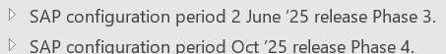

SAP configuration period 2 June ’25 release Phase 3.

Employees included for period 2.
SES Employee subgroup:
XF SES (Police)

NonSES commissioned officers:
XC Police Inspector
XD Police Chf Inspector
XE Police Super

NonSES non-commissioned officers:
XA Police NCO (C/SC)
XB Police NCO (S/SS)

Technical and Functional
Use the Employee subgroups to restrict period 2 processing and to define Non-Commissioned officers

Assumptions
Period 2 will always commence at the start of a Workers compensation week within the NSWPf fortnight pay cycle. The period 2 completion of 39 weeks signals the commencement of period 2. Period 1 weeks are counted based on WC weeks as build in the SAP solution. The WC weeks start at the commencement of a pay period and ends after 7 days when the 2nd week commence and complete at the pay period end date.

Period 2 definition
Period 2 commence after period 1 ended. Period 2 start will always be the start of a week/Friday as per the current NSWPf fortnight pay cycle.
Period 1 ends after 39 weeks of period 1 payments as per the current design.
Period 1 end and period 2 start can change in retrospect per incident due to retro period 1 payment changes that impacts the period 1 counter.

Technical

Corrections to the week table for retrospective changes
This is fix to ensure the week count fix due to period 1 retrospective payments/no payments do not only fix from the retro period onwards, but also take care of the week settings the periods before the retrospective pay period.

Payroll operation change for period 1 or 2
TBC new or change: Propose the existing payroll operation that provides WT 9ORP to payroll for period 1 salary is enhanced to return a 1 for period 1 and a 2 for period 2 and with that the value of the relevant period salary.
Payroll to check the return of 1 or 2 and pending the return value add the value returned to period 1 salary WT 9ORP or to period 2 salary WT 9P2S (Period 2 salary).
TBC An option is also for a NEW operation, implying the new operation focus on period 2 only and the existing operation do not change. In that event there will be 2 operations for period 2, one that provides the ‘salary’ and another that indicates period 1 or period 2 in a return parameter.
The operation/s are called while processing WT 9WCO for the split. WT 9WC0 been processed indicates the primary claim and return info to payroll is to be as per the WPBP split start date split validity.
Note: in one week it can happen that the employee change from one claim to another. That is why the WPBP split is of importance.
Question: Is OLIMS able to support payroll in this way. TBC the technical process in retrieving the information.
Assumption: The change to period 2 will always be the start of a week. This week is not always the start of a pay period.
Retro pay rise impacts to the period 1 counter to be incorporated in the period 2 changes.

Functional
Use the new or changed operation to store WT 9P2S (Period 2 salary) per WPBP split.
When using period 2 salary, factor the salary as per the planned working hours TBC attendance hours including substitutions. This is required due to the potential of a new period 2 salary mid pay period.
Eg claim A for 3 days week 2 = 22.8 hours
Claim B for 2 days week 2 = 15.2 hours
Total planned hours in week 2 = 38.
Claim A salary is $1000, factored down to 1000* 22.8/38
Claim B salary is $1200, factored down to 1200*15.2/38

* tbc if week2 is period 2 if operation gives week 1 back instead of maybe week 38 (if the prior is already completing)

Extend period 2 for days working more than 7 days- Olims functionality
Extend with PID and what if these dates overlaps with a change to period 2 where period 2 is now starting after the PID dates

Supplementary payment period 2

Definition of ‘Salary’ used as comparison for supplementary payment.
Salary for the benchmark of the weekly supplementary payment is compiled from data effective on the last date of period 1, that is the end date of the week when period 1 reached 39 weeks. The effective date can change in retrospect because earnings/pay rises can impact if a week counts for period 1 or not. The effective date is the date relevant to the current claim as per WT 9WCO for the pay period and payroll split (WPBP) been processed for WT 9WCO,
The data for the salary as on the defined effective date is cumulated and has percentages applied in the following order:
- Add to total: HDA from IT0509 for the below listed temp appointment reason codes (P0509-REACD) that is payable (P0509-UPHDA = space)
81 | SES Section 33 Appointment
82 | Section 66A Acting Appointment
83 | Section 66AA Provisional Appt
84 | Section 67 Temporary Appt
94 | Section 33/66-Temp Appointment
96 | Secondment
99 | Sct 66 - Comm Off to Comm Off

- Add to total: IT0008 basic pay WT 1000 or WT 0S00
- for a non-commissioned police officer add 17% to the total.
- Apply the capacity utilisation level percentage in the selected basic pay infotype.
- Apply 75% to the total.
- Divide the total by 26.08929.
- Divide the total by 2 (for weekly value).
Payroll do not look ‘back’ and due to no limits to the number of claims and to cater for retrospective pay rises to be the incorporated as the latest ‘salary’, a custom operation will be used to find the ‘salary’.

Technical:
A new payroll operation is required that will return the ‘salary’ of the processed claim as reflected in WT 9WCO for payroll processing.
The operation is called when WT 9WCO is present. The outcome is expected to be the same for payroll splits in week1 or for splits in week2 of the fortnight pay, but it can be different in week1 and week 2.
The calculated ‘salary’ is returned in the two variables 9ES1 and 9ES2.

The operation is called for all pay splits of WT 9WCO when it is period 2 only (As per the operation returning period 1 or 2). The operation is to check the incident date of WT 9WCO, then read IT8 basic pay for the effective date prior to the incident date. TBC First add the base +loading together for a non-commissioned police officer, then apply 75% or apply 75% individually? Answer impacted pending whether the pay frequency is the same per employee and pending rounding decision?. The operation will send the 75% to be used by payroll back in the amount field.
The fortnight value of the ‘Salary’ is defined as the full value of WT 0100 and 1050 as per payroll calculations. This is the fortnight value before any reductions, eg. Purchase leave, paid leave, LWOP.

Note. A custom table to store the 75% is not relevant as the check needs to be done in all future pay periods to cater for retrospective pay rises and to be aligned with when the employee change from one claim to the next.

Payroll put the 75% WT through existing fortnight period calculations as would WT 1050 currently. Note WT 1000 creates WT0100 in SAP fortnight calculations and we do not want this to happen for the ‘salary’.
Concerns with ‘one’ salary vs multiple WT’s for base and loading will be assessed when we check the fortnight formation.

External earnings
One new WT will be created to be used as external earnings.
It will be entered in OLIMS and it will integrate to IT0015 once of payments and deductions.
Data entry will be dated by the business to align with the pay week where the external earning was relevant. The supplementary pay for the ‘week’ will be impacted aligned with the effective date.
WT 9WCO is to co-exist with the external earning to have an effect.

Supplementary payment calculation
At first the supplementary payment is calculated per week:
‘Salary’ as a fortnight value / 2 factored by working planned hours (current factor process)
Minus
Actual earnings *WT 9WCA (as used for period 1)
Minus
External earnings
Minus
Workers compensation WT ???? 4901?

Assumption: Factoring based on planned working hours/current process to be reviewed for the same

Manual adjustment WT for period 2

Monthly cap

Options

Option a Use the SAP monthly totals
SAP has an option to report on monthly totals as it has for yearly totals.
Monthly totals are not defined exactly to EOM. It includes pay periods based on one of the below options (saved in T54C1):
Payment day for period
1 Start date for period
2 End date for period
At NSWPf the payment day and the end date are the same.
NSWPF defined the pay periods to be included in the month based on pay date/period end date.
TBC if the Monthly total of the supplementary payment can be used to check against the monthly cap and if it exceeds, then create a negative in to offset the total of the supplementary payments for the month. Hence compare the Monthly total of the supplementary and create a negative for the same supplementary if it exceeds.

Option b define a fortnight cap
Create a fortnight cap as the monthly cap divided by 26.08929.
Apply the fortnight cap to the total fortnight supplementary payment

Option c Complex build for factors to EOM

SAP configuration period Oct ’25 release Phase 4.

Oct’25 go live date.
Go live migration of transports can be before, but needs to be ready for processing in:
pay 9 2025 (10.10.2025 To 23.10.2025).
Most changes are not date driven.
Where changes are date driven to be effective from go live, then the effective dating of the changes are to align with whether the calculations occur in retro or in the current pay period. Eg. EPSS supplementary payments calculate in retrospect whereas Insurance premiums calculates in the current period.
Transport migration ready for pay 9 2025 but with retro calculations (like EPSS payments), will typically need effective dating relevant from go live only, to be pay 8 2025.
pay 8 2025 (26.09.2025 To 09.10.2025)
With the above dates in consideration, migration of changes to production is recommended for cob 03/10/2025 or over the weekend of 4-5 October 2025. That is after pay 8 2025 exit. It allows for any manual tasks and to check for issues before pay 9 2025 prelim pay executes on 14/10/2025.
Migration to production prior to the above dates needs to align in a similar fashion as described above.

Test phases.
Due to some changes that are date driven, planning is required to define and build test cases that align with the perceived ‘go live’ pay period for date driven changes.
The date driven changes are ideally the same across all test platforms and only changes again when changes are migrated to production.
The majority of the changes are not date driven, therefore the proposal is to isolate the date driven test cases based on defined ‘test’ go live date.
This will limit the undo and redo of configuration and allows test cases to remain valid across systems until the final change for the actual go live.
DTT requires SAP support to assist with test data creation for unit testing due to the nature of OLIMS integration with SAP.
Test data is required to cover PBRI, EPSS period 1 and period 2 in combinations that will cover the areas of change. The test data is to be created asap not to slow down build and unit test time.

Period 2 CPI and Weekly cap increases

Current setup/issue

Period 2 salary
Period 2 salary is as per the end of the period 1 end date (end of week 39). This date is currently used ongoing.
The requirement is to increase the period 2 salary cumulative with a yearly CPI index. Period 3 salary will also receive this index once build in a future release.
The CPI percentage will only have 2 decimals.
The effective date for the CPI constant is always the 1st of October and a pay split is required effective 1 October to accommodate pay periods that cross 1 October for EPSS employees that are eligible for potential P2/P3 payments.
An enhancement to the OLIMS period 2 salary display to showcase the CPI index impact will be detailed in the technical design.
The CPI index percentage is date driven.
System changes are not date driven other than by implication due to the date driven CPI indexed rates.
Payroll Split example: Payroll week 1: 29 sept - 5 Oct
a)Period 2 always commence at the start of a pay week. Say P2 commence on 29th of Sept, then the rule is that the CPI apply from 1 Oct 2025: Require force payroll split effective 1 Oct for relevant EPSS employees. Eg. P2 salary at the end of P1 (28Sept) = 10K and CPI 3% on 1 Oct, 29Sept-30Sept P2 salary is 10K and 1-5Oct is $10300.
b)Period 2 commenced in the week of 1-7Jan '25. P2 salary was 10K (at the end of P1). 10K is used. Pay week 29 Sept to 5Oct is still period 2: As period 2 started in Jan '25, the 1Oct '25 CPI index is to be applied from 1Oct 25 onwards. In line with sample a), Say the CPI on 1 Oct'25 is 3%, then 29Sept-30Sept use P2 salary 10K and 1-5 Oct used P2 salary $10300. A force payroll split is required on 1 Oct.
c) Payroll week 29 Sept - 5 Oct with splits in the week where a P2 incident is valid 29 Sept to 1 Oct. The employee moves to a P1 incident from 2-5Oct. P2 salary at end of P1 =10K, CPI on 1 Oct is 3%; then P2 salary 29-30Sept is 10K and 1 Oct - 1Oct is $10300. The P2 salary is zero from 2-5Oct as the employee is on a different incident that relates to Period 1.
d) Payroll week 29 Sept - 5 Oct with splits in the week where a P2 incident is valid 29 Sept to 30 Sept. The employee moves to a P1 incident from 1-5Oct. P2 salary at end of P1 =10K, CPI on 1 Oct is 3%; then P2 salary 29-30Sept is 10K. P2 salary from 1-5Oct is zero as the employee is on a different incident that relates to Period 1.
Payroll Split example 2 : Period 2 starts in payroll week 1 that runs from 1 Oct - 7 Oct; The indexation does NOT apply. Refer to the old weekly CAP Constant not the increased constant.
e) Pay week 1-7Oct'25 and Period 2 commence in this week. P2 always commence at the start of a week, hence commenced on 1Oct '25. In this case because P2 did not commence before 1Oct'25 the CPI logic for 1Oct25 is ignored/does not take place. P2 Salary at the end of Period1 (30Sept) is 10K and for the week 1-7Oct the P2 salary remains 10K. The P2 salary remains 10K until the CPI increase 1Oct' 26, say with 4%, then the 10K P2 salary increase as per prior samples; effective 1 Oct '26 to $10400. (10000*1.04). If the CPI on 1Oct '27 increase with 3%, then in line with prior samples the P2 salary increase effective 1Oct'27 for supplementary payment calculations to $10712 (10400*1.03).

Weekly cap
A weekly cap for Period 2 supplementary payments (and in later developments for Period 3), is in place, utilising SAP constant ZEPS2 Max. EPSS Period 2 Weekly Cap. This cap increases yearly on 1 October.
Currently the weekly cap is read as at a payroll split end date and pro-rated (if there is a payroll split). That implies if P2 has no split in the pay week overlapping with 1 October, then the weekly cap applies to the full week, whereas a pay split effective 1 October, could read and pro rate the worth of the weekly cap per payroll split.
That implies a pay week without a split on 1 Oct. where the pay week runs from example 29Sept-5 Oct and with a weekly cap increase from $900 to $1000 on 1 October, will in that pay week use $1000 as the weekly cap.
Was there a payroll split on 1 October, then the total weekly cap would be less, eg. if we had 15.2 hours from 29-30Sept and 22.8 hours from 1-5Oct (total 38 hours in week 1), then a split from 29-30Sept will have a weekly cap of 15.2/38/*900=$360, plus, for hours from 1Oct to 5 Oct 22.8/38*1000=$600; bringing the total weekly cap to $960.
The correct weekly cap for the above example is $960, whereas without a split on 1 Oct the weekly cap of $1000 will be used.
A change is required to enforce a pay split on 1 October for EPSS period 2 employees (EPSS period 3 employees, when build in the future will also need this change).
The weekly cap is date driven.
System changes are not date driven other than by implication due to the date driven weekly cap.

Changes required.

Functional
Create a new constant for the CPI index percentage. 2 decimals are sufficient.:
ZECPI EPSS CPI index percentage.
Load the index default as 0%.
TBC the new index effective 1.10.2025. (Set to 3% until the % is advised)
Create a custom payroll rule that calls a new custom operation that will force and distribute splits on 1 October for EPSS period 2 employees. The custom operation will require payroll rules to compliment as per Force payroll split on 1 Oct (and for P3 start date)

Build/Config

Constant ZECPI EPSS CPI index percentage (To be revised for go live/delete 2026 onwards entries/extend 1.10.2025 to 31.12.9999)
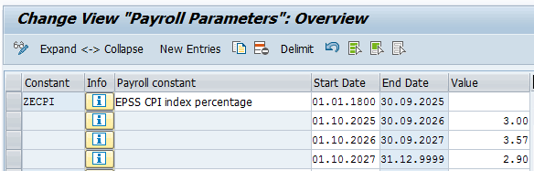

Email received from Aruna on 09 Oct. 2025:
The CPI Functionality is not required yet, hence we were asked to make it 0%
Unit Testing was performed to confirm that making this constant 0% will keep Payrin the same Salary the employee is on with 0% Indexation.
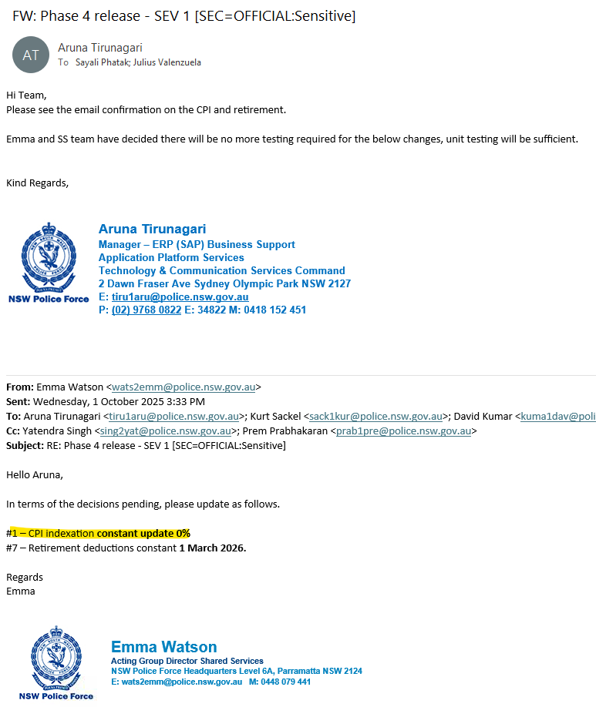

After:
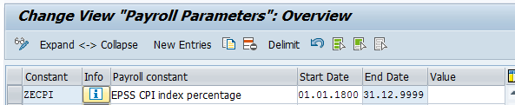

Schema and rule for auto payroll split

Schema ZUBD

Before change
See Config objects check before change.xlsx worksheet ‘Schema ZUBD B4 chg‘. It shows schema ZUBD differences before changes for EPSS phase 4. Essentially there are no differences other than EPSS phase 4 proof of concept changes done during the design phase.

After change
..
IF ZSES * SES: Check for SES EE's Only
IF ZPF1 SES: monthly versus fortnight
IF APPL 9WCO Check go live D&D
P0014 ZWC1 GEN NOAB Import wagetype 9WCO
P0014 ZWSL NOAB Add split per 1 Oct 2025 ßNew line added
PIT ZWCI NOAB Set Variable for >270 days
ENDIF ****************************************
ELSE ****************************************
P0014 ZW14 GEN NOAB SES: PCRL47 processing / JB 13/6/12 PDSY
ENDIF SES: Check for SES EE's Only
..

New Rule: ZWSL Create Split in 9WCO from 1 Oct 2025
The rule is used to auto create a WPBP split on 1 October when the EPSS CPI index percentage increase occurs.
The index is relevant to EPSS period 2 employees.
The auto split also indirectly accommodate for a pay split on 1 October in relation to the weekly EPSS top up cap.
Criteria that drive the auto WPBP split on 1 October is:
The Processed WT 9WCO relates to an EPSS employee that commenced EPPS period 2 prior to the CPI increase relative to the processed pay period.
The constant ZECPI EPSS CPI index percentage has an entry where the start date (1Oct) overlaps with the processed WT 9WCO.
There is no WPBP split on the start date of constant ZECPI.

Technical

OLIMS
The requirement for OLIMS display of P2 salary due to indexation will be defined in the technical design. Below is a high-level display of the anticipated changes to the OLIMS screen. The yellow highlighted columns are the columns to show the index increases pending the Index year chosen and these are envisaged to have the unit (eg weekly/hourly rate) text moved to the left to make space for the CPI inclusive salary. The OLIMS screen will utilise the payroll CPI index constant, ZECPI EPSS CPI index percentage.
Noted the technical design takes precedence.
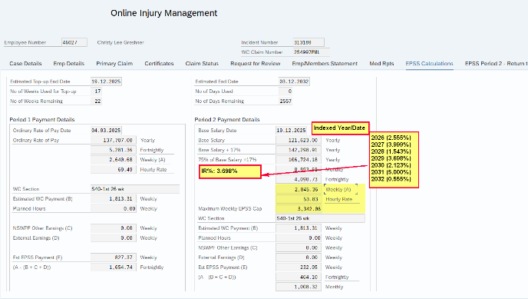

SAP

P2 salary operation Z75S
The P2 salary returned for payroll processing via operation Z75S needs adjustment to include the CPI index where applicable. The below formula/matrixes are to be read in combination with the samples provided under Period 2 salary.
- Check 1; Potential eligibility check constant table T511K ZECPI: Does the CPI period (T511K start/end date) have validity on or before the payroll (WPBP) split end date, then include the entry for the 2nd CPI check. Ignore T511K ZECPI entries where the CPI period (start/end date) is in the future vs the pay split end date (wpbp-endda).
- For the potential eligible CPI periods that passed the first check: Sort in ascending order. Check 2: If the period 2 start date (week39 end +1 day) of the processed incident (as per WT 9WCO), is < potential eligible CPI constant ‘start’ date, then the CPI % increase is applied cumulative from the first to the last eligible entry that pass the 2nd check.
“If P2 start is < cpi constant ‘start’ date, then the CPI is considered for increase, but only IF the CPI period (T511K start/end date) is valid on or before the wpbp split end date (ignore if the CPI period is in the future vs the wpbp-endda).
The initial P2 salary remains as per period 1 end date, and any CPI is added cumulatively.”
Example with fictious CPI %’es:
T511K CPI constant start/end dates |  | T511K  CPI % Value | Initial P2 salary before CPI | Period2 start 1Jan'25 | Period2 start 1Jan'25 | Period 2 start 1Oct'25 | Period 2 start 1Oct'25
CPI start | CPI end | CPI % | P2 salary at P1 end Week39 | Retro Pay split  29 sept -30Sept'26  P2 Sal=$10300 | Retro Pay split  1Oct-5Oct '26  P2 Sal=$10712 | Retro Pay split  29 sept -30Sept'26  P2 Sal=$10000 | Retro Pay split  1Oct-5Oct '26  P2 Sa=$10400
01/10/2024 | 30/09/2025 | 0% | 10000 | 10000 | 10000 | 10000 | 10000
01/10/2025 | 30/09/2026 | 3% | 10000 | 10300 | 10300 | 10000 | 10000
01/10/2026 | 30/09/2027 | 4% | 10000 | n/a | 10712 | n/a | 10400
01/10/2027 | 30/09/2028 | 2.5% | n/a | n/a | n/a | n/a | n/a

Force payroll split on 1 Oct
Information on SAP operation WPBPCS (to leverage from)
SAP operation WPBPCS called while processing an IT0014 WT through SAP function P0014, will do the following:
- If the IT0014 WT has a start/end date mid the accounted pay period, and if there are no WPBP splits already on the WT start/end date, then the operation will create WPBP splits for the start/end date of the IT14 WT (if it start /stop of the WT is mid pay)
- The S at the end of the operation will then also distribute the newly formed WPBP splits to all the existing WT’s
Important for the standard use of the operation is that it must be called from payroll function P0014, it sends an error if that is not the case.
See code in RPCBU309_OPWPBPC, FORM opwpbpc.
Replicate operation WPBPCS functionality to force payroll splits:
Borrow code from the above operation to be used in a new custom operation with the below requirements:
- A payroll rule calls the new operation per WT 9WCO from function P0014.
- To cater for the CPI and P2 weekly cap increases effective 1 Oct, where we do not necessarily have a split for P2 EPSS employees on 1 October:
  - If the WT 9WCO is called within a WPBP split that cross 1 October (that is any start date of constant ZECPI), and the processed WT 9WCO incident is for EPSS Period2, (and later P3 when implemented), then enforce a pay split for the CPI increase effective date (expect 1 Oct), if not already available.
    - When EPSS P2 is valid in the pay split, then for the ZECPI constant start date (expect 1 Oct), that falls within the processed pay split of WT 9WCO, check if there is already a WPBP split for this start date (1 Oct). If there is, then keep WT 9WCO in the IT without forcing a split.
    - When EPSS P2 is valid in the pay split, then for the ZECPI constant start date (expect 1 Oct), that falls within the processed pay split of WT 9WCO, if there is no WPBP split with this start date (1Oct), then force a WPBP split on the start date (1Oct), and distribute all wage types in the input table to the new splits. (We do not have to concern with an end date split creation as operation WPBPCS does, only the start date of 1 Oct as per the start date of constant ZECPI is relevant).
      - Example: WPBP split exist for 26Sept to 2Oct. Calling the new operation for WT 9WCO that has WPBP pay split dates 26Sept to 2 Oct and the incident is in period 2 since July (P2 is valid). Constant ZECPI has a value other than 0% effective 1 Oct. Operation to a) Create more WPBP splits within 26/9 to 2/10 so we have WPBP splits for 26/9 -30/9 and for 1/10-02/10. b) Distribute the existing WT’s to the newly created WPBP split.
Before operation | 0100 base | 9WCO
WPBP 26/09-02/10 | 90000 | 2300
After operation
WPBP 26/09-30/09 | 90000 | 2300
WPBP 1/10 to 2/10 | 90000 | 2300

Business impact
If the creation of the pay split on 1 Oct via payroll automation is not successful, then the project will revert to a new WT that cause payroll splits that will need to be loaded on 1 Oct. The project will advice if the below is required. Current expectation is that the below will not be required:
If automated virtual pay splits can’t be accomplished via payroll; implement a business process to load the new IT14 WT for EPSS P2 employees effective 1 Oct to the end of the relevant pay period.
Enter $1, this is just to keep the WT for processing. The WT is notional. It will be designed to cause payroll splits only.
When the pay period or a pay week (Friday) commence 1 Oct, do not load. In this case we expect a Workers compensation split for the start of the week.
The new WT is set to cause a payroll split on 1 Oct.

Salary factor- Paid leave marked as unpaid and the effects on EPSS factoring. WIP

Current setup/issue definition
Factors applied to the P1 & P2 salary as well as the weekly cap currently reduce LWOP hours using SAP standard counting of LWOP hours.
At NSWPf there are paid absences that has been setup as if they are unpaid leave types. It is believed this was done for other factoring purposes and it will not be changed.
It is possible that NSWPF can have the P1 & P2 salary and the weekly cap reduced with the relevant paid leave absence hours if we continue to use the SAP standard counting of LWOP hours. The impact is expected to be evident when an EPSS employee with WT 9WCO Workers Comp Rates, and that is eligible for EPSS top up/supplementary pay, is on one of the below absences. This is because these absences count in SAP standard as LWOP due to their configuration setup, but in reality they are paid absences.
A fix is required not to reduce the EPSS salary via factoring with the listed absences. The change is effected in retrospect and require pay force retro for employees with the listed absences.
Noted, the ½ paid leave listed below is paid 50% and unpaid 50% but the value for actual earnings (WT 9WCA) that reduce the top up, is multiplied with 2 for pay periods where EPSS WT 9ORP is valid and by default from 25.4.2025 when STP2 pre-work went live (brought up to 100%). Payroll rule ZWC4 is relevant to the creation of WT 9WCA in this regard.
IT0573 Leave code for PS infotype | IT0573 description | IT2001 A/AType | IT2001 description | Factor WT’s generated | Note
1400 | Extended leave | 0100 | Extended leave | 9983 | Also see BR019 Leave impact to EPSS payments.
1400 | Extended leave | 0110 | Extend lve 1/2 pay | 9982 | Also see BR019 Leave impact to EPSS payments.
2000 | Maternity leave | 0650 | Maternity leave 1/2 pay | 9981
2200 | Adoption leave | 0850 | Adoption leave 1/2 pay | 9981
2410 | Parental leave | 1010 | Parental leave 1/2 pay | 9981
4100 | Special leave | 1401 | Special Leave @ 1/2 pay | 9981
5000 | Suspended with pay | 1800 | Suspended with pay | 9987
1402 | Extended leave double pay | 0115 | Extended leave double pay | 9983 | Also see BR019 Leave impact to EPSS payments.
2450 | Rec leave Radio/Comms | 0210 | Recreation leave 1/2 Pay | 9981
2500 | Rec leave Admin/SES | 0210 | Recreation leave 1/2 Pay | 9981 | Also see BR019 Leave impact to EPSS payments.
2600 | Recreation Leave | 0210 | Recreation leave 1/2 Pay | 9981 | Also see BR019 Leave impact to EPSS payments.
2010 | Paid Parental Leave | 0660 | Paid Parental Lve 1/2 Pay | 9981
2015 | Paid Parental Lve - Bonus | 0665 | Paid Parent Lve Bonus 1/2 | 9981

Changes required

Functional
The below change is NOT date driven. It applies to EPSS Period 1 EPSS period 2 factoring including to the weekly cap factoring.
Continue to reduce the EPSS pro-rate factoring with the SAP standard hours of unpaid leave counting. Add the hours held in the below WT’s back to the EPSS pro-rate factoring. These are the hours that will then increase the factor again. These hours represent the paid leave that was included in the SAP standard unpaid leave hours count.
9981 LWHP- Factoring
9982 Ext LWHP – Factoring (Added in V0.3)
9983 EXT Lve - Factoring
9987 Suspended Leave- Factorin
From a technical view the hours of the above WT’s will cumulate to another custom WT with special EPSS pay week (CNTR) keys set, then add the custom WT back to the EPPS salary factors. This is required to ensure the right hours are added back.
The actual changes in the project need to incorporate BR019 Leave impact to EPSS payments. The build can be done in any way, but it needs to incorporate the different values of half paid and extended double pay absences before and post STP2 prework. The Non-extended Half pay absences share the same factor WT (9981) as recreational half paid leave. That and the STP2 pre-work go live changes effective 25.4.2025 is to be taken in consideration and that is why the above is the recommended design.
The recommended process as per the design document is to
- Change not reduce the period salary factor with any of the above leaves (by adding the leave hours back from what is in included in TSAU (the SAP standard cumulation for LWOP))
  - Reduce the period salary with the above leaves via the actual earnings WT. See BR019 Leave impact to EPSS payments.
    - The actual earnings WT to at first include 100% worth of the above absences (worth varies pre and post STP2 prework been all-inclusive vs a Gross based value)
    - Then the actual earnings WT is to be reduced with 100% worth of the Extended and recreational leave at the all-inclusive rate.

Build/config

Wage types
Create new WT: 9250 Pd lve, Flag as Unp: Hrs PdUnpHrs
WT 9250 will hold all the hours of the paid leave flagged as unpaid. The WT will have the week1/week2 CNTR3 split assigned to align with EPSS salary & actual earnings compilations.
WT 9250 is created in rule Z324. It is used for all EPSS periods and can be used in other areas as well.

New rule Z324 EPSS Count of paid lve hrs flagged as unpaid with week CNTR3
The rule creates WT 9250 that holds the paid leave hours that are flagged as unpaid. It holds the EPSS / WC pay week in the CNTR3 split to align with subsequent use in EPSS rules. The input leave hours WT’s (9981 9982 9983 9987) historically holds the hours in the rate field as it is used in standard factoring.
EPSS needs the hours in the hours field. The rule ensures WT 9250 reflects the hours field populated.
Z324 * 9981
D ADDWT * %WEEKP "HALF PAID LEAVE EXCLUDING EXT
1 SETIN 3=01NUM=1 MULTI NRN ADDWT 9250
2 SETIN 3=02NUM=1 MULTI NRN ADDWT 9250

Z324 * 9982
D ADDWT * %WEEKP "EXT HALF PAID
1 SETIN 3=01NUM=1 MULTI NRN ADDWT 9250
2 SETIN 3=02NUM=1 MULTI NRN ADDWT 9250

Z324 * 9983
D ADDWT * %WEEKP "EXT 100% AND EXT DOUBLE LEAVE
1 SETIN 3=01NUM=1 MULTI NRN ADDWT 9250
2 SETIN 3=02NUM=1 MULTI NRN ADDWT 9250

Z324 * 9987
D ADDWT * %WEEKP "SUSPENDED PAID LEAVE
1 SETIN 3=01NUM=1 MULTI NRN ADDWT 9250
2 SETIN 3=02NUM=1 MULTI NRN ADDWT 9250

Change Rule Z315 Change amount of 4909 to calculate using ORP from OLIMS

Before change
Last changed by N1123611 On 22.04.2025 At 18:08:55
Compare to DB1 and TST010: No differences found.
See Config objects check before change.xlsx worksheet ‘Rule Z315 B4 chg’. It shows rule Z315 before changes for EPSS phase 4.

After change
Added items is highlighted in green. Added items from other build items are highlighted in teal.
Z315 * 9ORP
D SPLIT 3?
** ZERO= NRA ADDWT *
01 ZERO= A ZORP= NUM=TSSOLLPRINT NUM-TSAU**NEXTR A
01 A PRINT NUM+ 9250PRINT MULTI NAA PRINT NEXTR B
01 B ZERO= N PRINT AMT/TSDIVPPRINT AMT*2 NEXTR C
01 C PRINT ADDWT * AMT- 9WK1PRINT AMT- 3670NEXTR D
01 D PRINT ADDWT 4909
02 ZERO= A ZORP= NUM=TSSOLLPRINT NUM-TSAU**NEXTR A
02 A PRINT NUM+ 9250PRINT MULTI NAA PRINT NEXTR B
02 B ZERO= N PRINT AMT/TSDIVPPRINT AMT*2 NEXTR C
02 C PRINT ADDWT * AMT- 9WK2PRINT AMT- 3670NEXTR D
02 D PRINT ADDWT 4909

Change Schema ZWC3 NSW Police - Workers Compensation Release 2
Schema equal DB1 and TST010 before change.

Before change
See Config objects check before change.xlsx worksheet Schema ZWC3 B4 chg. It shows schema ZWC3 before changes for EPSS phase 4.

After change
Lines added are in green:
..
ACTIO Z318 Top Up Fortnight check
PIT Z324 NOAB EPSS Phse4:Hrs pid lve flag as unp T554C ß New line added
IF ZWZZ Check if PBRI is applicable or EPSS
..

Change rule Z351 Prorate 9EP2 (75% Base) & 9EPC (EPSS P2 Weekly Cap) & Calc 49S9

Before change
Last changed by N1123611 On 23.06.2025 At 14:02:13
DB1/TST010 used WT 9980 whereas DEV is using TSAU for the LWOP hours. Since WT 9980 does not have the CNTR applied, and since WT 9980 is expected to have the number of leave hours in the rate field (not the number fields), it is expected that LWOP was not reducing the P2 factor at all in DB1 since the last EPSS phase went live. See existing rule ZPPA that moves the number of hours to the rate field. This is done historically because WT 9980 is used in general factoring and that needs the hours in the rate field.
The DEV change to use TSAU** has not migrated to TST or DB1 at the time of the EPSS phase 4 implementation. The decision was for phase 4 changes to supersede the BAU changes.
Differences before change is also listed in Config objects check before change.xlsx worksheet ‘Rule Z351 B4 chg’. It shows rule Z351 before changes for EPSS phase 4.

 | Rule | ESGPCR | WT | More details | Next line |  | Operation
 | Z351 | * | **** |  |  |  | ADDWT *
 | Z351 | * | 9EP2 |  |  |  | DSPLIT 3?
 | Z351 | * | 9EP2 | ** |  |  | ZERO= NRA ADDWT *
ML | Z351 | * | 9EP2 | 01 |  |  | NUM=TSSOLL PRINT NUM-TSAU** PRINT MULTI NAA NEXT
MR | Z351 | * | 9EP2 | 01 |  |  | NUM=TSSOLL PRINT NUM- 9980 PRINT MULTI NAA NEXT
 | Z351 | * | 9EP2 | 01 | A |  | PRINT ZERO= N PRINT AMT/TSDIVP PRINT NEXT
 | Z351 | * | 9EP2 | 01 | B |  | AMT*2 PRINT ADDWT * AMT- 9WE1 PRINT NEXT
 | Z351 | * | 9EP2 | 01 | C |  | AMT- 3670 PRINT ADDWT 49S9
ML | Z351 | * | 9EP2 | 02 |  |  | NUM=TSSOLL PRINT NUM-TSAU** PRINT MULTI NAA NEXT
MR | Z351 | * | 9EP2 | 02 |  |  | NUM=TSSOLL PRINT NUM- 9980 PRINT MULTI NAA NEXT
 | Z351 | * | 9EP2 | 02 | A |  | PRINT ZERO= N PRINT AMT/TSDIVP PRINT NEXT
 | Z351 | * | 9EP2 | 02 | B |  | AMT*2 PRINT ADDWT * AMT- 9WE2 PRINT NEXT
 | Z351 | * | 9EP2 | 02 | C |  | AMT- 3670 PRINT ADDWT 49S9
 | Z351 | * | 9EPC |  |  |  | DSPLIT 3?
 | Z351 | * | 9EPC | ** |  |  | ZERO= NRA ADDWT *
 | Z351 | * | 9EPC | 01 |  |  | NUM=TSSOLL PRINT MULTI NAA PRINT ZERO= N NEXT
 | Z351 | * | 9EPC | 01 | A |  | PRINT AMT/TSDIVP PRINT AMT*2 PRINT NEXT
 | Z351 | * | 9EPC | 01 | B |  | ADDWT *
 | Z351 | * | 9EPC | 02 |  |  | NUM=TSSOLL PRINT MULTI NAA PRINT ZERO= N NEXT
 | Z351 | * | 9EPC | 02 | A |  | PRINT AMT/TSDIVP PRINT AMT*2 PRINT NEXT
 | Z351 | * | 9EPC | 02 | B |  | ADDWT *

After change
Green highlights were added in EPSS phase 4. WT 9250 increase the number of hours in the factor again with the paid leave hours that is included in TSAU**.
Z351 * ****
ADDWT *

Z351 * 9EP2
D SPLIT 3?
** ZERO= NRA ADDWT *
01 NUM=TSSOLLPRINT NUM-TSAU**PRINT NUM+ 9250NEXTR A
01 A PRINT MULTI NAA PRINT ZERO= N PRINT NEXTR B
01 B AMT/TSDIVPPRINT AMT*2 PRINT ADDWT * NEXTR C
01 C AMT- 9WE1PRINT AMT- 3670PRINT ADDWT 49S9
02 NUM=TSSOLLPRINT NUM-TSAU**PRINT NUM+ 9250NEXTR A
02 A PRINT MULTI NAA PRINT ZERO= N PRINT NEXTR B
02 B AMT/TSDIVPPRINT AMT*2 PRINT ADDWT * NEXTR C
02 C AMT- 9WE2PRINT AMT- 3670PRINT ADDWT 49S9

Z351 * 9EPC
D SPLIT 3?
** ZERO= NRA ADDWT *
01 NUM=TSSOLLPRINT MULTI NAA PRINT ZERO= N NEXTR A
01 A PRINT AMT/TSDIVPPRINT AMT*2 PRINT NEXTR B
01 B ADDWT *
02 NUM=TSSOLLPRINT MULTI NAA PRINT ZERO= N NEXTR A
02 A PRINT AMT/TSDIVPPRINT AMT*2 PRINT NEXTR B
02 B ADDWT *

Cutover impact

Business cutover impact
Manually set the retro date to force retro employees with the leave types listed if the leave types were taken for EPSS employees during Period 1 or period 2. The retro date is limited back to period 1 start dates.
Do not set retro dates if a retro has already been set for an earlier date for the employee.

External earnings for Period 1

Current setup/issue
The current description of external earnings WT 3670 is ‘EPSS P2 External Earnings’, and it is only used to reduce the EPSS period 2 salary.
The change required is to rename the WT to a generic description and to use the same WT to reduce P1 / 2 and 3 salaries (once period 3 is build).
The change is retrospective.

Changes required.

Functional
Change description of WT3670 EPSS P2 External Earnings to “EPSS External earnings”.
In the formula that reduce the P1 ORP with actual earnings and workers comp earnings, also reduce the P1 ORP with the value of WT 3670 relevant to the pay split.
This change is not date driven. It is valid from the start of Period 1.
WT 3670 is to reduce Period 1, 2 and period 3 salary. Noted P3 requirements will be implemented later.

Build/Config

Change in rule Z315

Before change
Compare to DB1 and TST010: No differences found.
See Config objects check before change.xlsx worksheet ‘Rule Z315 B4 chg’. It shows rule Z315 before changes for EPSS phase 4.

After change
Added items is highlighted in green. Added items from other build items are highlighted in teal.
Z315 * 9ORP
D SPLIT 3?
** ZERO= NRA ADDWT *
01 ZERO= A ZORP= NUM=TSSOLLPRINT NUM-TSAU**NEXTR A
01 A PRINT NUM+ 9250PRINT MULTI NAA PRINT NEXTR B
01 B ZERO= N PRINT AMT/TSDIVPPRINT AMT*2 NEXTR C
01 C PRINT ADDWT * AMT- 9WK1PRINT AMT- 3670NEXTR D
01 D PRINT ADDWT 4909
02 ZERO= A ZORP= NUM=TSSOLLPRINT NUM-TSAU**NEXTR A
02 A PRINT NUM- 9250PRINT MULTI NAA PRINT NEXTR B
02 B ZERO= N PRINT AMT/TSDIVPPRINT AMT*2 NEXTR C
02 C PRINT ADDWT * AMT- 9WK2PRINT AMT- 3670NEXTR D
02 D PRINT ADDWT 4909

Change Schema ZWC3

Before change
See Config objects check before change.xlsx worksheet Schema ZWC3 B4 chg. It shows schema ZWC3 before changes for EPSS phase 4.

After change
New lines added has green highlights.
..
IF ZWZZ Check if PBRI is applicable or EPSS
IF ZWP4 * Check if PBRI is applicable or EPSS
ZEPSD Delete Weeks Table EPSS
PIT ZWZI NOAB EPSS Phse4:Add week CNTR3 W3670 OhEarn ß Add line
PIT Z321 NOAB Add V0 + Sign on 9WCA
..

Cutover impact

Business cutover impact
The relevant EPSS weekly external earnings WT 3670 must be in SAP IT15 for the period 1 dates (if not loaded before, ensure it is loaded now as a weekly value, in the relevant week)
Any existing manual adjustments made for Period 1 in the past in relation to external earnings that were not reducing Period 1 ORP/top up, must be deleted.
Ensure payroll retro as required to incorporate external earnings for P1:
- The deletion of the manual adjustments will cause a pay retro.
- If the earliest WT 3670 was created during cutover, then that will set payroll to retro automatically.
  - If the earliest P1 WT 3670 was entered in the past, before cutover, and if the earliest manual adjustment in relation to this issue was effective after the earliest WT 3670 that relates to period 1, then the employee must be set to retro to the earliest effective date of WT3670 within period 1 manually.
Do not set retro dates if a retro has already been set for an earlier date for the employee.
Noted: There is a potential claw back of earnings in P1 and subsequently P2 can start later if there were no earnings as a result in P1.

Pause Period 2 commencement.

Current setup/issue
The current setup auto commences Period 2 EPSS calculations after week 39 of period 1. That is at the start of week 40, or week 39 end date +1.
It is required to pause the commencement of period 2 by default and only commence period 2 when indicated to start. The start of period 2, when indicated to start, will still commence after period 1 week 39, that is at week 40 start date. When period 2 is not indicated to commence, it implies that for a time after period 1 ended, the employee will not receive any supplementary period 2 payments. When the period 2 is indicated to commence, then the period 2 earnings is to be paid in retrospect to the original period 2 automated pay week start (EPSS week 40 start date).
Changes are retrospective.

Changes required.

Functional
Changes are retrospective.
Before the October 2025 release WT 4909 was cleared when EPSS P2 was to be calculated. The clearing of the WT was indicted by having a value for the period 2 salary.
When EPSS period 2 is paused, then a zero period 2 salary will be returned by operation Z75S after the October ’25 release. The employee is however still deemed to be in EPSS period 2 and not in period 1 and not in PBRI. During this time WT4909 is still to be cleared as this is not a PBRI period, it is a paused EPSS period 2.
Another method is required to clear WT 4909. Eg. When operation ZE1O2 indicates it is EPSS periods 2, then clear WT 4909.

Technical
The technical design takes preference.

OLIMS
Implement a flag/tick per EPSS incident. The flag is not set as a default.
When the flag is checked/ticked in Olims, or, if it was checked and then unchecked; then do checks and if required, update the employees’ earliest MD change date in IT0003 (Payroll status, field P0003-RRDAT) to initiate a payroll retro back to the period 2 commencement date.
The date in the earliest MD change date is to set to at least week39 end date +1 day (start of week40 for the incident). If the earliest MD change date is already equal or less than week 39 end date +1day, then do not update the earliest MD change field as it is already set to retro to a date before week39 end date+1.
When the pause flag change and the employee did not advance to P1 week39, then the IT0003 earliest MD change date update is not required, as period 2 has not occurred and therefor it does not need retrospective corrections.
See Cutover impact for consideration to allow updates to the new flag at go live via backend instead of via OLIMS. We do not want unnecessary retro invoked if the flag is set via OLIMS for data migration activities.

SAP
Changes are retrospective.

Review existing operations and function modules that reflect period 2 to be valid or that provide Period 2 salary.
Operation Z75S= In addition to existing checks, the operation is to return a zero salary if the new P2 pause/commencement flag has not been set for the incident.
Payroll will not pay supplementary P2 payments when the returned Period 2 salary is zero.
Operation ZE1O2 No change. Continue to return period 2 when applicable, regardless of the new P2 pause/commencement flag has been set or not.
Payroll will use operation ZE1O2 to perform tasks required for EPSS in general, like the removal of PBRI payments (WT4909) that still need to happen during the period 2 pause.

Cutover impact

Business impact

Tick/check Period 2 commencement flag.
At go live the new period 2 flag needs to be checked for people that were accepted for period 2.
Setting the flag via OLIMS will cause a retro that is not required (as per the new development).
For employees that need the flag checked at go live, we do not want the earliest MD change (retro) date to set as per the new development because their payments were authorised and would have paid as per the current automated start of period 2; there is no need to recalculate.
Options to consider for the period 2 commencement flag ‘check’ at go live:
- A backend method, eg. SM30.
- Pending numbers SAP support to create an SAP script or LSMW to load.

Set retro to P2 (week 40) if P2 commencement flag should remain unchecked/not ticked.
For employees that are already in P2 that should not have the flag set, there is no flag data conversion required, but these employees need a cutover activity to set the IT0003 earliest master data to retro to the start of period 2 (week 39 end date +1). These employees had unauthorised supplementary earnings paid to them already. The set earliest MD change (retro) date will cause a payroll retro that will claw supplementary payments back because the flag is not set for them.
Do not set retro dates if a retro has already been set for an earlier date for the employee.
Leaving the flag as unchecked for people already in P2 is likely to cause claims in retro.

BR019 Leave impact to EPSS payments.

Current setup/issue
Currently:
Paid leave adds to actual earnings WT 9WCA.
Paid leave is increased with purchase leave before adding to WT 9WCA.
Half paid leave is multiplied with 2 before it adds to WT 9WCA. This is because the EPSS salary is 100% regardless of the type of absence.
Extended double paid leave only adds 100% of the leave to WT 9WCA.
WT 9WCA then reduce the EPSS salary and indirectly the EPSS top ups for P1/2 that is in place.
The change required:
SAP recreational and extended leave should ‘not’ reduce the EPPS period 1/2 or 3 salary. This change applies whether the extended or recreational leave is for full pay, half pay or double extended pay leave. The named leave will not add to the actual earnings that is used to reduce EPSS Period 1/2 or 3 salary, effective retrospectively for EPSS P1/2/3. A new actual earnings wage type for EPSS is recommended. The employee so to speak double dip in that he receives EPSS top up for the worth of the already paid recreational and extended leave. The only exception is when the named leaves were taken in connection to the incident. When taken in connection to the incident, then the EPSS P1/2/3 salary and indirectly the top up, is to be reduced. The exception will be accomplished via manually entered external earnings WT 3670 (dollar value). For the Oct ’25 release this entry is still via direct SAP entry, eg. transaction PA30. Entry via SAP allows for notes to be added, but no document upload. Noted, in future releases the entry will be via OLIMS with the supporting documentation upload, but the OLIMS change was set for a delivery after Oct’25. The dollar value will be for the worth of the rec/extended leave in connection to the incident. The payroll solution will reduce the EPSS P1/2/3 salary with the external earnings from the OLIMS entries.
The leave worth will be based on the all-inclusive rate (like the finance notional values for leave found in WT’s 49* and 94*).
All other leave (that are not recreation/extended), are to continue to reduce the EPSS salary, regardless of if it was taken in connection to the injury or not.
Workers Comp absences do not have paid leave WT’s and is excluded from “other leave”. Workers comp absences are expected to be paid via basic pay components with workers compensation rules applied, this remains unchanged.
The changes are retrospective.

Changes required.

Functional

New actual earnings WT effective retrospectively.
New WT proposed: 9WCM EPSS actual earnings.
WT 9WCM has the same value as WT 9WCA with the difference that it should not include the recreational and extended leave value at the all-inclusive rate value, whether full pay or half pay or double pay.
The all-inclusive rate is defined to be the old notional rate as used for finance calculations; that is inclusive of basic pay earnings whether defined for STP2 as gross or as allowances. This rate does not align with ATO STP2 definitions for rate of pay for leave taken.
WT 9WCA includes the rec/extended absences where 9WCM should not include these.
WT 9WCM continues, like WT 9WCA, to include other paid leaves that are not related to recreational or extended leave.
Definition to derive WT 9WCM (the project configuration can be done differently, but below provides the expected outcome).
Set WT 9WCM up like 9WCA, then the below all-inclusive rate worth WT’s for the leave needs to be reduced from WT 9WCM again. The WT’s holding the all-inclusive rate differ pending if the ‘for’ pay period processed is prior to STP2 pre work go live (prior to P23 2024) or since STP2 prework go live (since Pay 23 2024). The relevant all-inclusive leave WT values needs to be increased with purchase leave repayment percentages virtually before reducing WT 9WCM.
Wage types used to reduce WT 9WCM pending the processed pay period
Wage type | WT Description | Prior to  P23 2024 | P23 2024 and onwards
4910 | Recreation Leave | X | X
4915 | Recreation Leave 1/2 Pay | X
9415 | Recreation Leave 1/2 Pay |  | X
4940 | Extended Leave | X | X
4950 | Extended Leave 1/2 Pay | X
9450 | Extended Leave 1/2 Pay |  | X
4960 | Extended Leave Dbl Pay | X
9460 | Extended Leave Dbl Pay |  | X

Cumulations of individual WT’s to WT 9WCA is via Evaluation class 18 and hard coded WT’s.
Essentially WT 9WCA/M is at first inclusive of paid extended and rec leave to cater for pre and post STP2 prework setups (different rates and reductions to base/allowances pre P23 2024), then 9WCM will reduce with the worth of the named leaves at the all-inclusive rate. In the event of purchase leave repayments, then the all-inclusive rate WT’s are to increase virtually as if purchase leave repayments are not at play, then this virtual value is used to reduce WT 9WCM. The WT 9WCA was designed to hold all the paid leave (that was designed as leave for STP2, noted WC absences were not ‘designed’ as leave). WT 9WCA caters for pre and post STP2 go live as per STP2 PreWork SAP design and configuration V2.docx, heading ‘Change for EPSS WT 9WCA (to migrate to DB1 with EPSS BRD 3)’. The intention is not to change WT 9WCA.
Extended and recreational full pay leave:
Full pay extended and recreational leave should not impact the EPPS P1/2/3 salary. If the EPSS salary was say 9K and the employee was on these leave types for the full pay, then the EPSS salary should still be 9K.
The all-inclusive rate values for full paid Rec and Ext leave that reduce WT 9WCM, have purchase leave reductions removed for this reason.

Extended and recreational leave half pay:
Half pay extended and recreational leave should not impact the EPPS P1/2/3 salary. If the EPSS salary was say 9K and the employee was on half pay recreational or extended leave the full period, then the EPSS salary should still be 9K.
The all-inclusive rate values for Rec and Ext half leave that reduce WT 9WCM, is for this reason, multiplied with 2 and purchase leave reductions are removed.
Extended double pay leave
Extended double pay leave should not impact the EPPS P1/2/3 salary. If the EPSS salary was say 9K and the employee was on extended double pay leave the full period, then the EPSS salary should still be 9K.
The all-inclusive rate values for Ext double pay (this is already only for 100%), that reduce WT 9WCM, have purchase leave reductions removed for this reason.

Notes from previous implementations
With previous implementations, the recreational and extended leaves increased WT 9WCA (actual earnings).
SAP has dollar values for leave inclusive of all allowances, that is at the all-inclusive rate.
Prior to 25.4.2025, only HP (Half pay) and ext (extended) double was actually 'paid' at the all-inclusive rate and HP reduced the base and allowances for the leave worth, while ext double only paid a 100% separately to the base earnings. The other 49* leave WT values (full paid leave) were purely notional.
Since 25.4.2025 we still have values at the all-inclusive rate but none of these are paid. HP and double ext re-used the original 49* WT's as ‘paid leave’ and these changed to a Gross only rate effective 25.4.2025; these leaves have new WT 94* that hold the all-inclusive rate effective 25.4.2025 onwards for notional purposes. Other full (100%) paid leave continued to hold the all-inclusive rate as a notional value in the original 49* WT's and since 25.4.2025, new 4P* WT's generate for 100% leave taken that are 'paid' at a rate which aligns to basic pay components seen as Gross in STP2 reporting.
NSWPf does NOT have the Gross based rate values reflected in WT’s for any leave taken prior to 25.4.2025.

Full paid leave before P23 2024
Full paid recreational and extended leave was paid via the basic pay components before P23 2024. The leave relevant 49* WT’s generated was notional for finance postings and these were at the all-inclusive rate. Only the basic pay components added to WT 9WCA.

Full paid leave From P23 2024
Full paid recreational and extended leave is pay as themselves (4P* WT’s) and the basic components related to STP2 Gross reporting are reduced with the full paid leave from pay 23 2024 onwards. The 4P* leave WT’s adds to 9WCA after they are increased with purchase leave repayment reductions (in replacement to the basic pay Gross WT’s that becomes zero for the worth of the leave). Basic pay components designed to be allowances for STP2 continues to pay as themselves and to add to 9WCA as themselves.

Half paid leave Before P23 2024:
Half paid leave in the 49* WT range was paid at the all-inclusive rate via the 49* WT’s and the base and allowances were reduced with the leave prior to pay 23 2024. That implies the base and allowances did not exist in relation to the leave and did not add to WT 9WCA. This was corrected by adding the half-paid leave to WT 9WCA. Rule ZWZ2 multiplies the hours in WT 9982 (HP leave hours) with the rate in /096; it did not multiply with 2, but effective from EPSS (when operation ZORP= returns a P1 ORP), then for pay periods before P23 2024, the 49* WT value is virtually corrected to add purchase leave reductions back and then multiplied with 2 before adding to WT 9WCA (rule ZWC4). When not EPSS (as per operation ZORP), then rule ZWC4 process the HP WT 49* and added it to 9WCA (in total the value is then still *2)

Half paid leave From P23 2024:
From P23 2024 onwards, the 49* WT value was virtually corrected to add purchase leave reductions back and then multiplied with 2 before adding to WT 9WCA (rule ZWC4).
From P23 2024 onwards the WT 49* for Half paid leave holds 50% of the STP2 basic pay Gross relevant earnings and these earnings are reduced with the leave. The STP2 Allowance basic pay earnings are paid at 50%. WT 9WCA holds:
- 50% of the HP leave related to allowances (allowances adds to 9WCA as themselves).
- Negative of WT 9216 STP2 HP49-94+HD NonS:9WCA (Increase allowance value adding to 9WCA with another 50% to get 100% worth, like when multiplying the HP leave with 2, just for allowances)
- 0% for the Gross basic pay earnings that was reduced with the HP leave.
- WT 49* for HP (at gross rate) increased virtually for purchase leave repayments, then multiplied with 2.

Extended double Before P23 2024:
Before P23 2024, WT 4960 held 100% of the leave and the other 100% was contained in the base salary and allowances. The base salary and allowances add to WT 9WCA whereas WT 4960 did not add to 9WCA. Therefore only 100% of the extended double added to WT 9WCA via the base and allowances. This aligns with the fact that the EPSS salary is only 100%.

Extended double From P23 2024 onwards:
Effective from P23 2024, WT 4960 holds 200% of Gross related STP2 basic pay earnings and these “gross” earnings are now zero. The allowances not contained in the rate of WT 4960 is paid at 200%. WT 9WCA is holding only 100% to align with the EPSS salary that is only 100%. This was accomplished by adding 100% of the extended double at the Gross rate to 9WCA via WT’s:
9207 STP2 Ext dble 100% only A (Using EV18=OP/first character = O. Replacing the base earnings that reduced to zero)
9217 STP2 ExtD49-94+HD:NS 9WCA (Hard coded in rule ZWC4)
The use of WT9217 is to counteract for the allowances paid at 200% in STP2. The allowances add to WT 9WCA and is overstated with 100% in relation to the EPSS salary due to extended double paid leave. WT 9217 reduce 9WCA down with the additional 100%.

EPSS rules using WT 9WCA
Review EPSS rules to replace use of WT 9WCA to 9WCM, effective retrospectively.

Use of WT 3670
Use of WT 3670 to reduce EPSS salary is relevant for EPSS period 1, 2 and 3. This change is retrospective.
See changes for this release under External earnings for Period 1.

Build/Config

Wage types
Create new WT 9WCM EPSS Actual Earnings EPSSActE
WT 9WCM is a copy of 9WCA, with adjustments not to include Rec and extended leave at the all- inclusive rate.

No change: Rule Z321 To add V0 + Sign on 9WCA
Rule Z321 adds a V0 split to WT 9WCA from IT0014. WT 9WCA is not from IT0014 and the expectation is that the V0 added to WT 9WCA is the assignment number from the IT0014 record last processed/in the header table of P0014. Test samples indicates the assignment number of WT 9WCO was used / the assumption is that it was the last processed WT.
The rule was not expanded to do the same for WT 9WCM at this stage.

New Rule: Z325 ZEPSS Copy 9WCA to 9WCM, reduce with Rec/Ext
The rule build WT 9WCM that is used for EPSS actual earnings. In the past WT 9WCA was used for EPSS actual earnings. WT 9WCM will be used retrospectively.
WT 9WCM equals WT 9WCA, and in addition, the value in 9WCM is reduced with the all-inclusive rate of WTs related to recreational and extended leave at 100% worth. Before reducing 9WCM with the leave, the values are further adjusted as follows:
- The all-inclusive rate leave is increased in case of purchase leave agreements to get 100% worth.
- The all-inclusive rate Half pay leave is multiplied with 2 to get 100%.
Noted: Extended double pay only have 100% of the leave added to 9WCA and subsequently only 100% at the all- inclusive rate reduces 9WCM.

Change rule: Z316 Add amounts in Variables for EPSS Calc
Rule Z316 adds the actual earnings for week1/week2 to EPSS Period 1 actual earning WT's 9WK1 9WK2. The earnings are derived from WT 9WCA and WT 4901. WT 9WK1/2 has the pay week indicated in CNTR3.
The rule is changed to form 9WK1 and 9WK2 from WT 9WCM instead of from WT 9WCA during EPSS phase 4 . WT9WCM is less than WT 9WCA with recreational and extended leave values at the all-inclusive rate. These leave types are to double dip via the leave payment and again via the EPSS top up (if applicable). This change is retrospective.
9WCA WComp Actual Earn
9WCM EPSS Actual Earnings
4901 Workers Compensation

9WK1 ORP Week 1
9WK2 ORP Week 2
New Rule: Z329 - Add Rec & Extended Lv and 9WCA amounts in a Variables
An Issue was discovered in Tracker Item #93 where if the Rec/ Extended Leave hours are more than stadard hours the proration went wrong. This happened for Rostered employees on Rotating shifts.

New Logic was given by David where if the Leave earnings are more than 9WCA we capped the leave earning to 9WCA so essentially the 9WCM became 0. As 9WCM = 9WCA – Rec & Extended Leave.

2 separate docs are created on this new Logic and Unit Testing.

Rule Z329 was created to add the Leave hours to Variables. Separate Logic is added for STP2 Go-live pre and post periods

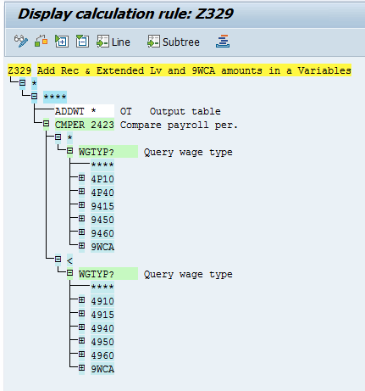

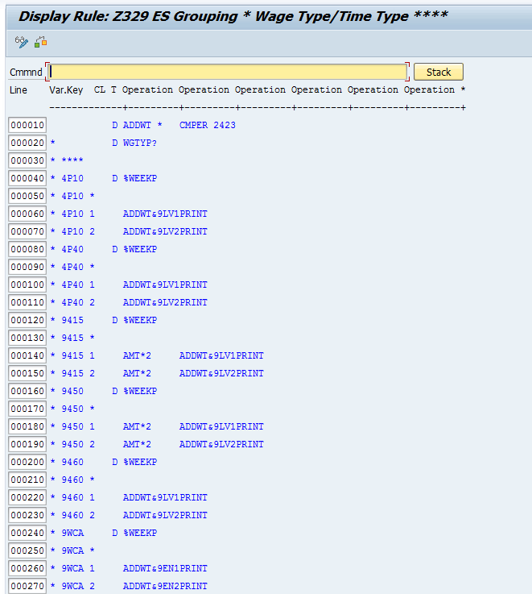
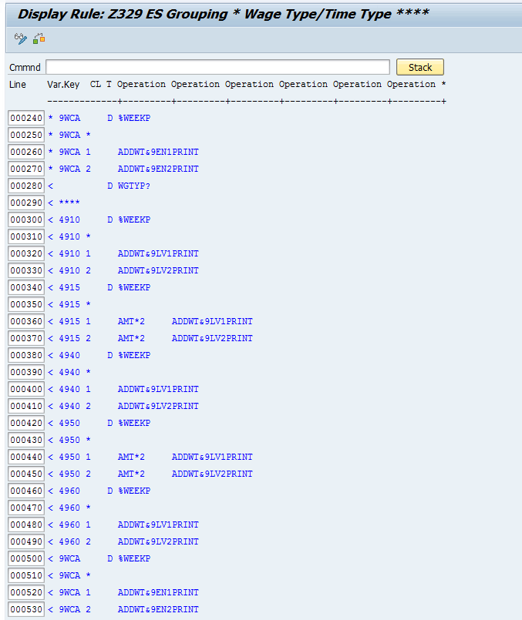

New Rule: Z330: Drop 9WCM if negative only when Rec & Ext Leave are more than 9WCA
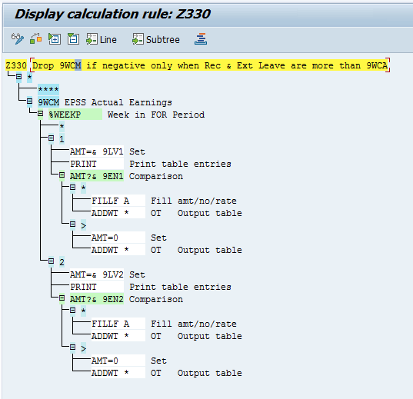

Changed: Schema ZWC3: Added new Rules here.

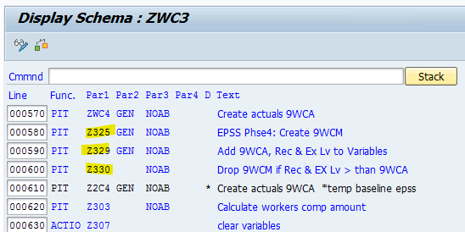

Before change
Last changed by N1123611 On 26.03.2025 At 19:49:47
See Config objects check before change.xlsx worksheet ‘Rule Z316 B4 chg‘. It shows rule Z316 before changes for EPSS phase 4. (DEV and TST/DB1 aligned)
The red highlights will be copied to WT 9WCM and the entries for 9WCA will be removed in the EPSS phase 4 changes.
WT 4901 and 9WCM will not inherit the CNTR3 as part of the EPSS phase 4 changes. WT 9WCO never inherited the CNTR3 and WT 4901 is not EPSS generated, therefor best not to change it. At this stage there is no impact from the past assignment of CNTR3 to WT 4901 as it was only set for Police and is only used by Admin in subsequent payroll rules.
Rule | ESGPCR | WT | More details | Next line |  | Operation
Z316 | * | ****
Z316 | * | 4901 |  |  |  | D%WEEKP
Z316 | * | 4901 | 1 |  |  | SETIN 3=01 ADDWT 9WK1 ADDWT&4E01 PRINT ADDWT *
Z316 | * | 4901 | 2 |  |  | SETIN 3=02 ADDWT 9WK2 ADDWT&4E02 PRINT ADDWT *
Z316 | * | 9WCA |  |  |  | D%WEEKP
Z316 | * | 9WCA | 1 |  |  | SETIN 3=01 ADDWT 9WK1 ADDWT&4E01 PRINT ADDWT *
Z316 | * | 9WCA | 2 |  |  | SETIN 3=02 ADDWT 9WK2 ADDWT&4E02 PRINT ADDWT *

After change
See before change for lines removed/moved around. Below green highlights were added during EPSS phase4.
Z316 * ****
Z316 * 4901
D %WEEKP
1 ADDWT * SETIN 3=01ELIMI X ADDWT 9WK1ADDWT&4E01PRINT ß move addwt * to front/ add elimi x
2 ADDWT * SETIN 3=02ELIMI X ADDWT 9WK2ADDWT&4E02PRINT ß move addwt * to front/ add elimi x

Z316 * 9WCM ß new line (replaced 9WCM)
D %WEEKP ß new line (replaced 9WCM)
* ßNew line
1 ADDWT * SETIN 3=01ADDWT 9WK1ADDWT&4E01PRINT ß new line (replaced 9WCM)/move addwt * to front
2 ADDWT * SETIN 3=02ADDWT 9WK2ADDWT&4E02PRINT ß new line (replaced 9WCM)/move addwt * to front

Change schema ZWC3

Before Change
See Config objects check before change.xlsx worksheet Schema ZWC3 B4 chg. It shows schema ZWC3 before changes for EPSS phase 4. (Aligned with DB1 and TST010)
..
IF ZWZZ Check if PBRI is applicable or EPSS
IF ZWP4 * Check if PBRI is applicable or EPSS
ZEPSD Delete Weeks Table EPSS
PIT ZWZI NOAB EPSS Phse4:Add week CNTR3 W3670 OhEarn
PIT Z321 NOAB Add V0 + Sign on 9WCA
PIT Z316 NOAB Add WC to Variables splitwise
PRINT VAR
PIT Z320 NOAB Clear 4909 before calc. new 4909
PIT Z315 NOAB Calculate new top up for EPSS splitwise
PIT Z323 NOAB Remove splits on 4909
PIT Z322 NOAB Calculate EPSS TopUp per week
PIT Z319 NOAB Remove Extra week Pay if 39 wk completed
ENDIF
…

After change
New lines are highlighted in green. Commented /obsolete lines are highlighted in red.
See New Rule: Z325 ZEPSS Copy 9WCA to 9WCM, reduce with Rec/Ext
Comment rule Z321. It attempts to add the V0 to WT 9WCA. WT 9WCA is not relevant for EPSS anymore. The V0 added to WT 9WCA is not certain to align with WT 9WCO either.
..
PIT ZWC4 GEN NOAB Create actuals 9WCA
PIT Z325 GEN NOAB EPSS Phse4: Create 9WCM ßNew line
PIT Z2C4 GEN NOAB * Create actuals 9WCA *temp baseline epss
PIT Z303 NOAB Calculate workers comp amount
..
IF ZWZZ Check if PBRI is applicable or EPSS
IF ZWP4 * Check if PBRI is applicable or EPSS
ZEPSD Delete Weeks Table EPSS
PIT ZWZI NOAB EPSS Phse4:Add week CNTR3 W3670 OhEarn
PIT Z321 NOAB * Add V0 + Sign on 9WCA ßComment this line
PIT Z316 NOAB Add WC to Variables splitwise
PRINT VAR
PIT Z320 NOAB Clear 4909 before calc. new 4909
PIT Z315 NOAB Calculate new top up for EPSS splitwise
PIT Z323 NOAB Remove splits on 4909
PIT Z322 NOAB Calculate EPSS TopUp per week
PIT Z319 NOAB Remove Extra week Pay if 39 wk completed
ENDIF
..

Change Schema ZWC4

Before change
See Config objects check before change.xlsx worksheet ‘Schema ZWC4 B4 Chg’. It shows schema ZWC3 before changes for EPSS phase 4. (Aligned with DB1 and TST010)
..
PIT ZWZI NOAB Create weekwise split on WT3670 OthrEarn
PIT Z321 NOAB Add V0 + Sign on 9WCA
PIT Z361 NOAB Add WC & Earnings to Variables Splitwise
..

After change
Comment rule Z321. WT 9WCA is not used. Do not add the V0 split against WT 9WCA. It is not 100% certain it will always be the relevant V0 that aligns with WT 9WC0.
PIT ZWZI NOAB Create weekwise split on WT3670 OthrEarn
PIT Z321 NOAB * Add V0 + Sign on 9WCA ß- Comment this line
PIT Z361 NOAB Add WC & Earnings to Variables Splitwise

Change Rule: Z361 Add amounts in Variables for EPSS 2 Calc

Before change
Last changed by N1117570 On 06.06.2025 At 10:55:28
The rule equals TST010 and DB1 before it was changed for EPSS phase 4.
See Config objects check before change.xlsx worksheet ‘Rule Z361 B4 chg‘. It shows rule Z361 before changes for EPSS phase 4.
The red highlights below show lines that were deleted/replaced. WT 9WCA was replaced with WT 9WCM.
Rule | ESGPCR | WT | More details | Next line |  | Operation
Z361 | * | ****
Z361 | * | 4901 |  |  |  | D%WEEKP
Z361 | * | 4901 | * |  |  | ADDWT *
Z361 | * | 4901 | 1 |  |  | SETIN 3=01 ADDWT 9WE1 PRINT ADDWT *
Z361 | * | 4901 | 2 |  |  | SETIN 3=02 ADDWT 9WE2 PRINT ADDWT *
Z361 | * | 9WCA |  |  |  | D%WEEKP
Z361 | * | 9WCA | * |  |  | ADDWT *
Z361 | * | 9WCA | 1 |  |  | SETIN 3=01 ADDWT 9WE1 PRINT ADDWT *
Z361 | * | 9WCA | 2 |  |  | SETIN 3=02 ADDWT 9WE2 PRINT ADDWT *

After change
The green highlights were added during phase 4. See ‘before change’, red highlights for the lines that were deleted. Essentially WT 9WCA was replaced with WT 9WCM retrospectively. WT 9WCM differs to WT 9WCA in that it is less with earnings of paid recreational and extended leave at the all-inclusive rate.
Trial change 1: Do not attempt to have the V0 split in the week1/2 WT’s 9WE1/2. It is unsure if 9WCM would have the same V0 assigned (if we tried to assign), as WT 4901 (both adds to WT’s 9WE1/2). Attempting to have 9WCM with the same V0 as WT4901 could lead to multiple lines and incorrect downstream calculations as the V0 field is not a key. In case of multiple lines with different V0 entries, the calculations will only read the first line due to all having the same key, but a different V0 which is not a key.
Trail change 2: The rule used to add WT 4901 out with the CNTR3 added. Subsequent rules (eg Z306 Z313 ZWZE) that use WT4901 is not expected to be impacted as the these are executed for Admin and the CNTR3 is added for Police (otherwise they would have failed the intended processing). There is no use of WT4901 after adding CNTR3 to it for EPSS Police. WT 9WCO also does not have CNTR3 added to it. As WT 4901 creation is not EPSS related and as it historically aligns with WT 9WCO in relation to other indicators, this rule is changed not to inherit CNTR3 against WT 4901.

Z361 * ****
Z361 * 4901
D %WEEKP
* ADDWT *
1 ADDWT *SETIN 3=01ELIMI X ADDWT 9WE1PRINT ß addwt * moved to front, add elimi X
2 ADDWT *SETIN 3=02ELIMI X ADDWT 9WE2PRINT ß addwt * moved to front, add elimi X

Z361 * 9WCM ßNew line added (replaced WT 9WCA)
D %WEEKP ßNew line added (replaced WT 9WCA)
* ADDWT * ßNew line added (replaced WT 9WCA)
1 ADDWT *SETIN 3=01ADDWT 9WE1PRINT ßNew line added (replaced WT 9WCA)/addwt * moved to front
2 ADDWT *SETIN 3=02ADDWT 9WE2PRINT ßNew line added (replaced WT 9WCA)/ addwt * moved to front

Technical
The technical design document takes precedence.

OLIMS
There is no additional change for OLIMS.

SAP
There is no additional change for SAP technical.

Cutover impact

Business Cutover impact
EPSS Employees that had any type of recreational or extended leave, (full or half pay), needs to be set for SAP payroll force retro to the first date within the EPSS period 1/ 2 or 3 where the leave was taken by the employee.
Do not set retro dates if a retro has already been set for an earlier date for the employee.
The same leave needs to be analysed and if it was taken in connection to the EPSS claim, then a weekly dollar value is to be loaded in IT15 WT 3670. Payroll will use the value to reduce weekly actual earnings in the pay split where the WT exist.
The expected result is a potential higher top up when there is no WT 3670 loaded, but when WT 3670 is loaded then the likeliness is for no or very little change to the original top up from the retro period pending the value in WT 3670.

Period 1 salary – basic pay used

Current setup/issue
Period 1 salary (ORP) used for payroll EPSS payment calculations is fixed as at the date of disablement. Increases to the Base salary (changes to IT0008) post the disablement date does not increase the ORP.
The period 1 payroll change required is to use the basic pay relevant at the pay period/split end date, for compilation of the period 1 (ORP) salary instead of the static period 1 salary as at date of disablement.
The change is retrospective.
OLIMS require a screen where all the Period 1 salaries display. Salaries after period 1 week 39 is not mandatory for display.

Changes required.

Functional
No specific change is required other than verification / testing that the Period 1 salary used is the active ORP in the period 1 pay period split, whether in retro or the current pay period.

Build/Config

Rule ZWZB

Before change
See Config objects check before change.xlsx worksheet ‘Rule ZWZB B4 chg‘. It shows rule ZWZB before changes for EPSS phase 4. (DEV and TST/DB1 aligned)
D ADDWT * %WEEKP
*
1 AMT=& 9WA1RTE= /813MULTI RAA AMT/KGENAUZERO= RN NEXTR A
1 A ADDWT 9WCIZERO= NRA ZORP= SETIN 3=01ADDWT 9ORPNEXTR B
1 B ADDWT&9OR1
2 AMT=& 9WA2RTE= /813MULTI RAA AMT/KGENAUZERO= RN NEXTR A
2 A ADDWT 9WCIZERO= NRA ZORP= SETIN 3=02ADDWT 9ORPNEXTR B
2 B ADDWT&9OR2

After change
The change is to move operation SETIN= to be before operation ZORP=. This way the week number is available for the operation ZORP to use.
D ADDWT * %WEEKP
*
1 AMT=& 9WA1RTE= /813MULTI RAA AMT/KGENAUZERO= RN NEXTR A
1 A ADDWT 9WCIZERO= NRA SETIN 3=01ZORP= ADDWT 9ORPNEXTR B
1 B ADDWT&9OR1
2 AMT=& 9WA2RTE= /813MULTI RAA AMT/KGENAUZERO= RN NEXTR A
2 A ADDWT 9WCIZERO= NRA SETIN 3=02ZORP= ADDWT 9ORPNEXTR B
2 B ADDWT&9OR2

Technical
The technical design document takes precedence.

OLIMS
OLIMS technical design takes precedence in defining changes required. The below is expected to be detailed in the OLIMS design:
- Screen to show all the Period 1 salaries (where basic pay relates to period 1)
- Change to not save the period 1 salary in a table and not to report from the table holding the static period 1 salaries already created in the past.
- OLIMS design to consider a cleanup of the static period 1 salaries table

SAP
The ORP is not a fixed value that can be read from a static OLIMS table anymore.
Change SAP operation ZORP that provide the ORP (Period 1) salary to look at the basic pay WT’s relevant to the pay period split (split end date), instead off at the date of disablement.
The change is not date driven.

Cutover impact

Business cutover impact
All EPSS period 1 employees with a basic pay change during their EPSS period 1 payroll periods up to the implementation of this change, need to be set for a payroll force retro to the first pay rise relevant for the employee where he was in EPSS period 1. The retro will re-calculate the EPSS period 1 top up based on the higher ORP. This can lead to P2 commencing earlier.
Do not set retro dates if a retro has already been set for an earlier date for the employee.

BRD06 ICARE recoup report

Current setup/issue
The ICARE recoup report is currently compiled manually every quarter.
The report is to be automated. The technical design takes precedence.
For the Oct ’25 release the columns with the green highlights will be shown in the report, the pink will have columns but no values and the orange highlights are not mandatory but will be considered for display in the Oct ’25 release.
The report is to be executed after the last pay period for the quarter was exited, and before the first pay of the next quarter’s first preliminary pay run.
EPSS adjustment wage types are not included in the payment amount reported. It must be added in manually. Only the EPSS auto period payments are included in the payment amount, eg.
49E9 EPSS P1 Top Up
49S9 EPSS P2 Supp. Pay

Changes required.

Functional
No change required.

Technical
The SAP technical design takes precedence over the below.

SAP
The SAP technical design takes precedence over the below. Inclusions in this document is purely to align SAP payroll input to the report.
The report execution date is expected after the reported quarter’s payroll periods have been completed/exited, but before the first pay of the following quarter has been processed in SAP.
This is important because the EPSS OLIMS week table could have moved on to a new ‘in’ period that is after the reported quarter.
The report selection is to allow for entering a start and end date. Any pay periods accounted with a period end date that falls within the start/end date will be included in the report.
An example standard SAP baseline report is the Wage type (WT) reporter, transaction PC00_M13_CWTR. See below for typical selections from the WT reporter that will result in a similar output, but it will not be granular enough for the ICARE recoup report:
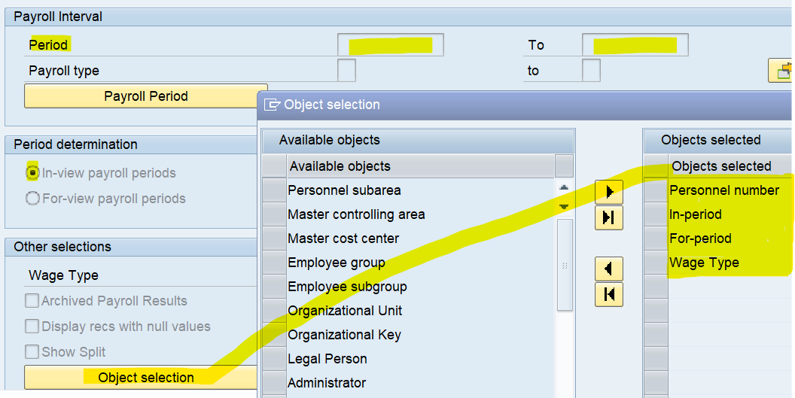
For the ICARE report the output values from the SAP standard WT report output is refined with additional ‘keys’, causing unique line outputs as per the blue highlights below.
Below explain the output for the columns.
Column | Payroll note | Other Comment
POS Claim no (Incident no) | Link the incident number up with the nett difference of the EPSS top up WT’s reported in the column ‘Payment Amount’, where the payment is related to the net difference from the ‘for period’ (columns Incapacity from /and to period) of the reported quarter “in periods”. The link to the incident is interpreted via the SAP V0 table that is assigned to the EPSS top up wage type.  Example; TST030 7728821 Pay 23 2024:  WT 49E9 V0 variable assignment type for this sample was + and variable assignment was 01. Info for the WT is then linked to the v0 table. 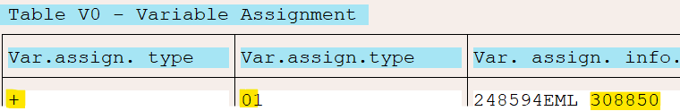  **See disclaimer A in relation to testing data | The V0 assignment to the EPSS top up /supplementary pay WT’s are expected to align with the WT 9WCO V0 assignment and this originates from the WT 9WCO assignment field in IT0014.  It is recommended to retrieve the incident via the EPSS top up WT’s in the pay results and it’s reference to the V0 table as master data could have changed in retrospect.
Officers registration number | The SAP employee number with EPSS top up WT’s to be reported:  49E9 EPSS P1 Top Up  49S9 EPSS P2 Supp. Pay
WC Claim number | As for POS Claim no, but derive the EML number for the net EPSS top up WT value reported as related to the for period displayed.
Payment date | This is the end date of the IN pay period of which the net differences are reported. Eg. pay 3 in 4 has a net difference of $50 to pay 3 in 3; then show $50 with the pay 3 incapacity from/end dates, but the payment date is that of pay 4.
Incapacity period from/to dates | The period dates that reflect the net difference for an incident. See the column ‘Payment date’ example, P3 dates
Payment amount | The net difference amount for the Incapacity period from/to dates. See the column ‘Payment date’ example.  Note on retro change of primary incident:  Pay 3 in 3 $0  Pay 3 in 4 $50 Incident A  Pay 3 in 4 $50 Incident B  The above example implies the primary incident changed. Then two lines report  Incident A; Incapacity start/end Pay 3; $-50  Incident B; Incapacity start/end Pay 3; $ 50  However, if both was primary incident A, then there is nothing to report.
No of weeks of period 1 utilised | The week number in ZIM_EPSS_WEEK_NO ‘for’ the Incapacity start/end pay period as accounted “in” the quarter period that is included in the report.  As per the payment amount column sample the for period was 3 and the in period was 4.
No of pay weeks of period 1 available | If ‘No of weeks of period 1 utilised’ =>39, then zero, otherwise 39 minus No of weeks of period 1 utilised.
No of weeks of period 2 utilised | If Period 2 did not commence in or prior to the incapacity period been reported, then zero, otherwise (Incapacity pay period end date – Period2 start +1)/7. Round week up, eg. 10.49 =10; 10.5 or = 11 weeks.
No of pay weeks of period 2 available | 365 minus No of weeks of period 2 utilised
Claim type (Physical or Physiological) |  | Retrieved from the P902 of the incident from the location of injury. A mapping condition if injury is not psychological to default to 'physical' instead of location of physical injury i.e Knee (right)
Claim status (open or closed) |  | Workers Compensation claim status from OLIMS Field Name: WC_STATUS
**Disclaimer A
There was a period where the EPSS top up wage type was a fortnight total with the payroll and the variable assignment splits removed. It is understood that this issue was fixed during a prior UAT period and that it is not evident in production. It is possible that data in test environments will report incorrectly when the link to the EPSS incident can’t be located. It is best to test the report with data that is from a system refresh from production.
**Disclaimer B
The only WT’s reported for the payment date is that of the top up/supplementary pay.
It does NOT include the adjustment wage types as they do not have a definite reference in SAP to the EPSS incident.
The below WT’s are not included in the payment amount:
6A48 EPSS P1 Adjustment
6A49 EPSS P2 Adjustment

WT’s included in the payment amount are:
49E9 EPSS P1 Top Up
49S9 EPSS P2 Supp. Pay

Business impact
Execute the quarterly Icare recoup report after the last pay of the quarter was exited, but before the first pay of the next quarter’s first preliminary pay run. Timing of execution is important for the correct weeks used and estimated weeks left.
Provide the start and end dates of the quarter reported in the program selection screen. The pay periods reported will be all periods that has an end date that falls within the date selection.
The selection screen is to select only the reportable WT’s (for the payment amount) that can be linked in pay results with the EPSS incident and the WC claim:
49E9 EPSS P1 Top Up
49S9 EPSS P2 Supp. Pay

Add EPSS adjustment wage types manually to the report after execution.

Section 36/37 Period 1 weeks

Current setup/issue
During EPSS Period 1, the week counter increase with one when wage type 49E9 EPSS P1 Top Up had at least a $1 value in the pay week. This rule currently applies regardless of the WC section of the act that is relevant.
The change required is to add 1 to the EPSS Period 1 week count for section 36 or section 37 even when there was no EPSS period 1 top up. A maximum of 1 is to add to the pay week.
In scenarios where a EPSS period 1 pay week had splits where part was not Section 36/37 and part was Section 36/37, then maximum 1 is added to that week count. The increased week count is regardless of whether there was $1 EPSS P1 Top up in the portion that was not S36/37. This apply even if S36/37 was only valid for 1 day in the pay week, provided Period 1 is relevant when S36/37 is effective.
The sections 36 and 37 is defined in SAP via the reason code assigned to IT0014, WT 9WCO Workers Comp Rates. Below reason codes will be deemed S36/37 for this requirement:
ZA S36
ZB S37
The change is only valid for EPSS period 1.
The change will not attempt to incorporate PBRI (DOD prior to 1.10.2024) that was transferred to EPSS/that is park that for when have an effective date for transfers to EPSS in future releases.
The S36/37 change will deem period 1 to be:
- Per processed WT 9WCO:
  - DOD for the WT 9WCO EPSS incident is = or > 1.10.2024 and
  - The DOD is prior or within the processed WT 9WCO pay split dates and
  - The incident of the processed WT 9WCO is still in period 1 (week count of the prior week for the incident is less than 39)
The change is retrospective.

Changes required.

Functional
We had to do a small change in Rule ZWZI to include the Week No. count in front of Wage type 9WCO. This is a new Rule as part of Phase 4 changes anyway.
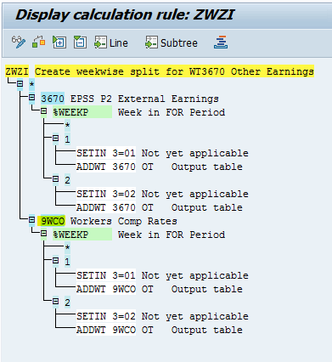

Testing effort in support of the technical changes.

Technical

SAP
Enhance function ZEPS1.
It is anticipated that the function will need change to not only read WT 49E9 for $1 to impact the week count, but also to find if WT 9WCO, when relevant to EPSS Period 1 for the WPBP split of WT 9WCO, and if WT 9WCO is a S36/37, then to also continue with the week count increase as if there was a $1 earning from WT 49E9, even if there was no WT 49E9 in the pay week. The EPSS period 1 week count increase with maximum 1. Existing period 1 limits of 39 weeks continue to apply. The use of WT 9WCO is only relevant if P1 is valid to the extend that there will be a ORP salary related to the 9WCO split. See the definition of Period 1 as stated under Current setup/issue.
Assumption is we will have a pay split when the section change as this is shown in WT 9WCO.
Samples:
Assumption is EPSS period 1 is valid and WT 9WCO is available for the below samples unless mentioned it is not:
Scenario | Check S36/37? | Rationale
Pay split 27.9.24 to 1.10.24  DOD of 30.09.2024 (or prior) | No | DOD < 1.10.2024  Deemed PBRI
Pay split 27.9.24 to 1.10.24  DOD of 1.10.2024 | Yes | DOD 1.10.2024; Deemed EPSS  DOD Valid in P1 pay split.
Pay split 1.11.24 to 7.11.24  DOD of 1.10.2024 | Yes | DOD 1.10.2024; Deemed EPSS  DOD Valid in P1 pay split.
Pay split 1.11.24 to 7.11.24  DOD is 1.12.24 | No | DOD >1.10.2024; Deemed EPSS  DOD NOT valid in pay split.
Pay split 1.03.25 to 7.03.25  DOD is 1.10.2024  There is no WT 9WCO on 1.3.25 | No | DOD =1.10.2024; Deemed EPSS  No WT 9WCO to process
Pay split 1.11.25 to 7.11.25  DOD is 15.10.2024  Prior pay week table is already at 39 | No | DOD >1.10.2024; Deemed EPSS  DOD Valid in pay split  Split is NOT deemed EPSS P1.
As per prior workers compensation designs, the sections 36/37 can be identified via the rate field value of WT 9WCO (instead of reading the IT14 reason code):
WT 9WCO with Section 36 will have a rate of 2301
WT 9WCO with Section 37 will have a rate of 2302
Example 70024172 DEV010 pay 26 2024 in 01 2025

Cutover

Business impact
Employees that were on Section 36/37 while been processed for EPSS period 1 prior to go live, needs to be set manually for retro to the when Section 36/37 applied for them at first during EPSS period 1 validity.
Do not set retro dates if a retro has already been set for an earlier date for the employee.

EPSS age driven employee contributions

Current setup/issue
Currently the EPSS employee contributions for the below wage types related to super fund codes 9DDL 9DDM 9DDN, are limited to employees that are less than 65 years old:
104F Police Ins (D) death (aware super)
104G Police Ins (OFD IP) off duty IP (TAL)
104E Police Ins OFD IP 0.88 contrib for SASS
7707 ER PoliceIns(OFD IP)
7708 ER PoliceIns(OFD IP)
104H Police Ins (ODD)
104I Police Ins (OFD)
Other 9EP*/9DD* WT’s related to the super fund codes 9DDL 9DDM 9DDN
The age limit is to increase to age 67 pending the date of birth as per the table listed in EPSS payments cease at retirement.
Due to the effective dating of the change, only retirement age 67 will be a valid scenario as per the birth date retirement table:
The change is applicable from the next accounted pay period after the changes migrate to production. (not retrospectively).
Existing age based contribution adjustments in place will not be removed.

Changes required.

Functional

Effective date
Create a go live Non-Statutory Sub-application ‘9EPB’. The date is to reflect the first accounted pay after the changes move to production. The go live date is expected to be 10.10.2025 as per Oct’25 go live date.
The date can change during the different test phases and pending the actual go live date.
The reason the effective date is from the first pay to be accounted after the changes migrate to production, is because the employee contributions calculate in the current period. (It is not like the EPSS payments that always calculate in retro).
This application will be used in SAP functions for date effective checks.

Build/Config

T596A Sub-applications
New entry:
9EPB NSW Police EPSS phase 4 Pay period go live

T596D Non-statutory sub-applications
Add new entry:
9EPB NSW Police EPSS phase 4 Pay period go live 10.10.2025 31.12.9999
As per David’s email Dated 16 Oct 2025:
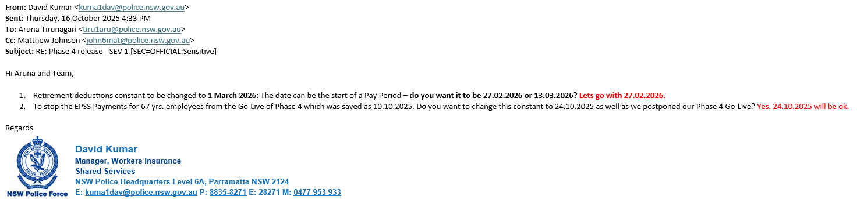
Changing 9EPB to 24.10.2025 and 9EPC to 10.10.2025
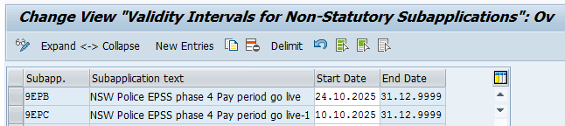

Super fund changes
Change the retirement age for males and females from 65 to nothing for the below super funds effective 10.10.2025 (start date of the first pay when the change is in production/this can vary). The effective date will change for the different test phases and at go live.
9DDL Police Officer Insurance 0.88%
9DDM Police Officer Ins (ODD & Off DD) 0.35%
9DDN Police Officer Insurance (OFD IP) 1.45%
Disclaimer: If downstream issues are uncovered then the above Super fund retirement ages can be set to 67, effective from the first accounted period after go live, as that is the only retirement age that is currently a valid scenario.
The reason the retirement age against the super funds are proposed to change to ‘nothing’, is because the function _EPS1 can take care on the different retirement age checks based on the date of birth. The super function does not check for a retirement age pending when the date of birth is. The super functionality uses the configured super fund retirement ages to compare to the age at the pay date (same as period end date at NSWPf).
See program RPCSUPQ0_PVT, functionality in forms: ‘AGE_OF_PERSON ‘, ‘retired_or_not’.

Technical
The technical design takes precedence.

SAP
For pay periods where the pay period start date is = or> than the T596D, application ‘9EPB’:
Change SAP function _EPS1 to replace checks that limit creation of the EPSS WT’s from age 65 to the age as per the birthdate/age table noted under EPSS payments cease at retirement.
Noted, with the birth date/retirement age input provided, only retirement age 67 is expected to be relevant for pay periods with EPSS pay dates from 1.10.2024 and onwards. Employees with birthdates prior to 1 January 1957 will already be 67 by 1.10.2024.

Cutover impact

Functional V_T5QSF:
The super fund effective date changes need to change for each test phase and again at go live.
Before:
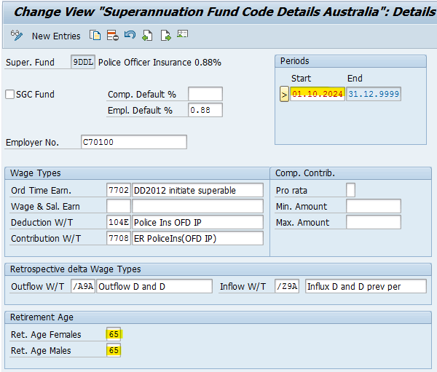
After:
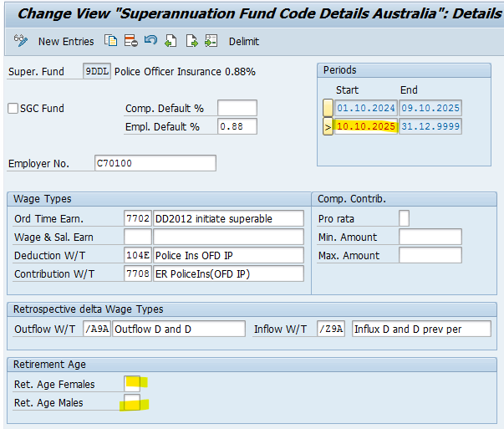
Same has been done to the following 2 Funds too
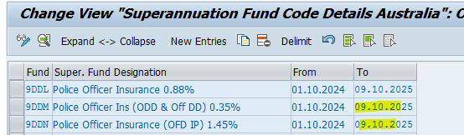
As per email from David dated 16 Oct 2025: Changing these effective dates as the Go Live date moved from 10.10.2025 to 24.10.2025
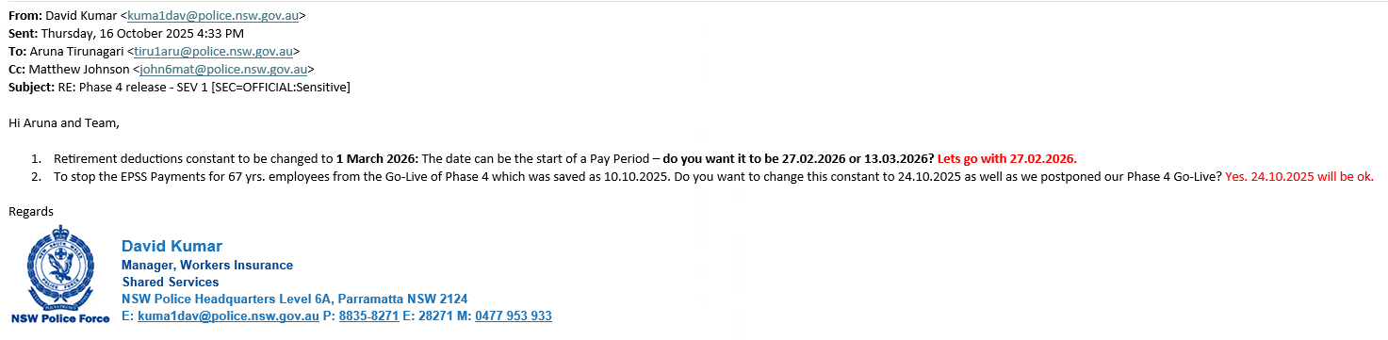

Final Config for Go-Live:
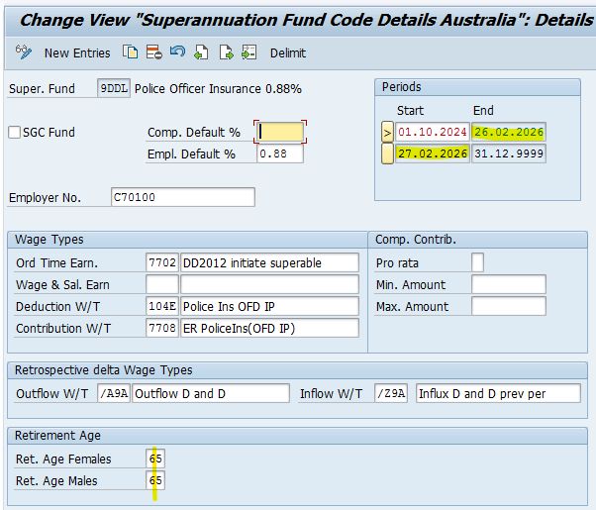
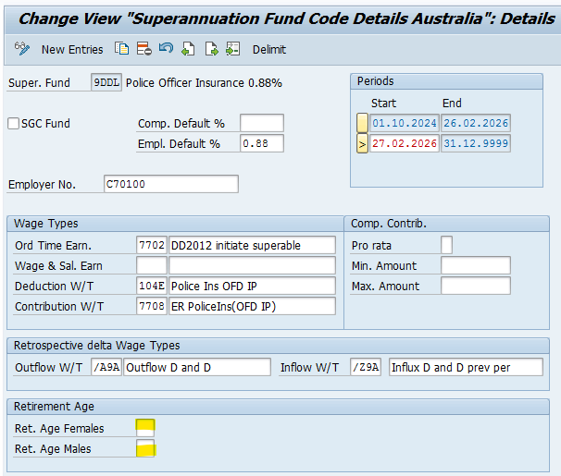
The same change has been performed on 9DDM & 9DDN as well.
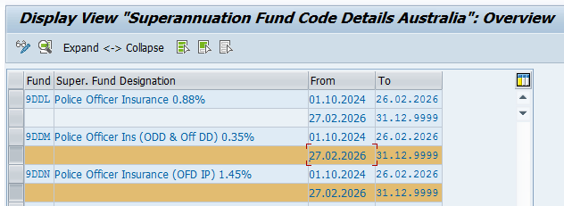

Testing impact - all
The change of the effective date for test phases vs production go live implies the age based UAT test data will become obsolete when the effective date of the change moves forward compared to the date used for testing.
Data for testing is required and the ‘go live’ for each test phase needs to be considered and advised to the project team.

EPSS payments cease at retirement.

Current setup/issue
Currently the EPSS top up/payments are paid when the EPSS employee reaches retirement age:
49E9 EPSS P1 Top Up
49S9 EPSS P2 Supp. Pay
Change is required for the EPSS top up/payments for all EPSS periods to cease when the employee reaches retirement age. The age is checked as per the below table, effective at the end of the pay period (fortnight) or on the last active date in case of a terminated employee.
Year of Birth | Retirement Age
1 January 1954 to 30 June 1955 | 66 years
1 July 1955 to 31 December 1956 | 66 years and 6 months
If born after 1 January 1957 | 67 years
Manual adjustments will be made when the age was reached mid the fortnight pay period.
The change is to be implemented from the October ’25 go live only. The change is not applied retrospectively, but due to the nature of EPSS payments that occur in retro, the go live for the changes will be the last accounted period before the changes moves to production. This implies the go live for this requirement is one pay period in retrospect.

Changes required.

Functional

Effective date
Create a go live Non-Statutory Sub-application ‘9EPC’. The date is to reflect the last pay that was accounted before the changes move to production. This new application date moves to production after this last pay was exited, together with the other changes. The go live date is expected to be 26.09.2025 as per Oct’25 go live date.

Build/Config

T596A Sub-applications
New entry
9EPC NSW Police EPSS phase 4 Pay period go live-1

T596D Non-statutory sub-applications
Add new entry:
9EPC NSW Police EPSS phase 4 Pay period go live-1 26.09.2025 31.12.9999

Payroll rules
Utilise payroll rules prior to function _EPS1 to set variable ‘9ETN’ to zero/delete the variable.
Utilise payroll rules to drop the below WT’s for both pay weeks in the pay period if the variable ‘9ETN’ exist. In the future when Period 3 payments are developed, then the same will apply.
49E9 EPSS P1 Top Up
49S9 EPSS P2 Supp. Pay
When variable 9ETN exist and there was a EPSS top up from any EPSS period to be dropped, add it out as WT 9ETN EPSS retirement age. The WT is to be created new as a notional WT in the results with no splits or other wage type keys. It is used as an indication to payroll that EPSS top up was stopped due to the employee retirement age.

Build/Config
New Wage Type created:
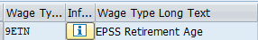
We tried using the above logic but faced many issues in testing hence the retirement solution was created as given below:

Retirement Payroll Build:

_ZAGE function was built to bring the real Age of the employee into a Variable ZAGE.
Details on _ZAGE are available in the Technical document.
Rule ZERT was created to Remove the EPSS Top Ups if employee has reached retirement age that is 67 years of age.
Also this rule is only applicable after 26.09.2025 - controlled by 9EPC Sub-application Constant
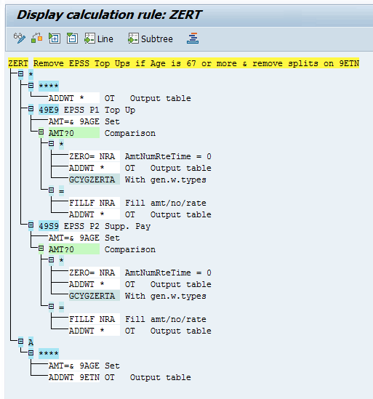
As we are removing the EPSS Top Ups if employee has reached Retirment age, a corresponding rule ZWP7 was also created to check that if Employee has reached retirement age, then dont update the WEEK No. Counting Table
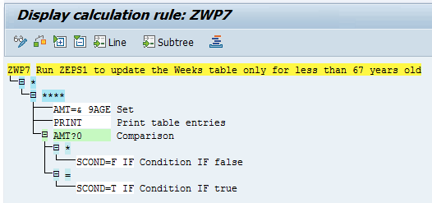

Schema ZWC3 is updated as given below.
All Retirement related configuration is highlighted in Yellow:
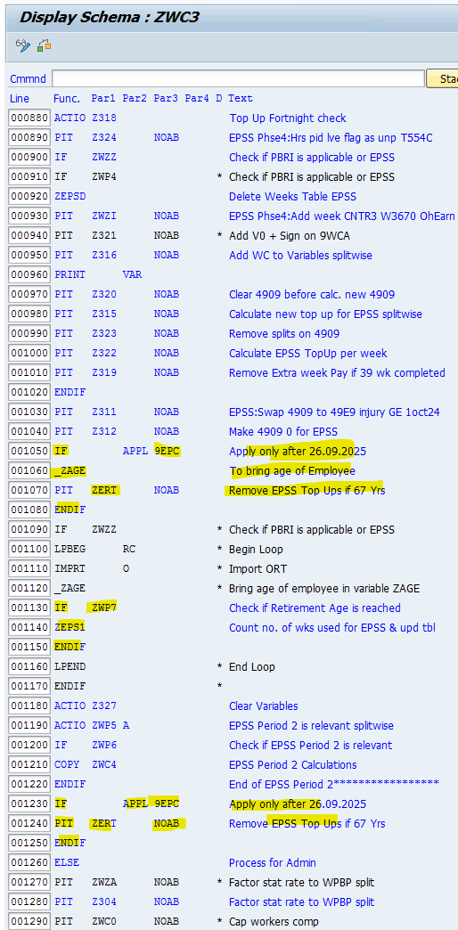

Technical

SAP
The technical design takes preference.
For pay periods where the pay period start date is = or > than the T596D, application ‘9EPC’, prior to the SAP function _EPS1 changes noted under EPSS age driven employee, enhance function _EPSS to add ‘9ETN’ to the VARiable table with amount = 1, when the employee age at the period end (or last active date for a terminated employee) is equal or greater pending the birthdate matrix. We expect with the current age vs birth date matrix that all employees will be older than 67 when their birth date is prior to 1/1/1957.
The below custom table is recommended but not required, because the current age/birth date matrix, and based on the relevant pay periods where the age is to be checked, only employees that is already over 67 years is expected to be impacted. A table as below with effective dates will assist with future effective dated changes.
Eg.
Field | Key field or data | Comment
Effective from | Key | Read entry valid at pay period end date
Effective to | Key | Read entry valid at pay period end date
Start date of birth year | Key | Read entry valid on employee birthdate
End date of birth year | Key | Read entry valid on employee birthdate
Retirement age YYYY  RT_Age_YYYY | Data | Get the number of years/months/days between the birthday and the pay period end date (inclusive)/last active day,  B_YYYY / B_MM / B_DD.  Allow EPSS fund contributions & related WT’s and do not create the variable when the entry read have:  RT Age_MM = zero, then for entry read, check B_YYYY < RT_Age_YYYY  If check is not passed, then do not create EPSS fund code WT’s and create the variable (noted the effective pay for the 2 items differ)
Retirement age Month  RT_Age_MM | Data | Get the number of years/months/days between the birthday and the pay period end date (inclusive)/last active day,  B_YYYY / B_MM / B_DD.  Allow EPSS fund contributions & related WT’s and do not create the variable when the entry read have:  RT_Age_MM not zero, then for entry read, and if B_YYYY = RT_Age_YYYY, then check the B_MM < RT_Age_MM; or if the if the B_YYYY not equal to the RT_Age_YYYY, then check B_YYYY < RT_Age_YYYY.  If checks are not passed, then do not create EPSS fund code WT’s and create the variable (noted the effective pay for the 2 items differ)

Business impact
Continue to monitor if manual adjustments are required for employees that reached the retirement age mid pay period.
The payroll message for retirement age will not show for funds 9DDL/M/N anymore. Instead find employees that had EPSS payments dropped due to retirement age via notional WT 9ETN. *Disclaimer, the project team will advise if the use of WT9ETN changes/if the fund message is re-instated.

Sign-off – Oct ’25 release phase 4
Manager – Workers Insurance, HRTS | David Kumar
Manager - TCSC ERP Platform Business Support | Aruna Tirunagari
Manager – SAP Technical | Yameng Chen
A/Senior Project Officer - SS HR Transactional Services | Matthew Johnson

SAP configuration released TBC – kept for future FYI.

IT15 external earnings - Integration

Current setup/issue definition
Currently IT15 WT 3670 is only used for Period 2 external earnings. The same external earnings used for P2 is to be used for Period 1 and P3 to reduce payments.
Currently IT15 external Period 2 earnings (WT 3670) is entered manually via transaction PA30.
It is required to add supporting documentation to the external earnings that are not from EML. IT15 allows for a note to be added, but the requirement is to upload a document, eg. a payslip.
NSWPf already have a methodology to upload documents but this is not via the infotypes themselves. It involves a custom table with a key that the document relates to and a link to where the document will be uploaded.
A build is required to accommodate IT15 upload via OLIMS for non-EML earnings with supporting documentation attached.
When EML provides external earnings, then the documentation is with EML and NSWPf do not need to keep the documentation. There is no mass IT15 upload in OLIMS for the EML external earnings. The EML external earnings relates to detached officers. TBC An upload without documentation from within OLIMS is required to accommodate. TBC The upload is to be build when the detached employee solution goes live.

Changes required

Functional

WT 3670
Currently WT 3670 EPSS P2 External Earnings is allowed data entry only once per day.
Allow EPSS external earning WT’s to be entered multiple times on the same effective date. This is to cater for earnings from multiple sources on one day.
Set WT to force a minimum amount of 0.01 (positive) and a maximum of the highest number available.
TBC (Josh) is there a WT for Hardship Cases? The hardship payment WT/s (if they exist), is to add to actual earnings to stop top up from been double dipping on the hardship payment. TBC if we need a design for hardship that will stop EPSS top ups /or/ will adding hardships to actual earnings suffice together with a business process that report employees that has hardship+top up in the same pay; if found, then reconsider the hardship payments (business process).
TBC David Check if the P1/2/3 top up is negative (and dropped). If the top up is dropped been negative AND the fortnight had external earnings WT 3670 in the pay period (regardless of when the external earning is dated in the fortnight), then create a new WT tbc during build XXXX with description tbc ‘EPSS Neg with Ext earn’. The new WT holds the negative P1/2/3 top up that was dropped. Use the same WT for all EPSS periods. The WT is informational only and should not have any payroll relevant characteristics.
Eg.
Pay week | Pay fortnight | EPSS salary | WT 4901 | WT 9WCA | WT 3670 | EPSS pay/top up
week1 | Pay 20 2025 | 5000 | 300 | 5000 | 0 | -300
week2 | Pay 20 2025 | 5000 | 300 | 700 | 3900 | 100
Total top up |  |  |  |  |  | -200
WT XXXX | EPSS Neg with Ext earn | 22 |  |  |  | -200

Pay week | Pay fortnight | EPSS salary | WT 4901 | WT 9WCA | WT 3670 | EPSS pay/top up
week1 | Pay 21 2025 | 5000 | 300 | 5000 | 0 | -300
week2 | Pay 21 2025 | 5000 | 300 | 5000 | 0 | -300
Total top up |  |  |  |  |  | -600
WT XXXX | EPSS Neg with Ext earn |  |  |  |  | Do not create

See External earnings for Period 1 for more functional requirements.

Technical (from a payroll perspective)
The OLIMS /technical design takes precedence.
The technical info in this document is to reviewed by the technical team for impacts to payroll expectations and alignment.

Olims

WT 3670
OLIMS to allow create and delete of the external EPSS earning WT 3670 via a OLIMS frontend.
Create requires an effective date.
An effective date entered for external earnings that are not aligned to EPSS period 1, 2 or 3 top up payment calculation periods, (also driven by WT 9WCO), will not reduce EPSS Period 1, 2 or 3 top up payments. The effective date will impact the reduction of the P1/2&3 EPSS claim valid on the IT15 effective date. Retrospective effective dates will cause payroll retro processing and this can cause claims.
Only allow IT15 entries when the effective date relates to an EPSS period. This can be from EPSS period 1 to the end of period 3. Noted, period effective dates can change due to retroactive changes in payroll. Therefor the business is to accept that external earnings still in SAP that does not relate to an EPSS period has no impact to EPSS calculations.
When the entry is ‘created’ via OLIMS (not bulk upload), then force a document upload.
A mass upload of entries is required via a file. These entries will have the same validations except, they will not have documentation for upload.
In general, allow SAP standard validations before data entry is allowed for creation in IT15.
The OLIMS screen will display the IT15 entries already loaded into SAP (both those loaded via PA30 in the past that does not have a document attached and entries created via the OLIMS screen).
Allow for a period selection of entries to display.
When the entry is deleted, then delete the document uploaded before (if applicable).
For each entry displayed that have documentation attached, show a push button for “Repeat” and “Delete”.
When the “repeat button” is selected, prompt the user to input the number of repeats.
When the number of repeats entered is between 15 and 260, a warning message is given. The repeats are allowed for creation after acknowledgment of the warning.
The maximum number of repeats is 260. An entry above 260 repeats results in an error message and no repeat entry is created.
When the number of repeats provided passed all messages, prompt for a save.
On save, then create copies of the IT15 entry with ‘copies’ of the same documentation linked to the new IT15 entries. The copies are created on effective dates that are equal to the processed IT15 record start date + 7 days after. Repeat the process for the number of repeats, using the last start date created as input to the next repeat record + 7 days.
The external earnings do NOT reflect the EPSS incident number. (no entry in the assignment field)
A positive dollar value is required.
Payroll will reduce EPSS period 1/2/3 period payments with the external earning value when the value is relevant to a payroll split where P1/P2/P3 top ups are generated. There is no checking for alignment to the incident number.
It is envisaged that the key to the document will as a minimum hold the below IT15 key fields as well as a document id. The sequence number (SEQNR) will be space for the first entry on a specific effective date. Subsequent entries on the same effective date will increase from 1 and up as per SAP standard.
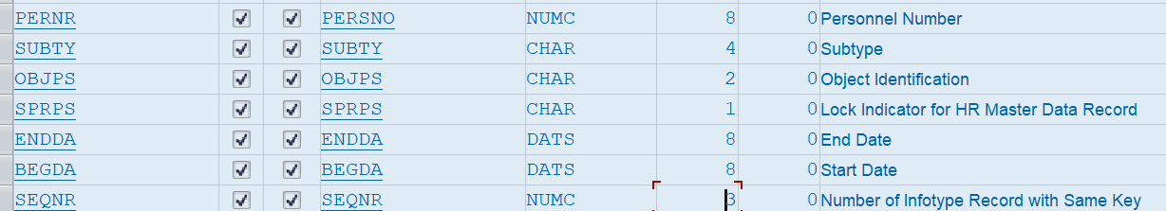

SAP

WT 3670
Via infotype user-exits, stop any data processing ( Eg. create/insert/delete/change) of the External EPSS earning WT 3670. Display is allowed, but no maintenance.
Entry is only allowed via OLIMS to enforce the document upload.

Business
Use of external earnings via recurring earnings and deductions (IT14) were discussed, but the requirement was for entries in once off earnings and deductions (IT15) as a weekly value to allow more granular control for the case manager in relation to external earnings.
It is important to load external earnings as a weekly value for the week where payroll is to account a reduction to the Period 1/2/3 salary and subsequently reduce the aligned EPSS payment (top up).
External earnings with an effective date that does not relate to an EPSS period has no impact to EPSS calculations.
When the EPSS salary is less than the external earnings and other earnings that reduce the EPSS salary, then the external earnings are NOT carried over for reduction in the next period. The employee potentially receives the benefit of the high external earnings when the total calculated top up in the fortnight is negative.
TBC A new WT XXXX will indicate when the fortnight top up was negative and subsequently dropped when there was any external earning input in the fortnight. The negative is not necessarily due to external earnings only. Other reductions like actual earnings and workers compensation also contributes. The existence of the new WT can be used to investigate if additional external earnings are to be loaded in future pay periods.
In general, a Friday effective date for the external earnings implies relevancy to the relevant pay week. Noted, if there is no medical certificate (WT 9WCO) on the Friday or if EPSS is not relevant on a Friday, then the external earning will have no effect.
Payroll backend will reduce P1/P2/P3 salary relevant to the payroll split where the external earning is valid. It was noted that the splits can change due to master data, especially note when the employee moves into EPSS period 1 or from EPSS Period 2 to Period 3 or from Period 2 to period 1.
Where payroll has a split within a week, then the entry will reduce the EPSS payment (top up) in the calculation of that split. Multiple external earnings on the same date (eg. Friday) will add together and reduce the EPSS salary on the total of the same dated entries in the pay split where it falls. Multiple entries in one week with different effective dates in the week will add together if they both fall in the same payroll split, but they will apply separately to period salaries if they fall in different payroll splits.
Generally the expectation is for the weekly external earnings to be entered on a Friday (of the relevant week) or where the medical certificate commence in the week. An exception example is when the employee change between P2 and P1 mid-week (or from P2 to P3 midweek); in this case, if the external earning needs to offset both P2 and P1 EPSS payment WT’s (they are unique WT’s), then the external earning, if required, needs a manual factor applied and the two entries dated for payroll splits effective P2 and P1 in the same week. The manual factor applied in the example is to ensure payroll do not apply the full weeks’ worth of the external value to P2 and the full week value to P1. If the external earning for this example only applies to for example P2, then date it in P2 only for the full weekly external value.

Enter IT15 External EPSS earnings via OLIMS and ensure the supporting document is available for upload.
The external earnings, including the EML bulk upload need a manual Pro-Ration of the total amount 'per week' because top up is calculated per week.
Inform the security team of employees that need access for IT15 create/delete and document upload.
It is understood that external earnings are generally entered effective in the upcoming pay period. This is to avoid claims due to SAP retroactivity. For true overpayments that can’t be recovered the external earnings entered in retro will cause potential claims as payroll retro and recalculate a reduced EPSS salary in the retro period that then impacts the EPPS payments/top ups from the retro period.

Security (NSWPf)
Ensure access/roles are in place for defined users to create and delete IT0015 for defined EPSS external earning WT’s with the subsequent document upload.
The NSWPf business is to liaise with the security team to ensure requirements and userids are communicated timely for system setup.

Period 2 ends mid pay week, no pay split for P3 to commence. Phase 5?

Current setup/issue
The same WT 9WCO is send been the same incident/claim for the full pay period/week, it implies payroll will not have a payroll split to calculate differently for period 3 when period 3 is meant to start mid-week.
The requirement is to generate P3 payments pro-rate if P3 commence mid-week. P2 can’t be valid till the end of the week for this scenario.
TBC. Period 3 calculations are like period 2. A new WT is used for supplementary payments for P3. How is the P3 payment WT characteristics different to Period 2/finance posting etc.

Changes required

Functional
TBC Create a new IT0014 WT XXXX Force pay split. See CPI index for period 2 salary (use the same WT).
Set the WT to create a payroll split and to have WT’s distributed to payroll splits.
Negative points: the start date of Period 3 can move due to SAP retroactivity and that will require the WT to be deleted and reloaded by NSWPf.

Or tbc
New SAP custom operation to create and force splits for the accounted pay period. (Preferred option) See Force payroll split on 1 Oct (and for P3 start date)

Technical

SAP
See Force payroll split on 1 Oct (and for P3 start date)

Business impact
TBC. If the auto split can’t be generated, then the IT14 force split WT is to be created effective where P3 commence mid pay, end date equal to the pay period end date. This will force a split mid week where P3 commence.

Period 2 weeks movement

Current setup/issue
EPSS Period 2 always start at week 40.
When all of period 1 and some of period 2 weeks are paid under PBRI, then the new requirement is to commence period 2 payments from a week after week 40. TBC the PBRI periods perceived as EPSS for payment is static.
If the EPSS payments is for instance to commence in week 45 (that is period 2 already), then the period 2 period is still running from the start of week40, but EPSS payment is only from the start of week 45.
TBC, will the transition to EPSS be week 45 for the sample or at EPSS week 1 of period 1. If week 1 period 1, then assume due to period 2 weeks movement, SAP top ups is to be suppressed and only commence in week 45 (as per the sample).
The only extension to the 7 years of period2, is when the employee is back to work for 7 for more days. The return to work for more than 7 days is already in place and is different to the when period 2 EPSS payments is to only start from after week 40.

Changes required.

Functional

Rule Z319 that check if period 2 is mid-week
Operation ZEPSR is used to check if the week number is 038 and if it is, then it drops WT 4909 Base Salary Adjustment in week2.
Review pending the SAP technical design. Eg. if there is no week 38 and we just commence from week45.
Expectation is in general is that if period 1 never commence due to period 2 commencing in say pay 45, then operation ZORP will send zero to stop period 1 calculations. This will also impact actual earning changes prior to pay 23 2024 to only take affect from period 2, eg. from week 45.

Technical

OLIMS

New field for P2 week commencement
In OLIMS allow for a new field to save the period 2 week commence for the EPSS incident.

Table ZIM_IN_ORP
The ORP salary is currently sourced from ZIM_IN_ORP which is filled when the employee transition to EPSS. TBC if the employee transition to EPSS in say week 45 or still week 1 and how this table will be updated with the P1 salary? TBC how the value in the table is overridden to zero (or is that a dynamic calculation), when there is a move in the P2 weeks commencement. Potentially set to zero once P2 weeks movement is set?

SAP

Week table
Propose to keep the week table running as per normal as we still need to know when week 40 is for the 7 year count.
or
Thee week table will hypothetically not have week 39 or week 40, the weeks will start at a week number higher than 40 as per OLIMS input that put the employee into period 2. If this is chosen, then how is the period 2, 7 years count still from week 40 (if there is no indication of when week 40 is)

Operation ZORP
This operation provides the period 1 ORP salary.
If there is no EPSS period 1, and period 2 start in say in week 45, then the expectation is that operation ZORP that provides the period 1 salary will return zero for the incident.

Operation Z75S
This operation provides the period 2 salary.
If we have period 2 start week set to 45, then payroll expect a zero P2 salary for weeks prior to week 45 for the incident.
TBC If there is no period 1 payments and period 2 commence say in week 45, what is the period 2 salary that is to be used, especially if we have no track record of EPSS week 1 to week 44 / no entry to say where EPSS week 38 falls as this was paid as PBRI? Is the P2 salary then as at the end of week 44, (how would we know the true end of P1?) /or/ is P2 salary as the the week end date (Th) of :(P2 start week (45) minus (P2 start week (45) - 38))= working back from p2 start week to the salary at the end of week 38?.

Period 1 and 2 no payments for a period IT14

Current setup/issue
There is no functionality to EPSS stop payments for a period.
A method is required to stop EPSS payments for a period.
During the period the period 2, 7 years is still consumed.
The Period 1 period is potentially extended due to the freeze of the EPSS payments for the period, unless it is Sec 36/37 during which time the EPSS weeks continue to increase.
TBC The same WT is used to stop payments for all EPSS periods.
TBC the WT does not reflect the incident information in the assignment number. That implies the WT is used generically to suppress any EPPS top up.
TBC If the WT to not pay EPSS payments was entered say for dates that cover pay 5 and pay 5 was in period 1 at the time, then period 1 is impacted. If due to retro pay 5 is now deemed period 2, then period 2 will be impacted.

Changes required

Functional
Create a new IT0014 WT XXXX EPSS No payment.
Set the WT to create payroll a payroll split and to have WT’s distributed to payroll splits.
Allow the WT to have multiple entries on the same date.
TBC The incident number will NOT be reflected in the assignment field and therefor the V0 is not required to be created in association to the WT.

Technical

Olims
TBC. Functionality in OLIMS for entry and deletion of the IT14 EPSS No payment WT.

SAP
TBC Do not allow data entry or deletion via SAP PA30 and PA70 for the IT14 EPSS No payment WT.
For splits where the IT14 EPSS No payment WT is valid on the end date of the split, send zero EPSS period 2 salary (operation Z75S), TBC, continue to send the ORP salary (operation ZORP) (as this is used for actual earnings changes effective when EPSS period 1 commence), but TBC method to stop EPSS payments Period 1 to aligned with payroll rules.

BR002 Detached EPSS officer (keep notes for future)

Current setup/issue
Terminated employees that are to continue to receive EPSS payments are to be hired under a new employee number. The new number is to hold the IT0105 FREM Former Employee Number.
The former number (that is now inactive) is to be linked to the active employee (the new number used for the terminated employee). The former employee details are to be used in OLIMS and SAP calculations for EPSS incidents.
TBC In the event of a rehire, then the original and the new terminated number will we adjusted to ensure they do not overlap in validity.
TBC Certificates (WT 9WCO) will be send to payroll under the new active employee number.

Changes required.

Functional

New ESG
New Employee subgroup withing Employee group G Non-Employee
TBC Aruna ESG Key ?? ESG Description ??
The new employee subgroup has grouping like EE group G ESG XV, but with the below differences:
CAP = space (no pay scales for basic pay/no basic pay created) (TBC if payroll is OK without IT8. If IT8 is required, then no WT entry in IT8, and then we need to consider what pay scale type /area to choose)
No leave accrual for the new employee group/subgroup.
TBC Aruna Employee use the CAS work schedule, time status 1 SAP wk schedule. (like G/XV)
TBC Aruna Hire action: Do we need a new hire action or will NSWPf use the Income protection (ZM) hire action. Hire action ZM has these Infotypes in the hire action:
0002 Personal Data
0006 Addresses 1
0006 Addresses 96
0007 Planned Working Time
0016 Contract Elements
0009 Bank Details
0188 Tax Australia
0227 TFN Australia
0105 Communication FREM
TBC Aruna is there an existing termination reason code that can be used for the new employee number for when EPSS payments eventually ceases?
TBC what employment basis is to be reported for the new employee in STP2? Eg Full time/Part time/Casual

Technical

Olims
OLIMS technical design to link EPSS claims of the terminated employee to the active employee in the new EE/ESG via the active employee IT0105 subtype FREM (tbc if FREM) holding the number of the inactive employee.
When the new active employee receives medical certificates, then instead of creating 9WCO against the terminated employee, create the 9WCO WT records in IT0014 against the active employee.
OLIMS design to incorporate requirements for OLIMS displays of the EPSS claims related to the terminated employee when processing the new employees in the new ESG.

SAP
Operations returning the ORP or P2/P3 salary to payroll needs change.
When the processed employee is in the new EE/ESG within a payroll split, then read the data for the split as if the employee been processed is the employee found in the IT0105 subtype FREM (tbc if FREM). If the employee in the pay split is the new EE/ESG and there is no IT0105 subtype FREM, then return a zero salary and create a warning message for payroll. A zero salary imply payroll will not pay a top up/supplementary pay.

Downstream impacts – NSWPf team
To be reviewed by NSWPf technical team. Expect the below, but final decisions are for NSWPf technical team to source and implement.
Below TBC
- The new hire does not have an SAP userid/SAP access
- The new hire does not have a NSWPf e-mail
- The new hire does not have access to NSWPf systems, eg. system directories
- The new hire does not have access to NSWPf systems, eg SAP ESS/Kronos
- TBC How do people see payslips at NSWPf? Will the terminated employee need to see his payslip (under the new hire #) via a NSWPf system, eg SAP ess or Kronos?

Business impact
Update processes for the new employee group/subgroup from hire to retire.
In the event of a rehire, then the original and the new terminated number will we adjusted to ensure they do not overlap in validity.
If the former employee number is not recorded for the new hire in IT0105 subtype FREM (tbc), then the new hire will not receive any top ups or supplementary EPSS payments. Check for related payroll messages.

BR002 Detached EPSS officer (interim solution)

Current setup/issue
There can be terminated employees that are to continue to receive EPSS payments.
A method is required to pay the detached employees.
The interim change required is to allow for these employees to be hired under a different employee number, a different employee group and subgroup, and in the ‘05000000’ employee number range. The employee number is allowed for override. NSWPf intends to enter the former employee number after ‘05’. Eg. former number is 123456 then the new number is 05123456.
The current number ranges for NSWPf set the first of 8 characters available as 0, implying inclusive of the number 5, NSWPf restricted a number length of 7 (following the existing trend).
There will be no auto payments in SAP for the new employee number. Payment will be via manual EPSS adjustment wage types.
TBC the below adjustment WT’s will be used as is (STP2 setting for the below is PW- Paid Leave - Workers' Compensation):
6A48 EPSS P1 Adjustment
6A49 EPSS P2 Adjustment
The new employee will not be linked in OLIMS for the interim solution and will therefore not have WT 9WCO entries in IT0014.
The EPSS detached officers, will be in the employee group G Non Employee. TBC Josh, The ESG "KEY" will be ?? . TBC Josh the ESG key will not impact code/downstream/email/system access for the EPSS detached officers.

TBC David The STP2 employment basis is for the new employee number will be ?? /or if the employees will be excluded from STP2.
The prior employee number must be saved as a former employee number in the communications IT0105 subtype FREM.
In the event of a rehire, then the original and the new terminated number will we adjusted to ensure they do not overlap in validity.

Changes required.

Functional

Changes for the new EE & ESG

New ESG
New Employee subgroup withing Employee group G Non-Employee
ESG Key XW EPSS Onduty detached

EE/ESG groupings
The new employee subgroup is envisaged to have the below groupings. This can change during the build as required to pay the employee at least the EPSS adjustment WT’s:
6A48 EPSS P1 Adjustment
6A49 EPSS P2 Adjustment

EE/ESG grouping | Value | Comment
Calculation rules | 4 | This follows rate formations and general rules like Full time non-ses.
ESG/CAP |  | Intention is there is no basic pay TBC no payroll issues with no basic pay
Primary WT | 6 | This allows WT’s available to the non-employee groups. WT 6A48 and 6A49 is included in the allowed WT’s.
Time Quota |  | No selection of time quota accrual rules
Work schedule | 1 | Grouping as for full time employees in anticipation for the next release when EPSS salary requires factoring to enable automated EPSS payments.

Work schedule
Create and generate a copy of Work schedule like ‘76XX’ ‘Data Conversion only’ for
ESG 1; Public holiday calendar Z1, PSG 01 and 02.
New schedule :76EP ‘EPSS Onduty detached’.
The existing work schedule 7601 can’t be use because rule ZMON in time management overrides time settings based on the work schedule name and this override will cause leave accrual.
Change feature SCHKZ to default to the new work schedule 76EP for the new employee subgroup.

Time management status
Change feature TMSTA to default a time status of zero for the new EPSS detached employee subgroup.

Basic pay
TBC if we need basic pay to run payroll at NSWPf. TBC if we need basic pay due to creation of WT 9AWH Award Hours that requires an IT8 as a reference pay scale for the weekly hours/and what the weekly hours of the pay scale should be/this can also impact the work schedule.
If we need IT8, then a new pay scale type “EP” /area “EP” (both called ‘EPSS Onduty detached’), with no WT or dollar defaults, and using the ESG for CAP 3 (in anticipation for future releases). For the October release there are no earnings in IT8

Employee number range
Change feature NUMKR; Set the number range number to ‘06’ for the new Employee subgroup.
Utilising transaction SNRO, object RP_PREL:
Set the 06 number range number to 05000000 to 05999999 TBC if this should be 06000000 to 06999999 as 05 is taken by ESG XU.
Use internal number assignment.

Feature Quomo (leave accrual selection rules)
The feature does not need change.
The feature is currently set for no leave accrual selections for Employee Group G.
Due to utilising a new work schedule that is not checked in rule ZMON, the QUOMO default is expected to stop any leave accrual for the employee.

New hire action:
Create a new hire action/event ZN EPSS Onduty detached and attached the new action to a new infogroup ZN EPSS Onduty detached.
Setup in T529A is like for action ZM Income Protection Hire but for the new action ZN.
Create a reason for action ZN with key space and value EPSS Onduty detached.
The infotypes proposed for the new hire infogroup ZN is like infogroup ZM Income Protection, excluding IT0016 Contract elements.
0002 Personal Data
0006 Addresses 1
0006 Addresses 96
0007 Planned Working Time
0009 Bank Details
0188 Tax Australia
0227 TFN Australia
0105 Communication FREM
0105 Communication MAIL (this is for payslip mailing)
Add the new action/event to the Action Menu at the end for user group 00 (as was done for action ZM, do for ZN)
No change to feature IGMOD (it will default to user group 00 for the new EE/ESG)

Termination
Change the termination description of 43 Income Protection Concluded to 'IP/EPSS Concluded' This will be used when the detached EPSS officer terminates.

STP2 employment basis
The current STP2 setup do not default an employment basis for Employee group G. This is handled via user-exits. No handling via user-exit will result in STP2 error logs and exclusion of the employee.
TBC the STP2 employment basis for the new EE/ESG; (Full time/Part time/Casual).
/or/ if the ESG will be excluded via the STP2 generation selection screen.

EPSS adjustment WT’s
TBC if the EPSS adjustment WT’s for the detached officers are to be reported in STP2 as Other paid leave (EV13=PO). If yes, then we need new adjustment WT's for detached officers as the EPSS adjustment WT's (6A48/6A49) are set to report as PW (paid leave workers comp). Note, if 6A48 /6A49 is also incorrect, then NSWPf need to go via Josey who will go via finance if these need to change for STP2. Assumption is if new WT’s are required, then a copy of the P1 an p2 adjustment WT’s with the same finance posting etc, just different STP2 setting, and then TBC what the new WT descriptions must be (after approval by finance).

Technical

NSWPf team - Downstream impacts
To be reviewed by NSWPf technical team. Expect the below, but final decisions are for NSWPf technical team to source and implement.
Below TBC and actioned by NSWPf in relation to Employee subgroup XW key provided by NSWPf for EPSS Onduty detached in combination with the employee group G Non-Employee:
- Programs (like Tivoli) will need to be updated to exclude ESG XW (same as ‘XV’)
- The new hire does not have an SAP userid/SAP access
- The new hire does not have a NSWPf e-mail
- The new hire does not have access to NSWPf systems, eg. system directories
- The new hire does not have access to NSWPf systems, eg SAP ESS/Kronos
- TBC Will the terminated employee need to see his payslip (under the new hire #) via a NSWPf system, eg SAP ess or Kronos/or e-mail payslip? If e-mail, then what IT0105 subtype must be added to the hire action?

STP2 user-exit
The STP user-exit is to be enhanced for the new ESG XW, to, like XV, report the employment basis of the prior employee number on the last day where the prior employee was active. The XW prior employee number is saved in IT0105 subtype FREM.

Business impact
Update processes for the new employee group/subgroup from hire to retire.
Consideration for the position/organisational unit and default cost centre.
In the event of a rehire, then the original and the new terminated number will we adjusted to ensure they do not overlap in validity.

Cutover impact

Business cutover impact
Manually hire EPSS detached employees via PA40. Expectation is for a low volume (if any).

Force payroll split P3 commencement
Information on SAP operation WPBPCS
SAP operation WPBPCS called while processing an IT0014 WT through SAP function P0014, will do the following:
- If the IT0014 WT has a start/end date mid the accounted pay period, and if there are no WPBP splits already on the WT start/end date, then the operation will create WPBP splits for the start/end date of the IT14 WT (if it start /stop of the WT is mid pay)
- The S at the end of the operation will then also distribute the newly formed WPBP splits to all the existing WT’s
Important for the standard use of the operation is that it must be called from payroll function P0014, it sends an error if that is not the case.
See code in RPCBU309_OPWPBPC, FORM opwpbpc.
Replicate operation WPBPCS functionality to force payroll splits:
Borrow code from the above operation to be used in a new custom operation with the below requirements:
- Called per WT 9WCO from function P0014.
- Requirement 1 (Issue: Period 2 ends mid pay week, no pay split for P3 to commence). Requirement 1 is not for Oct ’25 release, but is left below as the principle is described here for what requirement 2 needs to accomplish.
  - If the incident of the 9WCO WT, does not commence P3 in the WPBP split of the call, then no further action for requirement 1.
  - If the incident of the 9WCO WT, commences P3 in the WPBP split of the call, then check if we already have a WPBP split start date on the P3 commencement date. (check ‘all’ the existing entries in table WPBP)
    - If there is WPBP split with start date = the P3 start date, then no further action for requirement 1.
    - If there is no WPBP split with start date = the P3 start date, then like WPBPCS, ‘add’/’create’ the missing WPBP splits to accommodate the P3 start date and distribute the splits. (we do not have to concern with an end date, just the P3 commencement date). Noted the new WPBP split insert is not driven by the IT14 WT start/end date, but by the Period 3 start date for the incident of the processed IT14 Wt.
      - Example: WPBP split exist for 1-7jan and for 8-14Jan. Eg. calling the new operation for split dates 1–7Jan and P3 commenced on 4Jan. Operation to a) Create more WPBP splits within 1-7jan so we have 1-3Jan and 4-7Jan. The WT call is not for 8-14 Jan, leave that as is. B) Distribute the existing WT’s to the newly created WPBP split.
Before operation | 0100 base | 9WCO
WPBP 1-7Jan | 90000 | 2300
After operation
WPBP 1-3Jan | 90000 | 2300
WPBP 4-7Jan | 90000 | 2300

Salary factoring WC absences

Note on design (for future use)
We have outstanding requirements in this space and therefor the below is informational only.
It was at first anticipated to reduce the pro-rate factor with the factor WT’s relevant to the unpaid leave instead of using the SAP standard counting of unpaid hours.
TBC if this will require additional change to some absences to generate a unique WT and with that implied extra testing of absences and generation of this new WT in retrospect.
Issue absence identified are ‘paid’ WC absences and ‘unpaid’ WC leave code 5501 both uses WT 4R93 generated as a unique WT. 4R93 is also generated by other WC unpaid leave codes 5502 5505, but these also have a WT 9984 generated whereas leave code 5501 does not have WT 9984 generated. WT 9984 is used to reduce some basic pay components via factoring whereas WT 4R93 does not. That implies that absence code 5501 is be designed as unpaid but might be paid. Downstream use if WT 4R93 was not investigated to the full/samples were requested to see the impact. It is expected (need sample test cases to be verified by the SAP support) that the paid WC absences are paid via basic pay absences (of which the basic pay is included in actual earnings that reduce EPSS salary) and that there is WT 4901 that also reduce EPSS salary and whether that is OK. We need confirmation if leave code 5501 can be delimited and if not, then what the EPSS factor requirement is for it.
We need an understanding via test cases in relation to the below absences and with that the NSWPf requirement. Once understood more changes might be required for future releases post Oct ’25.

IT0573 Leave code for PS infotype | IT0573 description | IT2001 A/AType | IT2001 description | WT's generated | Config (T554C) set as paid/unpaid | General factors  Reduce ‘some’ IT8 earnings? | WC functional Note | Comment | Use | Reduce  EPSS factor with lve hrs?
5200 | Workers Compensation | 1900 | Workers Compensation | 4997 4R93 | Paid flag | No | WT 4R93 reduce WT 9WCH Wk CompWorked hours for admin staff (Rules ZWZ1 & Z212). | No leave/paid as WC | yes | No?
5300 | WC Pending Recoup | 2300 | WC Pending Recoup | 4997 4R93 | Paid flag | No | WT 4R93 reduce WT 9WCH Wk CompWorked hours for admin staff (Rules ZWZ1 & Z212). | No leave/paid as WC | yes | No?
5350 | Non wrk related Ins claim | 2350 | Non wrk related Ins claim | 4997 4R93 | Paid flag | No | WT 4R93 reduce WT 9WCH Wk CompWorked hours for admin staff (Rules ZWZ1 & Z212). | No leave/paid via base | yes | ?
5500 | WC auto Recoup | 2310 | WC Auto Recoup | 4R93 | Paid flag | No | WT 4R93 reduce WT 9WCH Wk CompWorked hours for admin staff (Rules ZWZ1 & Z212). | No leave/paid as WC | yes | ?
5501 | W C effective 14.09.2012 | 2311 | WC Autopay Suppress | 4R93 | Unpaid flag | No | WT 4R93 reduce WT 9WCH Wk CompWorked hours for admin staff (Rules ZWZ1 & Z212). | No leave/paid as WC | Not uses last 5 yrs | ?
5502 | WC Suspended without pay | 2312 | WC Suspended Without Pay | 9984 4R93 9994 | Unpaid flag | yes (via 9984) *excluding | WT 4R93 reduce WT 9WCH Wk CompWorked hours for admin staff (Rules ZWZ1 & Z212).  WT 9984 is used in various WC rules impacting for example WT's /813 /814 9WUA 9WUB, variables. | No leave/paid as WC | yes | ?
5503 | WC Suspended With Pay | 2313 | WC Suspended With Pay | 4R93 | Paid flag | No | WT 4R93 reduce WT 9WCH Wk CompWorked hours for admin staff (Rules ZWZ1 & Z212). | No leave/paid as WC | yes | ?
5504 | WC Suspen With Pay>270day | 2314 | WC Suspen With Pay>270day | 4R93 | Paid flag | No | WT 4R93 reduce WT 9WCH Wk CompWorked hours for admin staff (Rules ZWZ1 & Z212). | No leave/paid as WC | yes | ?
5505 | WCSusp Without Pay No Rec | 2315 | WCSusp Without Pay No Rec | 9984 4R93 9994 | Unpaid flag | yes (via 9984) *excluding | WT 4R93 reduce WT 9WCH Wk CompWorked hours for admin staff (Rules ZWZ1 & Z212).  WT 9984 is used in various WC rules impacting for example WT's /813 /814 9WUA 9WUB, variables. | No leave/paid as WC | yes | ?
5506 | WC Stood Down With Pay | 2316 | WC Stood Down With Pay | 4R93 | Paid flag | No | WT 4R93 reduce WT 9WCH Wk CompWorked hours for admin staff (Rules ZWZ1 & Z212). | No leave/paid as WC | yes | ?

The option investigated was to use WT’s to reduce EPSS factoring that holds LWOP hours only. These WT’s would need to cumulate to a new custom WT for EPSS CNTR 3 key settings.
Below are the WT’s defined to hold LWOP hours.
9980 LWOP – Factoring
9984 Suspended w/pay – Factori
The table shows what absences will generate these WT’s. By implication the below absences will reduce the EPSS payments via pro-rate salary factoring with this method (excluding IT0573 5501 WC effective 14.09.2012 / IT2001 2311 WC Autopay Suppress which does not generate WT 9984 which is TBC if a new WT is required to reduce EPSS salary; TBC if the leave code can be delimited as it has not been used in the last 5 years/EPSS requirements for the leave code). In general tbc if the Workers comp absences, paid and unpaid, reduce the EPSS salary correctly and if change is required. Noted the paid WC absences does NOT generate a SAP leave payment code. They are still paid via basic pay components/WC WT 4901.
IT0573 Leave code for PS infotype | IT0573 description | IT2001 A/AType | IT2001 description | WT to reduce EPSS factoring
1600 | FACS lve w'out pay 35hr | 450 | FACS lve w'out pay 35hr | 9980 LWOP - Factoring
1650 | FACS lve w'out pay 38hr | 420 | FACS lve w'out pay 38hr | 9980 LWOP - Factoring
1800 | Leave without pay | 1500 | Leave without pay | 9980 LWOP - Factoring
1810 | SLWOP with off-duty IP | 1510 | SLWOP with off-duty IP | 9980 LWOP - Factoring
2100 | Maternity leave w'out pay | 700 | Mat leave w'out pay | 9980 LWOP - Factoring
2110 | Unpaid Parental Leave | 710 | Unpaid Parental Leave | 9980 LWOP - Factoring
2300 | Adoption leave w'out pay | 900 | Adopt lve w'out pay | 9980 LWOP - Factoring
2400 | Parental leave w'out pay | 1000 | Parent lve w'out pay | 9980 LWOP - Factoring
2800 | Sick leave without pay | 1300 | Sick leave w'out pay | 9980 LWOP - Factoring
4150 | Special leave without pay | 1450 | Special leave without pay | 9980 LWOP - Factoring
4400 | Study leave without pay | 1650 | Study leave without pay | 9980 LWOP - Factoring
5100 | Suspended without pay | 1850 | Suspended without pay | 9980 LWOP - Factoring
5110 | Susp Without Pay No Rec | 1851 | Susp Without Pay No Rec | 9980 LWOP - Factoring
5400 | Unauthorised Leave | 2000 | Unauthorised leave | 9980 LWOP - Factoring
5450 | Secondment lve w/out pay | 2050 | Secondment Lve W/out Pay | 9980 LWOP - Factoring
5600 | Military LWOP Overseas | 2360 | Military LWOP Overseas | 9980 LWOP - Factoring
5601 | Military LWOP (Top Up) | 2361 | Military LWOP (Top Up) | 9980 LWOP - Factoring
5502 | WC Suspended without pay | 2312 | WC Suspended Without Pay | 9984 Suspended w/pay - Factori
5505 | WCSusp Without Pay No Rec | 2315 | WCSusp Without Pay No Rec | 9984 Suspended w/pay - Factori
5501 | W C effective 14.09.2012 | 2311 | WC Autopay Suppress | TBC if used, and if to include as LWOP for EPSS given it does not reduce basic pay

