

Technical Design Document

EPSS Phase 4 – October 2025 Release

Document Control
Version | Date | Responsible | Description
0.1 | 01/07/2025 | Andre Zorba | Initial Draft
0.2 | 28/07/2025 | Andre Zorba | Updates as per requirements gathered during the phase 4 design workshops – October 2025 release
0.3 | 15/08/2025 | Andre Zorba | Updates as per new Extract requirement on the EPSS Recoup Report
0.4 | 19/09/2025 | Andre Zorba | Technical Build updates
0.4 | 12/11/2025 | Salmie Malan | 2.4 EPSS P1 39 weeks are continuous 39 weeks for employees on Section 36 & 37 (Fix weeks count when 4901 does not exist for the 9WCO split)

Approval & Sign Off Phase 4 – October 2025 Released
Name | Position | Sign | Date
Darryl Mee | Lead Application Developer | 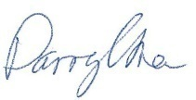 | 13/8/2025

Index
Contents
Index 2
Figures and Tables 3
Abbreviations 4
1. Introduction 5
2. Technical Requirements 6
2.1 CPI Indexation 6
2.2 ORP Amount 10
2.3 Over 65 years employee contributions up to retirement age which is 67 & Stop EPSS Top Ups when an officer reaches the official retirement age 12
2.4 EPSS P1 39 weeks are continuous 39 weeks for employees on Section 36 & 37 13
2.5 BRD06 ICARE Recoup Report 14
2.6 Pause EPSS Period 2 Commencement 19

Figures and Tables

Tables
Table 1 - Example with fictious CPI Percentages 8
Table 2 - ICARE Recoup Report Columns 16

Figures
Figure 1 - OLIMS EPSS Calculations tab - CPI fields 9
Figure 2 - Proposed ORP screen 11
Figure 3 - ICARE Recoup Report Columns 14
Figure 4 - Selection Screen - EPSS Icare Recoup Report 17
Figure 5 - Recoup Report Extract Screen 18
Figure 6 - Commence P2 Pay flag 19

Abbreviations
WC | Workers’ Compensation
P1 or Period 1 | EPSS Period 1
P2 or Period 2 | EPSS Period 2
P3 or Period 3 | EPSS Period 3
OLIMS | Injury Management System
ORP | Ordinary Rate of Pay
CPI | Consumer Price Index
WT | Wage Type
IT | SAP HR Infotype

Introduction
The purpose of this document is to outline the technical requirements, design and components used to implement the Phase 4 delivery of the Enhanced Police Support Scheme (EPSS) processes for Shared Services. This document will provide the technical design and changes required in the EPSS claim management module (OLIMS) as well as in SAP Payroll.
The Functional Design document will define the business and functional requirements and will take precedence over the Technical Design document with respect to the business requirements.

Technical Requirements

CPI Indexation
The requirement is to increase the period 2 salary cumulative with a yearly CPI index. Period 3 salary will also receive this index once build in a future release.
Period 2 salary is as per the end of the period 1 end date (end of week 39). This date is currently used ongoing.
ESPSS Supplementary Weekly Amount Calculation:
- [Indexation to be applied on figure we get * 75% of Base Salary +17% > Non-Commissioned Officer]/ 26.08929 /2
- [Indexation to be applied on figure we get * 75% of Base Salary > Commissioned Officer]/ 26.08929 /2 To be proportionately reduced for Part-Timers
- Base Salary is the salary on the last day of Period 1 (last day of the 39th week).
The effective date for the CPI constant is always the 1st of October and a pay split is required effective 1 October to accommodate pay periods that cross 1 October for EPSS employees that are eligible for potential P2/P3 payments.
Payroll Split example: Payroll week 1: 29 sept - 5 Oct
a) Period 2 always commence at the start of a pay week. Say P2 commence on 29th of Sept, then the rule is that the CPI apply from 1 Oct 2025: Require force payroll split effective 1 Oct for relevant EPSS employees. E.g. P2 salary at the end of P1 (28Sept) = 10K and CPI 3% on 1 Oct, 29Sept-30Sept P2 salary is 10K and 1-5Oct is $10300.
b) Period 2 commenced in the week of 1-7Jan '25. P2 salary was 10K (at the end of P1). 10K is used. Pay week 29 Sept to 5Oct is still period 2: As period 2 started in Jan '25, the 1Oct '25 CPI index is to be applied from 1Oct 25 onwards. In line with sample a), Say the CPI on 1 Oct'25 is 3%, then 29Sept-30Sept use P2 salary 10K and 1-5 Oct used P2 salary $10300. A force payroll split is required on 1 Oct.
c) Payroll week 29 Sept - 5 Oct with splits in the week where a P2 incident is valid 29 Sept to 1 Oct. The employee moves to a P1 incident from 2-5Oct. P2 salary at end of P1 =10K, CPI on 1 Oct is 3%; then P2 salary 29-30Sept is 10K and 1 Oct - 1Oct is $10300. The P2 salary is zero from 2-5Oct as the employee is on a different incident that relates to Period 1.
d) Payroll week 29 Sept - 5 Oct with splits in the week where a P2 incident is valid 29 Sept to 30 Sept. The employee moves to a P1 incident from 1-5Oct. P2 salary at end of P1 =10K, CPI on 1 Oct is 3%; then P2 salary 29-30Sept is 10K. P2 salary from 1-5Oct is zero as the employee is on a different incident that relates to Period 1.
Payroll Split example 2: Period 2 starts in payroll week 1 that runs from 1 Oct - 7 Oct; The indexation does NOT apply. Refer to the old weekly CAP Constant not the increased constant.
e) Pay week 1-7Oct'25 and Period 2 commence in this week. P2 always commence at the start of a week, hence commenced on 1Oct '25. In this case because P2 did not commence before 1Oct'25 the CPI logic for 1Oct25 is ignored/does not take place. P2 Salary at the end of Period1 (30Sept) is 10K and for the week 1-7Oct the P2 salary remains 10K. The P2 salary remains 10K until the CPI increase 1Oct' 26, say with 4%, then the 10K P2 salary increase as per prior samples; effective 1 Oct '26 to $10400. (10000*1.04). If the CPI on 1Oct '27 increase with 3%, then in line with prior samples the P2 salary increase effective 1Oct'27 for supplementary payment calculations to $10712 (10400*1.03).
ABAP changes required in Payroll:
A new function module will be developed to apply the CPI indexation into the EPSS Period 2 supplementary weekly amount.
The function module will be called by the custom payroll operation Z75S.
Assumption: CPI will always increase/ change on the 1st of Oct.
Indexation % will be a T511K Payroll Constant - ZECPI EPSS CPI index percentage.
Cumulative increase of the Indexation applies. E.g.: 4% increase in Oct 2025, then 4% in Oct 2026 applies to the increased amount in 2025.
The Function Module will have the following parameters:
- Importing parameters:
  - Period 2 Supplementary Weekly Amount (I_AMOUNT)
  - Period 2 Start Date (I_DATE_FROM)
  - WBPB End date (I_DATE_TO)
  - Payroll Constant (I_PAYR_CONSTANT)
- Exporting parameter:
  - Indexed Amount (E_INDEXED_AMOUNT)

Processing Logic:
- If I_AMOUNT or I_DATE_FROM or I_DATE_TO or I_PAYR_CONSTANT is blank or zero, return I_AMOUNT to E_INDEXED_AMOUNT and exit.
- Read the payroll constant I_PAYR_CONSTANT from T511K and retrieve records effective starting from EPSS Period 1 end date week 39+2 and onward. To determine the last CPI % to be applied, keep the T511K records where the start date is on or before WPBP-ENNDA. Move result to internal table LT_T511K.

- The result of the above step will be an internal table containing only the relevant T511K records for processing. Sort LT_T511K by I_DATE_FROM in ascending order.

- For each LT_T511K record:
- If I_DATE_FROM is less than LT_T511K-BEGDA.
  - If LT_T511K-KWERT is greater than zero(0)
    - Divide LT_T511K-KWERT by 100 and sum 1. The result is multiplied by I_AMOUNT. The result is moved to E_INDEXED AMOUNT. Exit.
  - Else If LT_T511K-KWERT is less or equal zero(0),
    - move I_AMOUNT to E_INDEXED_AMOUNT. Exit.
- Else I_DATE_FROM is greater or equal LT_T511K-BEGDA.
  - Move I_AMOUNT to E_INDEXED_AMOUNT. Exit.

T511K CPI constant start/end dates |  | T511K  CPI % Value | Initial P2 salary before CPI | Period2 start 1Jan'25 | Period2 start 1Jan'25 | Period 2 start 1Oct'25 | Period 2 start 1Oct'25
CPI start | CPI end | CPI % | P2 salary at P1 end Week39 | Retro Pay split  29 sept -30Sept'26  P2 Sal=$10300 | Retro Pay split  1Oct-5Oct '26  P2 Sal=$10712 | Retro Pay split  29 sept -30Sept'26  P2 Sal=$10000 | Retro Pay split  1Oct-5Oct '26  P2 Sa=$10400
01/10/2024 | 30/09/2025 | 0% | 10000 | 10000 | 10000 | 10000 | 10000
01/10/2025 | 30/09/2026 | 3% | 10000 | 10300 | 10300 | 10000 | 10000
01/10/2026 | 30/09/2027 | 4% | 10000 | n/a | 10712 | n/a | 10400
01/10/2027 | 30/09/2028 | 2.5% | n/a | n/a | n/a | n/a | n/a
Table 1 - Example with fictious CPI Percentages
Force payroll split on 1 Oct
Requirement to cater for the CPI and P2 weekly cap increases effective 1 Oct, where we do not necessarily have a split for P2 EPSS employees on 1 October.
A new payroll operation will be created (ZSPL) which will check if there is a CPI constant with start date that overlap with the processed split, if so then force a pay split as described if the employee is in P2 prior to the CPI start date; provided there is not already a WPBP split on the CPI effective/start date.
Check if employee is in EPSS P2 in the pay split (P2 commenced before or on WPBP-endda).
Is there a CPI start date that falls between WPBP-begda and WPBP-endda (inclusive)
Is there a on WPBP-begda equal to the CPI-begda, then no action other than adding the calling WT (9WCO) back.
Is there no WPBP-begda equal to the CPI-begda, then create a split with a start date equal to the CPI-begda and distribute the splits to all the input table (IT) wage types.

OLIMS ABAP changes required:
Introduce new fields into the EPSS Calculation tab in OLIMS as per yellow highlighted fields in image below.
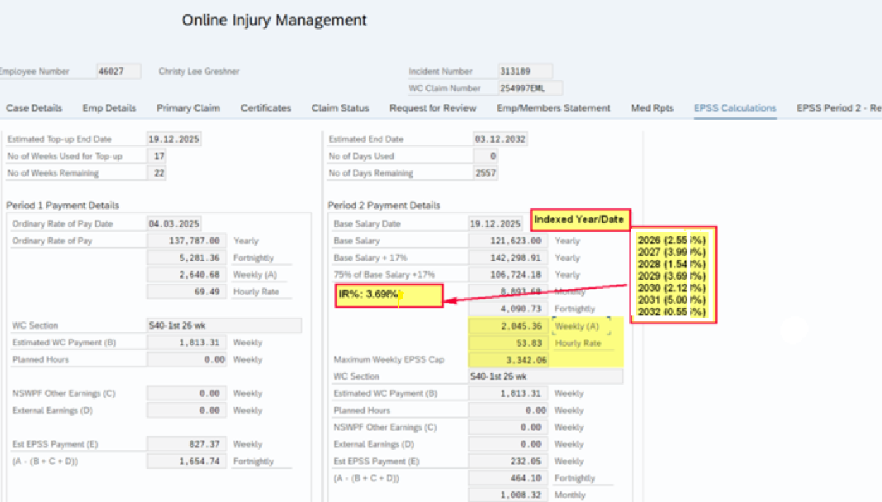
Figure 1 - OLIMS EPSS Calculations tab - CPI fields
The yellow highlighted fields are the fields to show the index increases pending the Index year chosen and these are envisaged to have the unit (e.g. Weekly/Hourly Rate) text moved to the left to make space for a column where the CPI inclusive salary fields will be placed. The OLIMS screen will utilise the payroll CPI index constant, ZECPI - EPSS CPI index percentage.
The following fields will be added:
- New field Index Year/Date (Default is current year/date)
- IR% - Indexed Rate Percentage (2 decimals)
- Weekly Indexed Salary (75% of Base Salary + 17% Loading + Indexation)
- Hourly Rate Indexed (75% of Base Salary + 17% Loading + Indexation)
- Maximum Weekly EPSS Cap Indexed
Once the Index Year/Date search button is clicked, the logic will read the payroll constant ZECPI from T511K table and retrieve records effective since P2 start + 1 till end of Period 2.
The IR Date will be displayed in a DD.MM.YYYY format (E.g. 01.10.2026). The IR Rate will be displayed with 2 decimals (E.g. 2.55).
By default, the corresponding Indexed Rate will be selected based on the system date.
Once the Index Year/Date is selected, the selected rate will be displayed in the IR% - Indexed Rate Percentage field and all the relevant CPI rates will be added cumulatively starting with the initial P2 salary as per Period 1 end date and applied into 75% of Base Salary + 17% Loading weekly and hourly rate and Maximum Weekly EPSS Cap indexed amounts/fields.

Build – OLIMS
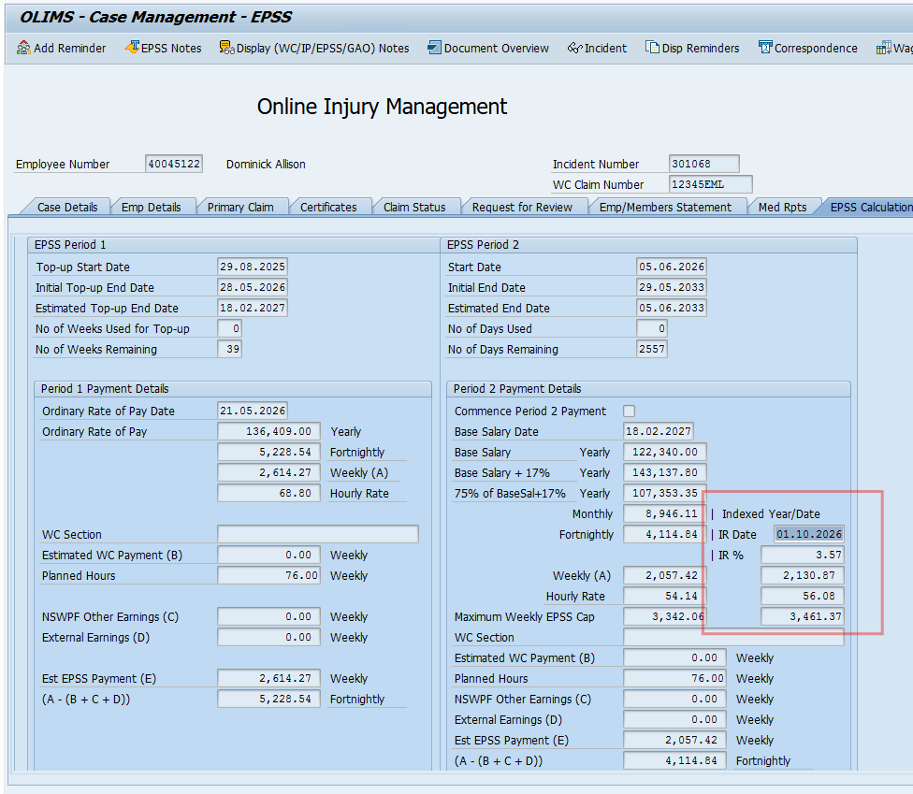
The CPI logic implemented in OLIMS are present in the EPSS Calculations screen (4106).
- STATUS_4106: If ZIM_IN_EPSS-MOCK_CURRENT_DATE_P2 is not blank, the defaulted indexed rate will be selected on the mock P2 date, else, the system date (sy-datum).
- Module CALCULATE_IR: This module receives the selected date (mock date or system date or IR (selected) Date) and apply the corresponding IR % to the Indexed 75% of Base Salary +17% Weekly amount, Indexed Weekly Cap and the IR Rate to IR% field. The Indexed 75% of Base Salary +17% Hourly Rate amount is calculated based on the Indexed weekly amount using employee’s weekly planning hours.
- MODULE IR_DATE_HELP: This module is trigger by PROCESS ON VALUE-REQUEST event which is triggered when the user clicks on IR Date search help.

Build - Function module Z_EPSS_APPLY_CPI_INDEX.
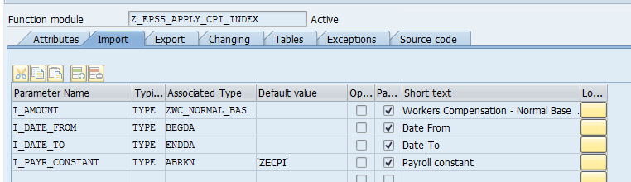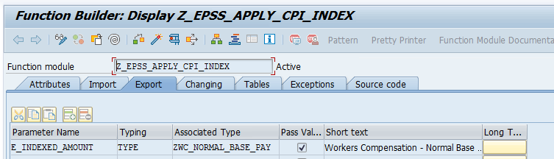

Pseudo-code
FUNCTION z_epss_apply_cpi_index.
*"----------------------------------------------------------------------
*"*"Local Interface:
*" IMPORTING
*" VALUE(I_AMOUNT) TYPE ZWC_NORMAL_BASE_PAY
*" VALUE(I_DATE_FROM) TYPE BEGDA
*" VALUE(I_DATE_TO) TYPE ENDDA
*" VALUE(I_PAYR_CONSTANT) TYPE ABRKN DEFAULT 'ZECPI'
*" EXPORTING
*" VALUE(E_INDEXED_AMOUNT) TYPE ZWC_NORMAL_BASE_PAY
*"----------------------------------------------------------------------
* This function module is used for EPSS Period 2/3 to apply
* CPI indexation rates on top of the EPSS P2 payment amount.
DATA: lt_t511k TYPE TABLE OF t511k,
ls_t511k TYPE t511k,
lv_amount_tmp TYPE zwc_normal_base_pay,
lv_cpi_rate TYPE /alg/gentk_4decneg_clr,
lv_cpi_start_yr TYPE i, "Used so that it does not pick up prior year CPI if not eligible.
lv_cpi_relevant_date TYPE datum.
e_indexed_amount = i_amount.
CLEAR: lv_amount_tmp, lt_t511k[].
IF i_amount EQ 0
OR i_date_from IS INITIAL
OR i_date_to IS INITIAL
OR i_payr_constant IS INITIAL.
e_indexed_amount = i_amount.
EXIT.
ENDIF.
" Read applicable CPI indexation rates for the interval
lt_t511k = cl_hr_t511k=>read_interval(
molga = '13'
konst = i_payr_constant
begda = i_date_from
endda = i_date_to
).
IF lt_t511k IS INITIAL.
e_indexed_amount = i_amount.
EXIT.
ENDIF.
SORT lt_t511k BY begda.
lv_amount_tmp = i_amount.
LOOP AT lt_t511k INTO ls_t511k.
IF i_date_from LT ls_t511k-begda. "Only trigger CPI increase if the effective date is LT the T511K begin date.
"Apply index if the T511K percent > 0, else return original amount.
IF ls_t511k-kwert GT 0.
lv_cpi_rate = ( ls_t511k-kwert / 100 ) + 1.
lv_amount_tmp = lv_amount_tmp * lv_cpi_rate.
e_indexed_amount = lv_amount_tmp.
ELSE.
e_indexed_amount = lv_amount_tmp.
ENDIF.
ELSE.
"If CPI is not meant to increase, just return the weekly salary.
e_indexed_amount = lv_amount_tmp.
ENDIF.
ENDLOOP.
ENDFUNCTION.

Build – Payroll Changes
PCBURZAU0 was changed to modify the operation opz75sl AND create operation opzsplt. The functionality of opz75sl was modified to add CPI indexation effective a go live date to apply an increase on the EPSS period 2 salary to the percentage of CPI increase defined in T511k ZECPI.
Operation Z75SL
Section of the code added below. The below code reads T511K ZECPI percentage to get th effective date. A function Z_EPSS_APPLY_CPI_INDEX is then called to increase the EPSS period 2 salary.

FORM opz75sl.
...
IF lv_epss_p1_end_date IS NOT INITIAL AND wpbp-begda GE lv_epss_p1_end_date.
" Retrieve the EPSS Period 2 supplementary payment (weekly) amount
CLEAR lv_epss_p2_wkly_amount.
CALL FUNCTION 'Z_EPSS_P2_CALC_SUPLEM_WKL_AMT'
EXPORTING
i_pernr = pernr-pernr
i_date = lv_epss_p1_end_date
IMPORTING
e_weekly_amount_p2 = lv_epss_p2_wkly_amount.
"Get the year when CPI eligibility starts.
"lv_cpi_year = ls_cm-epss_start_date_p2(4).
"Read T511K to get months and date
DATA ls_511k TYPE t511k.
CLEAR ls_511k.
CALL METHOD cl_hr_t511k=>read_at_date
EXPORTING
molga = '13'
konst = 'ZECPI'
date = wpbp-endda
RECEIVING
t511k = ls_511k.
"Build October 1 relevant for the period based on T511K months and date
"CONCATENATE lv_cpi_year ls_511k-begda+4(4) INTO lv_cpi_date.
"Set effective date of change and only trigger CPI indexation if the period 2 start date for the year is GT October 1st
IF aper-begda GT '20250925' AND ls_cm-epss_start_date_p2 LT ls_511k-begda.
"Call function module to increase the weekly amount based on idexation.
CALL FUNCTION 'Z_EPSS_APPLY_CPI_INDEX'
EXPORTING
i_amount = lv_epss_p2_wkly_amount
i_date_from = ls_cm-epss_start_date_p2
i_date_to = wpbp-endda
i_payr_constant = 'ZECPI'
IMPORTING
e_indexed_amount = lv_epss_p2_wkly_amount.
"End CPI Increase
ENDIF.
ot-betrg = lv_epss_p2_wkly_amount.
ENDIF. " if lv_epss_p1_end_date is NOT INITIAL.
...
ENDFORM. " OPZ75SL

Operation ZSPLT
Operation ZSPLT was created to force split based on the CPI indexation go live date. Splits are not automatically created due to CPI indexation and this operation will force a payroll split based on the effective date of the CPI index.

FORM opzsplt.
DATA: lv_claim TYPE zim_ip_wclmn,
lv_incident TYPE zhr_inc_identnr,
ls_v0 TYPE LINE OF hrpay99_v0,
lv_epss_start_date_p2 TYPE datum,
lv_epss_go_live TYPE datum,
sdt TYPE hrpy_sdates OCCURS 0 WITH HEADER LINE.
* lt_t511k TYPE TABLE OF t511k,
* ls_t511k TYPE t511k.
IF aper-begda GE '20250926'. "Temporary condition so it does not debug on non focus pay periods.
* READ TABLE v0 INTO ls_v0 WITH KEY v0typ = ot-v0typ
* v0znr = ot-v0znr.
* IF sy-subrc = 0.
* SPLIT ls_v0-vinfo AT space INTO lv_claim
* lv_incident.
* ENDIF.
*
SPLIT p0014-zuord AT space INTO lv_claim lv_incident.
SHIFT lv_incident RIGHT DELETING TRAILING space.
OVERLAY lv_incident WITH '0000000000'.
IF lv_incident IS INITIAL.
" No incident
EXIT.
ENDIF.
" Fetch disablement date from OLIMS - case details
CLEAR lv_epss_start_date_p2.
SELECT SINGLE epss_start_date_p2 FROM zim_in_cm INTO lv_epss_start_date_p2
WHERE pernr = pernr-pernr
AND incident = lv_incident.
DATA ls_511k TYPE t511k.
CLEAR ls_511k.
CALL METHOD cl_hr_t511k=>read_at_date
EXPORTING
molga = '13'
konst = 'ZECPI'
date = wpbp-endda
RECEIVING
t511k = ls_511k.
CLEAR sdt[].
"Build October 1 relevant for the period
sdt-datum = ls_511k-begda.
"CONCATENATE aper-begda(4) ls_511k-begda+4(4) INTO sdt-datum.
"Only trigger the split if there is Oct 1 between the period and EPSS period 2 is active
IF ( sdt-datum BETWEEN aper-begda AND aper-endda ). "AND ( wpbp-endda GT lv_epss_start_date_p2 ) .
APPEND sdt.
".. Use standard splitting functionality as per OPWPBPC
PERFORM split_wpbp_and_it TABLES sdt.
ELSE.
CLEAR sdt[].
ENDIF.
ENDIF.
ENDFORM.

ORP Amount
Period 1 salary (ORP) used for payroll EPSS payment calculations is currently fixed as at the date of disablement. Increase to the Base salary (changes to IT0008) post the disablement date does not increase the ORP.
The period 1 change required is to use the basic pay relevant at the pay period/split end date, for compilation of the period 1 (ORP) salary instead of the static period 1 salary as at date of disablement.
ABAP changes required in Payroll:
Payroll operation ZORP will be modified to call a new function module (Z_EPSS_SALARY_ORP), instead of reading the ORP from the custom table.
The function module will receive the WPBP split end date as input and will return the ORP amount dynamically (on the fly). This will provide to payroll the ORP amount for each WPBP split.
Additionally, a new check will be introduced in ZORP to only return a value to ZORP if the employee is in EPSS Period 1.
Processing Logic:
- The operation ZORP is called while processing WT 9WCO or 9ORP (9ORP is created from 9WC0)
- Get the incident from v0 table.
- Check DOD for the processed WT is =>1.10.2024 (to verify if EPSS).
- Check the DOD is Less or equal to the WPBP-endda (to check the DOD is not in the future compared to the processed pay period)
  - Check if there is an entry in ZIM_EPSS_WEEK_NO for the incident, selecting all records for the PERNR/INCIDENT combination.
  - Sort it by For Period and week in descending order.
  - Delete records where For Period is greater than APER-PAPER.
  - if no records, then this is the start of Period 1.
    - Read the ORP valid at WPBP-endda; call function module Z_SALARY_ORP and add ORP amount into OT-BETRG. End of processing.
If record found, get number of weeks used of EPSS Period 1 of the processing For Period/Week combination by reading the first record (read index 1).
- Check if number of weeks number is less than 39 and WPBP-ENDDA less than EPSS Period 2 start date:
  - If false, add zero (0) to OT-BETRG, exit.
  - If true, call function module Z_SALARY_ORP and add ORP amount into OT-BETRG exit.

ABAP changes required in OLIMS:
All references to (now obsolete) table ZIM_IN_ORP have been removed in OLIMS.
The ORP fields in the EPSS Calculations tab now uses the function module Z_EPSS_SALARY_ORP to calculate estimated ORP amount using system date instead of Date of Disablement. This has been implemented in the CALCULATE_EPSS_DATES form from include ZHUOLIMS_UPDATE2.

New ORP screen will be delivered in next phase.
The change required in OLIMS is a new read-only screen where all the Period 1 salaries/ORP will be displayed. Period 1 ends after 39 weeks after which pay rises are not required to show.
The ZIM_IN_ORP table and records will be deleted, and all related table-handling logic in OLIMS will be removed.
A new ORP tab (EPSS only) will be created in OLIMS with the following details:
- Infotype 8 records will be read since disablement date (if disablement date is =>1.10.2024) until current date – if current date is before end date of Period 1, otherwise until Period 1 end date - excluding future dated IT8 records.
- For each Infotype 8 record, the logic will use the infotype 8 start date as the reference date to calculate the ORP amount by calling the function module Z_SALARY_ORP.
- If there is a change in the ORP amount, the new ORP amount will be displayed in a new line/record.
- The following fields will be displayed:
  - Infotype 8 Start Date – BEGDA
  - Infotype 8 End Date – ENDDA
  - ORP Amount
- The records will be displayed sorted in descending order.

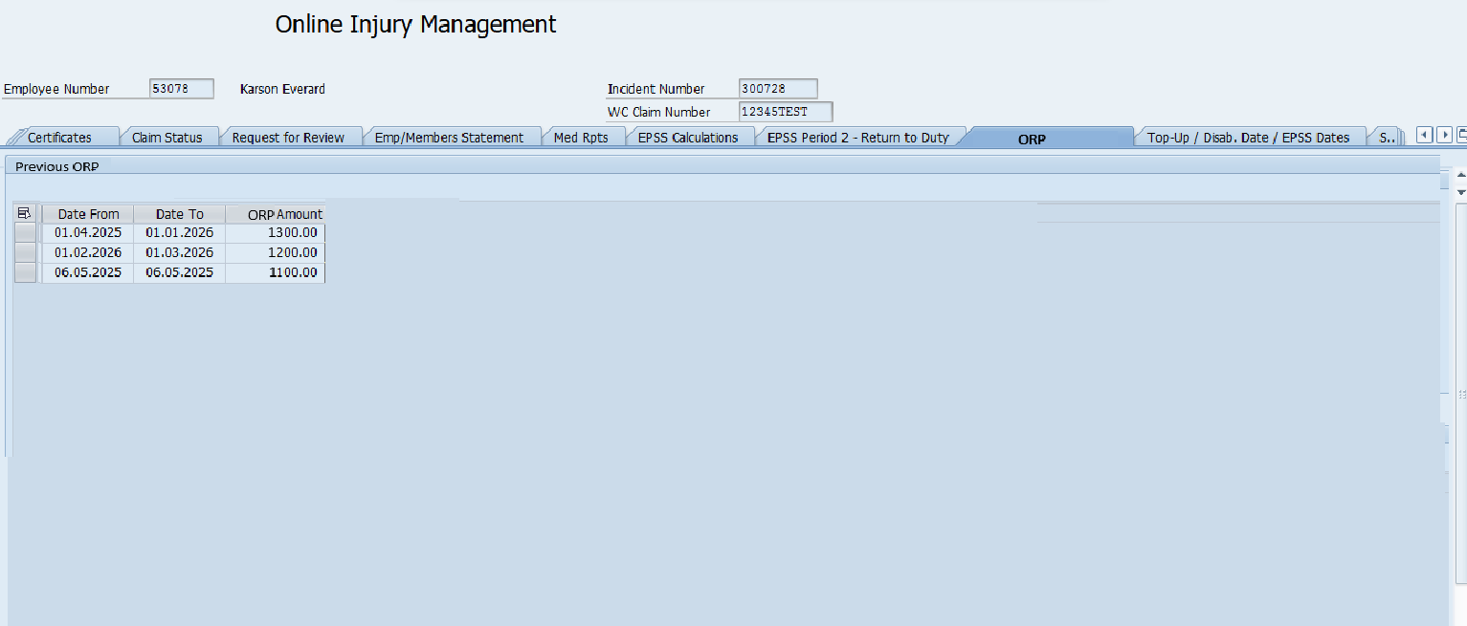
Figure 2 - Proposed ORP screen
Build Payroll Change
The ORP functionality has been changed to read the ORP of the employee based on payroll period run instead of at start of disablement date. This means that the old solution for ORP has been changed. During the build, it was recognized that the intial design will not work as we should not drop the ORP as old ORP functionality always returns ORP

ABAP changes required in Payroll:
Payroll operation ZORP will be modified to call a new function module (Z_EPSS_SALARY_ORP), instead of reading the ORP from the custom table.
The function module will receive the WPBP split end date as input and will return the ORP amount dynamically (on the fly). This will provide to payroll the ORP amount for each WPBP split.
Additionally, a new check will be introduced in ZORP to only return a value to ZORP if the employee is in EPSS Period 1.
Processing Logic:
- The operation ZORP is called while processing WT 9WCO or 9ORP (9ORP is created from 9WC0)
- Get the incident from v0 table.
- Check DOD for the processed WT is =>1.10.2024 (to verify if EPSS).
- Check the DOD is Less or equal to the WPBP-endda (to check the DOD is not in the future compared to the processed pay period)
- Call ORP function module to return the new ORP Z_EPSS_SALARY_ORP

***---------------------------------------------------------------------
* form opzorp
***---------------------------------------------------------------------
FORM opzorp.
* The operation read the ORP amount from ZIM_IN_ORP table, which is calculated
* OLIMS when a medical certificate is updated (p905), and move amount to WT 9ORP.
DATA: lv_claim TYPE zim_ip_wclmn,
lv_incident TYPE zhr_inc_identnr,
ls_v0 TYPE LINE OF hrpay99_v0,
ls_0001 TYPE pa0001,
* lt_orp TYPE TABLE OF zim_in_orp,
* ls_orp TYPE zim_in_orp,
ls_cm TYPE zim_in_cm,
lt_week_no TYPE TABLE OF zim_epss_week_no,
ls_week_no TYPE zim_epss_week_no,
lv_epss_live TYPE datum,
lv_weekno TYPE c LENGTH 2
.
CLEAR: ls_0001, ot-betrg.
SELECT SINGLE * FROM pa0001 INTO ls_0001
WHERE pernr EQ pernr-pernr
AND endda GE wpbp-endda
AND begda LE wpbp-endda.
IF sy-subrc EQ 0.
IF ls_0001-persk >= 'XG'. "Run only for employees in ESG XA to XF.
EXIT.
ENDIF.
ELSE.
EXIT.
ENDIF.
" Retrive the incident number (from v0/it14)
READ TABLE v0 INTO ls_v0 WITH KEY v0typ = ot-v0typ
v0znr = ot-v0znr.
IF sy-subrc = 0.
SPLIT ls_v0-vinfo AT space INTO lv_claim
lv_incident.
ENDIF.
SHIFT lv_incident RIGHT DELETING TRAILING space.
OVERLAY lv_incident WITH '0000000000'.
REFRESH: ait.
CLEAR ls_cm.
"Read zin_cm for disablement date and p2 start date
SELECT * FROM zim_in_cm INTO ls_cm
WHERE pernr = pernr-pernr
AND incident = lv_incident.
ENDSELECT.
" Fetch EPSS go live date
SELECT SINGLE begda FROM t596d INTO lv_epss_live
WHERE appl EQ '9EP1'
AND molga EQ '13'.
IF sy-subrc NE 0.
lv_epss_live = '20241001'. " EPSS go live date
ENDIF.
"Check if disablement date is > 2024.10.01 EPSS start date or if its transition to EPSS.
IF ls_cm-disablement_date GE lv_epss_live OR ls_cm-transition_to_epss = 'X'.
"If the wpbp-endda is greater than or equal to disablement date.
IF wpbp-endda GE ls_cm-disablement_date.
"IF wpbp-endda GE ls_cm-epss_start_date_p2.
"ls_week_no-no_weeks_used_p1 GE 39
"AND ( ls_cm-epss_start_date_p2 NE ''
"AND wpbp-endda GE ls_cm-epss_start_date_p2 ).
"ot-betrg = 0. "Return 0 ORP if wpbp-endda GE epss start date
"ELSE.
"Return EPSS period 1 salary
CALL FUNCTION 'Z_EPSS_SALARY_ORP'
EXPORTING
i_pernr = pernr-pernr
i_date = wpbp-endda
IMPORTING
e_orp_weekly = ot-betrg.
"ENDIF. "ENDIF check of week number
"lv_weekno = ot-cntr3.
"SHIFT lv_weekno LEFT DELETING LEADING '0'.
"Read epss week nubmber table
"SELECT * FROM zim_epss_week_no INTO TABLE lt_week_no
" WHERE pernr = pernr-pernr
" AND incident = lv_incident
" AND fpper LE aper-paper.
"If there is entry on epss week number table do below
"IF sy-subrc = 0.
"Comment out weeks used table for now as it is not needed. Old OLIMS logic does not look at weeks used and sends ORP salary when employee is in EPSS.
"SORT lt_week_no BY no_weeks_used_p1 DESCENDING.
"DELETE lt_week_no WHERE fpper EQ aper-paper AND week = lv_weekno.
"READ TABLE lt_week_no INTO ls_week_no INDEX 1.
"IF wpbp-endda GE ls_cm-epss_start_date_p2.
"ls_week_no-no_weeks_used_p1 GE 39
"AND ( ls_cm-epss_start_date_p2 NE ''
"AND wpbp-endda GE ls_cm-epss_start_date_p2 ).
" ot-betrg = 0. "Return 0 ORP if wpbp-endda GE epss start date
* "ELSE.
* "Return EPSS period 1 salary
* CALL FUNCTION 'Z_EPSS_SALARY_ORP'
* EXPORTING
* I_PERNR = pernr-pernr
* I_DATE = wpbp-endda
* IMPORTING
* E_ORP_WEEKLY = ot-betrg
* .
* ENDIF. "ENDIF check of week number
*
* ELSE. "No weeks user flag not found but disablement date is greater than epss start date and also
* "transtion to ess flag is yes, return orp salary. WPBP endda is also greater than disablement date.
* CALL FUNCTION 'Z_EPSS_SALARY_ORP'
* EXPORTING
* I_PERNR = pernr-pernr
* I_DATE = wpbp-endda
* IMPORTING
* E_ORP_WEEKLY = ot-betrg
* .
* ENDIF.
ENDIF. "ENDIF wpbp-endda GE lv_in_cm_disablement_date.
ENDIF. "ENDIF lv_in_cm-disablement_date GE '20241001' OR lv_in_cm-transition_to_epss = 'X'.
"OLD ORP Log
* SELECT * FROM zim_in_orp INTO TABLE lt_orp
* WHERE pernr = pernr-pernr
* AND incident = lv_incident.
* IF sy-subrc = 0.
* SORT lt_orp BY seq_no DESCENDING.
* READ TABLE lt_orp INTO ls_orp INDEX 1.
* IF sy-subrc = 0.
* ot-betrg = ls_orp-orp_amount.
* ENDIF.
* ENDIF.
ENDFORM. "opzorp

Build – Function Module
Function module Z_EPSS_SALARY_ORP was built to read employee basic pay IT0008 entries, compare the values against T510 table, and return weekly salary to the calling operation.

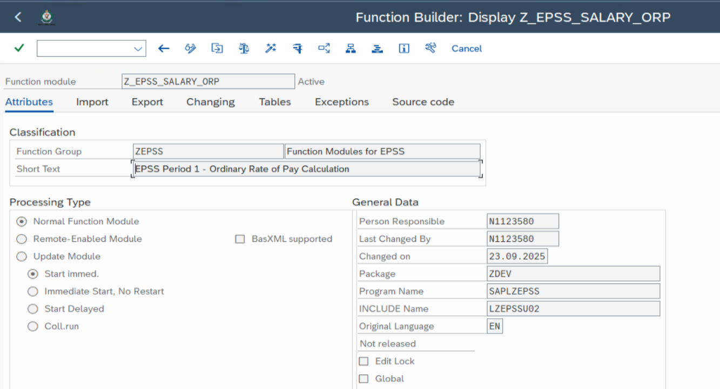

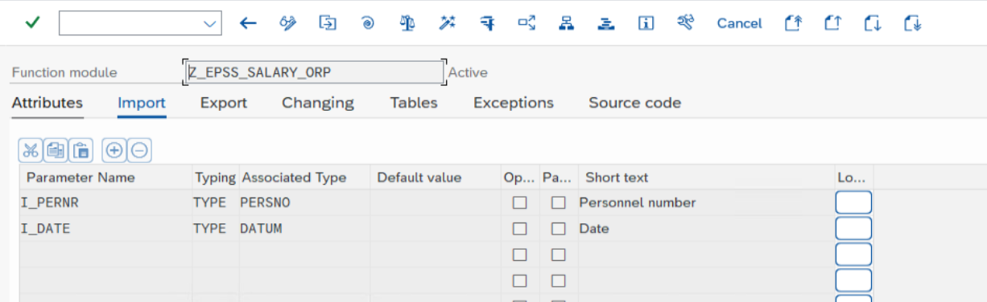

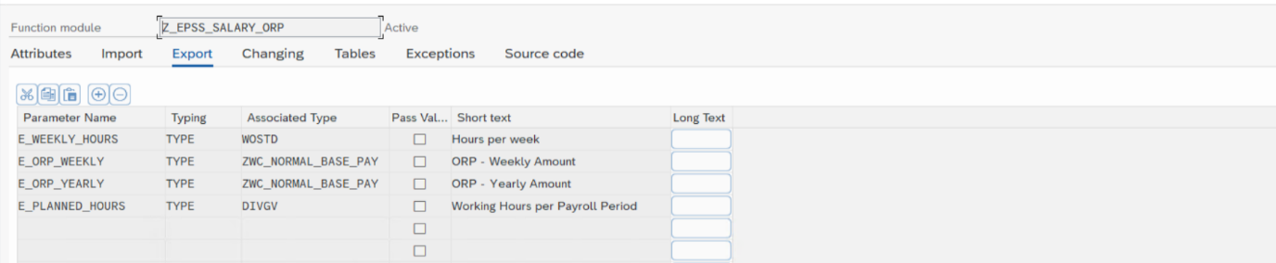

ABAP Code
FUNCTION z_epss_salary_orp .
*"----------------------------------------------------------------------
*"*"Local Interface:
*" IMPORTING
*" REFERENCE(I_PERNR) TYPE PERSNO
*" REFERENCE(I_DATE) TYPE DATUM
*" EXPORTING
*" REFERENCE(E_WEEKLY_HOURS) TYPE WOSTD
*" REFERENCE(E_ORP_WEEKLY) TYPE ZWC_NORMAL_BASE_PAY
*" REFERENCE(E_ORP_YEARLY) TYPE ZWC_NORMAL_BASE_PAY
*" REFERENCE(E_PLANNED_HOURS) TYPE DIVGV
*"----------------------------------------------------------------------
* This FM calculates the EPSS Ordinary Rate of Pay (or EPSS Period 1 Top-up).
CLEAR: e_planned_hours, e_weekly_hours, e_orp_weekly,
e_orp_yearly, gv_base, gv_cap_util_level, gv_weekly_hours.
PERFORM read_infotype USING i_pernr i_date.
LOOP AT p0007 WHERE begda <= i_date AND
endda >= i_date.
ENDLOOP.
LOOP AT p0008 WHERE begda <= i_date AND
endda >= i_date.
ENDLOOP.
gv_planned_hours = p0008-divgv.
gv_cap_util_level = p0008-bsgrd / 100.
gv_weekly_hours = p0007-wostd.
CLEAR gv_seqnr.
REFRESH: tbindbw, tblgart.
DO VARYING gv_lgaxx FROM p0008-lga01 NEXT p0008-lga02
VARYING gv_betxx FROM p0008-bet01 NEXT p0008-bet02
VARYING gv_anzxx FROM p0008-anz01 NEXT p0008-anz02
VARYING gv_opkxx FROM p0008-opk01 NEXT p0008-opk02
VARYING gv_indxx FROM p0008-ind01 NEXT p0008-ind02.
IF gv_lgaxx IS INITIAL. "EXIT AFTER LAST WAGE TYPE
EXIT.
ENDIF.
CLEAR t512w.
SELECT SINGLE * FROM t512w WHERE molga = '13' AND
lgart = gv_lgaxx AND
endda >= i_date AND
begda <= i_date.
IF t512w-aklas+38(2) NE 'EP'.
CONTINUE.
ENDIF.
CLEAR gv_amount.
PERFORM get_amount USING i_pernr
i_date
gv_lgaxx
gv_betxx
gv_anzxx
gv_opkxx
gv_indxx
CHANGING gv_amount.
tbl_wage_types-lgart = gv_lgaxx.
tbl_wage_types-anzhl = gv_anzxx.
tbl_wage_types-opken = gv_opkxx.
tbl_wage_types-indbw = gv_indxx.
tbl_wage_types-betrg = gv_amount.
ADD gv_amount TO gv_base.
APPEND tbl_wage_types.
ENDDO.
* convert week/annual to hour rates
SELECT SINGLE * FROM t510 WHERE molga = '13' AND
trfar = p0008-trfar AND
trfgb = p0008-trfgb AND
trfgr = p0008-trfgr AND
trfst = p0008-trfst AND
begda <= i_date AND
endda >= i_date.
IF sy-subrc NE 0.
SELECT SINGLE * FROM t510 WHERE molga = '13' AND
trfar = p0008-trfar AND
trfgb = p0008-trfgb AND
begda <= i_date AND
endda >= i_date.
ENDIF.
IF sy-subrc = 0.
* Standard hours is 0 for Casual staff
IF t510-trfkz = '2'. "weekly
IF gv_cap_util_level NE 0.
gv_weekly_base = gv_base * gv_cap_util_level.
gv_yearly_base = gv_base / gv_cap_util_level * '52.17858'.
ELSE.
gv_weekly_base = 0.
gv_yearly_base = 0.
ENDIF.
ELSE. "annually
IF gv_cap_util_level NE 0.
gv_weekly_base = ( gv_base / '52.17858' ) * gv_cap_util_level.
gv_yearly_base = gv_base * gv_cap_util_level.
ELSE.
gv_weekly_base = 0.
gv_yearly_base = 0.
ENDIF.
ENDIF.
ENDIF.
e_orp_weekly = gv_weekly_base.
e_orp_yearly = gv_yearly_base.
e_weekly_hours = gv_weekly_hours.
e_planned_hours = gv_planned_hours.
ENDFUNCTION.

Over 65 years employee contributions up to retirement age which is 67 & Stop EPSS Top Ups when an officer reaches the official retirement age

The requirement is to change employee contributions up to retirement age which is 67.
ABAP changes required in payroll:
Change payroll function _EPS1 which creates entries in AIT table for insurance premiums.
The change is to firstly read the constant 9EPC in T596D for the phase 4 go live date, one period retrospective – eg. Period 8. If pay period end date is equal or after the returned date, check the employee’s age and return age to payroll variable 9ETN and ‘1’ to IT-BETRG.
Then continue logic and now read constant 9EPB in T596D for the phase 4 go live date, first pay accounted since go live – eg. Period 9. If pay period end date is equal or after the returned date, use it as effective date for retirement age if 67 instead of 65, otherwise keep checking for age 65 (If WPBP-ENDDA is prior to phase 4 go live date – Period 9, continue with current check using age 65).

Build – Payroll Changes
Created a new function _ZAGE to return the age of the employee through a variable if employee is >67 years of age. This was created and added on top of the above design as the function _EPS1 happens before important functionalities in payroll to check age.
On the original design, current function _EPS1 was also modified to do 2 additional things:
- Return variable 9ETN. The variable will be returned after go live date when employee age is greater than 67
- Change the retirement age from 65 to 67 after go live date.

FORM fu_eps1.
....
"Change on retirement age JV EPSS Phase 4 - Retirement
DATA : lv_9epb TYPE datum,
lv_9epc TYPE datum,
lv_pp_endda TYPE datum.
l_age_c = 65.
SELECT SINGLE begda FROM t596d INTO lv_9epb
WHERE appl EQ '9EPB'
AND molga EQ '13'.
SELECT SINGLE begda FROM t596d INTO lv_9epc
WHERE appl EQ '9EPC'
AND molga EQ '13'.
IF aper-begda GE lv_9epc.
IF l_age GE 67.
var-lgart = '9ETN'.
var-betrg = l_age.
APPEND var.
ENDIF.
ENDIF.
IF aper-begda GE lv_9epb.
l_age_c = 67.
ENDIF.
"Change on retirement age JV EPSS Phase 4 - Retirement
...
* calculate benefit. This is both off and on duty. $amt same
* IF l_age GE 65. JV EPSS Phase 4 - Retirement
IF l_age GE l_age_c.
l_on_duty_death = 0.
ELSEIF l_age GE 61.
l_on_duty_death = ztpd_offduty-zzlimit. "9DDL
ELSE.
...
* IF l_age GE 65. Commented out to check date based on variable, either 65 or 67 EPSS Phase 4 - Retirement
IF l_age GE l_age_c. "Age dependent on go live date
"END JV EPSS Phase 4 - Retirement
ELSE.

FORM fu_zage.
* This function returns the age of the employee if age is > 67
DATA: l_age(2) TYPE n,
l_days TYPE i,
l_p0002 LIKE p0002 OCCURS 0 WITH HEADER LINE,
lv_9epb TYPE datum,
lv_9epc TYPE datum,
lv_pp_endda TYPE datum.
CONSTANTS : c_days_in_year TYPE p DECIMALS 2 VALUE '365.25'.
rp-read-infotype pernr-pernr 0002 l_p0002 wpbp-begda wpbp-endda.
READ TABLE l_p0002 INDEX 1.
l_days = wpbp-endda - l_p0002-gbdat.
l_age = trunc( l_days / c_days_in_year ).
SELECT SINGLE begda FROM t596d INTO lv_9epc
WHERE appl EQ '9EPC'
AND molga EQ '13'.
IF aper-begda GE lv_9epc.
IF l_age GE 67.
var-lgart = '9AGE'.
var-betrg = l_age.
APPEND var.
ENDIF.
ENDIF.
ENDFORM. " FUZEPSD

EPSS P1 39 weeks are continuous 39 weeks for employees on Section 36 & 37
The requirement is for EPSS Period 1 clock to keep ticking for employees on Section 36 & 37 even if no Payments. Therefore, 39 weeks are continuous 39 weeks.
Only applicable to S36 & 37 > clock keeps ticking even if no payments.
For PBRI incidents that are transitioned to EPSS, logic will apply after Phase 4 go live only.
Keep counting in the Week No. table (ZIM_EPSS_WEEK_NO) adding +1 to week count even if no top up on S36 & S37.
ABAP changes required in payroll:
A change will be required in the ZEPS1 payroll function to check for section 36 & 37 and add a week count into the number of weeks used of EPSS Period 1 (table ZIM_EPSS_WEEK_NO).
Processing Logic :
- Set a pay week1 and pay week2 flag to initial.
- Loop WT 9WCO in the IT (for the fortnight) and locate the pay week (1 or 2).
- Check for the pay week been processed if the pay week flag (1 or 2) for the WT 9WCO been processed has been flagged for a S36/37 that already added 1 to the pay week already. (In case of multiple splits in the week). If I was set, do the next loop for WT 9WCO, if not, continue with processing in the loop.
- Check WT 9WCO if rate (IT-BETPE) is:
- Rate 2301 = Section 36 /OR/
- Rate 2302 = Section 37.
- If true, read the incident from v0.
- Check if incident is EPSS (Incident DOD > 30.09.2024).
- Check if DOD less or equal to end date of pay week. (this is to ensure the DOD is not valid from a future pay period).
- Check if incident is in Period 1 relative to the processed pay period split – Read ZIN_EPSS_WEEK_NO table for the PERNR/INCIDENT combination. using pay period start date. If NO_WEEKS_USED_P1 < 39, it is Period 1. ZIN_EPSS_WEEK_NO might not exist for the pay period start date, should you read the week table for the <39 check for a) if 9wco processed is week1 of the pay, then the latest entry where the for period is < the processed for period, or b) if the 9wco processed is in pay week 2, then the latest entry in the table with for period = or < the processed pay period for period
- If true, add +1 to ZIM_EPSS_WEEK_NO-NO_WEEKS_USED_P1 for the pay week. Set flag for pay week 1 or 2 to indicate the pay week had 1 added to the week, continue with loop.
- When loop is completed, use week1 and week2 flags to decide if the check of WT 49E9 EPSS P1 Top Up is required for the $1 check. If the S36/37 already added 1 to the week table for the processed for period pay week, then the check for WT 49E9 is not required for that pay week.

Build – Payroll Changes
ZEPS1 was modified to fulfill the design above. Some changes, from above design Blue for additional logic from original):
- Set a pay week1 and pay week2 flag to initial.
- Loop WT 9WCO in the IT (for the fortnight) and locate the pay week (1 or 2).
- Check for the pay week been processed if the pay week flag (1 or 2) for the WT 9WCO been processed has been flagged for a S36/37 that already added 1 to the pay week already. (In case of multiple splits in the week). If I was set, do the next loop for WT 9WCO, if not, continue with processing in the loop.
- Check WT 9WCO if rate (IT-BETPE) is:
- Rate 2301 = Section 36 /OR/
- Rate 2302 = Section 37.
- If true, read the incident from v0.
- Check if incident is EPSS (Incident DOD > 30.09.2024).
- Check if DOD less or equal to end date of pay week. (this is to ensure the DOD is not valid from a future pay period).
- Check if incident is in Period 1 relative to the processed pay period split – Read ZIN_EPSS_WEEK_NO table for the PERNR/INCIDENT combination. using pay period start date. If NO_WEEKS_USED_P1 < 39, it is Period 1. ZIN_EPSS_WEEK_NO might not exist for the pay period start date, should you read the week table for the <39 check for a) if 9wco processed is week1 of the pay, then the latest entry where the for period is < the processed for period, or b) if the 9wco processed is in pay week 2, then the latest entry in the table with for period = or < the processed pay period for period?
- Check 4901 for each WPBP split of the 9WCO, make sure that the 4901 is existing and count 9WCO only if 4901 exists.
- If 4901 and 9WCO does not exist at the same time, delete the week number count if there was one existing. This is to ensure that when 4901 is deleted retroactively, it deletes the weeks used count as well.
  - SM 12/11/2025 Change: Continue with loop instead of exit. (Tracker 101)
- If true, add +1 to ZIM_EPSS_WEEK_NO-NO_WEEKS_USED_P1 for the pay week. Set flag for pay week 1 or 2 to indicate the pay week had 1 added to the week, continue with loop.
- When loop is completed, use week1 and week2 flags to decide if the check of WT 49E9 EPSS P1 Top Up is required for the $1 check. If the S36/37 already added 1 to the week table for the processed for period pay week, then the check for WT 49E9 is not required for that pay week

***---------------------------------------------------------------------
* form FUZEPS1
***---------------------------------------------------------------------
FORM fuzeps1.
...

IF aper-paper GE '202413'.
CLEAR: lv_tot_week1.
ENDIF.
"Loop at IT to find '9WCO' and check for section 36 and 37
LOOP AT it INTO ls_rt_1 WHERE lgart = '9WCO'.
"First check if the rate is S36 or S37. If it is not, do nothing and let the 49E9 > 1 check commence
IF ls_rt_1-betpe EQ '2301' OR ls_rt_1-betpe EQ '2302'.
"If its S36 or 37 add weeks used flag.
IF ls_rt_1-cntr3 = '01' AND lv_9wco_1 NE 'X'. "Week 1
"Read Indicent Number For Week 1
READ TABLE v0 INTO ls_v0 WITH KEY v0typ = ls_rt_1-v0typ
v0znr = ls_rt_1-v0znr.
IF sy-subrc = 0.
SPLIT ls_v0-vinfo AT space INTO lv_claim
lv_inc1.
ENDIF.
SHIFT lv_inc1 RIGHT DELETING TRAILING space.
OVERLAY lv_inc1 WITH '0000000000'.
"Read zin_cm for disablement date and p2 start date
SELECT * FROM zim_in_cm INTO ls_cm
WHERE pernr = pernr-pernr
AND incident = lv_inc1.
ENDSELECT.
" Fetch EPSS go live date
SELECT SINGLE begda FROM t596d INTO lv_epss_live
WHERE appl EQ '9EP1'
AND molga EQ '13'.
IF sy-subrc NE 0.
lv_epss_live = '20241001'. " EPSS go live date
ENDIF.
"Add weeks used on week number table
"Store weeks lv_9wco_1 to X so it does not do the processing of weeks number again
IF ls_cm-disablement_date GE lv_epss_live .
IF ls_cm-disablement_date LE wpbp-endda.
"read previous weeks used to determine if week 39 or 40
REFRESH lt_week_no_prev.
SELECT * FROM zim_epss_week_no INTO TABLE lt_week_no_prev
WHERE pernr = pernr-pernr
AND incident = lv_inc1.
" Just leave the previouses for periods records
SORT lt_week_no_prev BY fpper.
DELETE lt_week_no_prev WHERE fpper GE aper-paper.
SORT lt_week_no_prev BY no_weeks_used_p1 DESCENDING.
" Read the latest week number (for previous for period).
READ TABLE lt_week_no_prev INTO ls_week_no_prev INDEX 1.
" No sy-subrc = 0 check to cater for week 1 where there will be no week number for previous record in the table.
"New requirement to paid the 9WC0 for S36 and S37 with 4901.
CLEAR : lv_4901_flag1.
LOOP AT it WHERE lgart = '4901' AND apznr = ls_rt_1-apznr AND v0typ = ls_rt_1-v0typ AND v0znr = ls_rt_1-v0znr.
lv_4901_flag1 = 'X'.
ENDLOOP.
IF lv_4901_flag1 NE 'X'.
SELECT SINGLE * FROM zim_epss_week_no INTO ls_week_no
WHERE pernr = pernr-pernr
AND incident = lv_inc1
AND fpper = aper-paper
AND week = 1.
IF sy-subrc EQ 0 AND lv_9wco_1 NE 'X'. " Subtract only no of weeks for forperiod has already been counted
" Delete for period in case of retro on retro scenario
DELETE FROM zim_epss_week_no WHERE pernr = pernr-pernr
AND incident = lv_inc1
AND fpper = aper-paper
AND week = 1.
ENDIF. " SELECT SINGLE * FROM zim_epss_week_no INTO ls_week_no
*SM 12/11/2025 EXIT. "Replace with continue
Continue. "SM 12/11/2025 continue with the loop. (Tracker 101)
ENDIF.
" 1st week
IF ls_week_no_prev-no_weeks_used_p1 LT 39 OR ls_week_no_prev-no_weeks_used_p1 IS INITIAL.
"""""""""""""""""""""""""""""""""""""
SELECT SINGLE * FROM zim_epss_week_no INTO ls_week_no
WHERE pernr = pernr-pernr
AND incident = lv_inc1
AND fpper = aper-paper
AND week = 1.
IF sy-subrc NE 0.
" First run for the for period week 1
" Update EPSS Period 1 table that controls the Number of weeks and payroll runs
CLEAR ls_week_no.
ls_week_no-pernr = pernr-pernr.
ls_week_no-incident = lv_inc1.
ls_week_no-fpper = aper-paper.
ls_week_no-inper = aper-iaper.
ls_week_no-week = 1.
ls_week_no-no_weeks_used_p1 = ls_week_no_prev-no_weeks_used_p1 + 1.
ls_week_no-last_modified_by = sy-uname.
ls_week_no-last_modified_date = sy-datum.
ls_week_no-last_modified_time = sy-uzeit.
MODIFY zim_epss_week_no FROM ls_week_no.
lv_9wco_1 = 'X'.
ELSE.
" Update the no of weeks used for the for period with the no of weeks used from previous period + 1
" Fetch the previous for periods.
REFRESH lt_week_no.
SELECT * FROM zim_epss_week_no INTO TABLE lt_week_no
WHERE pernr = pernr-pernr
AND incident = lv_inc1
AND fpper LT aper-paper.
IF sy-subrc = 0.
SORT lt_week_no BY no_weeks_used_p1 DESCENDING.
READ TABLE lt_week_no INTO ls_week_no INDEX 1.
IF sy-subrc = 0.
" Update the no of weeks used in the for period table
ls_week_no-pernr = pernr-pernr.
ls_week_no-incident = lv_inc1.
ls_week_no-fpper = aper-paper.
ls_week_no-inper = aper-iaper.
ls_week_no-week = 1.
ls_week_no-no_weeks_used_p1 = ls_week_no-no_weeks_used_p1 + 1.
ls_week_no-last_modified_by = sy-uname.
ls_week_no-last_modified_date = sy-datum.
ls_week_no-last_modified_time = sy-uzeit.
MODIFY zim_epss_week_no FROM ls_week_no.
lv_9wco_1 = 'X'.
ENDIF.
ENDIF. " SELECT * FROM zim_epss_week_no INTO TABLE lt_week_no
ENDIF. " SELECT SINGLE * FROM zim_epss_week_no INTO ls_week_no
""""""""""""""""""""""""""""""""""""""""""
ENDIF.
IF ls_week_no-no_weeks_used_p1 EQ 39.
"Change P2 start dates and end dates for P2
CLEAR ls_cm.
SELECT SINGLE * FROM zim_in_cm INTO ls_cm
WHERE pernr = pernr-pernr
AND incident = lv_inc1.
IF sy-subrc EQ 0.
" Update the start end dates of Period 2 only when the start date of period 2 changes.
CLEAR lv_p2_begda.
"lv_p2_begda = rgdir-fpbeg + 7.
lv_p2_begda = aper-begda + 7.
IF lv_p2_begda NE ls_cm-epss_start_date_p2.
" The start date of Period 2 is the start date + 7 of the next for period following the 39th week
ls_cm-epss_start_date_p2 = ls_cm-ip_start_date = lv_p2_begda.
" Calculate the new period 2 end date based on the new period 2 start date
" End date is start date + 7 years + returned to duty days (min of 8 days)
ls_dur-duryy = 7. " 7 years
CLEAR: lv_7years_date.
CALL FUNCTION 'HR_99S_DATE_ADD_SUB_DURATION'
EXPORTING
im_date = ls_cm-epss_start_date_p2
im_operator = '+'
im_duration = ls_dur
IMPORTING
ex_date = lv_7years_date.
" When an employee returns to duty for more than 7 days the clock stops for the EPSS period 2.
" The return to duty periods are manually entered via the EPSS Period 2 - Return to Duty tab in OLIMS.
CLEAR: lv_tot_r2d_days, lt_epss_p2rd[].
REFRESH lt_epss_p2rd.
SELECT * FROM zim_in_epss_p2rd INTO TABLE lt_epss_p2rd
WHERE pernr = pernr-pernr
AND incident = lv_inc1.
SORT lt_epss_p2rd BY seq_no.
lv_no_r2d_days = lv_tot_r2d_days = 0.
" Get the returned to duty total number of days
LOOP AT lt_epss_p2rd INTO ls_epss_p2rd WHERE begda LE lv_7years_date
AND endda GE ls_cm-epss_start_date_p2
AND inactive = abap_false.
IF ls_epss_p2rd-begda LT ls_cm-epss_start_date_p2.
" Return to duty record starts before the start date of P2
" which means only consider the number of days within the P2 period
lv_no_r2d_days = ls_cm-epss_start_date_p2 - ls_epss_p2rd-endda.
lv_no_r2d_days = lv_no_r2d_days + 1. " +1 to include end date
IF lv_no_r2d_days LT 7.
" Skip record as Return to duty only applies if period is more 7 days
CONTINUE.
ELSE.
IF ls_cm-epss_end_date_p2 LT ls_epss_p2rd-endda.
" Record starts before and ends after period 2 period.
" Only consider the number of days within Period 2
lv_no_r2d_days = ls_cm-epss_start_date_p2 - ls_cm-epss_end_date_p2.
lv_no_r2d_days = lv_no_r2d_days + 1. " +1 to include end date
ELSE.
" Only consider the number of days starting from the start date of Period 2
lv_no_r2d_days = ls_cm-epss_start_date_p2 - ls_epss_p2rd-endda .
lv_no_r2d_days = lv_no_r2d_days + 1. " +1 to include end date
ENDIF. " IF ls_cm-ip_end_date LT ls_epss_p2rd-endda.
ENDIF. " IF lv_no_r2d_days LE 7.
ELSE.
" Record starts after P2 start date
IF ls_cm-epss_end_date_p2 LT ls_epss_p2rd-endda.
" Record end date is after period 2 end date.
lv_no_r2d_days = ls_epss_p2rd-begda - ls_cm-epss_end_date_p2.
lv_no_r2d_days = lv_no_r2d_days + 1. " +1 to include end date
ELSE.
" Record starts and ends within Period 2 period.
lv_no_r2d_days = ls_epss_p2rd-begda - ls_epss_p2rd-endda.
lv_no_r2d_days = lv_no_r2d_days + 1. " +1 to include end date
ENDIF. " IF ls_cm-ip_end_date LT ls_epss_p2rd-endda.
ENDIF. " IF ls_epss_p2rd-begda LT ls_cm-ip_start_date.
ADD lv_no_r2d_days TO lv_tot_r2d_days.
CLEAR: lv_no_r2d_days.
ENDLOOP. " LOOP AT lt_epss_p2rd INTO ls_epss_p2rd WHERE begda LE lv_7years_date
IF lv_tot_r2d_days = 0.
" No return to duty days (entered in OLIMS) so Period 2 end date is start date + 7 years.
ls_cm-ip_end_date = ls_cm-epss_end_date_p2 = lv_7years_date.
ELSE.
" Now add the return to duty days to the "new" period 2 end date (7 years after the start date)
CLEAR ls_dur.
ls_dur-durdd = lv_tot_r2d_days.
CALL FUNCTION 'HR_99S_DATE_ADD_SUB_DURATION'
EXPORTING
im_date = lv_7years_date
im_operator = '+'
im_duration = ls_dur
IMPORTING
ex_date = ls_cm-epss_end_date_p2.
ls_cm-ip_end_date = ls_cm-epss_end_date_p2.
ENDIF. " IF lv_tot_r2d_days GT 0.
UPDATE zim_in_cm FROM ls_cm.
ENDIF. " IF rgdir-fpbeg NE ls_cm-epss_start_date_p2.
ENDIF. " SELECT SINGLE * FROM zim_in_cm INTO ls_cm
ENDIF. "endif week 39
ENDIF. "endif ls_cm-disablement_date LE wpbp-endda.
ENDIF. "endif ls_cm-disablement_date GE lv_epss_live .
ELSEIF ls_rt_1-cntr3 = '02' AND lv_9wco_2 NE 'X'. "Week 2
"Read Incident Number For Week 2
READ TABLE v0 INTO ls_v0 WITH KEY v0typ = ls_rt_1-v0typ
v0znr = ls_rt_1-v0znr.
IF sy-subrc = 0.
SPLIT ls_v0-vinfo AT space INTO lv_claim
lv_inc2.
ENDIF.
SHIFT lv_inc2 RIGHT DELETING TRAILING space.
OVERLAY lv_inc2 WITH '0000000000'.
"Read zin_cm for disablement date and p2 start date
SELECT * FROM zim_in_cm INTO ls_cm
WHERE pernr = pernr-pernr
AND incident = lv_inc2.
ENDSELECT.
" Fetch EPSS go live date
SELECT SINGLE begda FROM t596d INTO lv_epss_live
WHERE appl EQ '9EP1'
AND molga EQ '13'.
IF sy-subrc NE 0.
lv_epss_live = '20241001'. " EPSS go live date
ENDIF.
IF ls_cm-disablement_date GE lv_epss_live .
"Add weeks used on week number table
"Store weeks lv_9wco_1 to X so it does not do the processing of weeks number again
IF ls_cm-disablement_date LE wpbp-endda.
"read previous weeks used to determine if week 39 or 40
REFRESH lt_week_no_prev.
SELECT * FROM zim_epss_week_no INTO TABLE lt_week_no_prev
WHERE pernr = pernr-pernr
AND incident = lv_inc2.
DELETE lt_week_no_prev WHERE fpper GT aper-paper.
DELETE lt_week_no_prev WHERE fpper EQ aper-paper AND week = 2.
SORT lt_week_no_prev BY no_weeks_used_p1 DESCENDING.
READ TABLE lt_week_no_prev INTO ls_week_no_prev INDEX 1.
"New requirement to paid the 9WC0 for S36 and S37 with 4901.
CLEAR : lv_4901_flag2.
LOOP AT it WHERE lgart = '4901' AND apznr = ls_rt_1-apznr AND v0typ = ls_rt_1-v0typ AND v0znr = ls_rt_1-v0znr.
lv_4901_flag2 = 'X'.
ENDLOOP.
IF lv_4901_flag2 NE 'X'.
SELECT SINGLE * FROM zim_epss_week_no INTO ls_week_no
WHERE pernr = pernr-pernr
AND incident = lv_inc2
AND fpper = aper-paper
AND week = 1.
IF sy-subrc EQ 0 AND lv_9wco_1 NE 'X'. " Subtract only no of weeks for forperiod has already been counted
" Delete for period in case of retro on retro scenario
DELETE FROM zim_epss_week_no WHERE pernr = pernr-pernr
AND incident = lv_inc2
AND fpper = aper-paper
AND week = 1.
ENDIF. " SELECT SINGLE * FROM zim_epss_week_no INTO ls_week_no
EXIT.
ENDIF.
" No sy-subrc = 0 check to cater for week 2 where there will be no week number for previous record in the table.
" 2nd week
IF ls_week_no_prev-no_weeks_used_p1 LT 39 OR ls_week_no_prev-no_weeks_used_p1 IS INITIAL.
"""""""""""""""""""""
SELECT SINGLE * FROM zim_epss_week_no INTO ls_week_no
WHERE pernr = pernr-pernr
AND incident = lv_inc2
AND fpper = aper-paper
AND week = 2.
IF sy-subrc NE 0.
" First run for the for period week 1
" Update EPSS Period 1 table that controls the Number of weeks and payroll runs
CLEAR ls_week_no.
ls_week_no-pernr = pernr-pernr.
ls_week_no-incident = lv_inc2.
ls_week_no-fpper = aper-paper.
ls_week_no-inper = aper-iaper.
ls_week_no-week = 2.
ls_week_no-no_weeks_used_p1 = ls_week_no_prev-no_weeks_used_p1 + 1.
ls_week_no-last_modified_by = sy-uname.
ls_week_no-last_modified_date = sy-datum.
ls_week_no-last_modified_time = sy-uzeit.
MODIFY zim_epss_week_no FROM ls_week_no.
"Set week 2 flag to X so it does not repeat
lv_9wco_2 = 'X'.
ELSE.
" Update the no of weeks used for the for period with the no of weeks used from previous period + 1
" Fetch the previous for periods.
REFRESH lt_week_no.
SELECT * FROM zim_epss_week_no INTO TABLE lt_week_no
WHERE pernr = pernr-pernr
AND incident = lv_inc1
AND fpper LT aper-paper.
IF sy-subrc = 0.
SORT lt_week_no BY no_weeks_used_p1 DESCENDING.
READ TABLE lt_week_no INTO ls_week_no INDEX 1.
IF sy-subrc = 0.
" Update the no of weeks used in the for period table
ls_week_no-pernr = pernr-pernr.
ls_week_no-incident = lv_inc1.
ls_week_no-fpper = aper-paper.
ls_week_no-inper = aper-iaper.
ls_week_no-week = 1.
ls_week_no-no_weeks_used_p1 = ls_week_no-no_weeks_used_p1 + 1.
ls_week_no-last_modified_by = sy-uname.
ls_week_no-last_modified_date = sy-datum.
ls_week_no-last_modified_time = sy-uzeit.
MODIFY zim_epss_week_no FROM ls_week_no.
"Set week 2 flag to X so it does not repeat
lv_9wco_2 = 'X'.
ENDIF.
ENDIF. " SELECT * FROM zim_epss_week_no INTO TABLE lt_week_no
ENDIF. " SELECT SINGLE * FROM zim_epss_week_no INTO ls_week_no
""""""""""""""""""""""
ENDIF.
IF ls_week_no-no_weeks_used_p1 EQ 39.
"Change P2 start date and end dates for week 2
CLEAR ls_cm.
SELECT SINGLE * FROM zim_in_cm INTO ls_cm
WHERE pernr = pernr-pernr
AND incident = lv_inc2.
IF sy-subrc EQ 0.
" Update the start end dates of Period 2 only when the start date of period 2 changes.
CLEAR lv_p2_begda.
"lv_p2_begda = rgdir-fpend + 1.
lv_p2_begda = aper-endda + 1.
IF lv_p2_begda NE ls_cm-epss_start_date_p2.
ls_cm-ip_start_date = ls_cm-epss_start_date_p2 = lv_p2_begda.
" Calculate the new period 2 end date based on the new period 2 start date
" End date is start date + 7 years + returned to duty days (min of 8 days)
ls_dur-duryy = 7. " 7 years
CLEAR: lv_7years_date.
CALL FUNCTION 'HR_99S_DATE_ADD_SUB_DURATION'
EXPORTING
im_date = ls_cm-epss_start_date_p2
im_operator = '+'
im_duration = ls_dur
IMPORTING
ex_date = lv_7years_date.
" When an employee returns to duty for more than 7 days the clock stops for the EPSS period 2.
" The return to duty periods are manually entered via the EPSS Period 2 - Return to Duty tab in OLIMS.
CLEAR: lv_tot_r2d_days, lt_epss_p2rd[].
REFRESH lt_epss_p2rd.
SELECT * FROM zim_in_epss_p2rd INTO TABLE lt_epss_p2rd
WHERE pernr = pernr-pernr
AND incident = lv_inc2.
SORT lt_epss_p2rd BY seq_no.
lv_no_r2d_days = lv_tot_r2d_days = 0.
" Get the returned to duty total number of days
LOOP AT lt_epss_p2rd INTO ls_epss_p2rd WHERE begda LE lv_7years_date
AND endda GE ls_cm-epss_start_date_p2
AND inactive = abap_false.
IF ls_epss_p2rd-begda LT ls_cm-epss_start_date_p2.
" Return to duty record starts before the start date of P2
" which means only consider the number of days within the P2 period
lv_no_r2d_days = ls_cm-epss_start_date_p2 - ls_epss_p2rd-endda.
lv_no_r2d_days = lv_no_r2d_days + 1. " +1 to include end date
IF lv_no_r2d_days LT 7.
" Skip record as Return to duty only applies if period is more 7 days
CONTINUE.
ELSE.
IF ls_cm-epss_end_date_p2 LT ls_epss_p2rd-endda.
" Record starts before and ends after period 2 period.
" Only consider the number of days within Period 2
lv_no_r2d_days = ls_cm-epss_start_date_p2 - ls_cm-epss_end_date_p2 .
lv_no_r2d_days = lv_no_r2d_days + 1. " +1 to include end date
ELSE.
" Only consider the number of days starting from the start date of Period 2
lv_no_r2d_days = ls_cm-epss_start_date_p2 - ls_epss_p2rd-endda .
lv_no_r2d_days = lv_no_r2d_days + 1. " +1 to include end date
ENDIF. " IF ls_cm-ip_end_date LT ls_epss_p2rd-endda.
ENDIF. " IF lv_no_r2d_days LE 7.
ELSE.
" Record starts after P2 start date
IF ls_cm-epss_end_date_p2 LT ls_epss_p2rd-endda.
" Record end date is after period 2 end date.
lv_no_r2d_days = ls_epss_p2rd-begda - ls_cm-epss_end_date_p2.
lv_no_r2d_days = lv_no_r2d_days + 1. " +1 to include end date
ELSE.
" Record starts and ends within Period 2 period.
lv_no_r2d_days = ls_epss_p2rd-begda - ls_epss_p2rd-endda.
lv_no_r2d_days = lv_no_r2d_days + 1. " +1 to include end date
ENDIF. " IF ls_cm-ip_end_date LT ls_epss_p2rd-endda.
ENDIF. " IF ls_epss_p2rd-begda LT ls_cm-ip_start_date.
ADD lv_no_r2d_days TO lv_tot_r2d_days.
CLEAR: lv_no_r2d_days.
ENDLOOP. " LOOP AT lt_epss_p2rd INTO ls_epss_p2rd WHERE begda LE lv_7years_date
IF lv_tot_r2d_days = 0.
" No return to duty days (entered in OLIMS) so Period 2 end date is start date + 7 years.
ls_cm-ip_end_date = ls_cm-epss_end_date_p2 = lv_7years_date.
ELSE.
" Now add the return to duty days to the "new" period 2 end date (7 years after the start date)
CLEAR ls_dur.
ls_dur-durdd = lv_tot_r2d_days.
CALL FUNCTION 'HR_99S_DATE_ADD_SUB_DURATION'
EXPORTING
im_date = lv_7years_date
im_operator = '+'
im_duration = ls_dur
IMPORTING
ex_date = ls_cm-epss_end_date_p2.
ls_cm-ip_end_date = ls_cm-epss_end_date_p2.
ENDIF. " IF lv_tot_r2d_days GT 0.
" Update EPSS Period 2 dates into the Case Management Table so correct dates are reflected in OLIMS
UPDATE zim_in_cm FROM ls_cm.
ENDIF. " IF lv_p2_begda NE ls_cm-ip_start_date.
ENDIF. " SELECT SINGLE * FROM zim_in_cm INTO ls_cm
ENDIF.
ENDIF.
ENDIF.
ENDIF.
ENDIF. "End BETPE Check
ENDLOOP..

BRD06 ICARE Recoup Report
The ICARE recoup report is currently compiled manually every quarter.
The requirement is for the report to be automated. To achieve this, a new ALV report will be developed in SAP for the EPSS - ICARE Recoup Report.
The report is to be exited after the last pay period for the quarter was exited, and before the first pay of the next quarter’s first preliminary pay run.
EPSS adjustment wage types are not included in the payment amount reported. It must be added in manually. Only the EPSS auto period payments are included in the payment amount, eg.
- 49E9 EPSS P1 Top Up
- 49S9 EPSS P2 Supp. Pay
The report to be available in the EPSS Reports folder in OLIMS – Claims Management Menu [SAP transaction code ZIM_CM].
The report to be exported as an excel file (xlsx) for team reconciliation and information sharing activities.
The report execution date is expected after the reported quarter’s payroll periods have been completed/exited, but before the first pay of the following quarter has been processed in SAP.
Due to audit requirements, the ability to produce this report later is a requirement. The report extract will be saved in SAP so it can be produced later.
This is important because the EPSS OLIMS week table could have moved on to a new ‘in’ period that is after the reported quarter.
The output values from the SAP standard WT report output are refined with additional ‘keys’, causing unique line outputs as per the blue highlights below.
For the Phase 4 (Oct ’25) release the columns with the green highlights will be shown in the report, the pink will have columns, but no values (or zero) and the orange highlights are not mandatory but will be considered for display.
Figure 3 - ICARE Recoup Report Columns
Below explains the output for the columns.
Column | Payroll note | Other Comment
POS Claim no (Incident no) | Link the incident number up with the nett difference of the EPSS top up WT’s reported in the column ‘Payment Amount’, where the payment is related to the net difference from the ‘for period’ (columns Incapacity from /and to period) of the reported quarter “in periods”. The link to the incident is interpreted via the SAP V0 table that is assigned to the EPSS top up wage type.  Example; TST030 7728821 Pay 23 2024:  WT 49E9 V0 variable assignment type for this sample was + and variable assignment was 01. Info for the WT is then linked to the v0 table. 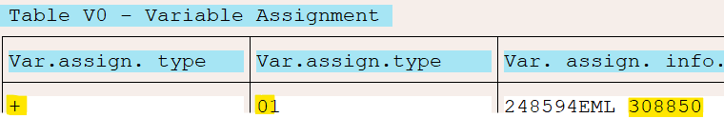  **See disclaimer A in relation to testing data | The V0 assignment to the EPSS top up /supplementary pay WT’s are expected to align with the WT 9WCO V0 assignment and this originates from the WT 9WCO assignment field in IT0014.  It is recommended to retrieve the incident via the EPSS top up WT’s in the pay results and it’s reference to the V0 table as master data could have changed in retrospect.
Officers registration number | The SAP employee number with EPSS top up WT’s to be reported:  49E9 EPSS P1 Top Up  49S9 EPSS P2 Supp. Pay
WC Claim number | As for POS Claim no, but derive the EML number for the net EPSS top up WT value reported as related to the for period displayed.
Payment date | This is the end date of the IN pay period of which the net differences are reported. Eg. pay 3 in 4 has a net difference of $50 to pay 3 in 3; then show $50 with the pay 3 incapacity from/end dates, but the payment date is that of pay 4.
Incapacity period from/to dates | The period dates that reflect the net difference for an incident. See the column ‘Payment date’ example, P3 dates
Payment amount | The net difference amount for the Incapacity period from/to dates. See the column ‘Payment date’ example.  Note on retro change of primary incident:  Pay 3 in 3 $0  Pay 3 in 4 $50 Incident A  Pay 3 in 4 $50 Incident B  The above example implies the primary incident changed. Then two lines report  Incident A; Incapacity start/end Pay 3; $-50  Incident B; Incapacity start/end Pay 3; $ 50  However, if both was primary incident A, then there is nothing to report.
No of weeks of period 1 utilised | The week number in ZIM_EPSS_WEEK_NO ‘for’ the Incapacity start/end pay period as accounted “in” the quarter period that is included in the report.  As per the payment amount column sample the for period was 3 and the in period was 4.
No of pay weeks of period 1 available | If ‘No of weeks of period 1 utilised’ =>39, then zero, otherwise 39 minus No of weeks of period 1 utilised.
No of weeks of period 2 utilised | If Period 2 did not commence in or prior to the incapacity period been reported, then zero, otherwise (Incapacity pay period end date – Period2 start +1)/7. Round week up, eg. 10.49 =10; 10.5 or = 11 weeks.
No of pay weeks of period 2 available | 365 minus No of weeks of period 2 utilised
Claim type (Physical or Physiological) |  | Retrieved from the P902 of the incident from the location of injury. A mapping condition if injury is not psychological to default to 'physical' instead of location of physical injury i.e Knee (right)
Claim status (open or closed) |  | Workers Compensation claim status from OLIMS Field Name: WC_STATUS
Table 2 - ICARE Recoup Report Columns

ABAP changes required
New custom report (suggested name: ZHRDD_EPSS_ICARE_RECOUP) and transaction code to be created.
The records will be displayed in ALV grid format with standard ALV functionality available such as exporting to Excel.
The report will have the following selection screen:
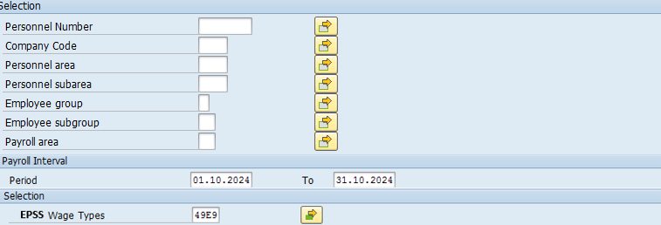
Figure 4 - Selection Screen - EPSS Icare Recoup Report
- Personnel Number ( PERNR)
- Company Code (BUKRS) – Default ‘1100’
- Personnel Area (WERKS)
- Personnel Subarea (BTRTL)
- Employee Group (PERSG)
- Employee Subgroup (PERSK)
- Payroll Area (ABKRS) – Default ‘ZF’
- Period Start Date (BEGDA)
- Period End Date (ENDDA)
- EPSS Wage Type (LGART) - Default
The report selection is to allow for entering a start and end date. Any pay periods accounted with a period end date that falls within the start/end date will be included in the report.
The EPSS wage types will be automatically pre-populated with the EPSS wage types (49E9 and 49S9).
Processing Flow:
- Prepare payroll area range based on the value entered on selection screen.
- Get PERNR
- Check if payroll is exited, if not display warning message on screen: #Please exit payroll.
- Create instance of class #CL_HRPAY99_PRR_4_PNP_PAYPER#.
- By using instance created in step 1 call method GET_PERNR_PAYR_RESULTS_ALLIN1 to get payroll results for the pay periods and save them in internal table.
- If EVP-SRTZA = ‘P’, multiply RT-BETRG to -1 and collect by PERNR/INCIDENT/FOR PERIOD/WC claim/Payment date combination.
- If EVP-SRTZA = ‘A’, collect RT-BETRG by PERNR/INCIDENT/FOR PERIOD combination.
- Get the OLIMS data for EPSS Period 1 & 2 for each PERNR/INCIDENT/FOR PERIOD/WC claim/Payment date combination.
- Display results in an ALV report.

Report Extract:
LTEX table would be used (or alternatively a new custom table) to store the report extract.
Program ZHRLVE_UNAPPROVED_SPOOL (screen 4500) could be used as reference for extract storing in LTEX table.
The report would have an extract button created (on report toolbar) which will open a new window with the following options:
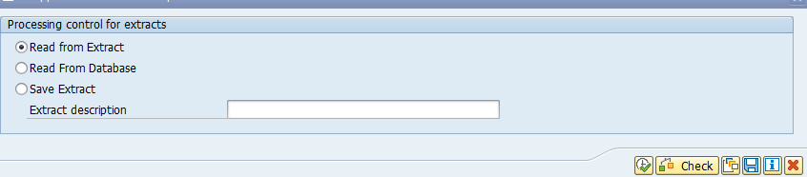
Figure 5 - Recoup Report Extract Screen
- Read from Extract: Read the records from the extract (LTEX table)
- Read from Database: Read the records from SAP dababase
- Save Extract: Saves the extract into the LTEX(or custom table).
  - Description: Extract description.

Program ZSU_EXTRACT_MASS_DELETE deletes records from LTEX table. The variant can be updated to exclude the EPSS iCare Recoup report extracts.
If LTEX table is NOT the option selected and the decision is to use a custom table, a new program will have to be developed to delete the records from the custom table after a given period. The deletion program should use ZSU_EXTRACT_MASS_DELETE program as reference to have similar functionality, selection screen, etc.

Pause EPSS Period 2 Commencement
Period 2 currently commences at the start of a pay week, where the pay week is a week within the NSWPf fortnight pay cycle (Friday). The start of this ‘pay week’ is always after a pay week (defined by the NSWPf fortnight pay cycle) where P1 reached 39 weeks (EPSS period 2 start at week 40).
The requirement is not to auto commence Period 2 at week 40. It should only commence at week 40 if there was agreement for period 2 to commence. It could be that for several weeks from week 40 the employee receives no top up, as system indication is required to say Period 2 may commence.
The system indication is a flag (“Commence Period 2 Payment”), not a date. When the flag is switched on for period 2 payments then EPSS Period 2 payments are payable in retrospect to when week 40 falls (as per the auto start of period 2).
ABAP changes required in OLIMS
Create new “Commence Period 2 Payment” flag which will be stored in the table ZIM_IN_EPSS. Re-generate SM30 of ZIM_IN_EPSS to include new field.
New log table (ZIM_IN_EPSS_LOG) to be created and table handling logic implemented for audit trail purposes.
The Commence Period 2 Payment flag will be placed and displayed in the EPSS Calculations tab Period 2 section in OLIMS as per green highlighted field in the image below.
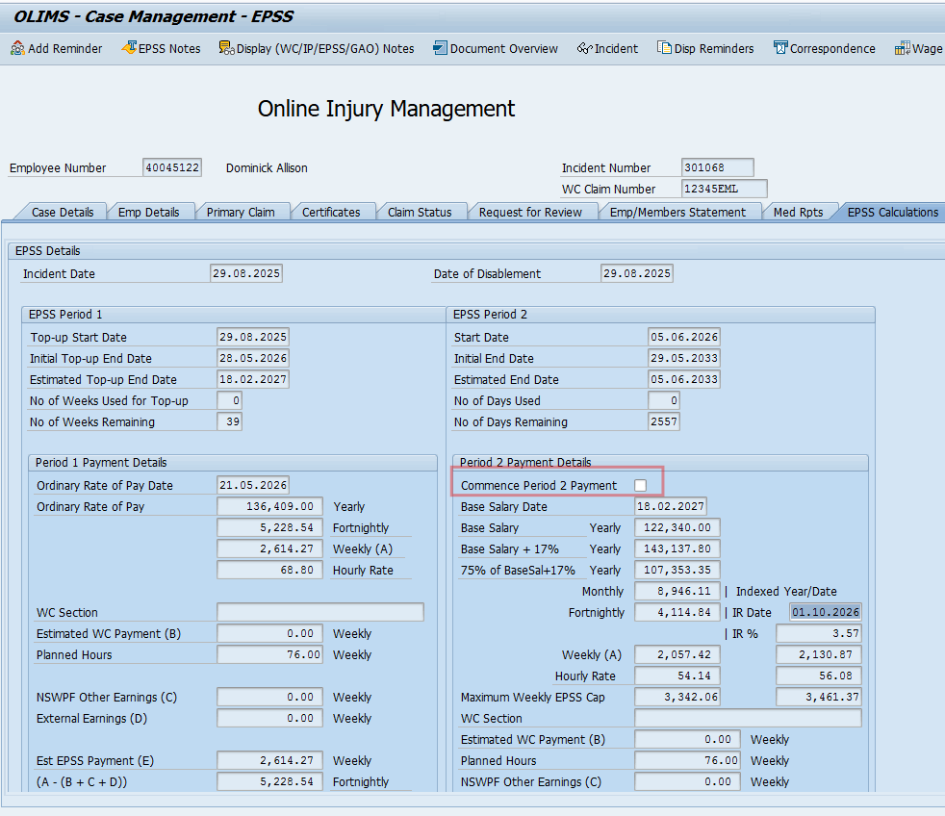
Figure 6 - Commence P2 Payment flag
Period 2 starts at week 40. When flag is ticked, Period 2 payment will commence starting 1 day after the end of EPSS Period 1 (40th week).
The defaulted selection of the flag will be unticked, meaning EPSS Period pay will not commence by default.
When the flag is ticked in OLIMS, new logic to update Earliest MD Change field in infotype 0003 to the first day of EPSS week 40 if IT0003 for the employee has the Earliest MD (master data) Change date (PA0003-RRDAT) later to the week 40 (or week39+1day or EPSS Period 2 start date), or if the earliest MD master data date is blank.
Build in OLIMS
Two new fields (EPSS_INIT_START_DATE_P2/ EPSS_INIT_END_DATE_P2) have been created in table ZIM_IN_CM to store the initial EPSS Period 2 Dates (Start date = DOD + 39 weeks + 1 day & End Date = P2 Start Date + 7 years).
When a new EPSS incident is create, only the initial P2 dates will be stored in ZIM_IN_CM table. The fields EPSS_ START_DATE_P2 & EPSS_ END_DATE_P2 will remain blank until the 39 weeks of period 1 is used. When the 39 weeks of period 1 is used, a custom function in payroll (ZEPS1) will update the fields EPSS_ START_DATE_P2 & EPSS_ END_DATE_P2 with the actual Period 2 start and end dates.
In OLIMS, the Period 2 initial dates will be displayed only if the actual Period 2 dates are blank. Once the actual Period 2 dates are updated (by payroll), the actual dates will be displayed (in EPSS Calculations tab).
New logic added for the new commence P2 flag in include ZHUOLIMS_UPDATE2 form SAVE_EPSS. If a records already exists in ZIM_IN_EPSS, and there is a change in the Commence P2 Payment flag (tick or untick),
When the flag is ticked or unticked, the logic queries table HRPY_RGDIR where for period end date is greater or equal than P2 start date. If no records are returned, Earliest MD Change fiend from infotype 3 is NOT updated and Commence P2 Payment flag updated in table ZIM_IN_EPSS.
If Earliest MD Change fiend from infotype 3 is greater than P2 start date or is blank, Earliest MD Change fiend from infotype 3 is updated with P2 start date and Commence P2 Payment flag updated in table ZIM_IN_EPSS.

ABAP Changes required in Payroll
Payroll operation Z75S will be modified to check for the flag and only return the EPSS Period 2 Supplementary weekly amount if the flag is ticked, otherwise 0 (zero) will be returned.

Build Payroll Changes
***---------------------------------------------------------------------
* form OPZ75SL
***---------------------------------------------------------------------
FORM opz75sl.
...

SELECT SINGLE * FROM zim_in_epss INTO ls_epss
WHERE pernr = pernr-pernr
AND incident = lv_incident.
IF ls_epss-commence_p2_payment NE 'X'. "Don't return salary if P2 payment not checked
EXIT.
ENDIF.
...
ENDFORM. " OPZ75SL

2.7 Simulation Run Should not update weeks used count
Weeks used count should not be updated on test mode. The weeks used count table is currently being updated in production even if we are running simulation mode. This is corrected as part of phase 4 development by putting a check in functionalities that deletes and updates weeks used count.

Payroll Change – Simulation mode check

CR and fixes

Issues and change list
Issue/CR Tracker references Tracker- Issues Log_EPSS_Phase4.xlsx
Date | Issue | Responsible | Reference | Transport
12/11/2025 | Week count entry missing Sec36 | Salmie | Tracker 101 | DEVK9HRH49

Unit Testing

Tracker 101
Dev030 retro #47277 to P16 2024 where the week count was missing. Week count now increase for Sec36 as expected.
