УДК 65.011.8
В. Мельничук, Є. Кабанова, Н. Кузнєцова
C1 (051) Економіка; F4 (124) Системний аналіз та наука про дані; F3 (122) Інформаційні технології

АНАЛІЗ ЕКОНОМІЧНОГО ПОТЕНЦІАЛУ ВИКОРИСТАННЯ ЦИФРОВИХ ІНСТРУМЕНТІВ У СФЕРІ ОХОРОНИ ЗДОРОВ’Я В УКРАЇНІ: ГЛОБАЛЬНИЙ КОНТЕКСТ ТА АДАПТАЦІЯ В УМОВАХ ВІЙНИ
Анотація
Стаття досліджує економічний та науковий потенціал цифрових інструментів у сфері охорони здоров’я в Україні, з акцентом на стійкість та адаптацію в умовах криз. Дослідження порівнює цифрову систему охорони здоров’я України зі світовими тенденціями, висвітлюючи стандарти, виклики воєнного часу та можливості розвитку. Використані методи включають наративний огляд, статистичний аналіз економічних секторів та оцінку цифровізації в умовах війни. Результати показують, що, хоча цифрова медицина в Україні поступається світовим лідерам, країна продемонструвала згуртованість і адаптивність у відповідь на COVID-19 та війну. Впровадження декількох сервісів відображає стійкість і готовність до глобальної інтеграції. Висновки показують, що цифрова охорона здоров'я в Україні має значний економічний потенціал за умови міжнародної співпраці, ефективного управління, захисту даних і чітких нормативів, що дозволяє покращити систему та прискорити інтеграцію у світові цифрові мережі охорони здоров’я.
Ключові слова: аналітика; аналіз даних; економічний потенціал; цифрова трансформація; цифрова медицина; здоров'я; охорона здоров'я; телемедицина.
ANALYSIS OF DIGITAL TOOLS’ USAGE ECONOMIC ASPECT IN THE HEALTHCARE SECTOR IN UKRAINE: GLOBAL CONTEXT AND WARTIME ADAPTATION
Abstract
The article investigates the economic and scientific potential of digital health tools in Ukraine, focusing on their resilience and adaptation in crisis conditions. The study compares Ukraine’s digital health system with global trends, highlighting standards, wartime challenges, and development opportunities. Methods include narrative review, statistical analysis of economic sectors, and evaluation of digitalization under wartime conditions. Results show that, although Ukraine lags behind global leaders, it has demonstrated cohesion and adaptability in response to COVID-19 and war. The implementation of several key digital services reflects resilience and readiness for global integration. The study concludes that Ukraine’s digital health sector has significant economic potential, contingent on international cooperation, robust governance, data protection, and clear regulations, enabling system improvements and accelerated integration into global digital health networks.
Keywords: analytics; data analysis; economic potential; digital transformation; digital medicine; eHealth; healthcare; telemedicine.
Introduction
In recent years, the rapid growth of cutting-edge technologies and continuous advances in machine learning (ML), Big Data, and artificial intelligence (AI) have been transforming healthcare systems worldwide. Concepts such as eHealth, telemedicine, AI, ML, and the Internet of Medical Things (IoMT) have become essential drivers of medical innovation, improving diagnostic accuracy, enhancing treatment efficiency, and reducing healthcare costs. International agencies such as the World Health Organization (WHO) [1] emphasize the role of digital innovation in promoting health, ensuring safety, and providing equitable access to medical services. Leading countries are actively leveraging digital technologies to overcome healthcare challenges, improve patient outcomes, and boost economies. From AI-powered diagnostics in the United States to Estonia’s fully digital healthcare platform [7].
Today, more than 70% of countries have adopted a national digital health strategy, with scaled digital health programmes underway in every region. Revenue in the Digital Health market is projected to reach $197.88 billion in 2025 [11]. However, despite these advances, many strategies lack financial commitments, face fragmented resources, inconsistent technical standards, weak national governance, and widespread concerns about data security.
In Ukraine, the healthcare system relied mostly on conventional approaches to medicine and patient care. Nonetheless, in recent years, the incursion of digital health, also known as eHealth, has emerged as a pivotal aspect of this transformation, reshaping the landscape of healthcare delivery in Ukraine. The full-scale war in Ukraine highlighted the urgent need for advanced analytical and computational tools to improve healthcare and ensure public safety. Revenue in the Digital Health market is projected to reach $195.52 million in 2025 [11]. Despite certain progress, digital medicine in Ukraine still faces significant barriers, including limited funding, regulatory gaps, national distrust, and unequal access to technological infrastructure [5].
Problem statement
This narrative review provides an overview of the theoretical foundations and economic aspects of digital medicine. It focuses on a comprehensive analysis of Ukraine digital health development and global trends. It highlights key achievements and their economic potential, current war challenges, and potential solutions to the usage of digital health technologies, with the focus on war conditions in the country. Such an approach shapes a more complete picture of the current state of digital healthcare and provides a theoretical basis for further research.
The aim and task of the study is to provide an in-depth economic comparison of Ukraine's digital health system with global trends, focusing on the emerging directions, precise definitions, established standards, and the key war challenges that constrain the country's further development.
Analysis of last achievements and publications
The analysis is based on a review of scientific articles, reports, and web resources, using methods of summarization, thematic grouping, and comparison methods to identify key trends in digital medicine.
Advances in digital health technologies, including telemedicine, electronic health records, artificial intelligence (AI), machine learning (ML), Big data, the Internet of Things (IoT), and cloud-based solutions, have improved patient care, clinical decision-making, and healthcare management [2, 10, 17].
Digital healthcare has expanded rapidly during crisis situations such as the COVID-19 pandemic and the war in Ukraine, making remote consultations and disease monitoring both essential and accessible. Scientific publications [8, 13, 14] demonstrate that telemedicine helps maintain patient care in remote areas, reduces the burden on medical staff, and enhances treatment efficiency.
The use of AI and ML in medical systems improves efficiency by lowering diagnostic and administrative costs, optimizing resource allocation, and enabling predictive modeling [18, 19, 21, 26].
Ukraine has made noticeable progress with the eHealth platform eZdorovya, which meets both national and international standards. However, there are still difficulties, including the use of paper records, low digital literacy among some groups of the population, the lack of clear legal rules, and the lack of trust in medical services [23, 25-27, 30, 31].
Comparative studies from Estonia, Singapore, the US, and the UK demonstrate that integrated, AI-powered systems enhance efficiency, transparency, and interdisciplinary cooperation, offering a model for Ukraine to align with global digital health standards [7, 11, 20, 27].
Successful implementation of such a system requires better standardization, data protection, regulatory support, and workforce training [2, 26, 28, 29].
Materials and methods
Digital medicine is the scientific field focused on the digital and digitally-supported care for individuals, which includes health preservation, diagnosis, monitoring, treatment, disease prevention, and disability compensation. In interdisciplinary and trans-sectoral care contexts, digital medicine employs digital concepts and technologies that assist and support patients, physicians, psychotherapists, nursing staff, and allied healthcare professionals in their medical practice [2].
Digital medicine is an interdisciplinary field that involves the use of digital technologies and concepts for diagnostic, therapeutic, and scientific purposes. The related products are based on research, development and clinical experimentation with an emphasis on evidence-based use of digital tools [2].
Before delving further into the definitions of each of the digital health technologies, it is important to establish a clear boundary of understanding between traditional and digital healthcare. Such a comparison, presented in Table 1, partly explains why digital healthcare can potentially be more precise, less error-prone, and more efficient.
Table 1. Differences between traditional and digital healthcare, and economic potential of such changes (Adapted by author) [10]
Traditional healthcare | Digital healthcare | Economic potential
Direct patient-physician relationships | Patient-machine-physician interface | Reduces physician workload
Standardized care based on physician experience and standard clinical workflow | Individualized care, precision medicine, with a non-traditional workflow | Improves efficiency of treatment
Data owned by the institutions/hospitals | Data owned and shared by multiple stakeholders, including the patient | Enhances interdisciplinary cooperation, support data-driven solutions in healthcare and enhances transparency
Physician as the central player who makes diagnosis and prescribes treatment plans | Physician as a consultant, guide, or collaborator with the patient’s active contribution in the decision making | Reduces costs of administrative labor

Currently, the spectrum of digital health technologies has expanded beyond telemedicine to include big data, health record digitization, wireless and mobile technology/5G, blockchain, telemedicine, Artificial Intelligence (AI), Machine Learning (ML), sensors, the Internet of Things (IoT), Extended Reality (XR), and Ambient Assisted Living (AAL). Cloud computing nowadays enables more complex diagnostic procedures via telemedicine, such as bioimage analysis that requires computational power not locally available [10].
These technologies are especially useful for remote medical facilities and institutions, and in cases of transportation of medical products, where there are high logistical risks. They manage the situation, warn about the emergence of problems that may threaten the safety of patients or damage medical drugs and equipment, and are even able to monitor the disinfection of the hands of medical personnel, which significantly reduces the risk of outbreaks of infections.
The United States is the largest medical technology market globally, accounting for approximately 40% of the global market share, while in Europe, the leading figure is Germany [31]. According to the World Health Organization, countries spent $9 trillion on healthcare in 2020 – 11% of the global gross domestic product – while a significant portion of expenditure on healthcare is wasteful due to systemic inefficiency [12]. AI systems already reduced such inefficiencies: for instance, Kheiron Medical uses AI to assess mammograms and screen for cancer in a more cost-effective way, eliminating the need for a second doctor to analyse the X-ray, while Methinks reduces assessment time for stroke patients by using AI to analyse preliminary CT scans [19].
The economic impact of digital healthcare also extends to hospital management. In a study conducted in a hospital operating in Ankara implementing HIMSS (Healthcare Information and Management Systems Society), it was determined that the primary costs of economic benefits in the digital hospital were paper and printing device depreciation expenses, toner fees, archive depreciation costs, and labor expenses. As a result, over three years, the annual cost savings from paper reduction amounted ₺48,494, while labor savings reached ₺7,779,474. Thus, the average annual cost savings from digital applications in hospitals amounted to ₺7,827,968 [18].
The digital transformation of healthcare also involves digital forms of patient communication with medical staff. Сhatbots optimize the process of the service, reduces the burden on medical institutions and saves time for doctors and medical staff, as patients are able to describe their symptoms in a calm manner without the pressure of limited time at a doctor's appointment. Thanks to the introduction of digital technologies, citizens have received an opportunity to save time and make an appointment, fill out primary documentation, provide the necessary information about themselves and their symptoms, as well as their medical history. While questions generated by artificial intelligence allow patients to record their complaints in detail and calmly, precisely specifying their symptoms and complaints. This, in return, allows doctors to fully concentrate on the patient and their medical problem, without spending time filling out paper documentation and looking for the diagnosis, making the communication process more effective, fast, and less exhausting.
In contrast, in Ukraine, digital services of this level are just beginning to be introduced in large clinics and leading diagnostic centers. Paper medical records in Ukraine still have greater legal weight than digital ones, and most medical institutions use both paper and electronic documentation. This hinders the development of digital media, as electronic records are often considered only an alternative [26].
Digital medicine has significantly accelerated during the COVID-19 era. Hospitals reported that although the number of in-person visits declined dramatically, the use of medical services peaked through mobile applications, websites, robots, and chatbots [13]. China, for instance, introduced a quick response (QR) code system to allow authorities to monitor health status and control movement, while Europe launched the Covid-19 Data Platform to exchange research data between countries, strengthening international collaboration [19]. Similarly, the acceleration of telemedicine in Ukraine was primarily due to the pandemic and later the war. Surveys showed that 99.20% of doctors continued to use telemedicine during the war, though the most popular tools were instant messaging apps and phone calls rather than specialized digital platforms [8].
Despite the barrier, Ukraine achieved progress in the development of the Electronic Health Care System. Today, eHealth is one of the largest electronic systems in Ukraine, with its functionality constantly updated. The available functionality allows for a conclusion, amendment, and termination of public health contracts and contracts for reimbursement under the medical guarantees program; preparation and submission of electronic reports, primary, settlement, and other documents under contracts through the central database; registration of users in the central database; preparation, submission, and review of healthcare declarations, prescriptions, referrals, and medical records; exchange of information and documents through electronic offices following user access rights; giving patient (their legal representatives) consent to access their personal data; searching and reviewing information in the central database in accordance with user access rights. The exchange of necessary medical data is made via an open software interface (API), which consist of the central database and enables interaction with with other information systems, including disease-specific registries — covering oncology, tuberculosis, HIV/AIDS, insulin-dependent diabetes, and injured military personnel — complementing state registers of medical facilities, pharmaceuticals, treatment standards, and healthcare professionals [26]. These registries provide the analytical backbone for predictive modeling, control resource allocation, and manage wartime healthcare logistics. A crucial part of the central component of the database is the integrated electronic medical record of the patient (EMR), which gathers patient medical history in the form of questions with alternative answers and text boxes to enter information about the individual characteristics of the disease [26]. With such a system, doctors can access the patient and their need for medical, psychological, and pedagogical corrections.
Global surveys and research also point to noticeable market growth. According to Statista , revenue in the digital health market is projected to reach USD 197.88 billion in 2025 with a CAGR of 6.88% through 2029, reaching USD 258.25 billion. In comparison, Ukraine’s digital health market in Ukraine is projected to reach USD 195.52 million in 2025 with a CAGR of 1.73% through 2029, reaching USD 209.45 million, which is significantly lower than the global average [11]. Still, the projected dynamics confirm that digital health remains one of the few growing segments of the Ukrainian healthcare economy even under war conditions.
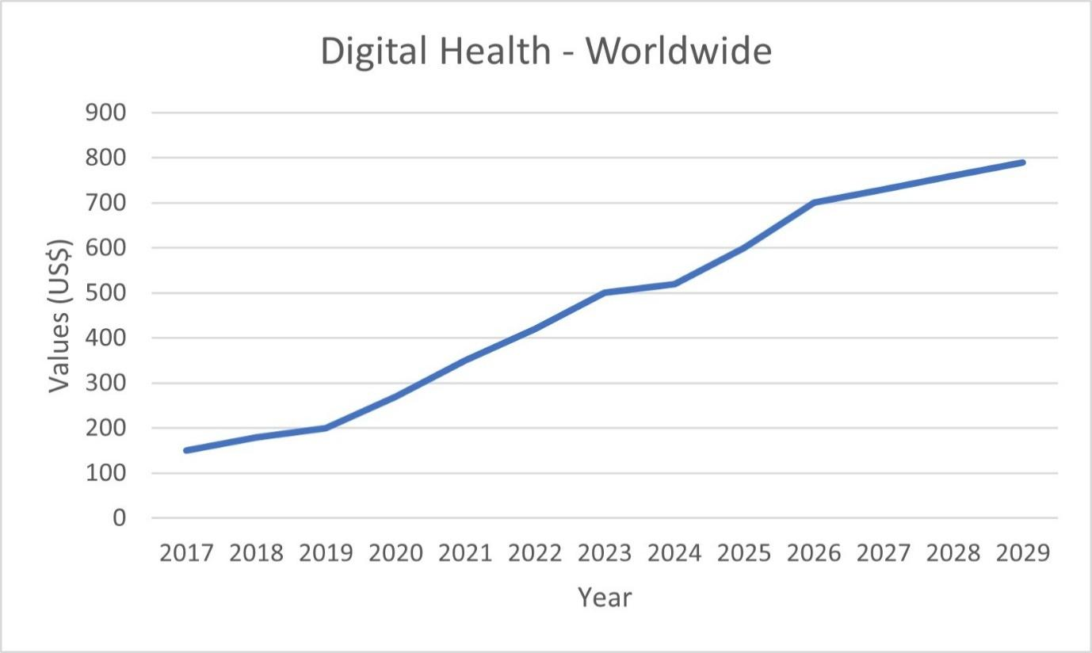
Figure 1. Revenue digital health market worldwide (Author’s own development)
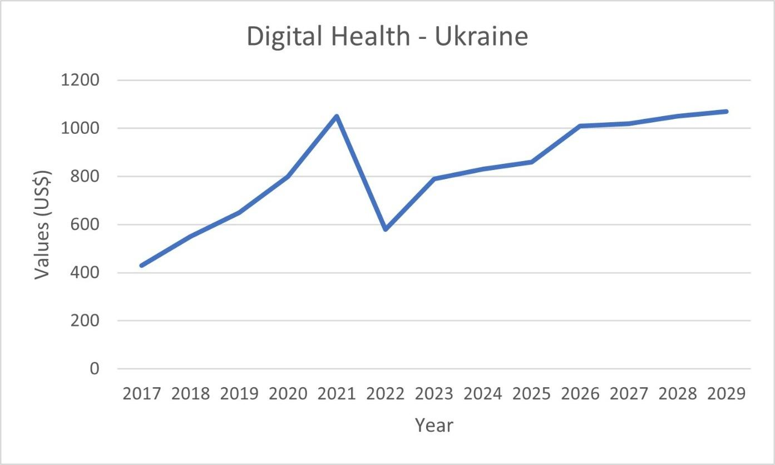
Figure 2. Revenue digital health market in Ukraine (Author’s own development)
Ukraine’s government health expenditures as a share of GDP remain lower than those in the USA, the UK, EU, and global average since the Russian invasion in 2014 [38]. The growth of expenditures remained the lowest, ranging between about 7.2% to 8%, and increasing to approximately 9% in 2022. In contrast, the world's average stayed just above 10% throughout the years, peaking in 2020 at about 11% before dropping back to approximately 10%. The USA’ expenditures were considerably higher during the entire period and peaked in 2000 to about 18% (Figure 6).
Before the full-scale war in 2022, Ukraine’s government health expenditures were around 7.5% of GDP, which was already a high level compared to about 9% global average. However, the EU average stood about 9-10%, making a gap of approximately 3% with Ukraine. This highlights Ukraine’s potential for growth, as well as significant pressure caused by the war.
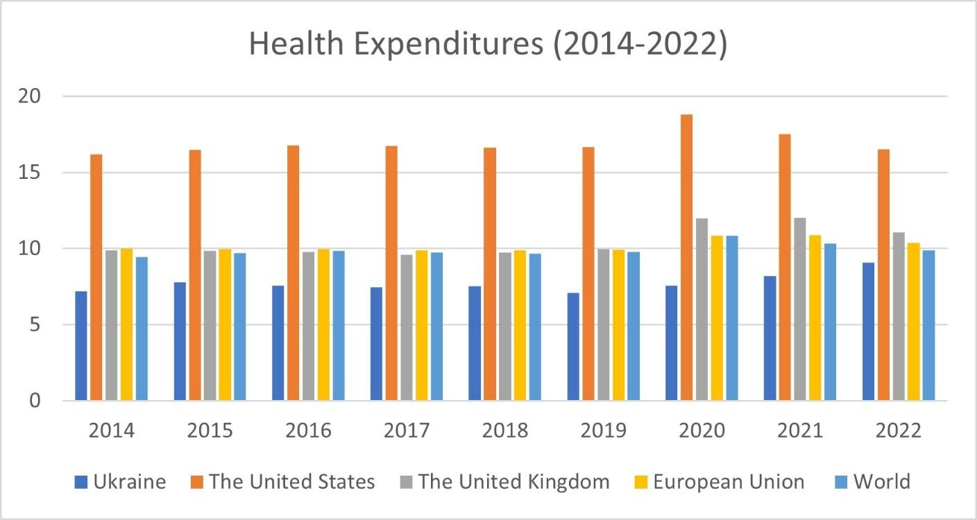
Figure 3. Global Health Expenditures by different regions worldwide (Author’s own development)
Digital health has also provided new career opportunities. In the United States, professionals with certification in health informatics are in high demand, as hospitals and healthcare systems seek experts who can manage data systems, analyze health data, and ensure the successful implementation of digital tools. The United Kingdom is also rapidly adopting electronic health records (EHRs) and data-driven care, creating opportunities for professionals specialized in health informatics [7]. Moreover, the United Kingdom has a thriving medical technology sector, with a focus on innovation and research, and actively invests in digital health initiatives [31]. Ukraine has not established health informatics as an independent field of study yet, but it continues to introduce new innovations that accelerate conventional healthcare practices. Like this, the introduction of the “Nursing Staff Workplace” system enabled nurses to register, manage electronic medical records, process referrals, record treatments and vaccinations, and access patient histories, thereby redistributing doctors’ workload and increasing the nursing staff’s role in care [23]. Although these steps are modest compared to the labor market in the USA and UK, such innovations demonstrate Ukraine’s potential in health informatics and willingness to use advanced technologies, including AI.
Estonia’s e-Health system connects all healthcare providers through a centralized digital platform, drastically improving the efficiency of healthcare delivery and reducing administrative costs [7]. Singapore has invested in “smart hospitals” that use IoT devices to monitor patients and manage hospital operations more efficiently by leveraging big data and AI [7]. Similarly, Ukraine’s system eZdorovya now serves over 17 million patients, enabling electronic health records along with digital tools for healthcare providers, administrators, and pharmacists [25].
Despite developments, according to a national study, more than 40% of Ukrainians still have a lower than basic level of digital literacy. This created difficulties in understanding and using digital health solutions for certain social groups, such as minorities, the elderly, and those in low-income or rural areas. Nevertheless, Ukraine managed to preserve its digital transformation. Except eHealth becoming one of the largest electronic systems in Ukraine, Telemedicine services received legal foundation through the adoption of the Strategy for the Development of Telemedicine in Ukraine (Cabinet of Ministers Order No. 625-p, July 14, 2023) and the Law of Ukraine No. 3301-IX (August 9, 2023) [28, 29]. The introduction of such regulations benefits economically, reducing travel costs through remote consultations, and also ensures greater safety for the nation.
Limited financial resources delay the introduction of new technologies, especially in frontline areas due to the low population and difficult access to infrastructure. The growth of Internet access is also negatively affected by the low level of digital literacy and education of part of the population, especially the older generation, which does not use digital services; competition from mobile electronic communications operators; too low income. Although the availability of the Internet in Ukraine and its speed is increasing, in terms of speed and convergence, it is still below that of EU countries. The level of coverage of mobile broadband access to the Internet in Ukraine in 2022 was 91% of the population, which is 8.8. below the median indicator for EU countries, where the indicator reaches 99.8% (Figure 3). While the penetration of mobile broadband access to the Internet, according to ITU data, was 80.1% of the population, which is more than 25% less than the median in EU countries - 105.3% (Figure 4). According to the Speedtest Global Index, in terms of mobile Internet speed, Ukraine today lags significantly behind European countries and is on a par with such countries as Ecuador, Tunisia, Indonesia, Myanmar, and Laos. While in Singapore, the UAE, Hong Kong, Chile, USA the average speed is over 250 Mbps, in Ukraine it is only 77.7 Mbps [35].
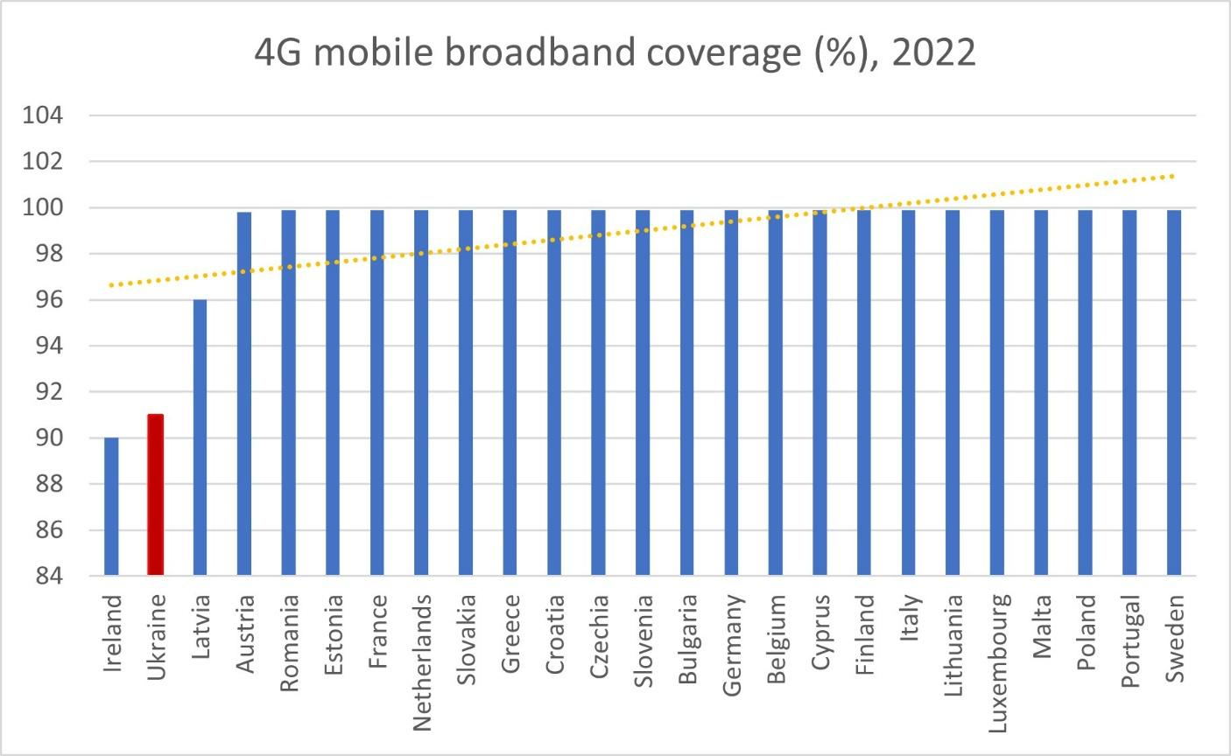
Figure 4. Mobile broadband Internet (4G) coverage in EU countries and Ukraine in 2022 (Author’s own development)
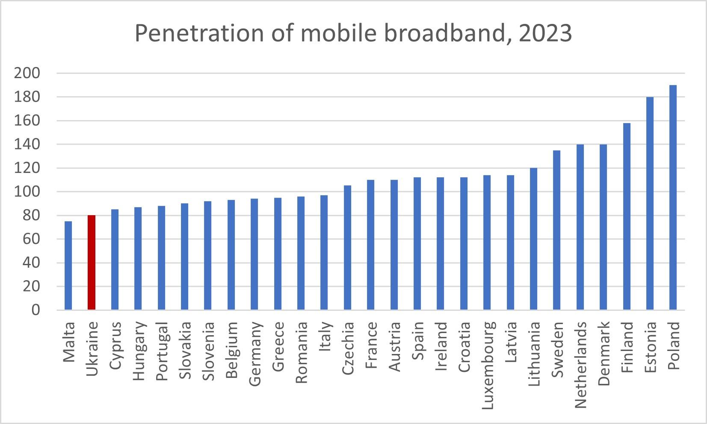
Figure 5. Mobile broadband Internet penetration in EU countries and Ukraine in 2023 (Author’s own development)
To address these challenges, the government of Ukraine introduced the Strategy for the Development of the Electronic Communications Sector until 2030 (Cabinet of Ministers Order No. 546-p, June 4, 2025), aimed at creating opportunities for connecting to the Internet for the maximum number of citizens, public institutions, enterprises, organizations, and comprehensive use of the opportunities that arise for users of the global network [36]. There was a goal of achieving the growth of up to 98% of the population of Ukraine with mobile broadband access to the Internet and 99% of social infrastructure facilities, with the average data transfer speed (DL) at least 90 Mbps. These changes are expected to accelerate the development of digital health by ensuring more reliable Internet connections and access to health services across the country.
Whereas the European Union has set an ambitious goal of providing 100% of citizens with access to their electronic health records by 2030, with Austria already reaching an eHealth maturity score of 88% in 2023, compared to an EU-27 average of 79% [22]. Ukraine, while not yet at this level, is actively taking part in initiatives with the European Health Data System (EHDS), which will enable the sharing of medical information between Ukraine and the 27 EU member states [27]. This cooperation is a solid opportunity to strengthen the country’s integration into European research. The development of an innovation ecosystem in Ukraine is of key importance in the context of Ukraine's European integration. According to the Global Innovation Index in 2023, Ukraine ranks 55th out of 132 countries surveyed in the world, which is two places higher than in 2022. The governance seeks deeper integration into the European Research Area to drive economic growth and innovations. Following these goals, the Strategy for the Digital Development of Innovative Activity of Ukraine until 2030 (Cabinet of Ministers Order No. 1351-p, December 31, 2024), aims to create new opportunities in research and innovations [36].
The Ukrainian government has also set the task of the phased introduction of e-health tools through legal principles, defining fundamental concepts, tasks, functions, components, and introduction stages of new mechanisms for realizing state-guaranteed medical care in Ukraine. The next two documents ensure patients with necessary medical services and medicines of adequate quality at the expense of the State Budget of Ukraine under the program of medical guarantees, and are actualized based on the electronic interaction of participants via eHealth: the Law of Ukraine "On State Financial Guarantees of Health Care Services" (No. 2168-VIII, October 19, 2017) and the Resolution of the Cabinet of Ministers of Ukraine “Some Issues of the Electronic Health Care System” (No. 411, April 25, 2018) [22]. Such documents are characterized by a change in financial principles and the introduction of an electronic health care system. The E-health system is able to strengthen connections among all participants in medical relations – the state, service providers, medical workers, and patients, based on the cost-effective and safe use of information and communication technologies.
Another key aspect of implementing digital healthcare is personal data safety. Ukraine’s digital healthcare system meets both international standards (certificate of conformity ISO 27001:2013, certificate No. IND17.0398/U issued by Bureau Veritas) and Ukrainian standards (SSSCIPU certificate of conformity No. 14162 July 22, 2016) [26]. The protection of information in the central database is guaranteed by the provisions of the Law of Ukraine 413/2022 CIVIL LAW AND PROCESS "On Information Protection in Information and Communication Systems" (No. 80/94-VR, July 5, 1994), and the processing of personal data in the electronic health care system is carried out in compliance with the requirements of the Law of Ukraine “On Personal Data Protection” dated (No. 2297-VI, June 1, 1010) [22]. It complies with the best world practices in data protection and with the involvement of international specialists, protecting patients against cyber attacks, intrusions, and unauthorized data interference. In addition to existing practices, Ukraine’s regulation authorities have made some measurements to solve existing problems with the proper protection of personal data processing, including the "Concept of the electronic healthcare system" approved by the Ordinance of the Cabinet of Ministers of Ukraine in December 28, 2020, which defines the priority areas of regulatory and legal support for the development of e-health by 2025. They involve defining requirements for e-health services, ensuring quality of advanced functionality, and improving approaches to electronic identification, user authentication, and data exchange standards. This includes maintaining central registers, medical documentation, and statistics; regulating access to health data under data protection laws; ensuring integration with other telecommunication systems; managing personal and sensitive health data, including depersonalized reuse for research and statistics; and harmonizing national standards with international ones for global integration.
At the same time, legislation, both Ukrainian and international, often fails to keep pace with technological changes. Today, most countries in the world do not have clearly developed legal norms that would regulate the use of digital services in the medical industry, which creates legal uncertainty for service providers and users [26]. The issue is also in determining the responsible party in case of errors due to software failures [18]. As digital services are often global in nature, the question arises as to which law applies to cross-border services and how this affects their legality.
The ongoing war also poses serious threats to Ukraine's digital healthcare system, making the task of table functioning of the entire healthcare system under martial law a priority. Since February 24, 2022, dozens of health facilities and health workers have been attacked and displaced, and continuous attacks on energy systems have jeopardized system stability. Due to the displacement of Ukrainians, the number of users increased in the west of the country, causing errors in some medical information systems. Notable areas include the Kyiv, Chernihiv, and Sumy regions, as well as parts of the Kharkiv, Kherson, and Luhansk regions [6]. According to the Center for Economic Strategy, as of the end of June 2023, 5.6-6.7 million Ukrainians were abroad due to the war, from 1.3 million to 3.3 million of whom may remain abroad. The failure of Ukrainians to return has a significant impact on the Ukrainian economy, which may additionally lose from 2.7 to 6.9 percent of its gross domestic product each year. According to Statista, average revenue from digital healthcare dropped by almost one-third in 2022 [11]. The paramount aim is to enable connections between experts from different countries in real-time in order to receive professional recommendations and to provide all those who need it with medical care regardless of the distance and request time.
However, Ukraine is actively developing digital medicine, adapting it to the challenges of wartime conditions. Thus, on January 1, 2025, a new system for assessing daily functioning was launched, which transferred all medical and social expert commissions to an electronic format. The main goal of this is to reduce bureaucracy and make interactions with doctors more convenient. The system is a free digital tool for doctors, administrators, and expert teams, built on the Diia.Engine platform. The use of Diia.Engine significantly accelerated the development of the system thanks to its built-in low-code components. Also, because Diia.Engine is a state-standardized solution, support and modernization of the system is greatly simplified and eliminates dependence on a single developer. The new electronic system not only optimizes the process but also creates a transparent and secure model for evaluating daily operations. The Ministry of Health of Ukraine aims to fully integrate it with the national electronic healthcare system and other state registries during 2025 [39].
This innovation will contribute to solving key problems:
- reducing costs and bureaucracy and maintaining physical MSEC commissions;
- optimizing doctors' working time and speeding up the administrative process;
- lowering corruption;
- enabling integration with other state registries;
- saving public budget funds;
- reducing future healthcare costs by proving faster access to treatment;
- strengthening public trust in the healthcare system and digital medicine.
While global practices clearly demonstrate the benefits of digital transformation, still many people in Ukraine face barriers in access to healthcare. According to the Health Index Ukraine 2023 survey, in which people across different regions were asked to explain their reasons for not seeking medical help in case of illness or injury (Table 2), the results showed that among the most common reasons, the majority (49.3%) reported that they had the knowledge to treat themselves. The second largest proportion (23.4%) hoped that the disease would pass without medical care, followed by those afraid of the cost of treatment (13.9%), and queues in healthcare facilities (13.2%). Additionally, a considerable proportion (8.5%) declared they do not trust the medical staff and their qualifications, while a new barrier has also appeared due to the full-scale war: 4.1% [32].
Table 2. Reasons for not seeing a doctor in case of illness or injury, and the number of respondents [32]
Reasons for not seeing a doctor in case of illness or injury | Percentage and number of respondents who indicated the reasons for not seeing a doctor
Reasons for not seeing a doctor in case of illness or injury | % | N
Too expensive (services, medicines, transport) | 13,9 | 207
I do not trust the medical staff and their qualifications | 8,5 | 122
Poor attitude of staff, impoliteness, rudeness | 2,4 | 41
Long queues at hospitals | 13,2 | 199
No transport connection | 3,6 | 72
I know how to treat myself from previous experience | 49,3 | 886
I don't know who to consult | 3,1 | 63
I expected that the disease would go away on its own; it didn't bother me much | 23,4 | 386
I was afraid of contracting the coronavirus | 2,8 | 44
I thought that non-coronavirus services were unavailable, of worse quality, more expensive, etc. | 0,5 | 8
Due to the full-scale war | 4,1 | 95
Other reasons | 4,5 | 66
Notably, it was mostly older respondents for whom the cost of services and distrust of medical staff and their qualifications remain significant barriers compared to other age groups (18.7% and 10.4% of respondents among 60+ who had health problems and did not seek help, respectively). In 2023, the share of the Ukrainian population aged 65 years and older was 20.1%, which is a considerable proportion. Urban residents were more likely to complain about queues at institutions (15.8% vs. 7.4% among rural residents), while rural residents pointed to problems or lack of transport as a barrier (7.3% vs. 2.0% among city dwellers). Around 70-71% of the population lived in cities and towns, and 30% in rural settlements, which shows that there is still a considerable proportion of people facing accessibility challenges in rural areas [33].
The results of this survey highlight the main drawbacks in the traditional healthcare system: unaffordable prices, poor management, and a lack of trust in medical service among Ukrainians.
Conclusion
Digital healthcare has a significant economic potential worldwide, offering benefits through reduced administrative costs, optimised resource allocation, the use of AI-driven predictive tools, the creation of new job opportunities, and reducing medical errors. In today’s circumstances, digital medicine is critically important for ensuring health care for everyone, regardless of distance and time. With the mission of achieving stable management of the digital healthcare system, countries must ensure reliable data protection technologies, as well as establish clear rules and regulations.
Although Ukraine is not yet as advanced in the digital health market as global leaders such as the United States, its rapid progress indicates strong potential to align with global standards in the near future. Ukraine has made substantial progress while adapting to COVID-19 and the full-scale war, including the introduction of the eZdorovya platform, disease-specific registries, and telemedicine legislation. At the same time, challenges such as insufficient funding, limited participation in global research, unequal digital literacy, and reliance on paper-based records continue to hinder further development.
The study analysed recent global achievements in digital medicine and compared them with the Ukrainian context, identifying both strengths and weaknesses. It has been defined that the rapid worldwide acceleration of digital healthcare occurred during the COVID-19 pandemic, while in Ukraine, it was additionally driven by wartime challenges. The analysis also highlighted the economic benefits of digital health and barriers that constrain its growth. Potential solutions were proposed, including international cooperation, stronger and more clear legal and regulatory standards, improved data protection, and greater support for innovations.
Perspectives of further development
Further research should focus on creating digital healthcare tools adapted to wartime conditions and limited resources, ensuring their functionality during emergencies. It is essential to establish clear and internationally aligned standards for regulating digital health technologies to ensure the protection of personal medical data and define responsibility in case of software failures.
Comprehensive cost-benefit and return on investment (ROI) analysis of digital tools in the healthcare sector in Ukraine should be conducted, evaluating both economic benefits such as reducing administrative and travel costs, optimizing resource allocation and their role in enabling predictive modeling and bringing new technologies for post-war recovery and healthcare sector optimization.
Future studies should also explore the potential of applying Ukraine’s digital health models in other critical sectors such as social care, rehabilitation, emergency response, and remote assistance for citizens in occupied territories, danger zones, and refugees abroad.
Additionally, Ukraine should focus on improving digital healthcare software to build citizens’ trust in technology and reduce the reliance on outdated, paper-based systems. Another priority is international collaboration with leading countries, openness to medical data exchange systems, participating in global digital health initiatives, attracting investments, creating jobs, and demonstrating its potential as a competitive contributor to the global digital health ecosystem.
References
[1] World Health Organization, Global strategy on digital health 2020–2025, Geneva: WHO, 2021. [Online]. Available: https://apps.who.int/iris/bitstream/handle/10665/344249/9789240020924-eng.pdf. [Accessed: Sep. 24, 2025].
[2] H. Mumtaz, M. H. Riaz, H. Wajid, M. Saqib, M. H. Zeeshan, S. E. Khan, Y. R. Chauhan, H. Sohail, and L. I. Vohra, "Current challenges and potential solutions to the use of digital health technologies in evidence generation: a narrative review," Frontiers in Digital Health, 2023. DOI: https://doi.org/10.3389/fdgth.2023.1203945.
[3] C. Ancona, E. Caroppo, and P. D. Lellis, "Digital solutions supporting the quality-of-life of European cancer patients and their caregivers: a systematic literature review," Health and Technology, 2025. DOI: https://doi.org/10.1007/s12553-025-00942-2.
[4] World Health Organization, "About WHO," [Online]. Available: https://www.who.int/about. [Accessed: Sep. 24, 2025].
[5] Ministry of Health of Ukraine, "eHealth system," [Online]. Available: https://ehealth.gov.ua/. [Accessed: 24-Sep-2025].
[6] K. Malakhov, "Insight into the Digital Health System of Ukraine (eHealth): Trends, Definitions, Standards, and Legislative Revisions," International Journal of Telerehabilitation, vol. 15, no. 2, 2023. DOI: https://doi.org/10.5195/ijt.2023.6599.
[7] D. Betty, Global Experience: How Other Countries Are Using Digital Technologies in Healthcare, Coachorg, 2024. [Online]. Available: https://www.coachorg.com/global-experience-how-other-countries-are-using-digital-technologies-in-healthcare/. [Accessed: Sep. 24, 2025].
[8] V. Poberezhets, A. Demchuk, and Y. Mostovoy, "How Russian-Ukrainian War Changed the Usage of Telemedicine: A Questionnaire-Based Study in Ukraine," Ankara Medical Journal, vol. 22, no. 3, pp. 305–318, 2022. DOI: https://doi.org/10.5505/amj.2022.08455.
[9] F. Herold, P. Theobald, T. Gronwald, M. A. Rapp, and N. G. Müller, "Going digital – a commentary on the terminology used at the intersection of physical activity and digital health," European Review of Aging and Physical Activity, vol. 19, no. 17, 2022. DOI: https://doi.org/10.1186/s11556-022-00296-y.
[10] A. Wai, A. Torkamani, A. J. Butte, B. S. Glicksberg, B. W. Schuller, B. Rodríguez, D. Shu, D. W. Bates, E. Schaden, H. Peng, H. Willschke, J. Car, K. Rahimi, L. A. Celi, M. Banach, M. Kletečka-Pulker, O. Kimberger, R. Eils, and M. Shariful, "The promise of digital healthcare technologies," Frontiers in Public Health, vol. 11, no. 1196596, 2023. DOI: https://doi.org/10.3389/fpubh.2023.1196596.
[11] Statista, "Digital Health – Worldwide Statista Market Forecast," [Online]. Available: https://www.statista.com/outlook/hmo/digital-health/worldwide?currency=USD. [Accessed: Sep. 24, 2025].
[12] World Economic Forum, "How digital healthcare tools cut costs and boost outcomes," 2024. [Online]. Available: https://www.weforum.org/impact/how-digital-healthcare-tools-cut-costs-boost-outcomes/. [Accessed: Sep. 24, 2025].
[13] E. Getachew, T. Adebeta, S. G. Y. Muzazu, L. Charlie, B. Said, H. A. Tesfahunei, C. L. Wanjiru, J. Acam, V. D. Kajogoo, S. Solomon, M. G. Atim, and T. Manyazewal, "Digital health in the era of COVID-19: Reshaping the next generation of healthcare," Frontiers in Public Health, vol. 11, no. 942703, 2023. DOI: https://doi.org/10.3389/fpubh.2023.942703.
[14] H. Aleksandrenko, M. Shevchenko, and O. Chervak, "Digital health intervention reconnects war-affected people living with HIV to healthcare: Ukraine case study," Oxford Open Digital Health, 2025. DOI: https://doi.org/10.1093/oodh/oqaf001.
[15] Institute of Medicine (US) Committee on Evaluating Clinical Applications of Telemedicine; M. J. Field, Ed., Telemedicine: A Guide to Assessing Telecommunications in Health Care, Washington (DC): National Academies Press (US), 1996.
[16] IBM, "What is the Internet of Things (IoT)?," 2023. [Online]. Available: https://www.ibm.com/think/topics/internet-of-things. [Accessed: Sep. 24, 2025].
[17] F. Jiang, Y. Jiang, H. Zhi, Y. Dong, H. Li, S. Ma, Y. Wang, Q. Dong, H. Shen, and Y. Wang, "Artificial Intelligence in Healthcare: Past, Present and Future," Stroke and Vascular Neurology, vol. 2, no. 4, pp. 230–243, 2017. DOI: https://doi.org/10.1136/svn-2017-000101.
[18] N. Torun, "Economic Effects of Digitalization: Health Sector Example," Anemon Muş Alparslan Üniversitesi Sosyal Bilimler Dergisi, vol. 12, no. 2, pp. 717–724, 2024. DOI: https://doi.org/10.18506/anemon.1507704.
[19] European Parliament, The digitalisation of healthcare, 2021. [Online]. Available: https://www.europarl.europa.eu/RegData/etudes/BRIE/2021/690548/EPRS_BRI(2021)690548_EN.pdf. [Accessed: Sep. 24, 2025].
[20] Digital Health Systems, "Digital Health Market Statistics," 2025. [Online]. Available: https://www.grandviewresearch.com/horizon/statistics/digital-health-market/technology/digital-health-systems/global. [Accessed: Sep. 24, 2025].
[21] A. A. Vysotsky, O. O. Surikov, and S. V. Vasilyuk-Zaytseva, "Rozvytok shtuchnoho intelektu v suchasnii medytsyni" ["Development of artificial intelligence in modern medicine"], Ukrainian Medical Journal, vol. 154, no. 2, 2023. DOI: https://doi.org/10.32471/umj.1680-3051.154.241221.
[22] European Commission, Digital Decade 2024: eHealth Indicator Study, 2024. [Online]. Available: https://digital-strategy.ec.europa.eu/en/library/digital-decade-2024-ehealth-indicator-study. [Accessed: Sep. 24, 2025].
[23] G. Myronova, "DIGITALIZATION OF HEALTHCARE IN UKRAINE: LEGAL SUPPORT OF PUBLIC AND PRIVATE INTERESTS," Entrepreneurship, Economy and Law, no. 3, pp. 40–47, 2022. DOI: https://doi.org/10.32849/2663-5313/2022.3.05.
[24] V. Vyhovska, V. Sholudko, M. Balytska, and A. Tropynina, "State Digital Transformation in Ukraine: 2019–2024 Review," VoxUkraine, Jul. 3, 2025. [Online]. Available: https://voxukraine.org/en/state-digital-transformation-in-ukraine-2019-2024-review. [Accessed: Sep. 24, 2025].
[25] Observatory of Public Sector Innovation, "The Public Private Collaboration model, eZdorovya, and the transformation of the healthcare system in Ukraine," 2022. [Online]. Available: https://oecd-opsi.org/innovations/the-public-private-collabroation-model-ezdorovya-and-the-transformation-of-the-healthcare-system-in-ukraine/. [Accessed: Sep. 24, 2025].
[26] M. S. Valchuk, "Digitalization of the healthcare sector in Ukraine on the way to ensuring client and patient orientation," Central Ukrainian Journal of Law and Public Administration (CUJ), no. 3, pp. 14–22, 2024. DOI: https://doi.org/10.32782/cuj-2024-3-2.
[27] Ukrainian World Congress, "EU to connect Ukraine to European health data system starting in 2026," 2025. [Online]. Available: https://www.ukrainianworldcongress.org/eu-to-connect-ukraine-to-european-health-data-system-starting-in-2026/. [Accessed: Sep. 24, 2025].
[28] Government of Ukraine, "On approval of the Strategy for the Development of Telemedicine in Ukraine," 2023. [Online]. Available: https://www.kmu.gov.ua/npas/pro-skhvalennia-stratehii-rozbudovy-telemedytsyny-v-ukraini-i140723-625. [Accessed: Sep. 24, 2025].
[29] Verkhovna Rada of Ukraine, "Law of Ukraine No. 3301-IX 'On Rehabilitation in the Field of Healthcare'," 2021. [Online]. Available: https://zakon.rada.gov.ua/go/1053-20. [Accessed: Sep. 24, 2025].
[30] United Nations Development Programme (UNDP), "Digital education hubs: How all Ukrainians can boost their digital skills for free," 2025. [Online]. Available: https://www.undp.org/ukraine/press-releases/digital-education-hubs-how-all-ukrainians-can-boost-their-digital-skills-for-free. [Accessed: 24-Sep-2025].
[31] Market.us, "Medical Technology and Innovation Statistics," 2025. [Online]. Available: https://media.market.us/medical-technology-and-innovation-statistics/. [Accessed: Sep. 24, 2025].
[32] National Study, Health Index Ukraine Report, 2023. [Online]. Available: https://healthindex.com.ua/HI_Report_UA_2023_EN.pdf. [Accessed: Sep. 24, 2025].
[33] State Statistics Service of Ukraine, Statistical Yearbook of Ukraine for 2022, 2023. [Online]. Available: https://www.ukrstat.gov.ua/druk/publicat/kat_u/2023/zb/11/year_23_e.pdf. [Accessed: Sep. 24, 2025].
[34] Ministry of Health of Ukraine, "Strategy for the Telemedicine Development in Ukraine," 2023. [Online]. Available: https://www.kmu.gov.ua/en/news/uriad-ukhvalyv-stratehiiu-rozbudovy-telemedytsyny-v-ukraini. [Accessed: Sep. 24, 2025].
[35] Cabinet of Ministers of Ukraine, "On approval of the Concept for the development of eHealth: Decree No. 1671-r, 28 December 2020," 2020. [Online]. Available: https://zakon.rada.gov.ua/go/1671-2020-%D1%80. [Accessed: Sep. 24, 2025].
[36] Ministry of Health of Ukraine, "Digital transformation of medical and social expertise: from 2025 all processes will be in the electronic system," 2025. [Online]. Available: https://moz.gov.ua/uk/news/cifrova-transformaciya-mediko-socialnoyi-ekspertizi-z-2025-roku-vsi-procesi-v-elektronnij-sistemi. [Accessed: Sep. 24, 2025].
[37] World Bank, "Current health expenditure (% of GDP) — Indicator SH.XPD.CHEX.GD.ZS," 2025. [Online]. Available: https://data.worldbank.org/indicator/SH.XPD.CHEX.GD.ZS. [Accessed: Sep. 24, 2025].

Відомості про авторів / About the Authors
Мельничук Вікторія Едуардівна – доктор філософії з економіки, доцент кафедри економічної кібернетики; Факультет менеджменту та маркетингу, Національний технічний університет України "Київський політехнічний інститут імені Ігоря Сікорського", Київ, Україна; email: melnychuk.viktoriia@lll.kpi.ua; ORCID ID: https://orcid.org/0000-0001-8246-4076
Melnychuk Viktoriia – PhD (Economics), Associate Professor at the Department of Economic Cybernetics; Faculty of Management and Marketing, National Technical University of Ukraine "Igor Sikorsky Kyiv Polytechnic Institute", Kyiv, Ukraine; email: melnychuk.viktoriia@lll.kpi.ua
Кабанова Єлізавета Ігорівна – студентка бакалавру спецільності 124 Системний Аналіз, Інститут прикладного системного аналізу, Національний технічний університет України "Київський політехнічний інститут імені Ігоря Сікорського", Київ, Україна; email: elizabeth.kyiv@gmail.com; ORCID ID: https://orcid.org/0009-0001-2692-5066; моб.: 067-236-29-20.
Kabanova Yelizaveta – Bachelor student of 124 System Analysis, Institute for Applied System Analysis, National Technical University of Ukraine "Igor Sikorsky Kyiv Polytechnic Institute", Kyiv, Ukraine; email: elizabeth.kyiv@gmail.com; mob. 067-236-29-20. ORCID ID: https://orcid.org/0009-0001-2692-5066
Кузнєцова Наталія Володимирівна - доктор технічних наук, професор кафедри математичних методів системного аналізу Інституту прикладного системного аналізу Національного технічного університету України "Київський політехнічний інститут імені Ігоря Сікорського", Київ, Україна; email: natalia-kpi@ukr.net; ORCID ID https://orcid.org/0000-0002-1662-1974; Scopus ID: 56412465200; Web of Science: https://www.webofscience.com/wos/author/record/E-3046-2017; моб: 097-280-73-16.
Nataliia Kuznietsova - Doctor of Technical Sciences, Professor at the Department of Mathematical Methods of System Analysis; Institute for Applied System Analysis, National Technical University of Ukraine "Igor Sikorsky Kyiv Polytechnic Institute", Kyiv, Ukraine; email: : natalia-kpi@ukr.net; mob. 097-280-73-16; ORCID ID https://orcid.org/0000-0002-1662-1974; Scopus ID: 56412465200; Web of Science: https://www.webofscience.com/wos/author/record/E-3046-2017;

