  - COREOS / MANUFACTURING INTELLIGENCE

Database Architecture & Schema Specification
SQLite-first prototype · Next.js App Router · Migration-ready data model
Version 1.0 | 16 Oktober 2026 | Working design draft
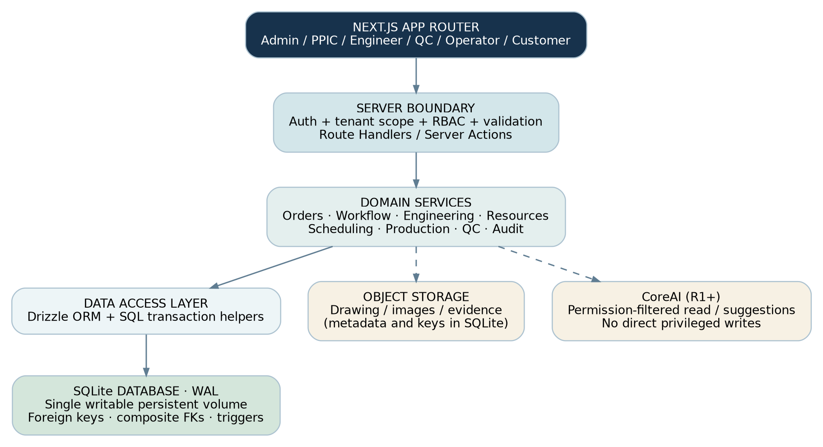
Target: discrete make-to-order, job-shop, dan custom manufacturing. Dokumen melengkapi CoreOS BRD v1, PRD v1, dan Feature Breakdown v1; bukan hasil database discovery terhadap codebase existing.
Design decision | Proposed choice
Prototype stack | Next.js (Node.js runtime) + TypeScript + Drizzle ORM + better-sqlite3
Database | SQLite file di persistent local volume; 1 writable app instance
Tenant model | Shared schema; tenant_id pada entitas operasional + scoped composite FKs
Schema size | 63 tabel target: 51 R0 / 11 R1 / 1 R2
Delivery strategy | Bangun vertical slice kecil dahulu; tabel R1/R2 disediakan sebagai reference DDL
Companion artifact | CoreOS_SQLite_Schema_v1.sql: runnable reference DDL, triggers, indexes

01 Scope, lifecycle, and architecture decisions
Tujuan database: menghasilkan satu sumber kebenaran atas komitmen customer, engineering release, workflow execution, technician eligibility, schedule reservations, shop-floor events, quality disposition, dan evidence. State operasional harus dapat ditelusuri dari customer order sampai delivery.

Architecture decision record (ADR)
ADR | Choice / rationale
ADR-01 · SQLite | Cocok untuk prototype local/single-server, migrasi mudah. Hindari multi-instance writer dan ephemeral filesystem.
ADR-02 · Next.js | App Router dengan server-only domain services dan Node.js runtime; mutasi dari Server Actions atau Route Handlers.
ADR-03 · Drizzle | Type-safe SQL schema, explicit migrations, SQL-first relationship semantics. File .sql adalah reference baseline.
ADR-04 · Tenancy | Global users dan tenants; tenant_id di semua tabel operasional; composite FK melindungi referensi antar-tenant.
ADR-05 · Immutable evidence | Production event, quantity ledger dan audit event append-only; koreksi melalui reversal atau event baru.
ADR-06 · Concurrency | Publish assignment + validate + reservations dalam BEGIN IMMEDIATE transaction; overlap trigger tetap menjadi backstop.
ADR-07 · Files | Drawing, foto QC dan evidence disimpan di object/disk storage yang diamankan, bukan BLOB SQLite.
ADR-08 · AI | R1+ hanya membaca data sesuai permission; rekomendasi dicatat, perubahan tetap lewat domain service dan approval.

Coverage by release
Release | Database state | Practical rollout
R0 · Operational MVP | 51 reference tables | Start with order→job→operation, skill/shift/assignment, event→QC, auth/audit; activate adjacent domains incrementally.
R1 · Connected | 11 additional tables | Customer portal, scheduling version, material reservation, shipment, genealogy, outbox, AI insight.
R2 · Intelligence | 1 additional table | Cost entry ledger; planning optimizer can initially operate on existing events and reservations.

Physical tables are not equal to backlog capabilities. 63 tables form a target reference schema, not a mandate to implement all UI features now.

02 System architecture & responsibility boundaries
Kriteria utama: business rules harus berada pada server-side domain layer. Client UI tidak pernah memilih tenant_id secara bebas untuk melewati authorization. Next.js server memperoleh tenant/facility scope dari authenticated membership.
- Presentation: role-specific Admin/PPIC/Engineer/QC/Technician/Customer pages; mobile-first shop-floor views.
- API boundary: authentication, tenant membership, facility policy, RBAC, request schema validation, correlation ID.
- Domain services: OrderService, WorkflowService, EngineeringService, EligibilityService, SchedulingService, ProductionService, QualityService.
- Persistence: Drizzle repository, parameterized queries, SQLite transactions, integrity constraints, migrations.
- External adapters: object storage, auth provider, messaging, ERP/HRIS sync (optional, beyond MVP).

Tenant isolation and access control
- Table milik tenant memiliki tenant_id TEXT NOT NULL; referensi tenant→child memakai FOREIGN KEY (tenant_id, child_id) ke UNIQUE (tenant_id, id) pada parent.
- Semua find/update/delete memfilter tenant_id dan site scope; resource creation derives tenant_id from trusted auth/session, bukan body request.
- Tabel users merupakan global identity. tenant_memberships, member_roles, dan customer_portal_users menentukan akses; customer portal queries harus dibatasi pada customer_id miliknya.
- Gunakan soft-delete hanya untuk master / transactional records yang diizinkan; audit dan event ledger tidak boleh dimodifikasi. SQLite tidak memiliki native PostgreSQL row-level security.
Composite FK melindungi tenant consistency, tetapi tidak otomatis menjamin izin per-role, facility, atau bahwa order_item milik order yang sama dengan job: semuanya tetap perlu divalidasi service.

03 Conceptual entity relationship diagram
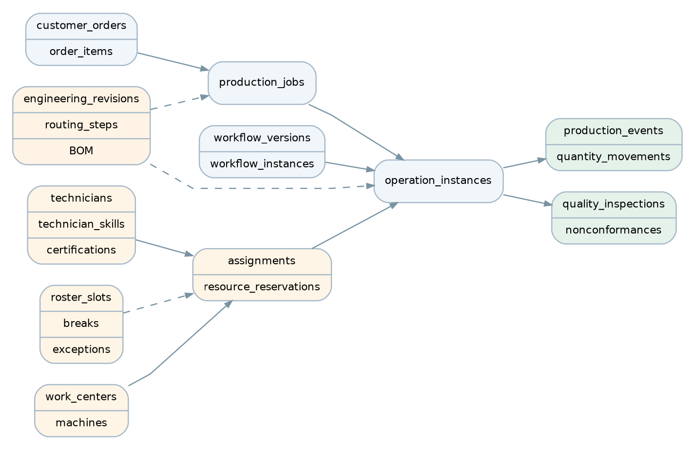
Relasi utama: customer_orders 1:N order_items 1:N production_jobs 1:1 workflow_instances 1:N operation_instances. Operation memiliki banyak production_events, quantity_movements, quality_inspections, dan assignments. Workflow version, engineering release, serta routing step dibekukan secara logis pada job yang dirilis.

Key cardinalities
Relationship | Cardinality | Invariant
Customer order → order items | 1 : N | Ordered qty > 0, immutable commercial changes via controlled revision.
Order item → jobs | 1 : N | Jumlah pekerjaan/shipments tidak boleh melampaui ordered+approved variation qty.
Job → workflow instance | 1 : 1 | Template version pinned after release.
Workflow instance → operations | 1 : N | Parallel dependency graph, explicit rework attempt.
Routing step → skill requirements | 1 : N | All mandatory skills/certifications met for published slots.
Operation → assignments | 1 : N | Confirmed exclusive resource reservations do not overlap.
Operation → production events | 1 : N | Idempotency key unique per tenant; append-only.
Operation → QC inspections | 1 : N | Good output not equal to QC accepted output.

04 SQLite physical conventions
Dimension | Rule
Primary IDs | TEXT IDs generated by app (UUIDv7/ULID). Avoid relying on SQLite rowid sequences as public IDs.
Dates and time | UTC ISO-8601 TEXT with fixed normalized format YYYY-MM-DDTHH:MM:SS.sssZ. Facility timezone stored separately.
Shift times | Local HH:mm stored in templates. Materialized roster slots/breaks stored as UTC intervals to handle overnight shifts.
Booleans | INTEGER 0/1 with CHECK. States TEXT with CHECK (enums managed by migrations).
Currency | INTEGER minor-unit amount with ISO currency code. Decimal calculation performed with explicit policy at service level.
Quantity | INTEGER per base unit in prototype. For kg/meters/etc. define fixed integer scaled units before real adoption.
JSON | TEXT with json_valid CHECK for bounded optional config/evidence; core relational fields remain normalized.
Timestamps | created_at populated by SQLite default UTC; updated_at/actor metadata updated by application.
Uniqueness | Tenant-scoped UNIQUE; soft-deleted records still occupy unique code unless partial-index policy defined.
FK / WAL | Enable PRAGMA foreign_keys=ON for every connection; WAL and busy_timeout for local durable file setup.

SQLite deployment constraints
- Deploy with a long-running Next.js Node.js instance and persistent mounted volume. Native better-sqlite3 does not run in Edge/Workers and is unsuitable for an ephemeral read-only/serverless file path.
- WAL supports concurrent readers with one active writer. Keep write transactions short; high write throughput / horizontally scaled workers → plan move to PostgreSQL.
- Use SQLite backup API or consistent snapshot strategy including WAL state; automate restore drill. Never assume copying only the .db file while writes are active yields a valid backup.
- Do not store large file binaries, model embeddings, or build artifacts in SQLite during prototype. Record pointers and checksums instead.

05 Physical schema catalog (all 63 tables)
R0 tables support the end-to-end MVP data model. R1/R2 are future-ready references and can remain absent from early application migrations. Domain descriptions below map to CoreOS PRD modules.

Platform — 13 tables
Table | Phase | Responsibility | Key domain columns
tenants | R0 | Tenant SaaS root. | slug, name, timezone
users | R0 | Global account identity; auth credentials handled by auth adapter. | email, display_name, account_status
facilities | R0 | Manufacturing site, timezone and operational policies. | code, name, timezone
tenant_memberships | R0 | User linked to tenant; optionally a specific facility. | user_id, facility_id
roles | R0 | Tenant-defined role catalog. | code, name, scope
permissions | R0 | Permission catalog per tenant. | code, description
role_permissions | R0 | RBAC permission grants. | role_id, permission_id
member_roles | R0 | RBAC roles attached to tenant membership. | membership_id, role_id
teams | R0 | Operational staff grouping. | facility_id, code, name
files | R0 | Metadata only; binary object outside SQLite. | storage_key, original_name, content_type, byte_size, sha256 ...
entity_attachments | R0 | File relation to typed business target; authorization enforced in API. | file_id, entity_type, entity_id, purpose
audit_events | R0 | Append-only critical business mutation record. | actor_user_id, entity_type, entity_id, action, event_at ...
notification_inbox | R0 | User-facing operational inbox. | user_id, title, body, subject_type, subject_id

Orders — 8 tables
Table | Phase | Responsibility | Key domain columns
customers | R0 | Business customer account. | code, name, email, phone
customer_orders | R0 | Commercial order and promised date. | facility_id, customer_id, order_no, requested_delivery_at, promised_delivery_at ...
order_items | R0 | Order line product and ordered quantity. | order_id, line_no, sku, description, ordered_qty ...
production_jobs | R0 | Executable job, often subset of order item quantity. | facility_id, order_item_id, job_no, target_qty, workflow_version_id ...
order_milestones | R0 | Internal and customer-visible milestones. | order_id, job_id, code, title, occurred_at ...
change_requests | R1 | Controlled order/engineering change and impact. | order_id, requested_by, reason, impact_json
shipments | R1 | Shipment and proof-of-delivery header. | order_id, shipment_no, delivered_at, proof_file_id
shipment_lines | R1 | Quantity delivered per order item. | shipment_id, order_item_id, quantity

Workflow — 7 tables
Table | Phase | Responsibility | Key domain columns
workflow_templates | R0 | Human-friendly template identity. | code, name, description
workflow_versions | R0 | Immutable published revision of a template. | template_id, version_no, published_at, published_by
workflow_nodes | R0 | Node in a workflow version. | workflow_version_id, node_key, label, node_type, sort_order ...
workflow_edges | R0 | Directed prerequisite between nodes. Cycles rejected in service. | workflow_version_id, from_node_id, to_node_id
workflow_instances | R0 | Single pinned workflow version running for one job. | job_id, workflow_version_id
operation_instances | R0 | Execution unit instantiated from a workflow node. | workflow_instance_id, node_id, routing_step_id, operation_no, target_qty ...
approval_requests | R0 | Controlled approval gate (including QC/engineering). | subject_type, subject_id, approver_id, decision_at, decision_reason ...

Engineering — 7 tables
Table | Phase | Responsibility | Key domain columns
engineering_documents | R0 | Engineering document family by order item. | order_item_id, doc_no, title, document_type
engineering_revisions | R0 | Released/draft immutable revision metadata. | document_id, revision_code, file_id, checksum_sha256, released_by ...
routing_versions | R0 | Released process routing for item/job. | order_item_id, version_no, released_at
routing_steps | R0 | Planned operations, time and work center. | routing_version_id, step_no, name, work_center_id, estimated_minutes ...
operation_skill_requirements | R0 | Hard skill and optional required certification for operation. | routing_step_id, skill_id, min_level, certification_type_id
bills_of_material | R0 | Bill of materials version associated with item. | order_item_id, version_no
bom_lines | R0 | Material per BOM, integer base unit in prototype. | bom_id, material_id, qty_per_unit, operation_step_id

Materials — 4 tables
Table | Phase | Responsibility | Key domain columns
materials | R0 | Material catalog; inventory ERP remains external. | code, name, base_uom
material_requirements | R0 | Material demand per production job or operation. | job_id, operation_id, material_id, required_qty, ready_qty
material_issues | R0 | Shortage, delay and production blocker. | job_id, operation_id, material_id, reason, owner_user_id ...
material_reservations | R1 | Reservations against material requirement. | requirement_id, quantity

People & Resources — 11 tables
Table | Phase | Responsibility | Key domain columns
technicians | R0 | Technician profile linked to user optionally. | facility_id, user_id, team_id, employee_code, full_name
skills | R0 | Tenant skill catalog. | code, name, category
technician_skills | R0 | Supervisor-verified skill capability, with validity window. | technician_id, skill_id, claimed_level, verified_level, verification_status ...
certification_types | R0 | Required certification / authorization type. | code, name, mandatory
technician_certifications | R0 | Actual certification/authorization and expiry. | technician_id, certification_type_id, credential_no, valid_from, valid_until ...
work_centers | R0 | Plant station/work center. | facility_id, code, name
machines | R0 | Machine and exclusive capacity in MVP. | work_center_id, code, name, capacity
shift_templates | R0 | Reusable roster definition with local times. | facility_id, name, local_start, local_end, crosses_midnight
roster_slots | R0 | Published technician availability intervals in UTC. | technician_id, shift_template_id, start_at, end_at
roster_breaks | R0 | Non-working intervals within roster slot. | roster_slot_id, start_at, end_at
calendar_exceptions | R0 | Leave, training, holiday and machine outage intervals. | technician_id, machine_id, start_at, end_at, kind ...

Scheduling — 3 tables
Table | Phase | Responsibility | Key domain columns
assignments | R0 | Planned technician operation work slot. | operation_id, technician_id, machine_id, start_at, end_at ...
resource_reservations | R0 | Committed exclusive person or machine block. | assignment_id, technician_id, machine_id, start_at, end_at
schedule_versions | R1 | Revision and publication of production plans. | facility_id, version_no, published_at, published_by

Shop Floor — 2 tables
Table | Phase | Responsibility | Key domain columns
production_events | R0 | Append-only operator action and idempotency anchor. | operation_id, actor_user_id, event_type, event_at, idempotency_key ...
quantity_movements | R0 | Append-only quantity ledger; QC accepted is a separate process. | operation_id, production_event_id, movement_type, quantity, reverses_movement_id ...

Quality — 4 tables
Table | Phase | Responsibility | Key domain columns
quality_inspections | R0 | QC batch/operation acceptance disposition. | operation_id, inspector_user_id, inspected_qty, accepted_qty, rejected_qty ...
nonconformances | R1 | NCR, corrective action and reinspection record. | inspection_id, ncr_no, severity, description, rework_operation_id
lot_batches | R1 | Batch or lot identity. | job_id, lot_no, quantity
lot_genealogy | R1 | Trace predecessor/consumed batches. | parent_lot_id, child_lot_id, quantity

Customer Portal — 1 tables
Table | Phase | Responsibility | Key domain columns
customer_portal_users | R1 | External user/customer access mapping. | user_id, customer_id

Integration — 1 tables
Table | Phase | Responsibility | Key domain columns
outbox_events | R1 | Transactional outbox for integration events. | aggregate_type, aggregate_id, event_type, payload_json, attempts

CoreAI — 1 tables
Table | Phase | Responsibility | Key domain columns
ai_insights | R1 | Read-only grounded AI insight with source and model metadata. | subject_type, subject_id, kind, summary, evidence_json ...

Cost Intelligence — 1 tables
Table | Phase | Responsibility | Key domain columns
job_cost_entries | R2 | Cost ledger by production job and category. | job_id, category, entry_type, amount_minor, currency

06 Critical data dictionary & business rules
Setiap tabel dalam companion SQL menyediakan definisi seluruh field dan index. Bagian ini menguraikan field yang paling penting untuk implementasi modul inti; bukan pengganti schema.sql.

customer_orders
Fields order_no, facility_id, customer_id, status, requested_delivery_at, promised_delivery_at
Rule Only confirmed date is a promise; customer-visible dates controlled separately.

order_items
Fields order_id, line_no, ordered_qty, uom
Rule Line quantity > 0; fulfillment tied to accepted and shipped balances.

production_jobs
Fields order_item_id, target_qty, workflow_version_id, engineering_revision_id, state
Rule Released job pins workflow and engineering revision; enforce approved split totals.

workflow_versions
Fields template_id, version_no, status, published_at
Rule Published workflow cannot be edited in-place; new version required.

workflow_edges
Fields workflow_version_id, from_node_id, to_node_id
Rule Validate same workflow version, reachable nodes, acyclic R0 graph.

operation_instances
Fields workflow_instance_id, node_id, target_qty, attempt_no, row_version
Rule Operation status independent of QC; support controlled rework via attempts.

technicians
Fields facility_id, user_id, employee_code, status
Rule Inactive technician is not assignable; person identity distinct from login.

technician_skills
Fields technician_id, skill_id, verified_level, verification_status, valid_until
Rule Only verified and valid skill level is eligible; claimed_level never authorizes.

technician_certifications
Fields technician_id, certification_type_id, valid_from, valid_until, status
Rule Required cert must remain active over full proposed assignment interval.

roster_slots
Fields technician_id, start_at, end_at, state
Rule Only published slots count as available; exclude breaks/exceptions.

calendar_exceptions
Fields technician_id/machine_id, kind, approval_state, start_at, end_at
Rule Approved leave/maintenance blocks scheduling; draft status not silently ignored.

assignments
Fields operation_id, technician_id, machine_id, start_at, end_at, status
Rule Versioned planning lifecycle; publish is atomic with reservations.

resource_reservations
Fields assignment_id, technician_id OR machine_id, interval, status
Rule Overlap DB trigger rejects concurrent confirmed reservations.

production_events
Fields operation_id, event_type, event_at, idempotency_key, payload_json
Rule Append-only action record and offline retry safety.

quantity_movements
Fields operation_id, production_event_id, movement_type, quantity
Rule Append-only positive delta ledger; correction via reversal linkage.

quality_inspections
Fields operation_id, inspected_qty, accepted_qty, rejected_qty, rework_qty
Rule Accepted + rejected + rework <= inspected; avoid double count between attempts.

audit_events
Fields actor_user_id, entity_type, entity_id, action, before_json, after_json
Rule Append-only high-value mutation evidence, no normal UPDATE/DELETE.

07 Scheduling, capability & concurrency design

Eligibility is not an AI judgment
A candidate technician is eligible only when EVERY mandatory condition holds. Order of evaluation matters: eligibility filters first; ranking/optimization second.
- Technician is ACTIVE and belongs to authorized tenant and relevant facility.
- For each operation_skill_requirements row: technician_skills.verification_status=VERIFIED, verified_level >= min_level, and validity covers entire assignment.
- Every required technician_certifications record is ACTIVE and valid_from <= slot start AND valid_until >= slot end.
- Operation is READY with released engineering documents, valid workflow prerequisites and material readiness.
- Slot is fully covered by PUBLISHED roster availability, excluding roster_breaks and APPROVED calendar_exceptions.
- Machine belongs to suitable work center, state AVAILABLE, and exclusive capacity is not booked.
- Requested interval is conflict-free and site/facility matching rules pass.

Publish transaction algorithm
- BEGIN IMMEDIATE to acquire SQLite write reservation early; load consistent latest entity versions.
- Validate tenant and RBAC, operation state/row_version, skills, certifications, roster, breaks, absence, machine and dependencies.
- Create/update assignment as PUBLISHED, insert two CONFIRMED resource_reservations (technician + machine when applicable).
- Overlap triggers enforce non-overlap as database backstop; any failure aborts whole transaction.
- Insert audit_events and optional outbox_events, then COMMIT; publish notifications after commit.
BEGIN IMMEDIATE;
-- validate eligibility with parameterized queries on the same connection
-- create assignment + confirmed person/machine reservations + audit
COMMIT; -- if anything fails: ROLLBACK;
Triggers protect exclusive resource intervals, not shift/cert validity, capacity >1, route consistency or timezone normalization. These remain server-side validation requirements. No LLM override.

Overlap predicate
existing.start_at < candidate.end_at
AND candidate.start_at < existing.end_at
Interval semantics: [start_at, end_at), so one job ending at 12:00 and another starting at 12:00 do not overlap. All stored timestamps must use the exact same UTC ISO string format to ensure lexical ordering.

08 Workflow versions, manufacturing history & quality

Released lifecycle controls
- A workflow_template can have multiple workflow_versions. New production_jobs select one published version and instantiate workflow_instances + operation_instances.
- engineering_documents and engineering_revisions separate logical document from immutable released revision. Released jobs keep engineering_revision_id until controlled change approval.
- Business service must block UPDATE to published workflow definition or released drawing; companion SQL does not yet implement immutable-release triggers for those mutable draft/released tables.
- workflow_edges are a directed acyclic graph for normal execution. Rework uses attempt_no and rework_of_operation_id rather than silently mutating past output.

Quantity and QC accounting
Production events record what operator reported. quantity_movements hold immutable GOOD/REJECT/REWORK (plus reversing entries). quality_inspections record independent dispositions. Shipping must not exceed accepted balances. Never derive fulfillment by counting Kanban cards.
Measure | Definition / source
Reported good | Net eligible GOOD ledger movements, adjusted for explicit reversals.
QC accepted | Sum accepted inspection disposition with reconciliation across attempts/batches.
QC rejected / rework | Distinct reject/rework outputs and NCR reason; do not add as delivered.
Delivered | Shipment lines plus controlled release/evidence; must be <= accepted product balance.
Lead time | Operation start/complete and versioned schedule with explicit downtime distinctions.

09 Index strategy & example read patterns
Index prefixes start with tenant_id. Additional composite indexes focus on high-frequency filters. Always check EXPLAIN QUERY PLAN on representative pilot data rather than indexing every column.
Query | Primary indexes / joining keys
Order list by customer & status | customer_orders(tenant_id, customer_id, status); UNIQUE order_no
Operations by job/workflow state | operation_instances(tenant_id, workflow_instance_id, state)
Skill eligibility | technician_skills unique (tenant_id, technician_id, skill_id); certificates by technician/expiry
Technician calendar | roster_slots(tenant_id, technician_id, start_at, end_at)
Detect resource overlap | resource_reservations by tenant/person/time or tenant/machine/time
Operation event timeline | production_events(tenant_id, operation_id, event_at)
Quantity and QC | quantity_movements(tenant_id, operation_id, movement_type); inspection operation/state
Customer portal | customer_portal_users unique mapping; order milestones by order, customer_visible

10 Next.js prototype implementation guide

Recommended stack
Layer | Recommendation
Frontend / Backend | Next.js App Router + TypeScript; API via Route Handlers, trusted Server Actions for web mutations.
Database + ORM | SQLite file (single Node.js instance) + Drizzle ORM + better-sqlite3.
Validation | Zod / equivalent at API input boundary; domain invariants in service functions.
Authentication | Dedicated auth adapter; do not implement passwords in CoreOS tables directly.
Storage | Local protected path in development; object storage preferred for shared deployment files.
Local CI | Apply migrations to temp SQLite, run PRAGMA foreign_key_check and deterministic race / rollback tests.

Suggested project layout
src/app/(admin)/... admin, PPIC, engineering, quality, tenant settings
src/app/(workstation)/... mobile-first operator experience
src/app/(portal)/... customer portal
src/app/api/... route handlers / integration webhooks
src/db/client.ts connection, pragmas, singleton, migrations
src/db/schema/{platform,orders,workflow,engineering,people,planning,production,quality}.ts
src/modules/{orders,planning,...}/ service, repository, validators, DTO, policies
src/lib/auth/ authenticated tenant/site context & guards
drizzle/ source-controlled SQL migrations
scripts/seed.ts sample tenant, workflow, engineer, PPIC, technician
data/coreos.sqlite ignored persistent data file (never commit)

Bootstrap commands and connection
pnpm add drizzle-orm better-sqlite3
pnpm add -D drizzle-kit @types/better-sqlite3
mkdir -p data && sqlite3 data/coreos.sqlite < CoreOS_SQLite_Schema_v1.sql
const sqlite = new Database(process.env.SQLITE_PATH ?? "data/coreos.sqlite");
sqlite.pragma("foreign_keys = ON"); sqlite.pragma("journal_mode = WAL");
sqlite.pragma("busy_timeout = 5000");
export const db = drizzle({ client: sqlite }); // server-only Node.js
Untuk implementasi sungguhan, definisikan schema Drizzle sebagai sumber migrasi; jalankan `drizzle-kit generate` dan `drizzle-kit migrate` dalam CI/deployment. Jangan menggabungkan schema.sql reference dengan migrasi Drizzle pada database yang sama tanpa baseline reconciliation.

Prototype vertical slice (first build)
- Slice A: tenants, users, memberships/roles, facilities, customers, orders, order_items, jobs.
- Slice B: workflow templates/versions/nodes/edges, workflow instance/operations, engineering release/routing.
- Slice C: technicians, verified skills, certifications, shifts/roster, machines/work centers, assignment/reservations.
- Slice D: production events + quantity ledger, QC inspection, audit, minimal customer-visible milestone.
Bootstrap should be staged into domain migrations rather than one giant UI delivery. Database target schema currently defines 63 tables; not every table is required for the first demo.

11 Database safety, backup & operational policies
Concern | Policy
Integrity | foreign_keys ON per connection; validation checks and composite FKs; PRAGMA foreign_key_check during CI.
Concurrent writers | WAL for read/write usability, but one active writer; BEGIN IMMEDIATE for scheduling commits.
Backup | Daily copy using SQLite backup API / controlled consistent snapshot; store securely, verify restore.
Migration | Versioned migration files reviewed and applied once, not at every user request.
Soft delete | No hard-delete on operational records except explicitly documented retention policies.
Audit | Append-only events; authorization checks before reading histories or attachments.
Secrets | Database file, env secrets, and object storage private; do not expose from public/static path.
Data isolation | Negative tests across tenant and customer portal; do not trust route-level UI restrictions.
Performance | Monitor query plans, write contention, DB/WAL growth, and event table indexes.

12 Migration path: SQLite → PostgreSQL
- Retain domain DTOs, service invariants, tenancy filters, and repository interfaces; implement PostgreSQL adapters with migration tests.
- Re-map UTC TEXT to timestamptz, BOOLEAN to boolean, JSON TEXT to jsonb, status CHECK to enum/CHECK per governance.
- Keep ULID/UUID text IDs initially for compatibility; optionally migrate to native uuid if IDs follow UUID format.
- Recreate overlap guard using PostgreSQL exclusion constraints (e.g., appropriate range/index extensions) or serializable booking policy; re-test concurrent planners.
- Move background integrations and heavy AI analytics to queues/workers, while keeping authoritative writes transactional.
- Conduct two-pass data migration: bulk copy + reconciliation, cutover read-only window, counts, FK checks and business invariant audits.

Triggers for moving away from SQLite
Expect a PostgreSQL move when needing multi-instance writes, geographically distributed application servers, high sustained write concurrency, complex analytical queries, extensive integrations, or database HA/managed backup/SLA requirements. Data volume alone is not the only deciding factor.

13 Test matrix & risks
ID | Acceptance scenario | Enforced where
DB-01 | Tenant T1 references facility/customer belonging to T2 → reject | Composite FK + service scope
DB-02 | Publish concurrent bookings for same technician overlapping → at most one confirmed | Transaction + overlap trigger
DB-03 | Certificate expires before assignment ends → cannot publish | Scheduling eligibility service
DB-04 | Shift excludes break 12:00–13:00 → no assignment occupancy during break | Scheduling eligibility service
DB-05 | Edit/delete production event → rejected; correction requires new event | Append-only trigger + service
DB-06 | Offline same idempotency key replay → no second event | Unique (tenant,idempotency_key)
DB-07 | QC accepted+rejected+rework exceeds inspected → reject | SQLite CHECK + reconciliation service
DB-08 | Unreleased drawing or workflow → job release blocked | Engineering/workflow service
DB-09 | Customer guesses unrelated order ID → no portal data returned | Auth/tenant/customer policy
DB-10 | Simultaneous two updates of operation version → one fails, retry expected | Optimistic row_version CAS / service
DB-11 | SQLite file recovered from backup → integrity and business reconciliation pass | Ops restore drill
DB-12 | Cross-release revision changes leave historical job version unchanged | Workflow / engineering service

Companion SQL tested on local SQLite in-memory engine: table creation, PRAGMA integrity_check, cross-tenant composite FK, confirmed-reservation overlap trigger, append-only production_events, and QC quantity bound. This is structural smoke testing, not an end-to-end certified manufacturing system.

Open decisions before pilot
- Tracking grain: order item vs production batch vs individual serialized unit for each target industry.
- Whether operator/machine assignment is exclusive or shared-capacity, and whether machine booking can cross facilities.
- Material base unit/precision and unit conversion requirements (pcs, kg, length, volume).
- Shift break policy for overnight shift and DST-aware facility timezones.
- Who can approve qualifications and whether certifications are legal/mandatory under specific site policies.
- Actual database hosting target: local dev vs self-hosted VPS with persistent disk; never assume serverless SQLite is durable.
- Retention, customer portal data sharing, and future integration ownership.

14 Primary references
- SQLite Foreign Keys — https://www.sqlite.org/foreignkeys.html
- SQLite PRAGMAs — https://www.sqlite.org/pragma.html
- SQLite WAL — https://www.sqlite.org/wal.html
- SQLite CREATE TRIGGER — https://www.sqlite.org/lang_createtrigger.html
- Drizzle SQLite Get Started — https://orm.drizzle.team/docs/sqlite/get-started-sqlite
- Next.js Route Segment Runtime — https://nextjs.org/docs/app/api-reference/file-conventions/route-segment-config
- CoreOS BRD v1 / CoreOS PRD v1 / CoreOS Feature Breakdown v1 (project inputs)

