6.
The numerical experiments have been carried out using the computational nodes of Lobachevskii supercomputer at Nizhnii Novgorod State University. The peak performance of the cluster was 573 Tflops, each computational node of the supercomputer was equipped with Intel Sandy Bridge E5-2660 processor 2.2 GHz, 64 Gb RAM. Within the framework of the present study, the construction of a numerical approximation (PDA) of the Pareto domain (PD) was understood as a solution of a MCO problem. In order to evaluate the efficiency of constructing the PDA, two main indicators applied widely were used: the completeness of coverage of the Pareto domain (hypervolume index, HV) and the uniformity of distribution of the numerical estimates of the effective decisions (distribution uniformity index, DU) [15,23,25]. The higher values of the index HV and the lower values of the index DU corresponds to the better approximation. A comparison of the AGCO algorithm with several other multicriterial optimization methods, among which there were the Monte-Carlo method, the generalized SEMO algorithm from the PISA library [22], the non-uniform coverage (NUC) method [23], and the bi-criterial Lipschitz optimization (BLO) algorithm [24] was performed in [15]. To compare the methods, the bi-criterial problem of the multicriterial optimization [23] was used:
, | ()
For the AGCO algorithm, the min-max convolution of the criteria (11) was used. For the AGCO algorithms, total subproblems (11) for the problem (28) were solved for various values of the convolution coefficient .
The results of the numerical experiments are presented in Table 1. The column “Iters” of Table 1 contains the total number of iterations (the number of computations of the criteria values) required for solving the problem (28). The column “PDA” shows the number of the effective decisions in the PDA obtained.
Table 1. The results of numerical experiments on comparing the MCO methods
by solving the test problem (28)
Method | Iters | PDA | HV | DU
MC | 500 | 67 | 0.300 | 1.277
SEMO | 500 | 104 | 0.312 | 1.116
NUC | 515 | 29 | 0.306 | 0.210
BLO | 498 | 68 | 0.308 | 0.175
AGCO | 390 | 90 | 0.317 | 0.094
As one can note, the results of experiments demonstrated a definite advantage of the AGCO algorithm as compared to other methods of solving the MCO problems.
For the conducting of the next experiments, the two-dimensional bi-criterial MCO problems were used, the criteria of which were defined with the use of the family of multiextremal functions [16] used widely in the evaluation of efficiency of the optimization methods. The functions of this family are defined by the following relations:
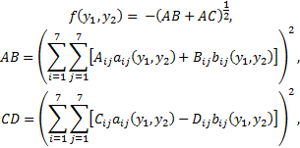 | (29)
where the expressions
,
are defined inside the area , and the parameters are the independent random numbers distributed uniformly in the interval specified above.
In the initial series of the numerical experiments, the evaluation of the positive effect (the reducing of the number of the global search iterations executed) due to the reuse of the search information obtained in the course of computations (see Section 4) was performed. When conducting the experiments, the AGCO algorithm was applied sequentially with all scalarization methods considered in Section 3: the min-max convolution of the criteria (11), the method of successive concessions (12), and the reference point method (13). For each method listed above, 50 subproblems with various values of the parameters , , and correspondingly have been solved. In order to evaluate the indicator HV of the completeness of the PDA approximation, the reference point (-4,-4) was used. For the AGCO algorithms, the reliability parameter was used; the accuracy in the stopping condition (27) was set as .
The results of performed experiments are presented in Table 2. In the first part of the table (columns 2-5), the results of solving all subproblems without the use of the search information are shown. In the second part (columns 6-9) the results of solving the same subproblems but with the use of the whole search information obtained in the course of computations (i. e. when solving every next subproblem, the search information obtained when solving all preceding subproblems was utilized) are presented. In the column “S”, the speedup obtained as a result of reducing the number of the global search iteration (the number of the criteria values computed) required to solve all 50 subproblems due to the reuse of the search information is shown.
The results of experiments presented in Table 2 demonstrate the reduction of the number of the executed iterations of the AGCO algorithm more than 9 times. At that, the indicator HV takes almost the same values independently on the usage of the search information. However, the indicator DU was better notably (except the method of successive concessions) at the computations without the use of the search information (similar note can be expressed on the number of effective decisions in the PDA as well) – most likely, this effect is manifested due to essentially less number of the executed iterations when using the search information. One can note also that the reference point method has some advantage in the efficiency indicators (the number of points in PDA, indicators HV and DU). However, this method inferior the use of the min-max convolutions in the number of iterations required to solve all 50 subproblems essentially.
Table 2. Efficiency of the reuse of the search information
in solving the problem (29) using various criteria scalarization methods
Search  information | Not used |  |  |  | Used |  |  |  | S
Scalarization  method | Iters | PDA | HV | DU | Iters | PDA | HV | DU | S
Min-max convolution (11) | 9124 | 152 | 53.4 | 0.64 | 922 | 44 | 52.7 | 0.91 | 9.9
Method of successive concessions (12) | 12802 | 88 | 52.8 | 1.16 | 1402 | 40 | 52.4 | 1.09 | 9.1
Reference point method (13) | 12881 | 240 | 53.6 | 0.51 | 1323 | 56 | 53.0 | 0.83 | 9.7

The Pareto domain approximations PDA obtained with the reuse of the search information using various criteria scalarization methods are shown in Fig. 1.
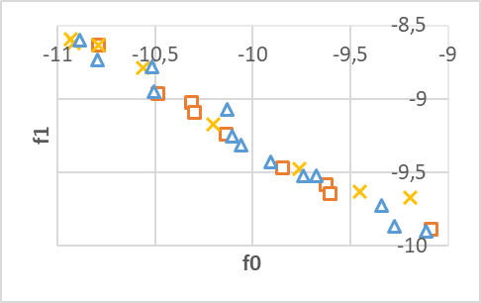
Fig. 1. Pareto domain approximations (PDA) obtained by solving a test MCO problem using various criteria scalarization methods.
In the final experiment, solving a test MCO problem has been conducted when applied criteria scalarization methods altered in the course of computations with a complete use of the whole search information. In this experiment, at the first stage of computations, the min-max criteria convolution was used in solving three subproblems (11) with the convolution coefficients (1,0), (0.5,0.5), and (0,1), correspondingly. At the second stage, the scalarization method was changed to the reference point method (13), where the estimate (-14,-7) was used as the reference point with the weighting coefficients vector (0.5,0.5). And finally, at the third stage, the method of successive concessions (12) was applied with the concession with respect to the first criterion .
The results of performed experiments are presented in Table 3. The column “Total iters” contains the total number of executed global search iterations whereas the column “New iters” shows the points of iterations executed at particular stage of solving the test MCO problem only. As follows from the results presented in Table 3, the number of the global search iterations executed at separate stages of solving the MCO problem reduced continuously (from 304 down to 35), and the reuse of the search information provides the opportunity of dynamic altering the criteria scalarization methods applied in the course of computations efficiently.
Table 3. Results of solving the problem (29) with altering the criteria scalarization methods in the course of computations
Stage of computations  criteria scalarization method | Total iters | New iters | PDA
1. Min-max criteria convolution (11), three subproblems | 304 | 304 | 14
2. Reference point method (13) | 402 | 98 | 19
3. Method of successive concessions (12) | 437 | 35 | 24

The approximations of Pareto set PDA obtained at the sequentially completed stages of computations are shown in Fig. 2.

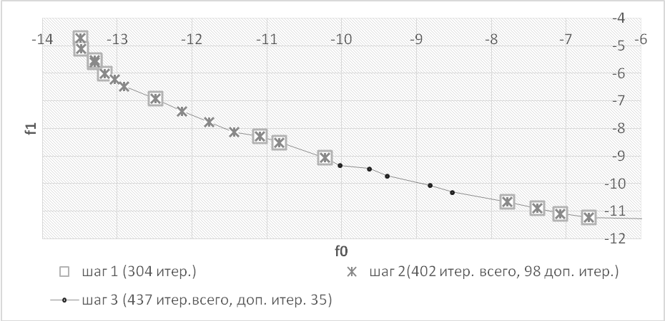
Fig. 2. Approximations of the Pareto set PDA obtained at the sequentially completed stages of computations

