The cloud part of our solution is compounded by a set of different services. The implementation of these services follows the next process:

1. Receives all the MQTT messages from the users (through the bridge brokers) in the central broker.
2. The central broker will persist the messages in a SQL database (for example MYSQL)
3. The dashboard will make queries in the database and fill the dashboard.

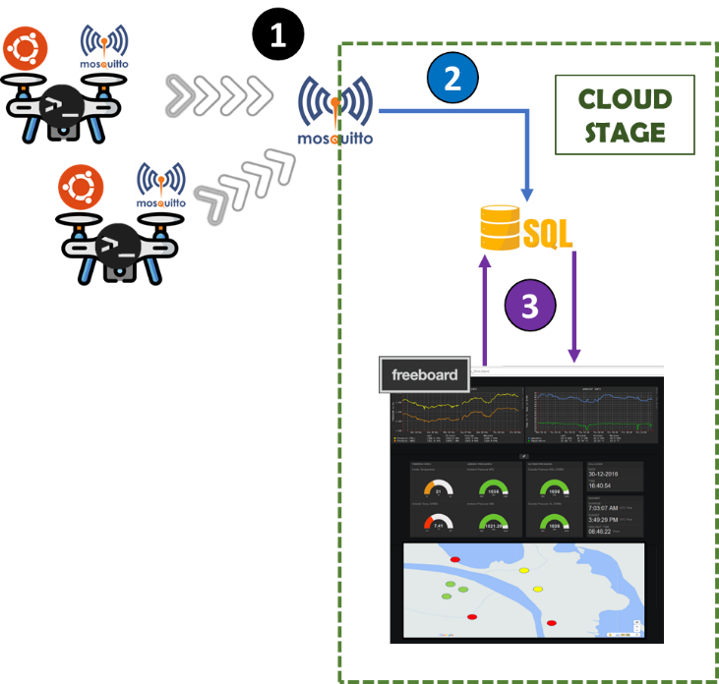

The dashboard supports the rescue team to identify and prioritize which actions is required to support the victims of a disaster. The dashboard will make queries to the database (data source) and process the answer to present the information in a more useful format.

As we told before, the users will publish messages where its content is the id, severity, and geo-location. The **severity (SEV)** is used to calculate the risk, where the **risk has three levels**: **low, middle, or high**, where the equation to calculate is presented below.

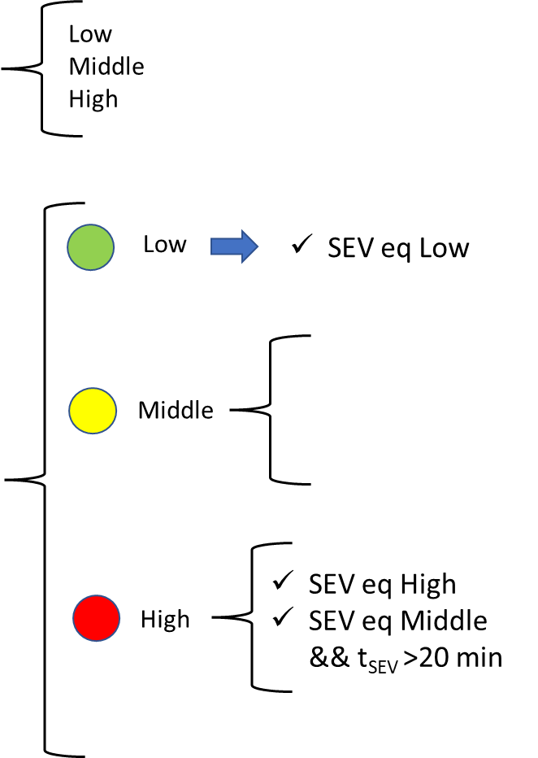

The dashboard application needs to implement the minimum requirement:

* A dynamic map where you identify the node positions, and they are colored by the risk situation.
* A dynamic map where you identify the node positions, and they are colored by the severity situation.
* A bar chart shows the number of nodes classified by risk.
* A bar chart shows the number of nodes classified by severity.

There is two good opensource options to create a dashboard application: Freeboard.io and Grafana. The two solution has a cloud and premise version (our suggestion is to install the premise version, that does not have any restriction). The main difference is that Freeboard requires a JSON data source, making require to transform the SQL answers to this format. For the other side, Grafana, has a plugin to a MYSQL data source.

About Freeboard.io

* The main page of Freboard.io is [HERE]( https://freeboard.io/).
* The freeboard git repository is [HERE](https://github.com/Freeboard/freeboard).
* A simplistic tutorial about how to install the Freeboard.io in Ubuntu machine is [HERE]( https://installati.one/ubuntu/21.04/freeboard/).
* A nice tutorial how to add a data source is [HERE]( https://rafaelaroca.wordpress.com/2021/07/31/adding-data-sources-to-freeboard-is-easy/).

About Grafana

* The main page of Grafana is [HERE]( https://grafana.com/).
* A complete tutorial about the foundations of Grafana is:
  + [HERE](<https://grafana.com/tutorials/grafana-fundamentals-cloud/>)
  + [HERE](https://www.sentinelone.com/blog/grafana-tutorial-detailed-guide-dashboard/)
* Good tutorials about how to configure a data source MYSQL in Grafana:
  + [Create MySQL Data Source, Collector and Dashboard](<https://sbcode.net/grafana/create-mysql-data-source/>)
  + [Create a Custom MySQL Time Series Query](<https://sbcode.net/grafana/custom-mysql_time_series_query/>)
  + [Graphing Non Time Series SQL Data in Grafana](<https://sbcode.net/grafana/graph-non-timeseries-sql/>)
  + [Using MYSQL to create a Grafana Dashboard – Video]( <https://www.youtube.com/watch?v=aUq85rp7yQU>)