**Document Contents:**

**Standard Features**

* Version Control
* Document Tagging or Metadata Capture
* User Roles and Security
* Searching
* Audit Logging and Tracking
* Document viewers
* Document Linking
* Calendar
* Mobile Access
* Document Scanning and Imaging
* Virtual Folders
* Work Offline
* Optical Character Recognition (OCR) and Indexing
* Matter Centric Filing (Auto Tagging)
* Email
* Reporting and document Compliance

**Optional Features**

* Workflow
* Fast Find
* Print Files tool
* Electronic signature
* Custom Document Naming and Number Sequencing
* Anonymous Portal
* Automatic Document Importation
* Web Cap
* Language Localization
* Rebranding

**Document Scanning and Imaging**

* Smart Soft Capture

**Standard Features**

The Software delivers essential, document, records and workflow management.  Following is a brief description of the many standard features that come with the software:

* 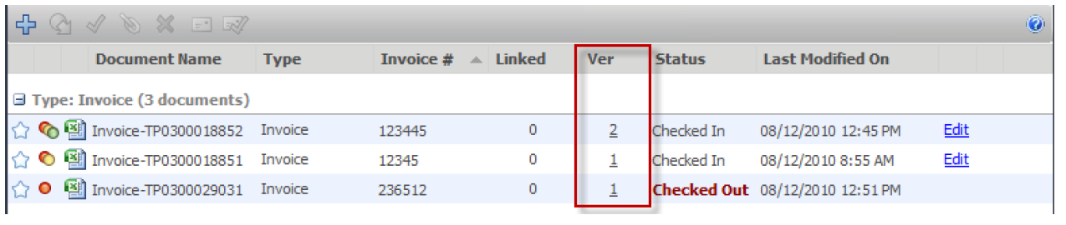**Version Control -** Document version control software provides: check in / checkout ability preventing documents from being overwritten or deleted as documents are updated by more than one party. The document management system retains a unique copy of each version of each file as it is checked out and back into the Library. When a document is checked in and changes have been made, System automatically creates a new version of the document.
* **Document "Tagging" or Metadata Capture -** Capturing metadata or "tagging" (key data about the document) is the key to successful search and document organization. The software has easy to use controlled document tagging insuring documents are classified. Tags associated with documents to help users to compare and retrieve documents without opening the actual file. Defining a document tagging or metadata vocabulary requires an understanding of different types of documents the company needs to manage and the essential information associated with each document type. The task of managing a tagging vocabulary is usually the Document Librarian or Library Administrator (in larger organizations) or business/ department managers in smaller companies. For example, many financial departments use system to track invoices, purchase orders and checks. Each one of these document types has a unique tagging profile associated with it. An Invoice document profile may contain invoice amount, invoice date, product name(s) and customer name.

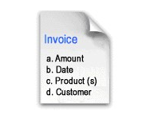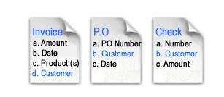

* **User Roles and Security –**The System ships with a choice out of 11 different user security roles ranging from "read only" to "System Administration" to provide an appropriate level of user access permissions for workers at all levels.  Users see only documents that administrators want them to see.

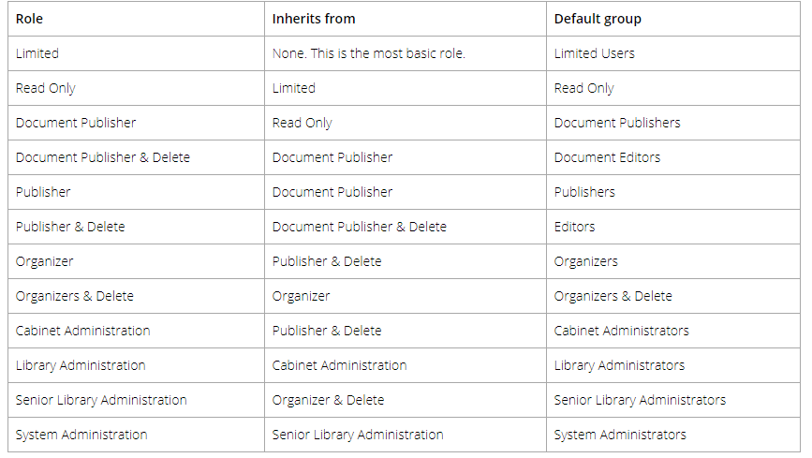

|  |  |
| --- | --- |
| **Role** | **Description** |
| Limited | A user assigned to a group with a “limited” role has restricted access to the  system. Users can only get a copy or view documents in the library.  Groups assigned to a “limited” role are used for when multiple people can  share the same username and password to log into system to see the  same documents in the library. For example, documents such as  newsletters, forms, or corporate policies may need to be accessible to all  company employees but they do not require a full registered user license  and full functionality. |
| Read Only | A Read-Only user role may only download or open and read documents. They cannot edit, delete, or create documents. They can email documents if given this functionality by system administrators. Read-only users may be restricted from downloading or printing documents. Read-only users can participate in workflows but cannot initiate workflows. |
| Document Publisher | Document Publisher user role can read, get a copy, add, check-in/check-  out, edit documents, and metadata. They can move documents that are  owned by them. They cannot delete any documents including those which  they have added to the system.  Document publishers can initiate workflows, participate in workflows, and  initiate Courier transmissions. |
| Document  Publisher +  Delete | Document Publisher Plus Delete user role can do everything a Document  Publisher can do and delete their own documents. They must be the owner  of the document in order to delete it. To see the owner of a document, you  can look at the version properties in the metadata pane. |
| Publisher | Publisher user role can do everything a Document Publisher can do plus:  • Create new folders and folder groups.  • Copy or move folders that they have already created.  • Clone folders and folder groups created by other users and become the  owners of the folders / folder groups.  • Publishers cannot delete existing documents, folders or folder groups  including those which they have added /created. All documents and folders  created by the Publisher will be owned by them and they cannot change  the ownership. |
| Publisher  + Delete | Publisher plus Delete user role can do everything that a Publisher can do  plus delete documents, folders and folders group owned (created) by them. |
| Organizer | The Organizer role is for users who are responsible for organizing  documents that are scanned or imported into the system or who are  assigned to organize documents added by other users. For example,  organizers would move the documents generated by scanner operators to  their correct folder in the library. Only trusted personnel should be given this  role. Organizer role user can:  • Move all documents (which they have an access to) in other places in the  library including documents which they do not own. In other words, they  can move documents that are owned by other users.  • Move, copy or clone all folders and folder groups regardless of them  ownership. In case of cloning they will become the owners of folder / folder  groups. In case of copying and moving the original ownership of folders /  folder groups are preserved.  • Change folder properties regardless of ownership.  • Add folders / folder groups (in which case they will become their owners)  and rename folders and folder groups.  • Delete documents that they own.  • Change document owner regardless of ownership  • Convert offline documents to electronic documents  • Export documents |
| Organizer  + Delete | Organizer plus Delete role can do everything that Organizers can do plus  delete all documents, folders and folder groups regardless of them  ownership. This organizer and delete role can only do this within Cabinets,  Folders and Schemas that they are a member of.  This role should be used by trusted personnel only. |
| Cabinet  Administration | Cabinet Administrators can only administer the cabinets that they own; they  cannot create cabinets for themselves. They can:  • Create, edit, and delete drawers, folder groups and folders and manage  their properties (i.e. membership structure).  • Access all documents (in Publisher and Delete capacity) from anywhere in  the library structure unless they are restricted from that area of the library  structure. If they do not have access to the Cabinet and Folder they will not  be able to access the documents.  • Delete and move electronic records as long they are owners of the cabinet.  Electronic records can only be moved to another Cabinet in which they  own.  • Move documents between cabinets as long as they are owners of the  Cabinet. If users need to move documents between Cabinets that they do  not own, then use an organizer role instead.  • Have access to all document schemas.  • Change document owner for documents in the cabinets that they own.  • Convert electronic documents to electronic records and vice versa for  cabinets that they own.  • Convert electronic documents to offline documents for cabinets that they  own.  • Manually move document to and from the library archive as long as they  are the Cabinet owner in the library archive? |
| Library  Administration | Library administrators can perform, within their cabinets, the same functions  as Cabinet Administrators plus:  • Create cabinets for which they will be the owner of and manage them in  the Library.  • Access to Library Administration functionality where they can manage  metadata fields, schemas, events, set up workflow templates, manage  numerous global settings (i.e. viewer permissions, search engine settings,  reporting services permissions and more), perform various managerial  functions such (as check-in for user, change document owner, recover  deleted document etc.) and access many useful reports and usage logs for  the cabinets that they own.  • Library administrators cannot create cabinets for Cabinet Administrators to  own. If a library administrator creates a cabinet, then they are the owners. |
| System  Administration | System administrators have complete control of the system. They can  perform all of the functions of all other roles. However, the main tasks of the  system administrators are to add users to the system (including assigning  the initial password and setting requirements for all new passwords and  ability to self-register), assign users to their appropriate groups, enable  document control numbers and version control numbers, manage user  accounts, user groups and the system license pool. The system  administrator also has access to various global settings (outbound e-mail,  system wide configurations for managing the various documents format  conversion permissions etc.) and as well as user activity reports. |

* **Searching -** Search documents from a simple Google-like search or an advanced search using metadata. Save the searches to create reports whenever you need them.

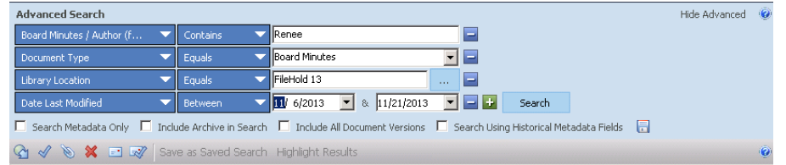

* **User Audit Logging and Tracking –** The System tracks and records every user activity to ensure a complete audit trail of document activity in the software.  This document auditing capability ensures compliance and protects intellectual property.
* **Document Viewers** – The System comes with every registered user license and allows users to see an image of a document without the need to have the native software installed on their computer the viewers work with both the web client and the desktop application.

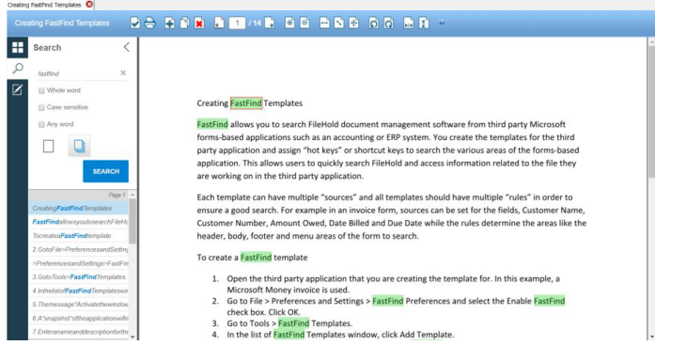

* **Document Linking -** Document to document linking builds parent or child relationships between documents and allows users to link and organize documents in logical groups.  Linking provides the ability to create document shortcuts to documents frequently needed.

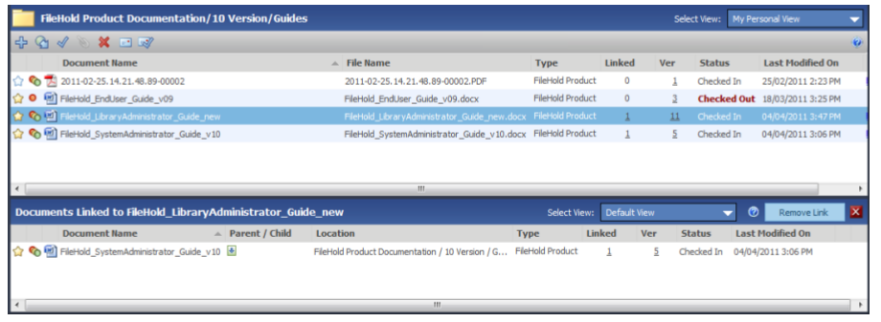

* **Calendar**– Differentiate your daily tasks and become more proficient at accomplishing your document management goals.

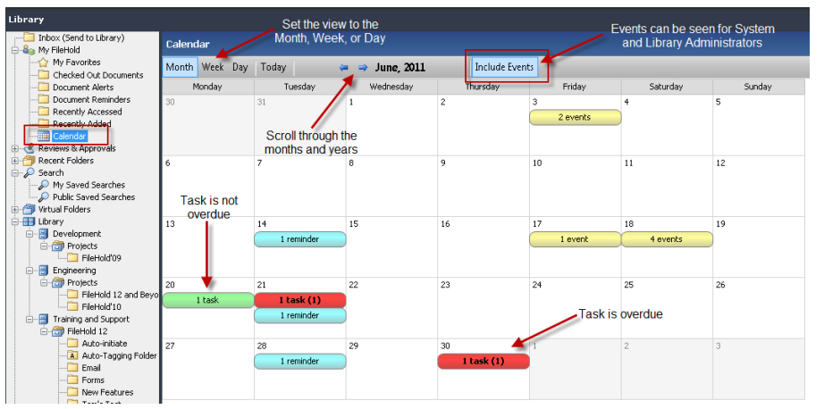

You can view the following items in the Calendar:

• Active, overdue, and completed workflow tasks:

• Completed tasks are in a light green background.

• Due tasks are in a green background with bold text and then number of tasks due in brackets.

• Overdue tasks are shown in red with bold text and the number of overdue tasks in brackets. A task is considered overdue the day after the task is due. Note that this

shows that there is only one task overdue but two tasks were due on that day. Only

one task was completed.

• Reminders are displayed in cyan background. Active reminders that have not been marked as read are bolded with the number of active reminders listed in brackets (). Active reminders that have been marked as read will be unbolded. Only the current days’ reminders are considered active. Lapsed and future reminders are not active.

• Scheduled events when they Include Events button is selected. Only users with library administrator roles and above can access this feature. Events are for when documents are set to be archived, converted to a record, disposed, or a user defined event. Events are displayed in yellow background.

* **Mobile Access** – Manage your documents while out of the office with the easiest mobile document management software you will ever use.
* **Document Scanning and Imaging –** The System ships with scanning and imaging software that support over 300 different scanners types to allow organizations to “go paperless”.  Basic and advanced third-party scanning software is supported for both simple and complex document scanning operations.

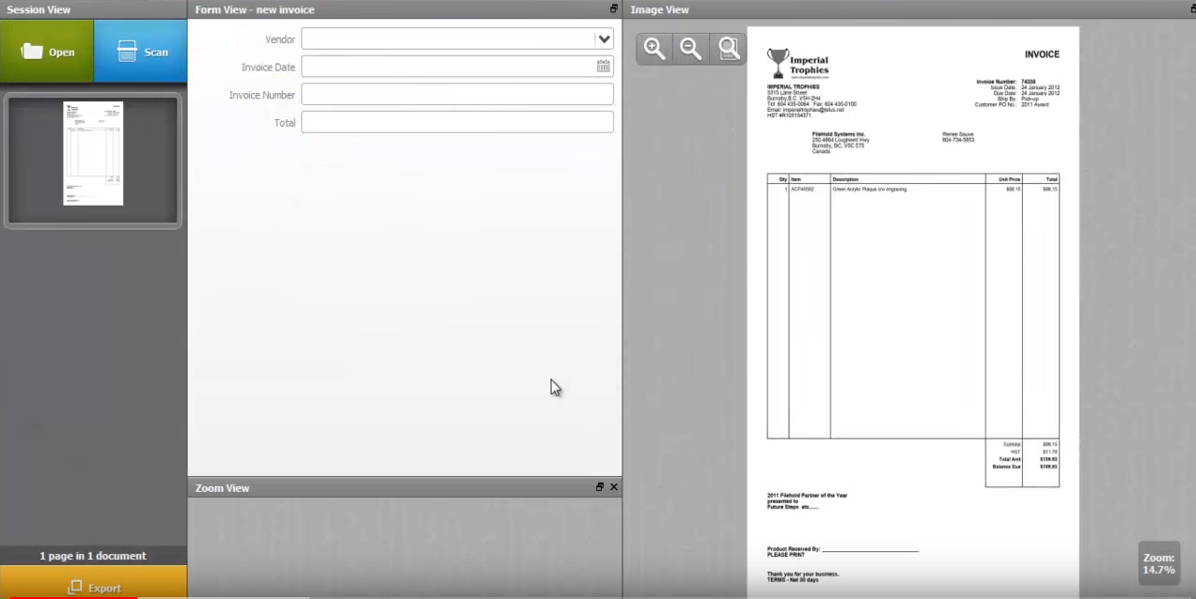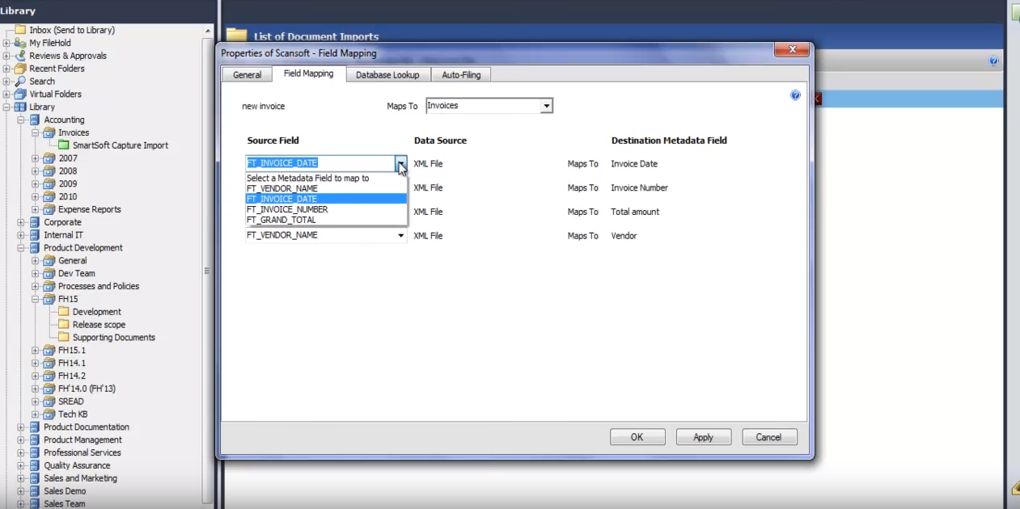

* **Virtual Folders -** The Virtual Folders feature in the software allows limitless aggregation of documents throughout the library into personal "views". A Project Manager might have a virtual folder containing project documentation, project legal contract documents, invoices, design documentation and emails even though each document is stored in different locations of the library.
* **Work Offline** - If you are traveling or out of the office and are not connected to the document management server, you can still [work on your important documents offline](https://www.filehold.com/features/standard/work-offline). The software will recognize the document changes and can be synchronized with the Library once you are back online.
* **Optical Character Recognition (OCR) and Indexing -** Using the scanning software that ships with the paperless office software users can convert the text on typed paper documents into editable and searchable information using Optical Character Recognition (OCR).
* **Matter Centric Filing (Auto Tagging) -** Metadata is automatically applied to a document when being added to a specific destination folder.  Matter Centric filing is a feature / term commonly used in the legal industry.
* **Email -** Email documents via attachments or links.
* **Reporting and document Compliance –** The System comes with many built in reports to give administrators information about the usage of documents and users.

**Optional features**

* **Document Workflow** – Fully automated document review and approval workflow for documents needing to be routed through several authors, reviewers and approvers before being ready for general distribution.

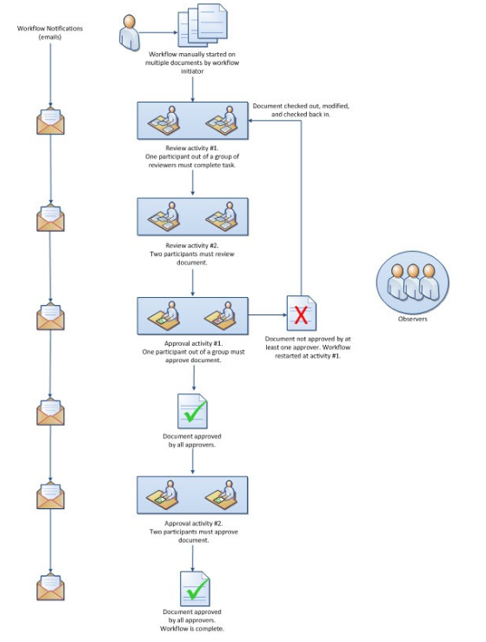

* ***Fast Find*Search Function**– *Fast Find* allows users to establish "hot key" links from third party applications to the document repository. This "hot key" allows users to find any document stored within the document library with a single key stroke.

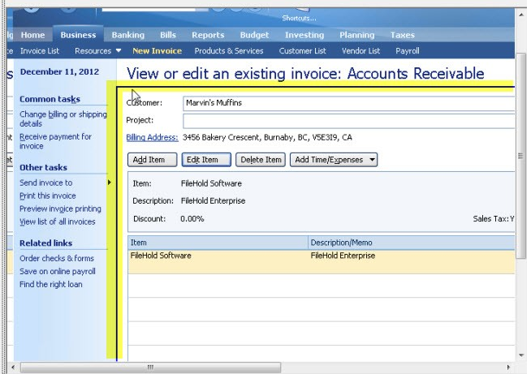

* **Print Files tool** – *Print Files* allows users to convert documents to a PDF and send your files to the document library using a virtual printer functionality. This allows users to store documents directly into the document library from any application that supports the print function.
* **Electronic signature –**isa part of the system workflow and approval process with documents stored in the library. When a document, such as a contract requires a signature they can be transmitted to Adobe Sign directly from the system workflow task.  Once the agreement is signed, Adobe sends the signed documents back to the system server. The signed documents are checked into system as new versions of the originals and the workflow task is completed.
* **Custom Document Naming and Number Sequencing** - The ability to name documents in custom ways and add auto sequencing numbers for version control and easy document identification.
* **Anonymous Portal** – Create a customized portal for external and internal access to the document repository without the need to login or have a full registered license. Workers can view documents in "read-only" mode and only see those documents to which they have permission. The [Anonymous Portal](https://www.filehold.com/help/system/create-anonymous-portal) is used in conjunction with limited register and portal alias user accounts.
* **Automatic Document Importation** – Allows importing a large number of documents into the document management system with minimal user intervention. It runs on the system server to facilitate the mass migration of documents. ADI is similar to the Watched Folders functionality but can also be integrated with various custom migration tools using an API.
* **Web Cap**– Remote users can scan and store documents into the document management repository from anywhere they have access to the internet. This feature appeals to organizations that have many remote offices or many mobile workers who need to scan documents such as contracts, bill of sales, expenses, or work estimates into the system.
* **Language Localization -** The user prompts in the software can be localized into different languages. The conversion work is typically done by the customer using the resource files that are provided who understands the language best.
* **Rebranding to customize the "look and feel -** Rebranding the logos and color scheme within the Web Client is available out of the box to customers. More elaborate customization to the web client and the desktop application can be made by the system developers to provide a unique look and feel that matched a customers or re-sellers exact requirements.

**Document Scanning**

The Software supports any TWAIN document scanner "out of the box" from the industry leading vendors. Learn more about document scanning. *This technical glossary of terms, is a resource for organizations who may want to add scanning to their document management software. This may be especially helpful for those considering the conversion of an existing archive of physical records into an electronic record repository.*  
  
**Anti-aliasing** - A process used to remove the stair stepping effect found in diagonal lines of an image. It involves inserting dots of an in-between tone along the edges.  
  
**Aspect Ratio** - The relative proportion of the length and width of an image. For example, if you scan an original that measures 4 by 6 inches, it will have an aspect ratio of 4:6, or 2:3.  
  
**Attribute** - Characteristics of a page or character, such as underlining, boldface, or font that can be captured by an optical character recognition (OCR) program.  
  
**Automatic Document Feeder (ADF)** - A device attached to a scanner that automatically feeds in one page at a time, allowing the scanning of multiple pages.  
  
**Auto Trace** - A feature found in many object-oriented image editing programs, such as Adobe Illustrator, that allows you to trace a scanned image and convert it to an outline or vector format.  
  
**Batch** - Actions carried out consecutively on a set of files.  
  
**Binary** - Base-two arithmetic, which uses only 1's and 0's to represent numbers. 0001 represents 1 decimal, 0010 represents 2 decimal and so forth. Binary numbers are used indirectly to refer to color depth, as in 24-bit or 8-bit color.  
  
**Bit** - The abbreviation for binary digit, either 0 or a 1. Scanners typically use multiple bits to represent information about each pixel of an image.  
  
**Bit Depth** - The number of bits used to represent colors or tones.  
  
**Bitmap** - An image represented as pixels in a row and column format. (Note that Adobe refers to a bitmap as a two-color image.  
  
**Calibration** - A way of correcting for the variation in output of a device such as a printer or monitor when compared to the original image data from the scanner.  
  
**Carriage** - The scanner component that moves down a page to capture an image.  
  
**CMYK** - The abbreviation for cyan, magenta, yellow, and black.  
  
**Compression** - Squeezing a file (especially an image) into a more efficient form to reduce the amount of storage space required.  
  
**Contrast** - The range between the lightest and darkest tones in an image. In a high-contrast image, the shades fall at the extremes of the range between white and black. In a low contrast image, the tones are closer together.  
  
**Data Compression** - A method of reducing the size of files, such as image files, by representing the sets of binary numbers in the file with shorter string that conveys the same information. Many image editing programs offer some sort of image compression as an optical mode when saving a file to disk.  
  
**Digitize** - To convert analog information, such as a continuous tone image, to a binary form that can be processed by a computer.  
  
**Dot** - A unit used to represent the smallest element a printer can image, but sometimes used to represent the resolution of other devices, such as monitors or scanners.  
  
**Dots Per Inch (DPI)** - The resolution of a printed page, expressed in the number of printer dots in an inch, abbreviated dpi. Scanner resolution is also expressed, somewhat in accurately in dpi.  
  
**Down sampling** - To reduce the amount of information in an image, usually to make it smaller or to discard some colors when changing bit depth. Also used when reducing the number of pixels in an image.  
  
**Dynamic Range** - The range of densities between the highlights and shadows of an image.  
  
**Export** - To transfer an image to another format type.  
  
**Filter** - An image transform tool used to process an image; for example, to sharpen, blur, or diffuse it. Often this is a plug-in in an image editor, but filters are also built into scanning software or hardware.  
  
**Gamma** - A way of representing the contrast of an image, shown as the slope of a curve showing tones from white to black.  
  
**Gamma Correction or Gamma Compensation** - The process of preconditioning or adjusting an image to correct for the gamma of the device used to reproduce the image, such as a printer or display screen. Without gamma compensation, the image will look too dark when printed or displayed.  
  
**Gang Scan** - The process of scanning more than one picture at a time, used when images are of the same density and color balance range.  
  
**Graphics Interchange Format (GIF)** - A compressed image format popular on the Web. GIF was the first commonly used image format, but was largely replaced by JPEG.  
  
**Grayscale** - Gray values in an image.  
  
**Halftoning** - A method of representing the gray tones of an image by varying the size of the dots used to show the image.  
  
**Interpolation** - A method of changing the size, resolution, or colors in an image by calculating the pixels used to represent the new image from the old ones. It is also being used to increase bit-depth claims on scanners (as in "Enhanced Bit Depth" or "Enhanced Color").  
  
**Invert** - To reverse an image's tones to its opposite value: to make a negative.  
  
**Joint Photographic Experts Group (JPEG)** - The JPEG format offers a compression scheme that makes the image file smaller than files in other formats by discarding some of the image information.  
  
**Landscape** - The orientation of a page in which the longest dimension is horizontal.  
  
**Legal size** - Paper or other media that is 8 1/2 inches wide and 14 inches long.  
  
**Moire** - In scanning, an objectionable pattern caused by interference of halftone screens, often produced when rescanning a halftone and the sampling frequency of the scanner (spi) interferes with the halftone or dither pattern of the original.  
**Monochrome** - Having a single color. Typically refers to a black and white image, but could be any single color image.  
  
**Noise** - Random information that distorts an image, especially the background distortion of an analog image before it is converted to digital format.  
  
**Optical Character Recognition (OCR)** - The process of converting printed characters into the ASCII characters and other attributes of a bitmapped image of text.  
  
**Optical Resolution** - The resolution of a scanner that is calculated by dividing the width of the scanned area by the number of pixels in the CCD. Optical resolution is also often called true resolution and does not include any interpolation to increase pixels.  
  
**Pixel** - A picture element of an image that refers to a single dot with in a digital photograph. A photograph is made up of thousands of pixels.  
  
**Pixels Per Inch (ppi)** - The number of pixels captured per inch by a scanner. This is a more accurate rate term than dpi (dots per inch) when applied to scanners because scanners capture pixels.  
  
**Portable Network Graphics (PNG)** - A loss less file format created to overcome deficiencies of the Graphics Interchange Format (GIF), such as the limited number of colors.  
  
**Portrait** - The orientation of a page in which the longest dimension is vertical.  
  
**Preview Scan** - A preliminary scan that can be used to define the exact area for the final scan. A low- resolution image of the full page or scanning area as shown, and a frame of some type is used to specify the area to be included in the final scan.  
  
**Raster Image** - An image defined by rows and columns of pixels. Scanners capture images as raster images, although some can convert them to vector images.  
  
**Raster to Vector Conversion** - The process of examining a raster image for lines and strokes, and creating a new image that looks the same but is made up of lines rather than pixels. When a person draws, they are creating a vector image. Vector images can be enlarged much more accurately and often have a smaller file size.  
  
**Resolution** - The number of pixels or dots per inch in an image. Also the capability of a scanner to resolve detail, which requires quality optics as well as high ppi or spi.  
  
**Sample Rate or Samples Per Inch** - The number of pixels per inch captured by a scanner.  
  
**Scanner** - A device that captures images or text and converts it to a bitmapped image.  
  
**Selection Area** - The part of a HP Deskscan preview scan that you select to be saved to a file or sent directly to a printer.  
  
**Sharpening** - Increasing the apparent sharpness of an image by increasing the contrast between the adjacent tones or colors.  
  
**Smoothing** - To blur the boundaries between tones of an image, usually to reduce a rough or jagged appearance.  
  
**Threshold** - A predefined level used by scanners to determine whether a pixel will be represented as black or white.  
  
**Thumbnail** - A miniature copy of a page or image, which gives you an idea of what the original looks like without having to open the original file or view the full size image.  
  
**Tagged Image File Format (TIFF)** - A graphic file format originally developed specifically for scanners. It can be used to store grayscale and color images and now is graphic standard image file format supported by most applications, printers, and scanners.  
  
**Transparency Adapter** - An add-on device used with a scanner to scan slides and other see-through media.  
  
**TWAIN** - A software driver interface between a scanner and other image capturing devices that lets you scan images from a scanning application directly into an application like Adobe Photoshop.  
  
**Vector Image** - An image defined by the beginning and ending points of each line.  
  
**Zoom** - To enlarge a portion of an image.

