**Document Contents:**

**Standard Features**

* Document Scanning and Imaging
* Version Control
* Document Tagging or Metadata Capture
* User Roles and Security
* Searching
* Audit Logging and Tracking
* Document viewers
* Document Linking
* Mobile Access ( option)
* Work Offline
* Optical Character Recognition (OCR) and Indexing
* Auto Tagging (after OCR)
* Emailing
* Reporting
* DocumentWorkflow
* Viewing and printing
* Electronic signature
* Custom Document Naming and Number Sequencing
* Automatic Document Importation
* Web access
* Language Localization

**Standard Features**

The Software should delivers essential, document, records and workflow management.  Following is a brief description of system features :

* 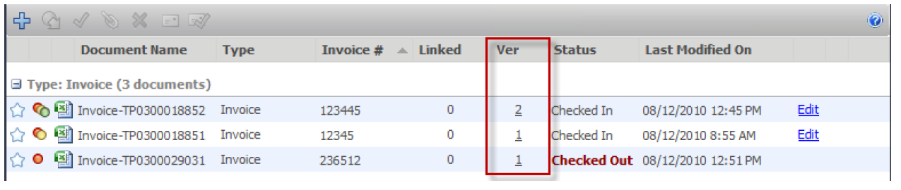**Version Control -** Document version control provides: check in / checkout ability preventing documents from being overwritten or deleted as documents are updated by more than one party. The document management system retains a unique copy of each version of each file as it is checked out and back into the Library. When a document is checked in and changes have been made, System automatically creates a new version of the document.
* **Document "Tagging" or Metadata Capture -** Capturing metadata or "tagging" (key data about the document) is the key to successful search and document organization. The system should has ability to use controlled document tagging insuring documents are classified. Tags associated with documents to help users to compare and retrieve documents without opening the actual file. Defining a document tagging or metadata vocabulary requires an understanding of different types of documents the company needs to manage and the essential information associated with each document type. The task of managing a tagging vocabulary is usually the Document Librarian or Library Administrator (in larger organizations) or business/ department managers in smaller companies. For example, many financial departments use system to track invoices, purchase orders and checks. Each one of these document types has a unique tagging profile associated with it. An Invoice document profile may contain invoice amount, invoice date, product name(s) and customer name.

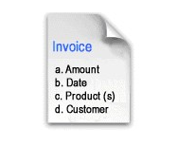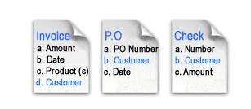

* **User Roles and Security –**Security roles ranging from "read only" to "System Administration" to provide an appropriate level of user access permissions for workers at all levels.  Users see only documents that administrators want them to see.

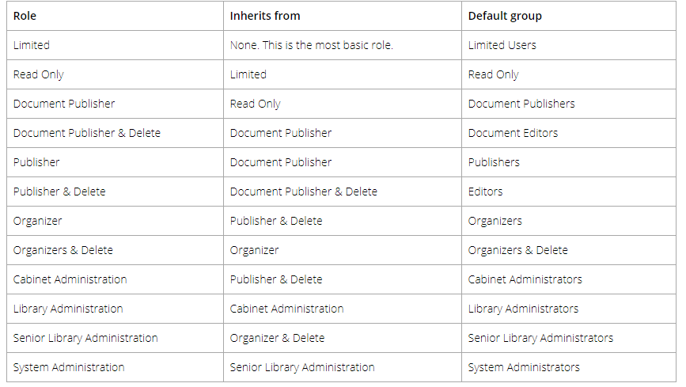

|  |  |
| --- | --- |
| **Role** | **Description** |
| Limited | A user assigned to a group with a “limited” role has restricted access to the  system. Users can only get a copy or view documents in the library.  Groups assigned to a “limited” role are used for when multiple people can  share the same username and password to log into system to see the  same documents in the library. For example, documents such as  newsletters, forms, or corporate policies may need to be accessible to all  company employees but they do not require a full registered user license  and full functionality. |
| Read Only | A Read-Only user role may only download or open and read documents. They cannot edit, delete, or create documents. They can email documents if given this functionality by system administrators. Read-only users may be restricted from downloading or printing documents. Read-only users can participate in workflows but cannot initiate workflows. |
| Document Publisher | Document Publisher user role can read, get a copy, add, check-in/check-  out, edit documents, and metadata. They can move documents that are  owned by them. They cannot delete any documents including those which  they have added to the system.  Document publishers can initiate workflows, participate in workflows, and  initiate Courier transmissions. |
| Document  Publisher +  Delete | Document Publisher Plus Delete user role can do everything a Document  Publisher can do and delete their own documents. They must be the owner  of the document in order to delete it. To see the owner of a document, you  can look at the version properties in the metadata pane. |
| Publisher | Publisher user role can do everything a Document Publisher can do plus:  • Create new folders and folder groups.  • Copy or move folders that they have already created.  • Clone folders and folder groups created by other users and become the  owners of the folders / folder groups.  • Publishers cannot delete existing documents, folders or folder groups  including those which they have added /created. All documents and folders  created by the Publisher will be owned by them and they cannot change  the ownership. |
| Publisher  + Delete | Publisher plus Delete user role can do everything that a Publisher can do  plus delete documents, folders and folders group owned (created) by them. |
| Organizer | The Organizer role is for users who are responsible for organizing  documents that are scanned or imported into the system or who are  assigned to organize documents added by other users. For example,  organizers would move the documents generated by scanner operators to  their correct folder in the library. Only trusted personnel should be given this  role. Organizer role user can:  • Move all documents (which they have an access to) in other places in the  library including documents which they do not own. In other words, they  can move documents that are owned by other users.  • Move, copy or clone all folders and folder groups regardless of them  ownership. In case of cloning they will become the owners of folder / folder  groups. In case of copying and moving the original ownership of folders /  folder groups are preserved.  • Change folder properties regardless of ownership.  • Add folders / folder groups (in which case they will become their owners)  and rename folders and folder groups.  • Delete documents that they own.  • Change document owner regardless of ownership  • Convert offline documents to electronic documents  • Export documents |
| Organizer  + Delete | Organizer plus Delete role can do everything that Organizers can do plus  delete all documents, folders and folder groups regardless of them  ownership. This organizer and delete role can only do this within Cabinets,  Folders and Schemas that they are a member of.  This role should be used by trusted personnel only. |
| Cabinet  Administration | Cabinet Administrators can only administer the cabinets that they own; they  cannot create cabinets for themselves. They can:  • Create, edit, and delete drawers, folder groups and folders and manage  their properties (i.e. membership structure).  • Access all documents (in Publisher and Delete capacity) from anywhere in  the library structure unless they are restricted from that area of the library  structure. If they do not have access to the Cabinet and Folder they will not  be able to access the documents.  • Delete and move electronic records as long they are owners of the cabinet.  Electronic records can only be moved to another Cabinet in which they  own.  • Move documents between cabinets as long as they are owners of the  Cabinet. If users need to move documents between Cabinets that they do  not own, then use an organizer role instead.  • Have access to all document schemas.  • Change document owner for documents in the cabinets that they own.  • Convert electronic documents to electronic records and vice versa for  cabinets that they own.  • Convert electronic documents to offline documents for cabinets that they  own.  • Manually move document to and from the library archive as long as they  are the Cabinet owner in the library archive? |
| Library  Administration | Library administrators can perform, within their cabinets, the same functions  as Cabinet Administrators plus:  • Create cabinets for which they will be the owner of and manage them in  the Library.  • Access to Library Administration functionality where they can manage  metadata fields, schemas, events, set up workflow templates, manage  numerous global settings (i.e. viewer permissions, search engine settings,  reporting services permissions and more), perform various managerial  functions such (as check-in for user, change document owner, recover  deleted document etc.) and access many useful reports and usage logs for  the cabinets that they own.  • Library administrators cannot create cabinets for Cabinet Administrators to  own. If a library administrator creates a cabinet, then they are the owners. |
| System  Administration | System administrators have complete control of the system. They can  perform all of the functions of all other roles. However, the main tasks of the  system administrators are to add users to the system (including assigning  the initial password and setting requirements for all new passwords and  ability to self-register), assign users to their appropriate groups, enable  document control numbers and version control numbers, manage user  accounts, user groups and the system license pool. The system  administrator also has access to various global settings (outbound e-mail,  system wide configurations for managing the various documents format  conversion permissions etc.) and as well as user activity reports. |

* **Searching -** Search documents from a simple search or an advanced search using metadata. Also can Save the searches to create reports for later usage .

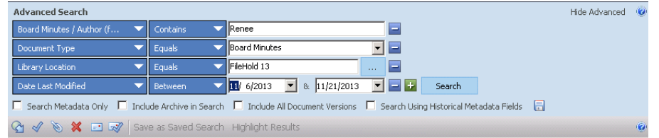

* **User Audit Logging and Tracking –** The System should tracks and records every user activity to ensure a complete audit trail of document activity in the software.  This document auditing capability ensures compliance and protects intellectual property.
* **Document Viewers** and printing – The System should allows users to see an image of a document without the need to have the native software installed on their computer the viewers work with both the web client.
* **Document Linking -** Document to document linking builds parent or child relationships between documents and allows users to link and organize documents in logical groups.  Linking provides the ability to create document shortcuts to documents frequently needed.

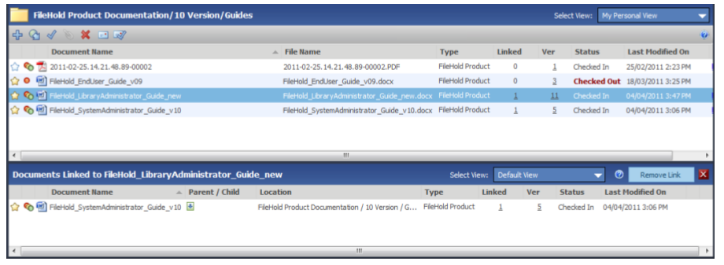

* **Mobile Access**  mobile app for document management.
* **Document Scanning and Imaging –** The System should support different types of scanners.  (we can use third party tool )
* **Virtual Folders -** The Virtual Folders feature allows limitless aggregation of documents throughout the library into personal "views". A Project Manager might have a virtual folder containing project documentation, project legal contract documents, invoices, design documentation and emails even though each document is stored in different locations of the library.
* **Work Offline** – should support offline mode . The software will recognize the document changes and can be synchronized with the Library once the user go back online.
* **Optical Character Recognition (OCR) and Indexing -** Using the scanning software that ships with the paperless office software users can convert the text on typed paper documents into editable and searchable information using Optical Character Recognition (OCR).
* **(Auto Tagging) -** Metadata is automatically applied to a document when being added to a specific destination folder
* **Email -** Email documents via attachments or links.
* **Reporting and document Compliance –** reports to give administrators information about the usage of documents and users.
* **Document Workflow** –automated document review and approval workflow for documents needing to be routed through several authors, reviewers and approvers before being ready for general distribution.

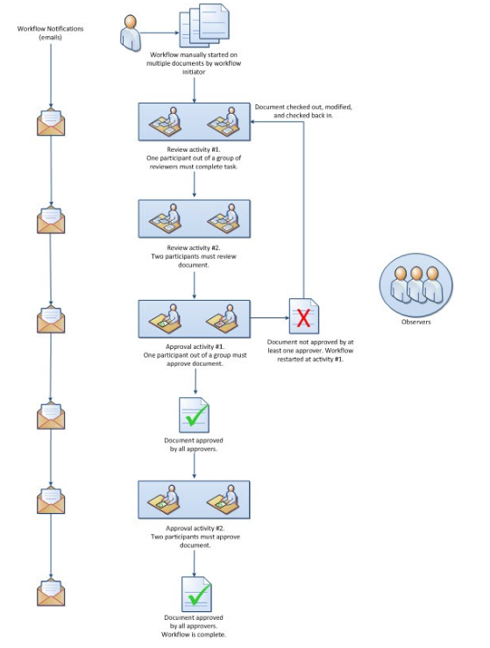

* **Electronic signature –**isa part of the system workflow and approval process with documents stored in the library. When a document, such as a contract requires a signature they can be transmitted to digital signature tool
* **Custom Document Naming and Number Sequencing** - The ability to name documents in custom ways and add auto sequencing numbers for version control and easy document identification.
* **Web access- Cap**– Remote users can scan and store documents into the document management repository from anywhere they have access to the internet.
* **Language Localization -**  localized into different languages.