

Archiving systems Features



November 11, 2019

Unicom Group

**Archiving system** is the process of handling documents in such a way that information can be created, shared, organized and stored efficiently and appropriately.

Setting up an archiving system involves four steps;

1. Import document (electronic document or scanning hard copy document)
2. Processing and export automation Tags (Meta Data) to apply easy search
3. Index documents and store them
4. Export document and Document Workflow

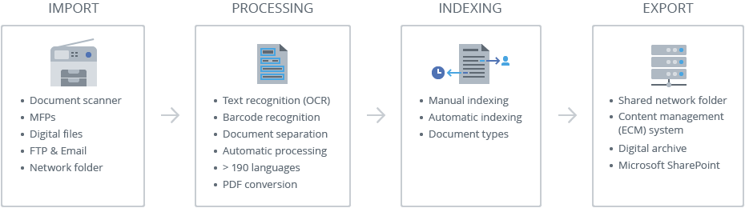

1. **Import document**

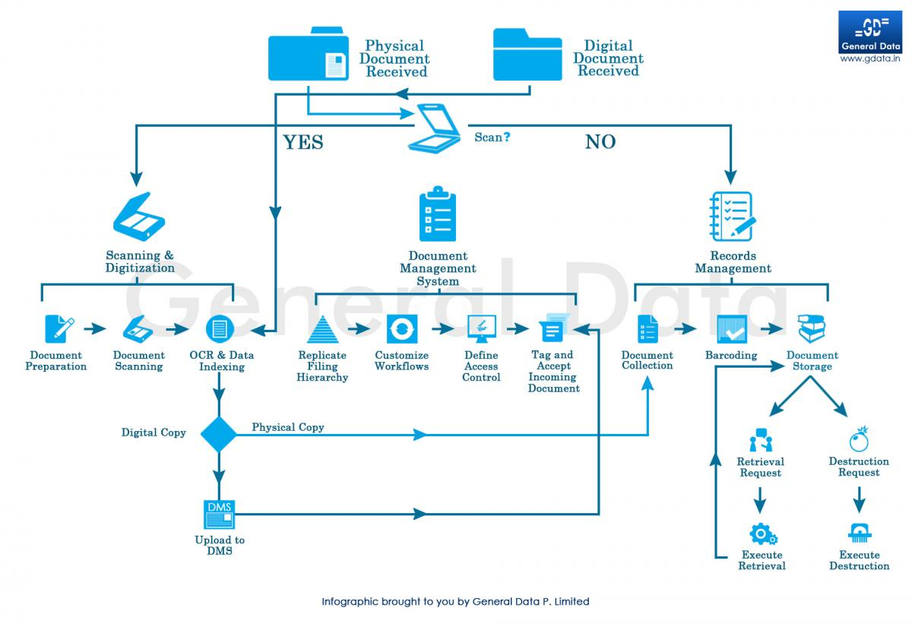Our operatives scan and digitize your files using the latest scanning technology through the following Diagram

The System ships with scanning and imaging software that support over 300 different scanners types to allow organizations to “go paperless”.  Basic and advanced third-party scanning software is supported for both simple and complex document scanning operations

1. **Processing and export automation Tags**

Capturing metadata or "tagging" (key data about the document) is the key to successful search and document organization. The software has easy to use controlled document tagging insuring documents are classified. Tags associated with documents to help users to compare and retrieve documents without opening the actual file. Defining a document tagging or metadata vocabulary requires an understanding of different types of documents the company needs to manage and the essential information associated with each document type. The task of managing a tagging vocabulary is usually the Document Librarian or Library Administrator (in larger organizations) or business/ department managers in smaller companies. For example, many financial departments use system to track invoices, purchase orders and checks. Each one of these document types has a unique tagging profile associated with it. An Invoice document profile may contain invoice amount, invoice date, product name(s) and customer name. Metadata is automatically applied to a document when being added to a specific destination folder.

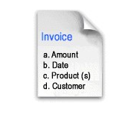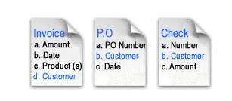

**Searching** - Search documents from a simple Google-like search or an advanced search using metadata. Save the searches to create reports whenever you need them.

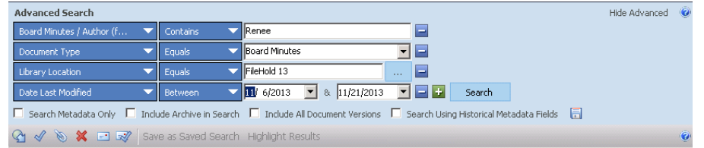

1. **Index documents and store them**

Indexing may be as simple as keeping track of unique document identifiers; but often it takes a more complex form, providing classification through the documents' metadata or even through word indexes extracted from the documents' contents. Indexing exists mainly to support information query and retrieval.

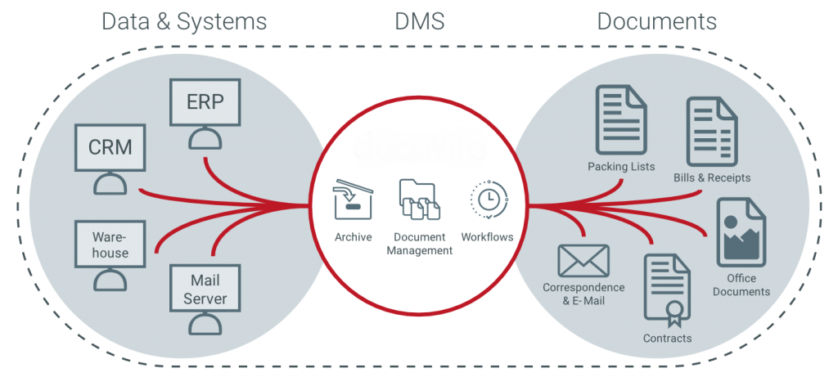

1. **Export document and Document Workflow**

Fully automated document review and approval workflow for documents needing to be routed through several authors, reviewers and approvers before being ready for general distribution.