Aptech
Learning
Random paragraph / justify content:
Video provides a powerful way to help you prove your point. When you click Online Video, you can paste in the embed code for the video you want to add. You can also type a keyword to search online for the video that best fits your document.

Screen shot:
Print screen in key board. 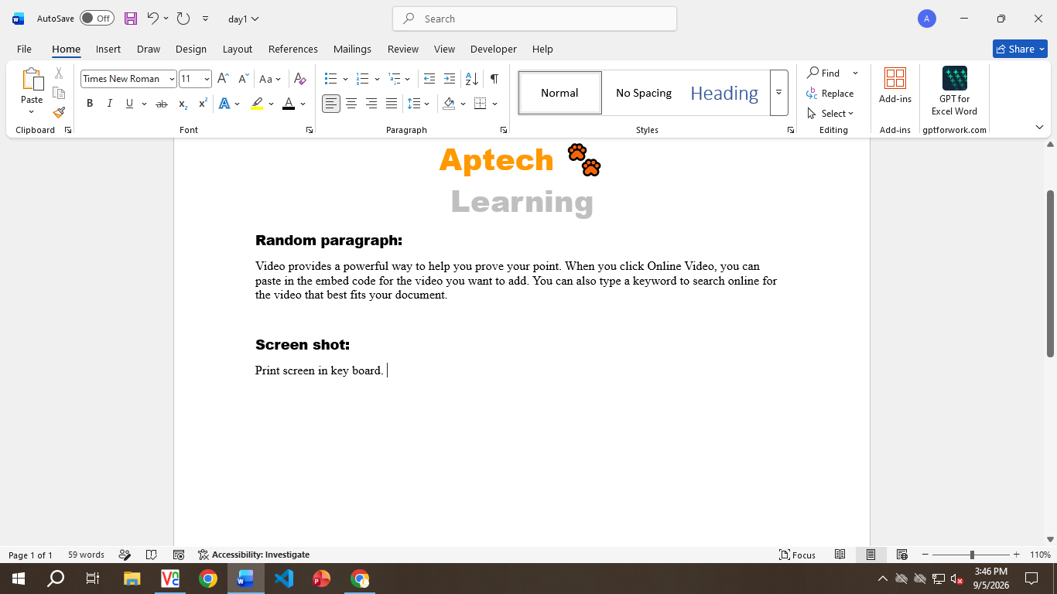
Fake Screen shot: 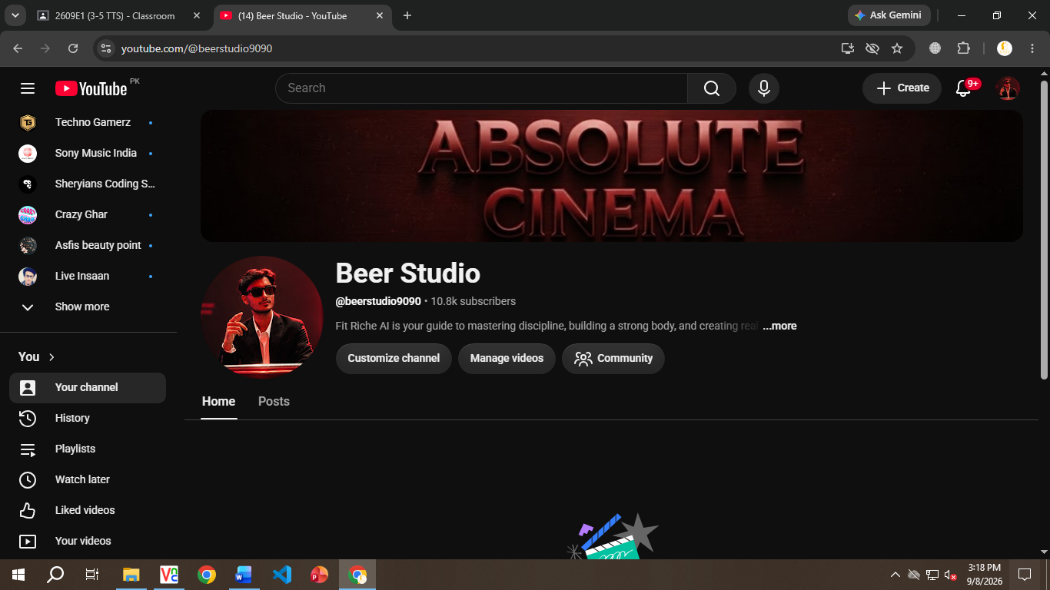


Insert image:

Features in bullet:
- Gta v
- COD
- Counter Strike
- Pubg
- Free fire

Table:
Name | Father name | Roll no
Kabeer | g. Qadir | 78
Umar | Iqbal | 23

Icons:

React
React

Cloud
Smart art:

3D MODEL:

