DPS924 Final Project Report
Note: This is an individual report. Please submit it under your name on Blackboard.

Date: Saturday January 3rd 2015

Name: Kabeer Rashid

Android Application Name: Torontouirsm

Short Description of the Application:

A. The Testing Environment
1. Android phone/table
a) Model name: SGH-T889V (Samsung Galaxy Note 2) b) Android version (and API level): 4.4.2Kitkat API: 19
a) Model name: SM-N910W8 (Samsung Galaxy Note 4) b) Android version (and API level) 4.4.4 Kitkat API: 21

2. Emulator
a) configuration information: Not Compatible b) Android version (and API level): Not Compatible

B. Use Cases
Proposed  (in the project proposal) | Implemented | Remarks/Explanation
1.Look Up Event | YES | Yes, I have implemented the features I have said. In my proposal I stated I will create a List view which will display the parsed information including a pictures and when clicked on more information will be given.
2. Map | Yes | Yes, In my proposal I stated I will make a map display on the detail page however after a scrum meeting and finding out that the map given in the xml file was a link to the website’s own map. Instead I created a link in which the user can click on and it will open the map on their default browser.

C. Essential Features
Identified  (in the design report) | Implemented | Remarks/Explanation
1. Parsing all information about the event | Yes | I parsed all information that the user requires and make it available for the user to view on the detail page.
2. Parse information to home screen: name, description, and image. | Yes | I parsed the information I stated except for description because it was becoming too crowed, hence I put location instead of description.
3. Create app to run activity for when map is clicked | Yes | When clicked on the map link it will open the browser and display the map on the browser with the location being centered.

D. User Feedback and Actions
User Feedback (summary) | Action Taken | Remarks/Explanation
- Should not be list view | NO | I didn’t not change from the list view design as I stated in my design report because creating a different design would make me change other designs, which would have caused much more work.

E. Additional Features
Recommended  (in the design report) | Implemented | Remarks
1. Add event to calendar | YES | I have created a button when clicked it will open the default calendar and sends the location and event name to the calendar and it will save when clicked on save or clicked back.
- Linked to website | Yes | Link has been provided to the official website when the user clicks on the link the default browser is invoked and the link is opened.

F. Summary of Research Work
- Image Loader – Loads the image that is being parsed and downloads it, so it can be viewed.
- File Cache - Saves the images temporarily on the device so that it doesn’t have to download the image over and over again.
- Memory Cache – This limits the memory usage when downloading images.
- Utils
- Opening the default calendar application on the device to pass the event information.

G. Challenges
Parsing data properly – at first when the data was parsed it only parsed the first element and skipped the rest. This meant that the parser was only getting the first element tag from the xml file and displayed it. To fix this I had to use the tags within the parent tag to get the data required.

Loading images – When an image tag was passed it gave a null error because some characters inside the parsed linked were not recognized by the parser. To fix this I had to change some characters and put them as spaces so that the image will load.

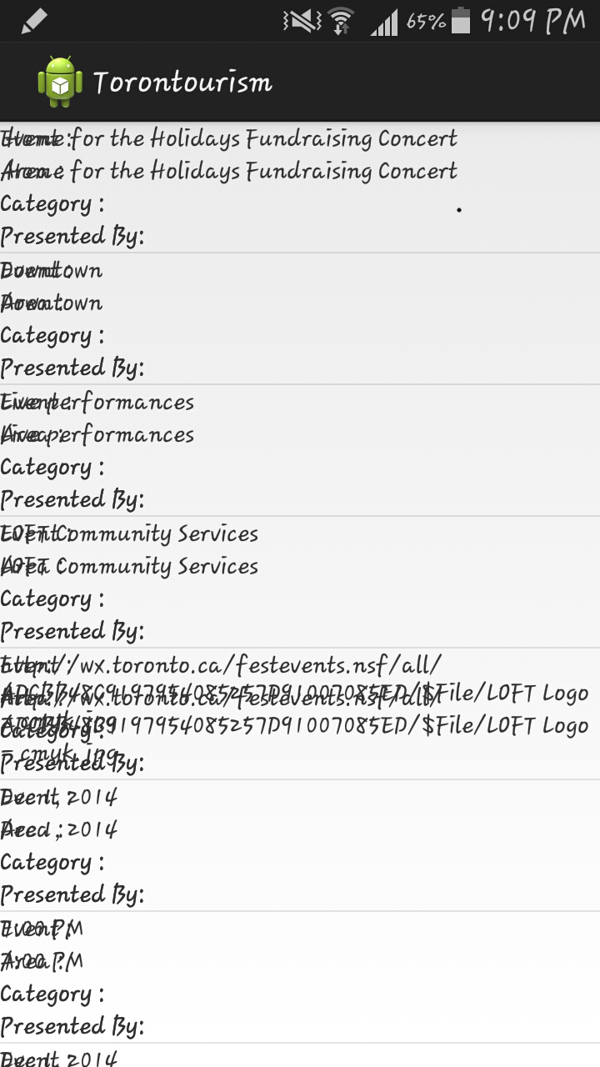
Inflating the text view properly – when inflating the text view I kept getting this error as shown in the picture on the right side. To Fix this I had to create another hash map and inside when getting the value I had to use the parent tag to get the first value and then use child and sub child to get the other values.

Out of memory errors – When the application ran I was loading a value when the value didn’t exist inside the xml file and trying to display that value gave me an out of memory error. To fix this I added the code require to display on the xml file. I figured it out when reading over my code.

Null pointer errors - When loading too much information from the xml file it would stop running because it would find a space and return null pointer. To get rid of this error I had to make sure when a blank space is reached it displays no available on the screen.

H. Team Work
I worked alone

I. Your Overall Experience
My experience for this project was stressful but enjoyable when everything started to work together. I would highly recommend this course to someone who wants to learn on Android. Plus I would keep working this Android project once I have submitted this assignment.

J. Self-Rating (on a scale from 0 to 10)
1. yourself: 8/10

H. Appendix
