Game Design Document
Fill up the Following document

- Write the title of your project.
Tom and Jerry

- What is the goal of the game?
Tom has to catch Jerry with three lives but if Jerry gets a piece of cheese, he can chase Tom and for 30 seconds the game switches.

- Write a brief story of your game?
Tom has 3 lives, he has to catch Jerry, when tom catches Jerry, the game ends

and if Jerry gets 1 of the 4 pieces of cheese around the map, he can chase and

make Tom lose 2 lives if he is caught.

- Which are the playing characters of this game?
- Playing characters are the ones which respond to the user based on the input from the user
- Cars, monkeys, dinos, wizards etc, are the playing characters in the game.
Number | Character Name | What can this character do?
1 | Tom | Chase Jerry with the arrow keys around the maze
2
3
4
5
6
7
8

- Which are the Non Playing Characters of this game?
- Non Playing characters are the ones which don't have an action or a behaviour when the user interacts with the game.
- Hurdles, stones, bananas, coins, etc are non playing characters in the game.
Number | Character Name | What can this character do?
1 | Jerry | Runs around randomly and tries not to get caught by Tom
2 | Cheese | When Jerry eats 1 of the 4 pieces of cheese around the map, he can chase Tom and make him lose 2 lives.
3
4
5
6
7
8

Draw your imagination of this game. What does this game look like?
- Draw the game either on your computer or on paper,
- Add images of scenes of the game to show each of the playing and non-playing characters at least once.

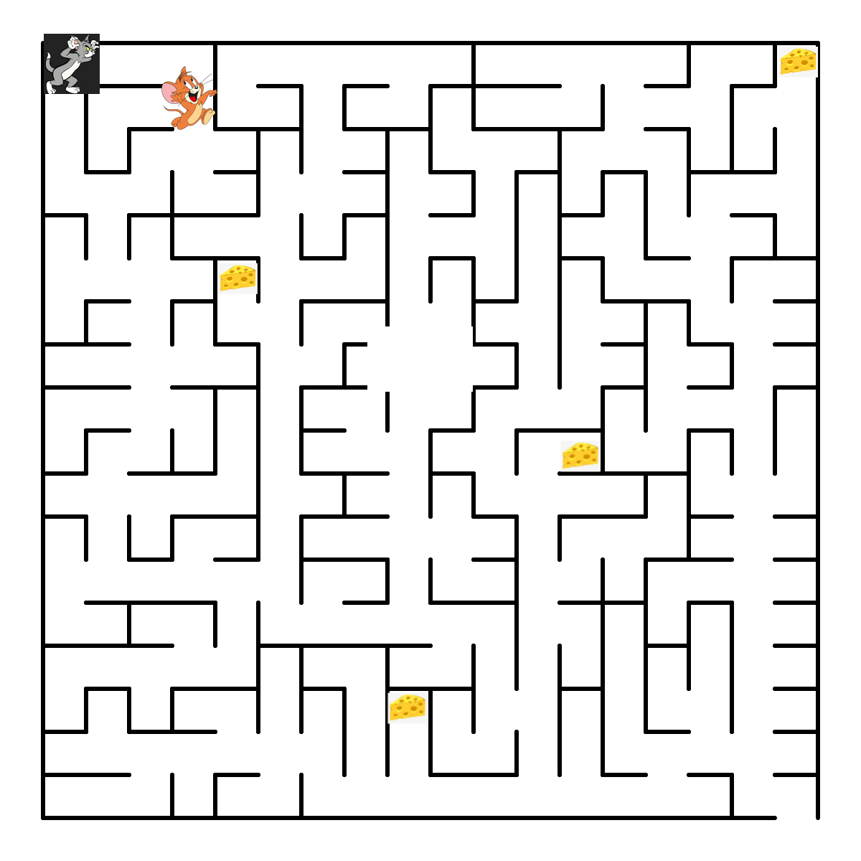

How do you plan to make your game engaging?
- With a bold title
- Put pictures of people having fun

