CS442 | Mobile Application Development | Fall 2026
Lab 3: Campus Cafe Order System
Session 3 (Part 1): Classes, Constructors, Getters & Setters

TASK 1
SUBMI.CHECKPOINT 1:
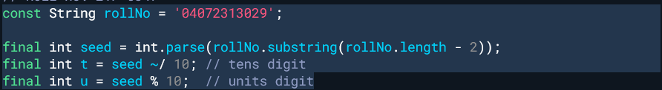
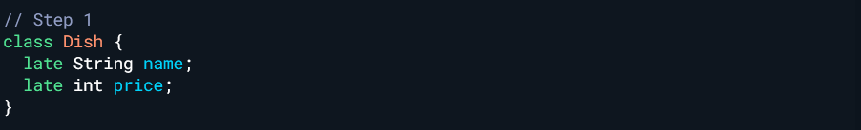
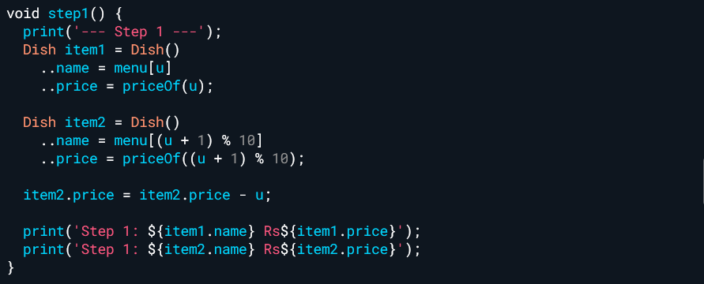
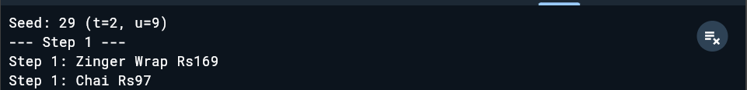

STEP2.SUBMIT
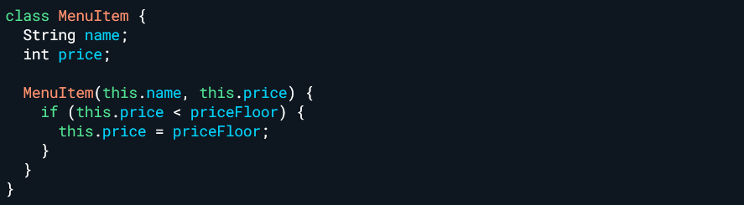
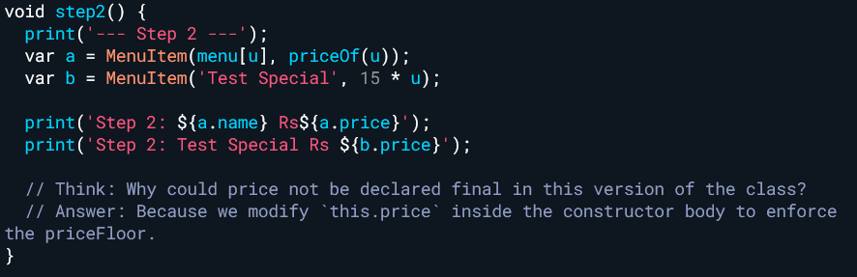

STEP3.SUBMIT
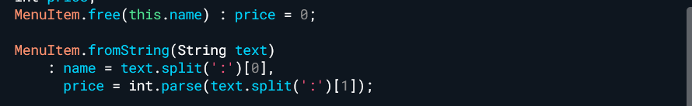
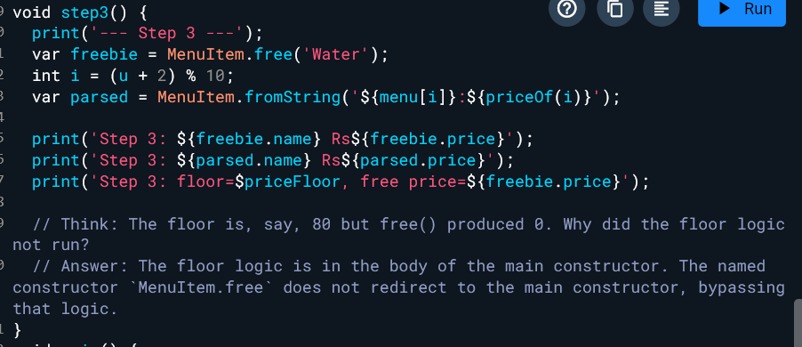
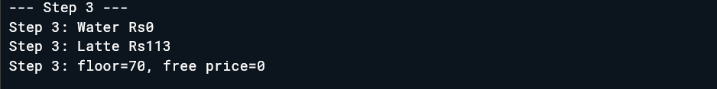

STEP 4.SUBMIT
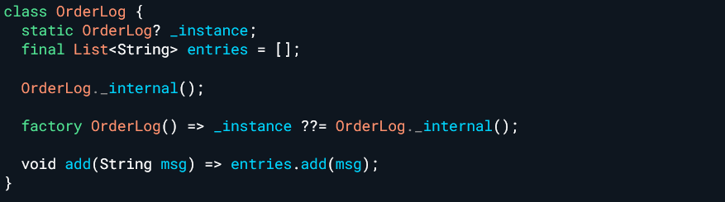
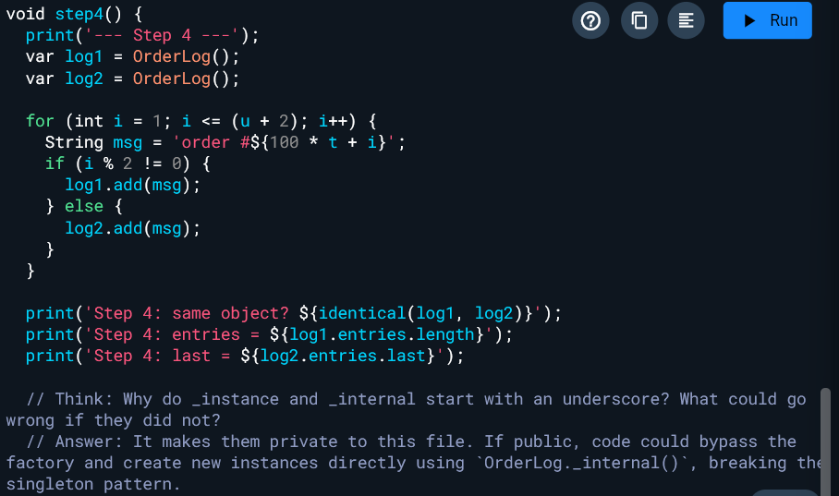
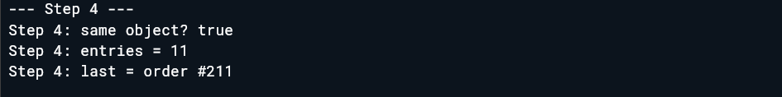

STEP 5.SUBMIT
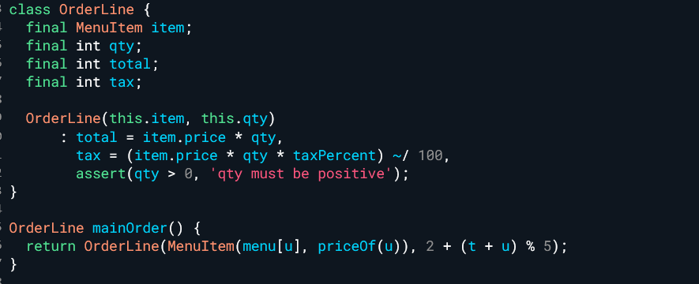
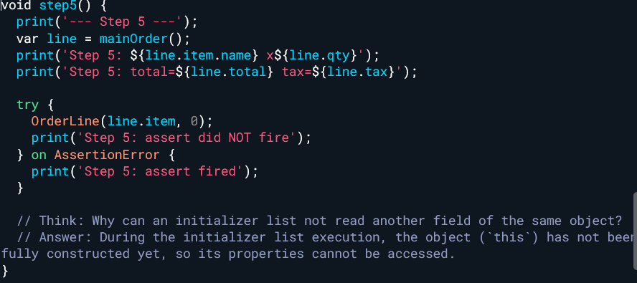
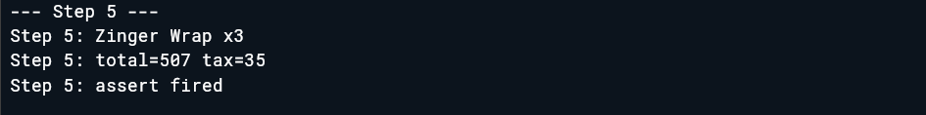

STEP 6.SUBMIT
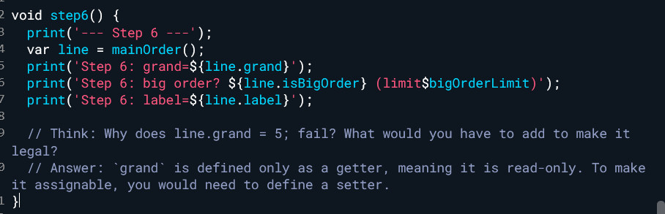
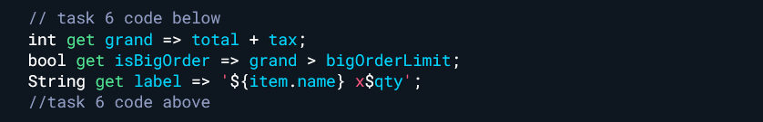
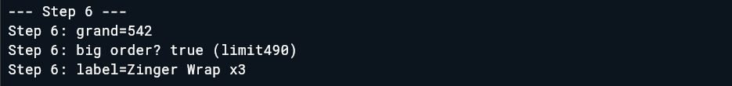

STEP 7.SUBMIT
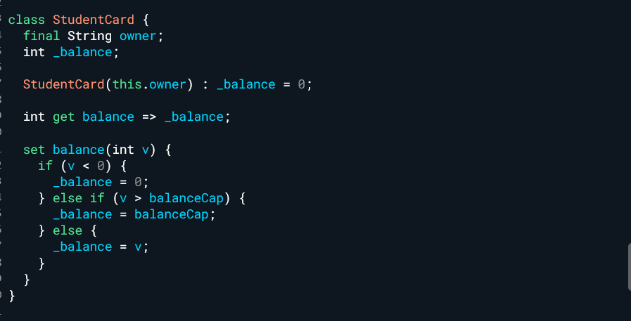
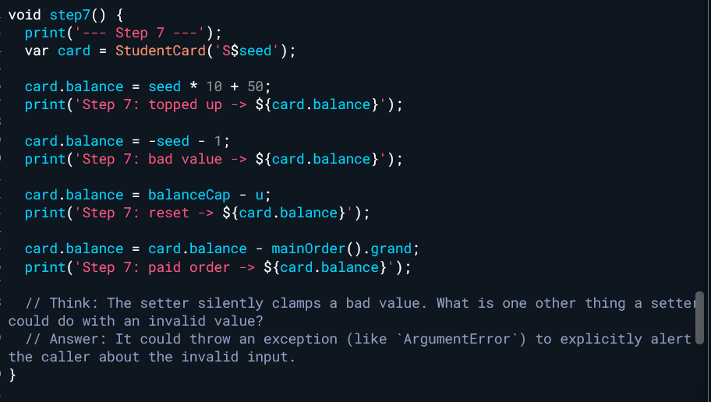
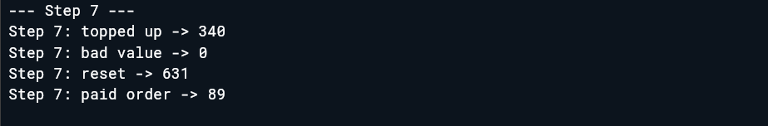
STEP8.SUBMIT
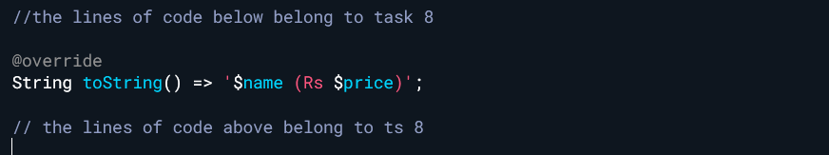
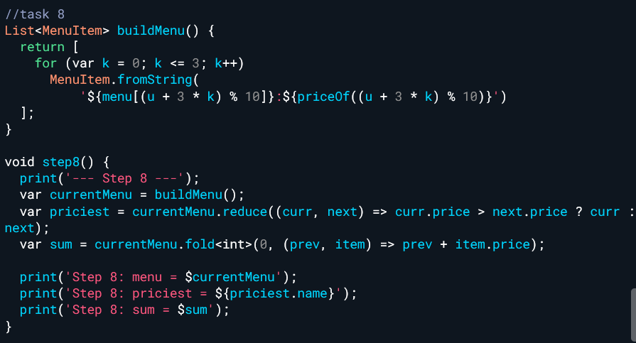
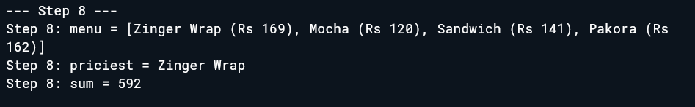

STEP9.SUBMIT
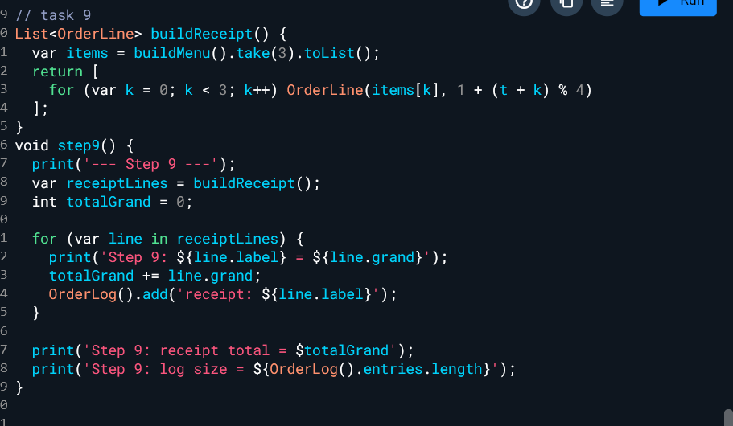
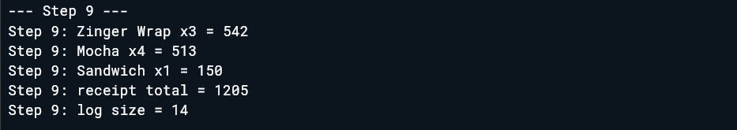

STEP10.submit
