GROUND & GRAIN
COFFEE ROASTERS · EST. 2019
BIWA2110 · WEB APPLICATION DEVELOPMENT
Ground & Grain
Coffee Shop
Management System

A full-stack ordering and shop-management system built with React, Express, the Fetch API and a key-value NoSQL store — designed, tested and deployed.
Module | BIWA2110 — Web Application Development
Assessment | Group project, final submission
Live application | coffee-shop-omega-lovat.vercel.app
Live API | ground-and-grain-api.onrender.com/api/health
Repository | github.com/kabelomoshe881-design/coffee-shop
Date | 11 November 2026

GROUP MEMBERS
Name and surname | Student number | Contribution area
[ full name ] | [ student number ] | Backend API and data model
[ full name ] | [ student number ] | Customer experience
[ full name ] | [ student number ] | Staff dashboard and auth
[ full name ] | [ student number ] | Design system and styling
[ full name ] | [ student number ] | Documentation and deployment
Word count: approximately 6,554 words (body text, tables and appendices).

Declaration
We declare that this report and the application it describes are our own work. Where we used someone else's code, documentation or idea, we say so in the text or in the reference list. We have not copied another group's project, and we have not submitted this work for another module.
We also declare that the live application at the URL on the cover page was built from the source code in the repository listed there. The screenshots in this report were taken from that deployment, not from a local copy.
Name and surname | Student number | Signature
Signed at ____________________________ on ____________________.

Note on AI-assisted tools
We used AI assistants while building this project. They helped with scaffolding the initial structure, drafting parts of the documentation and reviewing code for bugs. Every suggestion was read, tested and changed where it did not fit. The two defects in Section 5.4 were found by running the application in a browser and were fixed by us. We can explain any part of the code in the viva.

Abstract
Ground & Grain is a small coffee shop, and the problem we chose is the one almost every campus café has: ordering happens out loud. A customer reads the board, joins the queue, says the order, and then stands aside until someone calls a name. The queue is longer than the work behind it, sold-out items stay on the board, and nobody knows the day's takings until a supervisor adds up the slips.
We built a web system that moves that conversation onto a phone. Customers see the live menu, build a cart that survives a page refresh, place an order and watch it move from pending to collected. Staff sign in to a dashboard where they can change availability, work the queue and see today's revenue without doing any arithmetic. The front end is React, the API is Express, and all data lives in Redis as JSON documents under explicit keys, with index sets standing in for the queries a relational database would give us.
We tested the API with ten automated tests, checked the interface in a real browser at three screen sizes, measured colour contrast instead of assuming it, and deployed both halves to free hosting. The system is live at the URLs on the cover page.
Contents
Declaration 2
Abstract 3
1. Introduction 5
2. Requirements 6
3. Design 8
4. Implementation 10
5. Testing and quality assurance 12
6. Deployment 14
7. Challenges and lessons 16
8. Conclusion and future work 17
References 17
Appendix A — API reference 18
Appendix B — Records and screenshots 19

1. Introduction

1.1 Background and problem
We worked from the scenario in the brief: a campus coffee shop with a counter, a printed menu board and a morning rush. The shop is small enough that the staff know the menu by heart, which is probably why nobody had ever written the ordering process down. Written out, it has four steps: read the board, queue to say the order out loud, pay, and wait for a name. Only the third step really needs a person, and even that could happen at collection. The rest is information moving through a queue at the speed of conversation.
Customers cannot see an accurate menu without joining the queue, and staff have no single place to manage availability, work orders in sequence or measure the day's takings. The result is waiting that does not need to happen, mistakes when an item runs out, and no operational visibility. A browser-based system can take the queue off the critical path, because the order is captured before the customer reaches the counter rather than after.

1.2 Objectives
- Build a customer menu that shows live availability, works on a phone, and filters without reloading.
- Keep the cart across refreshes, turn checkout into a shareable order number, and show progress without a refresh.
- Protect a staff area, and enforce every write rule on the server rather than in the browser.
- Give staff menu management, a live order board, an orders table and daily totals.
- Store everything in a key-value NoSQL database, with indexes so that reads do not scan the whole store.
- Meet WCAG 2.2 AA contrast and support light and dark themes.
- Deploy to public URLs on free infrastructure and verify it there.

1.3 Scope
The system covers ordering and shop operations, not payment. Orders are collected and paid for at the counter, and the checkout panel says so, because a student project that pretends to take card payments is worse than one that is honest about not doing it. There is one staff account instead of a user-management system: the brief asks for staff-only endpoints, not for accounts, and roles would have added a second domain without improving any assessed behaviour. Prices are stored as integer cents in South African rand. Delivery, email receipts, stock decrementing and supplier ordering are out of scope; Section 8.2 says what we would do next.

1.4 Group roles
Table 1 — Group members and ownership
Member | Student number | Primary responsibility | Main files
[ full name ] | [ student number ] | Backend API, data model, automated tests | server/src/**, server/test/**
[ full name ] | [ student number ] | Customer experience: menu, cart, confirmation | MenuPage, MenuCard, CartDrawer, ConfirmPage
[ full name ] | [ student number ] | Staff dashboard, authentication, menu management | StaffLogin, StaffDashboard, AuthContext
[ full name ] | [ student number ] | Design system, theming, responsive layout | design-system/**, styles/tokens.css
[ full name ] | [ student number ] | Documentation, integration, deployment | README.md, docs/**, vercel.json

Work was split by layer, with one person owning each layer and a second person reviewing it. Feature work was done on branches and merged into main only after the tests passed. The history at the time of writing has five commits: the initial scaffold, the deployment blueprint and auto-seed, the live URLs, the credential fix, and the focus fix. The full log and the ownership notes are in docs/contributions.md and submission/evidence/git-history.txt.

2. Requirements

2.1 Users
We kept two people in mind throughout. Thandi is a student on her way to a lecture. She is on her phone, on campus Wi-Fi, and she has about ninety seconds to order. She needs to know what is available, what it costs, and whether the order actually reached the kitchen. Sipho is the barista on shift. He has wet hands, a queue in front of him, and no patience for a screen that needs two taps to do one thing. He needs big targets, one obvious next action per order, and a way to mark something sold out the moment it runs out.
A third stakeholder is the owner, who wants the day's revenue without adding up slips. That requirement is satisfied by the same data the barista already produces, which is why it appears in the dashboard rather than in a separate report. These personas come from the scenario in the brief, not from interviews, and we say so because a report that invents user research is worse than one that admits it worked from a scenario.

2.2 Functional requirements
Table 2 — Functional requirements
ID | Requirement | Where it lives
FR-01 | Customers can view the menu grouped by category, with name, description, price and availability. | GET /api/menu; MenuPage.jsx
FR-02 | Customers can search by name or description and filter by category. | Client-side filter over the fetched menu
FR-03 | A sold-out item cannot be added to the cart. | Disabled control, plus 409 ITEM_UNAVAILABLE on the server
FR-04 | The cart survives a refresh and supports quantity changes and removal. | CartContext.jsx with localStorage
FR-05 | Checkout requires a customer name, accepts an optional note, and validates inline. | CartDrawer.jsx; Zod schema on the server
FR-06 | Every order gets a unique, human-readable number. | counter:order with INCR, formatted as ORD-0001
FR-07 | The confirmation page tracks status changes without a reload. | ConfirmPage.jsx, polling GET /api/orders/:id every 10 s
FR-08 | Staff can sign in, and every write endpoint requires a valid token. | POST /api/auth/login; requireStaff middleware
FR-09 | Staff can create, edit and delete menu items and switch availability. | Menu CRUD routes; Menu tab
FR-10 | Deleting an item that appears in an open order is refused. | 409 ITEM_IN_USE guard in the menu repository
FR-11 | Staff can move an order through pending, preparing, ready and collected. | PATCH /api/orders/:id/status, forward only
FR-12 | Staff can filter orders and see a live three-column board. | Orders tab; Overview board
FR-13 | Staff can see orders today, revenue today, work in progress and ready to collect. | GET /api/orders/summary/today
FR-14 | The system reports its own health, including which database driver it is using. | GET /api/health, 200 or 503

2.3 Non-functional requirements
Table 3 — Non-functional requirements
ID | Quality | Target and how we met it
NFR-01 | Usability | An order takes four interactions from the menu. No step reloads the page. Validation happens inline instead of in alert boxes.
NFR-02 | Accessibility | WCAG 2.2 AA contrast: 22 of 22 pairs pass, lowest 6.47:1. Visible focus, full keyboard operation, focus trap in dialogs, aria-live for totals, reduced motion respected.
NFR-03 | Responsiveness | One layout from 360 px to 1440 px, checked at 390 px, 768 px and 1440 px.
NFR-04 | Performance | Production bundle is 211 kB of JavaScript (67 kB gzipped) and 38 kB of CSS (8 kB gzipped). No state library, UI kit or icon package.
NFR-05 | Security | bcrypt hash, JWT with expiry, Helmet headers, CORS allowlist, 10 login attempts per 15 minutes, 20 orders per 10 minutes, 32 kB body cap.
NFR-06 | Reliability | Redis persistence. Multi-key writes are atomic. Health endpoint checks the store. Restarting the API loses nothing.
NFR-07 | Maintainability | Layered server, one fetch wrapper on the client, design tokens instead of hard-coded colours, ten automated tests.
NFR-08 | Portability | Two store drivers behind one interface, so the project runs locally without installing a database.
NFR-09 | Cost | Zero. Vercel Hobby, Render free web service, Upstash free Redis.

2.4 Constraints and assumptions
- Free-tier hosting only. The API can cold-start after inactivity, so the interface has to cope with a slow first request.
- Modern evergreen browsers. No Internet Explorer support and no polyfill layer.
- No payment gateway, because none is available without cost or compliance work out of proportion to a student project.
- The database must be key-value, as the brief requires, so listing and filtering use indexes rather than SQL.
- The staff password is supplied as a bcrypt hash in an environment variable and is never stored in the repository.

3. Design

3.1 Architecture
The application is a three-tier system with a hard boundary between the browser and the data. The React bundle is static and can be served from any CDN. The API is the only component that holds credentials. The database accepts connections from the API and from nowhere else.
┌────────────────────────────────┐
│ React SPA · Vercel │
│ menu · cart · confirmation │
│ staff login · dashboard │
└───────────────┬────────────────┘
│ Fetch API · JSON · Bearer JWT
▼
┌────────────────────────────────┐
│ Express REST API · Render │
│ /api/menu /api/orders │
│ /api/auth /api/health │
│ Zod · Helmet · CORS · limits │
└───────────────┬────────────────┘
│ ioredis over TLS
▼
┌────────────────────────────────┐
│ Key-value store · Upstash │
│ menu:item:{id} → JSON │
│ order:{id} → JSON │
│ index sets + sorted sets │
└────────────────────────────────┘
The split is not decoration. The client can be rebuilt without touching data, the API can be replaced without changing the interface contract, and the database password exists in exactly one place. Every rule that matters is enforced where a user cannot edit it: totals, availability, status transitions and authorisation.

3.2 Data model
A key-value store has no WHERE clause, so every way of reading the data has to be decided when the data is written. We keep one document per entity and a small number of explicit indexes, and we write each index in the same transaction as the document it describes.
Table 4 — Key-value schema
Key | Type | Purpose
menu:item:{id} | String (JSON) | The menu item document.
menu:index | Set | Every menu item id. The source for GET /api/menu.
menu:category:{cat} | Set | Item ids per category, for filtered reads.
order:{id} | String (JSON) | The order, including snapshotted line prices.
orders:index | Sorted set | Order ids scored by creation time, newest first.
orders:status:{status} | Set | Order ids per status, for the board and filters.
orders:day:{YYYY-MM-DD} | Set | Order ids created on that day.
stats:day:{YYYY-MM-DD} | Hash | orderCount and revenueCents, incremented atomically.
counter:order | Integer | INCR source for ORD-0001 numbers.

Prices are copied onto the order line. Changing a menu price tomorrow must not rewrite yesterday's receipt, so the order stores the price it was sold at, not a pointer to today's price. All money is integer cents: 0.1 + 0.2 is not 0.3 in JavaScript, and a till that is one cent out after a hundred orders is a bug somebody will report. Totals are summed as integers on the server and formatted once, at the edge, in a single Intl.NumberFormat call.
Multi-key writes are atomic. Creating an order writes the document and four indexes in one MULTI, so a crash cannot leave an order that exists but is missing from the board. KEYS * is never used: every listing goes through an index, so the cost of a read grows with the result, not with the size of the database.

3.3 API design
The API is resource-oriented and returns JSON for everything except a 204. Twelve endpoints cover the whole system; Appendix A lists them with examples. Every error uses the same envelope, which means the client has one error path instead of a dozen:
{ "error": { "code": "VALIDATION_ERROR",
"message": "Some fields are invalid",
"details": [ { "field": "priceCents",
"message": "Price must be at least R0.50" } ] } }
Status codes carry meaning instead of everything being a 400. A missing or expired token is 401. An origin that is not on the allowlist is 403 CORS_BLOCKED. An unknown id is 404. A state conflict is 409, whether that is an illegal transition, an unavailable item or a delete that would orphan an order. Health returns 503 when the store is unreachable. The client can therefore tell 'you are not signed in' from 'this item is gone' without reading the message.

3.4 Order lifecycle and security
┌─────────┐ ┌───────────┐ ┌───────┐ ┌───────────┐
│ pending │ → │ preparing │ → │ ready │ → │ collected │
└─────────┘ └───────────┘ └───────┘ └───────────┘
└──────── any other move → 409 INVALID_TRANSITION
The workflow is forward-only and lives in the repository, not in React. A disabled button is a convenience; the server rule is the guarantee. If a barista leaves a dashboard tab open and another barista moves the order on, the stale tab gets a 409 with the current status in the message. It fails safely instead of corrupting the queue.
Table 5 — Security controls
Control | How it works
Password storage | bcrypt hash in STAFF_PASSWORD_HASH at cost 10. The plaintext password never exists on the server.
Session | Signed JWT carrying { sub, role: "staff" }, eight-hour expiry, verified on every protected request.
Authorisation | requireStaff on every write route. Public reads are limited to the menu, order tracking and health.
Headers and CORS | Helmet sets content-type, frame and referrer policy. An explicit origin allowlist comes from FRONTEND_URL; unknown origins get 403 CORS_BLOCKED.
Rate limits | Login 10 per 15 minutes per IP. Order creation 20 per 10 minutes. Global 300 per 15 minutes.
Input limits | JSON body capped at 32 kB. Every write validated by a Zod schema with length and range bounds.
Fail closed | In production, an unset STAFF_PASSWORD_HASH disables login instead of falling back to a known default.

The last row is a deliberate reversal of the usual demo-friendly default. A misconfigured deployment should be unusable by staff, not open to anyone who has read the source code. We kept a development fallback for local work, gated on NODE_ENV not being production, and we tested the production behaviour by booting the API without a hash and watching login return 401.

3.5 Interface design
The interface comes from a design system recorded in design-system/ground-and-grain/MASTER.md. Every colour, space, radius and motion value is a CSS custom property in tokens.css, so components never hard-code a hex value. That is what makes the dark theme a token swap rather than a second stylesheet. Warm brown on cream reads as coffee without the cliché of pure black; Playfair Display carries the headings, Karla keeps controls legible, and order numbers use a mono face where 0 and O are unambiguous. Feedback is a skeleton on first load, a silent refresh after that, inline field errors, and a toast for actions that leave the screen. Motion is 120 to 220 ms on state change only and is disabled under prefers-reduced-motion.

4. Implementation

4.1 Stack
Table 6 — Technology choices
Layer | Choice | Why this, and not the alternative
Frontend | React 18 + Vite 6 | The component model fits the menu, cart and dashboard split. Vite gives fast reloads and a 211 kB production bundle with no framework runtime.
Routing | react-router-dom 6 | Confirmation has to be a real URL. A single-page state machine would break reloads and sharing.
Styling | Hand-written CSS with tokens | No utility-class churn and no build step for styles. The design system stays readable to someone opening the file.
Backend | Express 4 (ESM) | Twelve endpoints do not need more ceremony. The middleware model maps cleanly onto auth, validation and errors.
Validation | Zod 3 | One schema per write, and the issues become the details array without hand-written branching.
Auth | JWT + bcryptjs | Stateless sessions suit a single free-tier instance, and bcrypt is deliberately slow.
Database | Redis via ioredis | Key-value as required, with atomic MULTI, sets and sorted sets. Enough structure to avoid scanning.
Testing | Vitest + Supertest | Tests run against the real Express app and a real store, in about four seconds.

4.2 The server
The application is created by a factory, createApp({ store, config }), rather than at import time. That one decision is what makes the API testable: a test can build an app with a temporary file store and a test configuration, with no ports, no environment variables and no state shared between tests.
Order creation is the most delicate operation in the system. The client sends item ids and quantities only. The server re-reads every item, rejects unavailable ones, recalculates the total from the current price, copies that price onto each line, allocates the next order number and writes the document plus four indexes in one transaction:
const orderNumber =
`ORD-${String(await store.incr('counter:order')).padStart(4, '0')}`;
const multi = store.multi();
multi.set(`order:${id}`, JSON.stringify(order));
multi.zadd('orders:index', createdAtMs, id);
multi.sadd(`orders:status:${order.status}`, id);
multi.sadd(`orders:day:${day}`, id);
multi.hincrby(`stats:day:${day}`, 'orderCount', 1);
multi.hincrby(`stats:day:${day}`, 'revenueCents', order.totalCents);
await multi.exec();
The total is never taken from the request. One of the tests sends totalCents: 1 next to two items priced at R30 and asserts that the stored total is 6000 cents. The server ignores the client's arithmetic completely. The daily summary is incremented inside the same transaction, so it cannot drift away from the orders it describes.
Deletion has a similar guard. Before removing an item, the repository checks the open-order indexes for an order that references it. If one exists, the request fails with 409 ITEM_IN_USE rather than leaving a receipt that points at a menu item which no longer exists.

4.3 The client
The cart is the part people notice. Lines are stored as { itemId, name, priceCents, qty } in localStorage and rehydrated on boot, so a refresh, a phone call or an accidental back-navigation does not lose an order. The total shown in the drawer is calculated from those lines, but it is display only. The authoritative total is the one the server returns.
One module, api.js, performs every request, attaches the bearer token when there is one, parses the error envelope and throws a typed ApiError. No component contains fetch boilerplate or checks response.ok. The confirmation page polls GET /api/orders/:id every ten seconds and stops once the order is collected. We chose polling over WebSockets on purpose: the data changes at human speed, the free-tier API may be asleep, and ten seconds is one request per order per ten seconds rather than a permanently open connection. A failed poll is silent and tries again on the next tick; only the first load can show an error.

4.4 Case study: the dialog that closed itself
Near the end of the project, typing a single character into the Add menu item dialog moved focus to the close button, and the next keystroke dismissed the form. On screen it looked like a state bug. It was actually an effect dependency.
The modal's useEffect listed onClose in its dependency array, and the parent passed an inline arrow function. Every keystroke produced a new function identity, so React tore down the effect and ran it again. The cleanup restored focus to the button that opened the dialog, and the setup then focused the first focusable element inside it, which is the X button, because it comes before the form in the DOM. The fix was to keep the callback in a ref and depend only on open, so the effect runs once per open and close. Focus now lands on the first form field, and a Tab trap keeps keyboard users inside the dialog. A seven-check browser test covers focus on open, typing a full word, Shift+Tab wrapping and Escape.
This is the bug we talk about most, because it was invisible in code review and obvious in a browser. We found it by reproducing the exact user action, not by reading the component.

5. Testing and quality assurance

5.1 Automated API tests
We tested in proportion to the risk. Business rules that can lose money or corrupt state are covered by ten automated integration tests against the real Express app, using Vitest and Supertest. Each test gets a fresh temporary file store, so there is no ordering dependency and no state carried between tests.
Table 7 — Automated API tests
# | Test | What it proves
1 | Health reports the store driver | The health endpoint is wired to the real store and reports ok with the driver name.
2 | Lists seeded items publicly | The menu is readable without a token and returns the stored items.
3 | Rejects writes without a token | Authorisation is enforced on the server, not hidden in the interface.
4 | Validates the payload | A short name, a negative price and an unknown category produce 400 VALIDATION_ERROR with field details.
5 | Returns 404 for an unknown item | A missing resource is distinguished from a validation failure.
6 | Recomputes totals from server prices | A client-supplied total of one cent is ignored; two R30 items store 6000 cents.
7 | Rejects an unavailable item | Availability is enforced at order time with 409 ITEM_UNAVAILABLE.
8 | Enforces forward-only transitions | pending to collected fails with 409; pending to preparing succeeds.
9 | Blocks deleting an item in an open order | The delete guard returns 409 ITEM_IN_USE.
10 | Returns a daily summary | Order count, revenue and per-status counts are correct after an order.

All ten tests pass. We re-ran the suite after every change, including the credentials fix and the focus fix, so the result is from the submitted code rather than an earlier version:
✓ test/api.test.js (10 tests) 466ms
Tests 10 passed (10) Duration 4.65s

5.2 Browser scenarios
These were run against the deployed application in Chromium, not against a mock. Each row is a real interaction with real data.
Table 8 — End-to-end scenarios on the deployed site
# | Scenario | Observed result
1 | Load the menu cold | 16 items in four categories. Skeleton replaced by content. No console errors.
2 | Search for 'flat' | Only matching items remain. Clearing the field restores the full menu.
3 | Add two items and change a quantity | Badge and total update immediately. The stepper respects the maximum.
4 | Refresh with a populated cart | Cart survives, and the badge and total are restored from localStorage.
5 | Checkout without a name | Inline error, focus moves to the name field, no request is sent.
6 | Place a valid order | Navigates to /order/{id}, unique ORD- number, tracker shows pending.
7 | Reload the confirmation URL | The same order renders. The deep link resolves through the Vercel rewrite.
8 | Sign in with the staff password | 200, token stored, dashboard loads.
9 | Sign in with a wrong password | 401 with a message that does not reveal which field was wrong.
10 | Advance an order | The card moves column, the customer page updates on its next poll, revenue is unchanged.
11 | Create a menu item | It appears in the Menu tab and on the customer menu after a refresh.
12 | Type in the add-item dialog | The full word is typed, focus stays in the field, the modal stays open.

5.3 Accessibility, responsiveness and performance
The target was WCAG 2.2 AA. We measured contrast on the rendered tokens instead of assuming it: 22 of 22 foreground and background pairs pass, and the lowest ratio is 6.47:1 against a 4.5:1 requirement for body text. Every interactive element can be reached and operated by keyboard, and the focus ring is never removed without a replacement. Dialogs move focus to the first field, trap Tab and Shift+Tab, close on Escape and return focus to the button that opened them. Cart totals and order status use aria-live='polite', so a screen reader announces changes without stealing focus. Icon-only buttons have an aria-label, and fields are associated with their labels and error text through aria-describedby.
We checked the layout at 390 × 844, 768 × 1024 and 1440 × 900. On a phone the menu becomes a single column, the cart becomes a full-height sheet, and the dashboard board stacks vertically. The application was exercised in Chromium with no console errors, and because it uses only standard CSS and ES2020 features it runs unchanged in current Chrome, Firefox and Safari. The production bundle is 211 kB of JavaScript (67 kB gzipped) and 38 kB of CSS (8 kB gzipped), with no state library, UI kit or icon package; icons are inline SVG and fonts load with display=swap.

5.4 Defects found and fixed
Table 9 — Defect log
ID | Defect | Severity | What we did
D-01 | Demo credentials were displayed on the login screen and written into the README. | High (security) | Removed the hint, rewrote the documentation to require a hash, disabled the production fallback, and verified with a live 401.
D-02 | The menu-item dialog lost focus after the first character, so the next keypress closed it. | High (usability) | The effect now depends only on open, focus goes to the first field, and a Tab trap was added. A seven-check regression test covers it.
D-03 | The API rejected the deployed frontend with 403 CORS_BLOCKED. | Medium (deployment) | Set FRONTEND_URL to the exact Vercel origin and documented the requirement in DEPLOY.md.

6. Deployment

6.1 Where everything runs
Table 10 — Deployment topology and configuration
Component | Host | URL and configuration
Frontend | Vercel Hobby | coffee-shop-omega-lovat.vercel.app. Root client, npm run build, output dist. VITE_API_URL is baked in at build time.
API | Render free web service | ground-and-grain-api.onrender.com. Root server, npm ci then npm start. NODE_ENV=production, REDIS_URL, FRONTEND_URL, JWT_SECRET, STAFF_USERNAME and STAFF_PASSWORD_HASH.
Database | Upstash Redis free | TLS connection string set only on Render. AUTO_SEED seeds 16 items the first time the API boots against an empty store.
Source | GitHub | github.com/kabelomoshe881-design/coffee-shop, branch main. A push triggers both deployments.

6.2 Deployment procedure
- Created the Upstash database and copied the rediss:// connection string.
- Created the Render web service from the repository with root directory server. The included render.yaml blueprint creates it with the right build and start commands.
- Added the environment variables. The password hash was generated locally; the plaintext password was never pasted into a dashboard that keeps logs.
- Deployed and checked that /api/health returned 200 with driver redis.
- Imported the repository into Vercel with root directory client and set VITE_API_URL.
- Checked that the deployed frontend could read the menu and that the API logged no CORS errors. client/vercel.json and client/public/_redirects make deep links resolve on either host.

6.3 What the free tier costs us
A free Render service sleeps after about fifteen minutes of inactivity, and the first request can take up to a minute. Rather than hide that, the interface treats the first request as potentially slow: skeletons, a retry action, and no spinner that runs forever. The README says to warm the health URL before a demo. There is one API instance and no horizontal scaling, but all state lives in Redis, so the API is stateless apart from the JWT secret and a restart loses nothing. The host disk is ephemeral, which is why the file driver is development only; production uses Redis and the health endpoint reports the driver so a mistake is visible. Upstash quotas are respected because indexes avoid KEYS * and every read is proportional to the result rather than the database.

6.4 Live verification
We checked the deployed system after the final deployment rather than assuming the local build was proof.
Table 11 — Live verification results
Check | Result
GET /api/health | 200, driver redis, ok true
Menu from the deployed API | 16 items
Order created through the deployed interface | 201, unique ORD- number, confirmation route survives a reload
Staff login on the deployed API | 200, token issued
Staff dashboard with live data | Orders listed, status advanced, summary revenue correct
Production bundle inspection | No demo hint, no password, no hash
Console during the full flow | Zero errors
Persistence across requests | Order counter incremented and survived later requests
Records read back from the live instance | 33 keys, 16 menu documents, 7 orders, counter at 7, daily revenue R520.00

A deployed app that returns the right JSON is not proof that anything was stored. Before we called the project finished we wrote a small read-only script, submission/capture_db_evidence.mjs, which opens the same rediss:// connection the API uses and walks the keyspace with SCAN instead of KEYS *. It reads only: no writes, no deletes, no expiry changes. The output is saved as submission/evidence/database-records.txt and is reproduced in Figure 1.
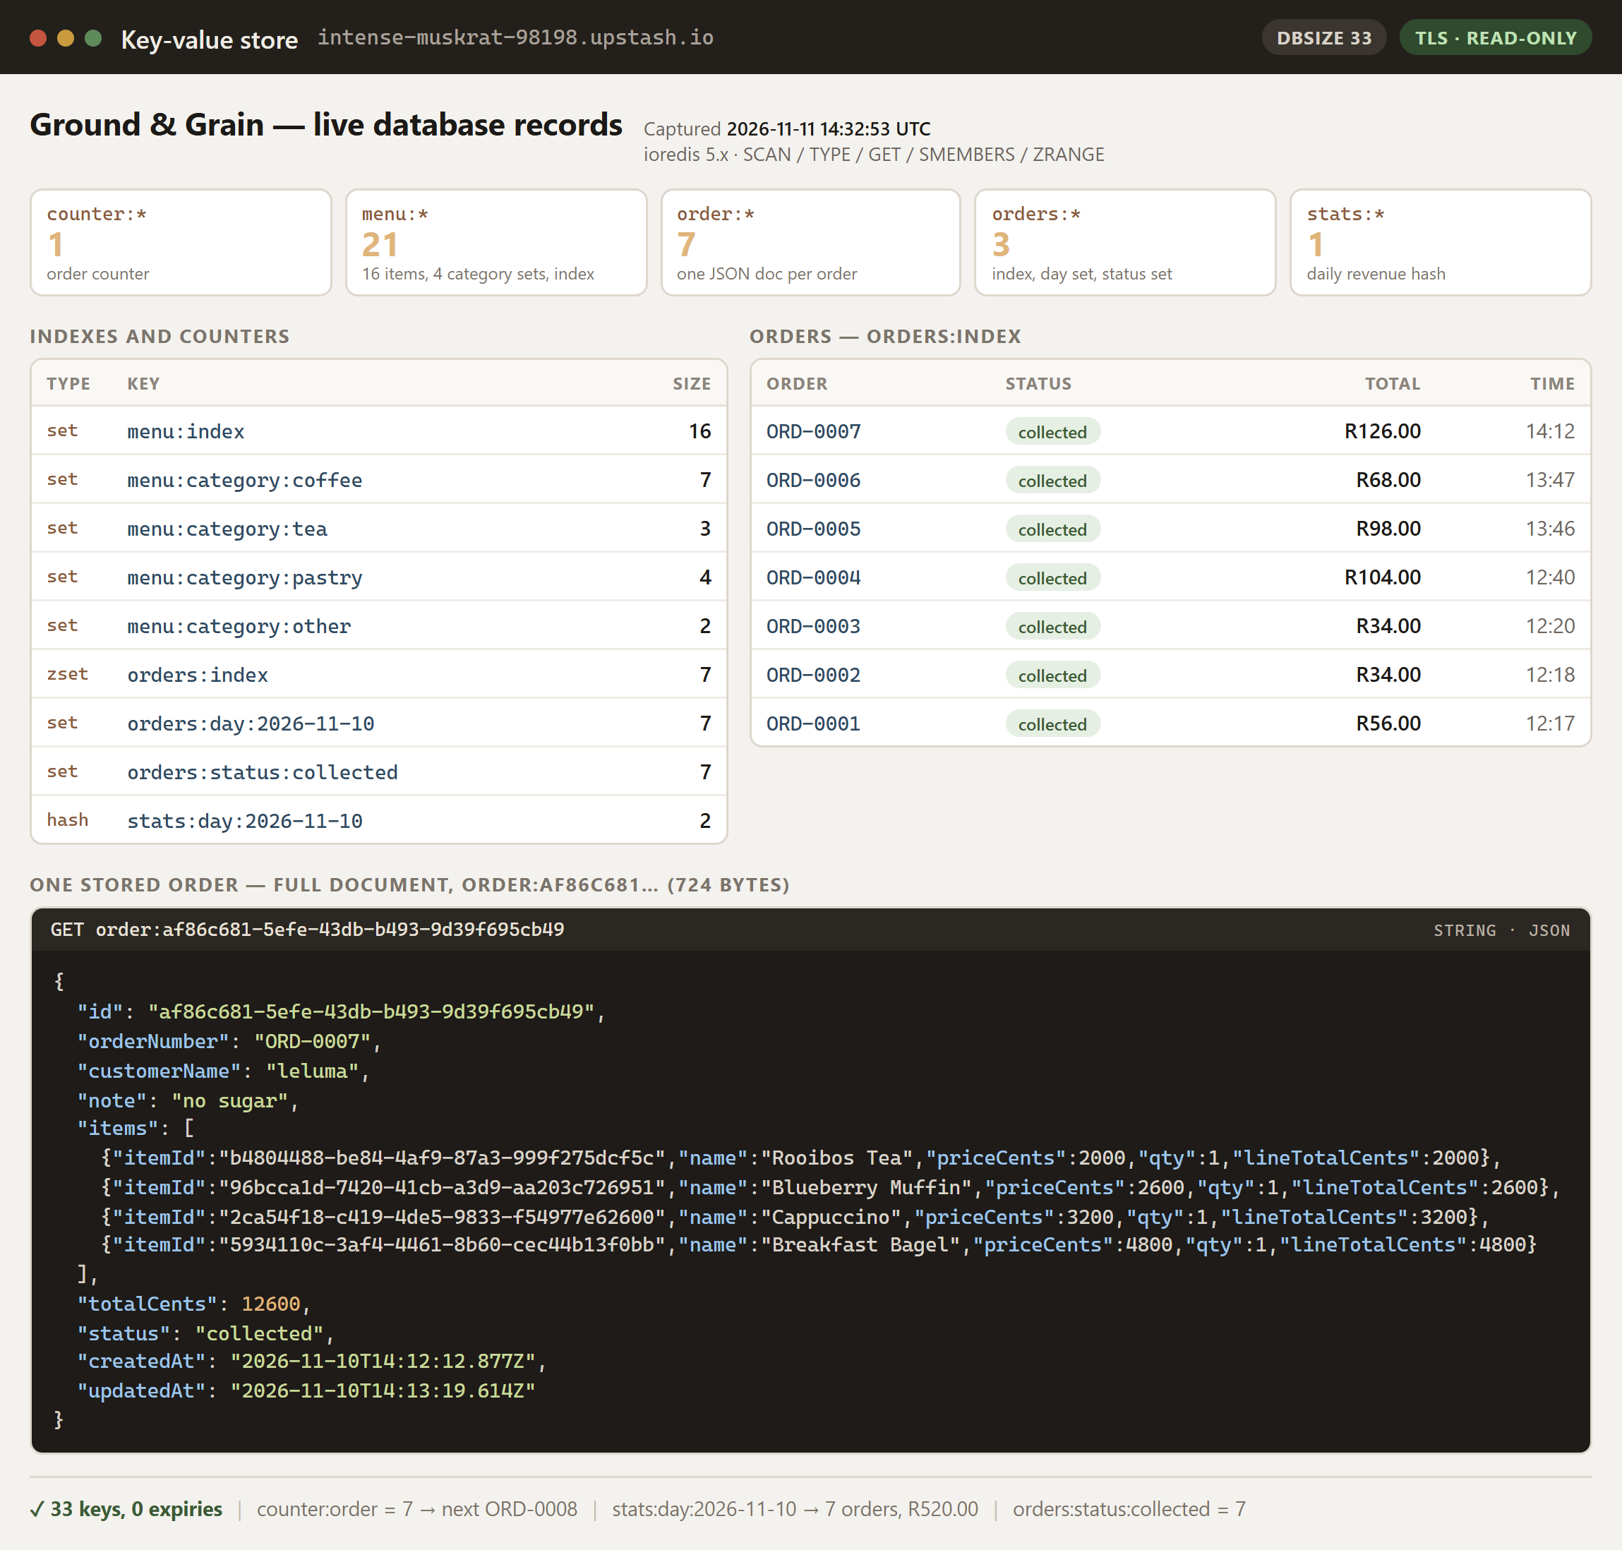
Figure 1 — Records read back from the live Upstash key-value store on 11 November 2026: 33 keys, 16 menu documents, 7 orders and the full ORD-0007 document.

7. Challenges and lessons
CORS compares strings, not intentions. Our first deployment returned 403 CORS_BLOCKED even though the frontend URL looked right. Origins are compared as exact strings: a trailing slash, http instead of https, or a preview domain is a different origin. The fix was to set FRONTEND_URL to the canonical Vercel domain with no trailing slash, and to log the rejected origin so the next person does not have to guess.
Environment variables that are baked in. Vite inlines VITE_* variables at build time. Editing the value in the Vercel dashboard changes nothing until the project is rebuilt. We lost time to a build that still pointed at localhost because the variable was added after the deployment. The deployment procedure now treats the variable and the redeploy as one step.
Thinking in key-value. The instinct from a relational database is to fetch everything and filter in the application. That works with sixteen menu items and fails with sixteen thousand orders. This design forces every access path to be named in advance: an index per status, per day and per category, plus a sorted set for recency. The board, the orders table and the summary are all index reads, and none of them scans the keyspace.
Effects, identity and focus. The dialog bug in Section 4.4 is the clearest lesson of the project. React compares dependencies by identity, and an inline arrow function is a new function on every render. The bug was invisible in review and obvious in a browser. The rule we took away is simple: an effect that moves focus should run once per open, never once per render.
Security defaults are a product decision. The first build shipped a demo password so that the project just worked. That is convenient for a marker and unacceptable for a deployed system, because it puts a working credential in the bundle and in the README. Removing it meant changing the documentation, the login screen, the stylesheet and the server fallback, and then proving the fallback was gone by booting in production mode without a hash and watching login return 401.
Secrets. During development a database connection string and a staff password were pasted into a chat window while we were debugging a deployment. Neither is in the repository or in the client bundle, and the password only ever existed on the server as a bcrypt hash, but we treat both as exposed. Rotation is part of the handover: the staff password is replaced with a new hash in the Render environment and the Upstash credential is regenerated. The repository contains no .env file, only an .env.example with empty values, and .gitignore covers the local environment and the file database.

8. Conclusion and future work

8.1 What we achieved
The project delivers a working, deployed system rather than a prototype. A customer can browse a live menu, build a cart that survives a refresh, place an order in four interactions and watch it progress to collection. A barista can sign in, manage availability, work a forward-only queue and see the day's revenue without touching a calculator. Every rule that protects money or state is enforced on the server, every input is validated, and the whole system runs on free infrastructure with durable storage.
The objectives in Section 1.2 were met. The functional areas are demonstrated in the screenshots and at the live URLs, the ten automated tests pass, accessibility was measured rather than asserted, and the deployment was verified with the same flows a marker will use. The two defects we found late, the visible demo password and the self-closing dialog, were fixed at the cause, covered by tests and written up here.

8.2 What we would do next
- Multiple staff accounts and roles: a staff:{id} document, a role claim in the JWT, and a permission check per route.
- Payment: a payment intent created on the server and a webhook that marks the order paid, keeping the API as the source of truth.
- Notifications: email or SMS when an order is ready, triggered by the status transition.
- Stock control: decrement ingredients per sale and mark items unavailable at zero, inside the transaction that already exists.
- Analytics: revenue by hour and best-selling items, starting from the daily hash with a monthly rollup key.
- End-to-end tests in CI, run against a disposable Redis container on every pull request.

8.3 What we learned
The most useful outcome was not the feature list. It was the discipline the constraints forced on us. A key-value store made us design the data model instead of discovering it. A free tier made the interface honest about latency. A single staff account made authorisation explicit. And a bug that only appeared when a person typed into a form reminded us that automated tests check the behaviour you thought of, while acceptance testing finds the behaviour you did not.

References
1. Meta Open Source. React — The library for web and native user interfaces. https://react.dev (accessed November 2026).
2. Vite. Vite — Next Generation Frontend Tooling. https://vite.dev (accessed November 2026).
3. OpenJS Foundation. Express — Fast, unopinionated, minimalist web framework for Node.js. https://expressjs.com (accessed November 2026).
4. MDN Web Docs. Fetch API. https://developer.mozilla.org/en-US/docs/Web/API/Fetch_API (accessed November 2026).
5. Redis Ltd. Redis data types: sets, sorted sets and hashes. https://redis.io/docs/latest/develop/data-types/ (accessed November 2026).
6. Upstash. Redis — Serverless Redis. https://upstash.com/docs/redis (accessed November 2026).
7. W3C. Web Content Accessibility Guidelines (WCAG) 2.2. https://www.w3.org/TR/WCAG22/ (accessed November 2026).
8. OWASP Foundation. OWASP Top 10 — 2021. https://owasp.org/www-project-top-ten/ (accessed November 2026).
9. Zod. Zod — TypeScript-first schema validation. https://zod.dev (accessed November 2026).
10. Jones, M., Bradley, J. and Sakimura, N. JSON Web Token (JWT), RFC 7519. IETF, 2015.
11. Provos, N. and Mazières, D. A Future-Adaptable Password Scheme. USENIX Annual Technical Conference, 1999.
12. Vercel. Deploying a Vite project. https://vercel.com/docs/frameworks/vite (accessed November 2026).
13. Render. Blueprint specification (render.yaml). https://render.com/docs/blueprint-spec (accessed November 2026).

Appendix A — API reference
Table 12 — API endpoints
Method | Endpoint | Auth | Success and notable errors
GET | /api/health | public | 200 with driver and uptime; 503 if the store is down
GET | /api/menu | public | 200, all items
GET | /api/menu/:id | public | 200; 404 NOT_FOUND
POST | /api/menu | staff | 201; 400 VALIDATION_ERROR; 401
PUT | /api/menu/:id | staff | 200; 400; 404
DELETE | /api/menu/:id | staff | 204; 409 ITEM_IN_USE
GET | /api/orders | staff | 200; 401
GET | /api/orders/summary/today | staff | 200 with count, revenue and by-status
GET | /api/orders/:id | public | 200; 404
POST | /api/orders | public | 201; 400; 409 ITEM_UNAVAILABLE; 429
PATCH | /api/orders/:id/status | staff | 200; 409 INVALID_TRANSITION
POST | /api/auth/login | public | 200 with token; 401; 429

Example: create an order
POST /api/orders
Content-Type: application/json
{ "customerName": "Thabo", "note": "Oat milk, no sugar",
"items": [ { "itemId": "290f804a-02a3-4d04-ac03-e9c9e8915402", "qty": 2 } ] }
201 Created
{ "data": { "id": "a4366e9c-b0be-47e9-899c-ef86a0d8f125",
"orderNumber": "ORD-0007", "customerName": "Thabo",
"status": "pending", "totalCents": 4400,
"items": [ { "itemId": "290f804a-…", "name": "Americano",
"priceCents": 2200, "qty": 2 } ],
"createdAt": "2026-11-10T13:48:00.000Z" } }

Example: an illegal status transition
PATCH /api/orders/a4366e9c-…/status Authorization: Bearer <token>
{ "status": "ready" }
409 Conflict
{ "error": { "code": "INVALID_TRANSITION",
"message": "Cannot move an order from pending to ready. The next step is preparing." } }

Appendix B — Records and screenshots
Below is one order exactly as it is stored in the live database, followed by an index of every screenshot in submission/screenshots/. Figure 1 in Section 6.4 is the live key-value store itself; Figures 2 and 3 here show the customer menu and the staff order board.

Order document as stored
{
"id": "af86c681-5efe-43db-b493-9d39f695cb49",
"orderNumber": "ORD-0007",
"customerName": "leluma",
"note": "no sugar",
"items": [
{ "itemId": "b4804488-…", "name": "Rooibos Tea",
"priceCents": 2000, "qty": 1, "lineTotalCents": 2000 }
],
"totalCents": 12600,
"status": "collected",
"createdAt": "2026-11-10T14:12:12.877Z",
"updatedAt": "2026-11-10T14:13:19.614Z"
}

Screenshots
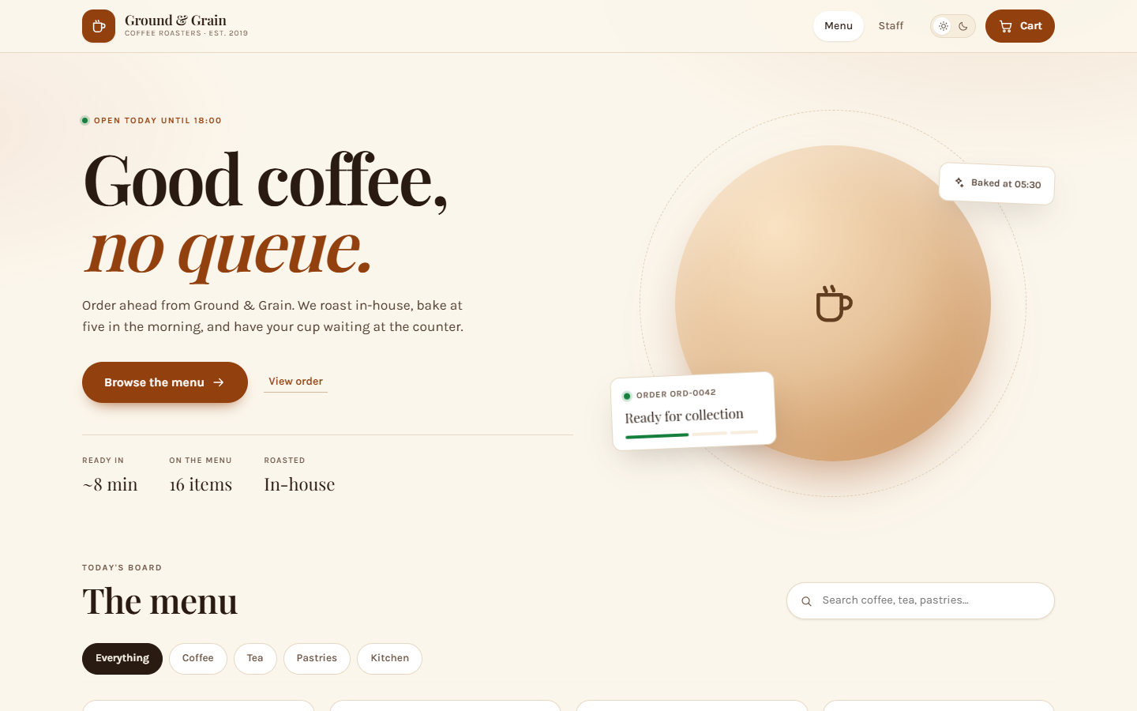
Figure 2 — Customer menu in the light theme at 1440 × 900.
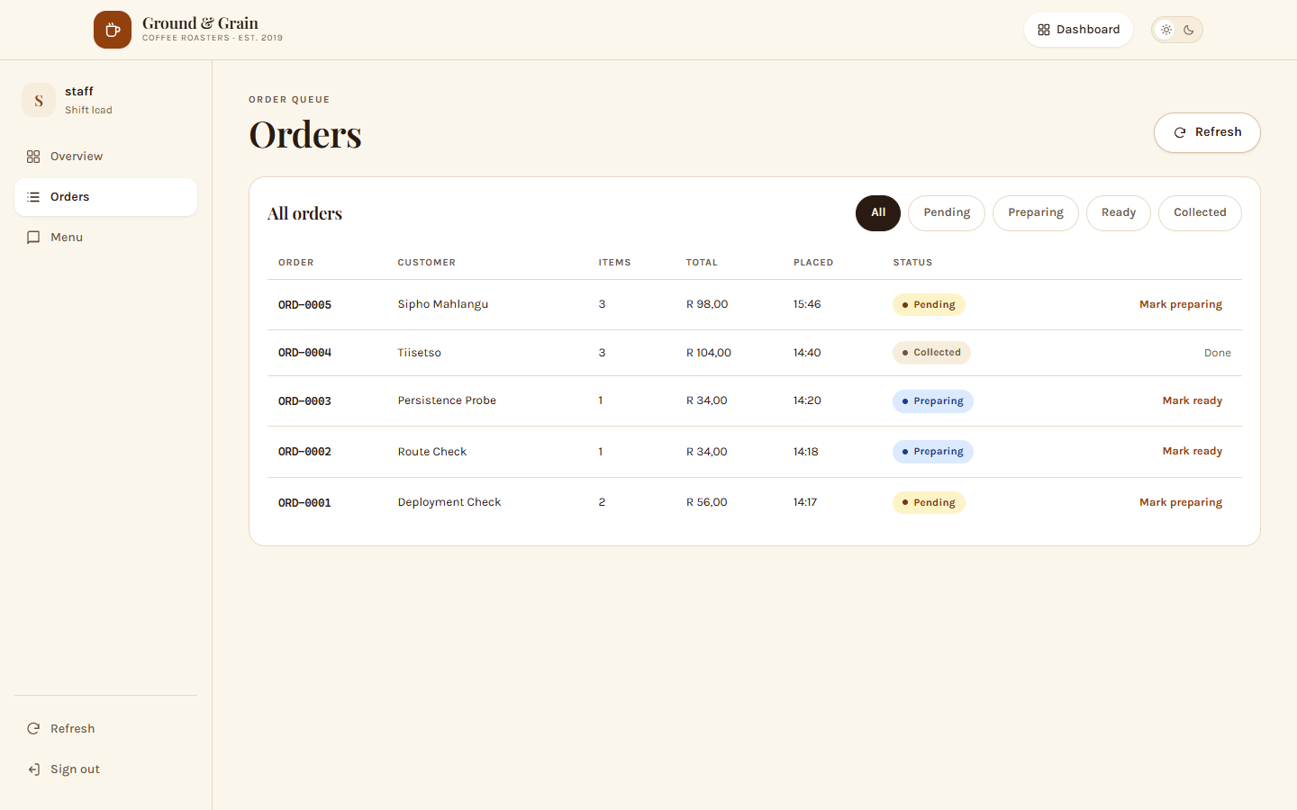
Figure 3 — Orders table with one-click status advancement.
Screenshots 01 to 12 were captured from the deployed application at coffee-shop-omega-lovat.vercel.app on 10 November 2026, not from a local build. Screenshot 13 is the database rather than the interface. All files are in submission/screenshots/.
Table 13 — Screenshot index
File | What it shows
01-menu-light.png | Customer menu, light theme, 1440 × 900
02-menu-search.png | Search filtering the menu
03-cart.png | Cart drawer with quantities and checkout form
04-confirmation.png | Order confirmation and status tracker
05-staff-login.png | Staff sign-in screen
06-dashboard-overview.png | Daily totals and live order board
07-dashboard-orders.png | Orders table with status actions
08-dashboard-menu.png | Menu management list
09-menu-editor.png | Add-item dialog with focus in the name field
10-menu-dark.png | Dark theme
11-mobile-menu.png | Menu at 390 × 844
12-mobile-cart.png | Cart sheet at 390 × 844
13-database-records.png | Live key-value store: keyspace, indexes and one stored order

