TPG226C GROUP PROJECT
SmartMart Retail Inventory Management App
Group members and project submission
Subject | Technical Programming IIA
Subject code | TPG226C
Programme | Diploma in Information Technology
Project | Retail Inventory Management App (SmartMart Retailers)
Due date | 14 October 2026

Group Members
No. | Student Number | Name & Surname
1 | 220048471 | Kyle van Aswegen
2 | 224037409 | Mlungiso Njoko
3 | 224002222 | Kabelo Nhlapo
4 | 219005935 | Rainier Bezuidenhout
5 | 224069913 | Mobakeng Mochwaro
6 | 223068452 | Nathaniël Stanley
7 | 224136508 | Owami Maphalala
8 | 224042164 | Philasande Simelane

Additional Features
Besides the required functionality, the app includes the following extra features:
- Search bar – filters the product list by product name or code as you type.
- Duplicate code check – a new product cannot use a product code that already exists; the code is locked when editing.
- Automatic stock status – entering a quantity sets the status (0 = Out of Stock, 1–5 = Low Stock, 6+ = Available), which can still be changed manually.
- Comma validation – product codes and names may not contain commas, so products.txt always stays in the correct format.
- User feedback – confirmation messages are shown after a product is added, updated or deleted.
- Category image preview – the Add/Edit form shows the product image, which changes with the selected category.

Screenshots
Screenshots of the completed app, taken on an Android emulator (Pixel 10 Pro).
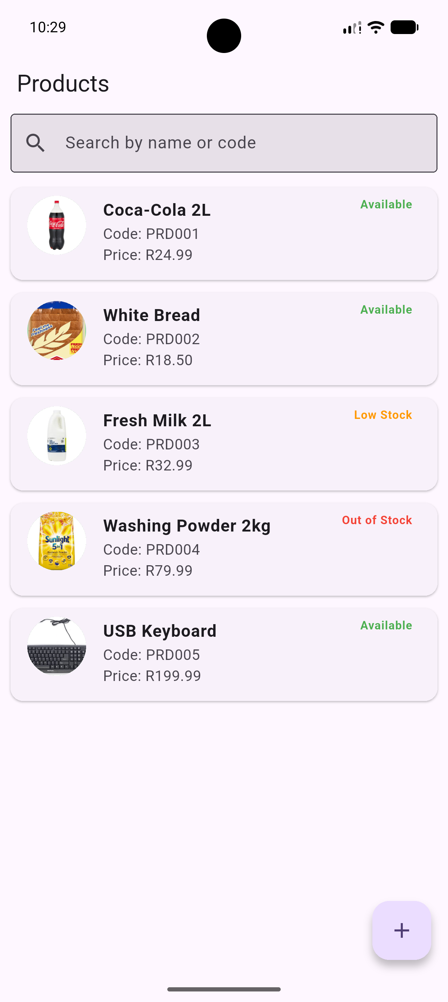  Figure 1: Product List screen | 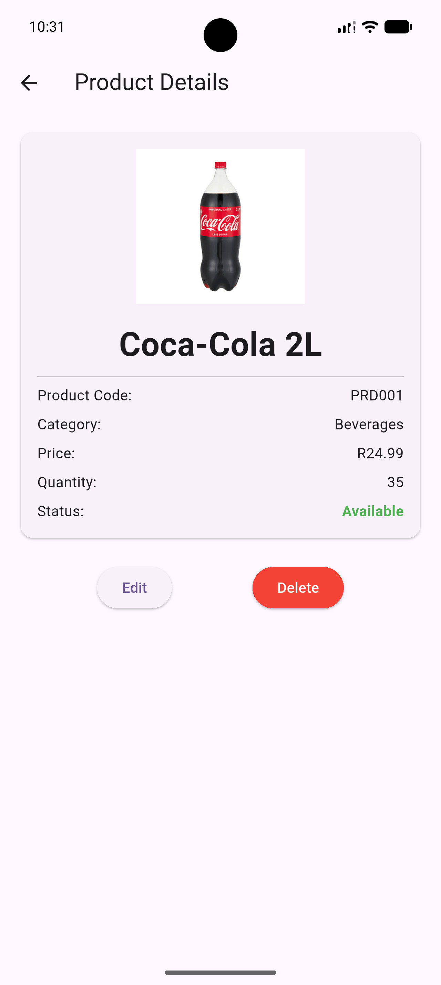  Figure 2: Product Detail screen | 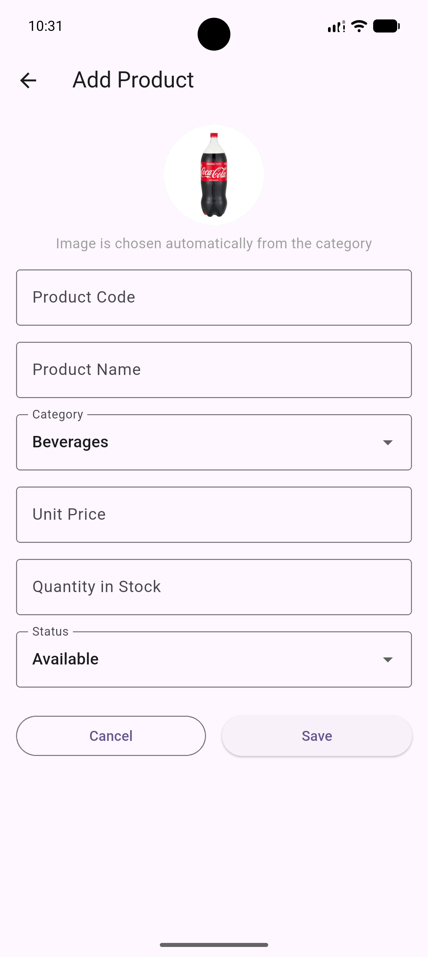  Figure 3: Add Product form
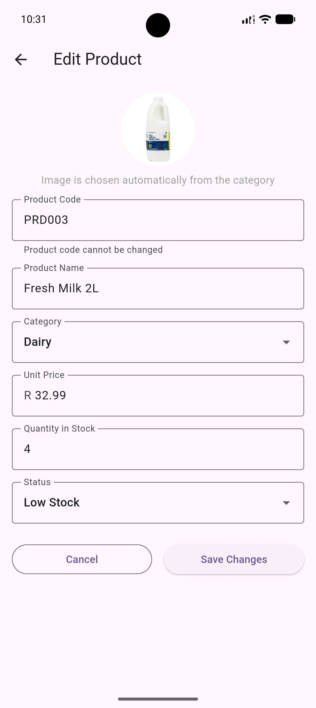  Figure 4: Edit Product form | 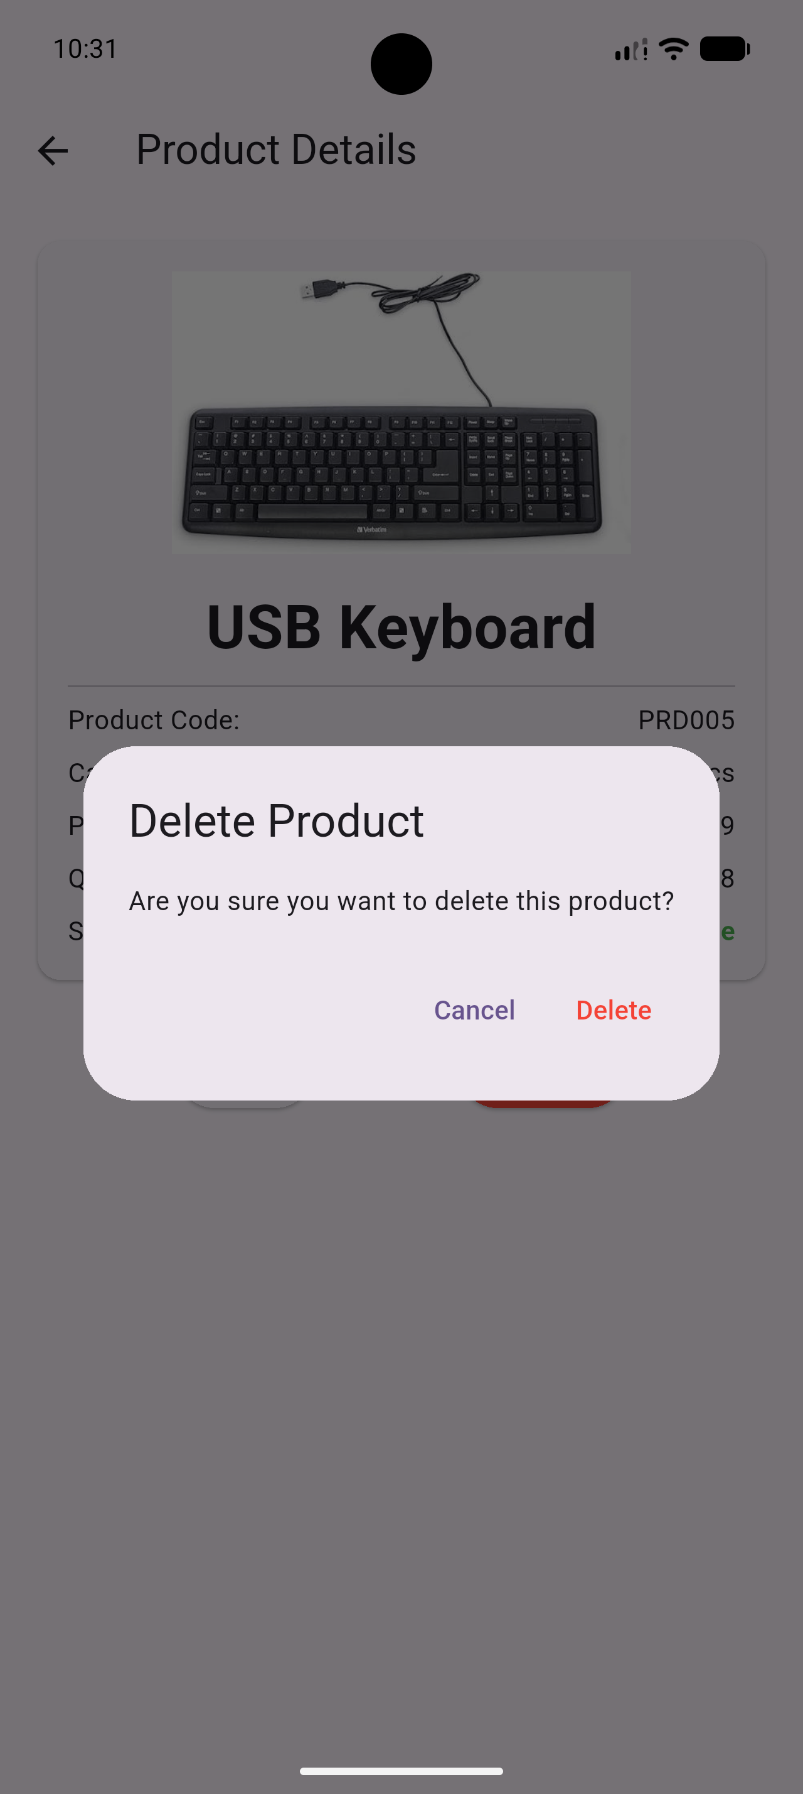  Figure 5: Delete confirmation dialog

