Fig.: 3.3.1 Identification of communities.

4
10
15

3
18
9
0
14
8
19
13
2

7
1
12
6
17

16
5
11

<- Nodes of community 0

<- Nodes of community 1
<- Nodes of community 2
<- Nodes of community 3

Fig. : 3.3.2 Boundary scores of all nodes.
4
10
10
15
0.25
0.50
0.50
0.50
3
18
0.50
9
0
0.20
0.571
14
0.50
0.33
8
19
13
2
0.33
0.25
7
1
0.50
0.142
12
6
17
0.00

16
5
11
0.40
0.00
0.33
<- Nodes of community 0

<- Nodes of community 1
<- Nodes of community 2
<- Nodes of community 3

Fig. : 3.3.3 Local closeness centrality of all nodes.

1.00
0.75
1.00
4
10
15
1.00
1.00
0.75
1.00
3
18
1.00
9
0
0.66
0.66
14
0.80
0.75
8
19
13
2
0.75
0.66
7
1
0.80
1.00
12
6
17
1.00

16
5
11
0.66
0.66
0.66
<- Nodes of community 0

<- Nodes of community 1
<- Nodes of community 2
<- Nodes of community 3

Fig.: 3.3.4 Composite scores of all nodes.
1.25
1.25
1.00
4
1.25
10
15
1.50
1.5
1.25
3
18
1.50
9
0
0.86
1.238
14
1.083
1.3
8
19
0.916
13
2
1.083
1.3
7
1
1.143
12
6
17
1.00

16
5
11
1.06
0.66
1.00
<- Nodes of community 0

<- Nodes of community 1
<- Nodes of community 2
<- Nodes of community 3

Fig.: 3.3.5 Community graph.

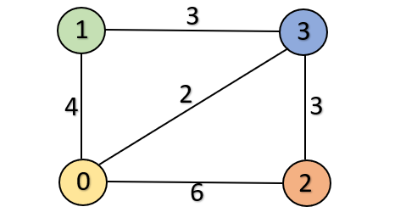

Fig.: 3.3.6 Closeness centrality in the community graph.
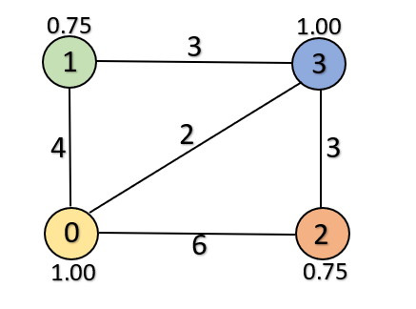

Fig.: 3.3.7.1 Rank of the communities.
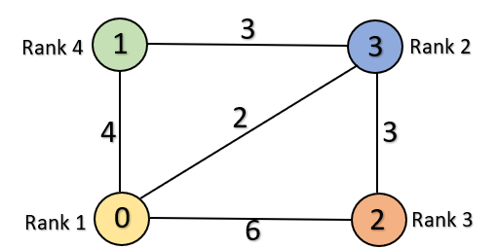

Fig.: 3.3.7.2 No. of selected nodes in each community.
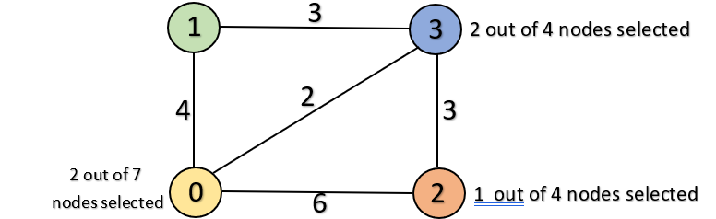

Fig.: 3.3.8 top-k Selected nodes.
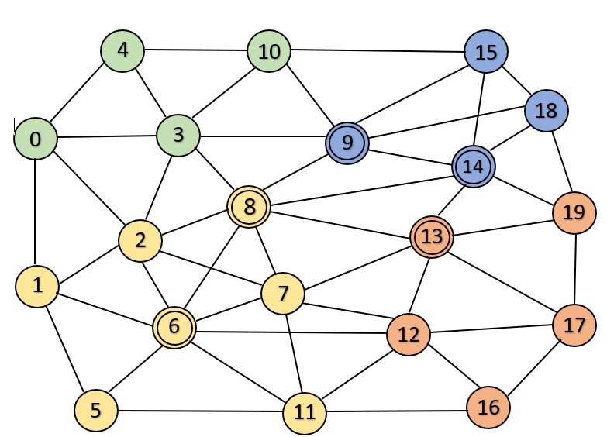

Fig.: 3.4.9 Graph after removing the top-k nodes.
