1) Create a Database called student

> use student
switched to db student
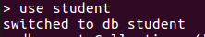

2) Create a collection called ​studentmarks

> db.createCollection("studentmarks")
{ "ok" : 1 }

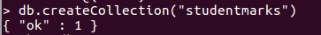

3) Create the documents listed in above table.

> db.studentmarks.insert({"name":"Mala","maths_marks":45,"english_marks":53,"science_marks":72})
WriteResult({ "nInserted" : 1 })
> db.studentmarks.insert({"name":"Vanu","maths_marks":80,"english_marks":75,"science_marks":85})
WriteResult({ "nInserted" : 1 })
> db.studentmarks.insert({"name":"Kala","maths_marks":32,"english_marks":46,"science_marks":53})
WriteResult({ "nInserted" : 1 })
> db.studentmarks.insert({"name":"Aruli","maths_marks":78,"english_marks":85,"science_marks":80})
WriteResult({ "nInserted" : 1 })
> db.studentmarks.insert({"name":"Shayu","maths_marks":80,"english_marks":76,"science_marks":65})
WriteResult({ "nInserted" : 1 })
> db.studentmarks.insert({"name":"kumaran","maths_marks":32,"english_marks":73,"science_marks":84})
WriteResult({ "nInserted" : 1 })
> db.studentmarks.insert({"name":"Lucky","maths_marks":66,"english_marks":90,"science_marks":45})
WriteResult({ "nInserted" : 1 })
> db.studentmarks.insert({"name":"Gva","maths_marks":71,"english_marks":75,"science_marks":56})
WriteResult({ "nInserted" : 1 })
> db.studentmarks.insert({"name":"Raam","maths_marks":41,"english_marks":65,"science_marks":88})
WriteResult({ "nInserted" : 1 })

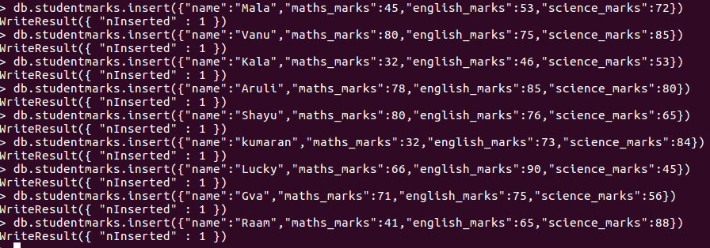
4) Increase the maths marks of Mala by 6 marks

> db.studentmarks.update({"name":"Mala"},{$inc:{"maths_marks":6}})
WriteResult({ "nMatched" : 1, "nUpserted" : 0, "nModified" : 1 })

5) List the names of students who got more than 50 marks in Maths Subject.

> db.studentmarks.find({"maths_marks":{$gt:50}}).pretty()
{
"_id" : ObjectId("5c3c5a65a04eedf995dba9ec"),
"name" : "Mala",
"maths_marks" : 51,
"english_marks" : 53,
"science_marks" : 72
}
{
"_id" : ObjectId("5c3c5a93a04eedf995dba9ed"),
"name" : "Vanu",
"maths_marks" : 80,
"english_marks" : 75,
"science_marks" : 85
}
{
"_id" : ObjectId("5c3c5b4fa04eedf995dba9ef"),
"name" : "Aruli",
"maths_marks" : 78,
"english_marks" : 85,
"science_marks" : 80
}
{
"_id" : ObjectId("5c3c5b68a04eedf995dba9f0"),
"name" : "Shayu",
"maths_marks" : 80,
"english_marks" : 76,
"science_marks" : 65
}
{
"_id" : ObjectId("5c3c5bd9a04eedf995dba9f2"),
"name" : "Lucky",
"maths_marks" : 66,
"english_marks" : 90,
"science_marks" : 45
}
{
"_id" : ObjectId("5c3c5bfda04eedf995dba9f3"),
"name" : "Gva",
"maths_marks" : 71,
"english_marks" : 75,
"science_marks" : 56
}

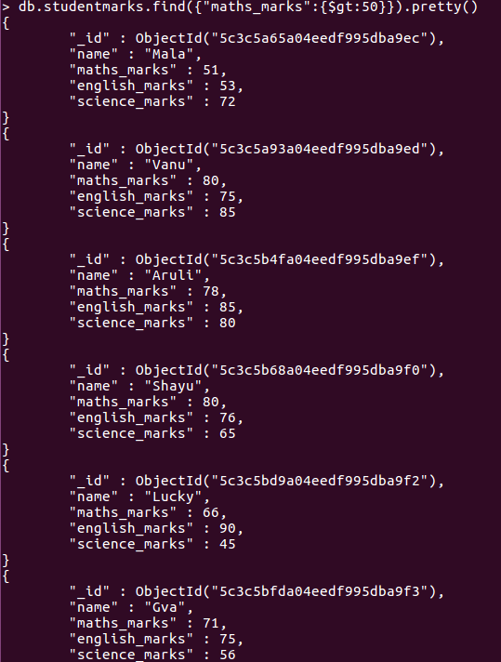
6)Add a new column(field) for Average for all students.

> db.studentmarks.update({},{$set:{"average":1}},{upsert:false,multi:true})
WriteResult({ "nMatched" : 9, "nUpserted" : 0, "nModified" : 9 })

7) Update Marks_Science=75 to Lucky .

>db.studentmarks.update({"name":"lucky"},{$set:{"science_marks":75}})
WriteResult({ "nMatched" : 1, "nUpserted" : 0, "nModified" : 1 })

8) List the names who got more than 50 marks in all subjects.

> db.studentmarks.find({$or:[{"maths_marks":{$lt:50}},{"english_marks":{$gt:50}},{"science_marks":{$gt:50}}]},{"name":1,_id:0}).pretty()
{ "name" : "Mala" }
{ "name" : "Vanu" }
{ "name" : "Kala" }
{ "name" : "Aruli" }
{ "name" : "Shayu" }
{ "name" : "kumaran" }
{ "name" : "Lucky" }
{ "name" : "Gva" }
{ "name" : "Raam" }

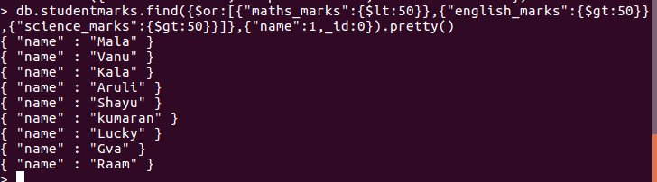

9) List the names who got less than 50 marks in Maths subject and more than 50 marks in English

> db.studentmarks.find({$or:[{"maths_marks":{$lt:50}},{"english_marks":{$gt:50}}]},{"name":1,_id:0}).pretty()
{ "name" : "Mala" }
{ "name" : "Vanu" }
{ "name" : "Kala" }
{ "name" : "Aruli" }
{ "name" : "Shayu" }
{ "name" : "kumaran" }
{ "name" : "Lucky" }
{ "name" : "Gva" }
{ "name" : "Raam" }
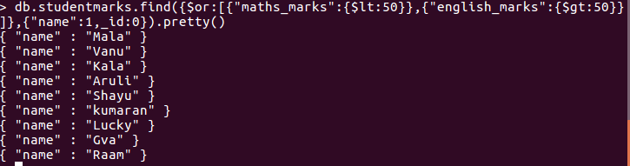
10) List the names who got less than 40 in both Maths and Science.

> db.studentmarks.find({$or:[{"maths_marks":{$lt:40}},{"science_marks":{$gt:40}}]},{"name":1,_id:0}).pretty()
{ "name" : "Mala" }
{ "name" : "Vanu" }
{ "name" : "Kala" }
{ "name" : "Aruli" }
{ "name" : "Shayu" }
{ "name" : "kumaran" }
{ "name" : "Gva" }
{ "name" : "Raam" }

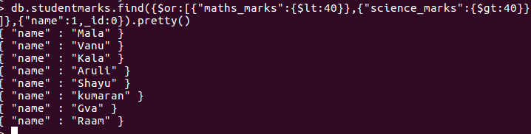

11) Remove Science column/field for Raam
> db.studentmarks.remove({"name":"Raam"},{"science_marks":88})
WriteResult({ "nRemoved" : 1 })

12) Update John’s Math mark as 87 and English mark as 23, if john not available upsert.

> db.studentmarks.insert({"name":"John","maths_marks":87,"english_marks":23})
WriteResult({ "nInserted" : 1 })

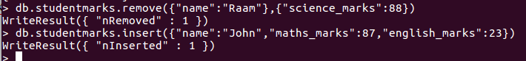

13) Rename the english_marks column/field for John to science_marks

> db.studentmarks.update({"name":"John"},{$rename:{"english_marks":"science_marks"}})
WriteResult({ "nMatched" : 1, "nUpserted" : 0, "nModified" : 1 })

14) Remove Kumaran’s document from collection

> db.studentmarks.remove({"name":"kumaran"},{})
WriteResult({ "nRemoved" : 1 })

15) Find Kala’s or Aruli’s math_marks and science_marks

> db.studentmarks.find({$or:[{"name":"Kala"},{"name":"Aruli"}]},{"maths_marks":1,"science_marks":1}).pretty()
{
"_id" : ObjectId("5c3c5ab0a04eedf995dba9ee"),
"maths_marks" : 32,
"science_marks" : 53
}
{
"_id" : ObjectId("5c3c5b4fa04eedf995dba9ef"),
"maths_marks" : 78,
"science_marks" : 80
}

