**1. 최종결과 캡쳐 화면.**

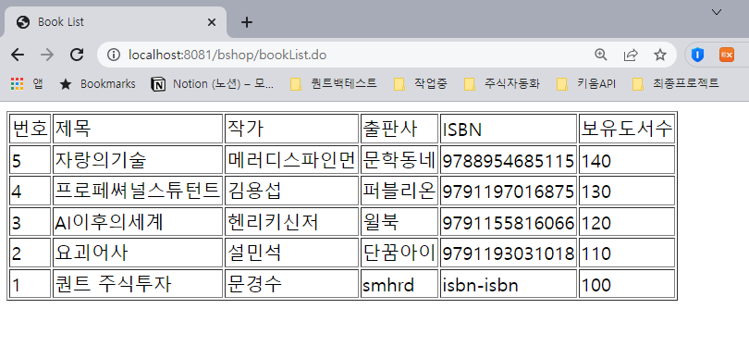

**2. SQL 문장.**

**drop** **table** Book;

**CREATE** **TABLE** Book

(

num **int** **not** **null** auto_increment,

title **varchar**(50) **not** **null**,

author **varchar**(30) **not** **null**,

company **varchar**(50) **not** **null**,

isbn **varchar**(30) **not** **null**,

count **int** **default** 100,

**primary** **key** (num)

);

**select** * **from** Book;

**insert** **into** Book(title, author, company, isbn)

**values** ('퀀트 주식투자', '문경수', 'smhrd', 'isbn-isbn');

**insert** **into** Book(title, author, company, isbn, count)

**values** ('요괴어사', '설민석', '단꿈아이', '9791193031018', 110);

**insert** **into** Book(title, author, company, isbn, count)

**values** ('AI이후의세계', '헨리키신저', '윌북', '9791155816066', 120);

**insert** **into** Book(title, author, company, isbn, count)

**values** ('프로페쎠널스튜턴트', '김용섭', '퍼블리온', '9791197016875', 130);

**insert** **into** Book(title, author, company, isbn, count)

**values** ('자랑의기술', '메러디스파인먼', '문학동네', '9788954685115', 140);

**commit**;

**select** * **from** Book;

**3. book.java 소스**

package kr.book.entity;

import lombok.AllArgsConstructor;

import lombok.Data;

import lombok.NoArgsConstructor;

@AllArgsConstructor

@NoArgsConstructor

@Data

public class Book {

private int num;

private String title;

private String author;

private String company;

private String isbn;

private int count;

}

**4. BookController.java**

package kr.book.bshop;

import java.util.List;

import org.springframework.beans.factory.annotation.Autowired;

import org.springframework.stereotype.Controller;

import org.springframework.ui.Model;

import org.springframework.web.bind.annotation.RequestMapping;

import kr.board.entity.Board;

import kr.book.entity.Book;

import kr.book.mapper.BookMapper;

@Controller

public class BookController {

@Autowired

private BookMapper mapper;

@RequestMapping("/bookList.do")

public String list(Model model) {

List<Book> list = mapper.bookList();

//객체 바인딩

model.addAttribute("list", list);

return "bookList"; // /WEB/views/board/list.jsp : forward

}

}

**5. BookMapper.java**

package kr.book.mapper;

import java.util.List;

import kr.book.entity.Book;

public interface BookMapper {

public List<Book> bookList();

}

**6. BookMapper.xml**

<?**xml** version=*"1.0"* encoding=*"UTF-8"*?>

<!**DOCTYPE** mapper PUBLIC "-//mybatis.org//DTD Mapper 3.0//EN" "http://mybatis.org/dtd/mybatis-3-mapper.dtd" >

<**mapper** namespace=*"kr.book.mapper.BookMapper"*>

<!-- 전체 게시물을 가져오는 SQL -->

<**select** id=*"bookList"* resultType = *"kr.book.entity.Book"*>

select * from Book order by num desc

</**select**>

</**mapper**>

**7. BookList.jsp**

<%@ **page** language=*"java"* contentType=*"text/html; charset=UTF-8"*

pageEncoding=*"UTF-8"*%>

<%@**taglib** prefix=*"c"* uri=*"http://java.sun.com/jsp/jstl/core"* %>

<%@**taglib** prefix=*"fmt"* uri=*"http://java.sun.com/jsp/jstl/fmt"* %>

<%@**taglib** prefix=*"fn"* uri=*"http://java.sun.com/jsp/jstl/functions"* %>

<!**DOCTYPE** html>

<**html**>

<**head**>

<**meta** charset=*"UTF-8"*>

<**title**>Book List</**title**>

</**head**>

<**body**>

<**table** class=*"table"* border = *"1"*>

<**thead**>

<**tr**>

<**td**> 번호 </**td**>

<**td**> 제목 </**td**>

<**td**> 작가 </**td**>

<**td**> 출판사 </**td**>

<**td**> ISBN </**td**>

<**td**> 보유도서수 </**td**>

</**tr**>

</**thead**>

<**tbody**>

<**c:forEach** var=*"vo"* items=*"*${list}*"*>

<**tr**>

<**td**> ${vo.num} </**td**>

<**td**> ${vo.title} </**td**>

<**td**> ${vo.author} </**td**>

<**td**> ${vo.company} </**td**>

<**td**> ${vo.isbn} </**td**>

<**td**> ${vo.count} </**td**>

</**tr**>

</**c:forEach**>

</**tbody**>

</**table**>

</**body**>

</**html**>